2022 Interim Report for Door County AIS Control: Door County AIS Control
Grant# ACEI27422
Door County Soil & Water Conservation Department
Grant Period of Performance: 3/15/2022-12/31/2023
Report Period of Performance: 3/15/2022-12/31/2022
Report Provided to: Amanda Smith, Mary Gansberg, & Gina Keenan
2/22/2023

This document outlines to the accomplishments of Door County Soil & Water Conservation Department (SWCD) pertaining to Aquatic Invasive Species Control in Door County in 2022 as it pertains to deliverables specified in the WDNR AIS Control Grant ACEI27422.

During 2022 SWCD made substantial progress towards grant deliverables spelled out in the grant agreement ACEI27422. During 2022 SWCD began working towards grant deliverables through match funds. In 2023 SWCD anticipates continuing to achieve and meet deliverables. This project is the beginning of SWCD utilizing newer technologies in partnership to prioritize project efforts and to continue to the knowledge of invasive species management.

Activity 1a. Generate a targeted map using a variety of data including the Renz Lab Invasive Species suitability modeling data to identify project areas of interest. Overlay the map with existing Green Print Initiative data to identify areas that are considered of high ecological importance and highly susceptible to the invasion of Phragmites & Purple Loosestrife.

Door County SWCD performed a GIS analysis utilizing the Renz lab data and the Door County Greenprint data. This analysis aims to focus efforts for inventory. The following maps are the results of this analysis. For both non-native phragmites and purple loosestrife SWCD included the intial analysis map and the final map which outlines the priority efforts for this grant. For reportings sake these maps are PDF that have been exported as JPEGs resulting in a degredation of the map image qulaity. If funders or others interested parties would like a higher resolution PDF please reach out to SWCD.

These maps during 2022 were the basework for inventory efforts and for 2023 will continue to be the structure for inventory efforts. In 2023 anticipates adding to this data set and maximize the model.

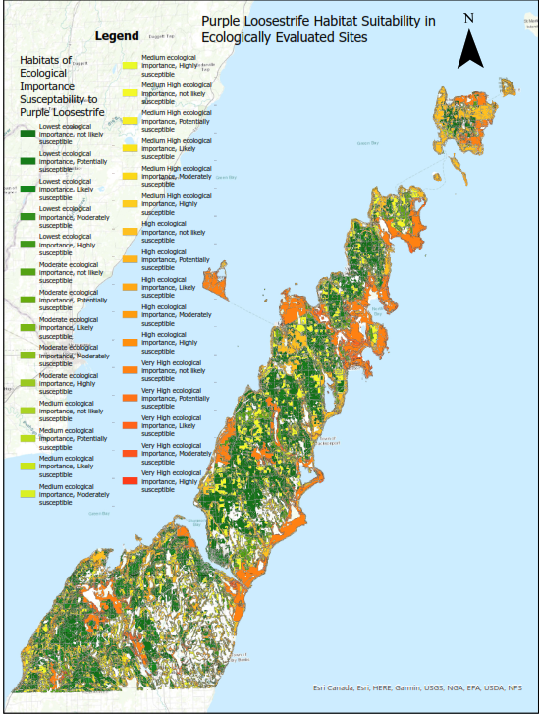
Figure 1 Purple loosestrife habitat suitability modeling in habitat assessed for ecological importance. This map is the first iteration of data displaying the total data set.

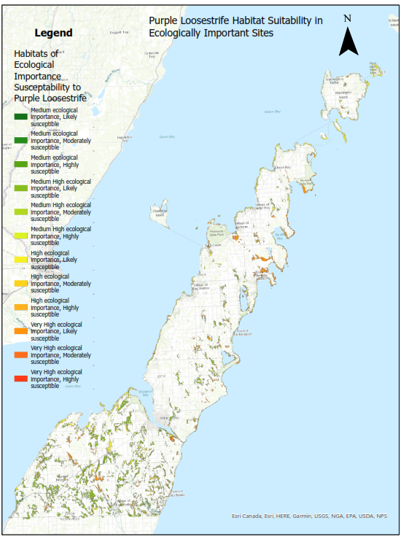
Figure 2 Purple loosestrife habitat suitability modeling in ecologically important habitat as determined by the Door County Greenprint model. This map is the final iteration of data, creating a focus area to inventory purple loosestrife that could most great impact Door County’s most ecologically important areas.
Figure 3 Non-native Phragmites habitat suitability modeling in habitat assessed for ecological importance. This map is the first iteration of data displaying the total data set.

Figure 4 Non-native Phragmites habitat suitability modeling in ecologically important habitat as determined by the Door County Greenprint model. This map is the final iteration of data, creating a focus area to inventory non-native phragmites that could most great impact Door County’s most ecologically important areas.

Activity 1b. Inventory target areas for Phragmites using maps generated in activity 1.a. Inventory purple loosestrife and Japanese knotweed in wetlands, riparian coordinators, drainage ways, and shoreline areas.

Door County utilized the models from 1a. to imform inventory efforts. During 2022 SWCD inventories 312 acres of non-native phragmites, 9 acres of purple loosestrife, and 9.7 acres of knotweed. SWCD collected samples of knotweed and will be mailing them out for genomic sequencing as part of another state project to identify populations of Japanese, bohemien, and giant knotweed. The following maps are the results of inventory efforts for 2022.
Figure 5 Non-native Phragmites inventoried in 2022 in priority project areas determined in activity 1a. described above.

Figure 6 Purple loosestrife inventoried in 2022 in priority project areas determined in activity 1a. described above.

Figure 7 Knotweed inventoried in 2022 along riparian, wetland, shoreline, and aquatic habitats throughout Door County.
Activity 1c. Control Phragmites australis, Japanese knotweed, and purple loosestrife using best management practices, following site specific control recommendations, recommendations by PAMF, and adhering to all federal and state requirements including permits. Control efforts will be consistent with the Door County Invasive Species Strategic Plan utilizing integrated pest management strategies. Control methods will consist of manual means (ex small singular plant occurrences, populations in critical habitats, etc), biological control (ex. large populations able to host the control agent) and chemical consisting of applications made by a certified and licensed applicator utilizing aquatic approved herbicides including but not limited to glyphosate (ex Aquaneat, Rodeo, and Touchdown) and imazapyr (Habitat, and Polaris).

SWCD through funding provided in part of this grant, but primarily though other funding sources for 2022 controlled 207 acres of non-native phragmites (exceeding 70 acre mark specified in deliverables), 5.4 acres of knotweed (shy of 8 acres specified in deliverables), and 5.2 acres of purple loosestrife (exceeding 5 acre mark specified in deliverables). During the 2022 inventory efforts SWCD encountered several populations of purple loosestrife that would be best controlled utilizing biocontrol. In 2023 SWCD anticipates participating in the WDNR and extension purple loosestrife biocontrol program.

Control efforts for each of these species were site and population dependent. SWCD contractor with a contractor to do most of the non-native phragmites work. They were required to meet all environmental considerations including utilizing glyphosate in Hines emerald habitat, utilizing various control techniques including hand swiping and foliar applications.

SWCD for knotweed and purple loosestrife utilized herbicide to control larger populations. For most knotweed populations SWCD utilized herbicide and for purple loosestrife utilized mechanical control since populations primarily were small.

Maps of the control efforts can be seen below.

In 2023 SWCD will be including biocontrol to their methods and looks forward to evaluating 2022 efforts.

Activity 1d. Monitor treatment progress.

SWCD in 2023 will be monitoring treated sites and evaluating treatments to inform 2023 efforts.

Figure 8 Non-native phragmites inventory and treatments throughout Door County during 2022.
Figure 9 Purple loosestrife inventory and treatments in Door County during 2022.
Figure 10 Knotweed treatments during 2022 in Door County.

