Photos:

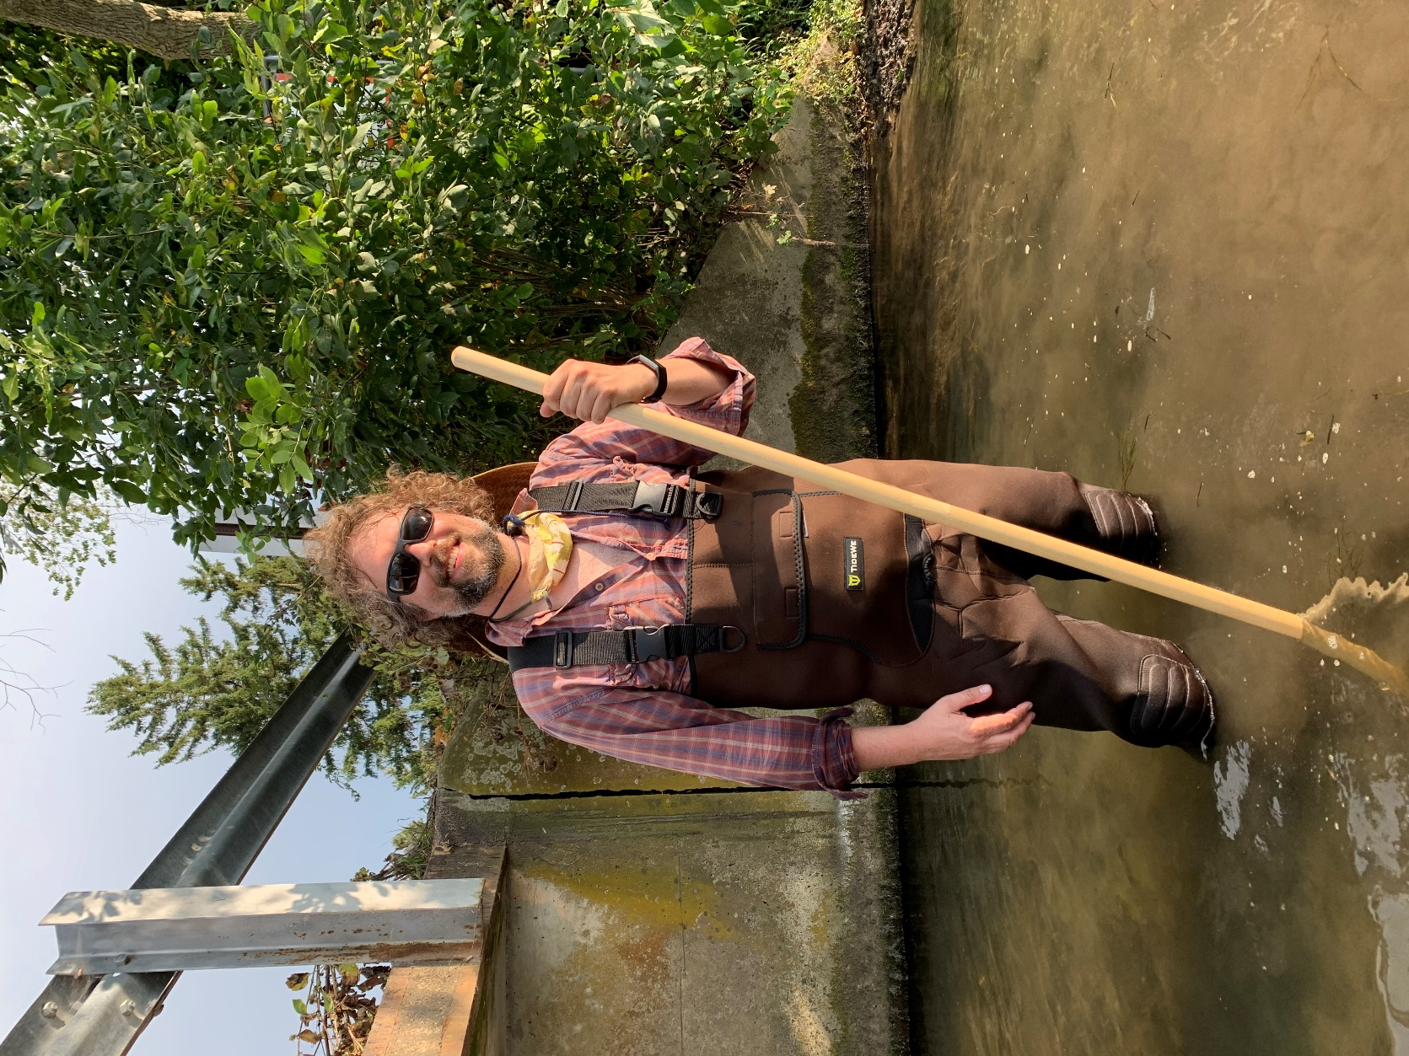
[Invasive Species Program Coordinator Matt Wallrath surveys a stream],

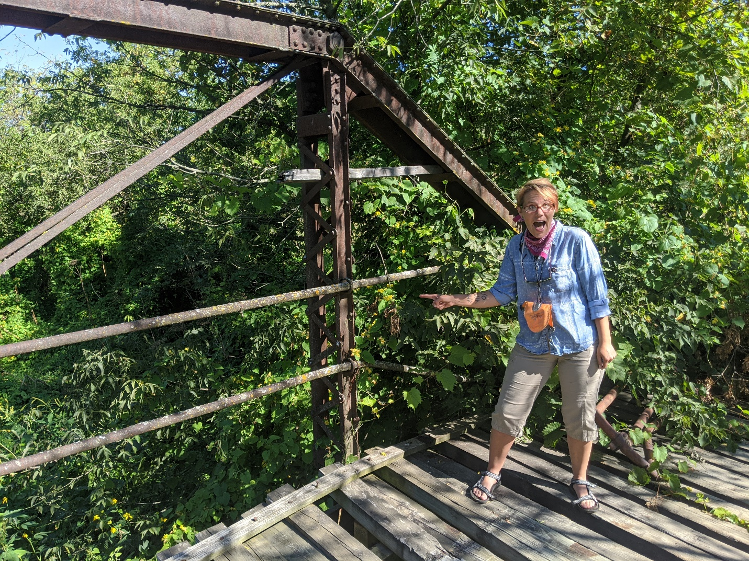
[Volunteer Abbie Lehman finds red hailstone invading a rivers edge]

Greetings from the Upper Sugar River Watershed Association invasive species program! 2020 was a great example of what you can still do online or remotely to protect the environment. Our core of great volunteers and an expanded staff allowed us to keep projects like boat landing outreach, access signage, and clean bait reminders rolling smooth in tough times.
I’m excited to continue our role as the Aquatic Invasive Species Coordinator for Dane, Iowa, Sauk, Green, Lafayette, Grant, and Vernon counties in 2021. Our team will enact on the ground training, monitoring and prevention outreach while serving the Driftless as a resource for invasive species issues.
In 2020, we verified stands of purple loosestrife as the plant continues to spread in the Mississippi and Lower Wisconsin River corridor. To help control this pesky shrub, this spring we are working with a natural bio-control project involving rearing insects that will munch on the stalks of that particular plant in the Lake Redstone and Lake Delton area. Extra eyes looking out for dense stands of this tough, knobby, purple flowered shrub are appreciated as we strive to keep our wetlands from getting overrun. We can then control them with the help of our ‘cella beetle friends.
Big machines are gearing up for spring, so please remember that mow decks can spread unwanted plants. Upper Sugar teamed up with the UW Renz lab on a public webinar geared towards right-of-way managers and machine operators. Take a stake in invasive species control by learning why prevention is important and best management practices and techniques. You can find the video on our YouTube channel.
It’s a great time to start your planning for how to get outside and get your boots wet after the thaw. We are holding trainings this season for those interested in invasive species identification. Our goal is to recruit citizen scientists via Project RED (Riparian Early Detection) at regional trainings, as well as hosting a site as part of the statewide Aquatic Invasive Species Snapshot Day on August 21st.
See you on the water,
Matt

