Eurasian water-milfoil (Myriophyllum spicatum) Fall Bed Mapping Survey
Round Lake – WBIC: 2640100
Burnett County, Wisconsin

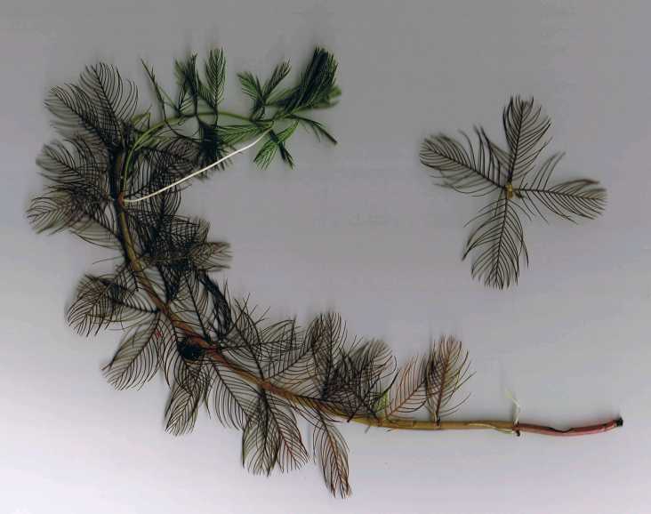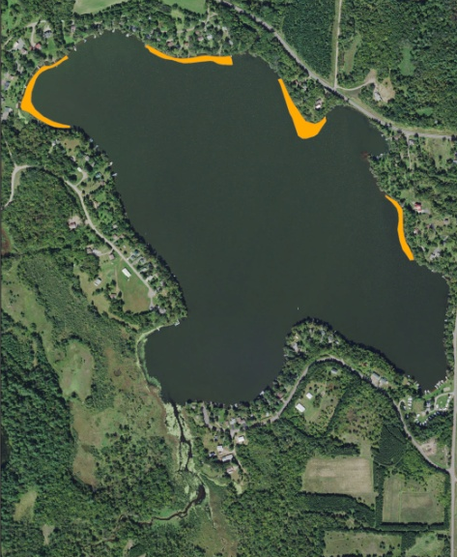
Eurasian water-milfoil Final 2017 EWM Treatment Areas
Project Initiated by:
Round-Trade Lakes Improvement Association Inc., Lake Education and Planning Services, LLC and the Wisconsin Department of Natural Resources
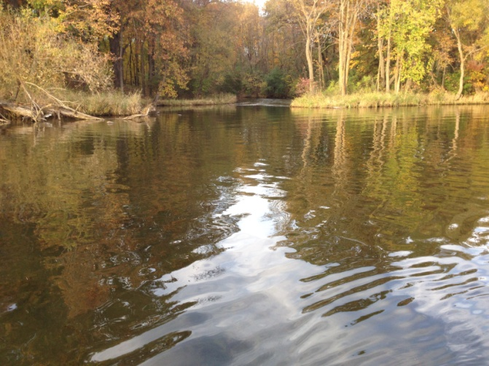
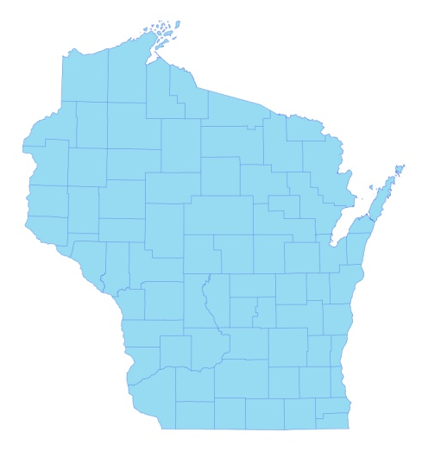

* Round Lake

Canopied Fall EWM – North Shoreline Outlet (10/10/17)

Survey Conducted by and Report Prepared by:
Endangered Resource Services, LLC
Matthew S. Berg, Research Biologist
St. Croix Falls, Wisconsin
October 10, 2017
TABLE OF CONTENTS

Page
LIST OF FIGURES AND TABLES…..……..…………………………………………….. ii

INTRODUCTION……….…..……..………………………………………………….…… 1

BACKGROUND AND STUDY RATIONALE…………………………………………… 1

METHODS……………………………………………………………….………………… 2

RESULTS AND DISCUSSION……………………………………………………………. 3

2017 EWM Treatment Areas….……………………………………………………. 3

Fall EWM Bed Mapping Survey…………………………………………………… 4

Descriptions of Current and Former EWM Beds…....……………………………... 6

LITERATURE CITED……….……………………….……………………………………. 7

APPENDIXES……….…….………………………………………………….……………. 8

I: 2017 EWM Treatment Areas…………………………………..………………….….. 8

II: Fall 2016 and 2017 EWM Bed Maps..………………..……………………………… 10

LIST OF FIGURES AND TABLES

Page
Figure 1: Aerial of 2017 EWM Proposed/Final Treatment Areas.…………………….…... 1
Figure 2: Rake Fullness Ratings……………………………….…….…………………….. 2
Figure 3: Final Treatment Areas……………….……………………………………….….. 3
Table 1: Spring Treatment Summary – Round Lake – June 1, 2017………….…..….…… 3

Figure 4: 2016 and 2017 Fall EWM Bed Maps …………………………..…..…………… 4
Table 2: Fall Eurasian Water-milfoil Bed Mapping Summary –
Round Lake, Burnett County – October 10, 2017....……………………………………….. 5

INTRODUCTION:
Round Lake (WBIC 2640100) is a 208 acre drainage lake in southwest/south-central Burnett County, Wisconsin in the Town of Trade Lake (T37N R18W S27 NE SW). It reaches a maximum depth of 27ft in two spots near the eastern shoreline midlake and has an average depth of approximately 15ft. Round Lake is eutrophic in nature with very poor to poor water clarity. From 1986 to 2017, summer Secchi readings have ranged from 1.7-5.5ft with an average of 3.4ft (WDNR 2017). This clarity produced a littoral zone that extended to approximately 8ft in fall 2017. The bottom substrate is predominately muck in the main basin and in the lake’s bays while the shoreline and midlake bars and humps are dominated by gravel and sand (Sather et al 1967).
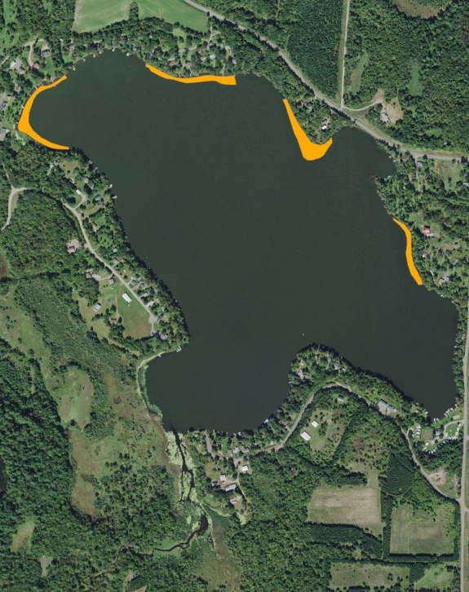
Figure 1: Aerial of 2017 EWM Final Treatment Areas

BACKGROUND AND STUDY RATIONALE:
In 2003, the Wisconsin Department of Natural Resources (WDNR) confirmed the presence of Eurasian water-milfoil (Myriophyllum spicatum) (EWM) in Round Lake. Following the approval of their aquatic plant management plan (APMP), the Round-Trade Lake Improvement Association, Inc. (RTLIA), under the direction of Dave Blumer (Lake Education and Planning Services, LLC - LEAPS), began actively managing the infestation using herbicide treatments. In 2017, LEAPS’s evaluation of the 2016 fall EWM bed mapping survey prompted them to schedule chemically treatment in four areas totaling 4.84 acres or 2.3% of the lake’s surface area (Figure 1).

Because the treatment area was small relative to the entire lake and in an effort to cut costs, it was decided NOT to do pre and posttreatment surveys in 2017. However, we were asked to complete a fall bed mapping survey to look for evidence of EWM expansion and to help determine where EWM control might be considered in 2018. This report is the summary analysis of that field survey conducted on October 10, 2017.
METHODS:
Fall Eurasian Water-milfoil Bed Mapping Survey:
We searched the entire visible littoral zone of the lake and mapped all known beds of Eurasian water-milfoil. A “bed” was determined to be any area where we visually estimated that EWM made up >50% of the area’s plants and was generally continuous with clearly defined borders. After we located a bed, we motored around the perimeter of the area, took GPS coordinates at regular intervals, and estimated both the range and mean rake fullness rating of EWM within the bed. Using the WDNR’s Forestry Tool’s Extension to ArcGIS 9.3.1, we used these coordinates to generate bed shapefiles and determine the acreage to the nearest hundredth of an acre. We also logged waypoints of EWM plants outside these beds as these pioneer plants tend to expand into beds.

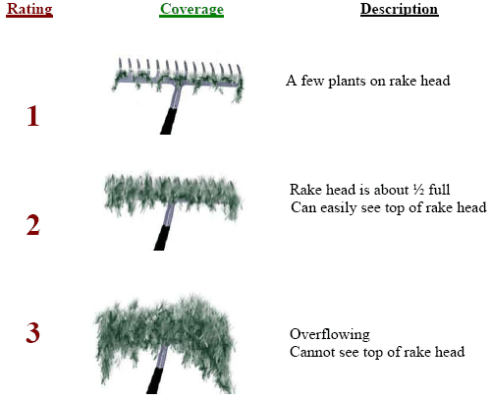
Figure 2: Rake Fullness Ratings

RESULTS AND DISCUSSION:
2017 EWM Treatment Areas:
Four Eurasian water-milfoil areas totaling 4.84 acres (2.3% of the lake’s surface area) were selected for chemical treatment in 2017 (Figure 3) (Appendix I). On June 1, Northern Aquatic Services (Dale Dressel – Dresser, WI), treated the beds with 2,4-D (DMA 4) at a concentration of 3.5-4ppm (Table 1). The reported water temperature at the time of application was 64F, and winds were calm.

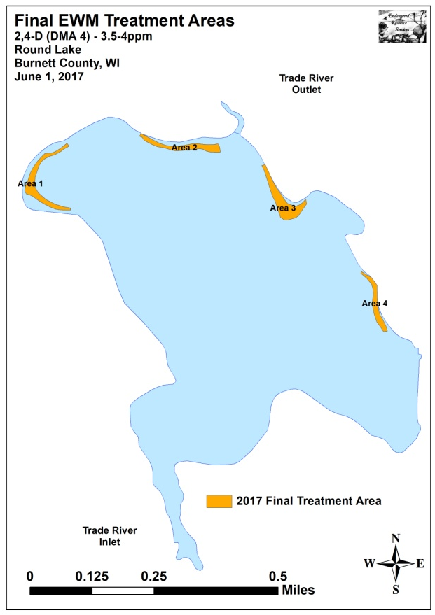
Figure 3: Final EWM Treatment Areas

Table 1: Spring Treatment Summary
Round Lake – June 1, 2017

Area Number | Final Acreage | Treatment Concentration/  Total Application
1 | 1.39 | 2,4-D (DMA 4) – 3.5ppm - 20.8gallons
2 | 1.06 | 2,4-D (DMA 4) – 4ppm - 18.1gallons
3 | 1.59 | 2,4-D (DMA 4) – 4ppm - 27.1gallons
4 | 0.80 | 2,4-D (DMA 4) – 4ppm - 13.6gallons
Total Acres | 4.84 | 2,4-D (DMA 4) – 3.5-4ppm  79.6 Total Gallons

Fall EWM Bed Mapping Survey:
On October 10th, we located and mapped 15 areas on the lake ranging in size from 0.02 acre (Bed 3A) to 0.53 acres (Bed 3) (Figure 4) (Appendix II). In total, these beds covered 2.76 acres (Table 2). This was a reduction of 4.81 acres from the 7.57 acres we mapped in fall 2016 (-63.5%). Outside these beds, EWM was widely scattered, but seldom abundant as we marked just 20 additional plants.

The majority of areas that were chemically treated with 2,4-D in June experienced noticeable reductions in both EWM density and distribution. Although some areas were apparently experiencing recolonization (young plants based on small EWM plant size/low stem count per cluster), the majority of the 2017 treatment areas continued to have little to no EWM into the fall. Conversely, untreated areas in the southeast bays and along the south shoreline experienced typical expansion. Because the prevailing summer winds tend to carry fragments from south to north, these areas likely deserve management consideration in 2018. Bed 6 in the northeast bay was also especially dense, and, because of the number of residences in the area, is also a potential candidate for control.

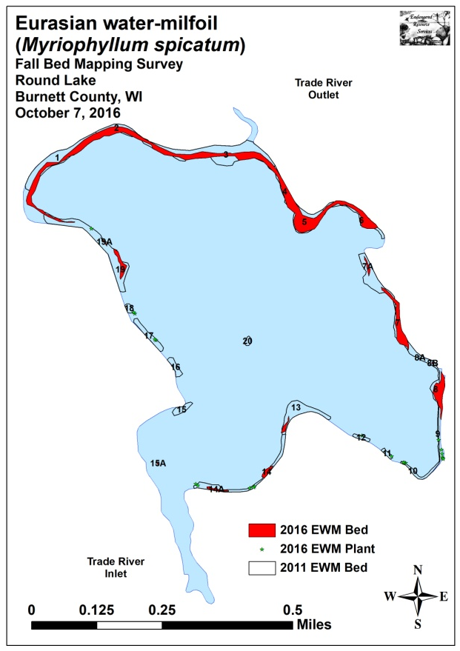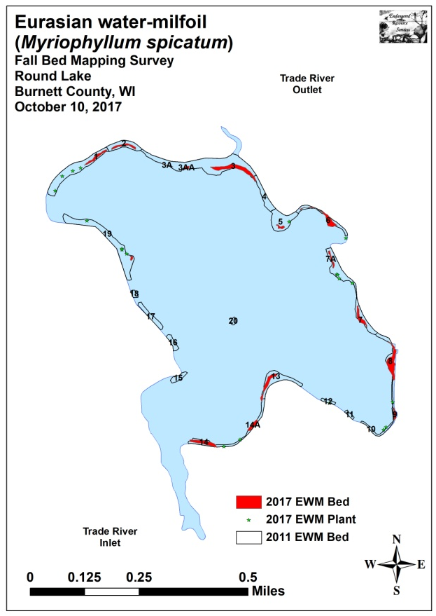
Figure 4: 2016 and 2017 Fall EWM Bed Maps

Table 2: Fall Eurasian Water-milfoil Bed Mapping Summary
Round Lake, Burnett County
October 10, 2017

Bed  Number | 2017  Area  (in Acres) | 2016  Area | 2015  Area | 2014  Area | 2013  Area | 2012  Area | 2011  Area | 2017  Acreage  Change | 2017 Rake Range;  Mean Rake Fullness | Field Notes
Merged 1-6 | 1.24 | 5.66 | 2.16 | - | - | - | - | -4.42 | - | Fragmented back to multiple beds.
1 | 0.17 | Merged | 0 | 0 | 0 | 0.52 | 1.91 | - | <<1-2; <1 | Scattered regular towers.
2 | 0.14 | Merged | 0 | 0.16 | 0.10 | 0.47 | 0.74 | - | <<1-2; <1 | Nearly continuous with Bed 1
3A/AA and 3 | 0.59 | Merged | 1.55 | 1.81 | 1.00 | 2.58 | 3.57 | - | <<1-3; 2 | Scattered west/becoming mat at outlet
4 | Merg. w/3 | Merged | - | Merg. w/ 3 | 0.11 | 0.68 | 0.63 | - | - | A few plants on the far north end
5 | 0.06 | Merged | 0.49 | 0.26 | 0 | 0.46 | 1.21 | - | <<1-2; 1 | A few well-established towers
6 | 0.28 | Merged | 0.11 | 0.06 | 0 | 0.43 | 0.61 | - | <<1-3; 2 | Becoming solid mat
7 and 7A | 0.28 | 0.78 | 0.65 | 0.05 | 0 | 0.80 | 1.73 | -0.50 | <<1-3; 1 | Patchy mats - spreading
8 | 0.52 | 0.57 | 0.43 | 0.23 | 0 | 0.19 | 0.55 | -0.05 | <1-3; 2 | Canopied mat
9 | 0.06 | 0 | 0 | 0 | 0 | 0.20 | 0.26 | 0.06 | <<<1-1; <<1 | Scattered but regular towers
10 | 0 | 0 | 0 | 0 | 0 | 0.06 | 0.11 | 0 | <<<1 | Two EWM plants rake removed
11 | 0 | 0 | 0 | 0 | 0 | 0.06 | 0.11 | 0 | 0 | No EWM found
12 | 0 | 0 | 0 | 0 | 0 | 0 | 0.13 | 0 | <<<1 | One EWM plant rake removed
13 | 0.25 | 0.08 | 0.28 | 0 | 0 | 0.44 | 1.04 | 0.17 | <<1-2; 1 | Expanding into deep water on point
14 and 14A | 0.29 | 0.19 | 0.06 | 0.07 | 0 | 0.39 | 0.92 | 0.10 | <<1-2; 1 | Merging towers
15A | 0 | 0.01 | 0.04 | 0 | 0 | 0 | 0 | -0.01 | 0 | No EWM found
15 | 0 | 0 | 0 | 0 | 0 | 0.12 | 0.27 | 0 | 0 | No EWM found
16 | 0 | 0 | 0 | 0 | 0 | 0.09 | 0.26 | 0 | 0 | No EWM found
17 | 0 | 0 | 0 | 0.10 | 0 | 0.15 | 0.46 | 0 | 0 | No EWM found
18 | 0 | 0 | 0 | 0 | 0 | 0 | 0.13 | 0 | 0 | No EWM found
19 and 19A | 0.03 | 0.27 | 0.03 | 0.46 | 0.19 | 1.15 | 2.27 | -0.24 | <<1-2; 1 | Regular towers
20 | 0 | 0 | 0 | 0 | 0.01 | 0.05 | 0.10 | 0 | 0 | No EWM found
Total | 2.76 | 7.57 | 3.65 | 3.20 | 1.41 | 8.84 | 17.01 | -4.81

Descriptions of Current and Former EWM Beds:
Beds 1 and 2 – EWM was largely eliminated from the treatment areas. Almost all plants found in this area during the fall survey were single-stemmed and appeared to be recently established.

Beds 3, 3A, 3AA, and 4 – The western area that included Beds 3A and 3AA supported very low levels of EWM, although plants were still more or less continuous. Closer to the lake outlet, EWM gradually thickened before eventually becoming a solid canopied mat in the flat directly in front of the outlet. Moving to the east, we found that densities steadily declined before plants disappeared altogether near the northern tip of what had been Bed 4.

Bed 5 – A few large multi-stemmed plants on the deep water edge of the point appeared to have survived the treatment. These were actively fragmenting, and they had satellite plants radiating north from them onto the rock bar. Clasping-leaf pondweed (Potamogeton richardsonii) and Wild celery (Vallisneria americana), two valuable native species, were fairly common in areas that had only supported EWM in fall 2016.

Bed 6 – One of the worst places on the lake, the northwest corner of the bed was a solid canopied mat before disappearing abruptly as the bay drops into deep water. Interestingly, although the south end of the northeast bay has a lot of residences/boat traffic/ecological disturbance, we’ve never found more than a handful of EWM plants along that shoreline.

Beds 7 and 7A – The treated area between the two beds remained EWM free, but plants appear to have survived on both ends. Dilution may have been an issue here as the lake drops off rapidly from the areas with surviving plants.

Bed 8 – Following noticeable expansion in 2016, this area experienced significant thickening to become one of the worst areas on the lake in 2017. EWM now covers all available habitat on the flat, and it formed a more or less continuous mat with numerous prop trails through it.

Bed 9 – More of a high density area than a bed, the shoreline near the campground in the lake’s southeast bay had scattered but regular EWM.

Beds 10, 11 and 12 – We found and removed three EWM plants in these former beds.

Bed 13 – Regular low density towers continued to expand on the southern point.

Beds 14 and 14B – These two small beds showed expansion and thickening since 2016.

Beds 15A-18 – We found no EWM in these former beds.

Beds 19 and 19A – Although not in the treatment area, Bed 19A disappeared, and Bed 19 was measurably smaller in 2017. Perhaps these areas experienced some residual control.

Bed 20 – We again found no EWM plants on the midlake rock bars.

LITERATURE CITED

Sather, L, C. Busch, R. House, and C. Harrison [online]. 1967. Round Lake Map. Available from
http://dnr.wi.gov/lakes/maps/DNR/2640100a.pdf (2017, November).

UWEX Lakes Program. [online]. 2010. Aquatic Plant Management in Wisconsin. Available from http://www.uwsp.edu/cnr-ap/UWEXLakes/Pages/ecology/aquaticplants/default.aspx (2016, November).

UWEX Lakes Program. [online]. 2010. Pre/Post Herbicide Comparison. Available from http://www.uwsp.edu/cnr-ap/UWEXLakes/Documents/ecology/Aquatic%20Plants/Appendix-D.pdf (2017, November).

WDNR. [online]. 2017. Round Lake - Citizen Lake Water Quality Monitoring Database. Available from http://dnr.wi.gov/lakes/waterquality/Station.aspx?id=073039 (2017, November).

Appendix I: 2017 EWM Treatment Areas

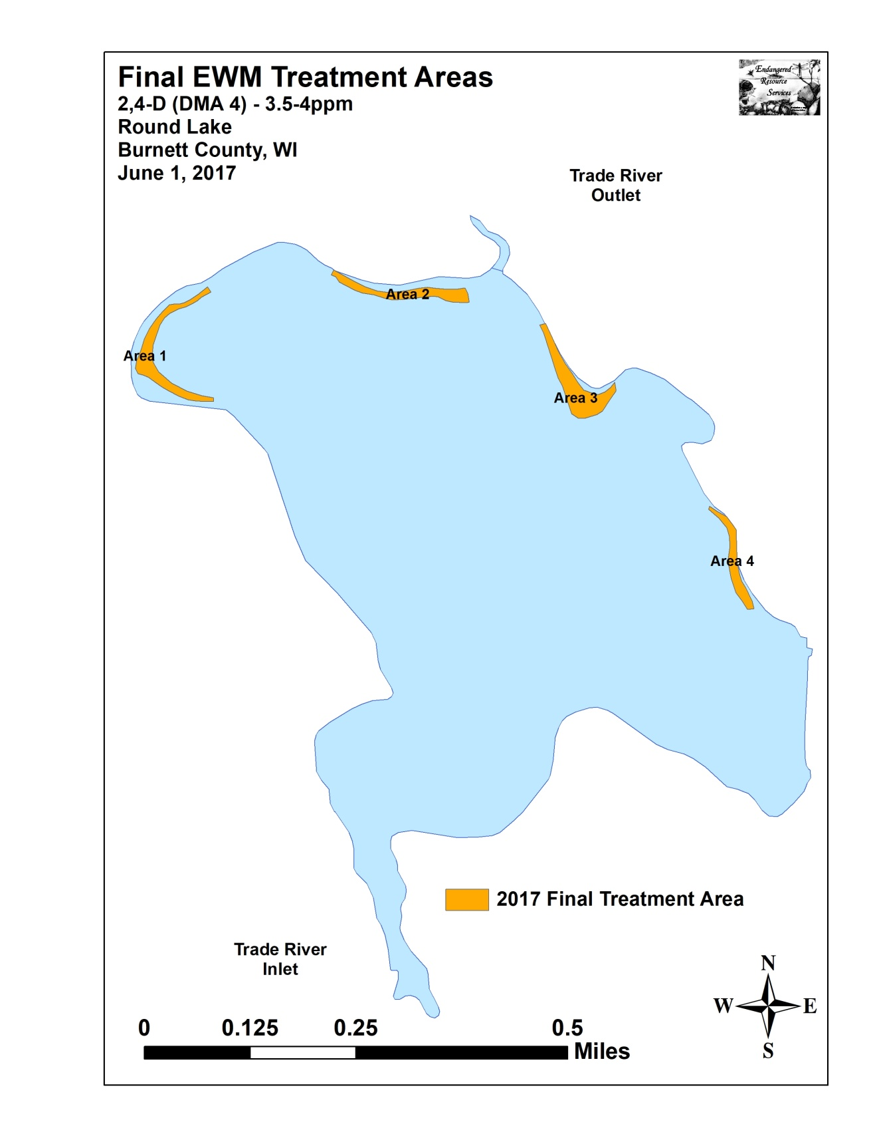

Appendix II: Fall 2016 and 2017 EWM Bed Maps
