Curly-leaf Pondweed (Potamogeton crispus) and
Eurasian Water-milfoil (Myriophyllum spicatum) Pre/Post Herbicide and Fall EWM Bed Mapping Surveys
Long Trade Lake – WBIC: 2640500
Polk County, Wisconsin

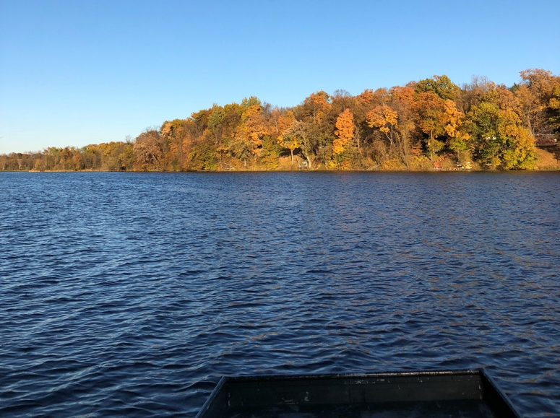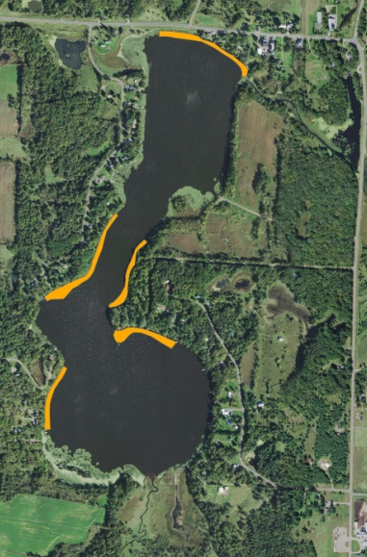
Bright sunshine and mostly calm survey conditions (10/15/18) 2018 CLP/EWM Final Treatment Areas
Project Initiated by:
Round-Trade Lakes Improvement Association Inc., Lake Education and Planning Services, LLC, and the Wisconsin Department of Natural Resources
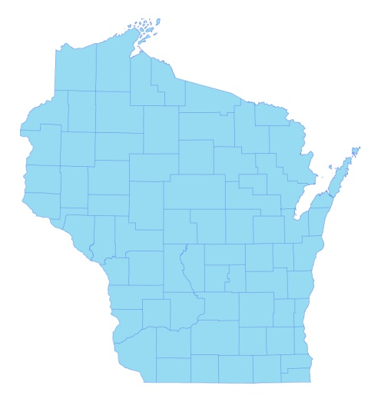

* Long Trade Lake

Canopied EWM Plant (10/15/18)

Surveys Conducted by and Report Prepared by:
Endangered Resource Services, LLC
Matthew S. Berg, Research Biologist
St. Croix Falls, Wisconsin
May 19, June 25, and October 15, 2018
TABLE OF CONTENTS

Page
LIST OF FIGURES.………………..……..………………………………………………... ii

LIST OF TABLES…………………..……..……………………………………………….. iii

INTRODUCTION.……….…..……..……………………………………………………… 1

BACKGROUND AND STUDY RATIONALE…..……………………………………….. 1

METHODS……………………………………………………………….………………… 2

RESULTS AND DISCUSSION……………………………………………………………. 3

Finalization of Treatment Areas………………………………………………….…. 3

Pre/Post Herbicide Surveys…...………………………..……………………….…... 4

Fall Eurasian Water-milfoil Bed Mapping Survey…………………………….……. 13

Descriptions of Current and Former Eurasian Water-milfoil Beds…………………. 15

LITERATURE CITED……….……………………….……………………………………. 16

APPENDIXES……….…….………………………………………………….……………. 17

I: Survey Sample Points and Treatment Areas…………………………………………. 17

II: Vegetative Survey Datasheet...………………………………………………………. 20

III: Pre/Post Habitat Variable Maps………………………………………………………. 22

IV: Pre/Post Littoral Zone, Native Species Richness and Total Rake Fullness.………..… 25

V: CLP and EWM Pre/Post Density and Distribution.…………………………….…...... 32

VI: Pretreatment Native Species Density and Distribution…...………………………...... 37

VII: Posttreatment Native Species Density and Distribution…...……………………….... 43

VIII: Fall 2017 and 2018 EWM Bed Maps……….……………………………………….. 53

LIST OF FIGURES

Page
Figure 1: 2018 CLP/EWM Treatment Areas…….………………………………………… 1
Figure 2: Rake Fullness Ratings……………………………….…….…………………….. 2
Figure 3: 2018 Survey Sample Points and Final Treatment Areas………………………… 3
Figure 4: Treatment Area Depths and Bottom Substrate….………..……………………… 4
Figure 5: Pre/Post Littoral Zone.…………..…………………………..…………………… 5
Figure 6: Pre/Post Native Species Richness……………………………………………….. 6
Figure 7: Pre/Post Total Rake Fullness…………………………………………………….. 6
Figure 8: Pre/Post CLP Density and Distribution………….…………………………….… 7
Figure 9: Pre/Post Changes in CLP Rake Fullness….….………………………………….. 7
Figure 10: Pre/Post EWM Density and Distribution………….…………………………… 8
Figure 11: Pre/Post Changes in EWM Rake Fullness…..…………………………………. 8
Figure 12: Pre/Post Coontail Density and Distribution..……………………………..……. 9
Figure 13: Pre/Post Common Waterweed Density and Distribution..……...……………… 9
Figure 14: Pre/Post Macrophyte Changes…………………..……………………………... 12
Figure 15: 2017 and 2018 Fall EWM Bed Maps….…………………………..….…….….. 13

LIST OF TABLES

Page
Table 1: Spring CLP and EWM Treatment Summary –
Long Trade Lake, Polk County – May 29, 2018..…………………..…………………..….. 3

Table 2: Pre/Post Surveys Summary Statistics –
Long Trade Lake, Polk County – May 19 and June 25, 2018……………………………… 4

Table 3: Frequencies and Mean Rake Sample of Aquatic Macrophytes
Pretreatment Survey - Long Trade Lake, Polk County - May 19, 2018..…………………... 10

Table 4: Frequencies and Mean Rake Sample of Aquatic Macrophytes
Posttreatment Survey - Long Trade Lake, Polk County - June 25, 2018…………………... 11

Table 5: Fall Eurasian Water-milfoil Bed Mapping Summary –
Long Trade Lake, Polk County – October 15, 2018………………………………………... 14

INTRODUCTION:
Long Trade Lake (WBIC 2640500) is a 150 acre drainage lake in northwest/north-central Polk County, Wisconsin in the Town of Laketown (T36N R18W S4 SE NE). It reaches a maximum depth of 13ft in two spots in the south basin and has an average depth of approximately 8ft. The lake is eutrophic bordering on hypereutrophic in nature with summer Secchi readings from 1986 to 2018 ranging from 1.2-3.0ft and averaging 2.1ft (WDNR 2018). This very poor water clarity produced a littoral zone that extended to approximately 6ft in 2018. The bottom substrate is primarily sand and gravel in the main basin with organic muck in sheltered bays (Miller et al. 1965).

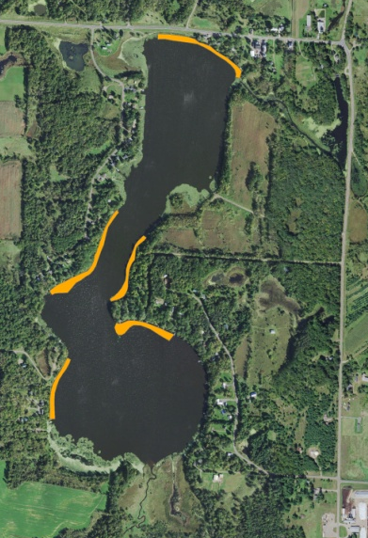
Figure 1: 2018 CLP/EWM Treatment Areas

BACKGROUND AND STUDY RATIONALE:
In 1995, the Wisconsin Department of Natural Resources (WDNR) identified the presence of Hybrid Water-milfoil – a cross between Northern and Eurasian Water-milfoils (Myriophyllum sibiricum X Myriophyllum spicatum) in Long Trade Lake. However, a 2006 WDNR point-intercept survey found no milfoil of any kind in the lake. By 2011, the situation had changed again with milfoil that morphologically looks like and grows like Eurasian Water-milfoil (EWM) having taken over most of the lake’s summer littoral areas. Following the development of a WDNR approved Aquatic Plant Management Plan (APMP) that outlined strategies to control EWM and Curly-leaf pondweed (Potamogeton crispus) (CLP) – another invasive exotic species that dominates the lake’s spring littoral zone, the Round-Trade Lake Improvement Association, Inc. (RTLIA) began treating the lake with herbicides to control these species.

In 2018, the RTLIA – under the direction of Dave Blumer (Lake Education and Planning Services, LLC - LEAPS) – applied for and was awarded a WDNR Aquatic Invasive Species control grant (ACEI21618) to help cover the costs associated with management. These funds were used to chemically treat five areas totaling 6.80 acres (4.53% of the lake’s surface area) for EWM and CLP (Figure 1). On May 19th, we conducted a pretreatment survey to gather baseline data from these areas and to allow LEAPS/RTLIA to finalize treatment plans. After the May 29th herbicide application, we completed a June 25th posttreatment survey to evaluate the effectiveness of the treatment. We also conducted an October 15th EWM bed mapping survey to determine where control might be considered in 2019. This report is the summary analysis of these three field surveys.

METHODS:
Pre/Post Herbicide Surveys:
LEAPS provided treatment shapefiles, and we generated pre/post survey points based on the size and shape of the proposed areas that covered 6.42 acres. The requested 115 point sampling grid approximated to almost 18 pts/acre – well over the minimum of 4-10 pts/acre required by WDNR protocol for pre/post treatment surveys (Appendix I).

During the surveys, we located each point using a handheld mapping GPS unit (Garmin 76CSx) and used a rake to sample an approximately 2.5ft section of the bottom. All plants on the rake were assigned a rake fullness value of 1-3 as an estimation of abundance, and a total rake fullness for all species was also recorded (Figure 2). Visual sightings of EWM and CLP were noted if they occurred within 6ft of the point; however, visuals of other species were not recorded as they do not figure into the pre/posttreatment calculation. In addition to plant data, we recorded the lake depth using a metered pole and the substrate (bottom) type when we could see it or reliably determine it with the rake.

We entered all data collected into the standard APM spreadsheet (Appendix II). Data was analyzed using the linked statistical summary sheet and the WDNR pre/post analysis worksheet. For pre/post differences of individual plant species as well as count data, we used the Chi-square analysis on the WDNR pre/post survey worksheet (UWEX 2010). For comparing averages (mean species/point and mean rake fullness/point), we used t-tests. Differences were determined to be significant at p<0.05, moderately significant at p<0.01 and highly significant at p<0.001.

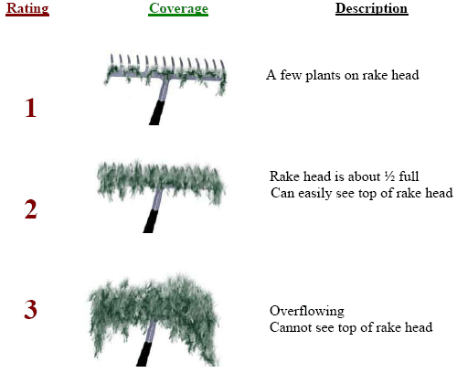
Figure 2: Rake Fullness Ratings

Fall Eurasian Water-milfoil Bed Mapping:
During the fall survey, we searched the entire visible littoral zone of the lake and mapped all known beds of EWM. A “bed” was determined to be any area where we visually estimated that EWM made up >50% of the area’s plants and was generally continuous with clearly defined borders. After we located a bed, we motored around the perimeter of the area, took GPS coordinates at regular intervals, and estimated both the range and mean rake fullness rating of EWM within the bed (Figure 2). Using the WDNR’s Forestry Tool’s Extension to ArcGIS 9.3.1, we plotted these coordinates to generate bed shapefiles and determine the acreage to the nearest hundredth of an acre. We also took waypoints of EWM plants outside these beds as they were generally few in number.
RESULTS AND DISCUSSION:
Finalization of Treatment Areas:
Initial expectations were to treat five beds for Curly-leaf pondweed and Eurasian water-milfoil using both liquid Endothall (Aquathol K) and 2,4-D (Shredder Amine 4) at concentrations of 2ppm and 3ppm respectively (Figure 3) (Appendix III). Following the pretreatment survey, minor changes that either added buffers around the polygon or pulled back from areas with low target species densities brought the total acreage from 6.42 up to 6.80. This represented a 0.32 acre increase (+5.9%) over initial expectations (Table 1).

Northern Aquatic Services (Dale Dressel – Dresser) carried out the treatment on May 29th. The reported water temperature at the time of application was 72°F, the ambient air temperature was 75°F, and winds were out of the southeast at 3mph.

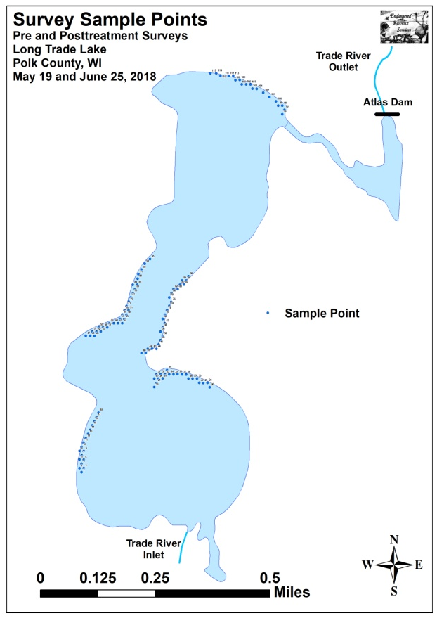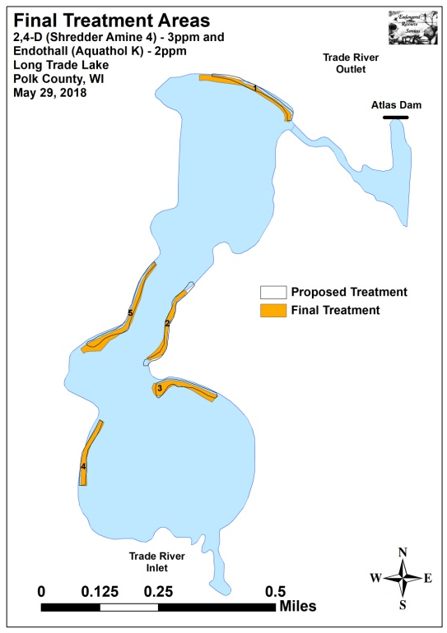
Figure 3: 2018 Survey Sample Points and Final Treatment Areas

Table 1: Spring CLP and EWM Treatment Summary
Long Trade Lake, Polk County
May 29, 2018
Treatment Area | Proposed  Acreage | Final Acreage | Difference  +/- | Chemical(s) – Dosage – Total Gallons
1 | 1.12 | 1.44 | 0.32 | Endothall – 2ppm – 6.7gal./2,4-D – 3ppm – 9.2gal.
2 | 1.38 | 1.06 | -0.32 | Endothall – 2ppm – 4.2gal./2,4-D – 3ppm – 6.8gal.
3 | 1.24 | 1.38 | 0.14 | Endothall – 2ppm – 5.5gal./2,4-D – 3ppm – 8.8gal.
4 | 1.03 | 0.95 | -0.08 | Endothall – 2ppm – 3.8gal./2,4-D – 3ppm – 6.1gal.
5 | 1.65 | 1.97 | 0.32 | Endothall – 2ppm – 9.2gal./2,4-D – 3ppm – 14.7gal.
Total Acres | 6.42 | 6.80 | +0.38

Pre/Post Herbicide Surveys:
All points occurred in areas between 1.0ft and 8.0ft of water. The mean and median depths of plant growth were almost unchanged at 2.8ft/2.5ft respectively pretreatment and 2.7ft /2.5ft posttreatment (Table 2). We found most Eurasian water-milfoil and Curly-leaf pondweed plants were established in a thin layer of muck over sand and rock (Figure 4) (Appendix III).

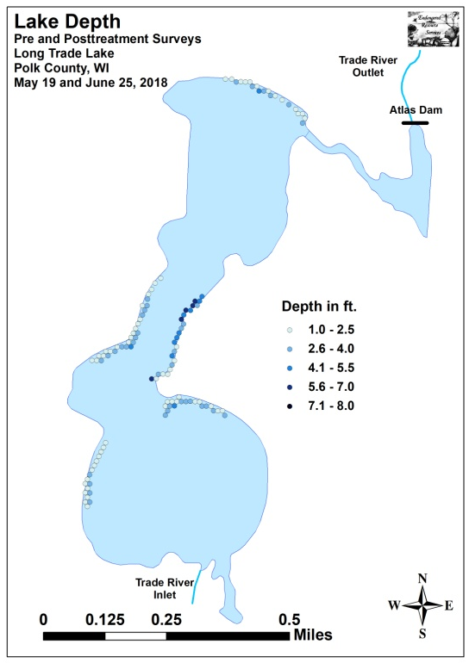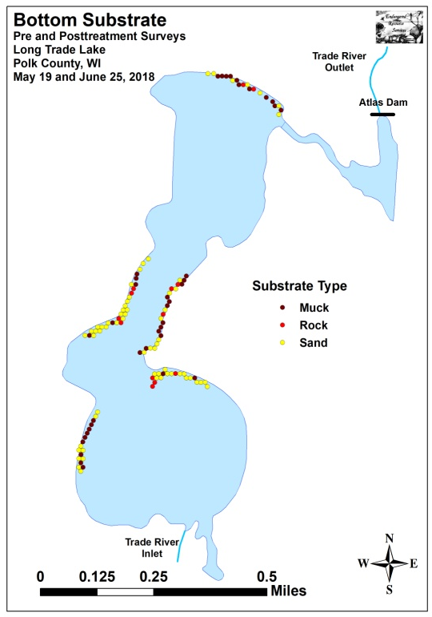
Figure 4: Treatment Area Depths and Bottom Substrate

Table 2: Pre/Post Surveys Summary Statistics
Long Trade Lake, Polk County
May 19 and June 25, 2018
Summary Statistics: | Pre | Post
Total number of points sampled | 115 | 115
Total number of sites with vegetation | 101 | 85
Total number of sites shallower than the maximum depth of plants | 114 | 115
Freq. of occur. at sites shallower than max. depth of plants (in percent) | 88.6 | 73.9
Simpson Diversity Index | 0.71 | 0.84
Mean Coefficient of Conservatism | 4.8 | 4.6
Floristic Quality Index | 9.5 | 13.1
Maximum depth of plants (ft) | 6.0 | 6.0
Mean depth of plants (ft) | 2.8 | 2.7
Median depth of plants (ft) | 2.5 | 2.5
Average number of all species per site (shallower than max depth) | 1.46 | 2.17
Average number of all species per site (veg. sites only) | 1.64 | 2.94
Average number of native species per site (shallower than max depth) | 0.72 | 2.11
Average number of native species per site (sites with native veg. only) | 1.32 | 2.93
Species richness | 6 | 10
Mean rake fullness (veg. sites only) | 1.69 | 1.75
The littoral zone within the beds extended to 6.0ft during both the pre and posttreatment surveys; however, the frequency of occurrence dropped sharply from 88.6% pretreatment to 73.9% posttreatment (Figure 5) (Appendix IV). Total richness ticked up from six species pretreatment to ten species posttreatment. The Simpson’s Diversity Index also increased from a moderately high pretreatment value of 0.71 to a high posttreatment value of 0.84. The Floristic Quality Index (another measure of native plant community health) climbed from 9.5 pretreatment to 13.1 posttreatment.

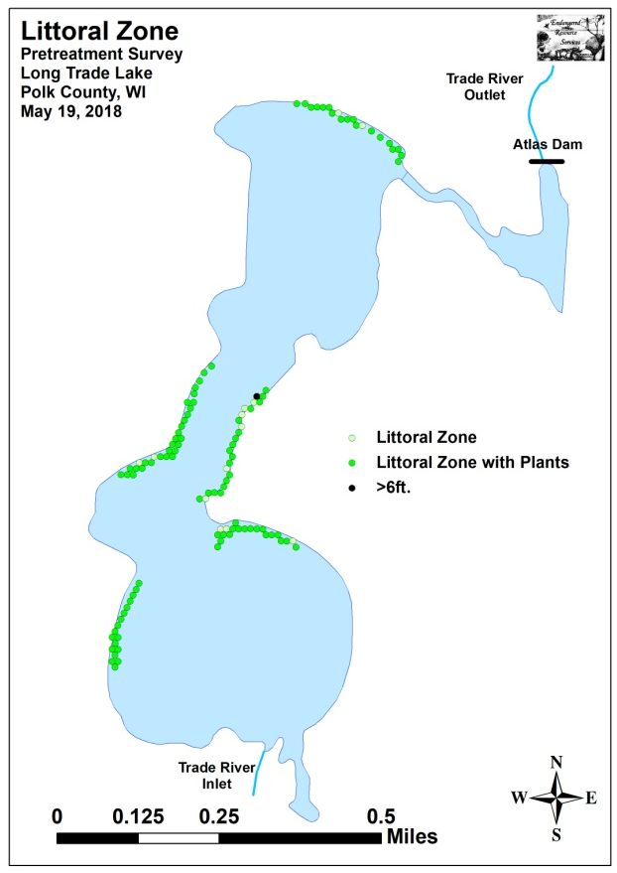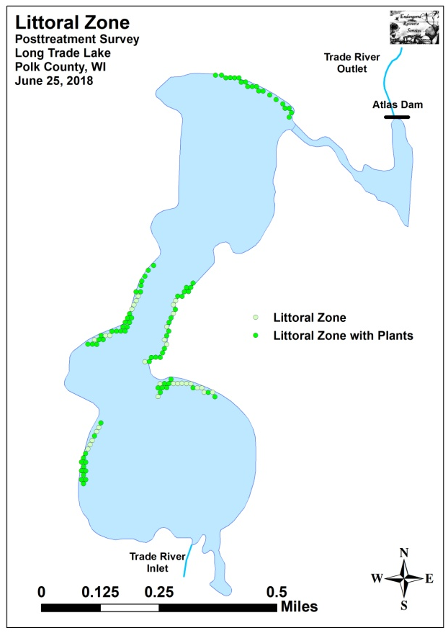
Figure 5: Pre/Post Littoral Zone

Mean native species richness at points with native vegetation more than doubled from 1.32 species/point pretreatment to 2.93 species/point posttreatment (Figure 6). Although this increase in localized richness was highly significant (p<0.001), it can largely be attributed to the rise in “duckweeds”. Total mean rake fullness experienced a non-significant increase (p=0.30) from a low/moderate 1.69 pretreatment to 1.75 posttreatment (Figure 7) (Appendix IV).
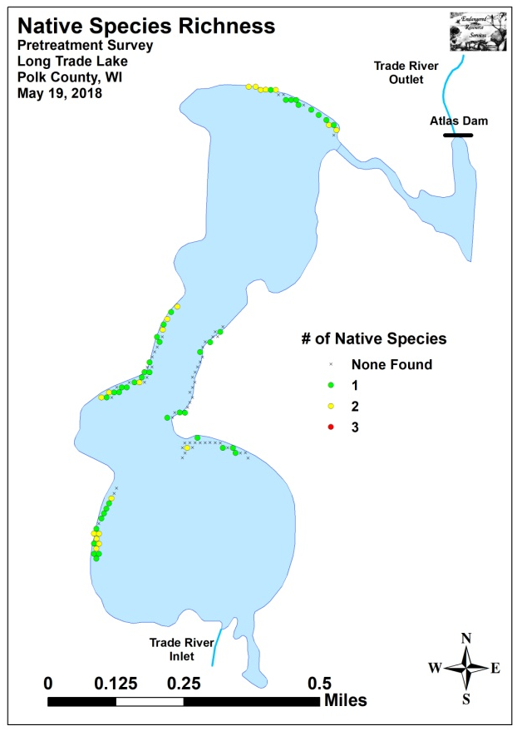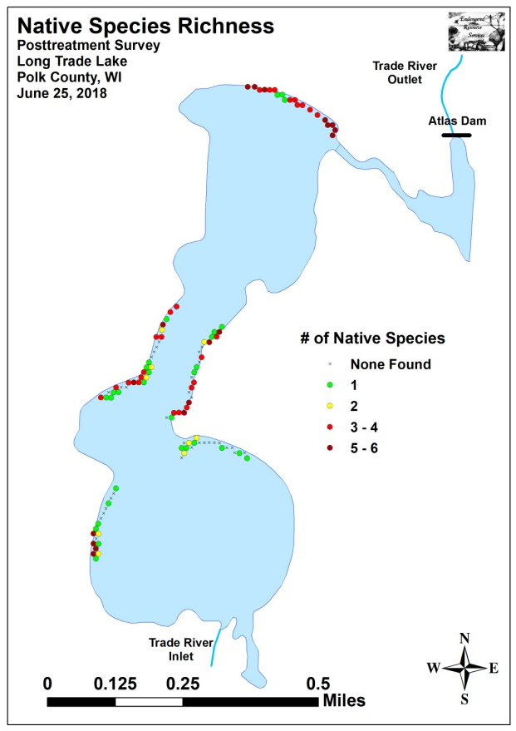
Figure 6: Pre/Post Native Species Richness
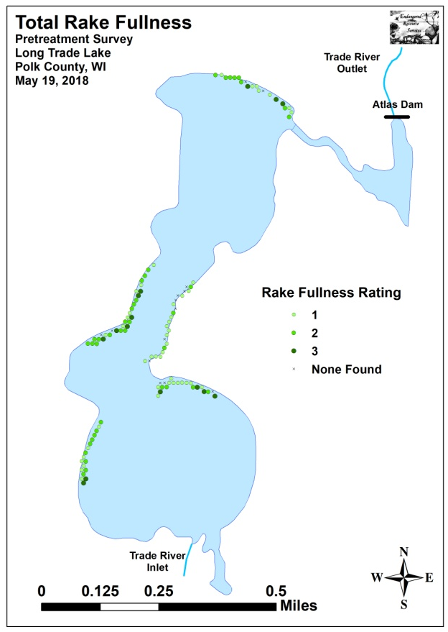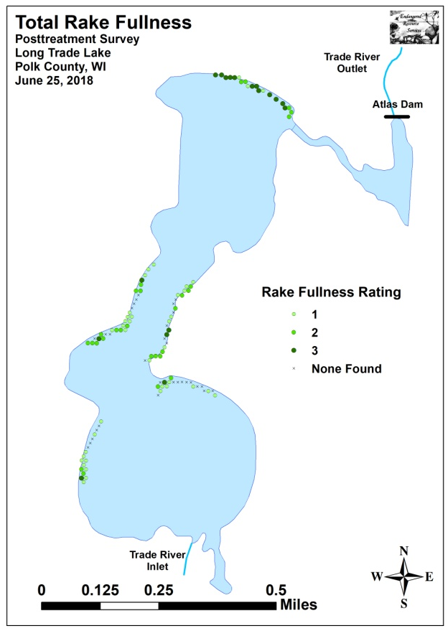
Figure 7: Pre/Post Total Rake Fullness

We found Curly-leaf pondweed at 72 of 115 sites during the pretreatment survey (62.6% coverage) (Figure 8). Of these, ten had a rake fullness rating of 3, 25 rated a 2, and the remaining 37 were a 1. This produced a mean rake fullness of 1.63 and suggested that 30.4% of the treatment areas had a significant infestation (rake fullness 2 and 3). During the posttreatment survey, we found CLP at just six points (5.2% coverage) all of which rated a 1. Our results demonstrated a highly significant decline in total CLP as well as rake fullness 2 and 1; and a moderately significant decline in rake fullness 3 (Figure 9) (Appendix V).
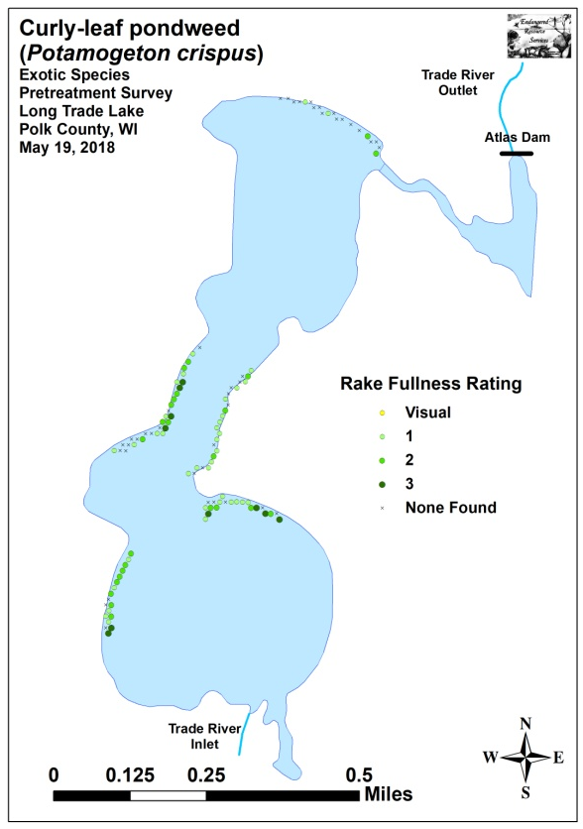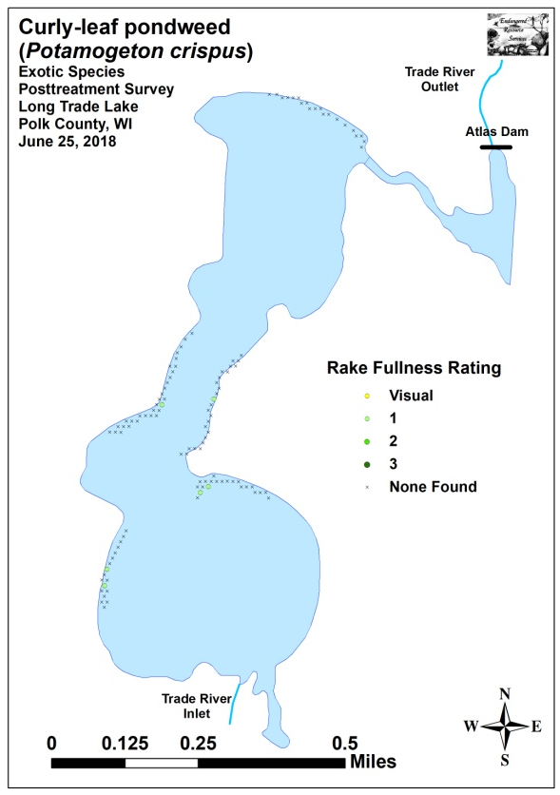
Figure 8: Pre/Post CLP Density and Distribution
-**
_***
_***
_***

Significant differences = * p<0.05, ** p<0.01, *** p<0.001
Figure 9: Pre/Post Changes in CLP Rake Fullness
Eurasian water-milfoil was present at 12 of 115 points (10.4% coverage) during the pretreatment survey (Figure 10). We rated two points a 3, four a 2, and six a 1. This produced a mean rake fullness of 1.67 and extrapolated to 5.2% of the treatment areas having a significant infestation (rake fullness 2 and 3). During the posttreatment survey, we found EWM at a single point (0.9% coverage) although it was a sizable tower that we rated a 2 prior to rake removing it. This overall reduction was moderately significant for total EWM, and significant for rake fullness 1 (Figure 11) (Appendix V).
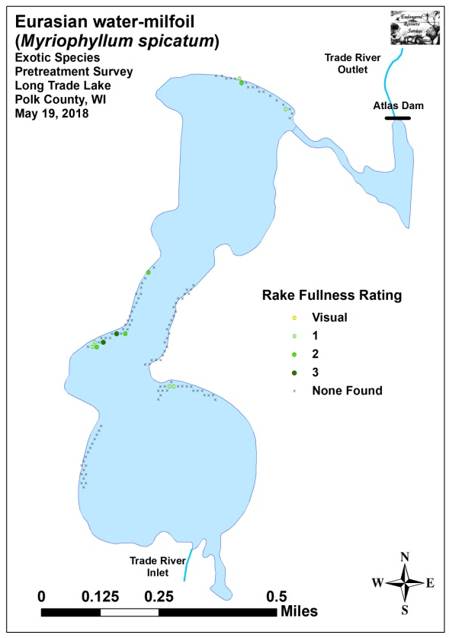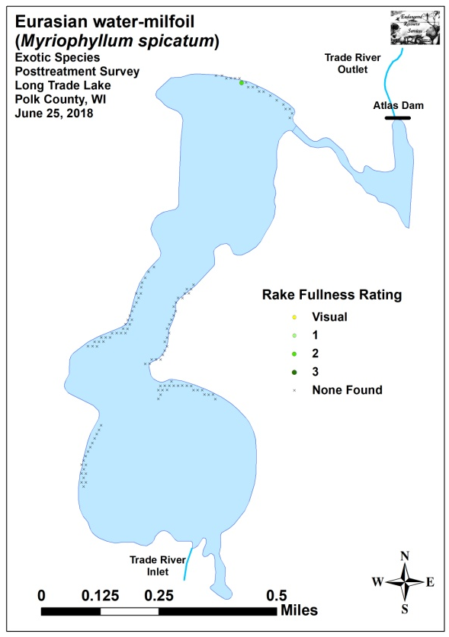
Figure 10: Pre/Post EWM Density and Distribution

_**
_*
Significant differences = * p<0.05, ** p<0.01, *** p<0.001
Figure 11: Pre/Post Changes in EWM Rake Fullness
Coontail (Ceratophyllum demersum) (44 sites – mean rake 1.32 pretreatment) (Figure 12) and Common waterweed (Elodea canadensis) (27 sites – mean rake 1.19 pretreatment) (Figure 13) were the most common native species in the pretreatment survey (Table 3). Posttreatment, Coontail remained the most common native species (Table 4). It experienced a non-significant increase (p=0.23) in distribution to 53 sites and a moderately significant increase (p=0.006) in mean rake fullness to 1.68. Common waterweed, despite being almost unchanged posttreatment (28 sites with a mean rake fullness of 1.18), was only the sixth most common native species following highly significant increases in White water lily (Nymphaea odorata), Small duckweed (Lemna minor), Common watermeal (Wolffia columbiana), and Large duckweed (Spirodela polyrhiza). Filamentous algae also experienced a moderately significant increase, and Slender naiad (Najas flexilis) demonstrated a significant increase. Other than CLP and EWM, no other species experienced a significant decline posttreatment (Figure 14). Maps for all native species from the pre and posttreatment surveys are available in Appendixes VI and VII.
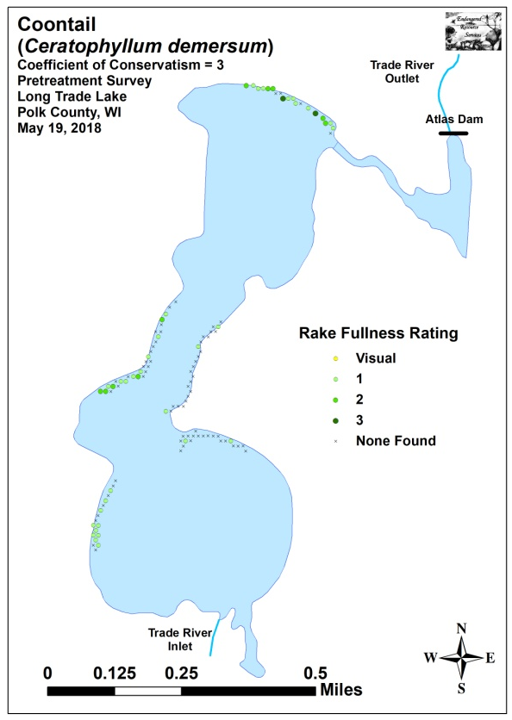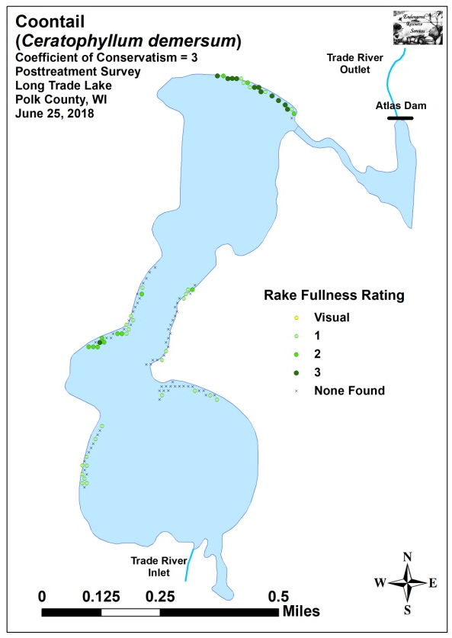
Figure 12: Pre/Post Coontail Density and Distribution
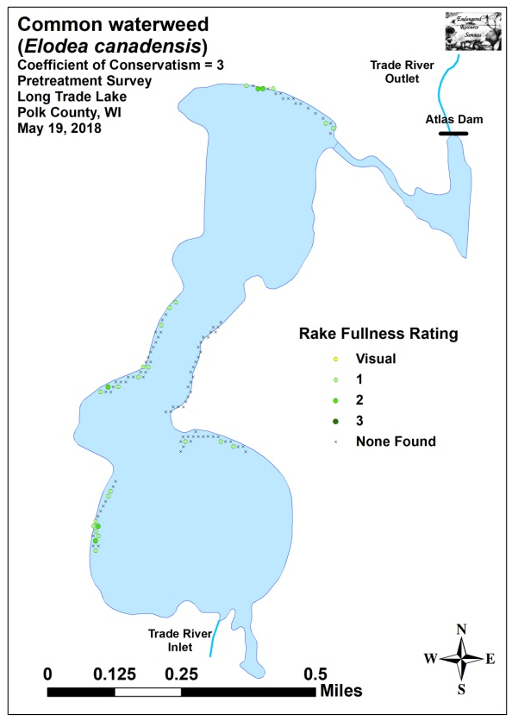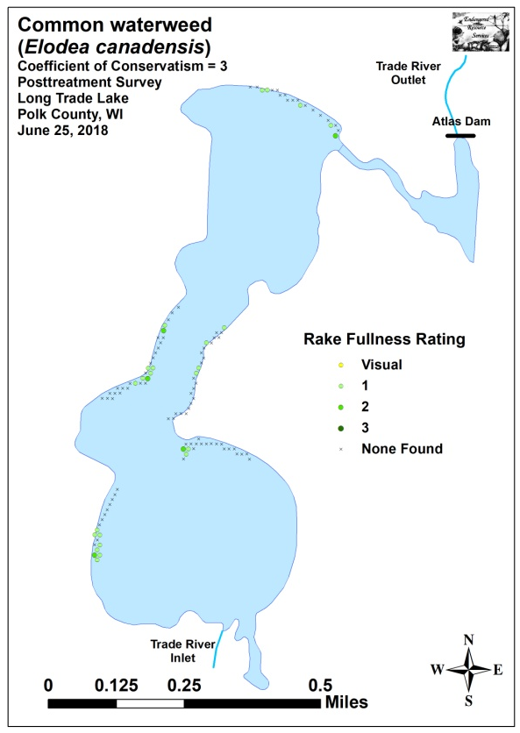
Figure 13: Pre/Post Common Waterweed Density and Distribution

Table 3: Frequencies and Mean Rake Sample of Aquatic Macrophytes
Pretreatment Survey – Long Trade Lake, Polk County
May 19, 2018

Species | Common Name | Total  Sites | Relative Freq. | Freq. in Veg. | Freq. in Lit. | Mean Rake
 | Filamentous algae | 98 | * | 97.03 | 85.96 | 1.99
Potamogeton crispus | Curly-leaf pondweed | 72 | 43.37 | 71.29 | 63.16 | 1.63
Ceratophyllum demersum | Coontail | 44 | 26.51 | 43.56 | 38.60 | 1.32
Elodea canadensis | Common waterweed | 27 | 16.27 | 26.73 | 23.68 | 1.19
Myriophyllum spicatum | Eurasian water-milfoil | 12 | 7.23 | 11.88 | 10.53 | 1.67
Nymphaea odorata | White water lily | 10 | 6.02 | 9.90 | 8.77 | 1.00
Potamogeton pusillus | Small pondweed | 1 | 0.60 | 0.99 | 0.88 | 1.00

* Excluded from relative frequency analysis
Table 4: Frequencies and Mean Rake Sample of Aquatic Macrophytes
Posttreatment Survey – Long Trade Lake, Polk County
June 25, 2018

Species | Common Name | Total  Sites | Relative Freq. | Freq. in Veg. | Freq. in Lit. | Mean Rake
 | Filamentous algae | 112 | * | 131.76 | 97.39 | 2.06
Ceratophyllum demersum | Coontail | 53 | 21.20 | 62.35 | 46.09 | 1.68
Lemna minor | Small duckweed | 43 | 17.20 | 50.59 | 37.39 | 1.53
Wolffia columbiana | Common watermeal | 43 | 17.20 | 50.59 | 37.39 | 1.35
Spirodela polyrhiza | Large duckweed | 42 | 16.80 | 49.41 | 36.52 | 1.74
Nymphaea odorata | White water lily | 29 | 11.60 | 34.12 | 25.22 | 1.83
Elodea canadensis | Common waterweed | 28 | 11.20 | 32.94 | 24.35 | 1.18
Potamogeton crispus | Curly-leaf pondweed | 6 | 2.40 | 7.06 | 5.22 | 1.00
Najas flexilis | Slender naiad | 4 | 1.60 | 4.71 | 3.48 | 1.75
Myriophyllum spicatum | Eurasian water-milfoil | 1 | 0.40 | 1.18 | 0.87 | 2.00
Potamogeton richardsonii | Clasping-leaf pondweed | 1 | 0.40 | 1.18 | 0.87 | 1.00

* Excluded from relative frequency analysis
+*
-***
+***
-**
+**
+***
+***
+***
Significant differences = * p<0.05, ** p<0.01, *** p<0.001
Figure 14: Pre/Post Macrophyte Changes

Fall Eurasian Water-milfoil Bed Mapping Survey:
During the October 15th survey, we found that Eurasian water-milfoil was almost undetectable as we located and rake removed just eight plants throughout the main lake. The only bed present occurred in the outlet channel, had fewer than 100 plants, and covered just 0.02 acre (Bed 6B) (Figure 15) (Appendix VIII). This represented a 98% decline in acreage from the fall 2017 survey when we mapped 11 small beds that totaled exactly 1.00 acre (Table 5).

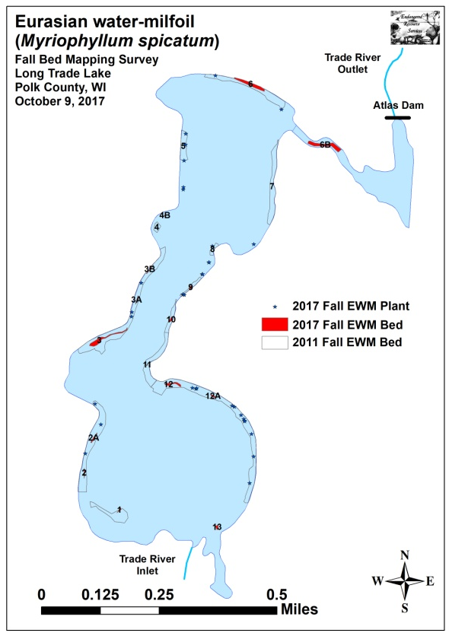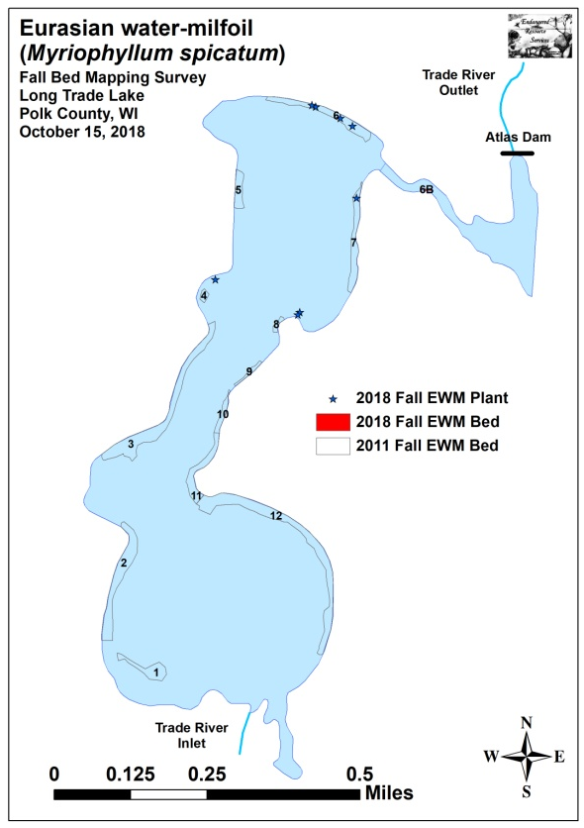
Figure 15: 2017 and 2018 Fall EWM Bed Maps

Table 5: Fall Eurasian Water-milfoil Bed Mapping Summary
Long Trade Lake, Polk County
October 15, 2018

Bed Number | 2018  Area in Acres | 2017  Area in Acres | 2016  Area in Acres | 2015 Area in Acres | 2014  Area in Acres | 2013  Area in Acres | 2012  Area in Acres | 2011  Area in Acres | 2018  Change in  Acreage | Range; and Mean Rake Fullness | 2018 Field Notes
1 | 0 | 0.02 | 0 | 0.36 | 0 | 0 | 0.45 | 0.70 | -0.02 | 0 | No EWM found
2 and 2A | 0 | 0.05 | 0 | 0.54 | 0 | 0 | 0 | 1.89 | -0.05 | 0 | No EWM found
3, 3A, and 3B | 0 | 0.26 | 0 | 2.24 | 0 | 0 | 0.02 | 2.69 | -0.26 | 0 | No EWM found
4 | 0 | 0 | 0 | 0 | 0 | 0 | 0 | 0.13 | 0 | 0 | No EWM found
4B | 0 | 0.01 | 0 | 0.12 | 0 | 0 | 0.03 | 0 | -0.01 | <<<1 | 1 EWM plant
5 | 0 | 0 | 0 | 0 | 0 | 0 | 0 | 0.51 | 0 | 0 | No EWM found
6 | 0 | 0.23 | 0 | 1.52 | 0 | 0 | 0.13 | 1.23 | -0.23 | <<<1 | 4 EWM plants
6B | 0.02 | 0.29 | 0 | 2.18 | 0.22 | 0 | 0.76 | 0 | -0.27 | 1-3; 2 | <100 plants
Mill Pond | 0 | 0 | 0 | 0 | 0 | 0 | 0 | 0 | 0 | 0 | No EWM found
7 | 0 | 0 | 0 | 0.73 | 0 | 0 | 0.21 | 1.03 | 0 | <<<1 | 1 EWM plant
8 | 0 | 0 | 0 | 0.01 | 0 | 0 | 0 | 0.11 | 0 | <<<1 | 2 EWM plant
9 | 0 | 0.01 | 0 | 0 | 0 | 0 | 0 | 0.16 | -0.01 | 0 | No EWM found
10 | 0 | 0.02 | 0 | 0 | 0 | 0 | 0 | 0.29 | -0.02 | 0 | No EWM found
11 | 0 | <0.01 | 0 | 0.48 | 0 | 0 | 0 | 0.88 | -<0.01 | 0 | No EWM found
12 and 12A | 0 | 0.09 | 0 | 3.05 | 0 | 0 | 0 | 3.35 | -0.09 | 0 | No EWM found
13 | 0 | 0.02 | 0 | 0.09 | 0 | 0 | 0 | 0 | -0.02 | 0 | No EWM found
Total  Acres | 0.02 | 1.00 | 0.00 | 11.33 | 0.22 | 0.00 | 1.60 | 12.97 | -0.98

Descriptions of Current and Former Eurasian Water-milfoil Beds:
Bed 1 – The southwest bay continues to be dominated by Curly-leaf pondweed, Coontail and White water lily. Unlike past years when we found at least a few plants, we saw no evidence of Eurasian water-milfoil anywhere in this area.

Beds 2, 3, 4 and 5 – We saw no evidence of EWM anywhere in these former beds.

Bed 4B – A single EWM was found growing among the White water lilies on the northern point in the western midlake bay.

Bed 6 – Four 3ft tall multi-stemmed EWM plants were found on the outer edge of this former bed in 4-5ft of water.

Bed 6B and Mill Pond – A small bed had regrown in the shallow area just before the old bridge. This spot seems to naturally filter out fragments as it’s always the first place in the outlet channel to reestablish. Other than this, we saw no evidence of EWM in the rest of the outlet or the Mill Pond suggesting residual herbicide flowing downstream was enough to knock plants out in these areas.

Beds 7 and 8 – We found and rake removed three 2-3ft tall multi-stemmed plants along the eastern shoreline of the northern third of the lake. Each was canopied in 2-3ft of water and was actively fragmenting. One of these occurred in the part of Bed 7 where Grantsburg High School students reintroduced 100’s of Northern water-milfoil (Myriophyllum sibiricum) turions in the fall of 2016. Unfortunately, we didn’t find a single surviving NWM plant.

Beds 9-12 – We didn’t find any EWM plants along the eastern shoreline in the southern 2/3rds of the lake. This was surprising as there have almost always been a few stragglers that seem to survive in the slough inlet. A check back to this area during the November turion survey also failed to locate any evidence of EWM.

LITERATURE CITED

Miller, G., M. Perkins, L. Sather, and E. Eaton [online]. 1965. Long Trade Lake Bathymetric Map.
http://dnr.wi.gov/lakes/maps/DNR/2640500a.pdf (2018, December).

UWEX Lakes Program. [online]. 2010. Aquatic Plant Management in Wisconsin. Available from http://www.uwsp.edu/cnr-ap/UWEXLakes/Pages/ecology/aquaticplants/default.aspx (2018, December).

UWEX Lakes Program. [online]. 2010. Pre/Post Herbicide Comparison. Available from http://www.uwsp.edu/cnr-ap/UWEXLakes/Documents/ecology/Aquatic%20Plants/Appendix-D.pdf (2018, December).

WDNR. [online]. 2018. Long Trade Lake - Citizen Lake Water Quality Monitoring Database. Available from http://dnr.wi.gov/lakes/waterquality/Station.aspx?id=493080 (2018, December).

Appendix I: Survey Sample Points and Treatment Areas

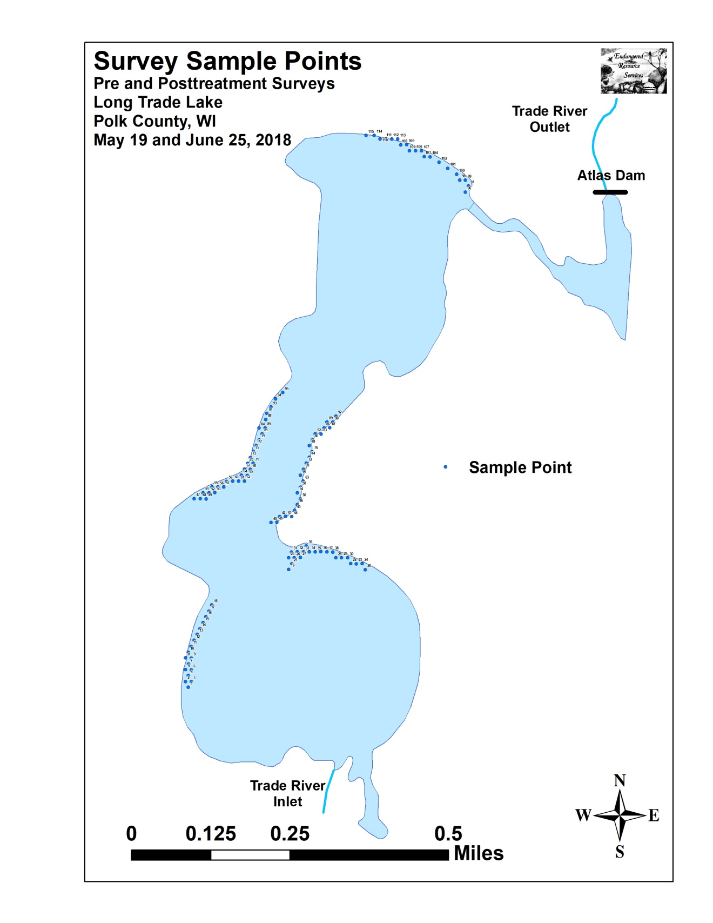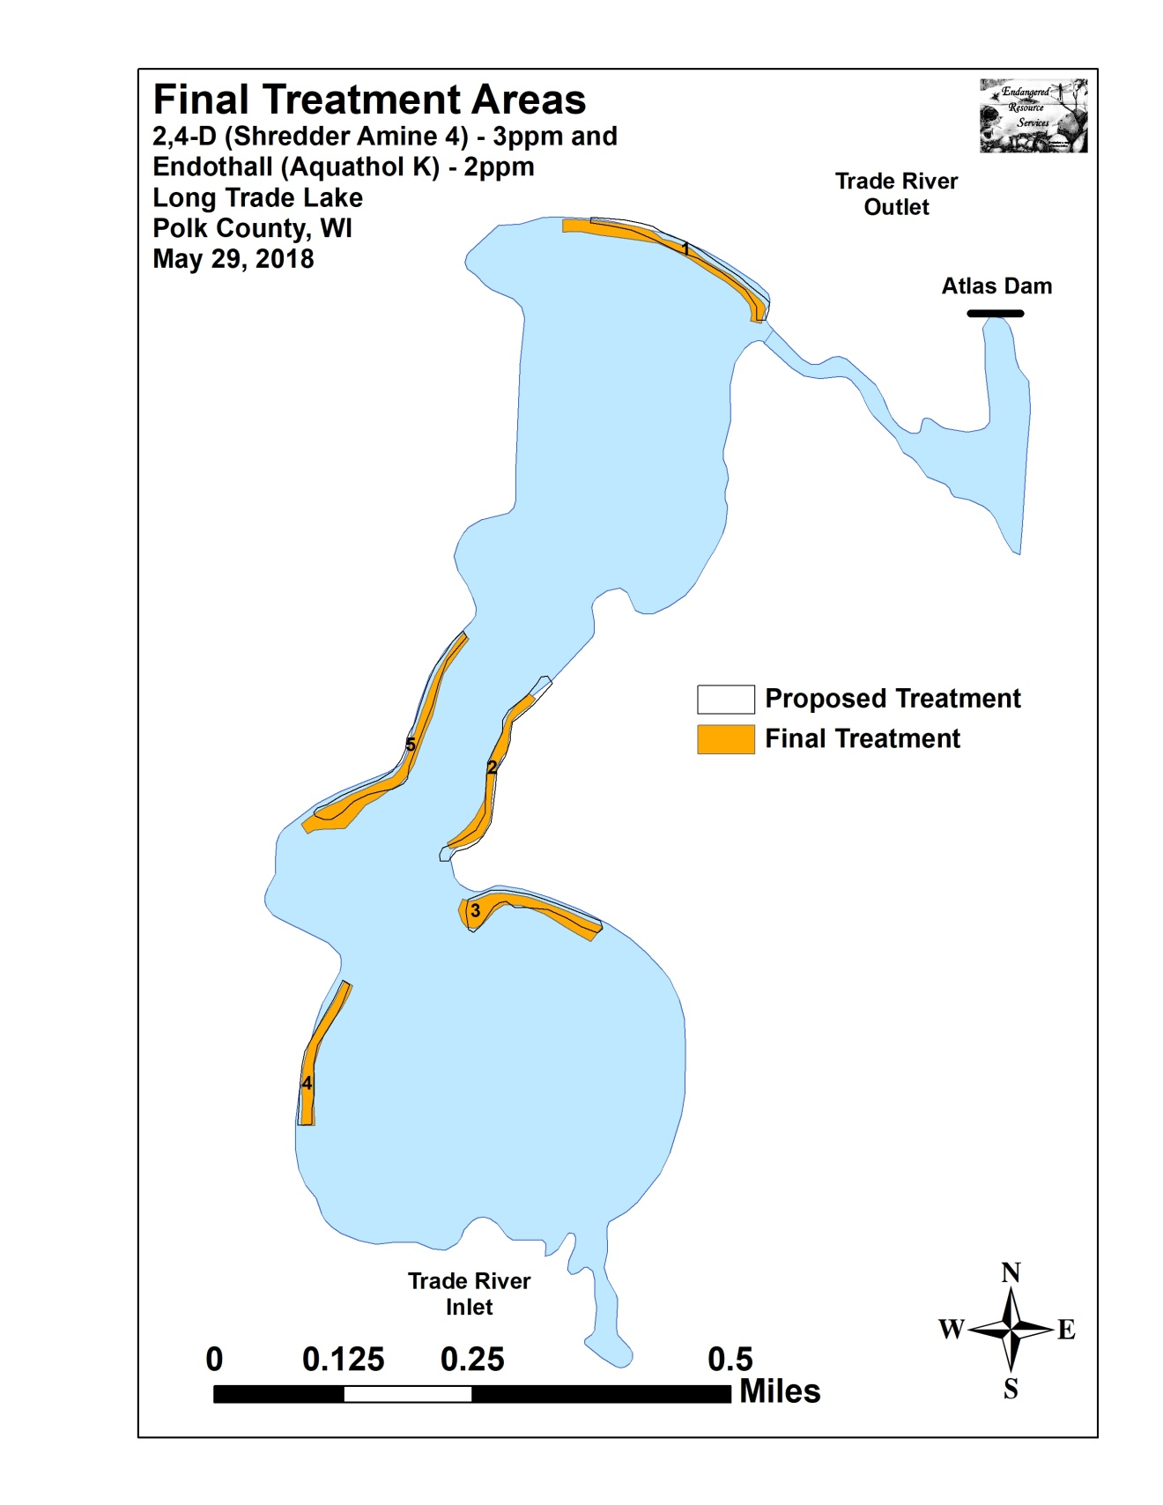

Appendix II: Vegetative Survey Datasheet

Observers for this lake: names and hours worked by each:
Lake: |  |  |  |  |  |  |  |  | WBIC |  |  |  |  |  |  |  |  | County |  |  |  |  |  | Date:
Site # | Depth (ft) | Muck (M), Sand (S), Rock (R) | Rake pole (P) or rake rope (R) | Total Rake Fullness | EWM | CLP | 1 | 2 | 3 | 4 | 5 | 6 | 7 | 8 | 9 | 10 | 11 | 12 | 13 | 14 | 15 | 16 | 17 | 18 | 19
1
2
3
4
5
6
7
8
9
10
11
12
13
14
15
16
17
18
19
20

Appendix III: Pre/Post Habitat Variable Maps

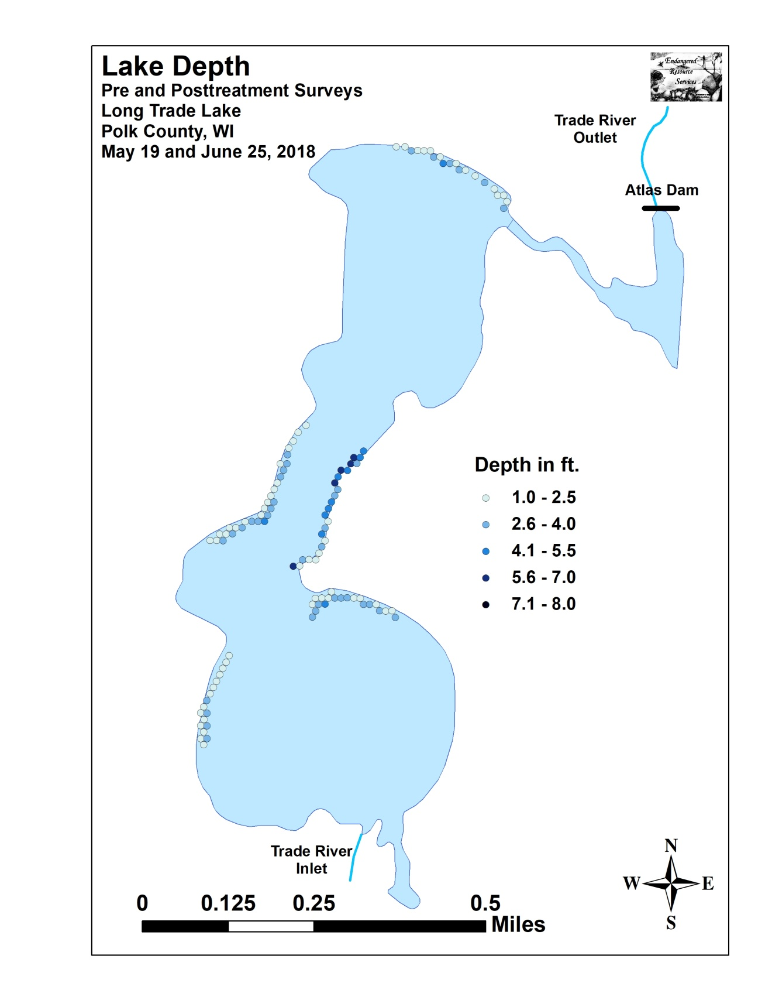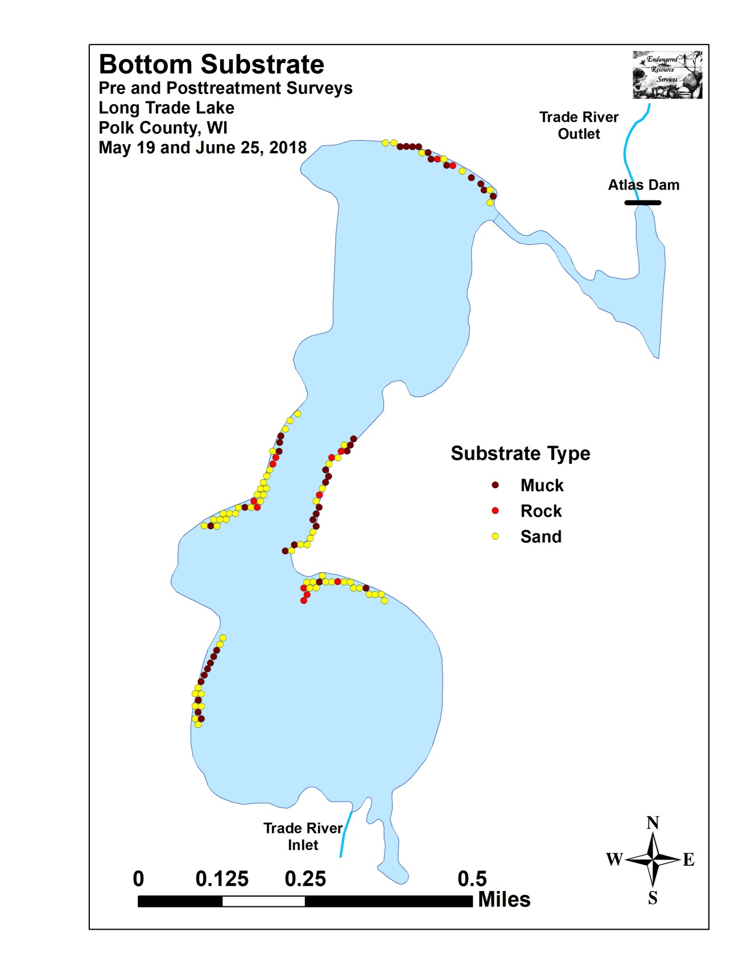

Appendix IV: Pre/Post Littoral Zone, Native Species Richness and
Total Rake Fullness

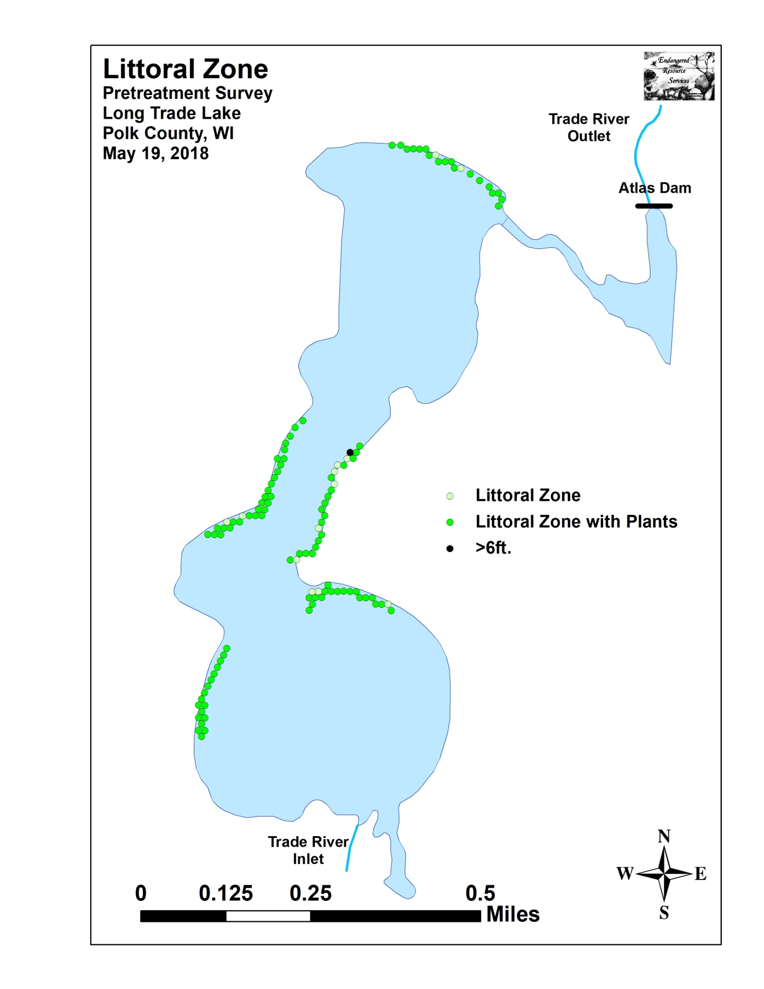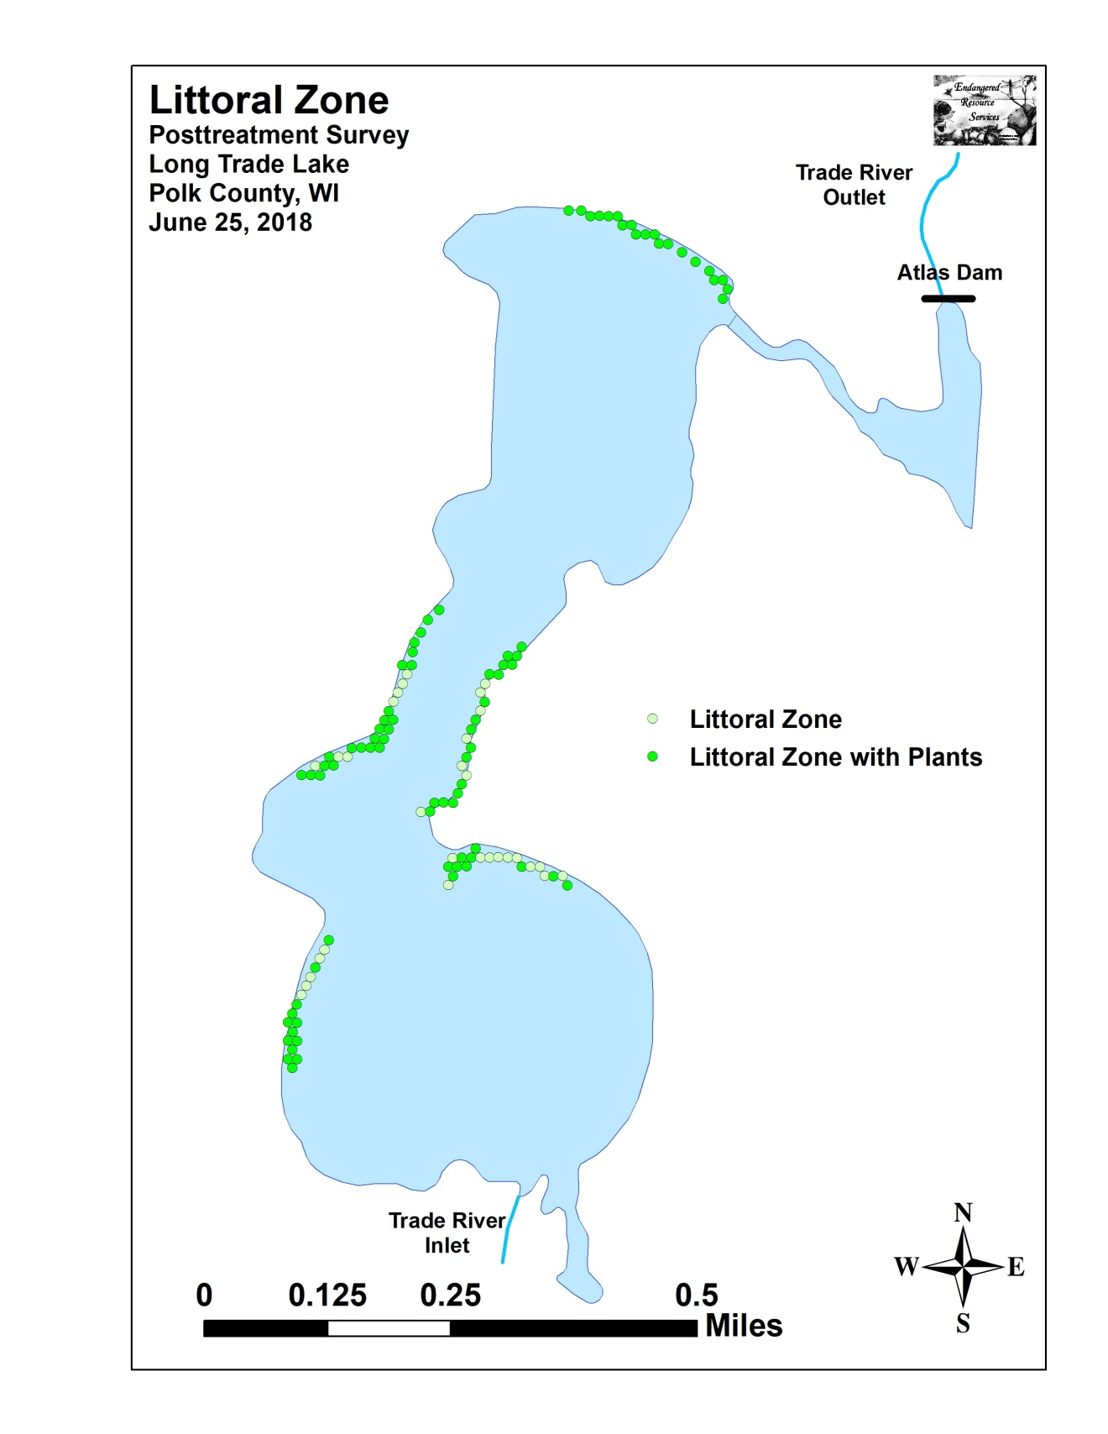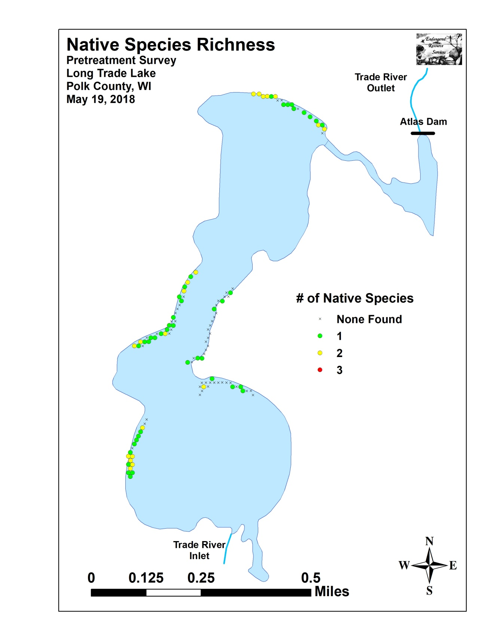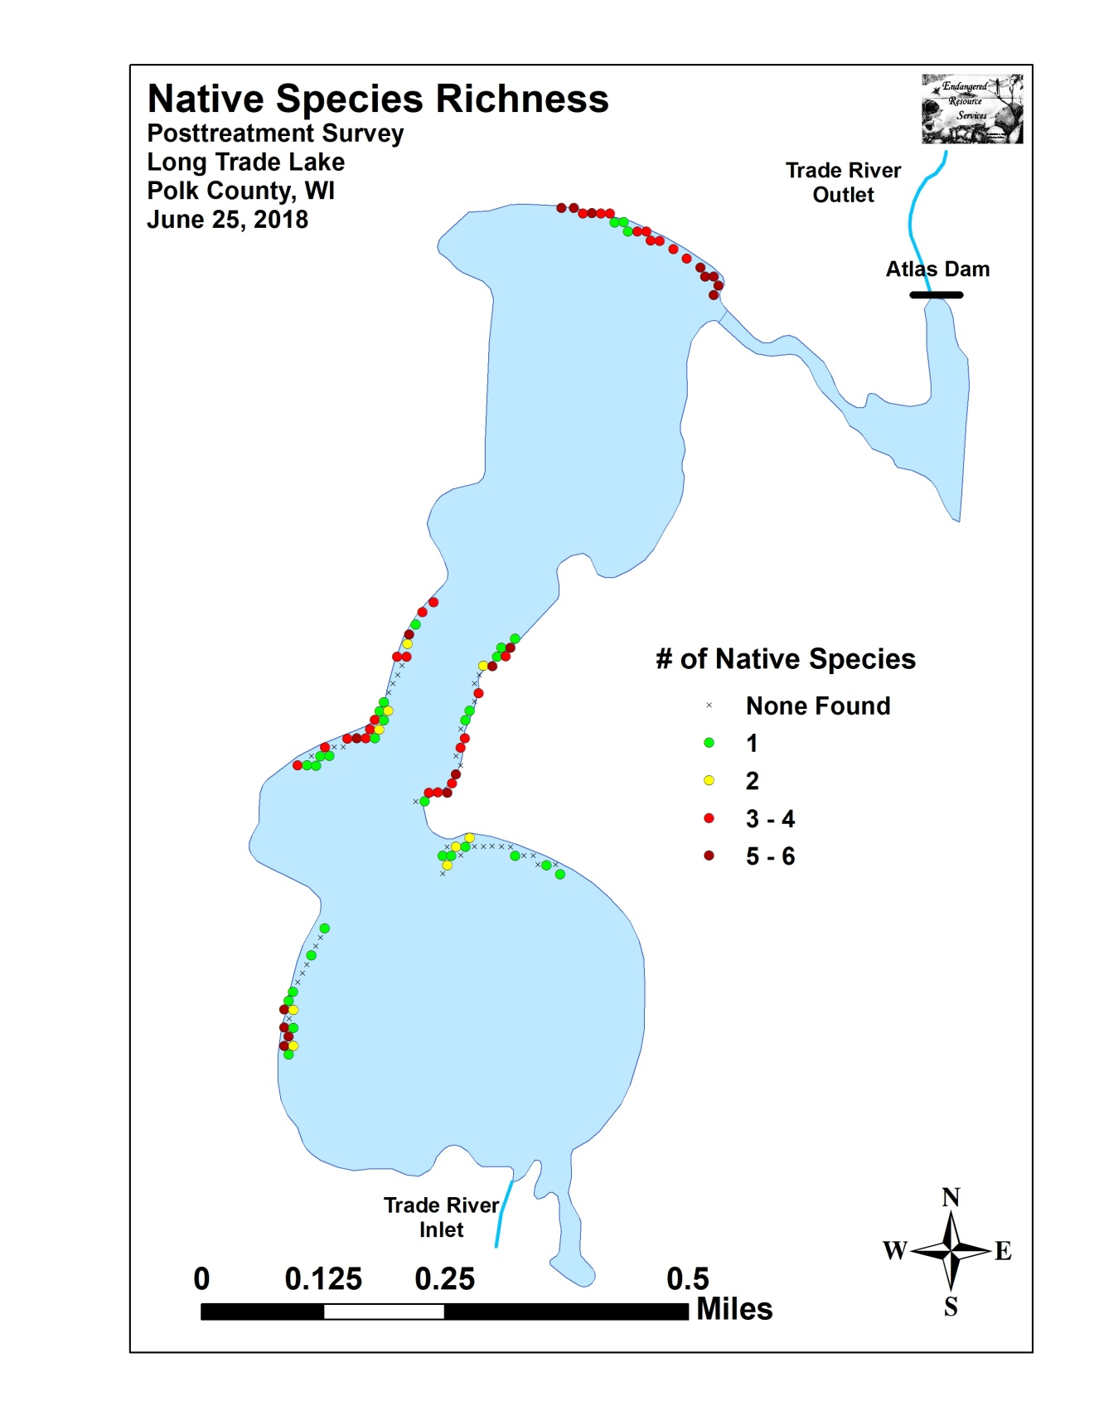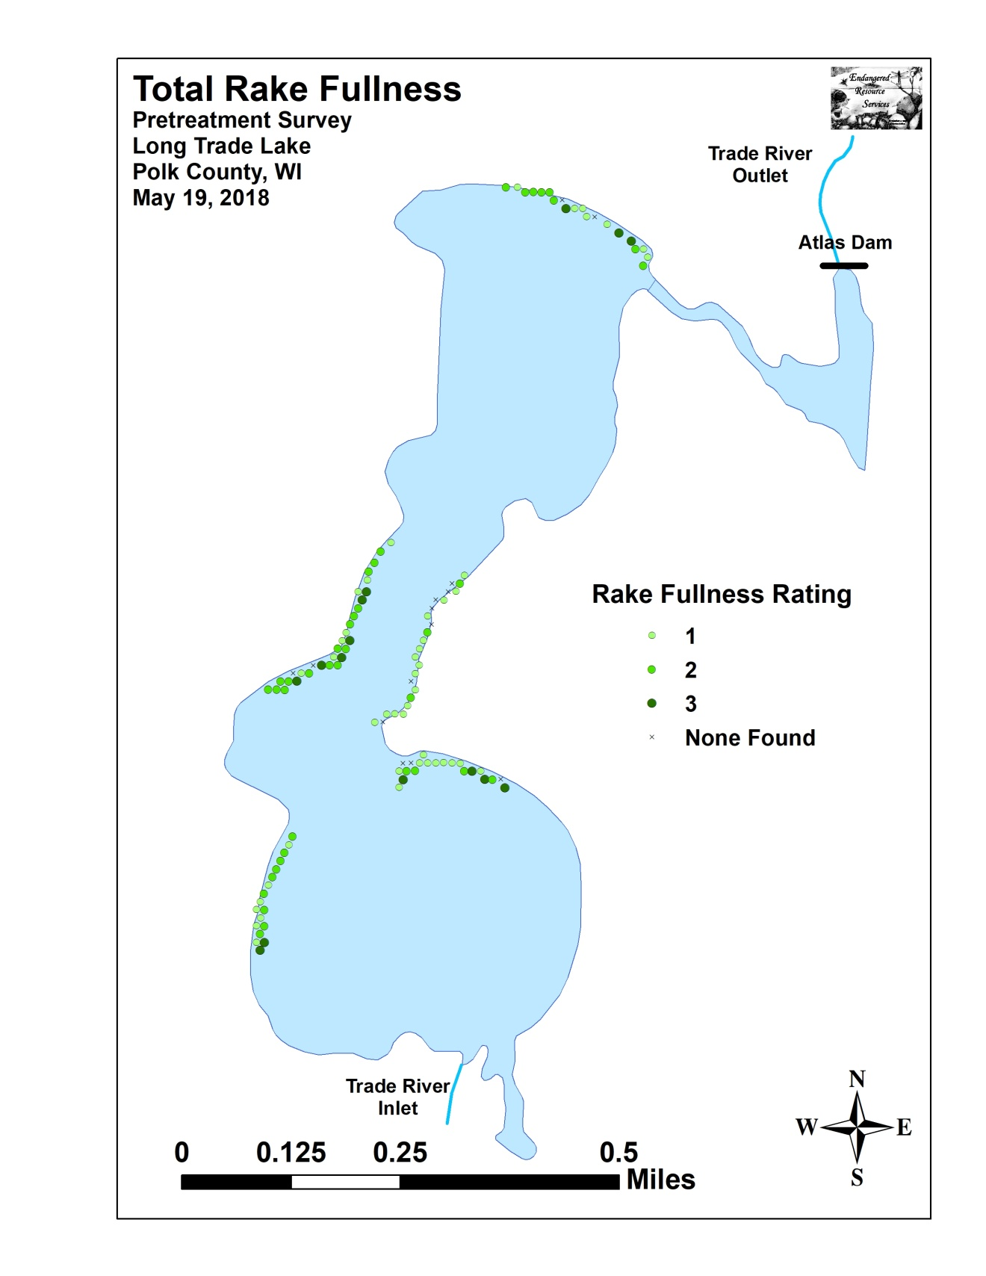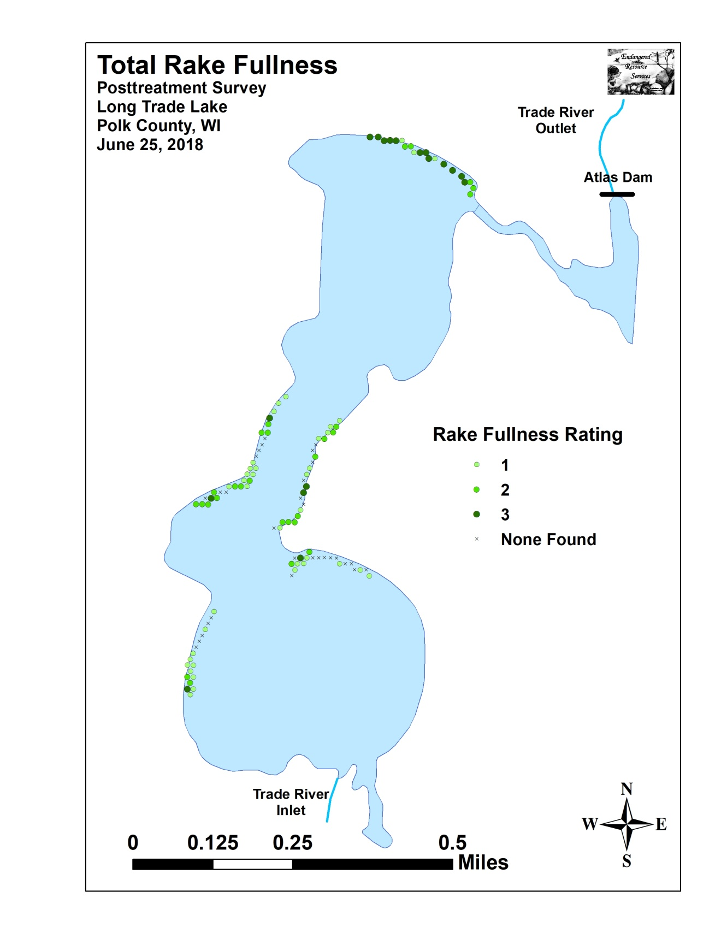

Appendix V: CLP and EWM Pre/Post Density and Distribution

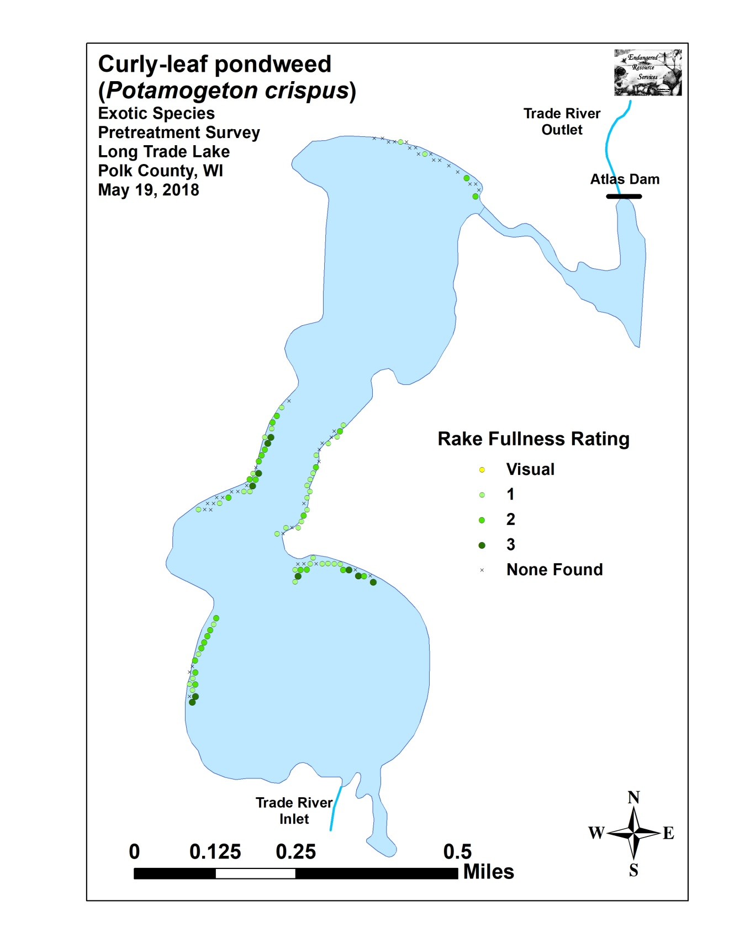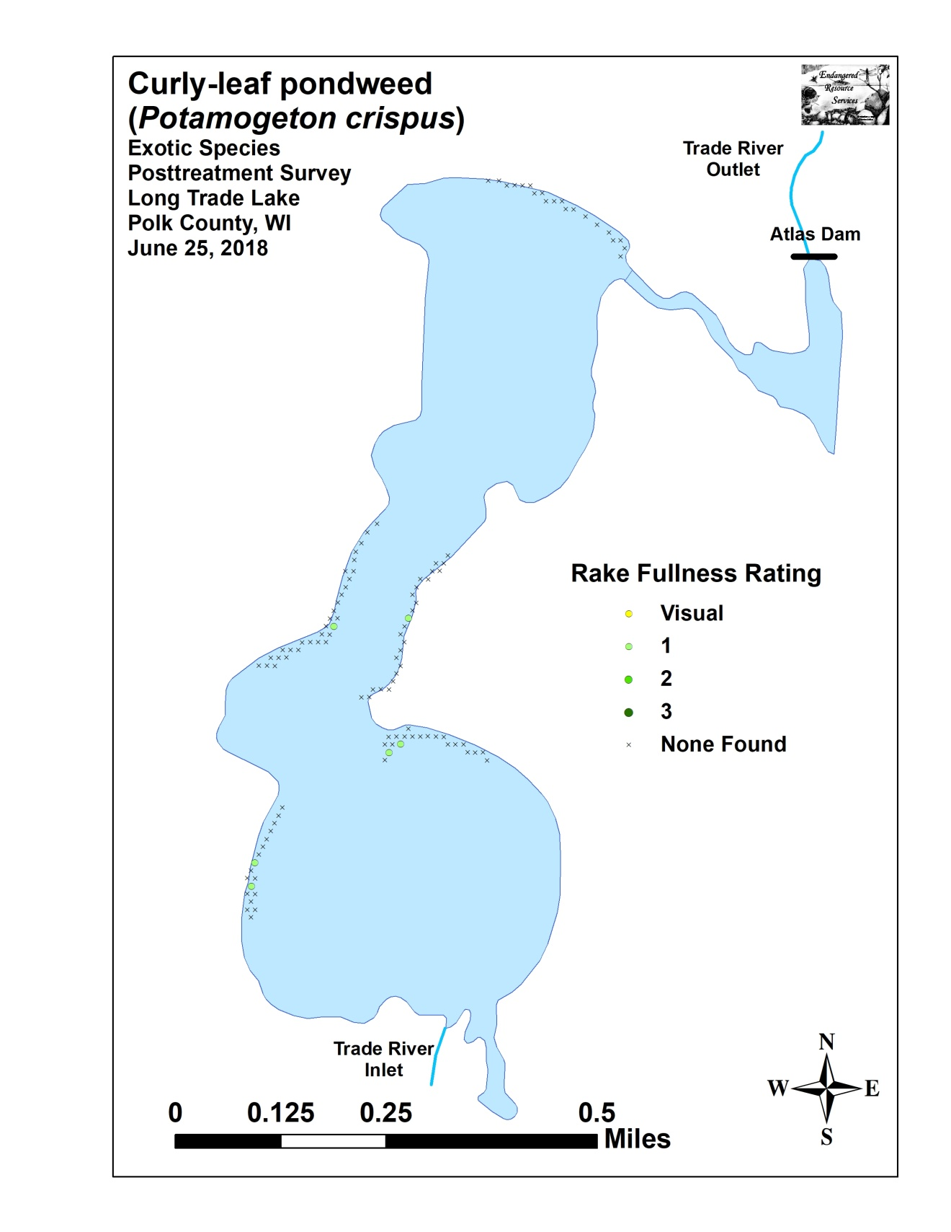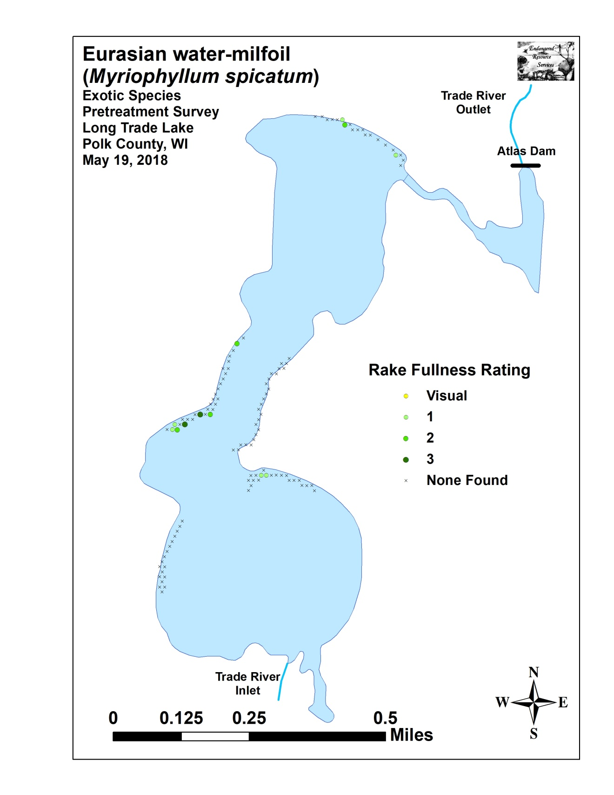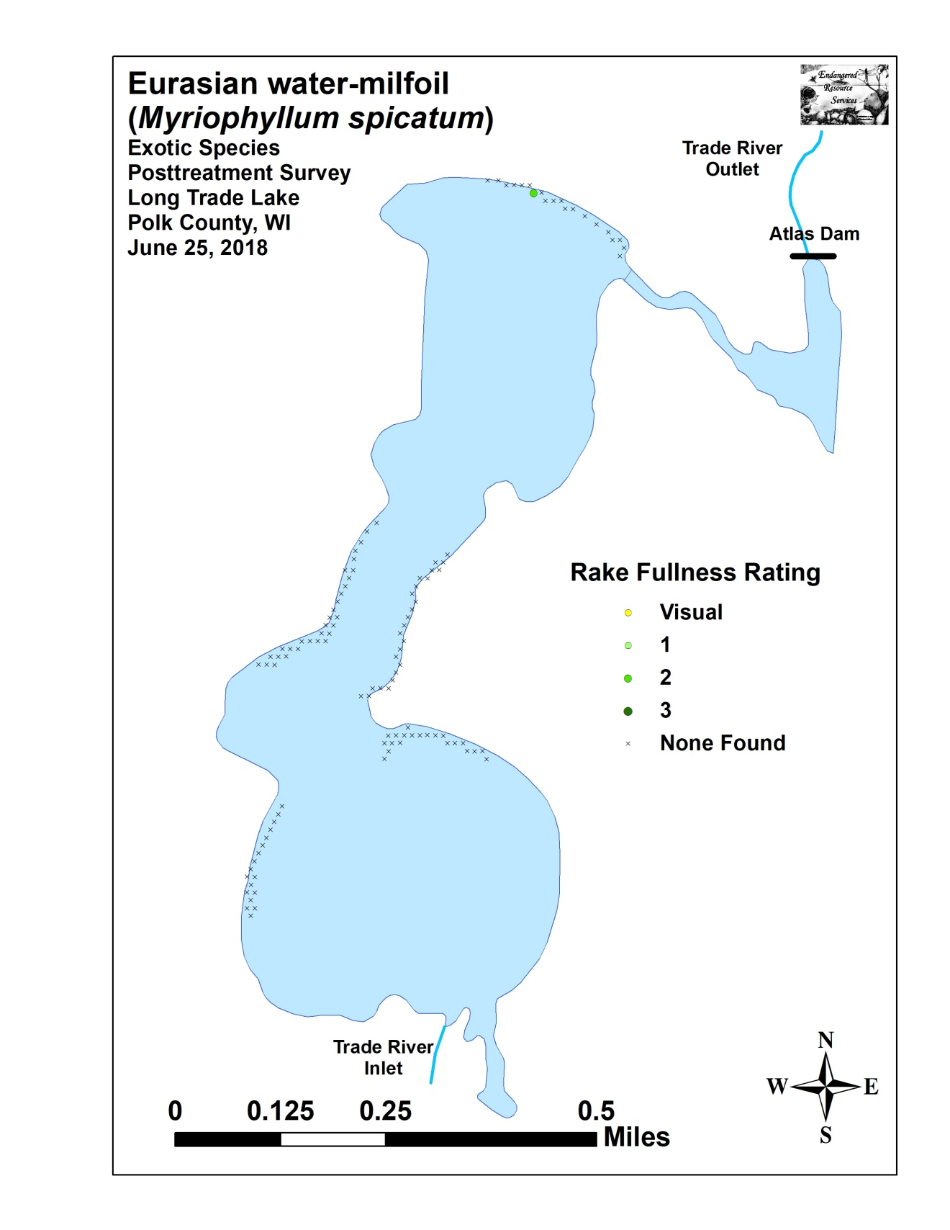

Appendix VI: Pretreatment Native Species Density and Distribution
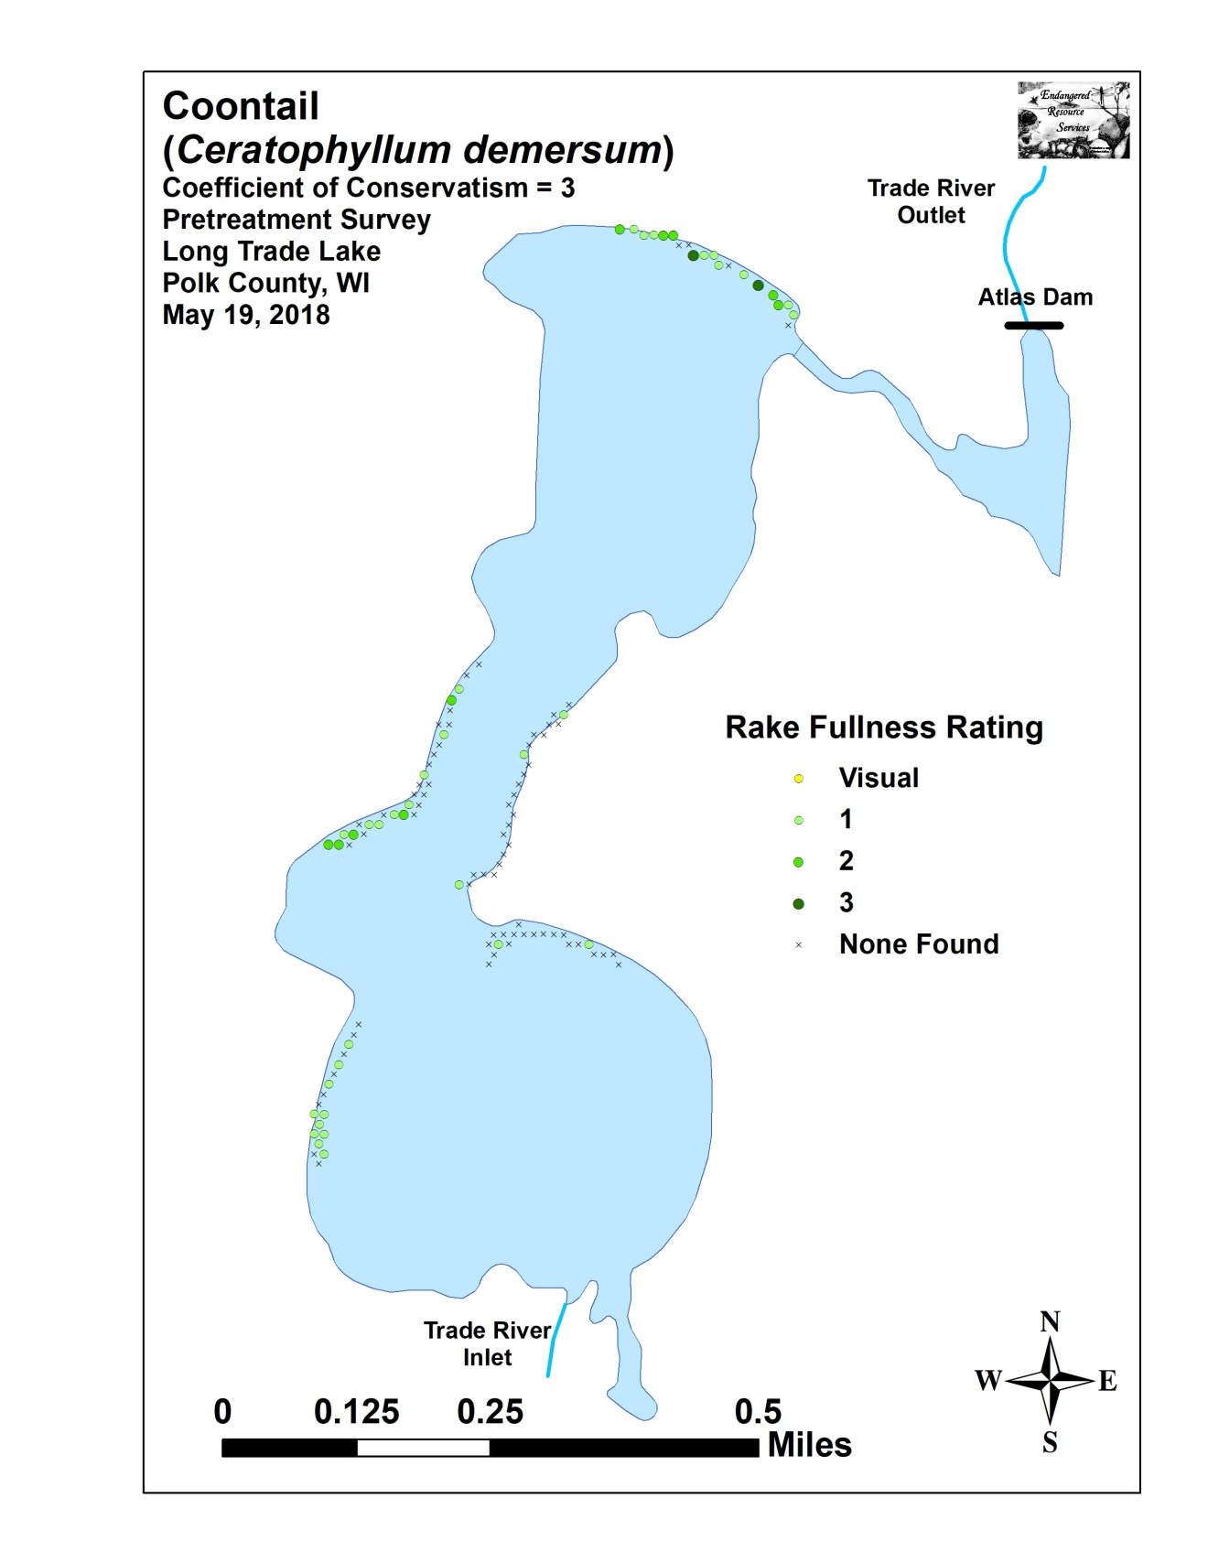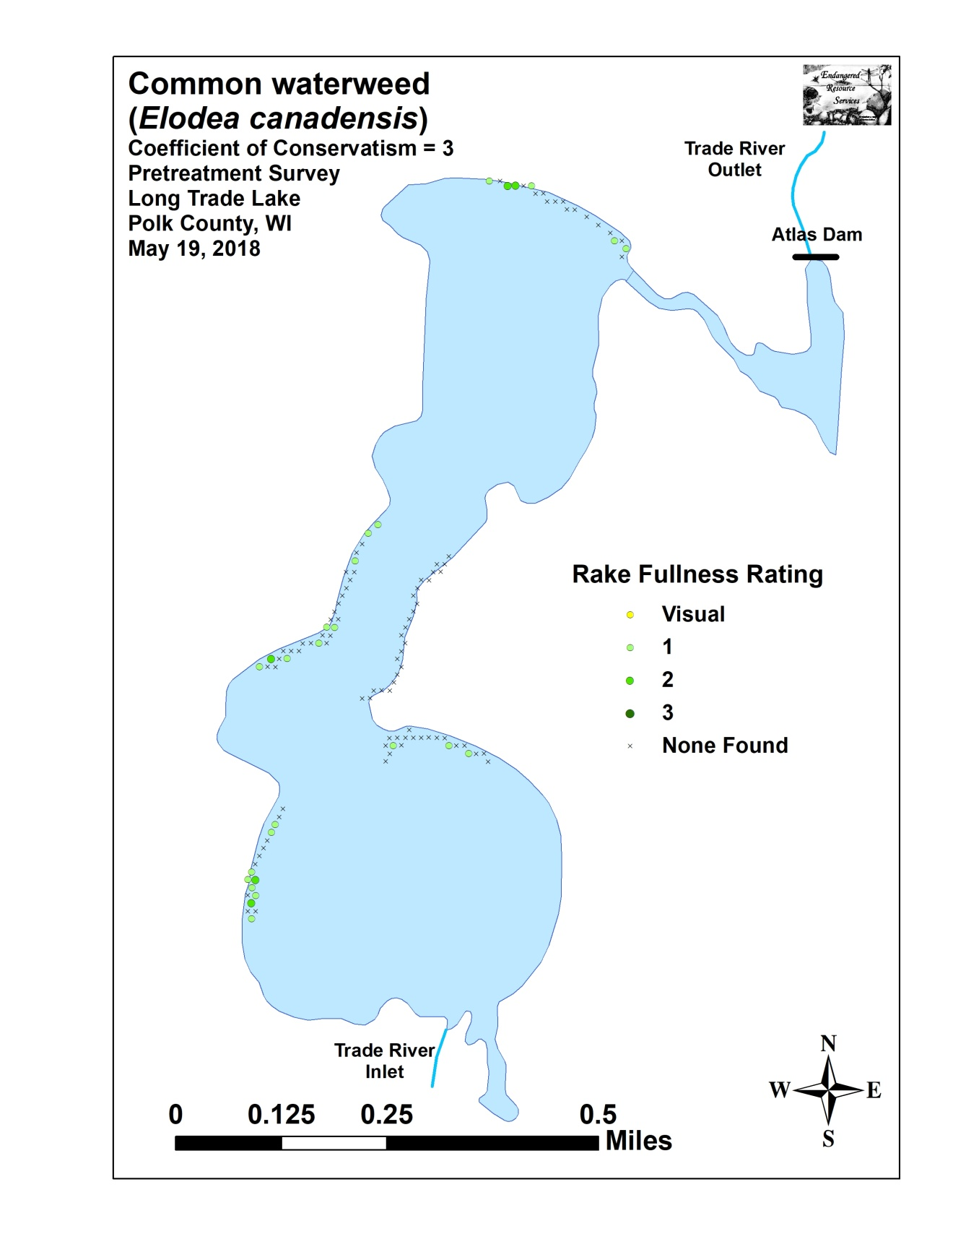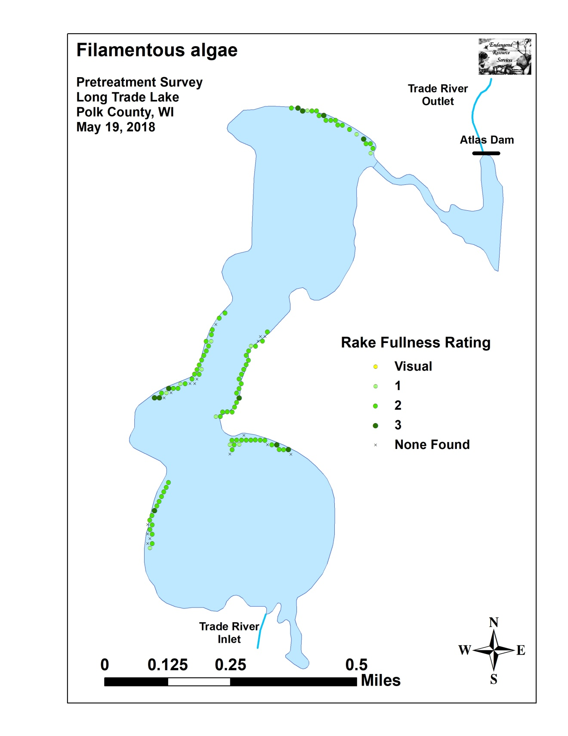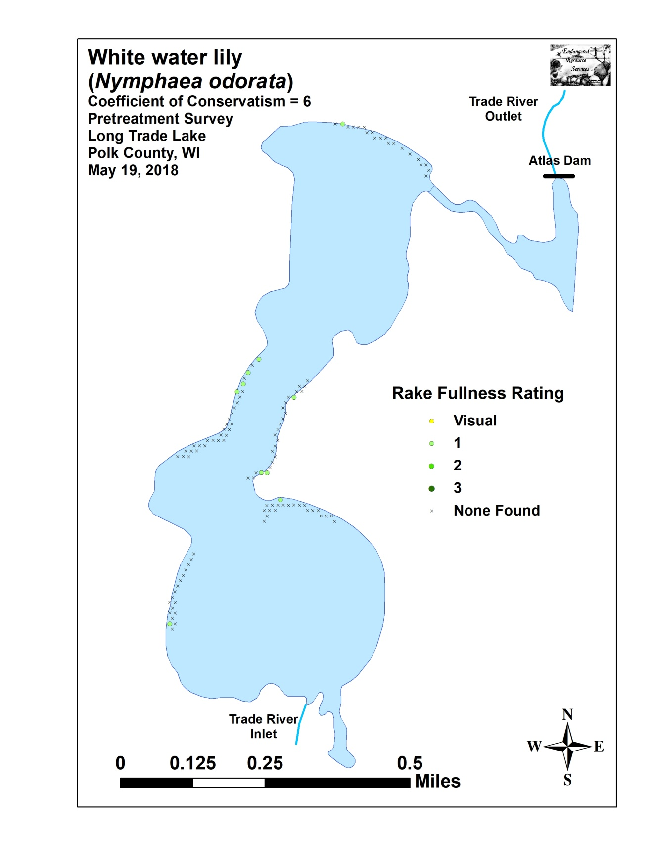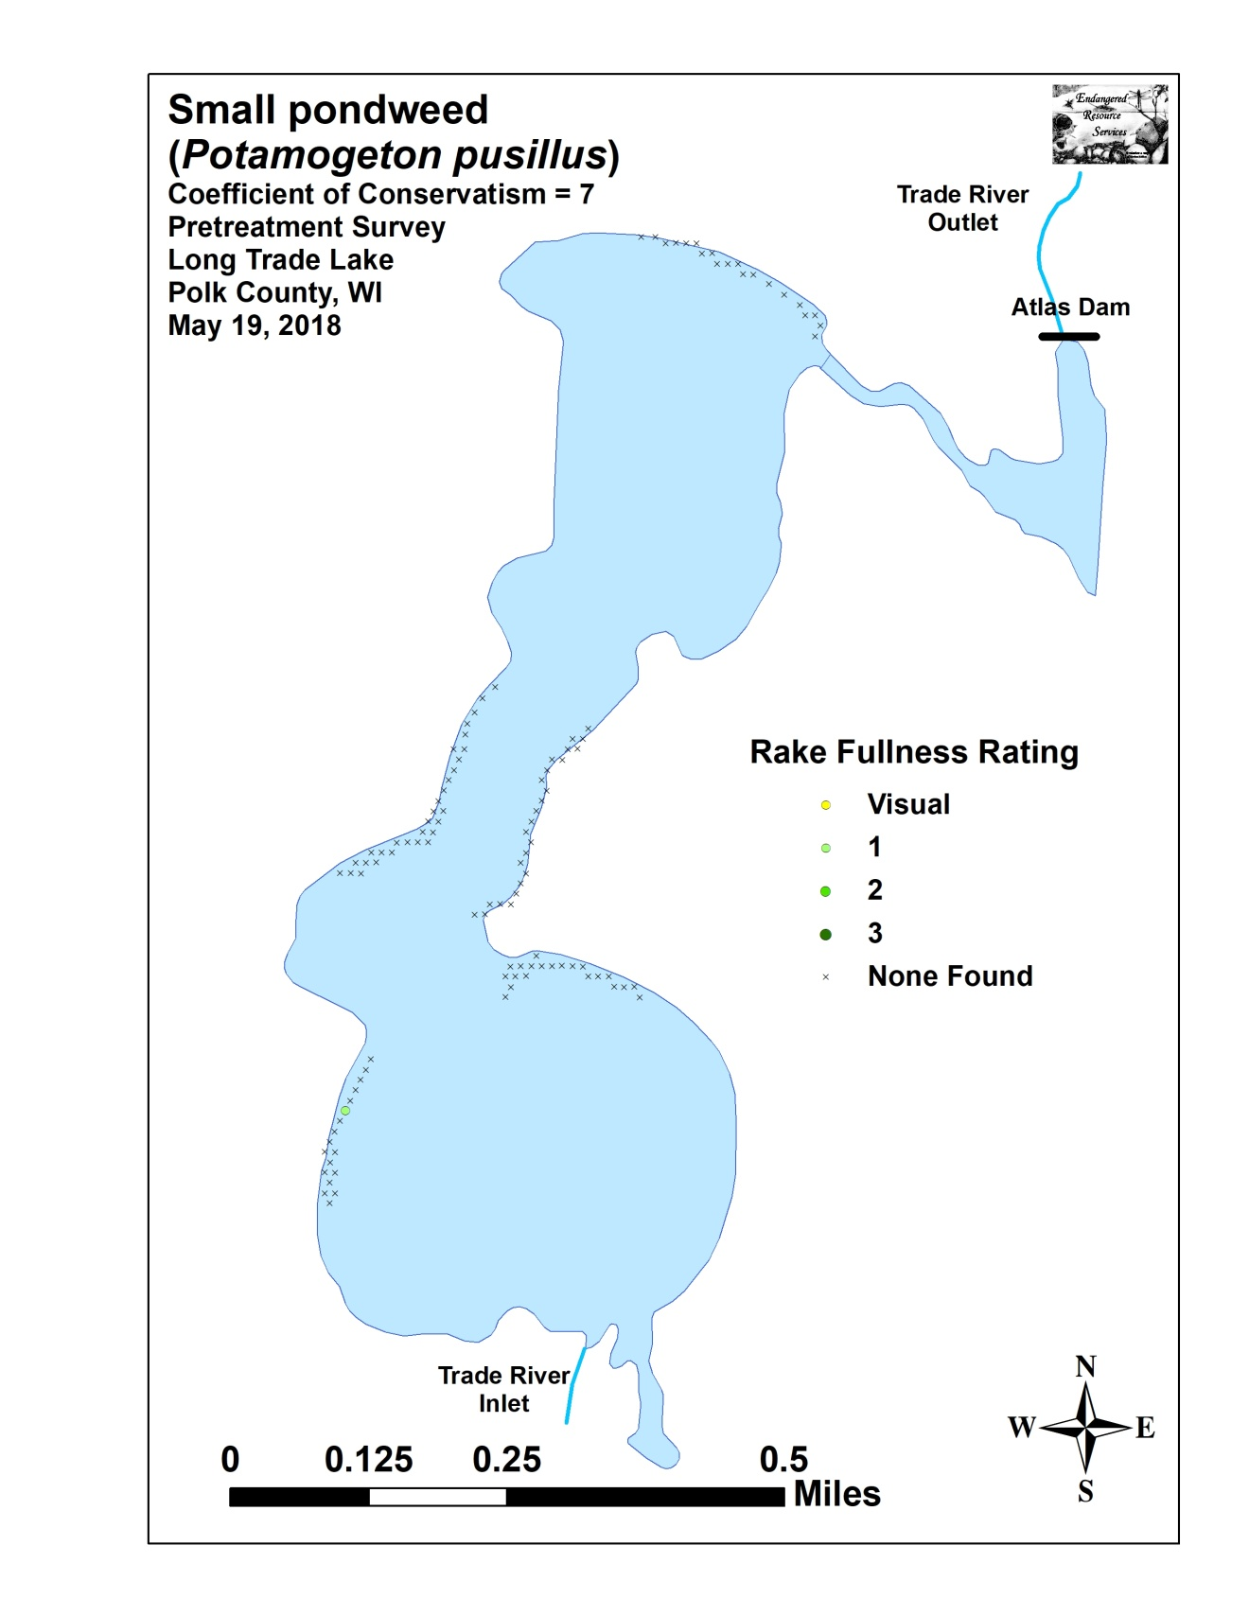

Appendix VII: Posttreatment Native Species Density and Distribution
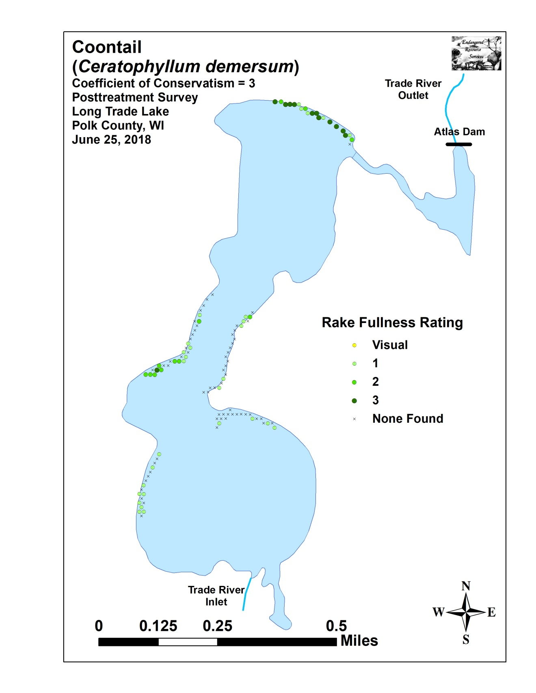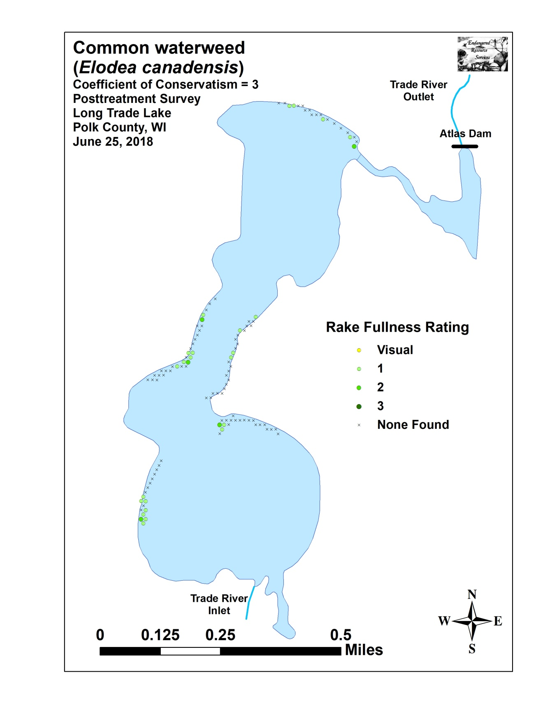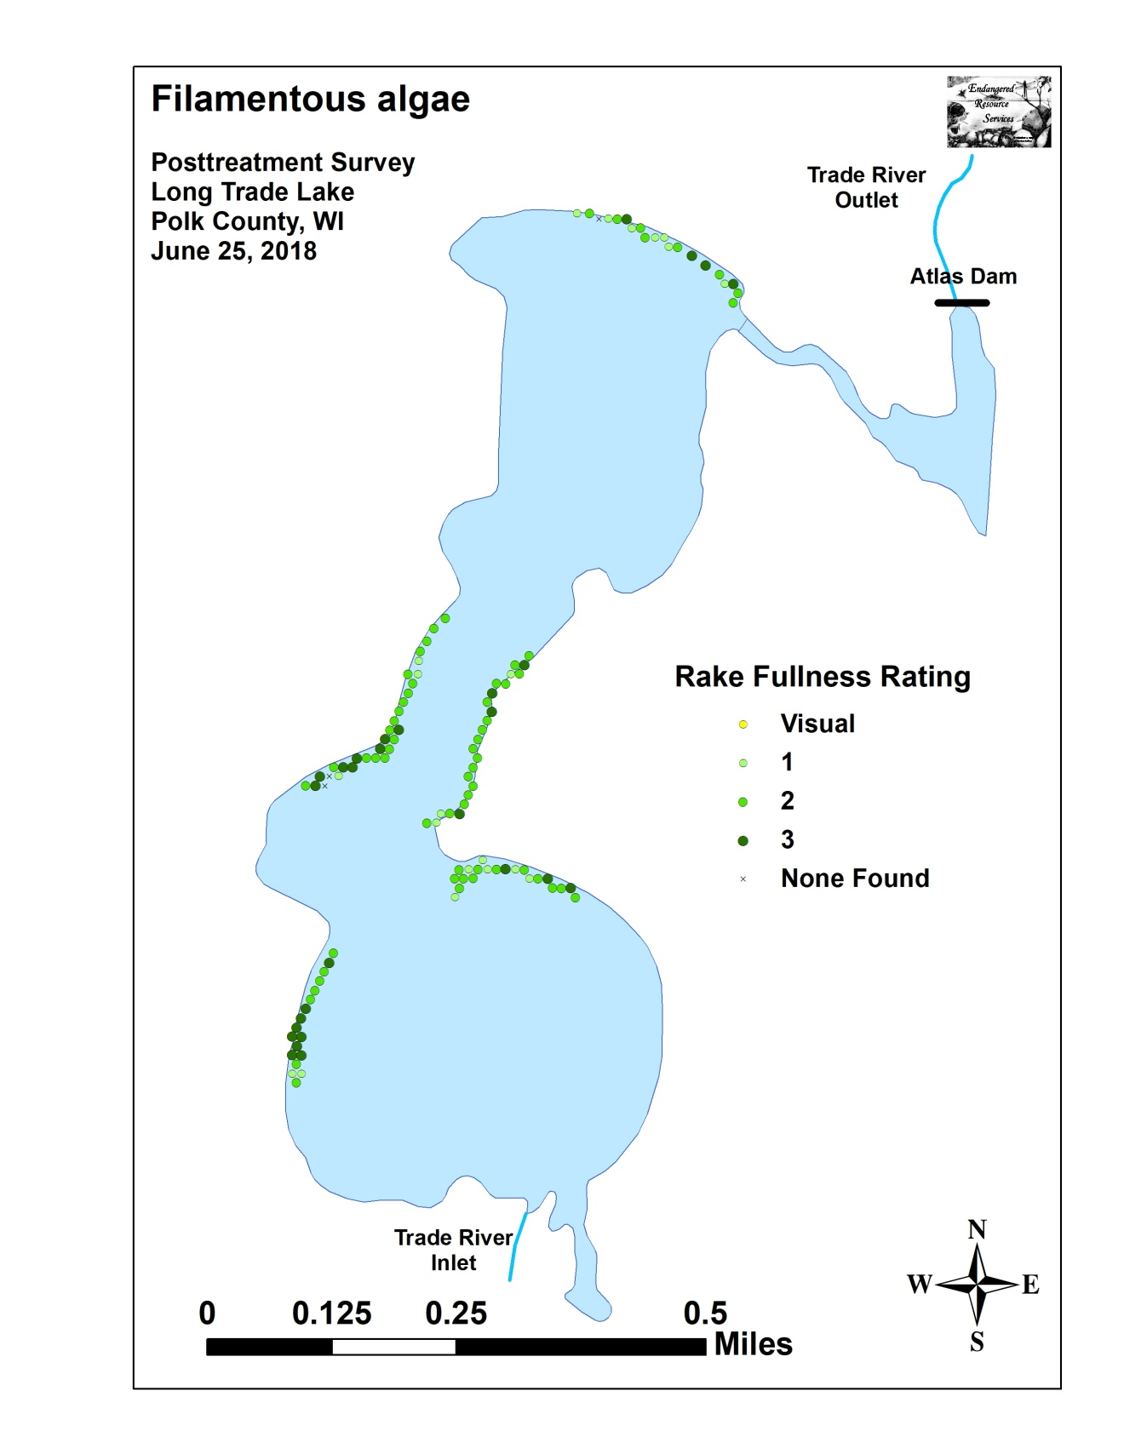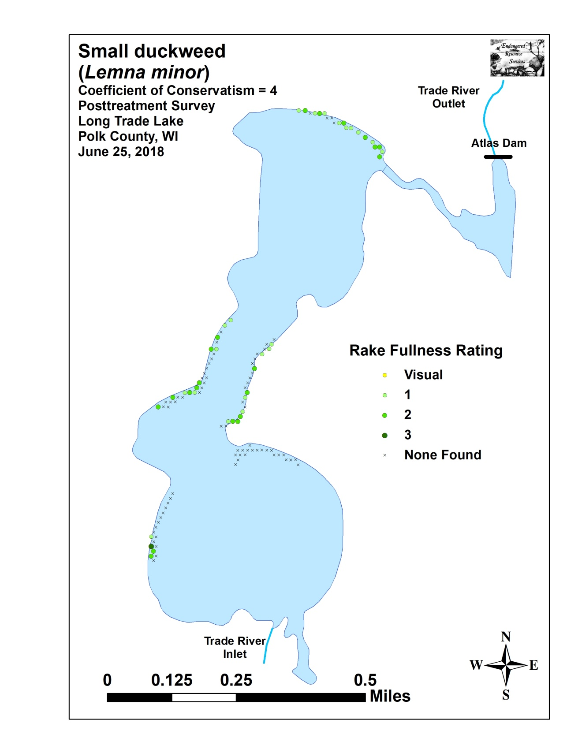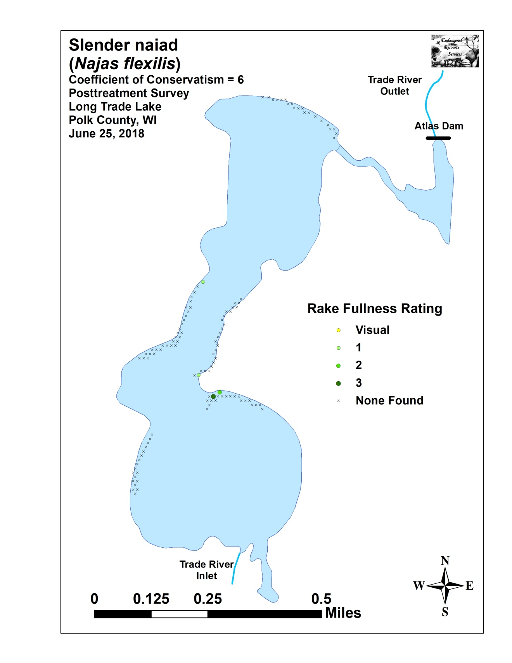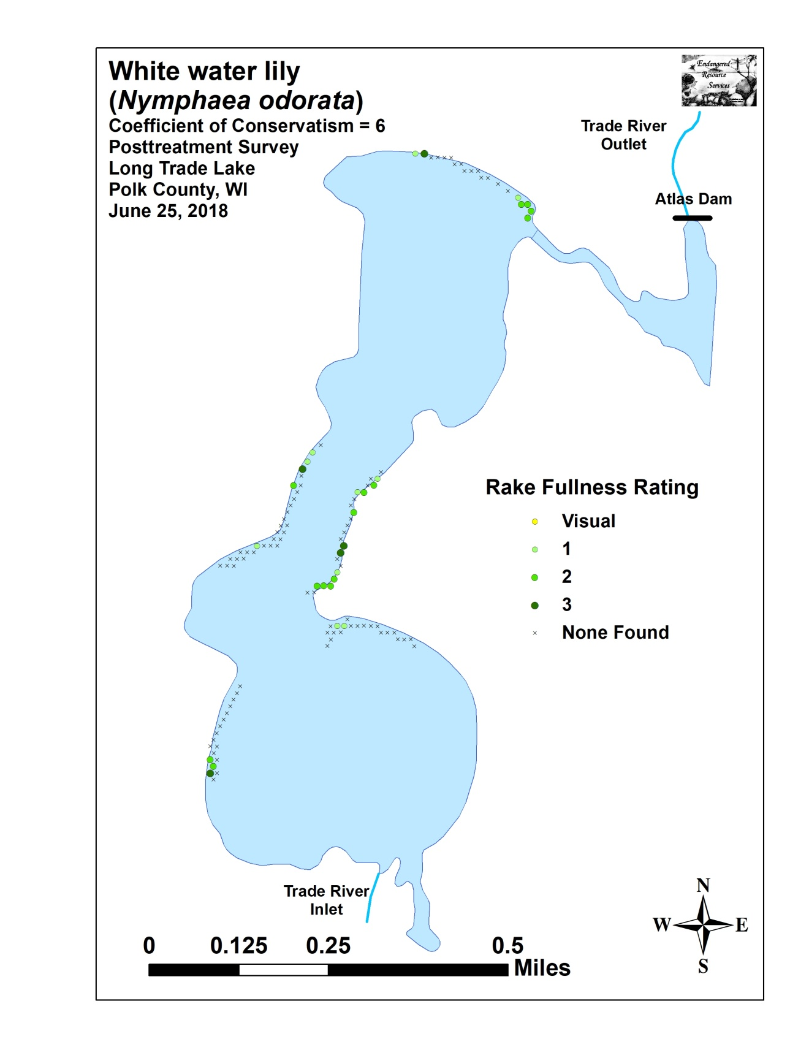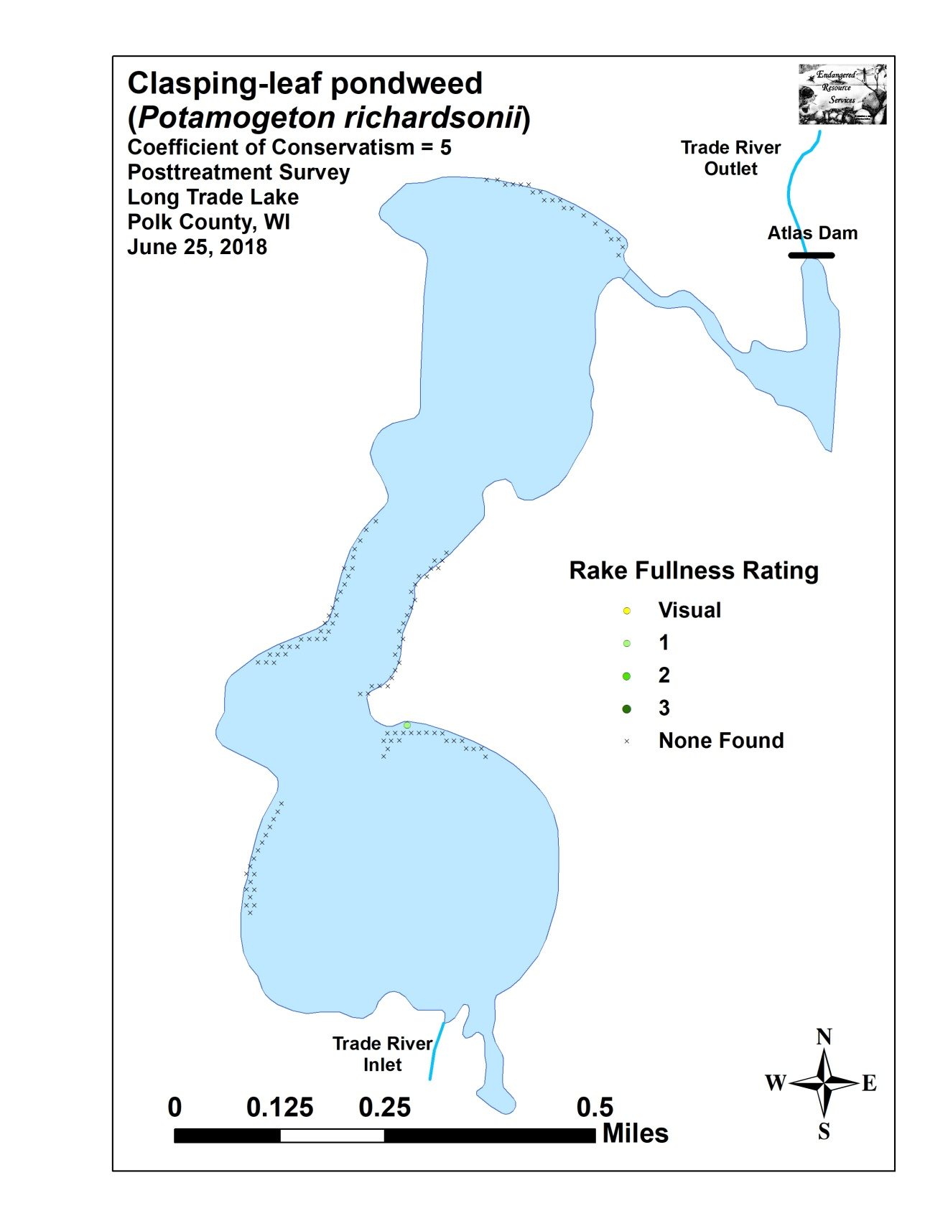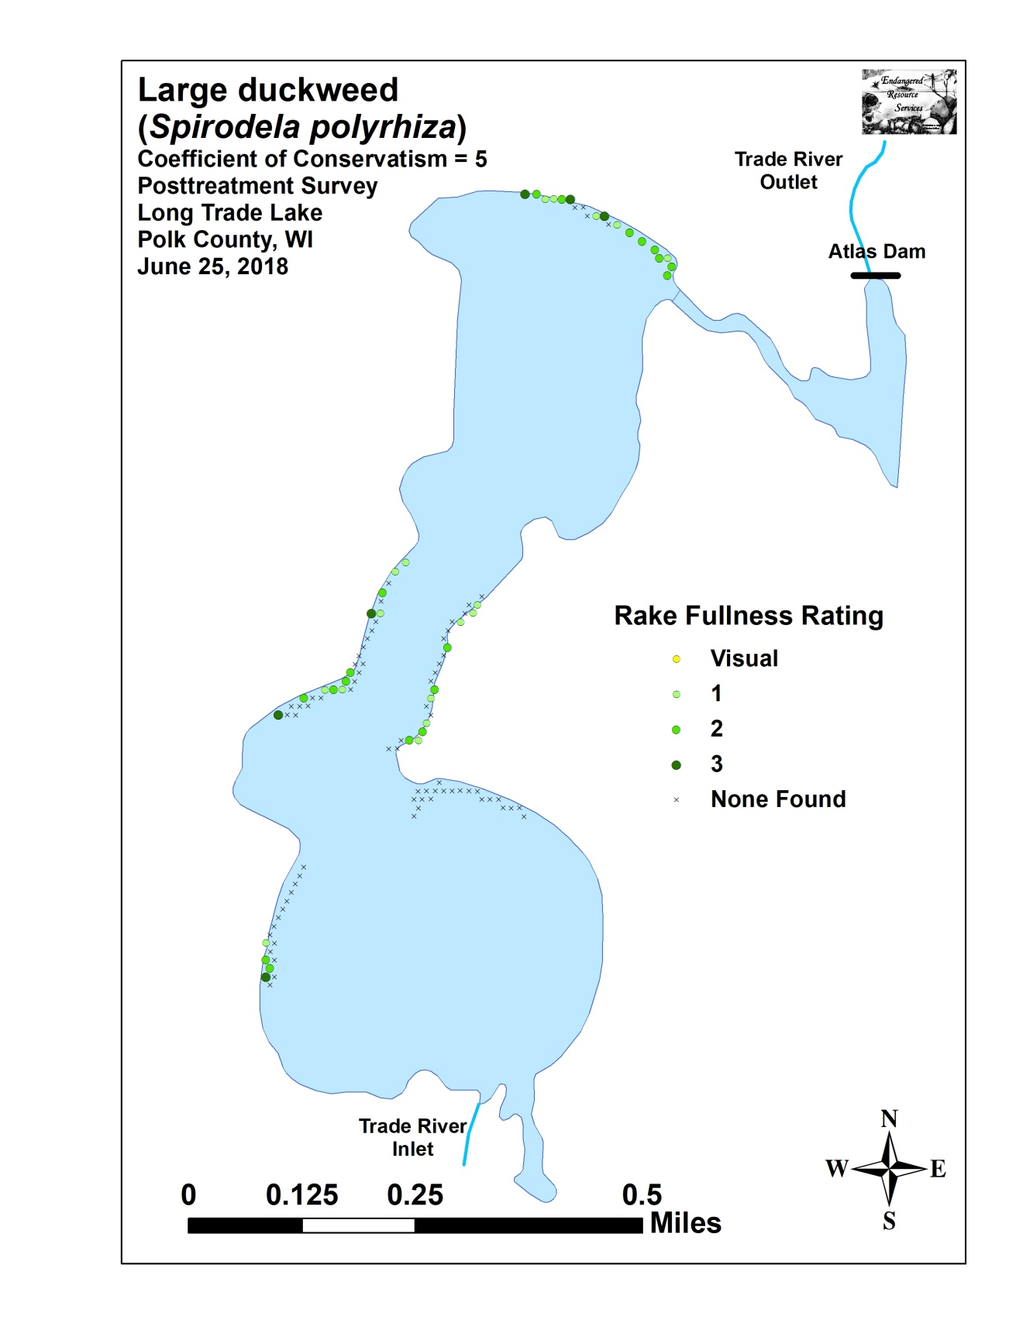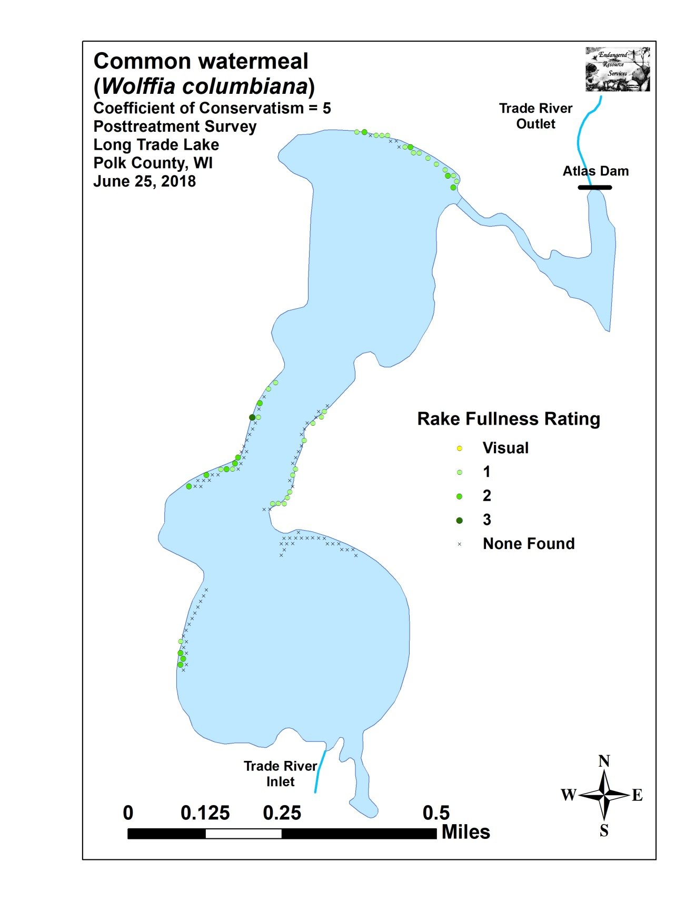

Appendix VIII: Fall 2017 and 2018 EWM Bed Maps
