High Density Macrophyte Bed Mapping and
Aquatic Invasive Species Survey
Dowling Lake (WBIC: 2858300)
Douglas County, Wisconsin

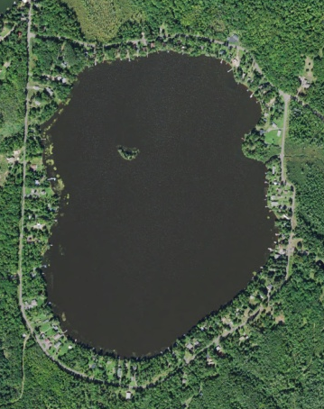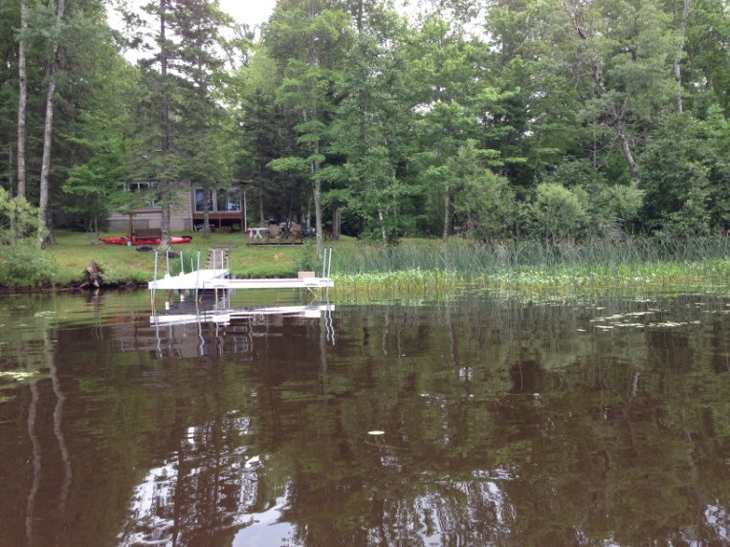
Dowling Lake Aerial Photo (2015) Typical shoreline emergent community on Dowling Lake (Berg 2016)

Project Initiated by:
Amnicon Dowling Lake Management Dist., Lake Education and Planning Services, LLC. and the Wisconsin Department of Natural Resources

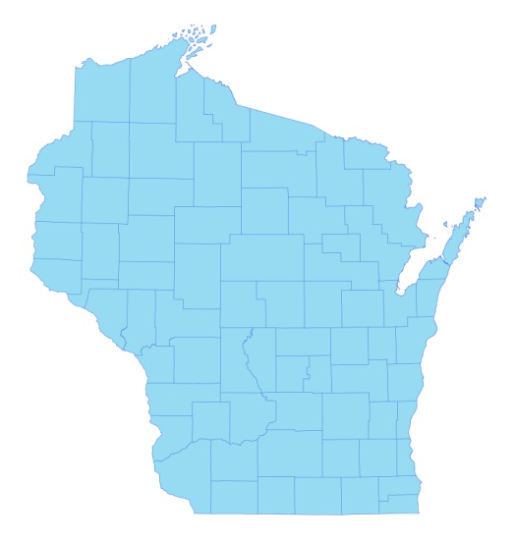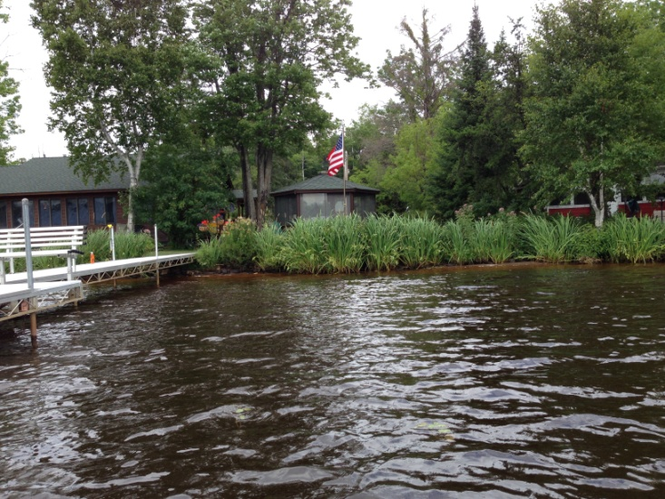
* Dowling
Lake
Dense Yellow Iris expanding along north shoreline (Berg 2016)

Survey Conducted by and Report Prepared by:
Endangered Resource Services, LLC
Matthew S. Berg, Research Biologist
St. Croix Falls, Wisconsin
July 31, 2016
TABLE OF CONTENTS

Page
LIST OF FIGURES AND TABLES..……………………………………………… ii
INTRODUCTION.…..……..………………………………………………………. 1
BACKGROUND AND STUDY RATIONALE…………………………………… 1
METHODS……………………..………..…………………………………………. 2
DATA ANALYSIS….……………………………………………………………... 3
RESULTS ……………………..………………………………………………….... 3
High Density Plant Bed Mapping Survey……………….…………………. 3
Aquatic Invasive Plant Species Survey……….……………………….….... 6
DISCUSSSION AND CONSIDERATIONS FOR MANAGEMENT..….………... 9
LITERATURE CITED ……………………….…………………………….…….… 10
APPENDIX…. …….…………………………………………………….…………. 11
I: GPS Coordinates of Yellow Iris Plants.……………………….…………….... 11

LIST OF FIGURES AND TABLES

Page #
Figure 1: Dowling Lake Bathymetric Map…………….…………………………... 1
Figure 2: Rake Fullness Ratings..………………………………………………….. 2
Table 1: Aquatic Macrophyte P/I Survey Summary Statistics
Dowling Lake, Douglas County August 3, 2012………….………………………... 3

Figure 3: 2012 Littoral Zone and Total Rake Fullness…………..………………... 4

Figure 4: Typical Narrow Emergent Community……….…………………….…… 4

Figure 5: Regular Boat Traffic Maintaining Navigation Channels……….……….. 5

Figure 6: Densest Floating-leaf Area on the Western Shoreline…..…….………… 6

Figure 7: Purple Loosestrife Along the North Shore…………..………………….. 7

Figure 8: Purple Loosestrife and Galerucella Beetles……………………………... 7

Figure 9: Yellow Iris Distribution 7/31/16……………………………………...…. 8

Figure 10: Dense Yellow Iris Along the Northeast Shoreline 7/31/16..………..…. 8

Figure 11: Exotic Reed Canary Grass and Native Blue Joint Grass………………. 9

INTRODUCTION:
Dowling Lake (WBIC 2858300) is a 141acre drainage lake located in the Town of Oakland in west-central Douglas County (T46N R13W S7, 18). The lake reaches a maximum depth of 13ft on the east-central side and has an average depth of 7ft (WDNR 2009). Dowling Lake is eutrophic in nature with summer Secchi readings averaging 3.2ft from 2002-2009 (WDNR 2016). This very poor water clarity resulted in a littoral zone that seldom extended beyond 3-4ft in July of 2016. The lake’s bottom substrate is almost exclusively sandy muck with the exception of a ring of pure sand along most of the shoreline, and a few rocky patches around the island and sunken island (Figure 1) (Ginder et al. 1971).

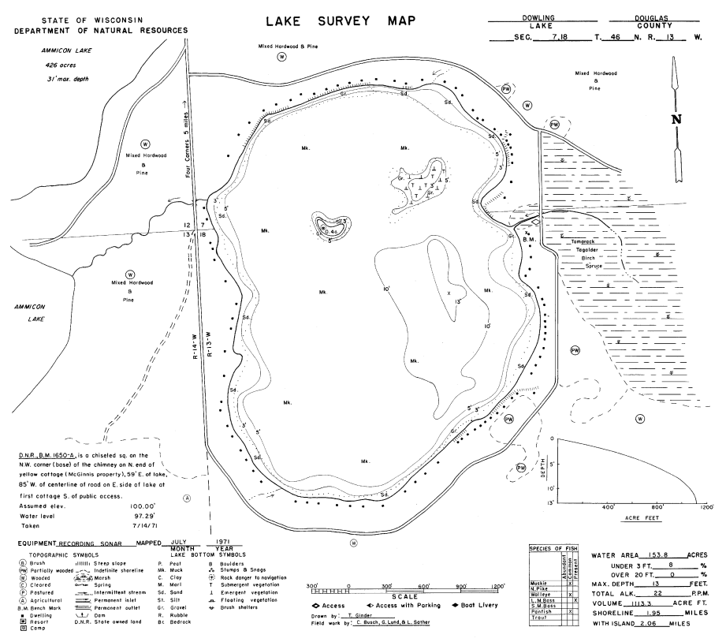
Figure 1: Dowling Lake Bathymetric Map

BACKGROUND AND STUDY RATIONALE:
The Amnicon Dowling Lake Management District (ADLMD), Lake Education and Planning Services, LLC (LEAPS), and the Wisconsin Department of Natural Resources (WDNR) requested a Northern wild rice (Zizania palustris) and high-density plant bed mapping survey in response to concerns from residents about plants making it difficult or, in some cases, impossible to access open water from their lakeshore. The immediate goals of the survey were to define the total acreage covered by wild rice, and to assess the level of impairment caused by plant growth. Because the survey required searching the visible littoral zone of the lake, it also served as an Aquatic Invasive Species (AIS) survey to determine if Eurasian water milfoil (Myriophyllum spicatum) (EWM), Curly-leaf pondweed (Potamogeton crispus) (CLP), or any other exotic plant had invaded the lake since the original point-intercept surveys conducted in 2012. These data will be used to update the lake’s Aquatic Plant Management Plan (APMP). This report is the summary analysis of the survey conducted on Dowling Lake on July 31, 2016.
METHODS:
High Density Plant Bed Mapping Survey:
By definition, a “bed” was determined to be any area where we visually estimated that plants were generally continuous with clearly defined borders, and they were canopied or close enough to being canopied that they would potentially interfere with normal boat traffic. During the survey, we searched the lake’s entire visible littoral zone. After we located a bed, we motored around the perimeter of the area and took GPS coordinates at regular intervals. We also estimated the rake density range and mean rake fullness of the bed (Figure 2), and the impact it was likely to have on navigation (none – easily avoidable with a natural channel around or narrow enough to motor through/minor – one prop clear to get through or access open water/moderate – several prop clears needed to navigate through/severe – multiple prop clears and difficult to impossible to row through). In the case of Northern wild rice, we also estimated the bed’s human harvest potential (none – only scattered plants/little – regular plants, but low density/medium – regular plants of moderate density/high – continuous high density plants). These data were then mapped using ArcMap 9.3.1, and we used the WDNR’s Forestry Tools Extension to determine the acreage of each bed to the nearest hundredth of an acre.

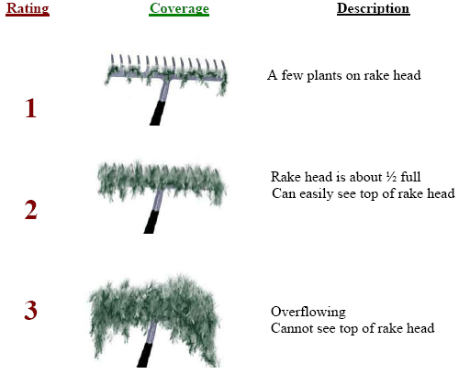
Figure 2: Rake Fullness Ratings (UWEX, 2010)

Aquatic Invasive Plant Species Survey:
To increase the chances of detection, the survey was conducted on a calm day. During the survey, we meandered back and forth throughout the lake’s visible littoral zone spacing transects close enough that our field of view overlapped from one transect to another. The most likely places for a new infestation to occur are the public boat landing and, in the case or Eurasian water-milfoil, along the far north shoreline of the lake where prevailing winds tend to carry plant fragments. Because of this, we surveyed especially slowly in these areas. We also paid special attention to the areas around docks and lifts as it is not uncommon for EWM to establish in these areas after becoming entangled in propellers.
RESULTS:
High Density Plant Bed Mapping Survey:
Dowling Lake has a very limited plant community in both density and distribution. Because of this, there were no areas anywhere on the lake that met the “bed” criteria where plants were likely causing a significant impairment to navigation that would have required multiple prop clears to travel through. During the 2016 survey, repeated random raking to establish the extent of the littoral zone never turned up submergent plants deeper than 5ft; apparently due to the poor water clarity. This was similar to the original point-intercept survey when we found plants at just 29 of 253 total points (11.5% of the entire lake and 29.9% of the then 7.0ft littoral zone) (Table 1) (Figure 3). Even when present, the majority of rake samples had just a few plants on the head. This was also similar to 2012 when the mean rake fullness was a low/moderate 1.52 (Figure 3).

Table 1: Aquatic Macrophyte P/I Survey Summary Statistics
Dowling Lake, Douglas County
August 3, 2012

Summary Statistics:
Total number of points sampled | 253
Total number of sites with vegetation | 29
Total number of sites shallower than the maximum depth of plants | 97
Frequency of occurrence at sites shallower than maximum depth of plants | 29.90
Simpson Diversity Index | 0.88
Maximum depth of plants (ft) | 7.0
Mean depth of plants (ft) | 3.5
Median depth of plants (ft) | 3.5
Average number of all species per site (shallower than max depth) | 0.54
Average number of all species per site (veg. sites only) | 1.79
Average number of native species per site (shallower than max depth) | 0.54
Average number of native species per site (veg. sites only) | 1.79
Species Richness | 16
Species Richness (including visuals) | 17
Species Richness (including visuals and boat survey) | 33
Average rake fullness (veg. sites only) | 1.52

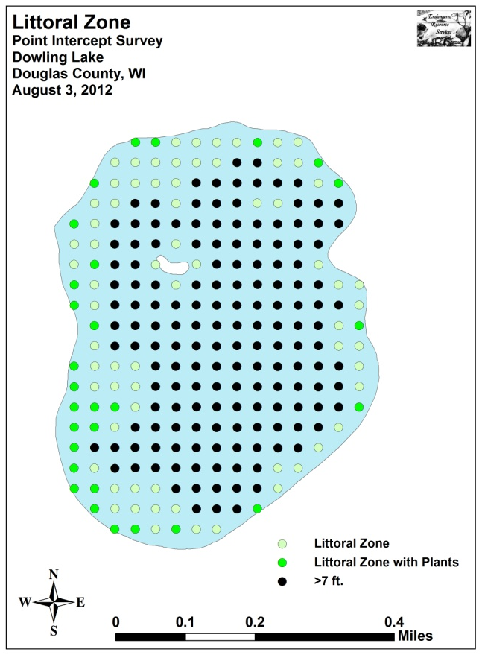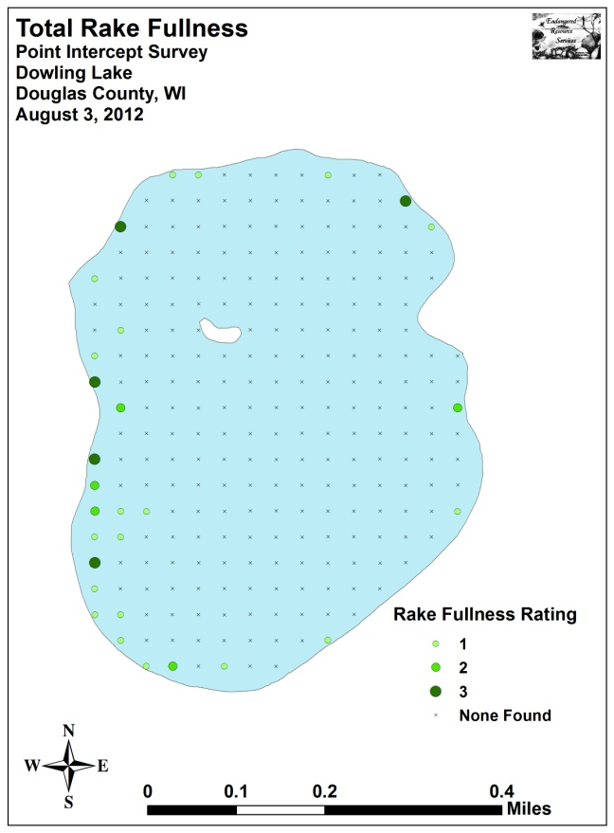
Figure 3: 2012 Littoral Zone and Total Rake Fullness

As in 2012, we did NOT find Northern wild rice present anywhere on the lake; however, we noted the overall emergent community continues to be both rich and diverse. With so few plants anywhere in the lake, these beds are likely important fish habitat; especially during spawning. Dominated by Hardstem bulrush (Schoenoplectus acutus), Creeping spikerush (Eleocharis palustris), and Pickerelweed (Pontederia cordata), the emergents seldom extended more than 10 meters from shore making it unlikely they would interfere with navigation (Figure 4). Even when docks occurred within the beds, regular boat traffic appeared to be keeping navigation channels open (Figure 5).

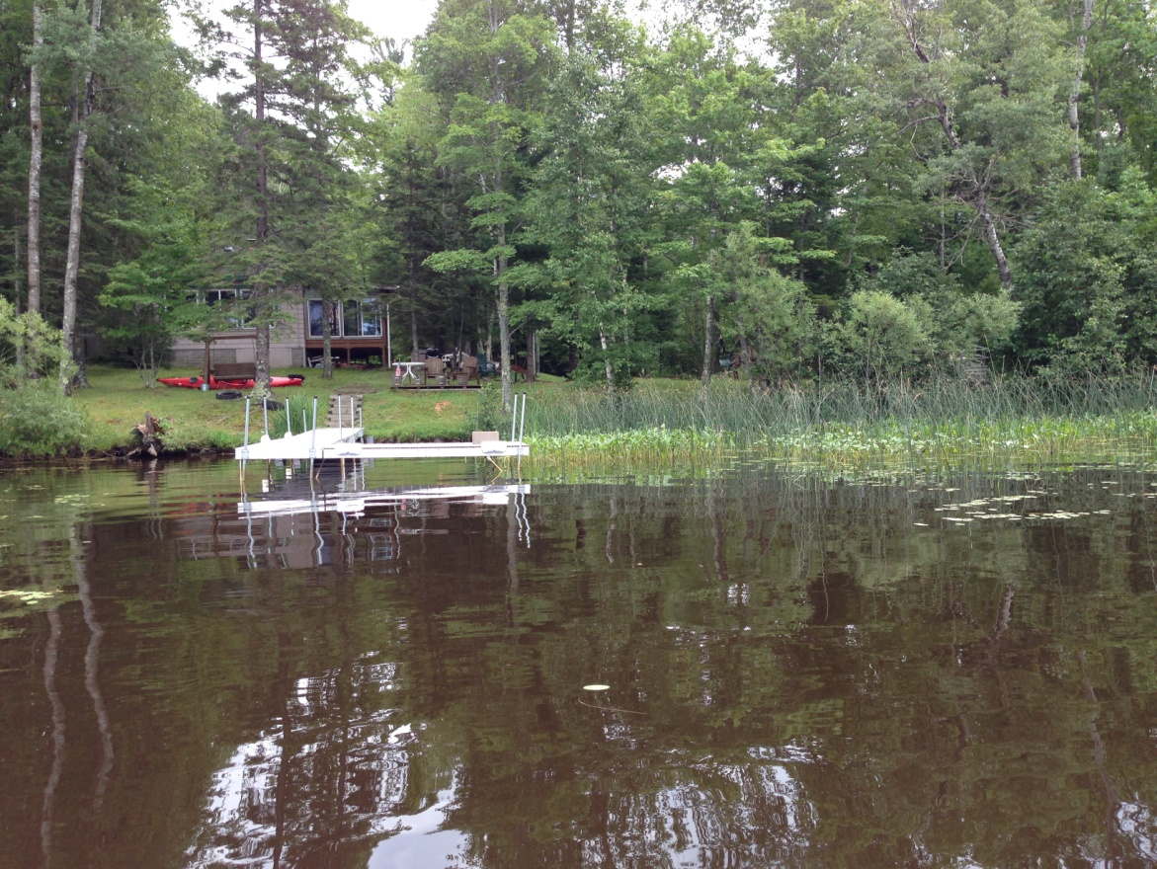
Figure 4: Typical Narrow Emergent Community

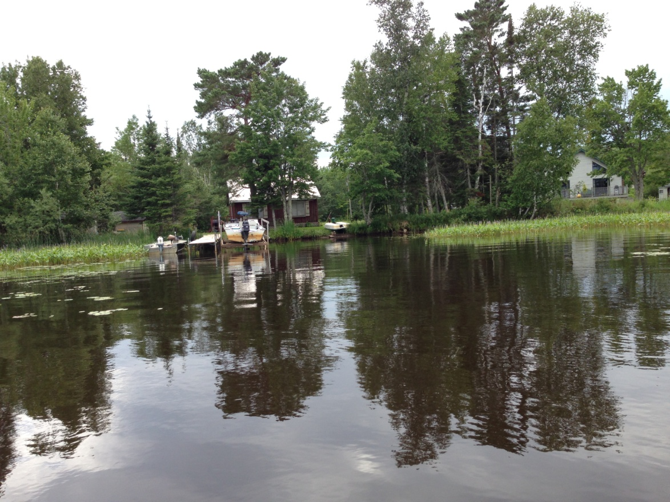
Figure 5: Regular Boat Traffic Maintaining Navigation Channels
The floating-leaf community tended to have low richness and diversity. Throughout much of the lake, scattered Watershield (Brasenia schreberi), Spatterdock (Nuphar variegata), and Floating-leaf bur-reed (Sparganium fluctuans) occurred as isolated clusters or in small patches that grew in a narrow band just beyond the emergents. The only exception to this was along the western shoreline where beds stretched a few 10’s of meters to the east along shallow flats. Even here, boat traffic seemed to be having no problem keeping navigation channels open (Figure 6).

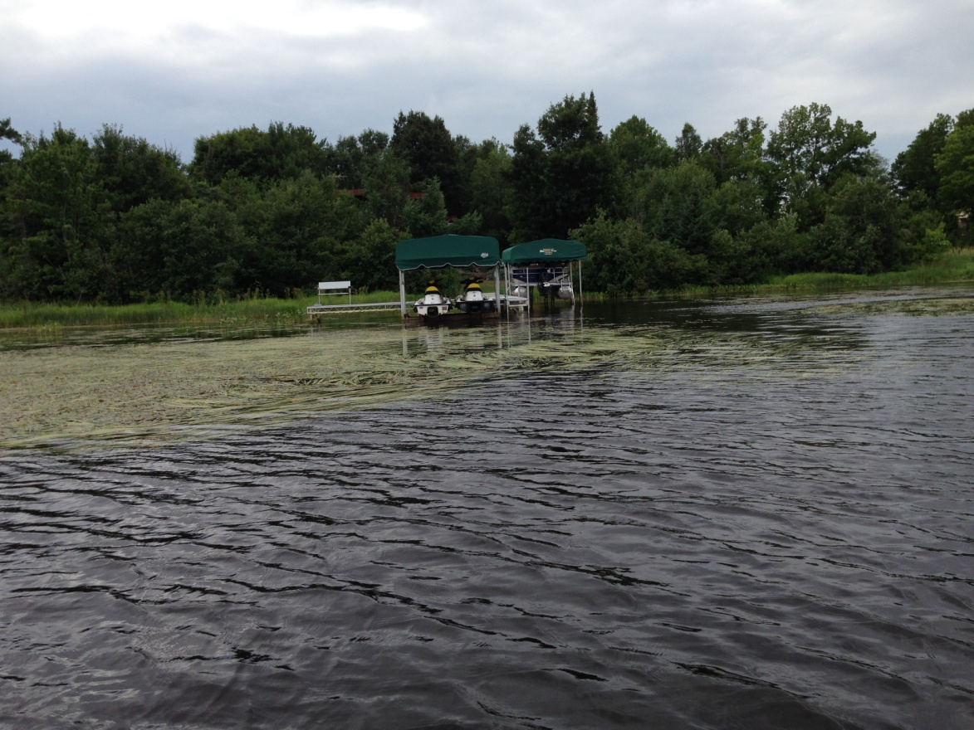
Figure 6: Densest Floating-leaf Area on the Western Shoreline

Aquatic Invasive Plant Species Survey:
We did NOT find any evidence of Eurasian water-milfoil or Curly-leaf pondweed. However, we again found Purple loosestrife (Lythrum salicaria) scattered near the boat landing, on the north and west sides of the lake (Figure 7), and in ditches through low areas on roads around the lake. In 2012, we noted that every loosestrife plant we examined showed extensive damage from Galerucella beetle (Galerucella spp.) herbivory (Figure 8); unfortunately, in 2016, we saw no evidence of beetle damage.

Yellow iris (Iris pseudacorus), a species we didn’t document in 2012, was present at seven locations scattered along the shoreline (Figure 9) (Appendix 1). It appeared to be spreading rapidly, and the worst areas occurred along the north and northeast shorelines (Figure 10).

The only other exotic species found on the lake was Reed canary grass (Phalaris arundinacea). This ubiquitous wetland species was present in limited numbers on the northeast shoreline and near the public boat landing. It was generally much less common than the native and very similar looking Bluejoint (Calamagrostis canadensis) (Figure 11).

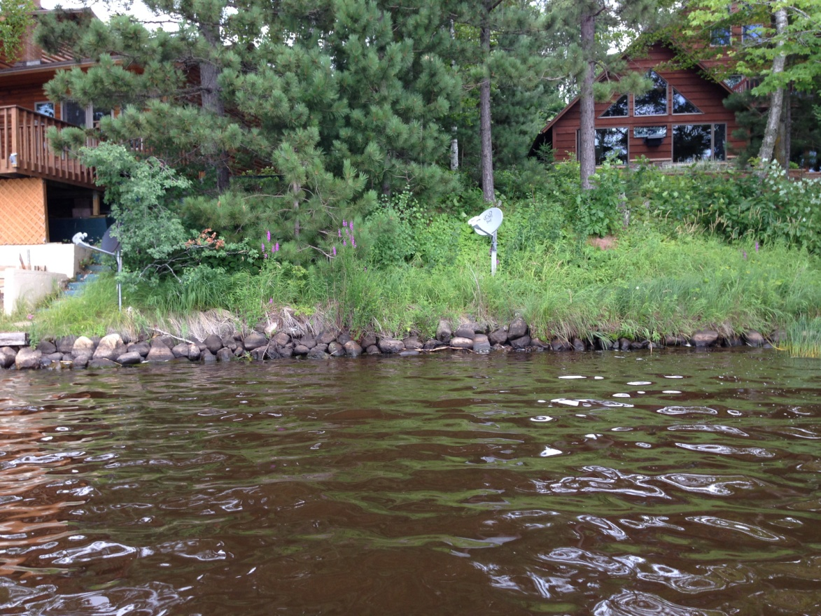
Figure 7: Purple Loosestrife Along the North Shore

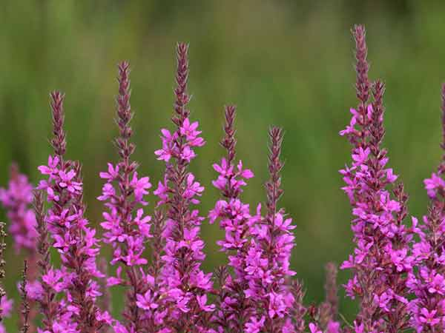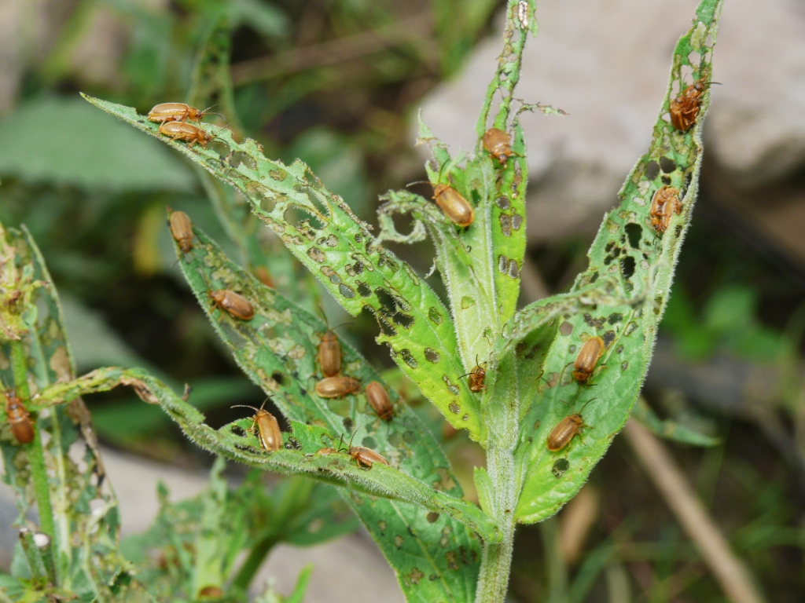
Figure 8: Purple loosestrife and Galerucella Beetles

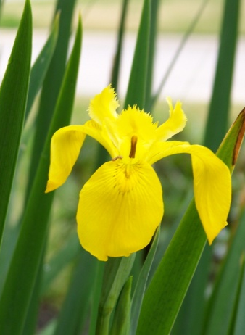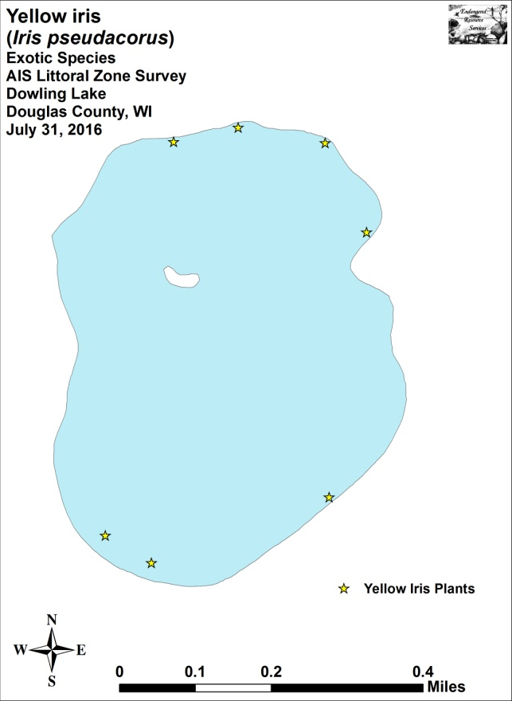
Figure 9: Yellow Iris Distribution 7/31/16

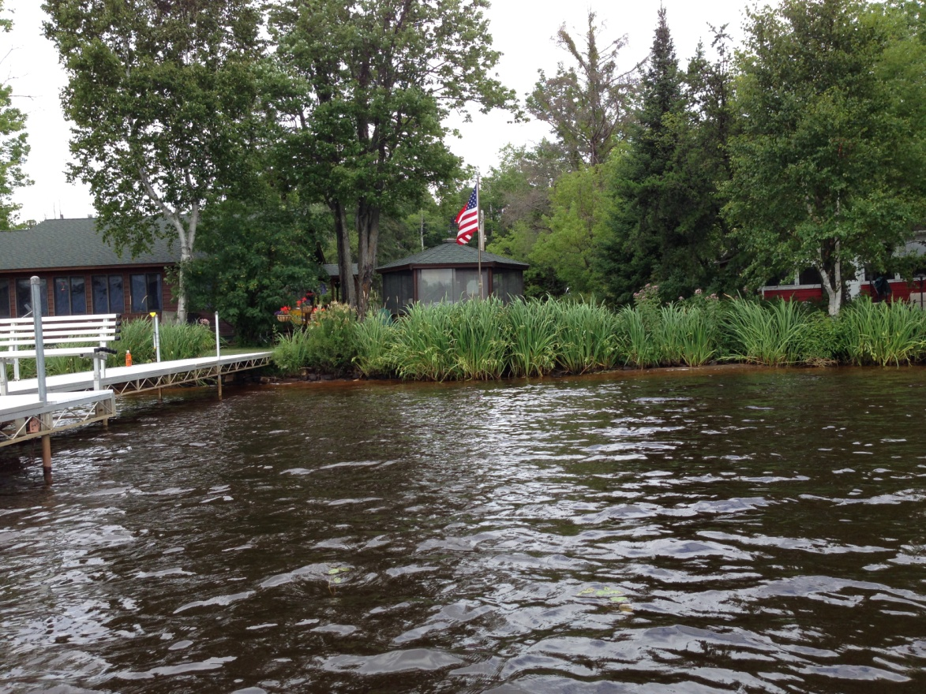
Figure 10: Dense Yellow Iris Along the Northeast Shoreline 7/31/16
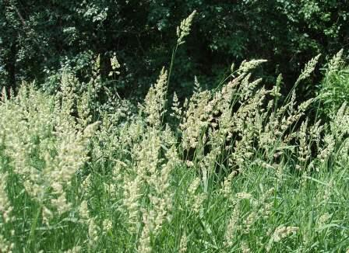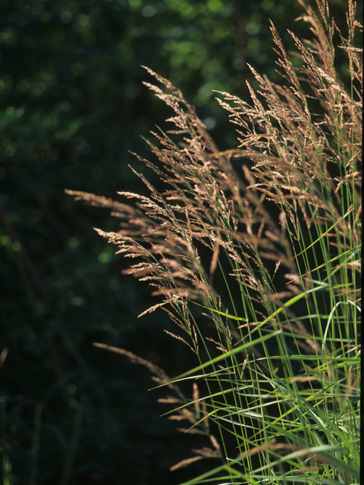
Figure 11: Exotic Reed Canary Grass and Native Blue Joint Grass

DISCUSSION AND CONSIDERATIONS FOR MANAGEMENT:
Purple Loosestrife:
Although Purple Loosestrife is widely established in the greater Tri-Lakes area, it is still not especially common along the Dowling lakeshore. Unfortunately, it seems the Galerucella beetle population which was apparently keeping the plants in check has, at least temporarily, crashed. Because of this, residents are encouraged to remove any loosestrife plants they find, bag them to prevent seed dispersal, and dispose of them well away from the lake or any other wetland. August and September are the best times to do this as the bright fuchsia candle-shaped flower spikes are easily seen. Because the plants have an extensive root system, care should be taken to remove the entire plant as even small root fragments can survive and produce new plants the following year.

Yellow Iris:
The presence and apparent rapid spread of Yellow iris on Dowling Lake is troubling. Because no biological control agents currently exist for Yellow iris, we STRONGLY encourage residents to eliminate plants on their property before a minor problem becomes a significant one. As with Purple loosestrife, plants should be bagged to prevent seed dispersal, and disposed of well away from the lake. June is the best time to look for this iris as the bright yellow fleur-de-lis are most common at this time. At other times of the year when it is not in bloom, its leaves could be confused with Northern blue flag (Iris versicolor) – a native and non-invasive species.

LITERATURE CITED

Ginder, T., C. Busch, G. Lund, and L. Sather. [online]. 1971. Dowling Lake Bathymetric Map. http://dnr.wi.gov/lakes/maps/DNR/2858300a.pdf (2012, August).

WDNR. [online]. 2016. Wisconsin Lake Citizen Monitoring Data for Dowling Lake, Douglas County. Available from http://dnr.wi.gov/lakes/CLMN/Station.aspx?id=163091 (2016, December).

WDNR. [online]. 2009. Wisconsin Lakes. PUB-FH-800 2009. Available from http://dnr.wisconsin.gov/lakes/lakebook/wilakes2009bma.pdf (2016, November).

Appendix I: Yellow Iris GPS Coordinates

ID Latitude Longitude
1 46.47130 -92.04175
2 46.46996 -92.04660
3 46.47046 -92.04789
4 46.47800 -92.04629
5 46.47830 -92.04452
6 46.47805 -92.04211
7 46.47637 -92.04091

