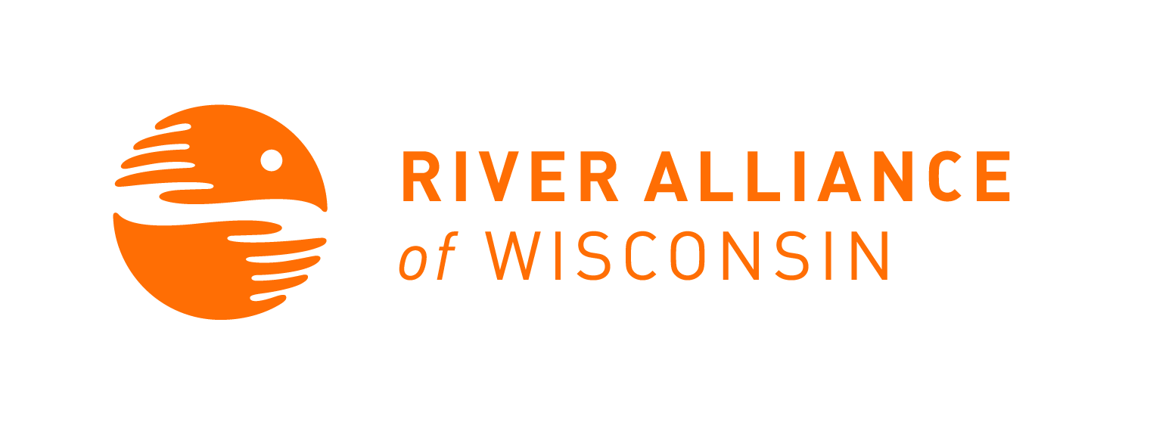
Project RED Sign In

Workshop Location: Online; Sierra Club |  |  | Date: October 27, 2020
Workshop host: Patrick Wilson, Sierra Club | Trainer(s): Ellen Voss | Workshop Start and End times: 7-8:30pm
Please Print and fill out sheet completely. We need all the information on this sheet to adequately track volunteers and assessing monitoring locations.

Volunteer Name | Email Address | River Monitored/Requested
Patrick Wilson | pbwilson@centurytel.net
Bobbie Wilson | pbwilson@centurytel.net
Cathy Van Maren | cvanmaren@protonmail.com
Kathy Allen | KK0427@live.com
Nora Woodworth
Meg Storkamp
Sue O'Brien | sueob1@gmail.com
Barb Nagel | bnagel@winona.edu
Carol Brewton | cbrewton@hbci.com
Erin H
Todd Huffman | todd.huffm@gmail.com
Rick K
Denise
Nancy Melin
John N
Linda Runstrom

