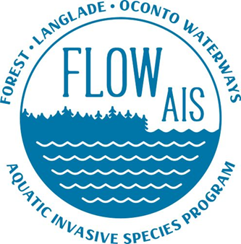

LCWA Meeting on 5/18/2022

- Purple loosestrife rearing supplies have been acquired. Plants will be grown at my house this year. Sawyer Lake in Langlade County will Receive around 5 plants for a bio control project. Digging begins next week with the Wisconsin Headwaters Invasive species Partnership (also of lumberjack RCD) and Oneida County AIS

- Snapshot Day is August 20th. Katie is the site leader for Langlade County. If your lake is interested in participating, please let her know so she can register your lake to be involved by June 3rd. See prompt about snapshot day I gave to Katie.

- FLOW AIS has a field season Kick off meeting planned with Katie on Monday the 23rd to talk about educational events and field monitoring sites

- FLOW AIS newsletter sign up. If anyone would like to receive the newsletter . email me and I will add you to the list. The last newsletter came out in April. The Nest one will be out in late July. These come out quarterly jun January, April, July, and October.

- Any interest in Citizens Lake Monitoring Network email me. (Perch Lake has expressed interest)

  - Deep woods lake hasn’t been monitored since 2007
  - Pickerel Crane hasn’t been monitored since 2010
  - White Lake has been monitoring since 2000….Way to go
  - Rolling Stone has been monitoring since 1987 as part of a long trend lake study

- If any Lake Association would like to talk about applying for a Clean Boats Clean Waters grant for the year 2023 email me and we can get a meeting set up. (There are no CBCW programs in Langlade County for 2022)

  - 200 hours need to be complete per landing
  - Lake associations need to be eligible to apply for grants (I can get you pointed in the right direction of you are not eligible)
  - CBCW grants are not competitive (you will get them if you apply)
  - Works well with volunteers or interns

- If anyone spots invasives in their lake or purple loosestrife let me know and I can look into it further

FLOW AIS website is: https://lumberjackrcd.org/flow-ais-program

Glad to have you all back in the area. I am looking forward to seeing everyone at the next meeting.

