Co Courthouse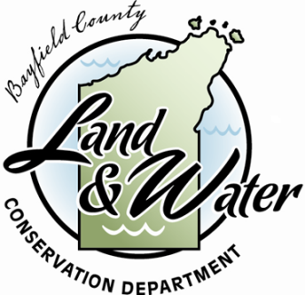

**Bayfield County**

**Aquatic Invasive Species Project**

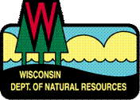

**AIS Control Grant #AEPP-483-16**

October 1, 2016 – December 31, 2016

**Progress Report**

Prepared January 2017

Prepared by:

Andrew Teal –Aquatic Invasive Species Project Coordinator

Bayfield County Land & Water Conservation Department

**Project Title:** Bayfield County Aquatic Invasive Species Project February 2016-June 2019

**Housed under the:**

**Bayfield County Land & Water Conservation Department**

County Conservationist- Ben Dufford

Support Staff- Arianna Austin

Land Use Technician- Travis Tulowitzky

Northwoods CWMA Coordinator- Adam Haecker

**Aquatic Invasive Species Committee**

Chair - Nan Olson-Long Lake Property Owners Association President

Vice Chair- Jim Krueger-Town of Namakagon Supervisor

Jeremy Oswald-County Board Supervisor

William Bussey- County Board Supervisor

Mike Defoe-Red Cliff Natural Resource Dept. Assistant Fisheries Biologist

Sarah Boles-Northern Native Plantscapes Owner, Citizen Member

Sally Pease-Clean Boats Clean Waters Coordinator, Citizen Member

**Land Conservation Committee**

Chair - Dennis Pocernich-County Board Supervisor

Vice Chair- Fred Strand-County Board Supervisor

William Bussey-County Board Supervisor

Larry Fickbohm-County Board Supervisor

Becky Anderson-FSA Representative

Peter Tetzner-Citizen Member

“And I would have infested that lake too, if it hadn’t been for you meddling kids!” –Milfoil Man

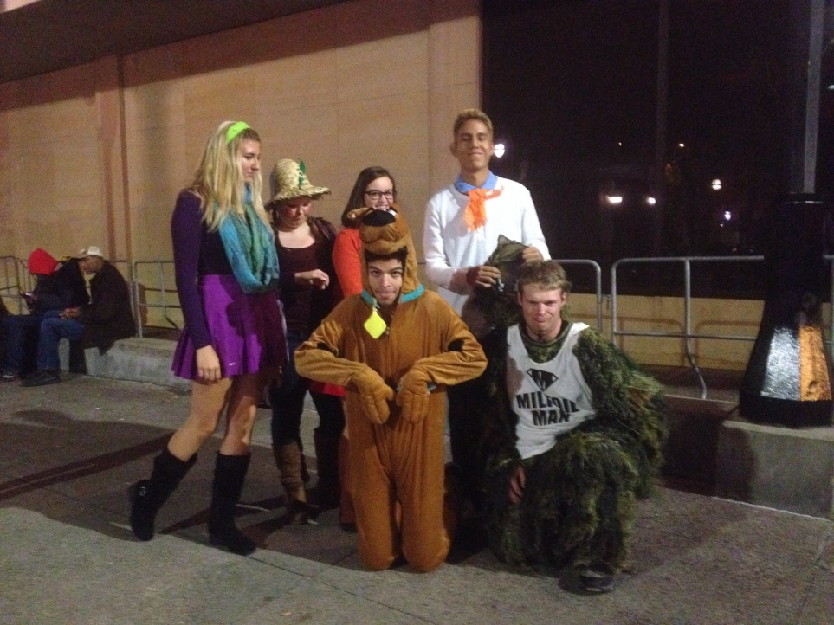

***2016 Bayfield County AIS Efforts***

This report will be shorter than normal, as it only covers 1 October-31 December 2016. Highlights of Fall 2016 include collaborating on and implementing the final Invasive Species ID Day at the Northern Great Lakes Visitor Center for the season and collaborating on ideas for approaching zebra mussel education/management in northwest Wisconsin. We partnered on some control work, serving as a central contact for the Lake Namakagon hybrid watermilfoil project. We have also provided AIS information and technical guidance regarding the Diver Assisted Suction Harvester (DASH) to the Town of Barnes. They have been working on an AIS Established Population Control grant, with guidance from us (Bayfield County) and the DNR. With these relationships in place, we can continue to establish and accomplish these new goals in the upcoming year with our newest AEPP grant.

**Goal A: Improve AIS Education and Outreach Efforts**

* Co-hosted our final monthly Invasive Species ID Days (ISIDD) in October at the Northern Great Lakes Visitor Center. We partnered with the NCWMA, U.S. Forest Service, Master Gardeners, Bad River Band of Lake Superior Chippewa, and the National Park Service. We focused on middle school students for October’s event, the Student Science Research Symposium. Our goal was to provide them with the opportunity to present and share what they have learned and done in class with other students of the same age, to protect natural resources, and prevent the spread of invasive species. We had the students rotate between four stations: fly tying, leaf printing, live bats (handled by a professional), and a tour/collection in the native seed orchard. We wove information about invasive species and the prevention message into these activities. A total of 54 students and 4 teachers attended, and all of them praised the event.
* Attended the Upper Midwest Invasive Species Conference in La Crosse, WI in mid-October. The presentations were so amazing! This was my first time attending, and I was glad I could volunteer to cover registration costs. I even won an UpRooter as a door prize!
* Dramatically increased the local recognition of Milfoil Man, his new archrival Weevil Knievel (thank you Paul and Allie Skawinski for the idea!) and their newest costumed companions: Garlic Mustard, Zeke the Zebra Mussel, Emma the Emerald Ash Borer, and Gypsy Moth Adult & Caterpillar. A special thank you to regional artist Anna Carlson for designing and creating these new costumes!

**Goal B: Assess the AIS presence/absence in Bayfield County Water Resources and plan management of any AIS present.**

* Partners helped survey twelve lakes in Bayfield County this year. The AIS Coordinator worked with the WI DNR Lake Superior Basin AIS Early Detection/Rapid Response Coordinator, DNR personnel, Northland College, and interns with Bayfield County. We also worked with consultants Dale Dressel, Onterra, LLC , and Endangered Resource Services, LLC to survey these lakes. Some lakes where management is occurring had point intercept (PI) and SCUBA surveys.

|  |  |
| --- | --- |
| **Lakes and Rivers Surveyed** | **AIS Detected** |
| Lake Owen*(shoreline meander) | Chinese Mystery Snails (CMS), Yellow Iris (YI)** |
| George Lake | None (known to have Eurasian Watermilfoil (EWM), but it has not been observed since treatment in 2012) |
| Middle Eau Claire Lake (SCUBA)* | Banded Mystery Snails (BMS), Curly-leaf pondweed (CLP), Rusty crayfish (RC) |
| Upper Eau Claire Lake (SCUBA)* | CMS, CLP, RC |
| Tomahawk Lake (SCUBA) | EWM |
| Sandbar Lake (SCUBA) | EWM |
| Lake Wilipyro (shoreline meander) | None |
| Lake Namakagon (shoreline meander) | Hybrid watermilfoil, CMS, PL |
| Iron Lake (shoreline meander) | YI (landowners say it has been present for decades but has not spread; downstream suggests otherwise) |
| Pike Chain-Buskey Bay, Hart, Millicent, Twin Bear-Lakes (PI surveys, snorkeling) | EWM, CMS, BMS, PL, RC |
| Iron River (short stretch of USFWS conservation easement) | CLP |
|  |  |

*Priority Waterbody as designated by Bayfield County AIS Strategic Plan

**New Discoveries

* Completed the review and update of the Bayfield County AIS Strategic plan, approved by the County AIS Committee and County Board, and posted to the LWCD page on County website
* Worked with Lake Namakagon to provide technical guidance and input for their Early Detection/Response grant and coordinate hand pulls for hybrid watermilfoil
* Worked with the Town of Barnes to provide technical guidance and input for their AIS Established Population Control grant proposal for EWM on Tomahawk, Sand Bar, and George Lakes. We also worked with them to create a diver assisted suction harvester work plan.
* The Pike Chain of Lakes Association received a grant to conduct full lake treatments on four of their lakes (2016 was for surveys and hand pulling/limited mechanical removal only, 2017 & 2018 are the treatments)

**Goal C: Track locations, control work, and spread of AIS**

* Reported new Yellow Iris, Purple Loosestrife and Japanese/Giant knotweed sites via Great Lakes Early Detection Network App.
* Through partnership with the Northwoods Cooperative Weed Management Area, maintained knotweed spreadsheets for tracking control dates and methods, landowner information, and population locations
* Served as a central contact for the hybrid watermilfoil control project on Lake Namakagon; led the hand pulling on one late-season manual removal event, attended a meeting regarding early detection/rapid response, obtained materials for the first of three stakeholder meetings to help guide Lake Namakagon’s Aquatic Plant Management Plan process.
* Provided guidance in hand pulling control efforts of curly-leaf pondweed on the Eau Claire Chain of Lakes

**Goal D: Maintain and Expand Partnerships**

* The Invasive Species ID Days remained popular this year, and we added partners. Our partners with the Friends of the Eau Claire Lakes Area and the Bad River Band of Lake Superior Chippewa joined us in 2016. In 2017, we will expand the events and partnerships to include UW-Extension, UW-Sea Grant, WI Master Naturalists, and possibly the Bad River Watershed Association. We would like to have guest speakers from other organizations, wear costumes, create family-friendly activities and run the event from May-October, too.
* Adam Haecker (Northwoods Cooperative Weed Management Area Coordinator) has attended AIS Committee meetings and provided reports.
* Participated in conversations with DNR and NCWMA about Best Management Practices and concerns over continued use of herbicide as a form of invasive species control
* Partnered with the NCWMA, Bayfield Regional Conservancy, and National Park Service to educate in Bayfield while hand pulling invasive plants with the Sea Scouts in the rain gardens
* Continued partnership with the St. Croix River Association by sharing updates/ideas and attending meetings

***Other accomplishments***

The reports prepared for the Bayfield County AIS Committee and Land Conservation Committee have been included with this document. These reports list other activities the AIS project has done in support of this grant and the Bayfield County AIS Strategic Plan. The minutes of the Bayfield County AIS committee are also included to provide further information on the AIS planning efforts in Bayfield County. We worked in partnership with the Northwoods CWMA to put on Invasive Species ID Day events from May-October, and I have included fliers and photos from these events. The Ashland Daily Press wrote a number of articles about our activities in summer 2016, which are also included.

*Of note, the counties with WI Lake Superior shoreline took a beating from Mother Nature in 2016. We faced unprecedented flooding, and a violent windstorm combined with the hottest heatwave of 2016. This affected site accessibility, safety, and fieldwork for several weeks. We are also concerned about how the seed bank and fragments of invasive plants have moved around. Our partners are also concerned about how new, albeit temporary, water connectivity changed the distribution of other invasive species.

**AIS ACTIVITIES 15 September 2016—30 November 2016** LCC /AISC

**Grant Updates**:

* *County AIS Project grant* 
  + WI DNR 2014-2015 AIS Education, Prevention, and Planning (AEPP) Grant has $0.00 remaining. We will not seek an extension for it, and final report compiling has commenced.
  + The new 2016-2018 WI DNR Aquatic Invasive Species Education, Prevention, and Planning grant has $127,075.25 remaining. This grant will extend the AIS Coordinator position out to 2018.
* *County CBCW Iron River & Delta Area grant* 
  + This grant is used up. An incredible amount of match has come in this year. We have a conservative $8,000 in match, possibly more when I finalize the match workbook.
* *Lake Superior CBCW Grant*
  + We will apply for another grant for 2017; however, I would like feedback about how much to apply for. Two interns on four landings was a big challenge, but even if we get more interns, the NCWMA has boat wash funds it can and would like to use. Would also like to improve waterfowl hunter outreach using information learned at the statewide AIS Coordinators meeting

**Outreach/Workshops**:

* September 20th—LEEP Field Day in Barnes
* September 30th—LEEP Wrap Up Day in Drummond
* October 12th—Student Science Research Symposium (Invasive Species ID Days event) at the NGLVC. This event was a huge success with students and teachers alike.

**Meetings/Trainings:**

* September 27th—Chequamegon Bay Area Partnership project priorities meeting at SOEI
* October 1st—Namakagon Lake Association meeting; Iron Lake Association meeting (gave a talk about local things that I noticed at the lake)
* October 3rd—Training webinar for UMISC volunteering
* October 4th—Monthly LYNC meeting/conference call
* October 14th—LCC Fall Tour in Bayfield County
* October 24th—Lake Namakagon ED/RR grant meeting at Namakagon Community Center
* October 25th—Northwest WI AIS Coordinators meeting in Spooner
* November 9th—NCWMA meeting at the NGLVC
* November 15-16th—Statewide AIS Coordinators meeting at George W. Mead Wildlife Area

**Other Events/Activities**:

* September 15th—Giant knotweed treatment at Herbster Beach Resort
* September 22nd —Lake Namakagon hybrid watermilfoil hand pulling at Lakewoods Resort
* September 28th—Curly-leaf pondweed hand pulling in the Iron River; visual survey of Iron Lake for invasive plants
* October 16-19—Upper Midwest Invasive Species Conference in La Crosse

**Future Events/Activities:**

* December 1st—SCRA General Team Meeting at William O’Brien State Park; Big McKenzie Lake Zebra Mussel Public Information Meeting in Spooner
* December 5th—Meetings in Barnes and Namakagon for AIS grant writing (December 10th is the deadline)
* December 15th—Webinar for Bait Dealer Outreach