Curly-leaf Pondweed (Potamogeton crispus) and
Eurasian Water-milfoil (Myriophyllum spicatum) Pre/Post Herbicide and Fall EWM Bed Mapping Surveys
Little Trade Lake – WBIC: 2639300
Burnett County, Wisconsin

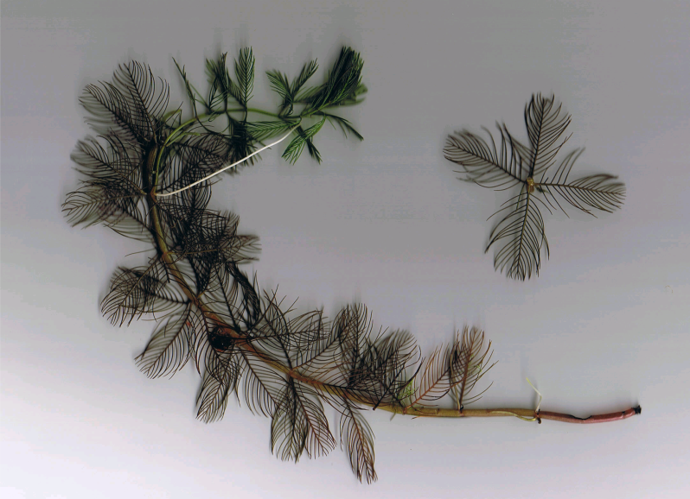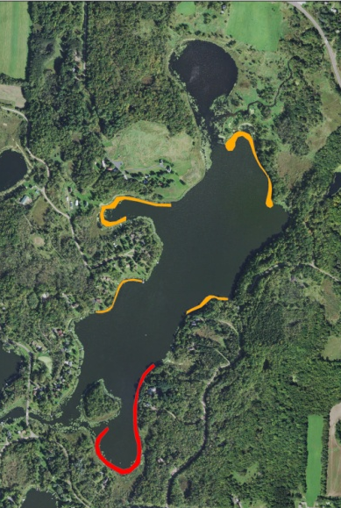
Eurasian water-milfoil (Berg 2007) 2018 CLP/EWM Final Treatment Areas
Project Initiated by:
Round-Trade Lakes Improvement Association Inc., Lake Education and Planning Services, LLC, and the Wisconsin Department of Natural Resources
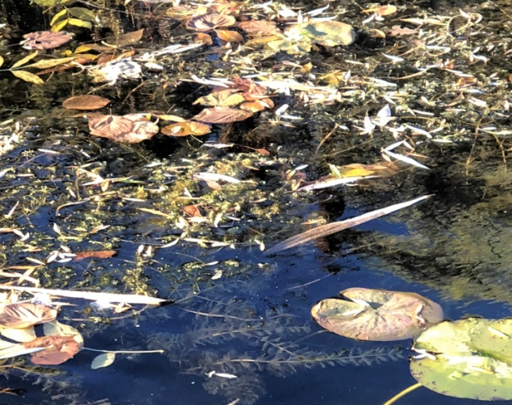
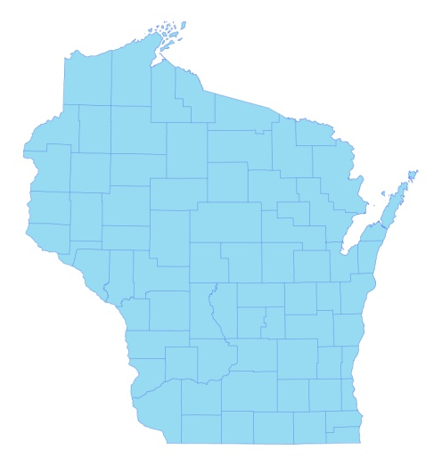

* Little Trade Lake

Canopied EWM Plant (10/17/18)

Surveys Conducted by and Report Prepared by:
Endangered Resource Services, LLC
Matthew S. Berg, Research Biologist
St. Croix Falls, Wisconsin
May 19, June 25, and October 17, 2018
TABLE OF CONTENTS

Page
LIST OF FIGURES.………………..……..………………………………………………... ii

LIST OF TABLES…………………..……..……………………………………………….. iii

INTRODUCTION.……….…..……..……………………………………………………… 1

BACKGROUND AND STUDY RATIONALE…..……………………………………….. 1

METHODS……………………………………………………………….………………… 2

RESULTS AND DISCUSSION……………………………………………………………. 3

Finalization of Treatment Areas………………………………………………….…. 3

Pre/Post Herbicide Surveys…...………………………..……………………….…... 4

Fall Eurasian Water-milfoil Bed Mapping Survey…………………………….……. 13

Descriptions of Current and Former Eurasian Water-milfoil Beds…………………. 15

LITERATURE CITED……….……………………….……………………………………. 16

APPENDIXES……….…….………………………………………………….……………. 17

I: Survey Sample Points and Treatment Areas…………………………………………. 17

II: Vegetative Survey Datasheet...………………………………………………………. 20

III: Pre/Post Habitat Variable Maps………………………………………………………. 22

IV: Pre/Post Littoral Zone, Native Species Richness and Total Rake Fullness.………..… 25

V: CLP and EWM Pre/Post Density and Distribution.…………………………….…...... 32

VI: Pretreatment Native Species Density and Distribution…...………………………...... 37

VII: Posttreatment Native Species Density and Distribution…...……………………….... 47

VIII: Fall 2017 and 2018 EWM Bed Maps……….……………………………………….. 58

LIST OF FIGURES

Page
Figure 1: 2018 CLP/EWM Treatment Areas…….………………………………………… 1
Figure 2: Rake Fullness Ratings……………………………….…….…………………….. 2
Figure 3: 2018 Survey Sample Points and Final Treatment Areas………………………… 3
Figure 4: Treatment Area Depths and Bottom Substrate….………..……………………… 4
Figure 5: Pre/Post Littoral Zone.…………..…………………………..…………………… 5
Figure 6: Pre/Post Native Species Richness……………………………………………….. 6
Figure 7: Pre/Post Total Rake Fullness…………………………………………………….. 6
Figure 8: Pre/Post CLP Density and Distribution………….…………………………….… 7
Figure 9: Pre/Post Changes in CLP Rake Fullness….….………………………………….. 7
Figure 10: Pre/Post EWM Density and Distribution………….…………………………… 8
Figure 11: Pre/Post Changes in EWM Rake Fullness…..…………………………………. 8
Figure 12: Pre/Post Coontail Density and Distribution..……………………………..……. 9
Figure 13: Pre/Post Common Waterweed Density and Distribution..……...……………… 9
Figure 14: Pre/Post Macrophyte Changes…………………..……………………………... 12
Figure 15: 2017 and 2018 Fall EWM Bed Maps….…………………………..….…….….. 13

LIST OF TABLES

Page
Table 1: Spring CLP and EWM Treatment Summary –
Little Trade Lake, Burnett County – May 29, 2018…….…………..…………………..….. 3

Table 2: Pre/Post Surveys Summary Statistics –
Little Trade Lake, Burnett County – May 19 and June 25, 2018.………………………….. 4

Table 3: Frequencies and Mean Rake Sample of Aquatic Macrophytes
Pretreatment Survey - Little Trade Lake, Burnett County - May 19, 2018..……………….. 10

Table 4: Frequencies and Mean Rake Sample of Aquatic Macrophytes
Posttreatment Survey - Little Trade Lake, Burnett County - June 25, 2018……………….. 11

Table 5: Fall Eurasian Water-milfoil Bed and High Density Area Mapping Summary –
Little Trade Lake, Burnett County – October 17, 2018…………………………………….. 14

INTRODUCTION:
Little Trade Lake (WBIC 2639300) is a 126 acre drainage lake in southwest/south-central Burnett County, Wisconsin in the Town of Trade Lake (T37N R18W S21 SW SW). It reaches a maximum depth of 19ft in the central basin and has an average depth that is approximately 9ft (the DNR’s stated depth average of 15ft combined depth data from Big Trade and Little Trade Lakes) (WDNR 2018). The lake is eutrophic in nature with Secchi disc readings from 2000-2018 ranging from 2.0-4.5ft and averaging 3.2ft (WDNR 2018). This very poor water clarity produced a littoral zone that extended to approximately 9ft in 2018. The bottom substrate is predominately organic muck with scattered gravel and sandy areas along the shoreline and around the island (Bush et al. 1968).
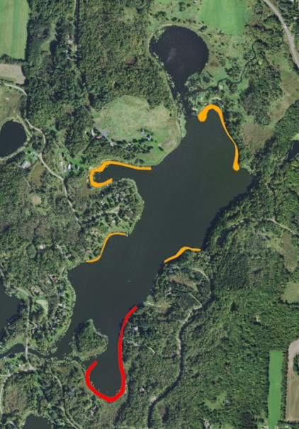
Figure 1: 2018 CLP/EWM Treatment Areas
(Red – Diquat/Orange – 2,4-D and Endothall)

BACKGROUND AND STUDY RATIONALE:
In 2009, the Wisconsin Department of Natural Resources (WDNR) confirmed the presence of Eurasian water-milfoil (EWM) (Myriophyllum spicatum) in Little Trade Lake. Following the development of a WDNR approved Aquatic Plant Management Plan (APMP) that outlined strategies to control EWM and Curly-leaf pondweed (Potamogeton crispus) (CLP), another invasive exotic species that dominates the lake’s spring littoral zone, the Round-Trade Lake Improvement Association, Inc. (RTLIA) began using manual removal and herbicide treatments to control these species.

To help cover the costs associated with management, in 2018, the RTLIA, under the direction of Dave Blumer (Lake Education and Planning Services, LLC - LEAPS), applied for and was awarded a WDNR Aquatic Invasive Species control grant (ACEI21618). These funds were used to chemically treat five areas totaling 6.70 acres (5.32% of the lake’s surface area) for EWM and CLP (Figure 1). On May 19th, we conducted a pretreatment survey to gather baseline data from these areas and to allow LEAPS/RTLIA to finalize treatment plans. After the May 29th herbicide application, we completed a June 25th posttreatment survey to evaluate the effectiveness of the treatment. We also conducted an October 17th EWM bed mapping survey to determine where control might be considered in 2019. This report is the summary analysis of these three field surveys.

METHODS:
Pre/Post Herbicide Surveys:
LEAPS provided treatment shapefiles, and we generated pre/post survey points based on the size and shape of the proposed areas that covered 12.20 acres. The requested 128 point sampling grid approximated to over 10pts/acre – just above the minimum of 4-10 pts/acre required by WDNR protocol for pre/post treatment surveys (Appendix I).

During the surveys, we located each point using a handheld mapping GPS unit (Garmin 76CSx) and used a rake to sample an approximately 2.5ft section of the bottom. All plants on the rake were assigned a rake fullness value of 1-3 as an estimation of abundance, and a total rake fullness for all species was also recorded (Figure 2). Visual sightings of EWM and CLP were noted if they occurred within 6ft of the point; however, visuals of other species were not recorded as they do not figure into the pre/posttreatment calculation. In addition to plant data, we recorded the lake depth using a metered pole and the substrate (bottom) type when we could see it or reliably determine it with the rake.

We entered all data collected into the standard APM spreadsheet (Appendix II). Data was analyzed using the linked statistical summary sheet and the WDNR pre/post analysis worksheet. For pre/post differences of individual plant species as well as count data, we used the Chi-square analysis on the WDNR pre/post survey worksheet (UWEX 2010). For comparing averages (mean species/point and mean rake fullness/point), we used t-tests. Differences were determined to be significant at p<0.05, moderately significant at p<0.01 and highly significant at p<0.001.

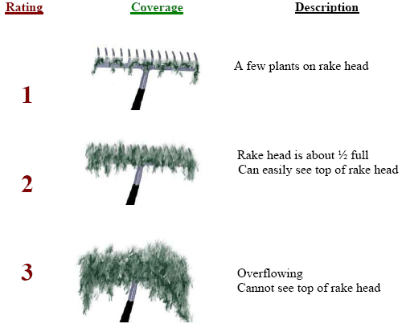
Figure 2: Rake Fullness Ratings

Fall Eurasian Water-milfoil Bed Mapping:
During the fall survey, we searched the entire visible littoral zone of the lake and mapped all known beds of EWM. A “bed” was determined to be any area where we visually estimated that EWM made up >50% of the area’s plants and was generally continuous with clearly defined borders. After we located a bed, we motored around the perimeter of the area, took GPS coordinates at regular intervals, and estimated both the range and mean rake fullness rating of EWM within the bed (Figure 2). Using the WDNR’s Forestry Tool’s Extension to ArcGIS 9.3.1, we plotted these coordinates to generate bed shapefiles and determine the acreage to the nearest hundredth of an acre. We also took waypoints of EWM plants outside these beds as they were generally few in number.
RESULTS AND DISCUSSION:
Finalization of Treatment Areas:
Initial expectations were to treat five beds for Curly-leaf pondweed and Eurasian water-milfoil using both liquid Endothall (Aquathol K) and 2,4-D (Shredder Amine 4) at concentration of 2ppm and 3ppm respectively (Figure 3) (Appendix III). Following the pretreatment survey, each polygon experienced a pull back from areas with low target species densities. This brought the total acreage down from 12.20 to 6.70, and, collectively, represented a 5.50 acres decline (-45.1%) from initial expectations (Table 1).

Northern Aquatic Services (Dale Dressel – Dresser) carried out the treatment on May 29th. The reported water temperature at the time of application was 72°F, the ambient air temperature was 75°F, and winds were out of the southeast at 3mph.

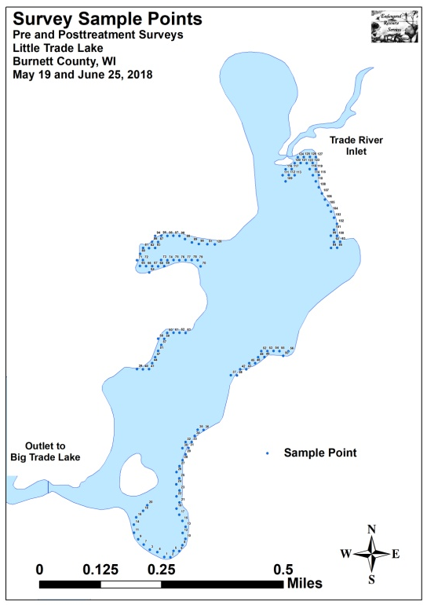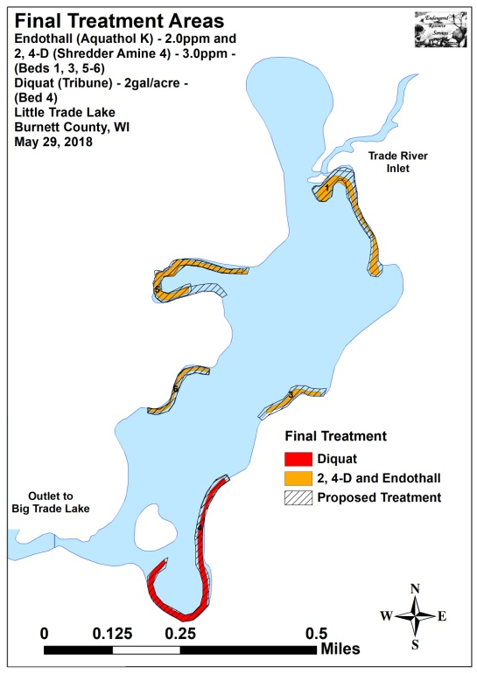
Figure 3: 2018 Survey Sample Points and Final Treatment Areas

Table 1: Spring CLP and EWM Treatment Summary
Little Trade Lake, Burnett County
May 29, 2018
Treatment Area | Proposed  Acreage | Final Acreage | Difference  +/- | Chemical(s) – Dosage – Total Gallons
1 | 3.00 | 1.58 | -1.42 | Endothall – 2ppm – 8.19gal./2,4-D – 3ppm – 13.46gal.
3 | 1.33 | 0.52 | -0.81 | Endothall – 2ppm – 2.77gal./2,4-D – 3ppm – 4.43gal.
4 | 3.57 | 2.59 | -0.98 | Diquat – 2gal/acre – 5.18gal.
5 | 3.10 | 1.53 | -1.57 | Endothall – 2ppm – 11.49gal./2,4-D – 3ppm – 13.04gal.
6 | 1.20 | 0.48 | -0.72 | Endothall – 2ppm – 2.84gal./2,4-D – 3ppm – 3.58gal.
Total Acres | 12.20 | 6.70 | -5.50

Pre/Post Herbicide Surveys:
All points occurred in areas between 1.0ft and 9.0ft of water. The mean and median depths of plant growth both declined slightly from 3.7ft/3.3ft respectively pretreatment to 3.5ft /3.0ft posttreatment (Table 2). Most Curly-leaf pondweed plants were established over thick nutrient-rich organic muck, while Eurasian water-milfoil was more common over sand and rock (Figure 4) (Appendix III).

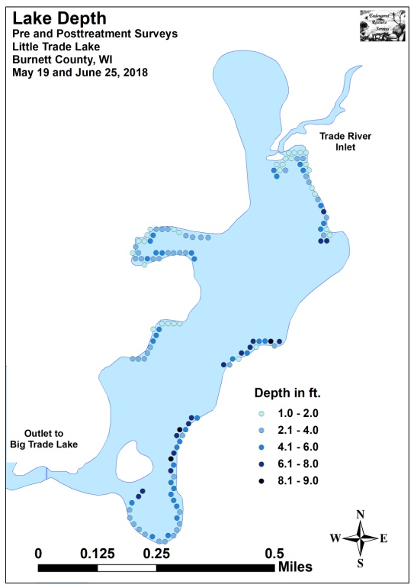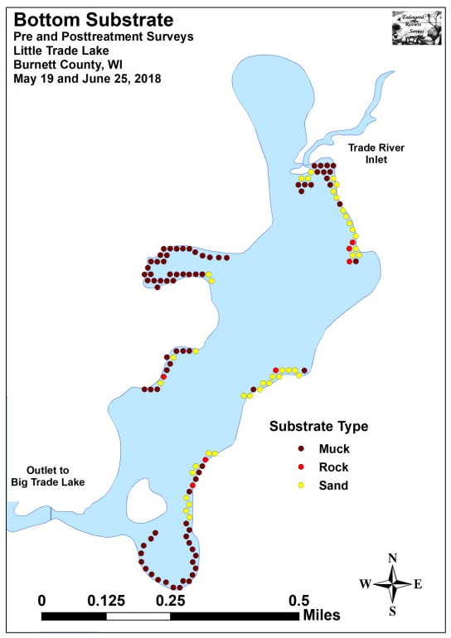
Figure 4: Treatment Area Depths and Bottom Substrate

Table 2: Pre/Post Surveys Summary Statistics
Little Trade Lake, Burnett County
May 19 and June 25, 2018
Summary Statistics: | Pre | Post
Total number of points sampled | 128 | 128
Total number of sites with vegetation | 118 | 110
Total number of sites shallower than the maximum depth of plants | 128 | 126
Freq. of occur. at sites shallower than max. depth of plants (in percent) | 92.2 | 87.3
Simpson Diversity Index | 0.68 | 0.81
Mean Coefficient of Conservatism | 5.3 | 4.8
Floristic Quality Index | 14.8 | 14.3
Maximum depth of plants (ft) | 9.0 | 8.5
Mean depth of plants (ft) | 3.7 | 3.5
Median depth of plants (ft) | 3.3 | 3.0
Average number of all species per site (shallower than max depth) | 1.77 | 2.25
Average number of all species per site (veg. sites only) | 1.92 | 2.58
Average number of native species per site (shallower than max depth) | 1.32 | 2.22
Average number of native species per site (sites with native veg. only) | 1.47 | 2.55
Species richness | 10 | 10
Mean rake fullness (veg. sites only) | 1.62 | 1.68
The littoral zone within the beds extended to 9.0ft during the pretreatment survey before dropping slightly to 8.5ft posttreatment. Similarly, the frequency of plant occurrence declined from 92.2% pretreatment to 87.3% posttreatment (Figure 5) (Appendix IV). Total richness was unchanged with ten species found during each survey. However, the Simpson’s Diversity Index jumped from a moderate pretreatment value of 0.68 to a high posttreatment value of 0.81. The Floristic Quality Index (another measure of native plant community health) fell from 14.8 pretreatment to 14.3 posttreatment.

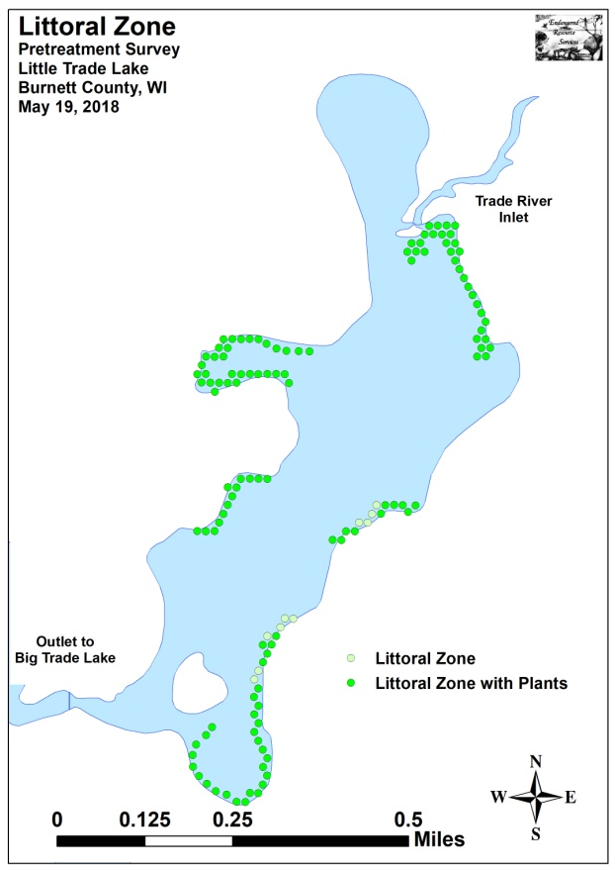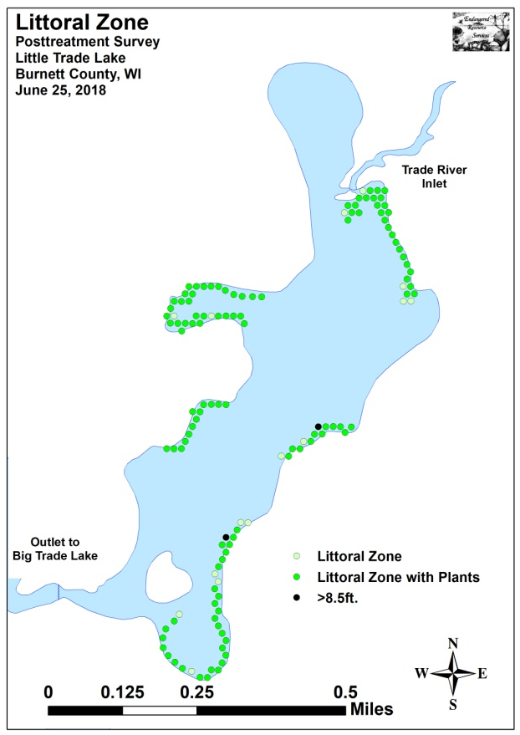
Figure 5: Pre/Post Littoral Zone

Mean native species richness at points with native vegetation increased sharply from 1.47 species/point pretreatment to 2.55 species/point posttreatment (Figure 6). Although this increase in localized richness was highly significant (p<0.001), it can largely be attributed to the rise in “duckweeds”. Total mean rake fullness experienced a non-significant increase (p=0.26) from a low/moderate 1.62 pretreatment to 1.68 posttreatment (Figure 7) (Appendix IV).
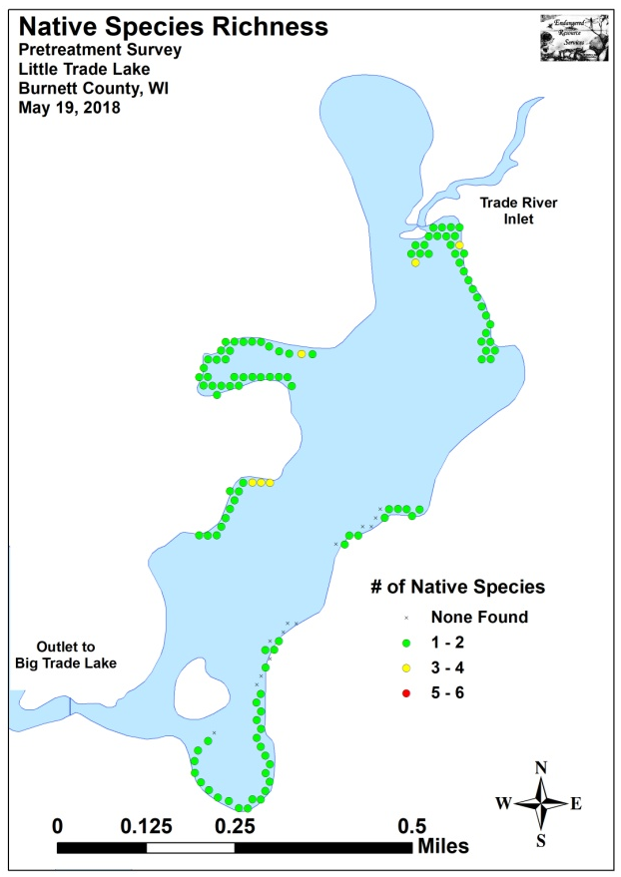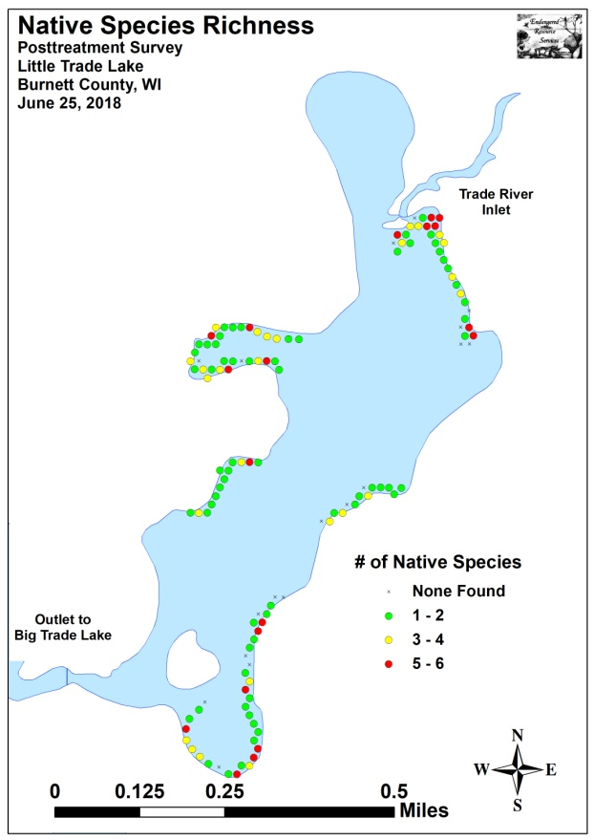
Figure 6: Pre/Post Native Species Richness

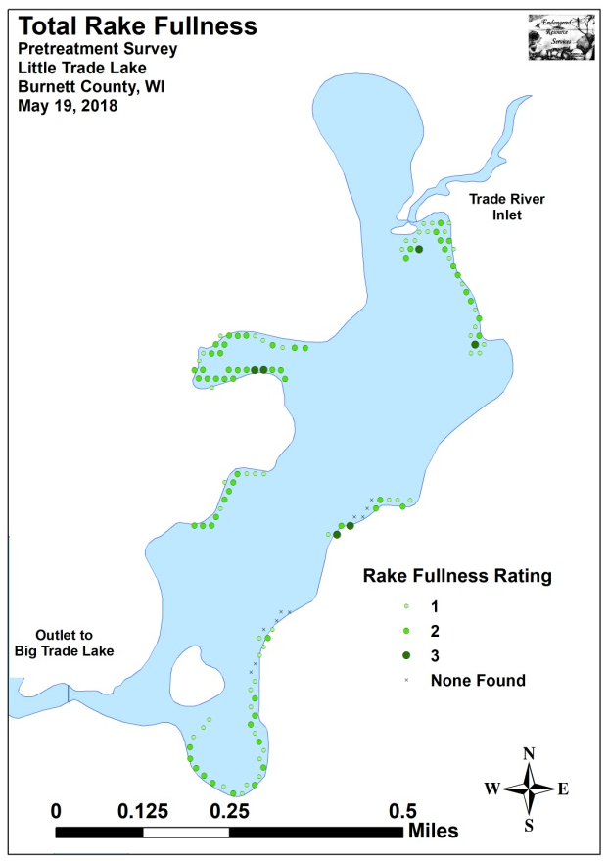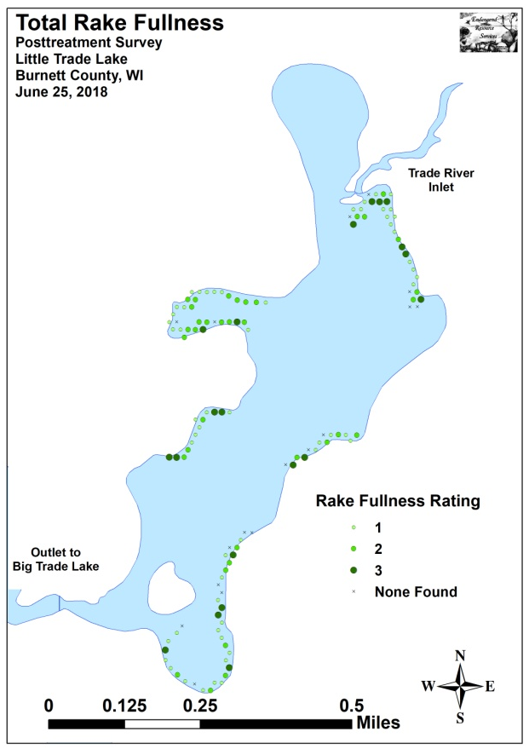
Figure 7: Pre/Post Total Rake Fullness

We found Curly-leaf pondweed at 54 of 128 sites during the pretreatment survey (42.2% coverage) (Figure 8). Of these, two had a rake fullness rating of 3, 12 rated a 2, and the remaining 40 were a 1. This produced a mean rake fullness of 1.30 and suggested that 10.9% of the proposed treatment areas had a significant infestation (rake fullness 2 and 3). During the posttreatment survey, we found CLP at just four points (3.2% coverage) all of which rated a 1. Our results demonstrated a highly significant decline in total CLP as well as rake fullness 2 and 1 (Figure 9) (Appendix V).
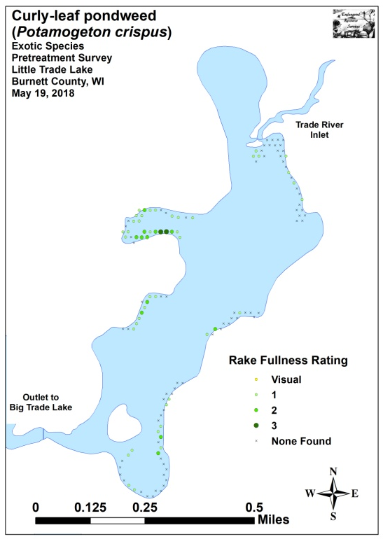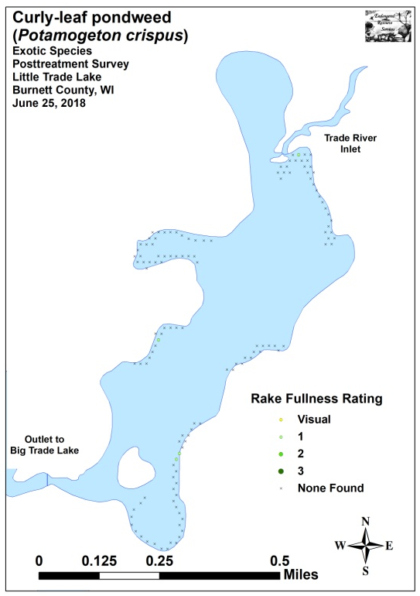
Figure 8: Pre/Post CLP Density and Distribution
_***
_***
_***

Significant differences = * p<0.05, ** p<0.01, *** p<0.001
Figure 9: Pre/Post Changes in CLP Rake Fullness
Eurasian water-milfoil was present at four of 128 points (3.1% coverage) during the pretreatment survey (Figure 10). We rated one point a 3, one a 2, and two a 1. This extrapolated to 1.6% of the proposed treatment areas having a significant infestation (rake fullness 2 and 3) and produced a mean rake fullness of 1.75. During the posttreatment survey, we didn’t see any evidence of EWM at or between any survey points. This overall reduction was statistically significant for only total EWM (Figure 11) (Appendix V).
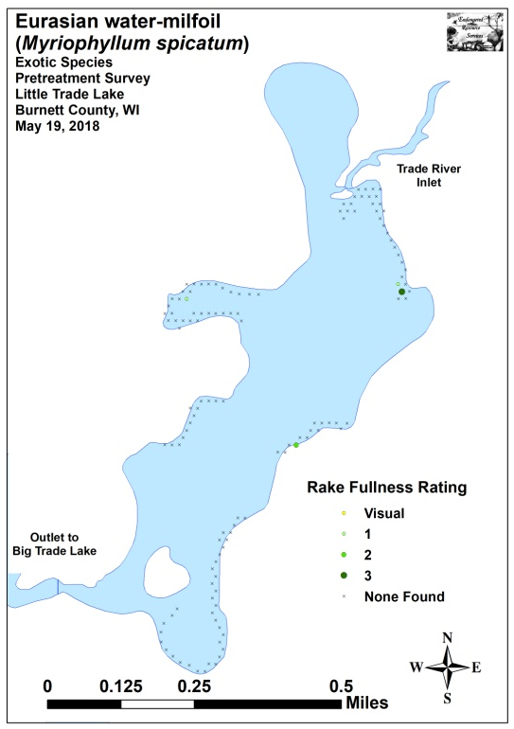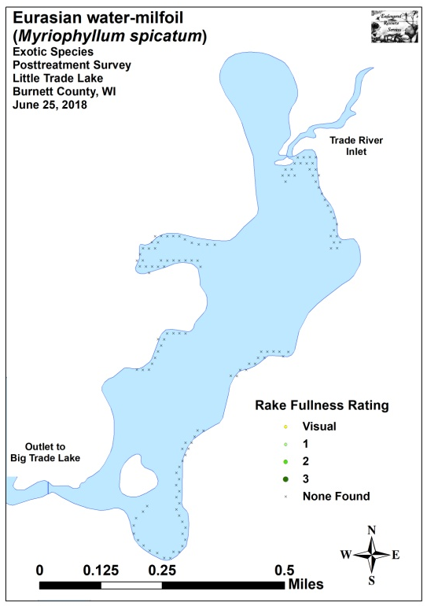
Figure 10: Pre/Post EWM Density and Distribution
_*

Significant differences = * p<0.05, ** p<0.01, *** p<0.001
Figure 11: Pre/Post Changes in EWM Rake Fullness
Coontail (Ceratophyllum demersum) (108 sites – mean rake 1.54 pretreatment) (Figure 12) and Common waterweed (Elodea canadensis) (39 sites – mean rake 1.21 pretreatment) (Figure 13) were the most common native species in the pretreatment survey (Table 3). Posttreatment, Coontail remained the most common native species (Table 4). Despite this, it experienced a significant decline (p=0.04) in distribution to 95 sites and a highly significant decline (p<0.001) in mean rake fullness to 1.28. Common waterweed also suffered a significant decline (p=0.04) in distribution posttreatment to 23 sites; however, its mean rake fullness was almost unchanged at1.22. It fell to become the sixth most common native species following highly significant distribution increases (p<0.001) in White water lily (Nymphaea odorata), Small duckweed (Lemna minor), Common watermeal (Wolffia columbiana), and Large duckweed (Spirodela polyrhiza). Filamentous algae also experienced a moderately significant increase. Other than CLP, EWM, Coontail and Common waterweed, no other species experienced a significant decline posttreatment (Figure 14). Maps for all native species from the pre and posttreatment surveys are available in Appendixes VI and VII.
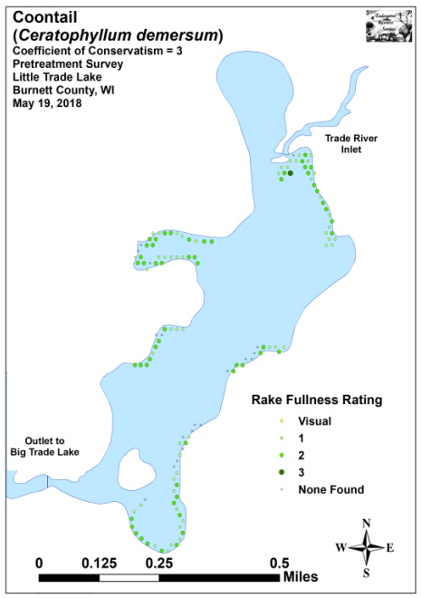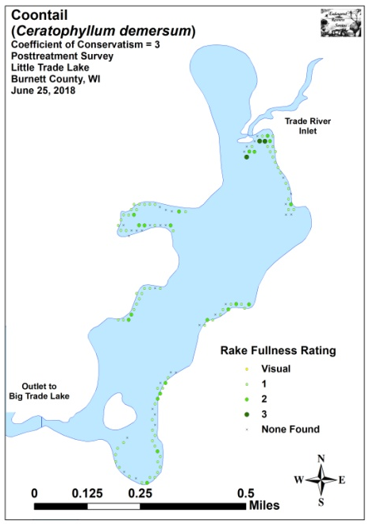
Figure 12: Pre/Post Coontail Density and Distribution
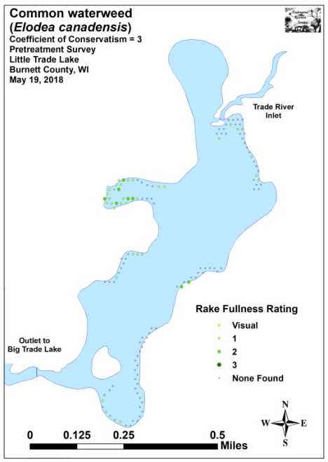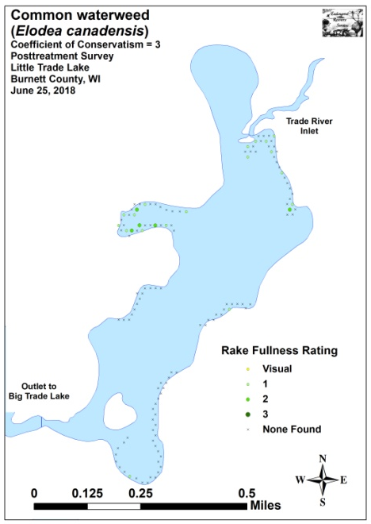
Figure 13: Pre/Post Common Waterweed Density and Distribution

Table 3: Frequencies and Mean Rake Sample of Aquatic Macrophytes
Pretreatment Survey – Little Trade Lake, Burnett County
May 19, 2018

Species | Common Name | Total  Sites | Relative Freq. | Freq. in Veg. | Freq. in Lit. | Mean Rake
Ceratophyllum demersum | Coontail | 108 | 47.58 | 91.53 | 84.38 | 1.54
 | Filamentous algae | 72 | * | 61.02 | 56.25 | 1.50
Potamogeton crispus | Curly-leaf pondweed | 54 | 23.79 | 45.76 | 42.19 | 1.30
Elodea canadensis | Common waterweed | 39 | 17.18 | 33.05 | 30.47 | 1.21
Nymphaea odorata | White water lily | 9 | 3.96 | 7.63 | 7.03 | 1.11
Nuphar variegata | Spatterdock | 6 | 2.64 | 5.08 | 4.69 | 1.00
Myriophyllum spicatum | Eurasian water-milfoil | 4 | 1.76 | 3.39 | 3.13 | 1.75
Ranunculus aquatilis | White water crowfoot | 3 | 1.32 | 2.54 | 2.34 | 1.00
Potamogeton pusillus | Small pondweed | 2 | 0.88 | 1.69 | 1.56 | 1.00
Lemna trisulca | Forked duckweed | 1 | 0.44 | 0.85 | 0.78 | 1.00
Stuckenia pectinata | Sago pondweed | 1 | 0.44 | 0.85 | 0.78 | 1.00

* Excluded from relative frequency analysis
Table 4: Frequencies and Mean Rake Sample of Aquatic Macrophytes
Posttreatment Survey – Little Trade Lake, Burnett County
June 25, 2018

Species | Common Name | Total  Sites | Relative Freq. | Freq. in Veg. | Freq. in Lit. | Mean Rake
Ceratophyllum demersum | Coontail | 95 | 33.45 | 86.36 | 75.40 | 1.28
 | Filamentous algae | 92 | * | 83.64 | 73.02 | 1.60
Nymphaea odorata | White water lily | 40 | 14.08 | 36.36 | 31.75 | 2.03
Lemna minor | Small duckweed | 39 | 13.73 | 35.45 | 30.95 | 1.36
Wolffia columbiana | Common watermeal | 39 | 13.73 | 35.45 | 30.95 | 1.36
Spirodela polyrhiza | Large duckweed | 36 | 12.68 | 32.73 | 28.57 | 1.14
Elodea canadensis | Common waterweed | 23 | 8.10 | 20.91 | 18.25 | 1.22
Nuphar variegata | Spatterdock | 5 | 1.76 | 4.55 | 3.97 | 3.00
Potamogeton crispus | Curly-leaf pondweed | 4 | 1.41 | 3.64 | 3.17 | 1.00
Potamogeton richardsonii | Clasping-leaf pondweed | 2 | 0.70 | 1.82 | 1.59 | 1.00
Vallisneria americana | Wild celery | 1 | 0.35 | 0.91 | 0.79 | 1.00

* Excluded from relative frequency analysis
+***
-*
-***
+***
+***
+***
+**
-*
Significant differences = * p<0.05, ** p<0.01, *** p<0.001
Figure 14: Pre/Post Macrophyte Changes

Fall Eurasian Water-milfoil Bed Mapping Survey:
On October 17th, 2018, we mapped seven Eurasian water-milfoil beds totaling 1.40 acres or 1.11% of the lake’s total surface area (Table 5). Outside of these areas, we marked 44 additional EWM plants (Figure 3) (Appendix VIII). This total was an increase of 0.31 acres (+28.44%) from the 14 small beds totaling 1.09 acres (0.87% coverage) mapped in 2017, and it was also higher than the 0.34 acre (0.27% coverage) we mapped in 2016; however, it was still well below the recent peak of 4.23 acres (3.36% coverage) mapped in fall 2015.

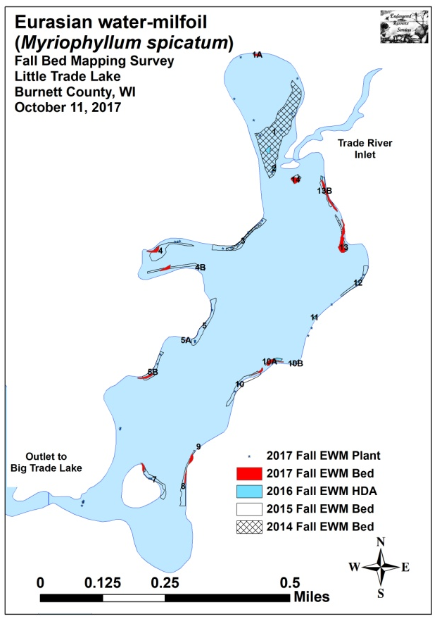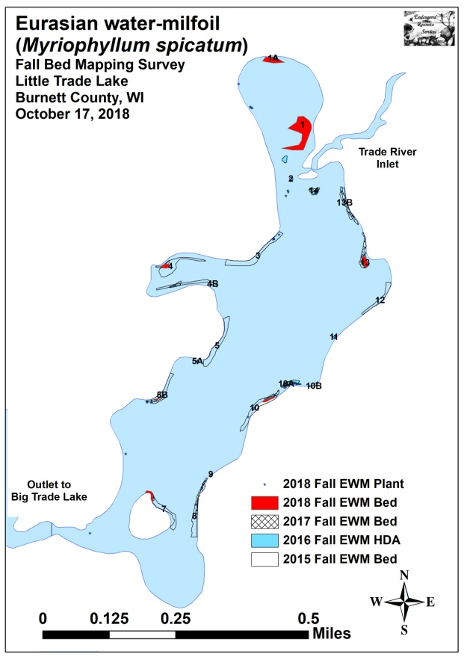
Figure 15: 2017 and 2018 Fall EWM Bed Maps

Table 5: Fall Eurasian Water-milfoil Bed and High Density Area Mapping Summary
Little Trade Lake, Burnett County
October 17, 2018

Bed Number | 2018 Fall Bed Acreage | 2017 Fall Bed Acreage | 2016  Fall Bed/  HDA  Acreage | 2015  Fall Bed  Acreage | 2014  Fall Bed  Acreage | 2013  Fall Bed/  HDA  Acreage | 2012  Fall Bed  Acreage | 2018  Change in  Acreage | Estimated 2018 Mean Rake Fullness | 2018  Field Notes
1 | 0.93 | 0 | 0.06 | 0 | 3.84 | 4.61 | 2.16 | 0.93 | <<<1-2; <1 | More of a HDA; many towers
1A | 0.18 | 0.04 | 0 | 0 | 0 | 0 | 0 | 0.14 | <<<1-2; <1 | More of a HDA; highly fragm.
2 | 0 | 0 | 0.02 | 0 | Merged | Merged | Merged | 0 | <<<<1 | 3 EWM plants
3 | 0 | 0 | 0 | 0.65 | 0.23 | 0.03 | 0 | 0 | <<<<1 | 5 EWM plants
4 | 0.06 | 0.07 | 0 | 0.58 | 0 | 0 | 0 | -0.01 | 1-3; 2 | Central mat with satellites
4B | 0 | 0.07 | 0 | 0.26 | 0 | 0 | 0 | -0.07 | - | No EWM seen
5 and 5A | 0 | 0.01 | 0 | 0.52 | 0 | 0 | 0 | -0.01 | <<<<1 | 2 EWM plants – both removed
5B | 0.02 | 0.07 | 0 | 0.33 | 0 | 0 | 0 | -0.05 | 1-3; 3 | Canopied mat near shore
6 | 0 | 0 | 0 | 0 | 0 | 0 | 0 | 0 | <<<<1 | 2 EWM plants – both removed
7 | 0.06 | 0.04 | 0.02 | 0.31 | 0 | 0 | 0 | 0.02 | <1-3; 2 | Small canopied mat near shore
8A and 8B | 0 | 0.10 | 0 | 0.42 | 0 | 0 | 0 | -0.10 | <<<<1 | 5 EWM plants
9 | 0 | 0.01 | 0 | 0 | 0 | 0 | 0 | -0.01 | - | No EWM seen
10 | 0.05 | 0.05 | 0 | 0.51 | 0 | 0 | 0 | 0 | <1-3; 1 | Regular nearshore towers
10A | 0 | 0.10 | 0.11 | 0 | 0 | 0 | 0 | -0.10 | <<<<1 | 5 EWM plants
10B | 0 | 0 | 0 | 0.05 | 0 | 0 | 0 | 0 | - | No EWM seen
11 | 0 | 0 | 0.01 | 0 | 0 | 0 | 0 | 0 | <<<<1 | 2 EWM plants – both removed
12 | 0 | 0 | 0 | 0.26 | 0 | 0 | 0 | 0 | - | No EWM seen
12B | 0 | 0 | 0 | 0 | 0 | 0 | 0.02 | 0 | - | No EWM seen
12C | 0 | 0 | 0 | 0 | 0 | <0.01 | 0.08 | 0 | - | No EWM seen
13 | 0.10 | 0.27 | 0.05 | 0.08 | 0.14 | <0.01 | 0 | -0.17 | 1-3; 2 | Near mat – worst area on lake
13B | 0 | 0.16 | 0.02 | 0.26 | 0 | 0 | 0 | -0.16 | - | No EWM seen
14 | 0 | 0.10 | 0.05 | 0 | 0.10 | <0.01 | 0.31 | -0.10 | <<<<1 | 3 EWM plants
Total | 1.40 | 1.09 | 0.34 | 4.23 | 4.32 | 4.65 | 2.57 | +0.31

Descriptions of Current and Former Eurasian Water-milfoil Beds:
Beds 1 and 2 – The north bay has historically been one of the worst places on the lake, and, after a year without management, we found the area contained nearly continuous Eurasian water-milfoil towers that were actively fragmenting in water up to 5ft deep. Although the majority of increase in acreage on the lake occurred in this area, most of the “bed” was still technically better described as a high density area.

Bed 1A – In 2017, this bed was little more than a tiny super cluster of plants. Following a dramatic expansion, regular EWM clusters were now present along almost a quarter of the northern shoreline of the north bay. These plants were still somewhat fragmented, but they were merging into microbeds rather than being just isolated towers as we saw in the past.

Bed 3 – Five plants were found in Bed 3 just southwest of the point on the western shoreline at the entrance to the north bay.

Beds 4 and 4B – The treatment was highly successful at knocking EWM back throughout the majority of the western midlake bay. Unfortunately, we found a few dozen large plants had already formed a small canopied mat and were recolonizing the northwest corner of Bed 4 just off the end of a resident’s dock. Several of them showed evidence of being prop-clipped, and this likely explained the rapid expansion north of the largest plants.

Beds 5 and 5A – We didn’t see any EWM in the area formerly covered by Bed 5; however, we rake removed two plants in bed 5A.

Bed 5B – In this area, we found a small dense canopied microbed with 10-15 well-established plants that were expanding near the end of a resident’s dock.

Bed 6 – Two single-stemmed EWM plants were found and removed from this area.

Bed 7 – A canopied mat again occurred on the northwest end of the island in <2.5ft of water near shore. This trouble spot might be an ideal candidate for manual removal.

Beds 8 and 9 – We found a total of five large towers along this narrow littoral shoreline.

Beds 10 and 10A – These two areas again had scattered individual plants, and there was a microbed on the northeast end of Bed 10. This area continues to have a significant amount of Northern water-milfoil (Myriophyllum sibiricum) mixed in with the EWM.

Beds 10B, 11, 12 – We rake removed the only two EWM plants found along the northeast shoreline.

Beds 13 and 13B – On the northeast point, Bed 13 was again the worst area on the lake. EWM formed a near mat of canopied plants at the core before declining on the periphery and disappearing altogether in the area formerly covering Bed 13B.

Bed 14 – We found four near-canopied plants on the sandbar near the river inlet.

LITERATURE CITED

Busch, C., C. Olson, L. Sather, and C. Holt. [online]. 1968. Big/Little Trade Lake Map. Available from http://dnr.wi.gov/lakes/maps/DNR/2638700a.pdf (2018, December).

UWEX Lakes Program. [online]. 2010. Aquatic Plant Management in Wisconsin. Available from http://www.uwsp.edu/cnr-ap/UWEXLakes/Pages/ecology/aquaticplants/default.aspx (2018, December).

UWEX Lakes Program. [online]. 2010. Pre/Post Herbicide Comparison. Available from http://www.uwsp.edu/cnr-ap/UWEXLakes/Documents/ecology/Aquatic%20Plants/Appendix-D.pdf (2018, December).

WDNR. [online]. 2018. Little Trade Lake - Citizen Lake Water Quality Monitoring Database. Available from http://dnr.wi.gov/lakes/waterquality/Station.aspx?id=073121 (2018, December).

Appendix I: Survey Sample Points and Treatment Areas

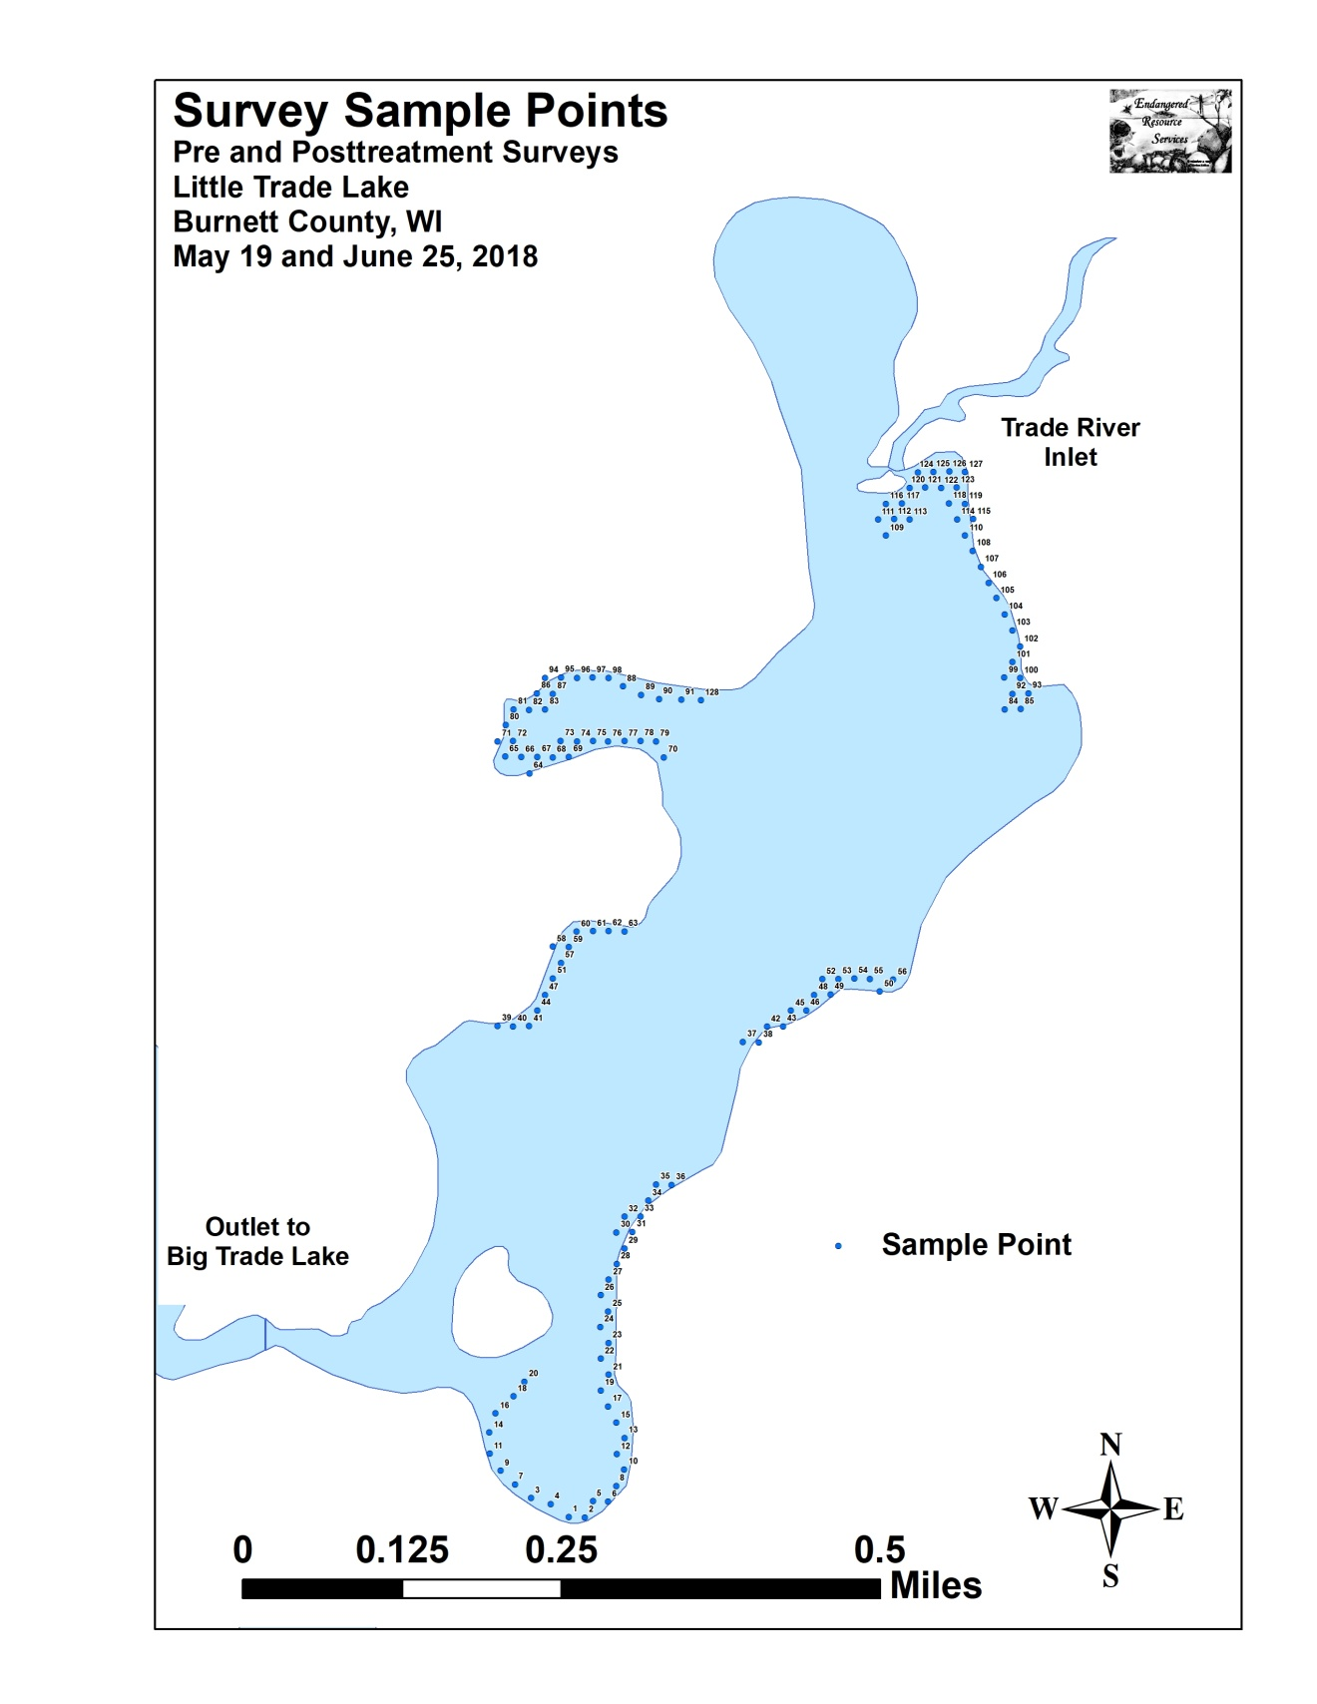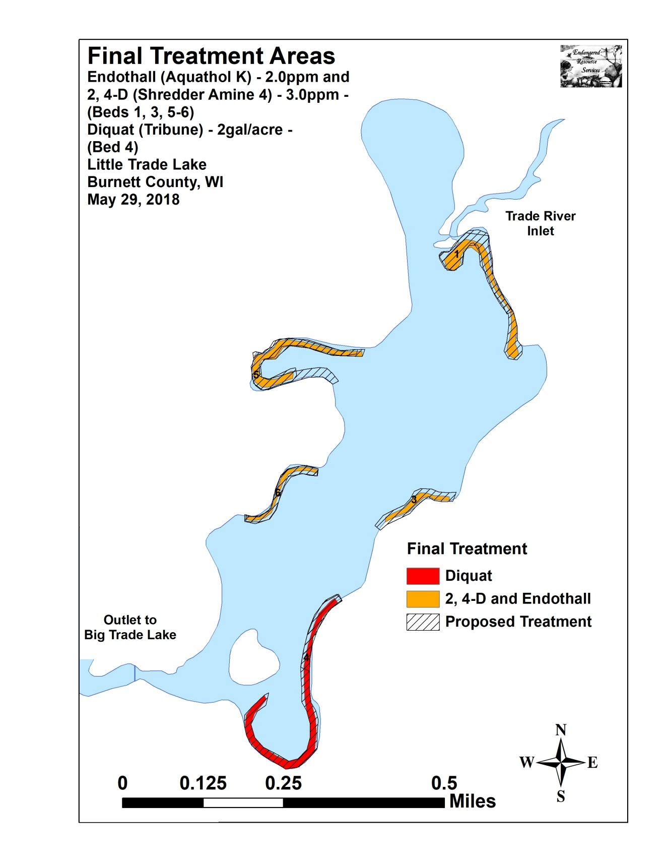

Appendix II: Vegetative Survey Datasheet

Observers for this lake: names and hours worked by each:
Lake: |  |  |  |  |  |  |  |  | WBIC |  |  |  |  |  |  |  |  | County |  |  |  |  |  | Date:
Site # | Depth (ft) | Muck (M), Sand (S), Rock (R) | Rake pole (P) or rake rope (R) | Total Rake Fullness | EWM | CLP | 1 | 2 | 3 | 4 | 5 | 6 | 7 | 8 | 9 | 10 | 11 | 12 | 13 | 14 | 15 | 16 | 17 | 18 | 19
1
2
3
4
5
6
7
8
9
10
11
12
13
14
15
16
17
18
19
20

Appendix III: Pre/Post Habitat Variable Maps

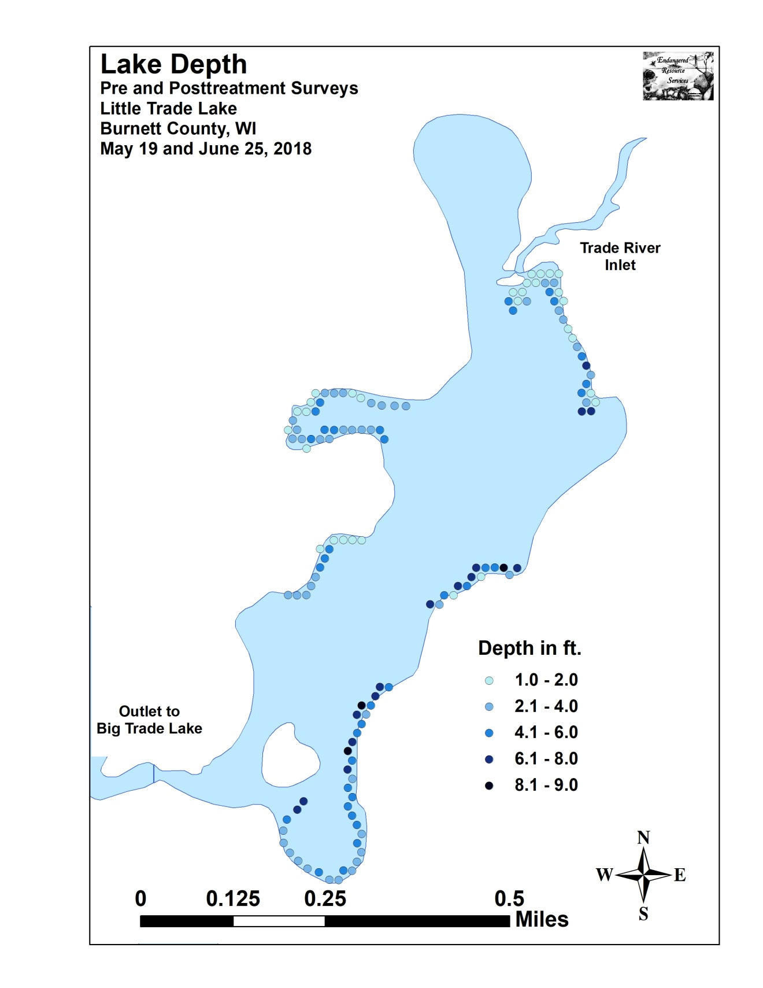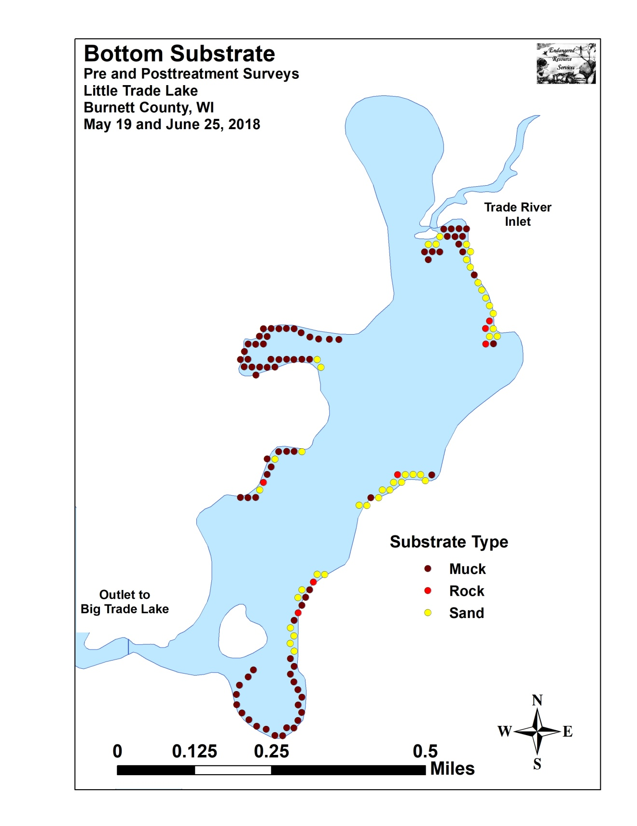

Appendix IV: Pre/Post Littoral Zone, Native Species Richness and
Total Rake Fullness

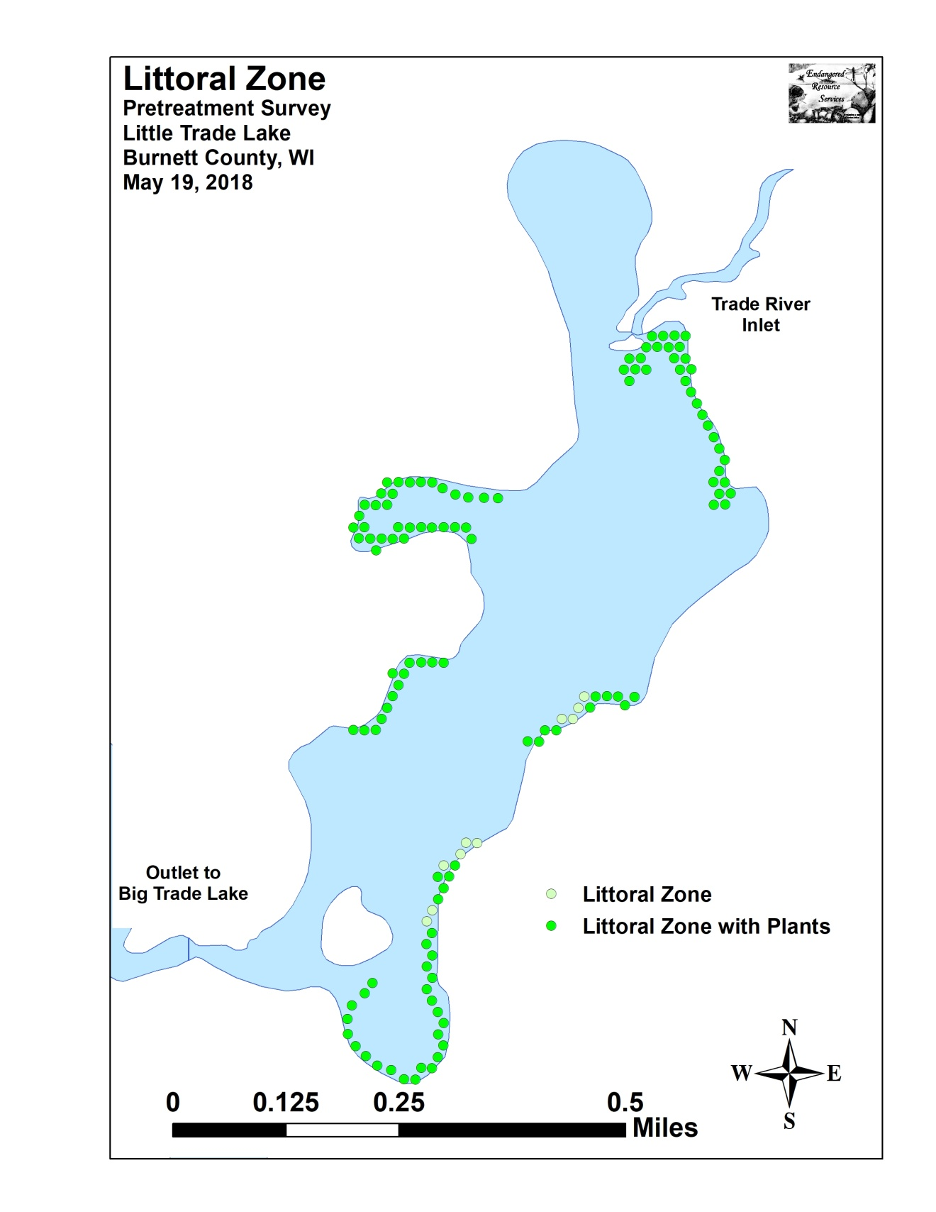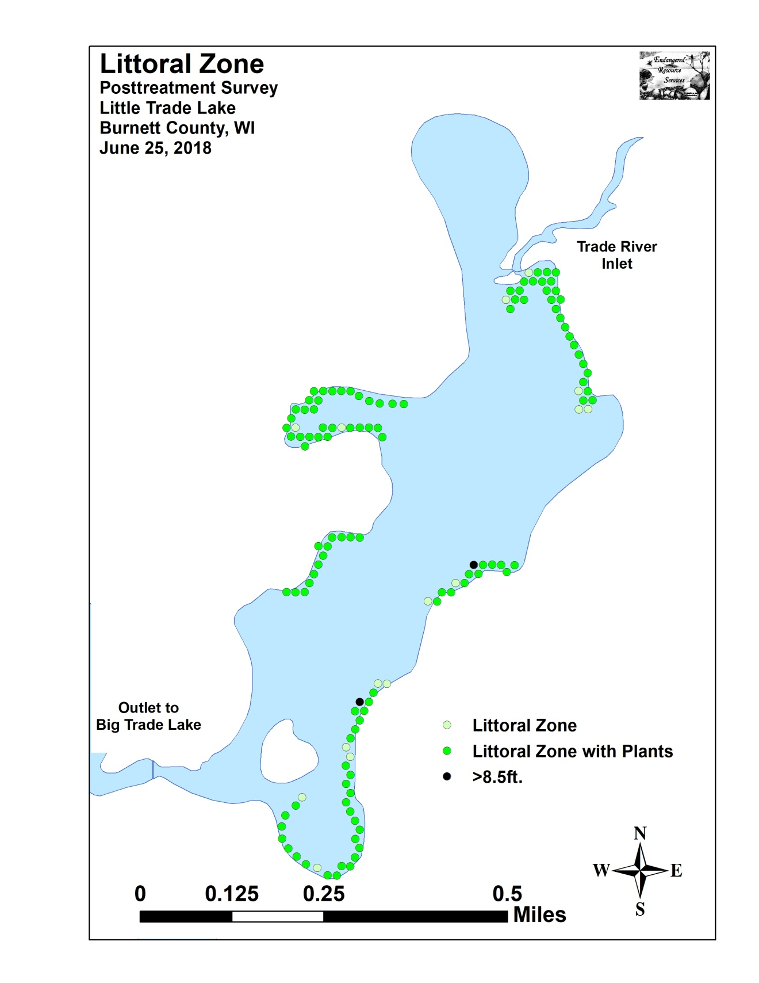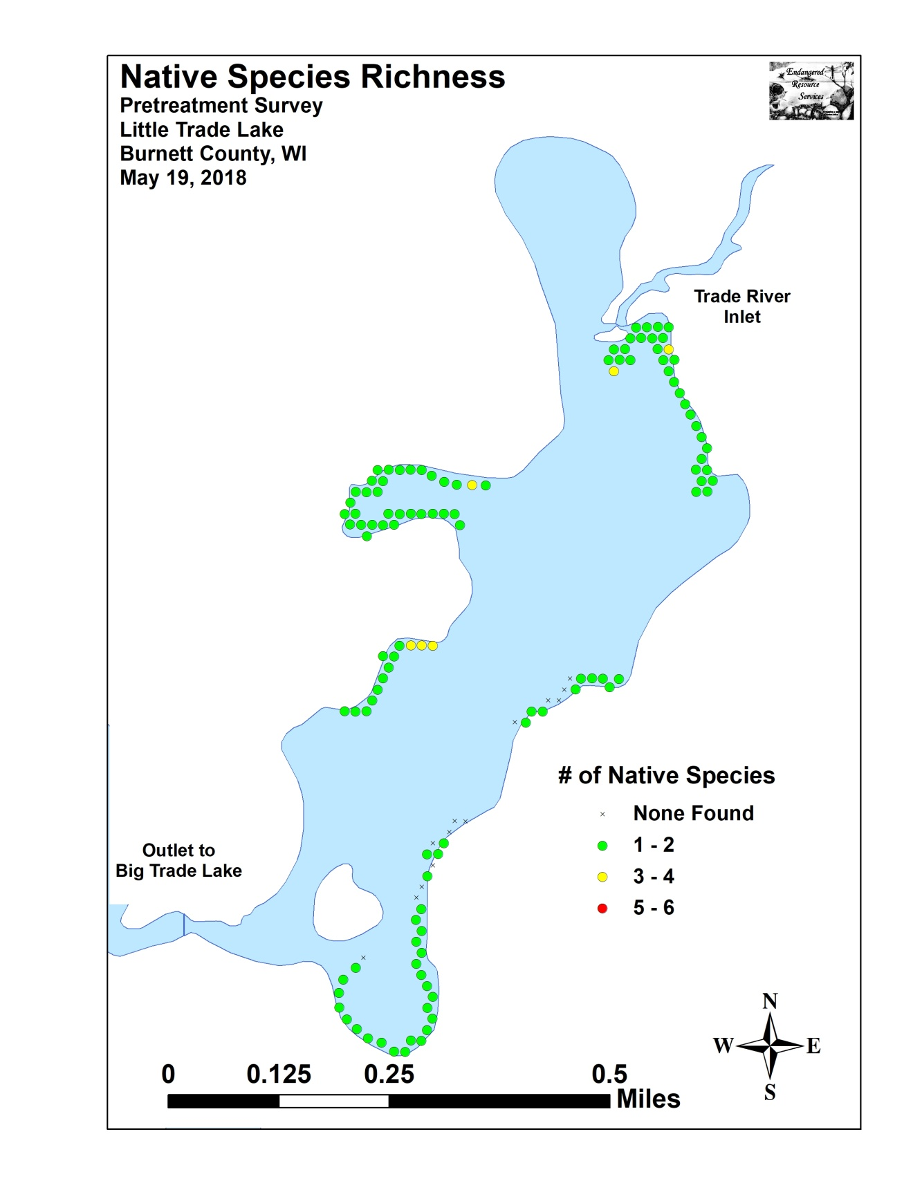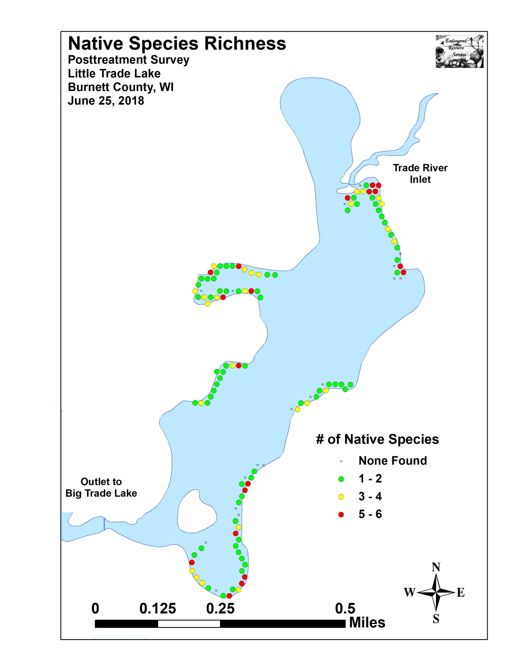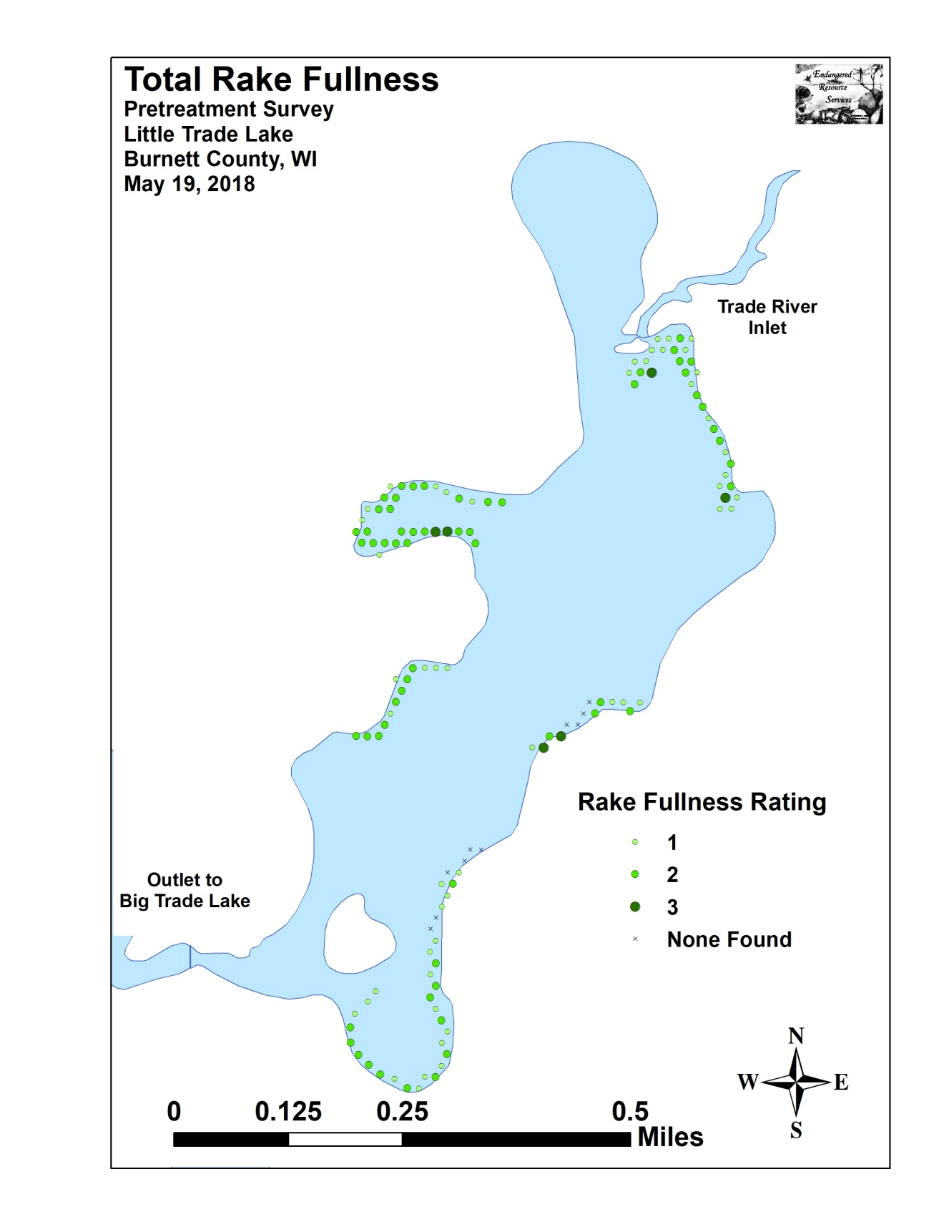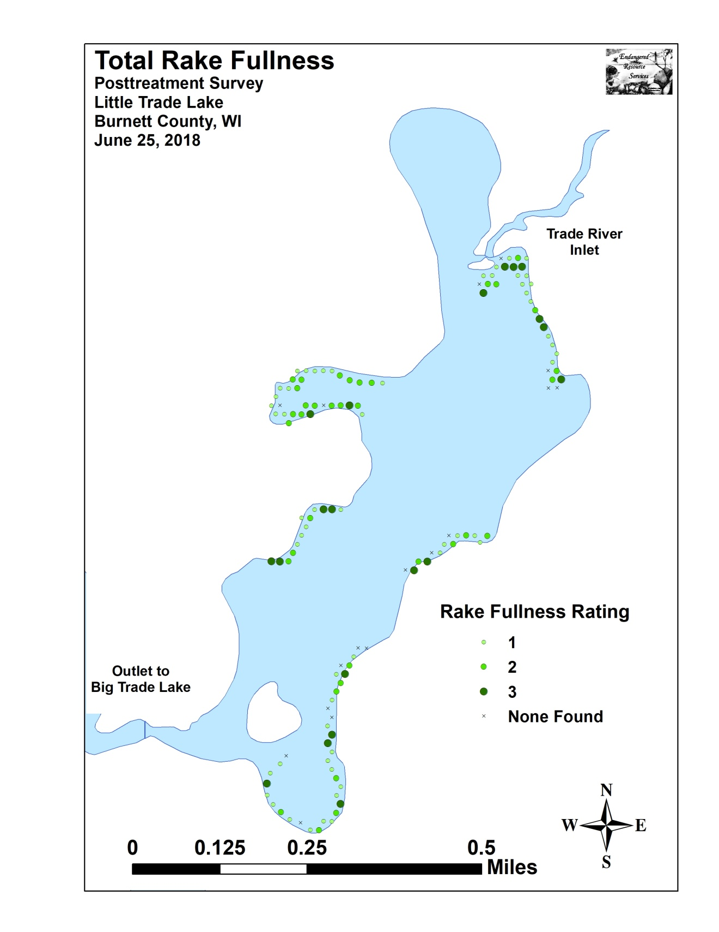

Appendix V: CLP and EWM Pre/Post Density and Distribution

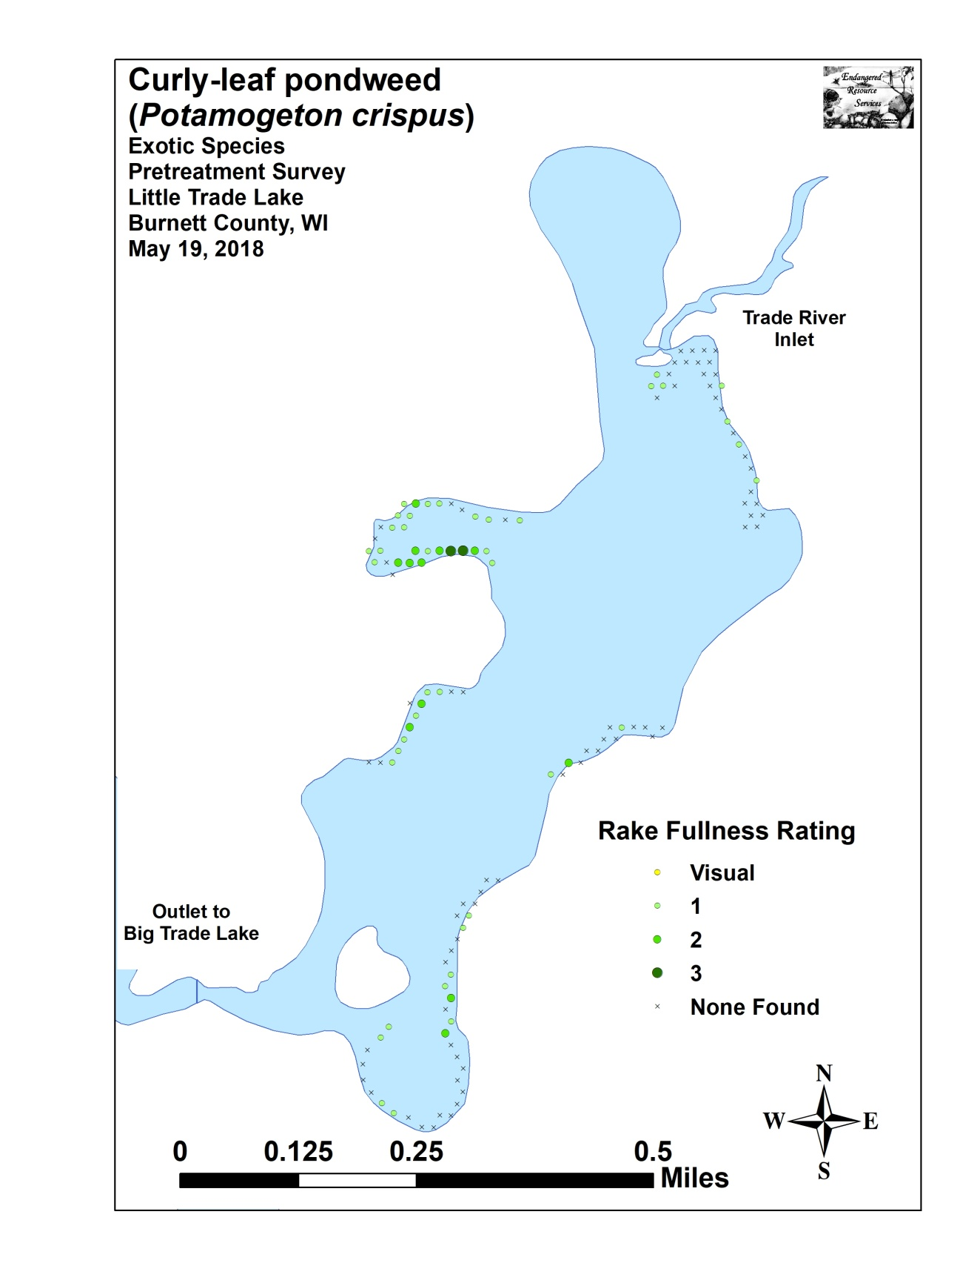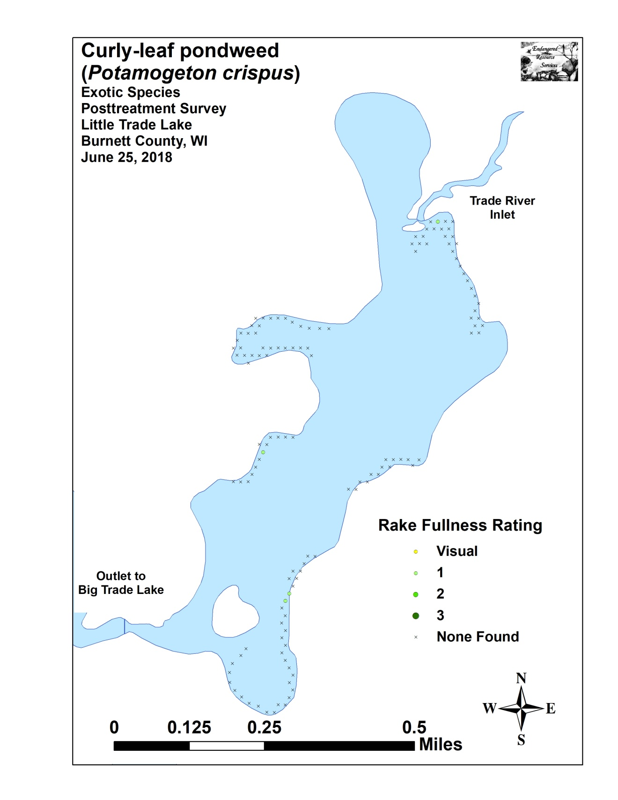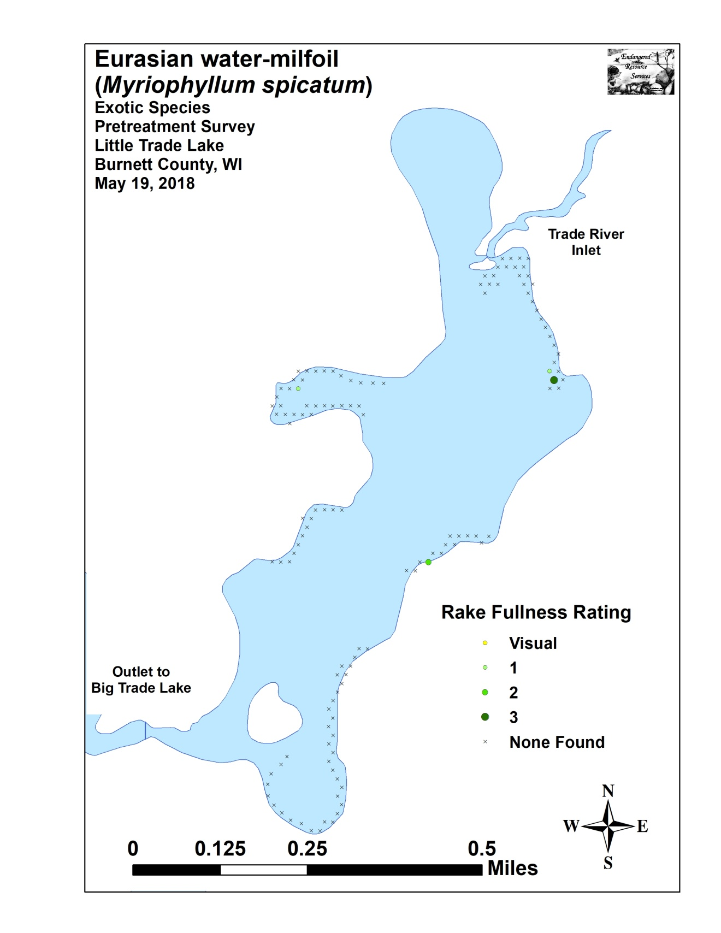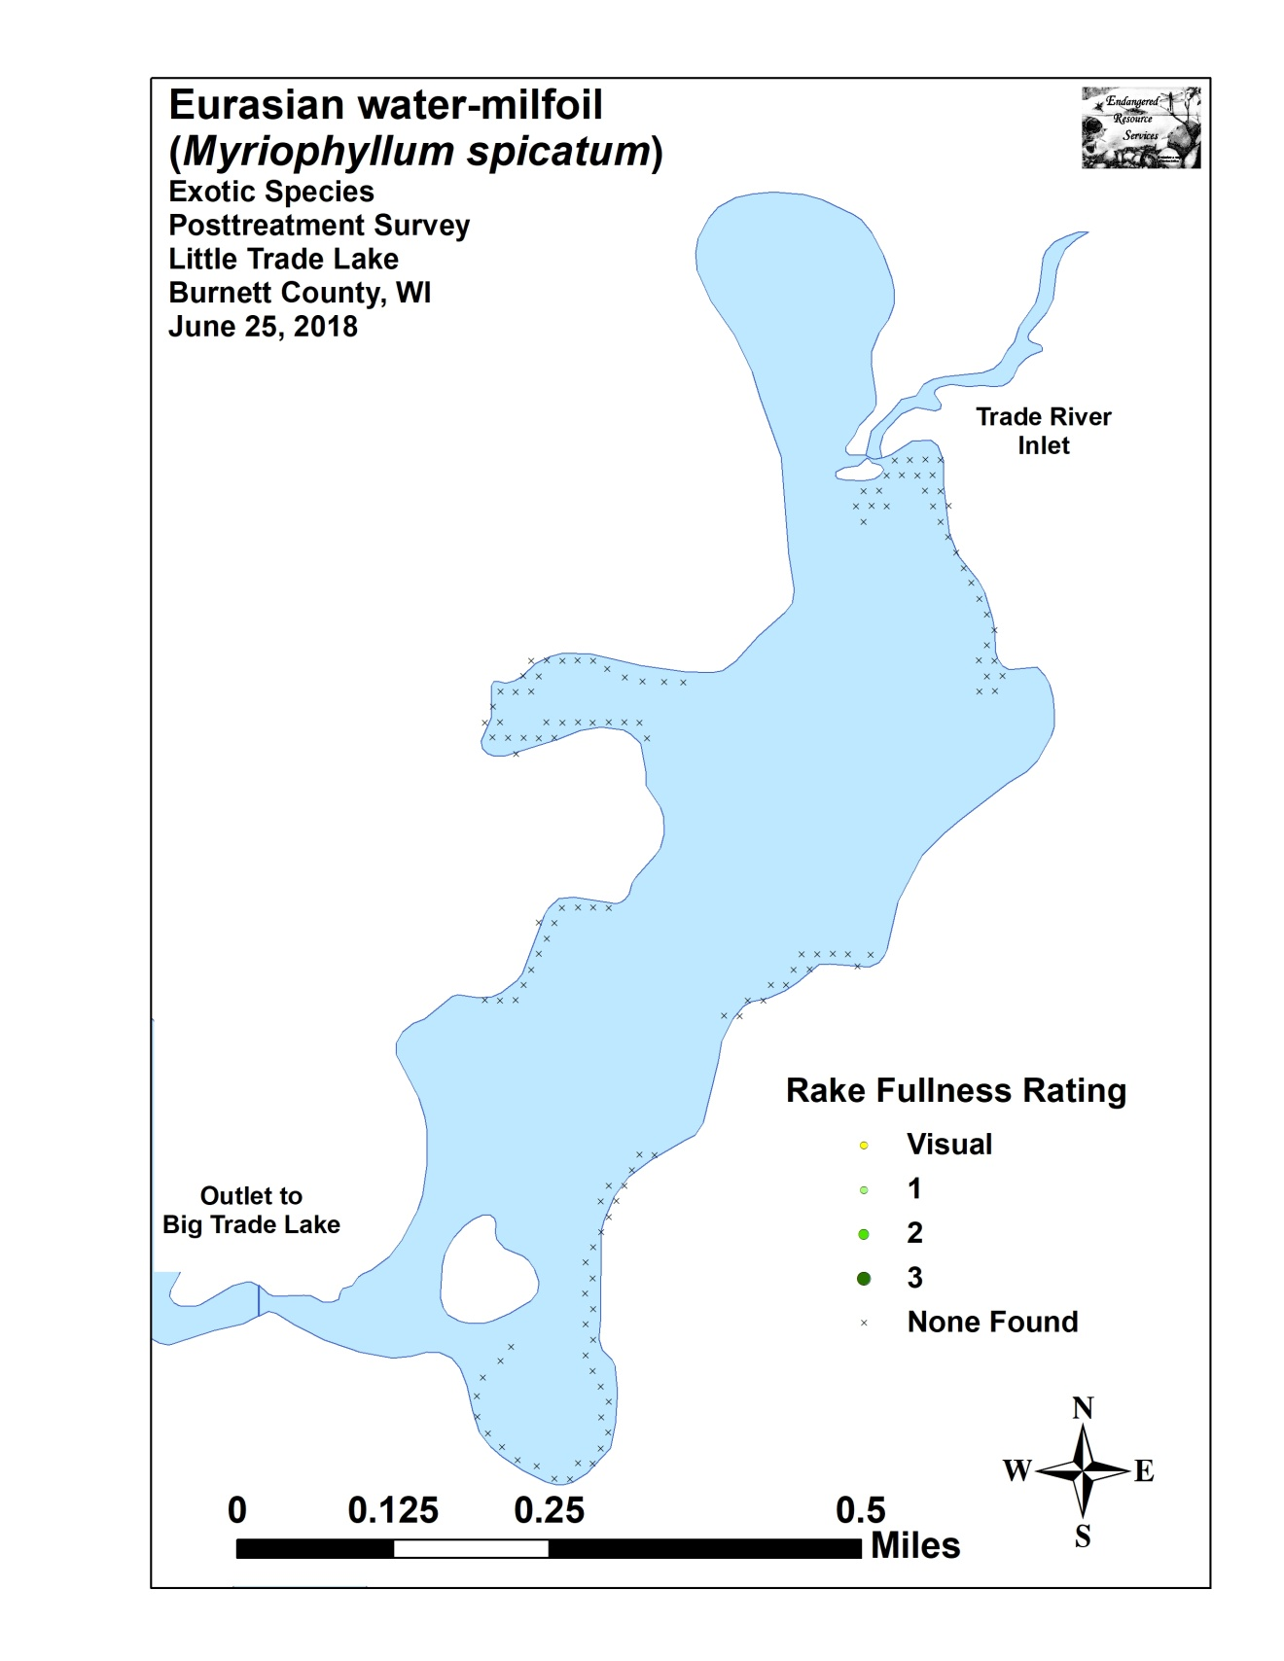

Appendix VI: Pretreatment Native Species Density and Distribution
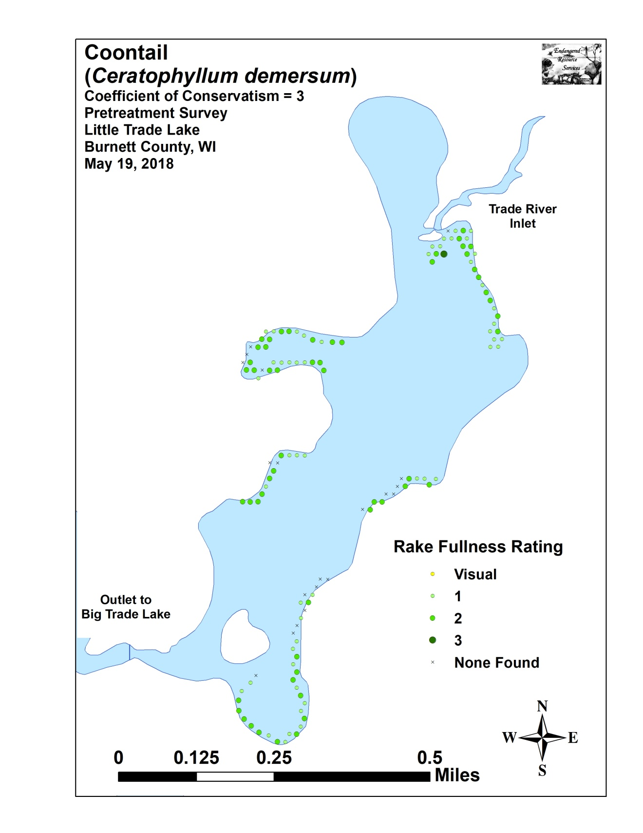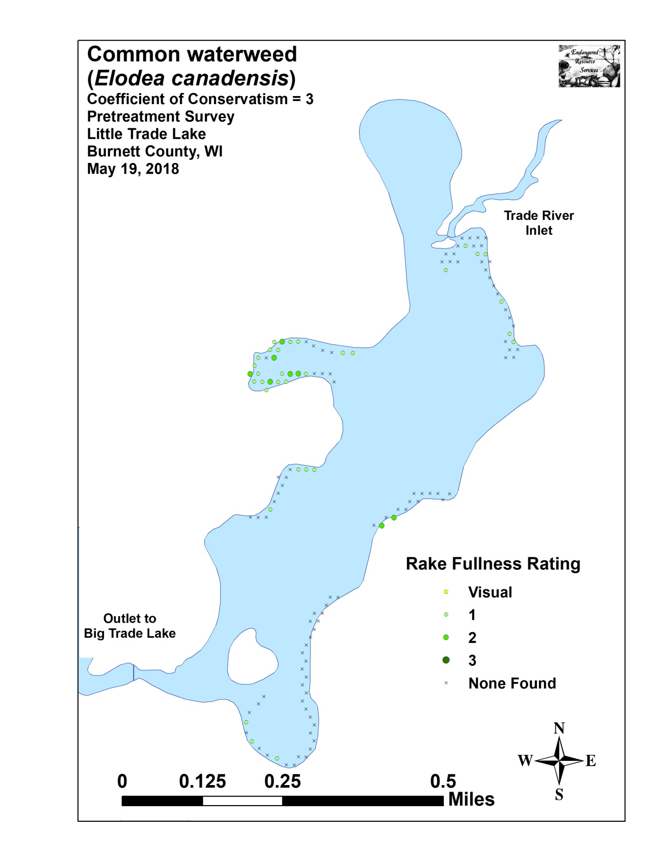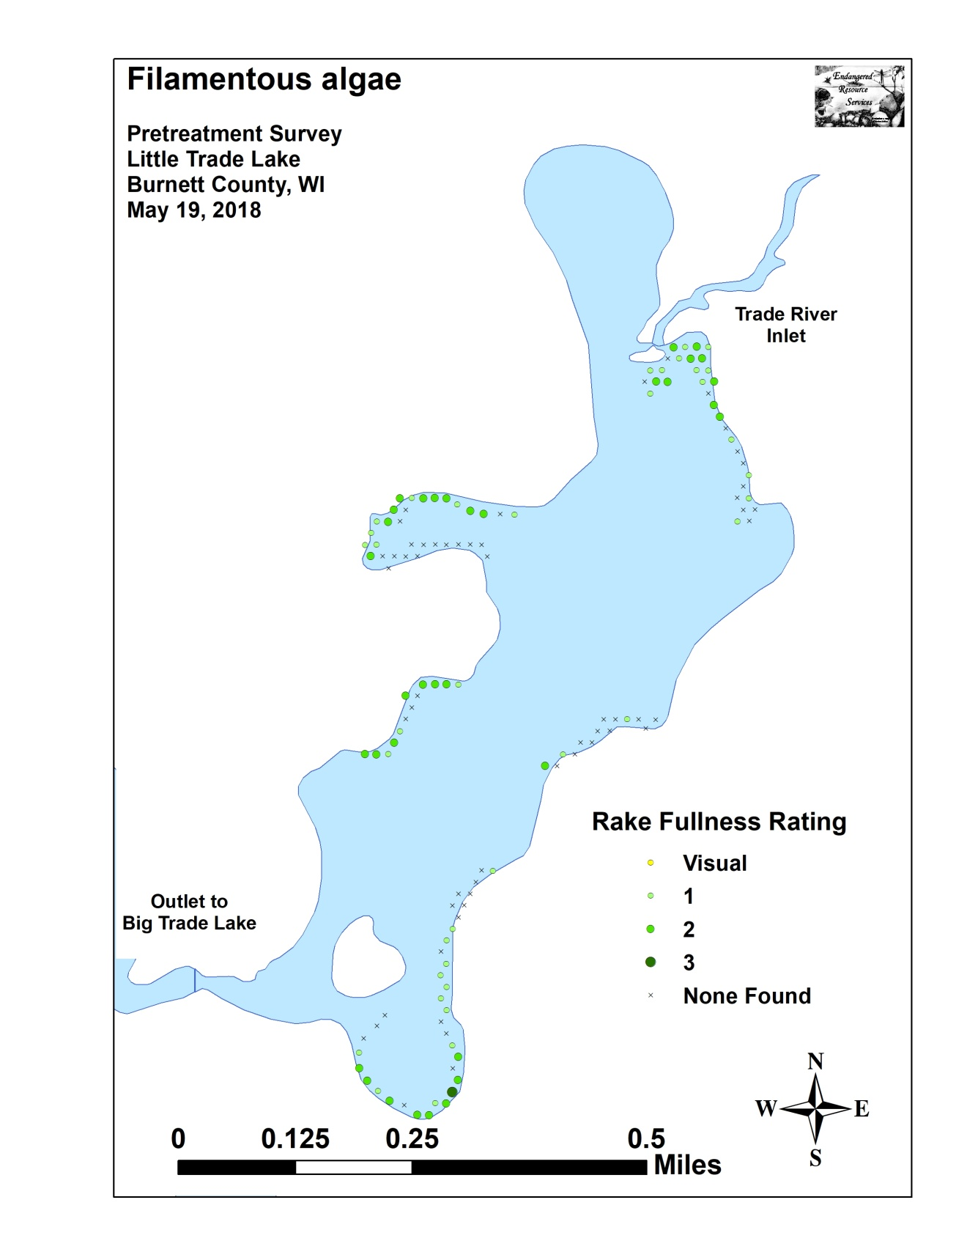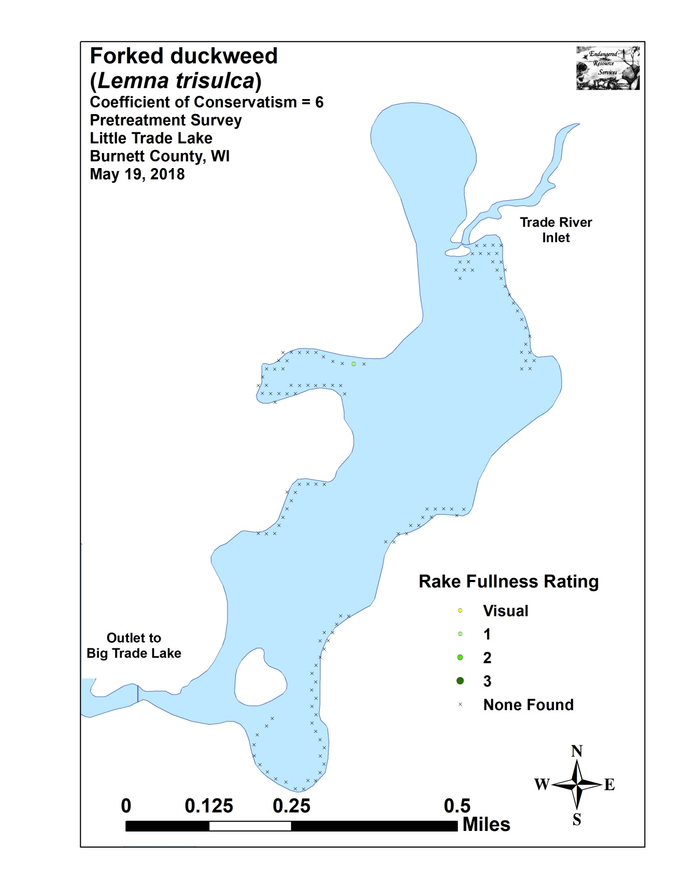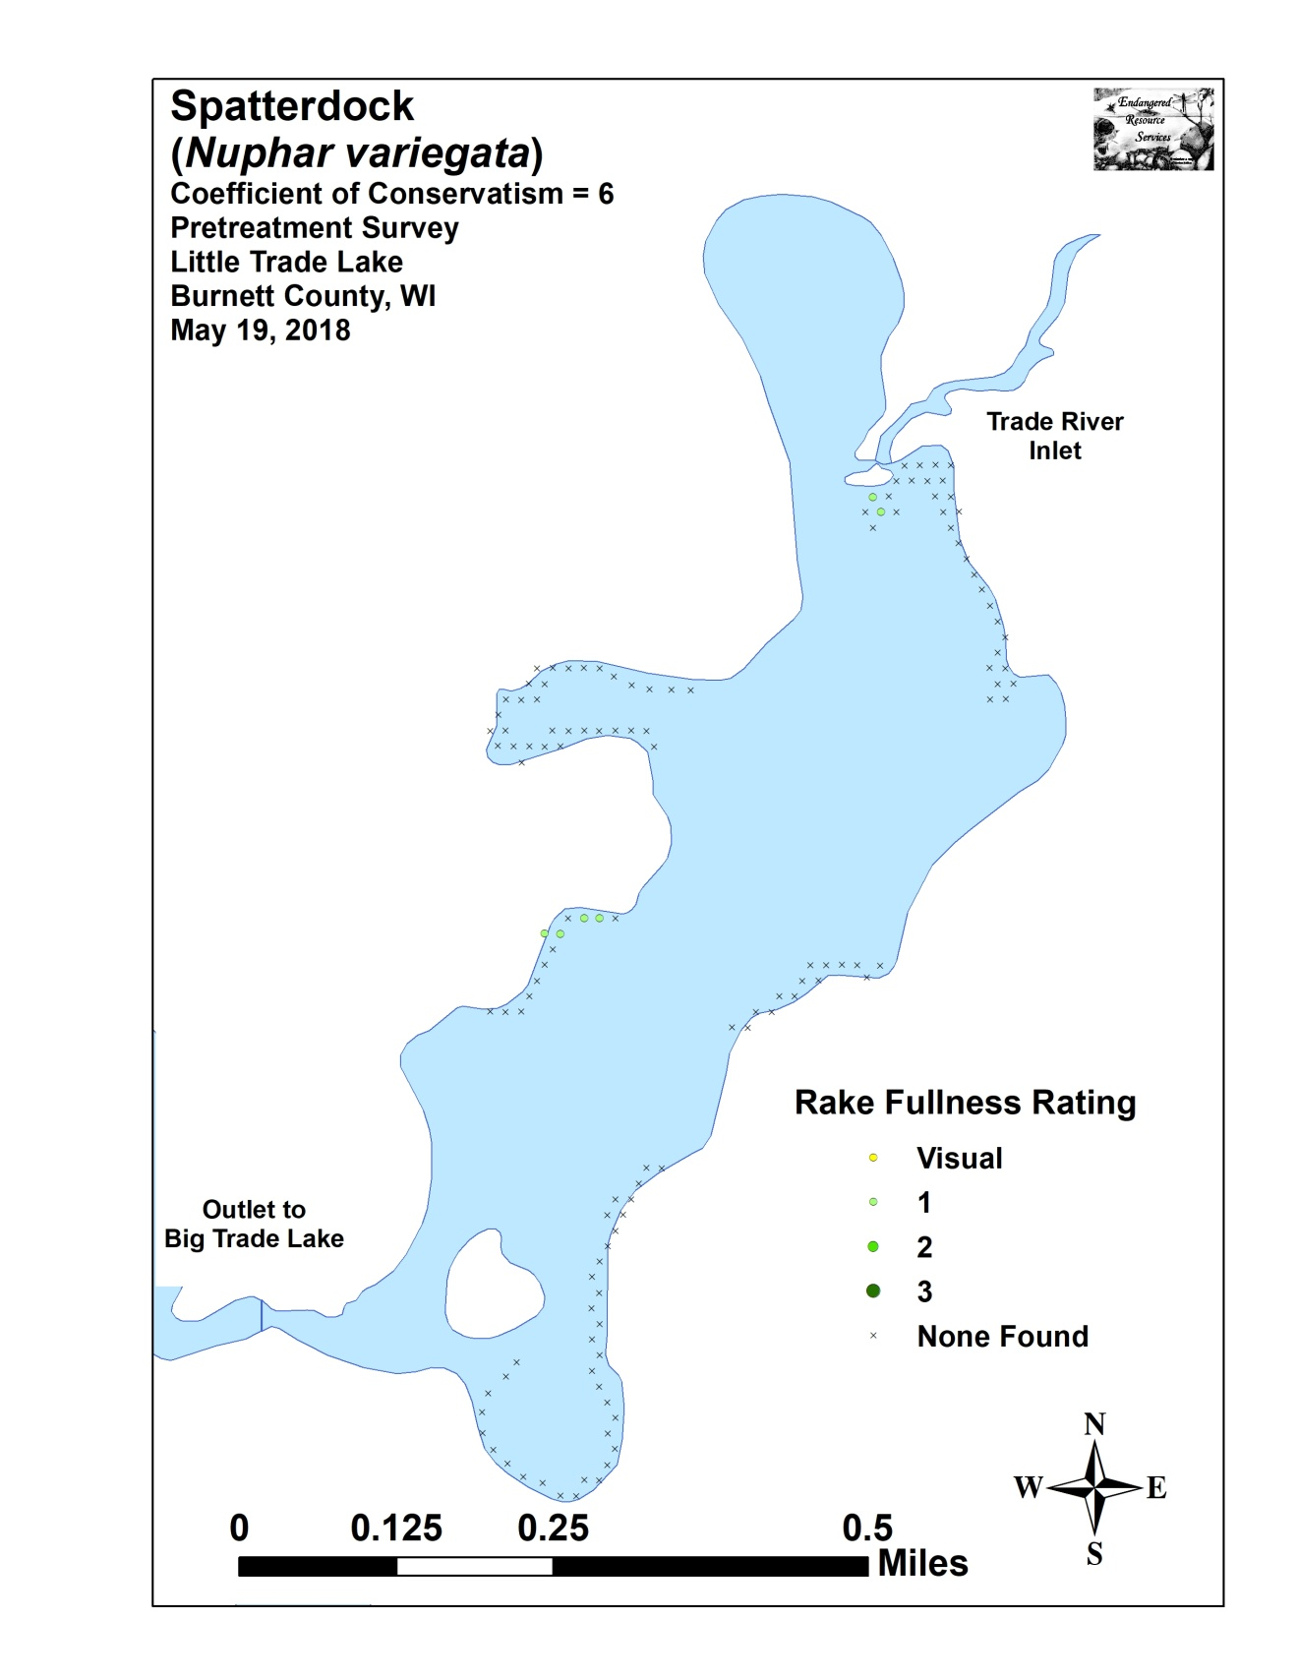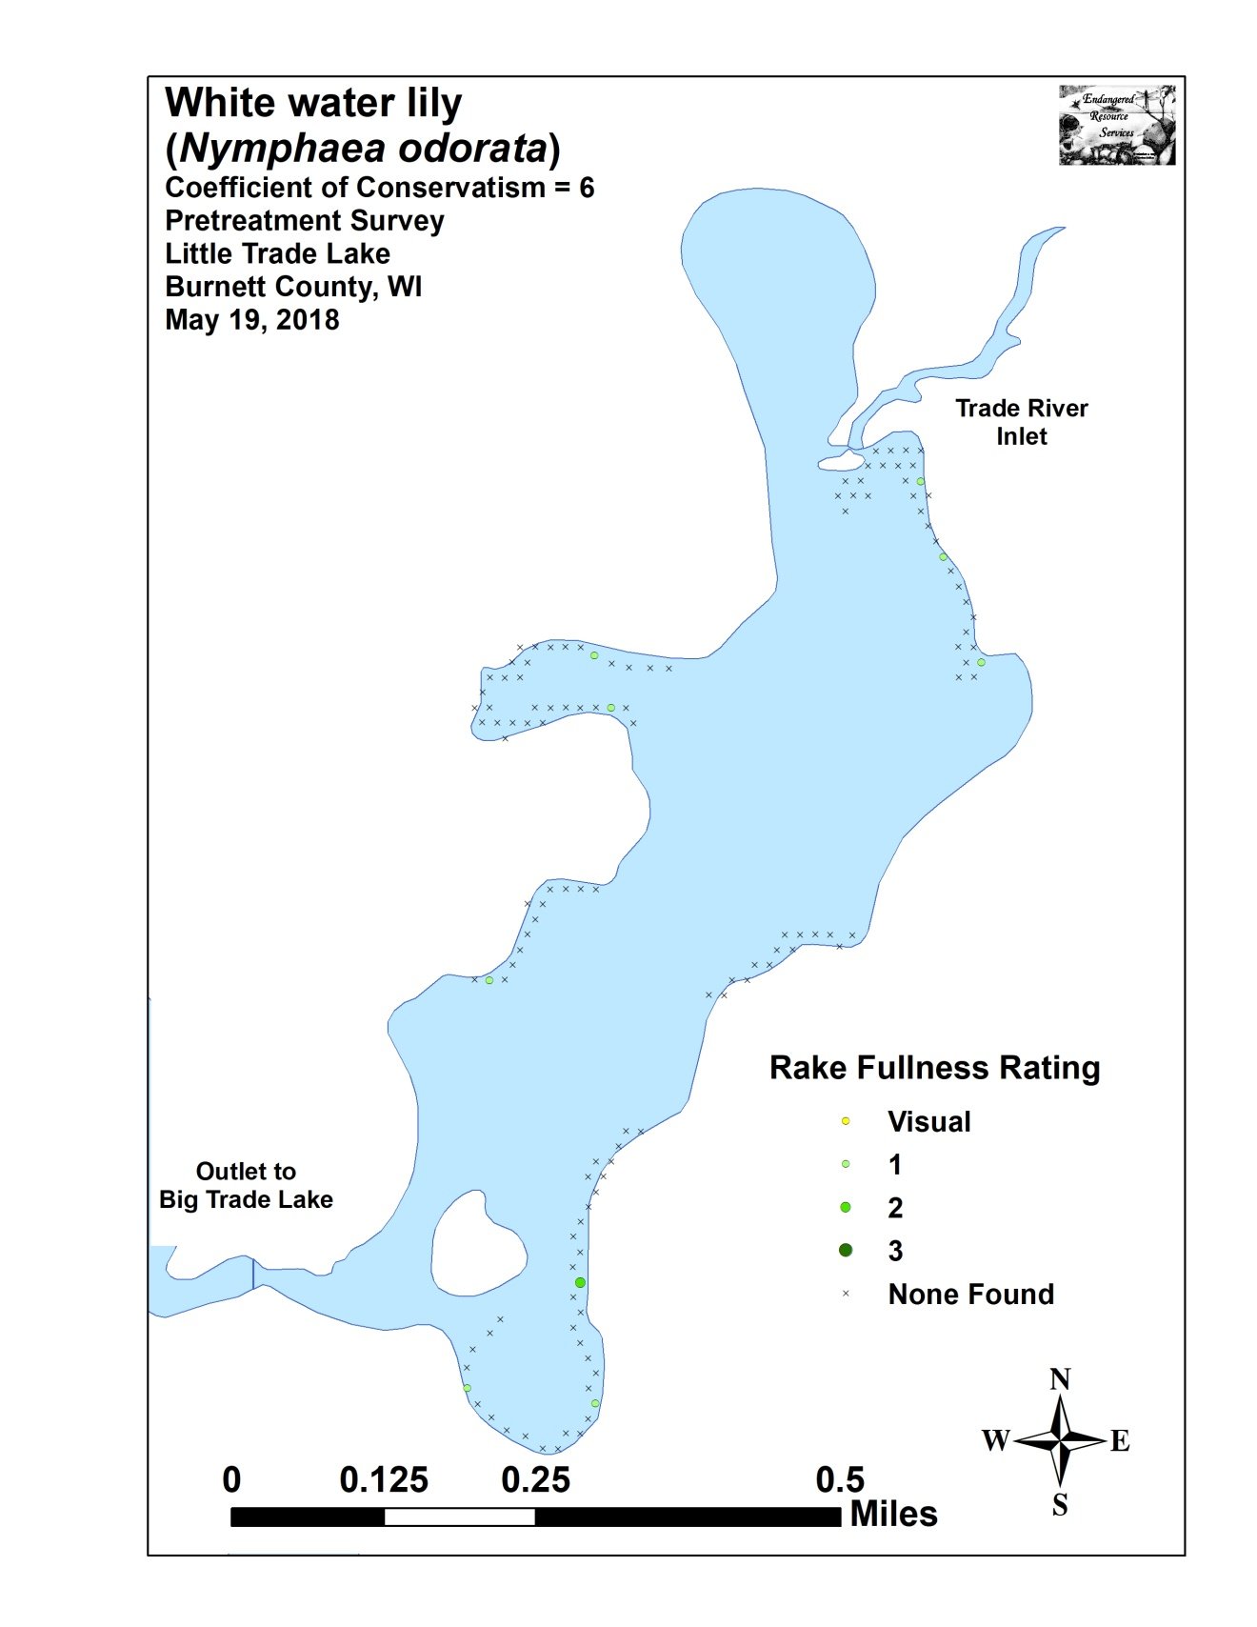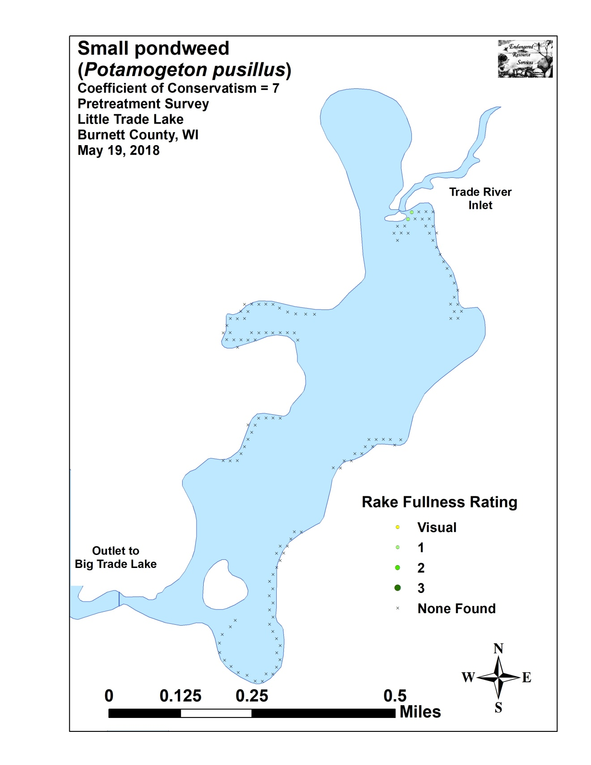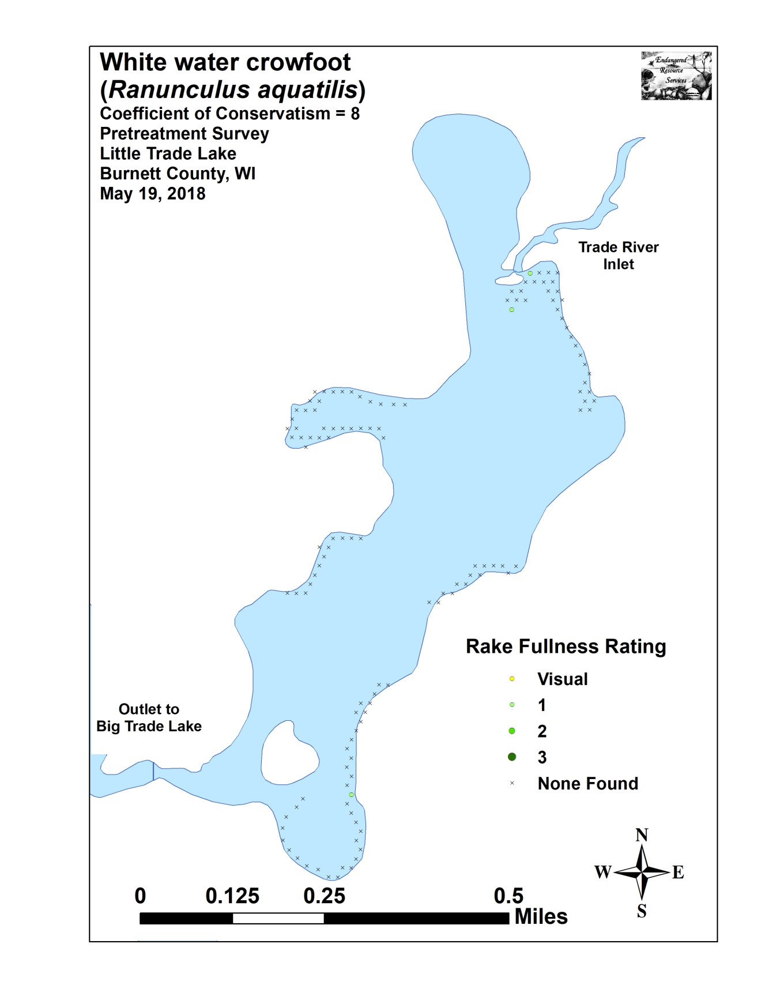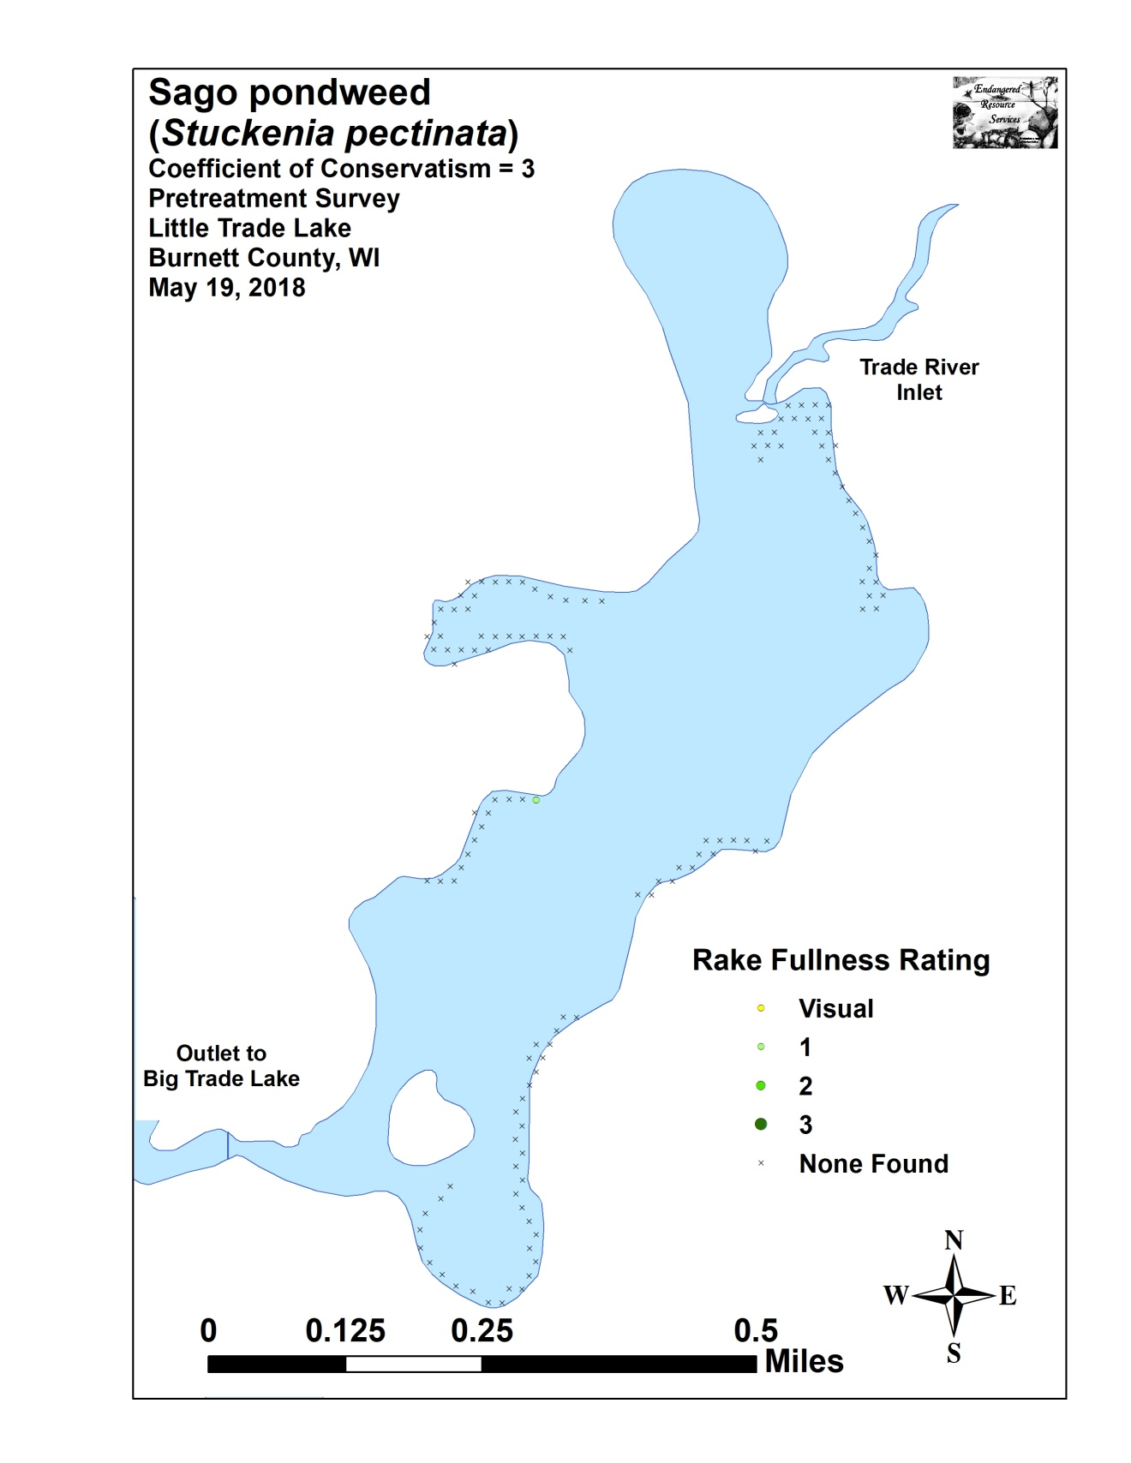

Appendix VII: Posttreatment Native Species Density and Distribution
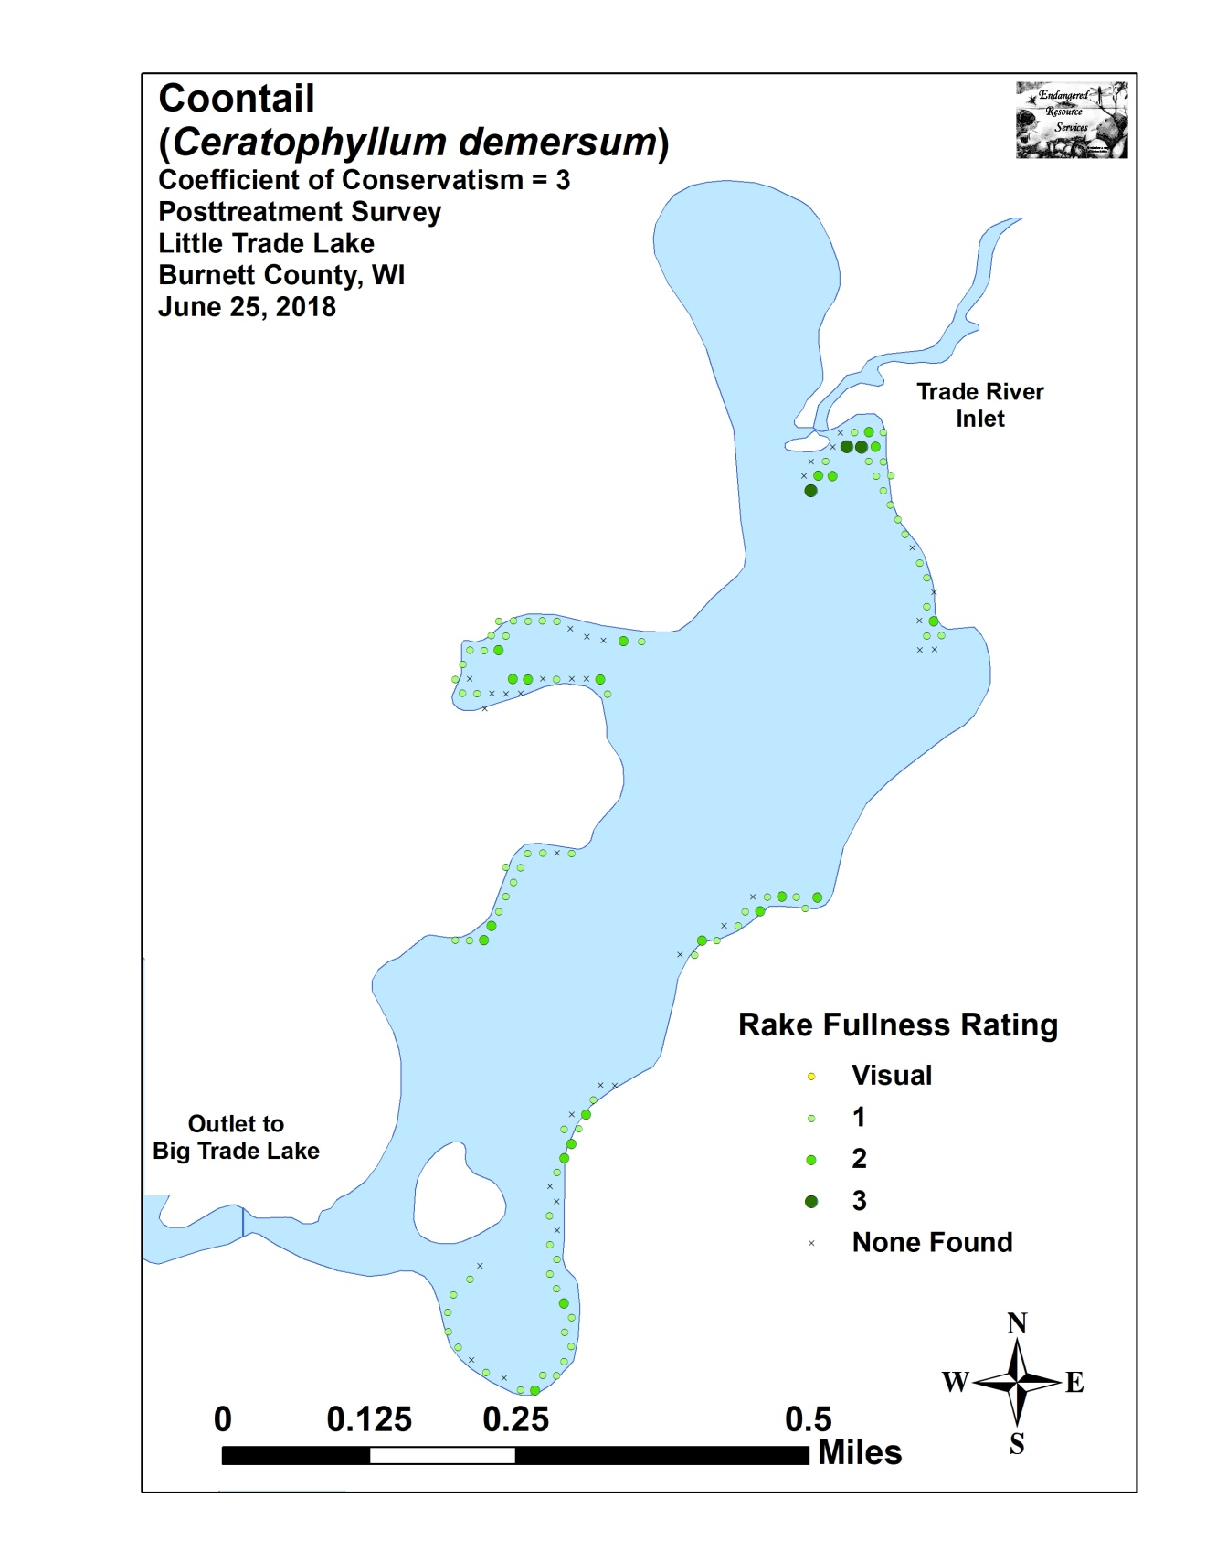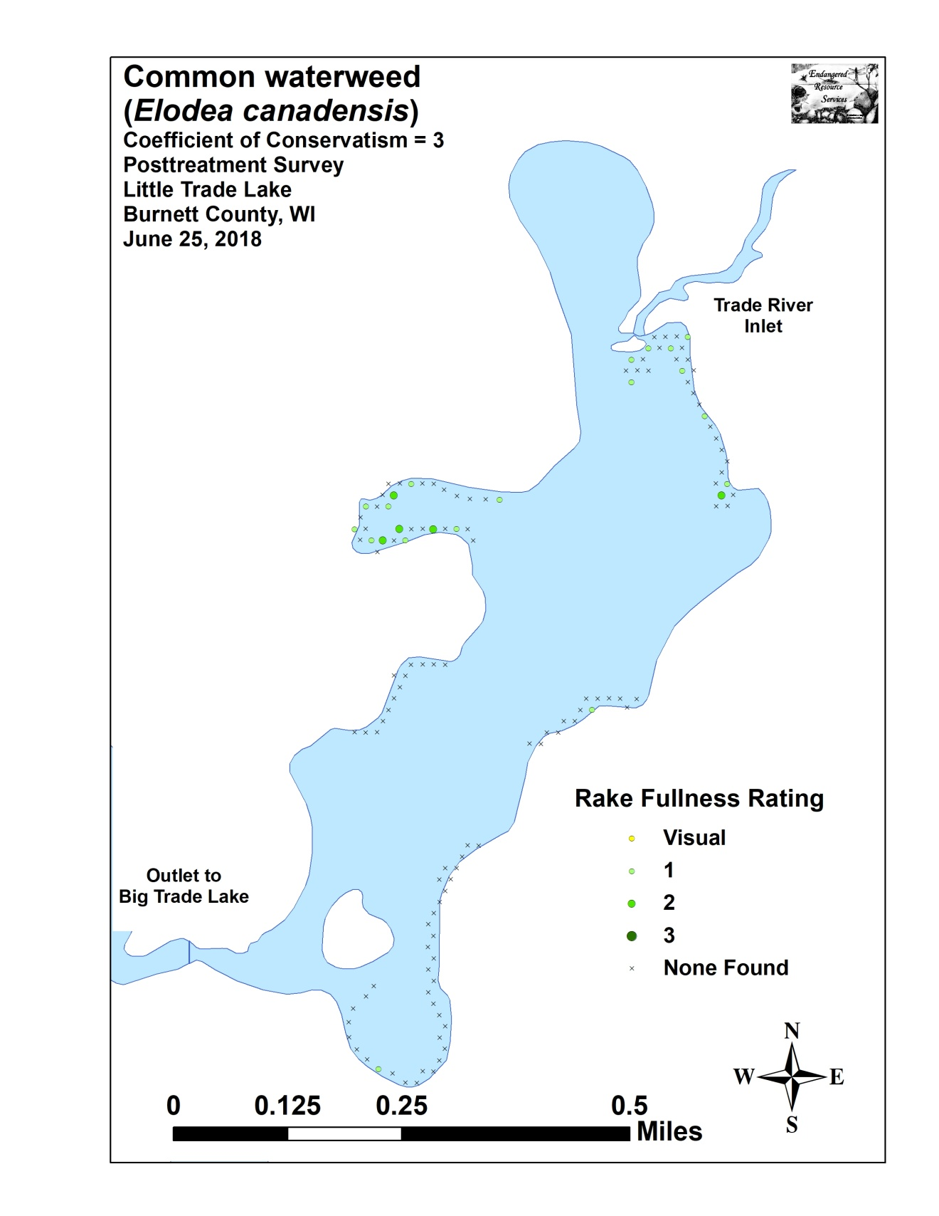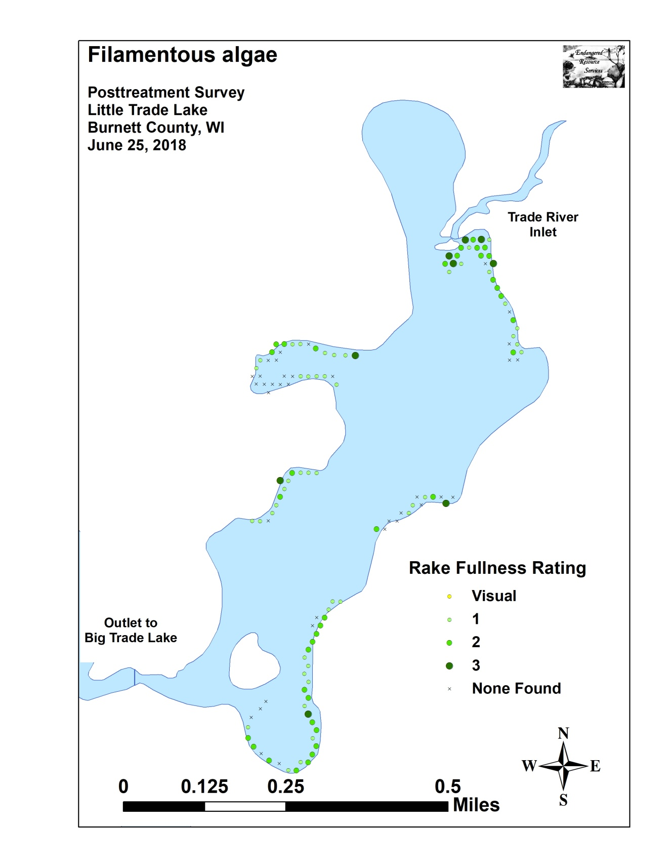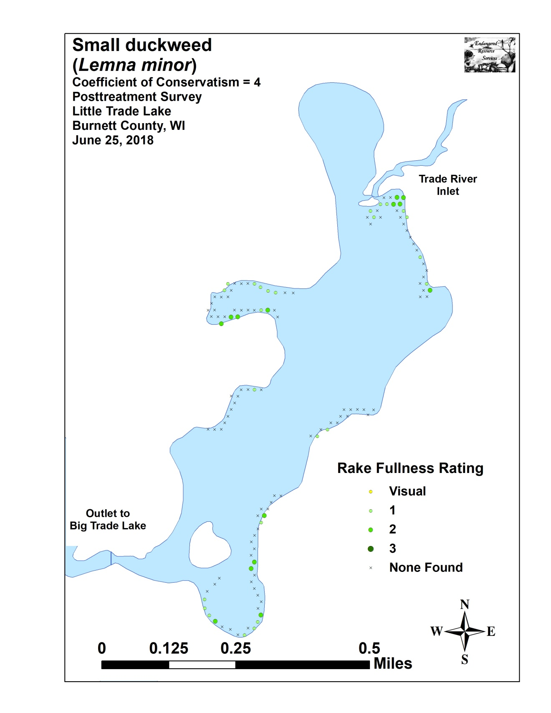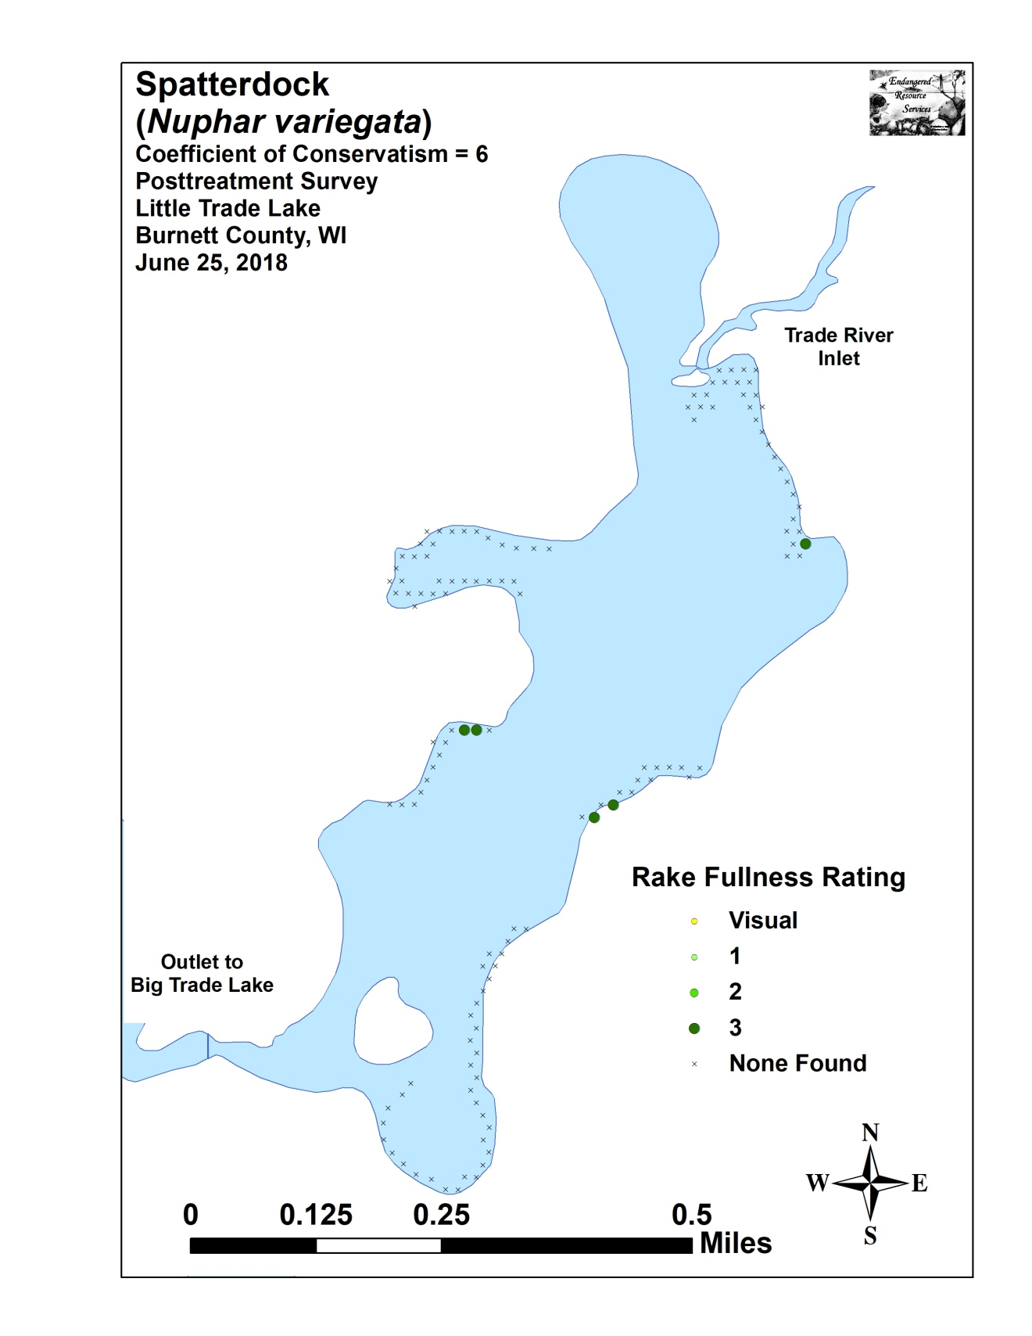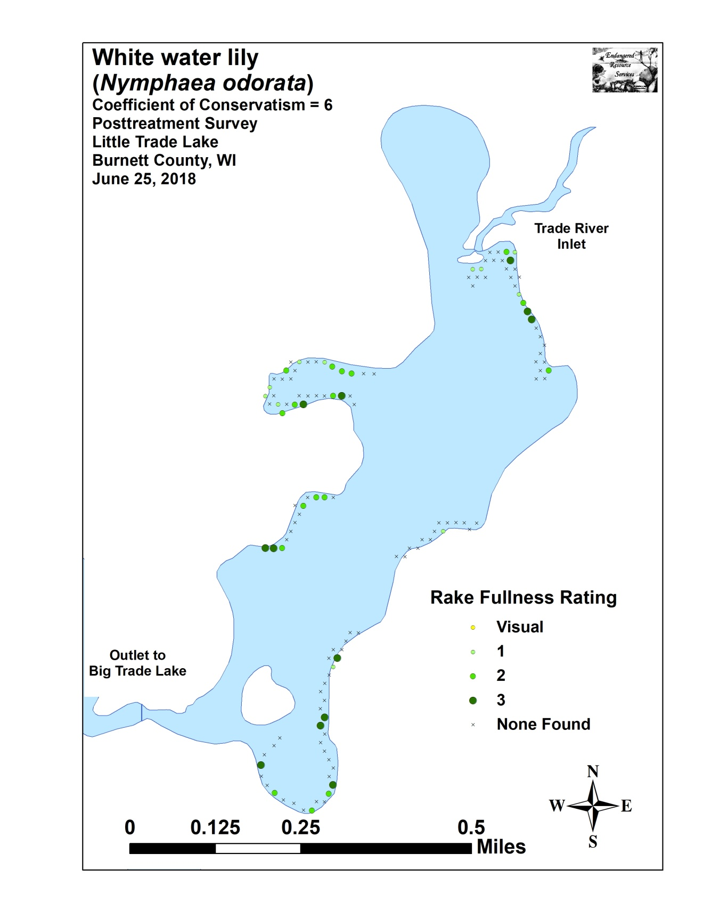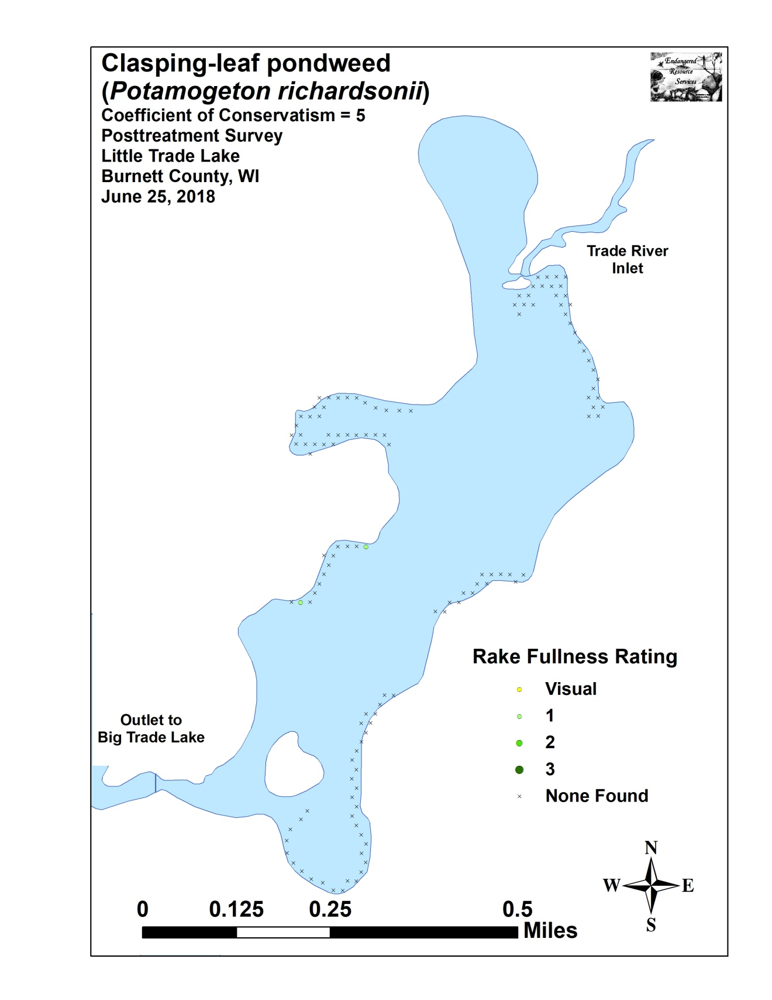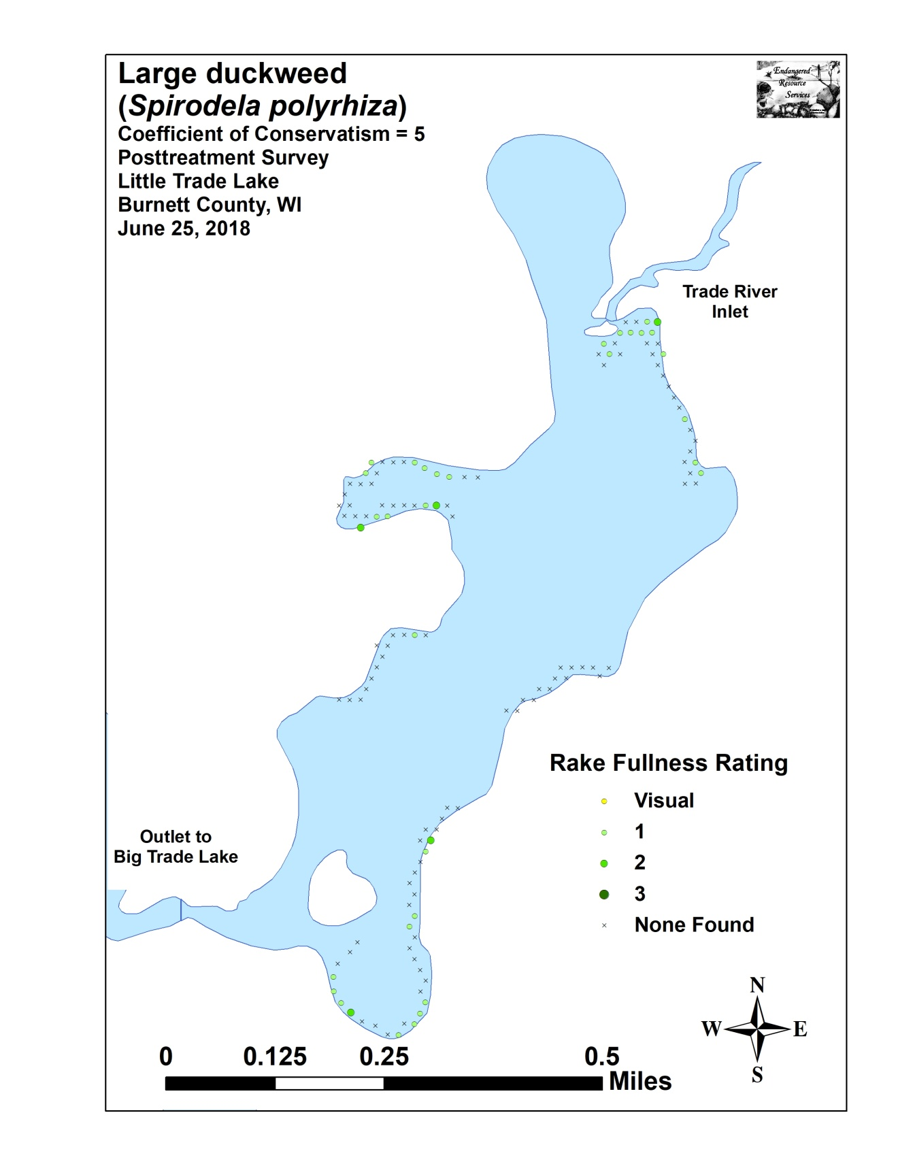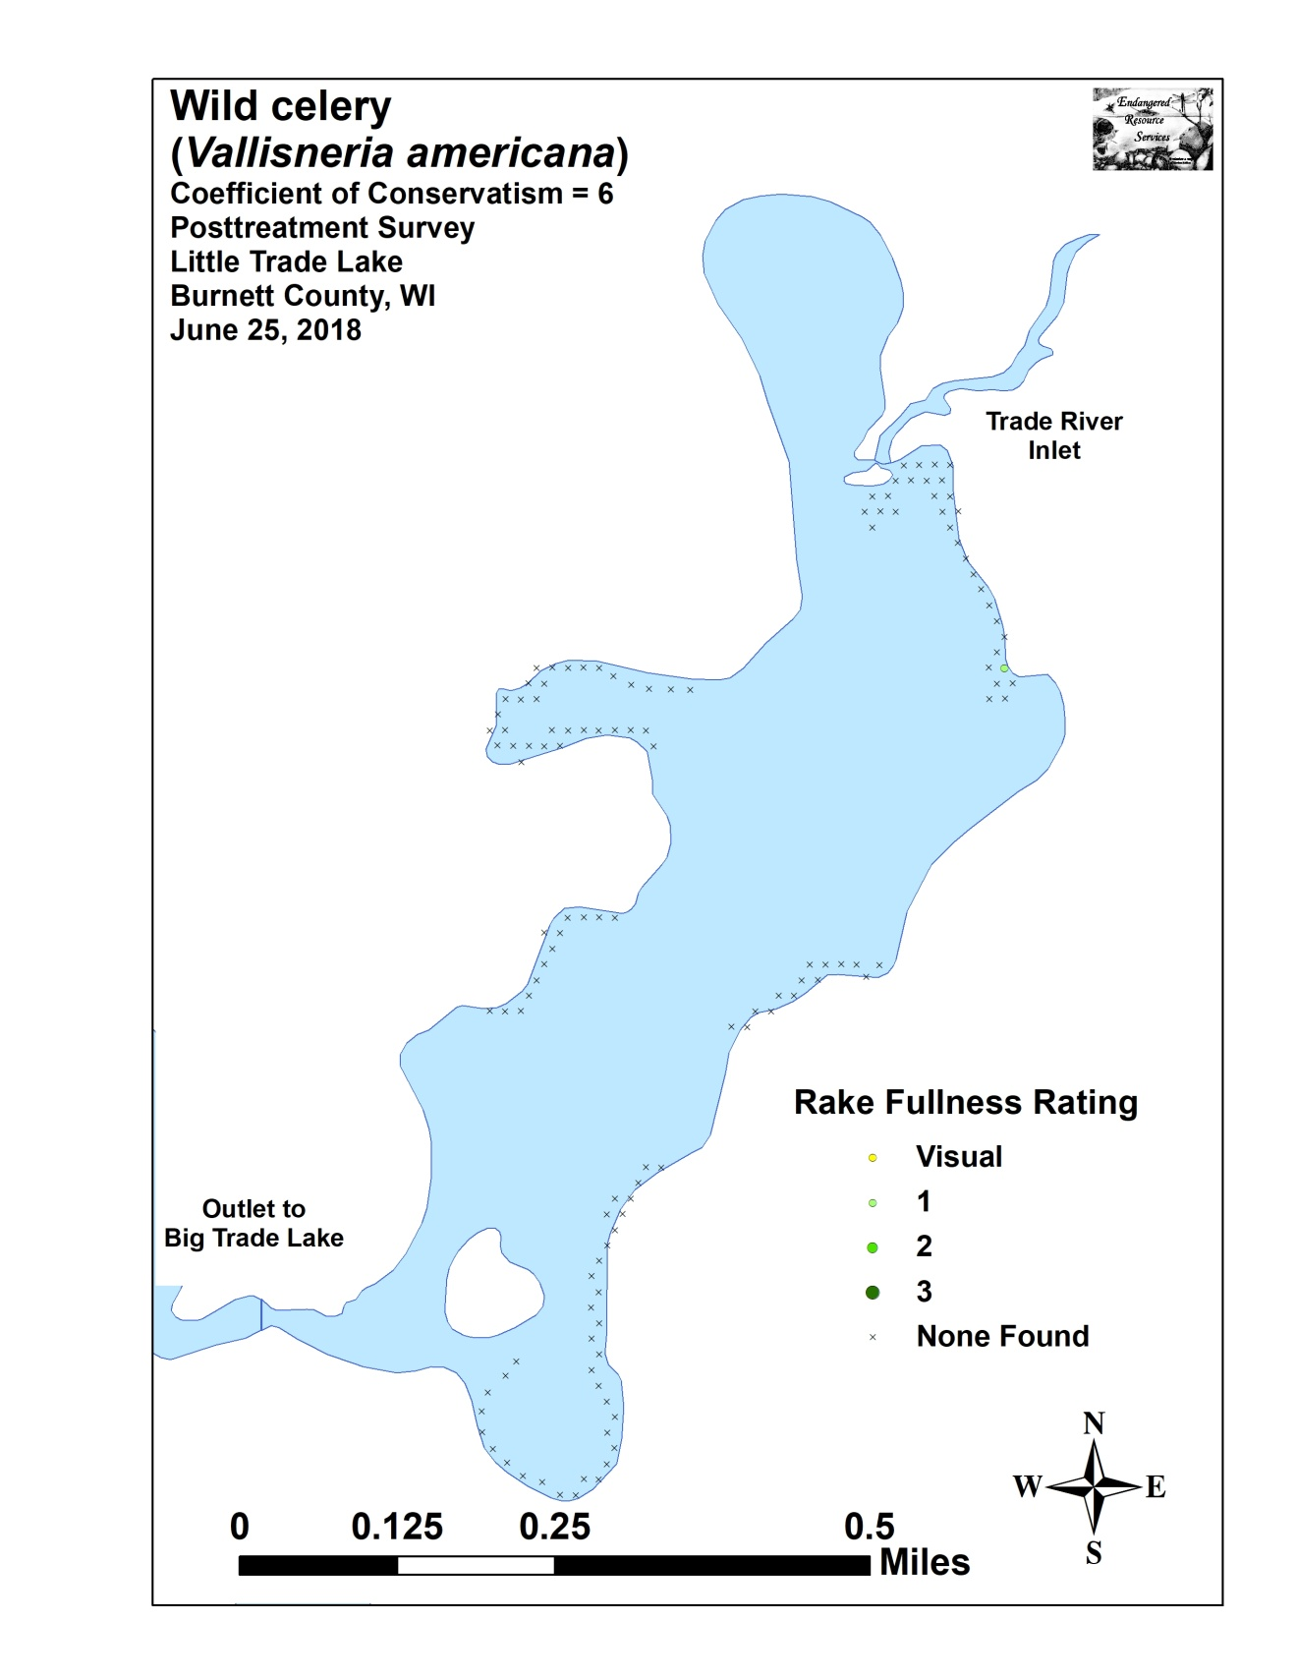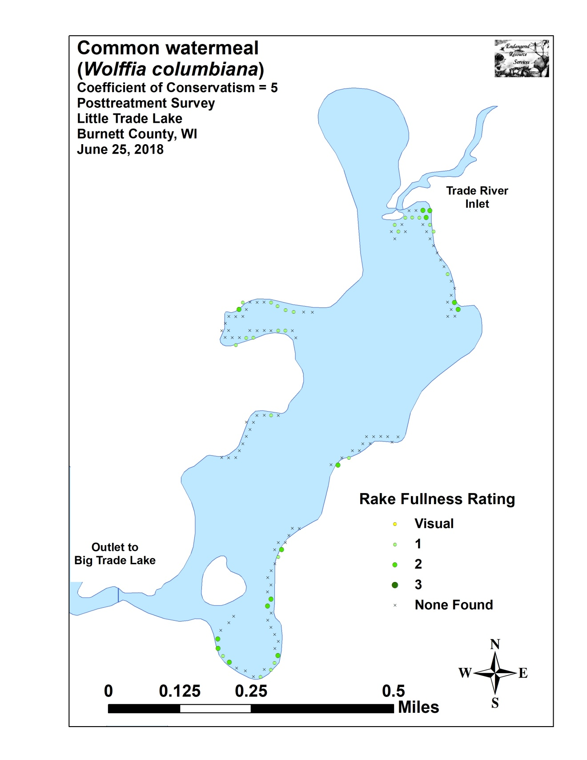

Appendix VIII: Fall 2017 and 2018 EWM Bed Maps
