Long Lake Rain Garden
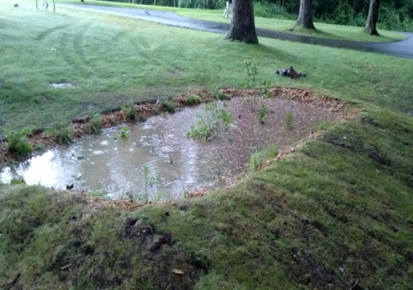
A rain garden is a shallow, constructed depression that is planted with deep-rooted native plants & grasses. It is located in your landscape to receive runoff from hard surfaces such as a roof, a sidewalk and a driveway. Rain gardens slow down the rush of water from these hard surfaces, hold the water for a short period of time and allow it to naturally infiltrate into the ground thus filter the water before it goes into the lake.
A rain garden can be thought of as a personal water quality system because it filters the runoff from your driveway, roof and lawn and recharges the groundwater.
If you decide to install a rain garden, know that you will have the professional help through Cheryl Clemens of Harmony Environmental to guide you through the process. She will help in identifying the area to best deal with your runoff issues. She will also develop a blueprint that consists of the size of the garden to best handle the runoff and identify the native plants and where to position them within the rain garden. To help you further, the lake association has funds available to offset some of your expenses. The biggest benefit is that we will have a cleaner and healthier lake to enjoy.
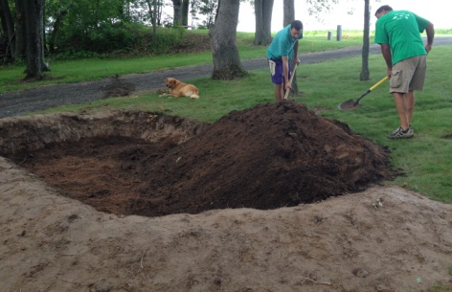
Getting Started
Step 1 - Contact Cheryl Clemens Harmonyenv@amerytel.net
Harmony Environmental 715-268-9992 (office)
Work with Cheryl and develop a plan

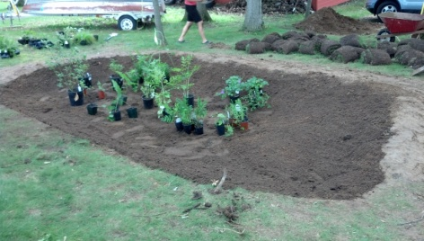
Step 2 - The toughest part was digging the hole. Our hole was 20' X 11' and 22" deep. We did it the hard way by hand but you could rent a bobcat or some type of digging device. A channel was dug across the drivway to funnel water into the garden. We used the dirt from the hole to build up a berm in the front and two sides of the hole. We also rented a sod cutter so we could reuse the sod on the berm we created.

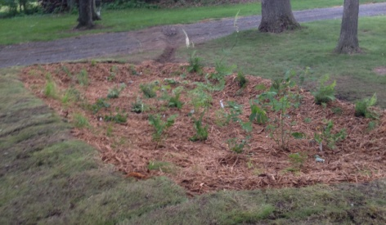
Step 3 - Refill the hole with a special mixture of sand and compost.
This was delivered and dumped into the hole.

Step 4 - We positioned the native plants within the hole and with the help of our neighbors planted and added cypress mulch.

Step 5 - Enjoy a cleaner Long Lake

Total cost for material and labor was about $1,200 of which we were reimbursed $830. This also included material and the installation of a french drain located in a different area to filter roof runoff.

We would be happy to talk to you about our rain garden and your next steps to help beautify Long Lake. Stop by and take a look.

Steve & Bonnie Sherod
1723 Tanglewood Trail

