Curly-leaf Pondweed (Potamogeton crispus) Pretreatment, Follow-up and Bed Mapping Surveys
Balsam Lake - WBIC: 2620600
Polk County, Wisconsin

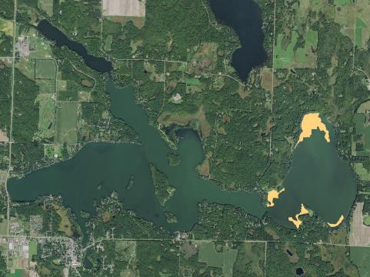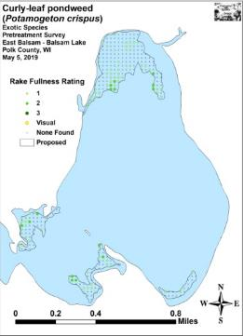
Proposed Spring 2019 CLP Treatment Areas 2019 CLP Pretreatment in East Balsam
Project Initiated by:
Balsam Lake Protection and Rehabilitation District and the
Wisconsin Department of Natural Resources – Grant ACEI21218

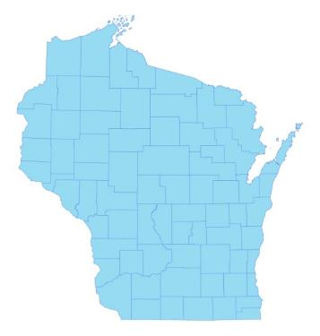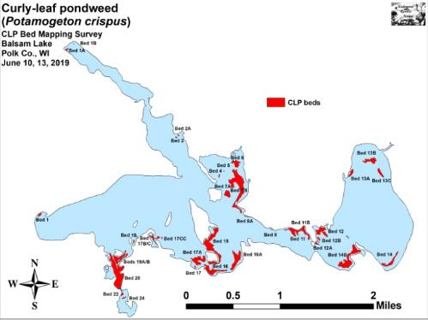

* Balsam Lake
2019 CLP Beds
Surveys Conducted by and Report Prepared by:
Endangered Resource Services, LLC
Matthew S. Berg, Research Biologist
St. Croix Falls, Wisconsin
May 5, June 10 and 13, 2019
TABLE OF CONTENTS

Page
LIST OF FIGURES AND TABLES……………………………………………….. ii

INTRODUCTION………………………………………………………………….. 1

BACKGROUND AND STUDY RATIONALE.…………………………………… 1

METHODS …………………………………………………………………………. 2

RESULTS AND DISCUSSION……………………………………………………. 3

Finalization of Treatment Areas…..…………….……………………………… 3

Pretreatment/Follow-up Surveys……………………………………………….. 4

Curly-leaf Pondweed Bed Mapping Survey……….…………………………… 15

Description of Past and Present Curly-leaf Pondweed Beds.………………….. 18

LITERATURE CITED.……………………….……………………………………. 20

APPENDIXES …….………………………………………………………………... 21

I: CLP Pre/Follow-up Survey Sample Points and Proposed Treatment Areas….. 21

II: Vegetative Survey Datasheet……..…………………………………………... 24

III: Pre/Follow-up Habitat Variables.……………………...……………………... 26

IV: Pre/Follow-up Lit. Zone, Native Species Richness and Total Rake Fullness... 29

V: CLP Pre/Follow-up Density and Distribution………………………………… 36

VI: Pretreatment Native Species Density and Distribution.…..…….……………. 39

VII: Follow-up Native Species Density and Distribution…………………………. 50

VIII: 2016, 2017, 2018, and 2019 Spring CLP Bed Maps..……………………….. 66

LIST OF FIGURES AND TABLES

Page
Figure 1: Balsam Lake with Proposed 2019 CLP Treatment Areas……………..… 1
Figure 2: Rake Fullness Ratings…..………………….…….…………………….... 2
Table 1: 2019 Spring CLP Treatment Summary - Balsam Lake, Polk Co………… 3

Figure 3: Pre/Follow-up Survey Points and CLP Treatment Areas…..……….…… 3
Figure 4: CLP Area Depths and Bottom Substrate...….……………..…….………. 4
Table 2: Pre/Follow-up Survey Summary Statistics –
Balsam Lake, Polk County May 5 and June 10, 2019……………………………… 5

Figure 5: Pre/Follow-up Littoral Zone.…………....….…….………………..…….. 5
Figure 6: Pre/Follow-up Native Species Richness…………………………………. 6
Figure 7: Pre/Follow-up Total Rake Fullness……………………………………… 6
Figure 8: Pre/Follow-up CLP Density and Distribution………………....………… 7
Figure 9: Changes in CLP Rake Fullness………………………………………….. 8
Figure 10: Pre/Follow-up Forked Duckweed Density and Distribution.…………... 9
Figure 11: Pre/Follow-up Coontail Density and Distribution……………………… 9

Table 3: Frequencies and Mean Rake Sample of Aquatic Macrophytes
Pretreatment Survey – Balsam Lake, Polk County May 5, 2019….………..…........ 10

Table 4: Frequencies and Mean Rake Sample of Aquatic Macrophytes
Follow-up Survey – Balsam Lake, Polk County June 10, 2019………….…….…… 11

Figure 12: Pre/Follow-up Macrophyte Changes………………………..………….. 12
Figure 13: Late May/June 2014-2019 – Differences for All Species – East Balsam 14
Figure 14: 2018 and 2019 Balsam Lake June CLP Beds……………….…..……… 15
Table 5: CLP Bed Summary – Balsam Lake, Polk Co. June 10, 13, 2019………… 16
Table 6: Historical CLP Bed and Treatment Summary –
Balsam Lake, Polk Co. 2009-2019…………………………………......................... 17
INTRODUCTION:
Balsam Lake (WBIC 2620600) is a 2,054 acre stratified drainage lake in central Polk County, Wisconsin in the Towns of Balsam Lake, Milltown, Georgetown, and Apple River (T34N R17W S10 NE NE). It reaches a maximum depth of 37ft north of Cedar Island in the western basin and has an average depth of 20ft (Hopke et al. 1964). The lake is mesotrophic bordering on eutrophic in nature, and water clarity is fair with historical summer Secchi readings averaging 5ft in East Balsam, 6ft in Little Balsam, and 8ft in the deep hole north of Cedar Island (WDNR 2019). Bottom substrate is variable with organic muck in most bays, and rock/sand in the Big and Little Narrows and around the lake’s many islands.

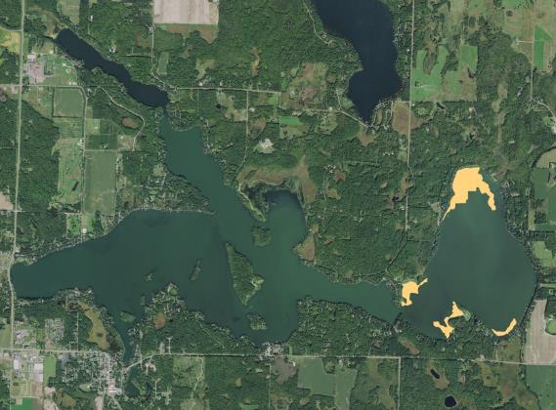
Figure 1: Balsam Lake with Proposed 2019 CLP Treatment Areas

BACKGROUND AND STUDY RATIONALE:
In the spring of 2019, the Balsam Lake Protection and Rehabilitation District (BLPRD) and the Wisconsin Department of Natural Resources (WDNR) authorized the herbicide treatment of 50.00 acres (2.43% of the lake’s total surface area) within four Curly-leaf pondweed (Potamogeton crispus) (CLP) beds totaling 65.45 acres in East Balsam (Figure 1). These beds were selected based on the 2013 spring CLP bed mapping survey that found CLP in these areas was interfering with boat traffic and/or restricting resident access to the lake from their docks, and the fall 2018 turion survey which suggested there would still be CLP growth in this area in 2019.

Prior to the planned 2019 herbicide application, we conducted a pretreatment survey of the lake on May 5th to determine initial CLP levels and finalize treatment areas. Similar to 2018, this survey found only patchy CLP. Because of this, it was decided to cancel the 2019 treatment in its entirety. However, in order to see how CLP and native plant populations responded to skipping treatment, it was requested that we do a follow-up survey on June 10th. We also returned to the lake on June 13th and completed a delineation of all CLP beds found within the visible littoral zone. These maps were used to guide mechanical harvesting in 2019, and they will also be used to help plan for future management in 2020. This report is the summary analysis of these three field surveys.
METHODS:
Pre/Follow-up Herbicide Survey:
Following a winter meeting of the BLPRD’s Aquatic Plant Management Committee, it was decided to treat the same general areas in 2019 that were treated from 2014-17. In order to make year-over-year comparisons, we used the same 276 survey points that we established in 2014 (offset regular points at 31m resolution) for each subsequent survey. This sampling grid approximated to just over four points/acre and was based on the WDNR protocol’s expected 4-10 survey pts/acre for pre/follow-up herbicide surveys (Appendix I).

These points were uploaded to a handheld mapping GPS (Garmin 76CSx) and located on the lake. At each point, we recorded the depth and bottom substrate and used a rake to sample an approximately 2.5ft section of the bottom. CLP was assigned a rake fullness value of 1-3 as an estimation of abundance (Figure 2). We also recorded visual sightings of CLP within six feet of the sample point. Because visual sightings are not calculated into the pre/posttreatment statistical formulas, we only assigned a rake fullness value for non-CLP plants. A cumulative rake fullness value was also noted.

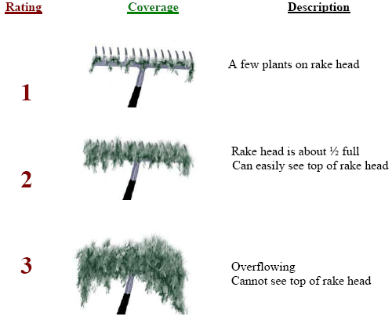
Figure 2: Rake Fullness Ratings

We entered all data collected into the standard APM spreadsheet (Appendix II), and data was analyzed using the linked statistical summary sheet. For pre/post differences of individual plant species and count data, we used the Chi-square analysis on the WDNR pre/post survey worksheet (UWEX 2010). For comparing averages (mean species/point and mean rake fullness/point), we used t-tests. Differences were determined to be significant at p<0.05, moderately significant at p<0.01 and highly significant at p<0.001.

CLP Bed Mapping Survey:
During the bed mapping survey, we searched the lake’s visible littoral zone. By definition, a “bed” was determined to be any area where we visually estimated that CLP made up >50% of the area’s plants, was generally continuous with clearly defined borders, and was canopied or close enough to being canopied that it would likely interfere with boat traffic. After we located a bed, we motored around the perimeter taking GPS coordinates at regular intervals. We also estimated the rake density range and mean rake fullness of the bed (Figure 2), the range and mean depth of the bed, whether it was canopied, and the impact it was likely to have on navigation (none – easily avoidable with a natural channel around or narrow enough to motor through/minor – one prop clear to get through or access open water/moderate – several prop clears needed to navigate through/severe – multiple prop clears and difficult to impossible to row through). These data were then mapped using ArcMap 9.3.1, and we used the WDNR’s Forestry Tools Extension to determine the acreage of each bed to the nearest hundredth of an acre.
RESULTS AND DISCUSSION:
Finalization of Treatment Areas:
The potential treatment areas covered 65.45 acres or approximately 3.19% of the lake’s 2,054 total acres (Table 1). In 2019, northwest Wisconsin experienced near record snowfall and a late ice-out in late April. These conditions appeared to negatively impact Curly-leaf pondweed turion germination and growth as many area lakes had unusually low overall CLP plant density and total biomass. Following analysis of the pretreatment survey, we noted CLP was only scattered throughout the treatment area and seldom reached even moderate density. After considering the cost/benefit, the BLPRD decided to cancel treatment in all areas in 2019 (Figure 3) (Appendix I).

Table 1: 2019 Spring CLP Treatment Summary
Balsam Lake, Polk Co.

Bed Number | Proposed Bed Area  (acres) | Potential  Treatment Area (acres) | Final  Treatment Area (acres) | Change from Proposed Acreage (+/-)
12 | 10.34 | 0.00 | 0.00 | -10.34
13 | 40.83 | 0.00 | 0.00 | -40.83
14 | 4.37 | 0.00 | 0.00 | -4.37
14B | 9.91 | 0.00 | 0.00 | -9.91
 | 65.45 | 0.00 | 0.00 | -65.45

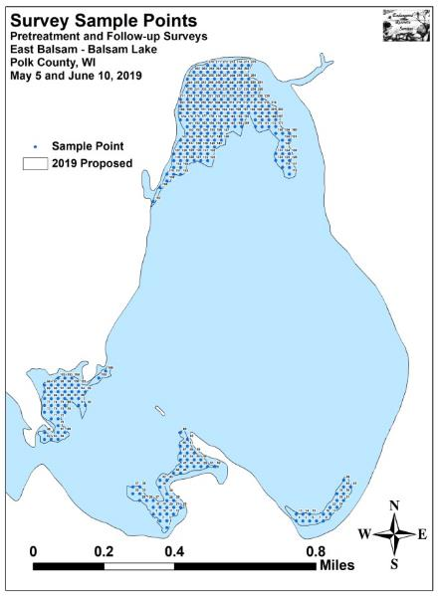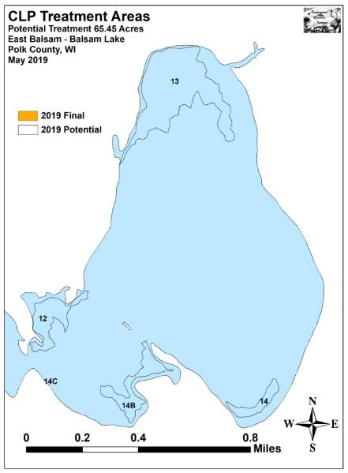
Figure 3: Pre/Follow-up Survey Points and CLP Treatment Areas

Pretreatment/Follow-up Surveys:
All beds occurred in areas between 2.5 and 11.5ft of water. During the pretreatment survey, we found the mean and median depth of plant growth was 7.6ft and 7.5ft respectively. By June, the mean had ticked up to 7.7ft, and the median had increased to 8.0 ft – presumably due to expansion of Curly-leaf pondweed on the outer edge of the littoral zone (Table 2). Most CLP was established over organic muck, but we also found scattered plants in the sandy/rocky areas of Beds 13 and 14 (Figure 4) (Appendix III).

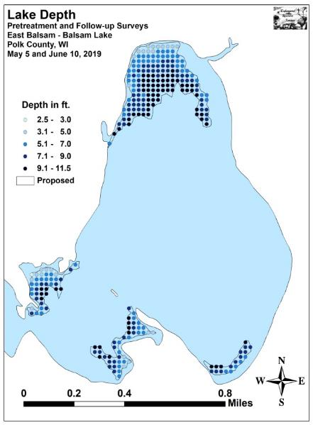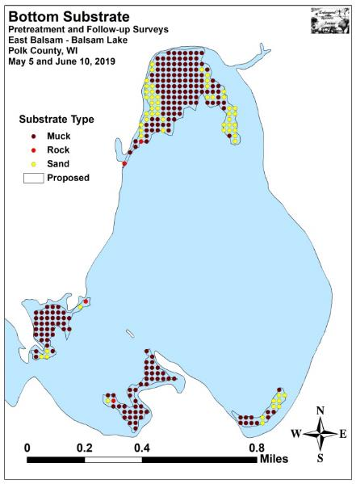
Figure 4: CLP Area Depths and Bottom Substrate

The littoral zone was unchanged at 11.5ft for both surveys; however, the frequency of plant occurrence at littoral points jumped from 80.1% during the pretreatment survey to 98.9% during the June follow-up (Figure 5) (Appendix IV). Species richness also rose sharply from nine pretreatment to 15 during the follow-up. The Simpson’s Diversity Index increased slightly from 0.69 in May to 0.71 in June; and the Floristic Quality Index (another measure of the native plant community health) increased from 16.3 pretreatment to 22.2 in June.

Table 2: Pre/Follow-up Survey Summary Statistics
Balsam Lake, Polk County
May 5 and June 10, 2019
Summary Statistics: | May | June
Total number of points sampled | 276 | 276
Total number of sites with vegetation | 221 | 273
Total number of sites shallower than the maximum depth of plants | 276 | 276
Frequency of occurrence at sites shallower than maximum depth of plants | 80.1 | 98.9
Simpson Diversity Index | 0.69 | 0.71
Mean Coefficient of Conservatism | 5.8 | 5.9
Floristic Quality Index | 16.3 | 22.2
Maximum depth of plants (ft) | 11.5 | 11.5
Mean depth of plants (ft) | 7.6 | 7.7
Median depth of plants (ft) | 7.5 | 8.0
Average number of all species per site (shallower than max depth) | 1.32 | 1.92
Average number of all species per site (veg. sites only) | 1.64 | 1.95
Average number of native species per site (shallower than max depth) | 1.02 | 1.35
Average number of native species per site (sites with native veg. only) | 1.43 | 1.51
Species Richness | 9 | 15
Mean Rake Fullness (veg. sites only) | 1.36 | 1.63

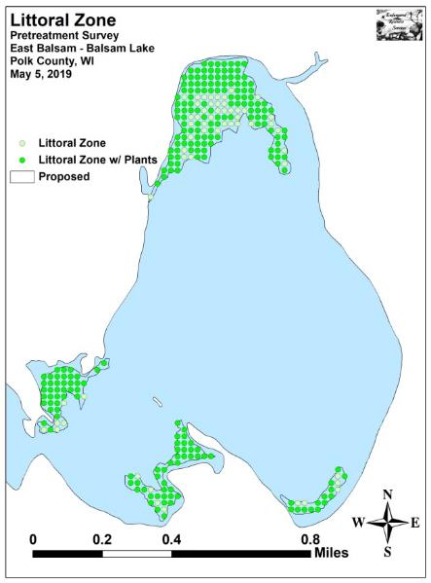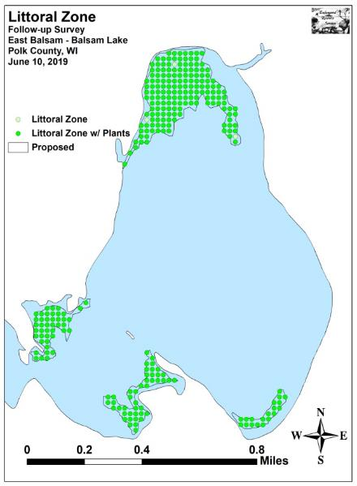
Figure 5: Pre/Follow-up Littoral Zone

Mean native species richness at points with native vegetation experienced a nearly significant increase (p=0.10) from 1.43 species/point in May to 1.51 species/point in June (Figure 6). The total mean rake fullness during the pretreatment survey was an exceptionally low 1.36. Although its increase to 1.63 in June was highly significant (p<0.001), it was still just a low/moderate density (Figure 7) (Appendix IV).

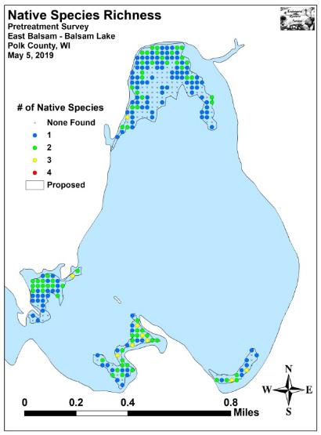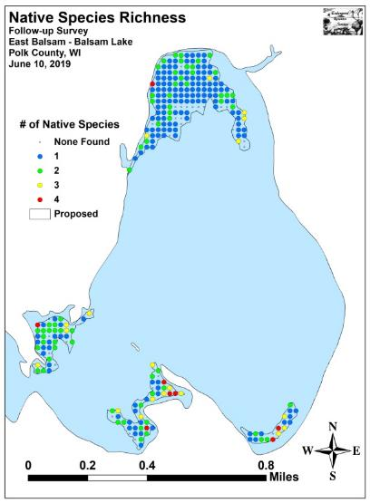
Figure 6: Pre/Follow-up Native Species Richness

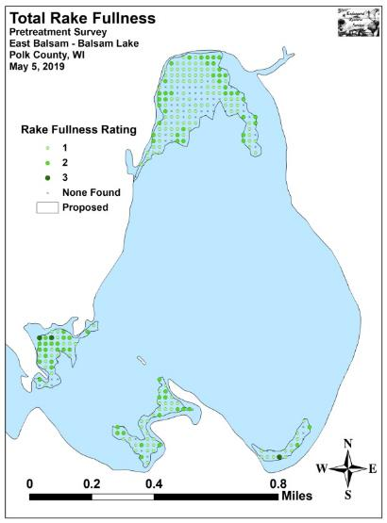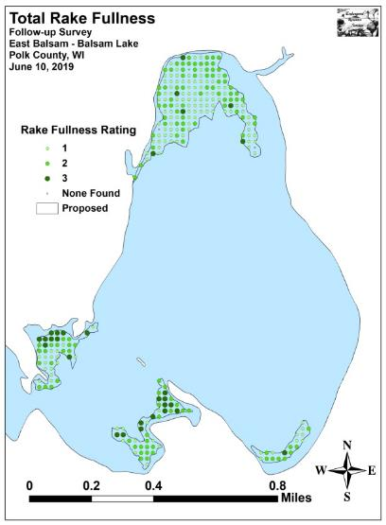
Figure 7: Pre/Follow-up Total Rake Fullness
We found Curly-leaf pondweed at 82 of 276 sites (29.7% coverage) during the pretreatment survey (Figure 8). Although this was an increase from the 53 sites (19.2% coverage) in 2018, it was still much below the 192 sites (69.6%) with CLP in 2017’s pretreatment survey; 159 sites (57.6%) in 2016; and 208 sites (75.4%) in 2015. Of these, none had a rake fullness rating of 3, 15 rated a 2, and 67 were a 1 with a single additional visual sighting. This produced a mean rake fullness for CLP of 1.18 and suggested just 5.4% of the beds had a significant infestation (rake fullness of 2 or 3). During the follow-up survey, we found CLP at 158 points (57.2% coverage) with 26 rating a 3, 53 rating a 2 (28.6% significant infestation), and the remaining 79 a 1 for a mean rake fullness of 1.66. CLP was also recorded as a visual at 16 points (Appendix V).

As expected after a second year without early-season active management, our results demonstrated a highly significant increase (p<0.001) in mean rake fullness, total CLP, rake fullness 3 and 2, and visual sightings (Figure 9). The 79 points (28.6%) with a significant infestation also represented a 427% increase over pretreatment values. It was also a 216% increase over 2018’s follow-up survey when we found 25 points (9.1%) with a significant infestation (74 total points/26.8% coverage where two rated a 3, 23 were a two, and 49 a 1 for a mean rake fullness of 1.36).

Analysis of the follow-up survey map showed that CLP distribution remained patchy in the north bay with plants either occurring in shallow areas <5ft deep or on the outer edge of the littoral zone in >9ft. In the south bays, almost all CLP occurred at shallower depths where the harvester should be able to make a significant impact.

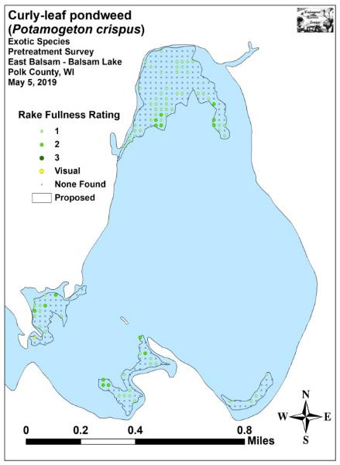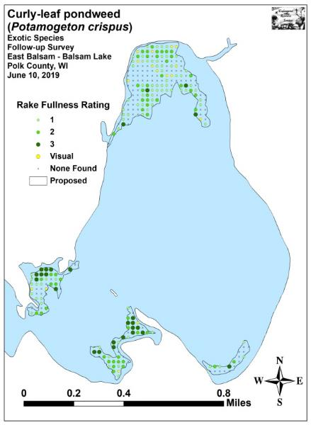
Figure 8: Pre/Follow-up CLP Density and Distribution

+***
+***
+***
+***
Significant differences = * p<0.05, ** p<0.01, *** p<0.001
Figure 9: Changes in CLP Rake Fullness

Forked duckweed (Lemna trisulca) and Coontail (Ceratophyllum demersum) were the most common native species in both the pretreatment and follow-up surveys (Figures 10 and 11) (Tables 3 and 4). Forked duckweed saw a highly significant increase (p<0.001) in distribution from 160 sites in May to 218 sites in June; however, its decline in mean rake fullness from 1.23 to 1.21 was not significant (p=0.37). Coontail was almost unchanged in both distribution (90 sites in May/92 sites in June) (p=0.86) or density (mean rake 1.32 in May/1.37 in June) (p=0.28).

Many additional species did show significant changes in distribution (Figure 12). Filamentous algae demonstrated a highly significant increase (p<0.001) in both density and distribution (112 sites/mean rake 1.21 May – 154 sites/mean rake 1.58 June); Northern water-milfoil (Myriophyllum sibiricum) enjoyed a moderately significant increase in distribution (3 sites in May/15 sites in June) (p=0.004) and a significant increase in density (mean rake 1.00 in May/1.27 in June) (p=0.04). Other later-growing species which weren’t present during the pretreatment survey saw significant increases in distribution. They included Illinois pondweed (Potamogeton illinoensis) and Wild celery (Vallisneria americana) which were present at five sites (p=0.02), and Water star-grass (Heteranthera dubia) and White water crowfoot (Ranunculus aquatilis) which were present at four sites (p=0.04) (Maps of all native species from the pretreatment and follow-up surveys can be found in Appendixes VI and VII).
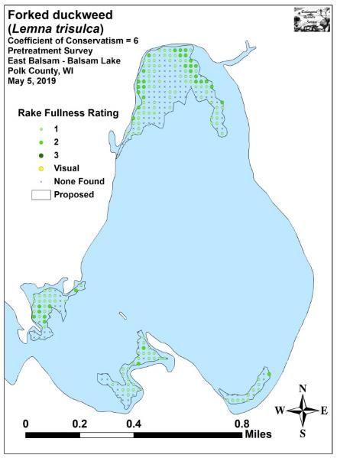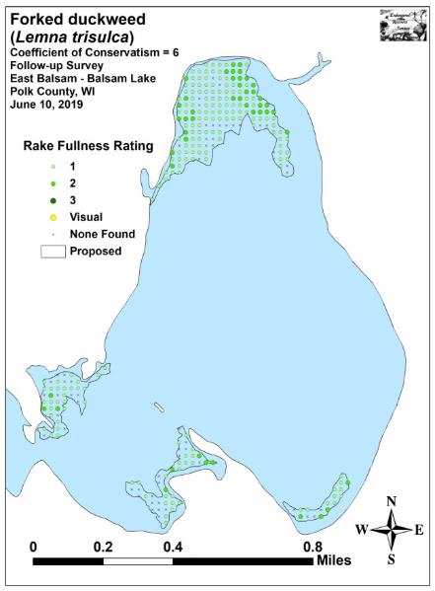
Figure 10: Pre/Follow-up Forked Duckweed Density and Distribution

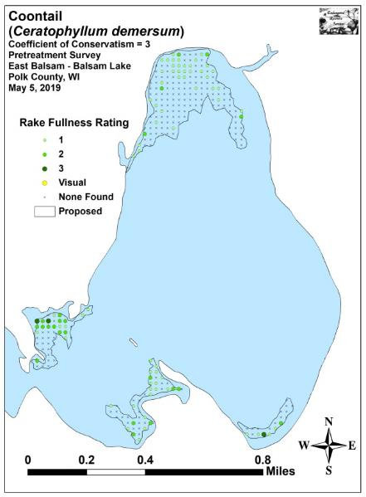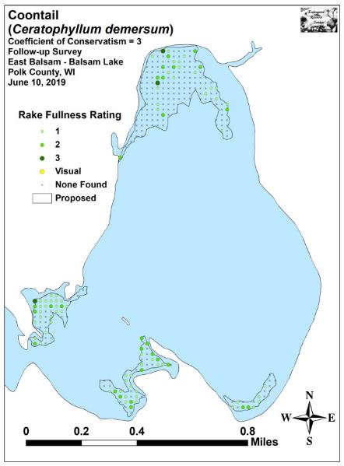
Figure 11: Pre/Follow-up Coontail Density and Distribution
Table 3: Frequencies and Mean Rake Sample of Aquatic Macrophytes
Pretreatment Survey - Balsam Lake, Polk County
May 5, 2019

Species | Common Name | Total  Sites | Relative Freq. | Freq. in Veg. | Freq. in Lit. | Mean Rake | Visual  Sight.
Lemna trisulca | Forked duckweed | 160 | 44.08 | 72.40 | 57.97 | 1.23 | 0
 | Filamentous algae | 112 | * | 50.68 | 40.58 | 1.21 | 0
Ceratophyllum demersum | Coontail | 90 | 24.79 | 40.72 | 32.61 | 1.32 | 0
Potamogeton crispus | Curly-leaf pondweed | 82 | 22.59 | 37.10 | 29.71 | 1.18 | 1
 | Aquatic moss | 20 | * | 9.05 | 7.25 | 1.20 | 0
Elodea canadensis | Common waterweed | 18 | 4.96 | 8.14 | 6.52 | 1.11 | 0
Potamogeton praelongus | White-stem pondweed | 6 | 1.65 | 2.71 | 2.17 | 1.00 | 0
Myriophyllum sibiricum | Northern water-milfoil | 3 | 0.83 | 1.36 | 1.09 | 1.00 | 0
Potamogeton pusillus | Small pondweed | 2 | 0.55 | 0.90 | 0.72 | 1.00 | 0
Chara sp. | Muskgrass | 1 | 0.28 | 0.45 | 0.36 | 1.00 | 0
Potamogeton zosteriformis | Flat-stem pondweed | 1 | 0.28 | 0.45 | 0.36 | 1.00 | 0

* Excluded from Relative Frequency Analysis

Table 4: Frequencies and Mean Rake Sample of Aquatic Macrophytes
Follow-up Survey - Balsam Lake, Polk County
June 10, 2019

Species | Common Name | Total  Sites | Relative Freq. | Freq. in Veg. | Freq. in Lit. | Mean Rake | Visual  Sight.
Lemna trisulca | Forked duckweed | 218 | 41.05 | 79.85 | 78.99 | 1.21 | 0
Potamogeton crispus | Curly-leaf pondweed | 158 | 29.76 | 57.88 | 57.25 | 1.66 | 16
 | Filamentous algae | 154 | * | 56.41 | 55.80 | 1.58 | 0
Ceratophyllum demersum | Coontail | 92 | 17.33 | 33.70 | 33.33 | 1.37 | 0
Myriophyllum sibiricum | Northern water-milfoil | 15 | 2.82 | 5.49 | 5.43 | 1.27 | 0
Elodea canadensis | Common waterweed | 14 | 2.64 | 5.13 | 5.07 | 1.14 | 0
 | Aquatic moss | 14 | * | 5.13 | 5.07 | 1.50 | 0
Potamogeton praelongus | White-stem pondweed | 6 | 1.13 | 2.20 | 2.17 | 1.00 | 0
Potamogeton illinoensis | Illinois pondweed | 5 | 0.94 | 1.83 | 1.81 | 1.20 | 0
Vallisneria americana | Wild celery | 5 | 0.94 | 1.83 | 1.81 | 1.00 | 0
Heteranthera dubia | Water star-grass | 4 | 0.75 | 1.47 | 1.45 | 1.00 | 0
Ranunculus aquatilis | White water crowfoot | 4 | 0.75 | 1.47 | 1.45 | 1.00 | 0
Nymphaea odorata | White water lily | 3 | 0.56 | 1.10 | 1.09 | 1.00 | 0
Nitella sp. | Nitella | 2 | 0.38 | 0.73 | 0.72 | 1.00 | 0
Potamogeton pusillus | Small pondweed | 2 | 0.38 | 0.73 | 0.72 | 1.00 | 0
Potamogeton zosteriformis | Flat-stem pondweed | 2 | 0.38 | 0.73 | 0.72 | 1.00 | 0
Potamogeton richardsonii | Clasping-leaf pondweed | 1 | 0.19 | 0.37 | 0.36 | 1.00 | 0

* Excluded from Relative Frequency Analysis

+*
+*
+*
+*
+**
+***
+***
+***

Significant differences = * p<0.05, ** p<0.01, *** p<0.001
Figure 12: Pre/Follow-up Macrophyte Changes

Looking back at the cumulative data from the posttreatment and follow-up surveys in East Balsam over the last six years (2014-2019) showed many species experienced significant changes (Figure 13). Following a relatively late treatment in 2014, Small pondweed (Potamogeton pusillus), a previously abundant fine-leaved early-growing species, showed highly significant declines and was not seen again until we found a single individual during the 2018 pretreatment survey.
In 2015, although it produced a highly significant reduction from the pretreatment survey, a relatively early treatment proved to be much less effective as Curly-leaf pondweed experienced a highly significant year-over-year increase – a change which was, based on our posttreatment observations, potentially due to latent turions sprouting after the treatment. The 2015 treatment also produced a highly significant year-over-year decrease in Coontail. Conversely, filamentous algae and Common waterweed (Elodea canadensis) experienced highly significant year-over-year increases; and Forked duckweed had a significant increase. All three of these species maintained these increases following the 2016 treatment. Other species that showed year-over-year increases in 2015 - such as Nitella, Illinois pondweed, and White-stem pondweed (Potamogeton praelongus) - dropped back to very low levels in 2016. Wild celery, a species that seems to exploit vacant habitat in the sandy shallows of East Balsam, inversely mirrored the changes in these broad-leaved pondweeds by significantly declining in 2015 before significantly rebounding in 2016. Coontail, a species that seems to be a competitor of CLP over muck in deeper water, experienced a significant rebound in 2016 that inversely mirrored the highly significant reduction in CLP.
Following the treatment in 2017, Forked duckweed experienced a highly significant reduction that mirrored the highly significant increase in filamentous algae and the moderately significant increase in the colonial algae Nitella. It may be that these species were competing for the same suspended nutrients. Common waterweed and Spatterdock (Nuphar variegata) also experienced significant year-over-year declines.
With no treatment in 2018, many species showed significant year-over-year changes. Filamentous algae suffered a highly significant decline, and Nitella saw a significant decline – again potentially because these colonial algae absorb nutrients from the water column that may not have been as readily available as they would be following a treatment when other plants are decomposing. Conversely, CLP, Forked duckweed, and Coontail enjoyed highly significant increases; White water crowfoot had a moderately significant increase, and both Spatterdock and Northern water-milfoil saw significant increases.
Following another year without treatment, many species continued to increase albeit at lower rates with few of these changes being significant. Only Forked duckweed and CLP had highly significant expansions in distribution. Aquatic moss and Illinois pondweed also showed significant expansion. Only Spatterdock suffered a significant decline – potentially as a result of the harvesting program.

+*
+*
+*
+**
-*
+*
-*
+*
-*
+***
+***
-***
+***
+*
-*
+*
-*
-*
-*
+***
+*
-*
+***
-***
+*
-***
+***
+***
+***
+***
-***
+*
Significant differences = * p<0.05, ** p<0.01, *** p<0.001
Figure 13: Late May/June 2014-2019 - Differences for All Species – East Balsam

Curly-leaf Pondweed Bed Mapping Survey:
In 2019, despite the heavy snow cover and late ice-out, Curly-leaf pondweed appears to have had ideal growing conditions on Balsam Lake as much below average temperatures throughout the rest of April and May resulted in little native plant growth. Without this competition, we found CLP turions continued to germinate into June, and early-growing CLP plants were able to canopy and occasionally form dense beds. In total, we located and mapped 34 beds – the most in any year we’ve worked on the lake (up from 28 beds in 2018; 21 beds in both 2017 and 2016; 14 beds in both 2015 and 2014; 13 beds in 2013; 20 beds in 2012, and seven beds in 2011). They ranged in size from 0.03 acre (Beds 1B in Little Balsam and Bed 5 in Stump Bay) to 16.11 acres (Merged Beds 7-8 in Stump Bay) (Figure 14) (Appendix VIII); and, collectively, they covered a total of 102.76 acres or 5.00% of the lake’s 2,054 total acres (Table 5).

The 2019 acreage total was also the highest we have ever mapped on the lake, and it represented a 67.35 acre increase (+190.2%) over the 35.41 acres (1.72% coverage) we found in 2018. Although, it was similar to the 97.73 acres (4.76% coverage) we mapped in 2017; it was still well above the 40.91 acres found in 2016 (1.99% coverage); the 16.32 acres in 2015 (0.79% coverage); the 4.54 acres in 2014 (0.22% coverage); and the 80.58 acres (3.92% coverage) mapped in 2013 (Table 6). Most of the expansion seen in 2019 occurred in Stump Bay, around Paradise Island, in the formerly treated areas in East Balsam, and in the channel leading north of the village beach landing.

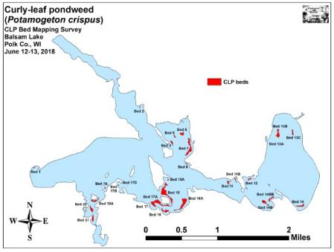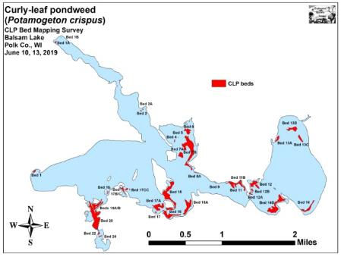
Figure 14: 2018 and 2019 Balsam Lake June CLP Beds

Table 5: CLP Bed Summary - Balsam Lake, Polk Co. June 10, 13, 2019

Bed # | Location | 2019  Area (Acres) | 2018  Area | 2018-19  Change in Area | Est. Range and Mean  Rake-full | Depth Range and Mean Depth | Navigation Impairment | Field Notes
1 | HWY 46 Landing | 0.51 | 0.14 | 0.37 | <1-2; 1 | 4-7; 6 | Minor | Patchy – mixed with natives
1A, 1B | Rice Creek Inlet | 0.31 | 0 | 0.28 | <<1-2; 1 | 2-4, 3 | Minor | Most plants around floating docks
2 and 2A | Boston Bay | 0.30 | 0.13 | 0.17 | <<1-2; 1 | 3-7; 5 | Minor | Most of former bed barren; natives
3-8A | Stump Bay and Outlet | 19.19 | 6.41 | 12.78 | <<<1-3; 1 | 3-8; 5 | Minor | Most narrow in front of residences
7A | East of Carlson Island | 2.18 | 0 | 2.18 | 2-3; 2 | 7-10; 8 | Moderate | Deep water bed mixed with natives.
9-11 | Bay NW of Big Narrows | 5.97 | 1.03 | 4.94 | <1-3; 2 | 2-10; 7 | Moderate | Mixed with natives; esp. crowfoot
12 | Bay NE of Big Narrows | 4.79 | 0.52 | 4.27 | <<<1-3; 2 | 2-8; 6 | Moderate | Canopied at edge of lilypads
13, A, B, C | N. Bay of East Balsam | 5.70 | 2.73 | 2.97 | <1-3; 1 | 6-10; 8 | Minor | CLP only near canopy
14 | SE Bay of East Balsam | 2.94 | 1.06 | 1.88 | <<<1-2; 1 | 7-10; 8 | Minor | Lots of native pondweeds
14B-BB, 14C | Bay SE of Big Narrows | 10.12 | 2.37 | 7.75 | <<1-2; 1 | 5-10; 8 | Minor | Patchy with natives mixed in
15, A, B | E. and SE of Big Island | 12.60 | 7.26 | 5.34 | <<<1-3; 2 | 3-11, 7 | Moderate | Mixed with natives/prop trails
16 | Bay S. of Paradise Island | 4.96 | 1.45 | 3.51 | <<<1-3; 2 | 5-10; 7 | Moderate | Mixed with natives/prop trails
16A + B | E. of Paradise Landing | 6.18 | 4.33 | 1.85 | <<1-3; 2 | 5-10; 8 | Moderate | Mixed with natives/prop trails
17 | Bay SW of Paradise Island | 0.20 | 0.04 | 0.16 | <<<1-2; 1 | 3-5; 4 | Minor | Couple of patches; easily avoided
17A | West of Paradise Island | 5.09 | 4.27 | 0.82 | <<<1-3; 2 | 5-11; 7 | Moderate | Mixed with natives/prop trails
17B+D | Raskin Bay | 1.62 | 0.11 | 1.51 | <<<1-2; 1 | 2-5; 3 | Minor | Plants uprooted by boat traffic
17C and CC | Raskin Bay Outlet | 0.12 | 0.01 | 0.11 | <<<1-2; <1 | 7-10; 8 | None | More natives than CLP
18 | Channel E. of Pine Island | 0.27 | 0.13 | 0.14 | <<<1-2; 1 | 4-7; 6 | Minor | Plants uprooted by boat traffic
19A , B | Channel S/E. of First Island | 4.30 | 1.18 | 3.12 | <<1-3; 2 | 4-10; 7 | Moderate | Boats keeping channel open
20, 20A, and 21 | East of Idlewild Bay | 14.74 | 2.25 | 12.49 | <<1-3; 3 | 4-10; 8 | Severe | Boats keeping channel open
22 | Northwest Mill Pond | 0.40 | 0 | 0.4 | <<1-3; 1 | 4-10; 7 | Minor | Lots of natives mixed in.
23 | Northeast Mill Pond | 0 | 0 | 0 | <<<1 | 4-6; 5 | None | Scattered CLP – native dominated
24 | Mill Pond Point | 0.28 | 0 | 0.28 | <<<1-2 | 4-9; 5 | Minor | Lots of natives mixed in.
25 | Southeast Mill Pond | 0 | 0 | 0 | <<<1 | 4-6; 5 | None | Scattered CLP – native dominated
 | Total | 102.76 | 35.41 | 67.35

Table 6: Historical CLP Bed and Treatment Summary - Balsam Lake, Polk Co. 2011-2019

Bed # | Location | 2019  Area (Acres) | 2018  Area | 2017  Area | 2016 Area | 2015  Area | 2014  Area | 2013  Area | 2012  Area | 2011 Area | Years  Treated | Acreage Treated
1 | HWY 46 Landing/Ward’s | 0.51 | 0.14 | 1.00 | 0.15 | 0.00 | 0.07 | 0.00 | 0.58 | 0.00 | 2011 | 1.81
1A, 1B | Rice Creek Inlet | 0.31 | 0.00 | 0.17 | 0.01 | 0.01 | 0.04 | 0.00 | 0.00 | 0.00 | - | -
2 and 2A | Boston Bay | 0.30 | 0.13 | 2.02 | 0.28 | 0.03 | 0.15 | 0.64 | 1.23 | 0.08 | - | -
3-5 | Stump Bay | 0.27 | 1.08 | Merged | 1.38 | 0.42 | 0.00 | 0.00 | 0.67 | 0.00 | - | -
6-8A | East Shore Stump Bay/Outlet | 18.92 | 5.33 | Merged | 9.61 | 0.42 | 0.08 | 3.08 | 4.91 | 0.00 | - | -
3-8A | Stump Bay (Merged) | (19.19) | (6.41) | 40.63 | - | - | - | - | - | - | - | -
7B | East of Carlson Island | 2.18 | 0.00 | 0.00 | 0.00 | 0.00 | 0.00 | 0.00 | 0.00 | 0.00 | - | -
9 | NW of Big Narrows | 0.08 | 0.00 | Merged | Merged | 0.00 | 0.00 | 0.00 | 0.19 | 0.00 | 2011 | 0.11
10 | NW of Big Narrows | 0.00 | 0.00 | Merged | Merged | 0.00 | 0.00 | 0.18 | 0.00 | 0.00 | 2011 | 0.22
11 | Bay NW of Big Narrows | 5.89 | 1.03 | 4.15 | 3.54 | 0.56 | 0.00 | 2.70 | 4.72 | 1.04 | 2013, 11 | 4.71, 2.80
12, 12A/B | Bay NE of Big Narrows | 4.79 | 0.52 | 0.00 | 0.00 | 0.00 | 0.00 | 10.34 | 0.00 | 5.91 | 2017,’16, ’15, ‘14, ‘12 | 10.34, 10.34,10.34,10.37, 5.91
13 A/B/C | N. Bay of East Balsam | 5.70 | 2.73 | 0.00 | 0.00 | 0.00 | 0.00 | 40.83 | 0.00 | 43.14 | 2017,’16, ’15, ‘14, ‘12 | 32.08, 35.37,40.83, 38.66, 43.14
14 | SE Bay of East Balsam | 2.94 | 1.06 | 0.00 | 0.00 | 0.00 | 0.00 | 4.37 | 0.00 | 6.95 | 2017,’16, ’15, ‘14, ‘12 | 3.09, 3.27,4.37, 4.37, 6.95
14B, 14C | Bay SE of Big Narrows | 10.12 | 2.37 | 0.00 | 0.00 | 0.00 | 0.00 | 9.92 | 0.00 | 0.00 | 2017,’16, ’15,‘14,‘11 | 8.66, 9.29,9.91, 9.92, 3.07
15, A, B | E. and SE of Big Island | 12.60 | 7.26 | 13.28 | 12.49 | 6.75 | 1.68 | 8.22 | 8.78 | 3.80 | 2013 | 8.70
16 | Bay S. of Paradise Island | 4.96 | 1.45 | 3.28 | 1.56 | 0.46 | 0.00 | 0.00 | 0.65 | 0.00 | 2011 | 1.26
16A + B | E. of Paradise Landing | 6.18 | 4.33 | 6.46 | 6.22 | 4.65 | 0.53 | 0.00 | 0.00 | 0.00 | - | -
17 | Bay SW of Paradise Island | 0.20 | 0.04 | 3.39 | 0.59 | 0.00 | 0.08 | 0.00 | 0.00 | 0.00 | - | -
17A | West of Paradise Island | 5.09 | 4.27 | 2.59 | 0.27 | 0.16 | 0.13 | <0.01 | 1.86 | 0.00 | - | -
17B+D | Raskin Bay | 1.62 | 0.11 | 1.94 | 0.45 | 0.24 | 0.00 | 0.00 | 0.00 | 0.26 | - | -
17C/ CC | Raskin Bay Outlet | 0.12 | 0.01 | 0.50 | 0.33 | <0.01 | 0.00 | <0.01 | 1.04 | 0.00 | - | -
18 | Channel E. of Pine Island | 0.27 | 0.13 | 0.72 | 0.31 | 0.00 | 0.00 | 0.00 | 0.00 | 0.00 | 2011 | 0.59
19A , B | Channel S/E. of 1st Island | 4.30 | 1.18 | 2.03 | 0.49 | 0.19 | 0.00 | 0.00 | 0.98 | 0.00 | 2011 | 4.87
20, 20A, 21 | East of Idlewild Bay | 14.74 | 2.25 | 14.18 | 3.22 | 2.43 | 1.58 | 0.30 | 0.10 | 0.00 | 2011 | 4.26
22 | Northwest Mill Pond | 0.40 | 0.00 | 0.25 | 0.00 | 0.00 | 0.00 | 0.00 | 0.40 | 0.00 | - | -
23 | Northeast Mill Pond | 0.00 | 0.00 | 0.00 | 0.00 | 0.00 | 0.05 | 0.00 | 0.43 | 0.00 | - | -
24 | Mill Pond Point | 0.28 | 0.00 | 0.57 | 0.00 | 0.00 | 0.15 | 0.00 | 1.37 | 0.00 | - | -
25 | Southeast Mill Pond | 0.00 | 0.00 | 0.56 | 0.00 | 0.00 | 0.00 | 0.00 | 0.30 | 0.00 | - | -
 | Total | 102.76 | 35.41 | 97.73 | 40.91 | 16.32 | 4.54 | 80.58 | 28.21 | 61.18

Description of Past and Present Curly-leaf Pondweed Beds:
Bed 1 – The small Curly-leaf pondweed bed near Ward’s resort was, at worst, only a minor impairment to navigation due to its narrow width and location away from the major navigation lane out of the resort. Much of the surrounding area was dominated by natives species; especially Coontail, Northern water-milfoil, and Flat-stem pondweed (Potamogeton zosteriformis).

Beds 1A and 1B – We found bed 1A had established further upstream that we’ve ever found it in an area around floating docks where it appeared incoming/outgoing watercraft were disturbing the bottom and making ideal conditions for CLP to establish. Per usual, Bed 1B was little more than a few scattered clusters near the Rice Creek Inlet adjacent to the lake’s largest Northern wild rice (Zizania palustris) bed.

Beds 2A and 2 – The bed in Boston Bay was patchy and mixed with native pondweeds and Coontail. The bed itself was likely only a minor navigation impairment as it was easily avoided.

Beds 3-8A – This “super bed” was fragmented, and the majority was mixed with natives except on the outer edge adjacent to deep water. On the eastern shoreline of the bay where most residences occur, Bed 7 was patchy and mixed with significant numbers of native pondweeds. As in the past, we encourage limiting management to the minimal amount needed for residents to access the lake; thereby preserving the area’s critical fish habitat.

Bed 7A – This was the first time this area has canopied that we’ve noticed. Although it was moderately dense, there were clear channels around both sides to access deep water. Anglers were also present around the entire periphery as this deep water bed appeared to be holding schools of panfish.

Beds 9, 10 and 11 – We found most of the area had moderate amounts of CLP, but there will still sizable amounts of natives mixed in.

Beds 12, 12A, and 12B – The bed just northeast of the Big Narrows had significant CLP in very shallow water at the edge of the lilypads in front of the residences with fountains. Outside of these nearshore areas, the bed became patchy with many gaps which created only minor impairment away from the moderately dense areas in <5ft of water.

Beds 13A, 13B, and 13C – Despite not being treated, the former giant bed that dominated the north bay of East Balsam continues to be very patchy. We again noted that almost no plants made it to canopy, and those that did occurred at such low densities that they likely wouldn’t have caused more than minor impairment.

Bed 14 – This bed was still patchy, but it was nearly continuous and had many moderately dense areas. We also found many high-value broad-leaved native pondweeds mixed in with the CLP suggesting a significant recovery following two years without herbicide application.

Beds 14B, 14BB, and 14C – Curly-leaf pondweed was present throughout these former beds, but it occurred at relatively low levels except near the shore. Native broad-leaved pondweeds were mixed in.

Beds 15 and 15A – This bed wrapped around the east side of Big Island and the north, east, and south sides of Paradise Island. It was canopied, often dense, and full of prop trails.

Bed 16 – This bed was also canopied, at least moderately dense, and full of prop trails where residents were forced to cut their way into open water.

Beds 16A and 16B – These areas again merged into a single large bed that was one of the worst on the lake. We noted that it would likely have been at least a moderate impairment, and we could see numerous prop trails cut through it.

Bed 17 – This bed was patchy, easily avoided, and likely not more than a minor impairment. The rest of the bay was full of native species, but they weren’t canopied and didn’t appear to be causing any issues.

Bed 17A – As in the past, 17A was situated next to a Hardstem bulrush (Schoenoplectus acutus) bed that provides important spawning habitat for the lake’s panfish (pers. obs.). Because of this, even harvesting in this area may be better off avoided even though we noted many parts of the bed had prop trails through it.

Beds 17B, 17C, 17CC, and 17D – Raskin Bay was the usual collection of dense canopied vegetation with scattered patches of CLP. Most of the bay was dominated by Coontail and White water lilies.

Beds 18 and 19A/B – By Pine Island, we found there were many prop-clipped or uprooted CLP plants with the remaining bed creating at least minor navigation impairment. The bed near First Island was somewhat thicker and may have been a moderate issue – at least outside of the very center of the navigation channel.

Bed 20 – CLP again filled much of the channel east of Idlewild Bay and beyond the “No Wake Zone” buoy to the north. As usual, we noted that many plants were prop-clipped or had been ripped out of the sediment by boat traffic. Outside of the immediate channel, CLP was likely a severe impairment.

Bed 21 – The bed by the village beach merged with Bed 20 to make one giant continuous CLP mat. As usual, there were many prop trails leading away from the public landing.

Beds 22-25 – Most of the Mill Pond had very low levels of CLP, and we found the only true beds were near the bridge. Fortunately, they were small, likely easily avoided, and probably not more than a minor impairment. Most other areas within the former beds were dominated by Coontail and Northern water-milfoil.
LITERATURE CITED

Hopke, R., E. Nelson, and E. Eaton [online]. 1964. Balsam Lake Maps. Available from http://dnr.wi.gov/lakes/maps/DNR/2620600a.pdf (2019, November).

UWEX Lakes Program. [online]. 2010. Aquatic Plant Management in Wisconsin. Available from http://www.uwsp.edu/cnr-ap/UWEXLakes/Pages/ecology/aquaticplants/default.aspx (2019, November).

UWEX Lakes Program. [online]. 2010. Pre/Follow-up Herbicide Comparison. Available from http://www.uwsp.edu/cnr-ap/UWEXLakes/Documents/ecology/Aquatic%20Plants/Appendix-D.pdf (2019, November).

WDNR. [online]. 2019. Balsam Lake Citizen Monitoring Water Quality Database. Available from http://dnr.wi.gov/lakes/lakepages/LakeDetail.aspx?wbic=2620600&page=waterquality (2019, November)

Appendix I: CLP Pre/Follow-up Survey Sample Points and
Proposed Treatment Areas
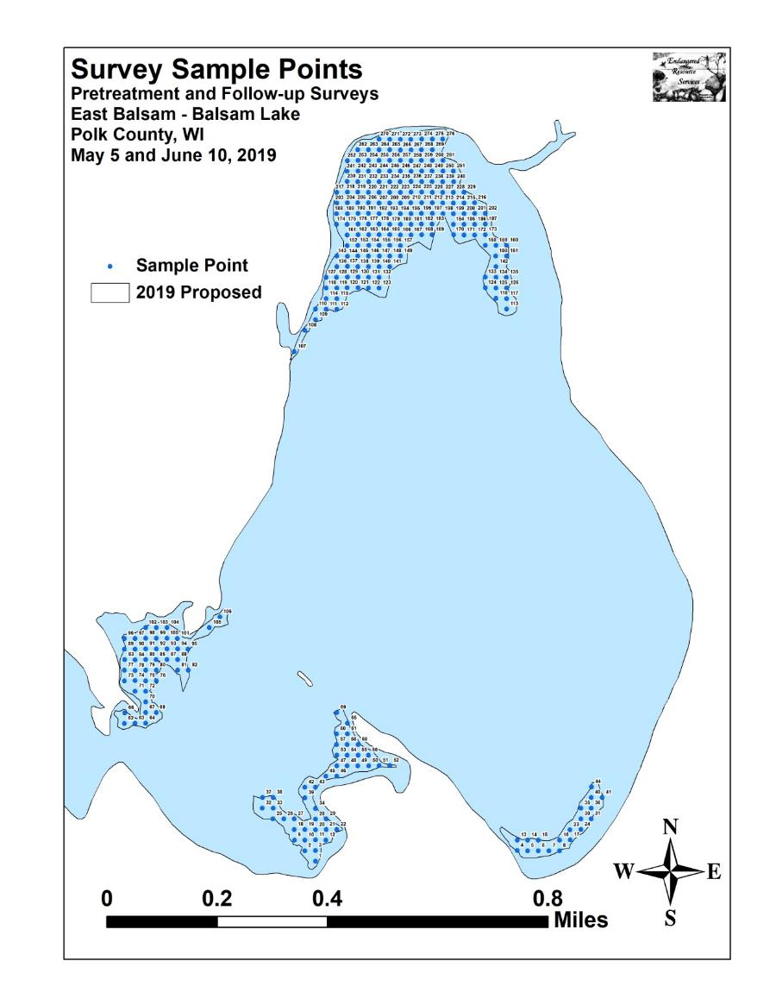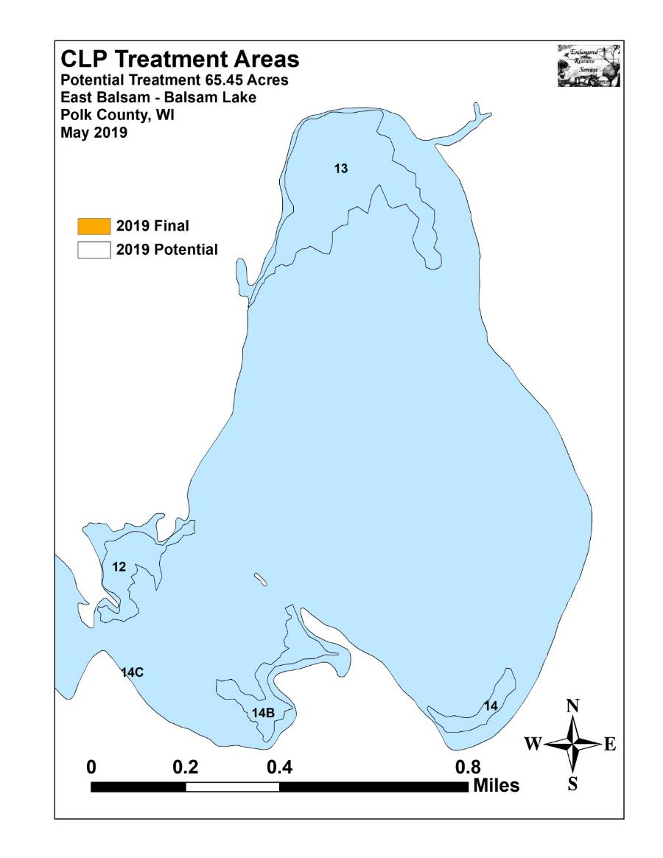

Appendix II: Vegetative Survey Datasheet

Observers for this lake: names and hours worked by each:
Lake: |  |  |  |  |  |  |  |  | WBIC |  |  |  |  |  |  |  |  | County |  |  |  |  |  | Date:
Site # | Depth (ft) | Muck (M), Sand (S), Rock (R) | Rake pole (P) or rake rope (R) | Total Rake Fullness | CLP | CLP | 1 | 2 | 3 | 4 | 5 | 6 | 7 | 8 | 9 | 10 | 11 | 12 | 13 | 14 | 15 | 16 | 17 | 18 | 19
1
2
3
4
5
6
7
8
9
10
11
12
13
14
15
16
17
18
19
20

Appendix III: Pre/Follow-up Habitat Variables
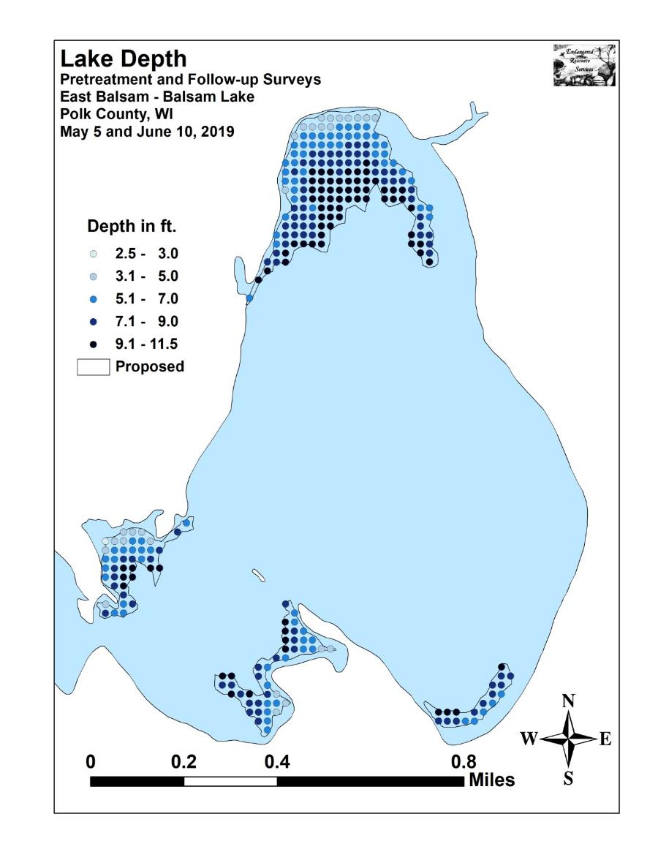
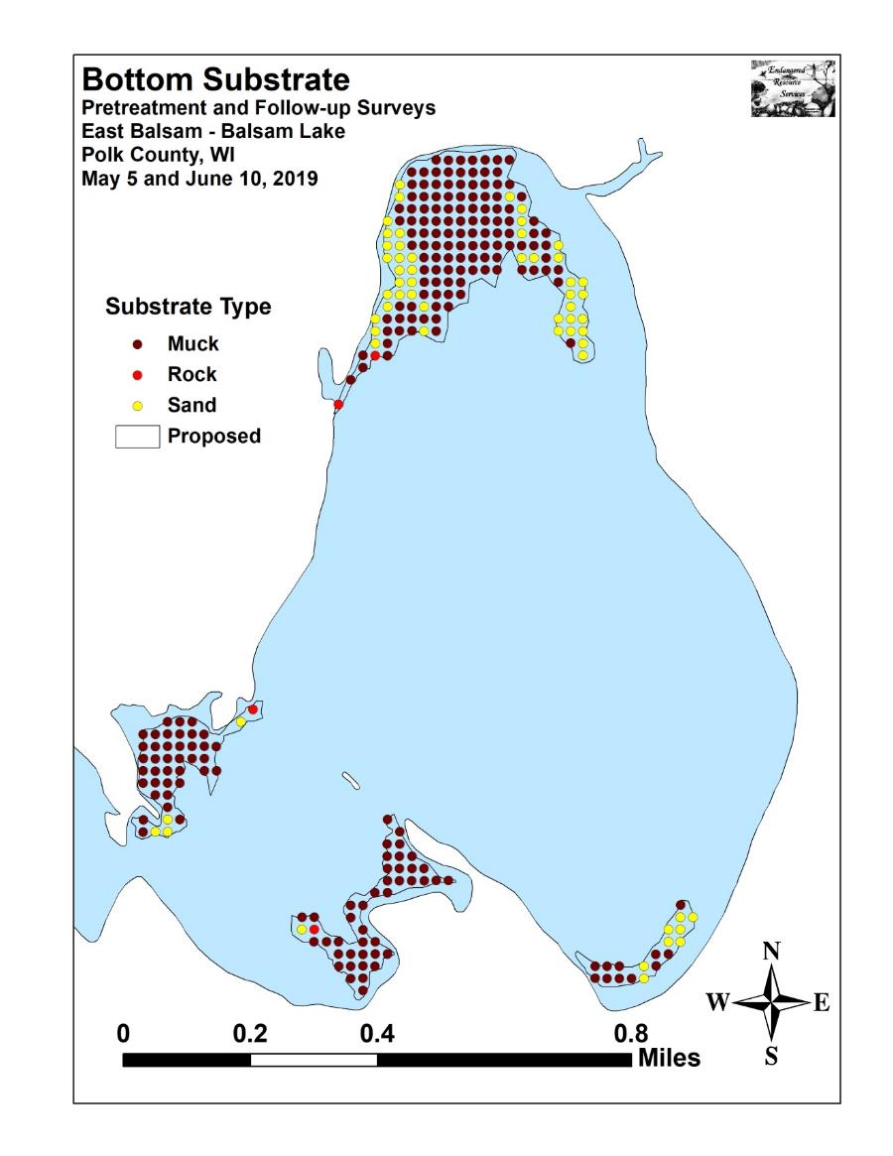

Appendix IV: Pre/Follow-up Littoral Zone, Native Species Richness and
Total Rake Fullness
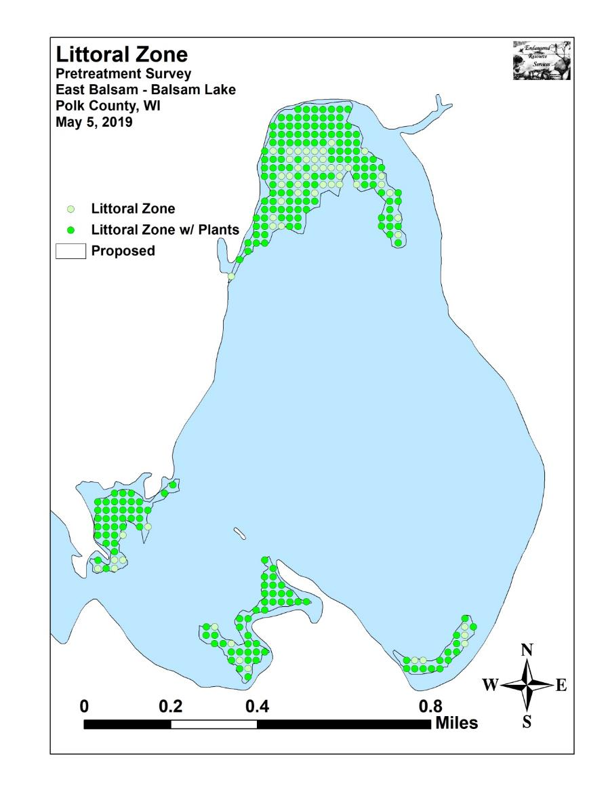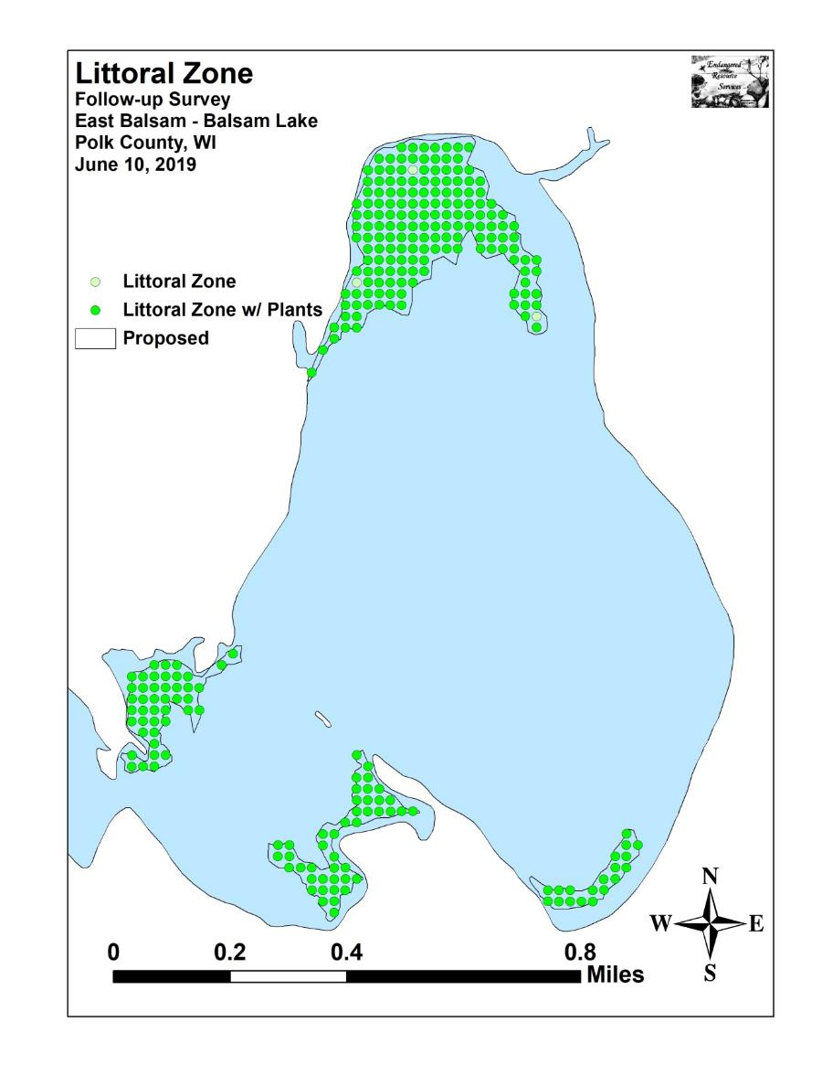
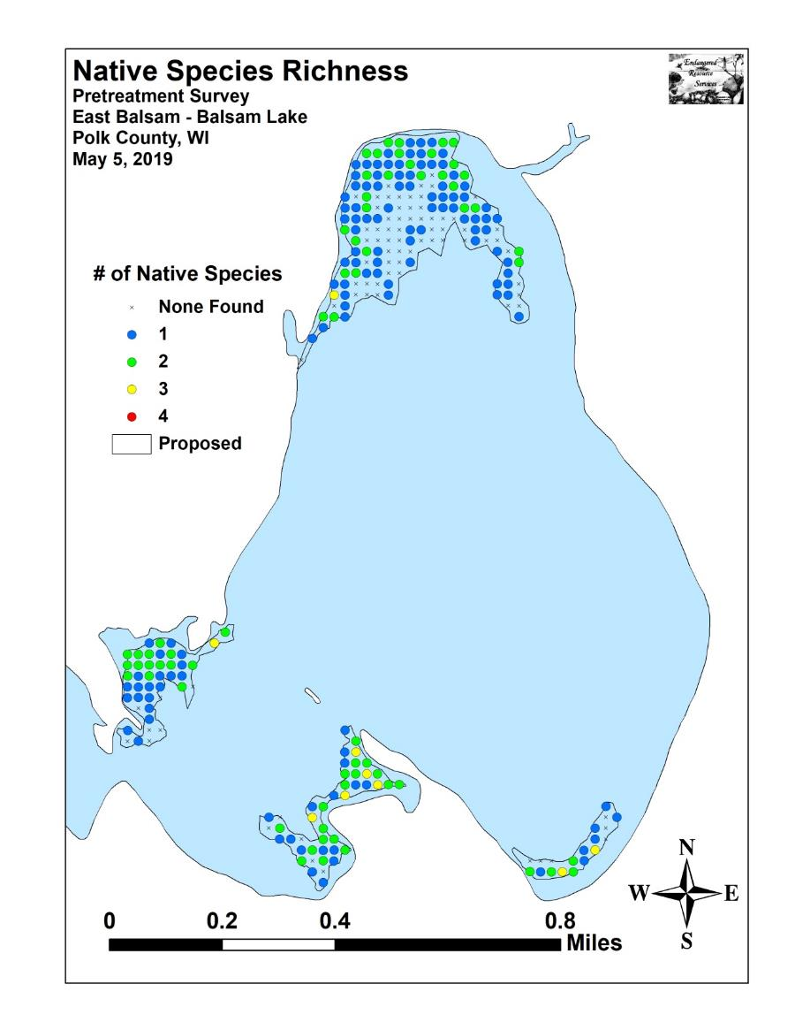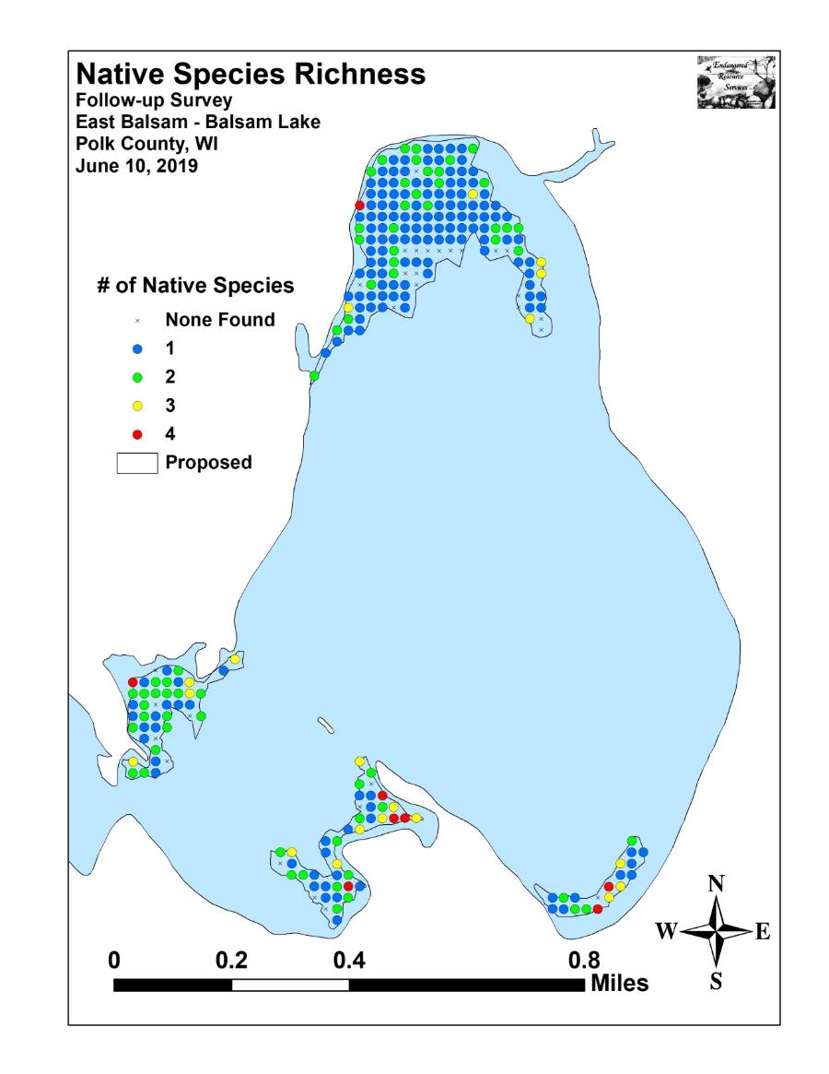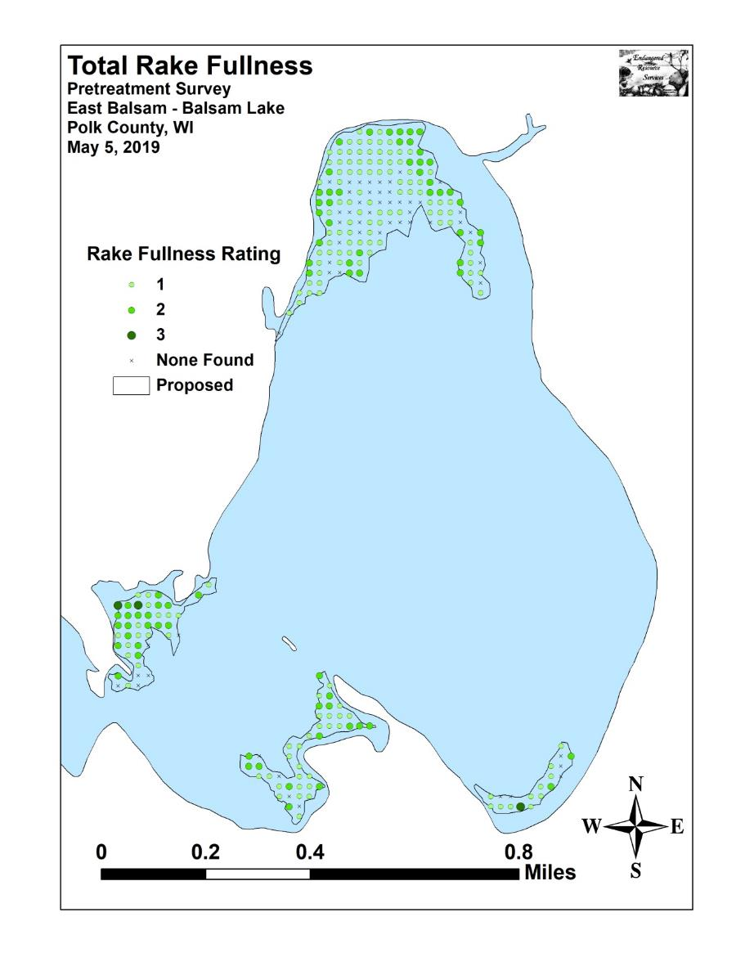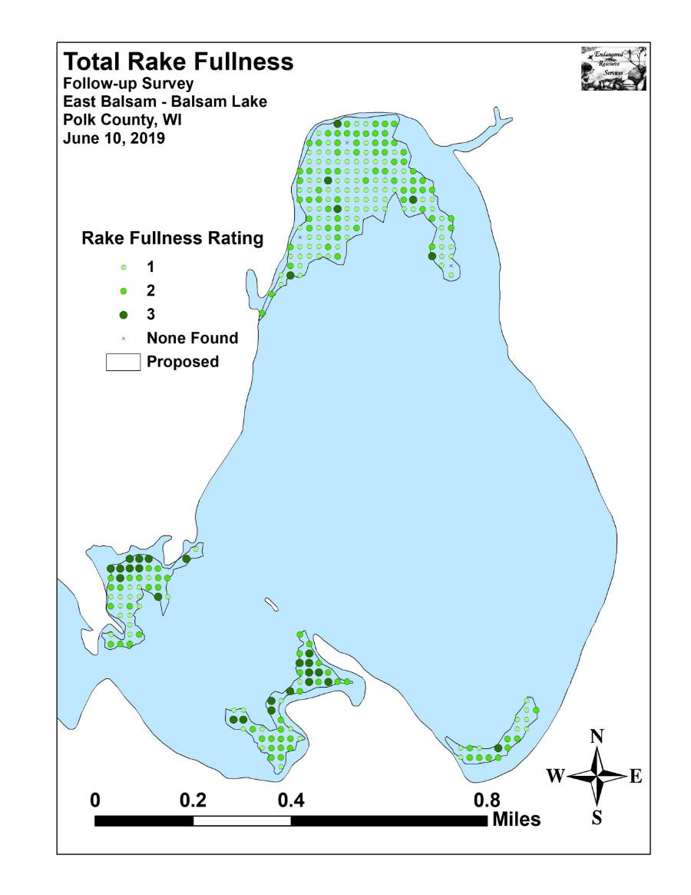

Appendix V: CLP Pre/Follow-up Density and Distribution
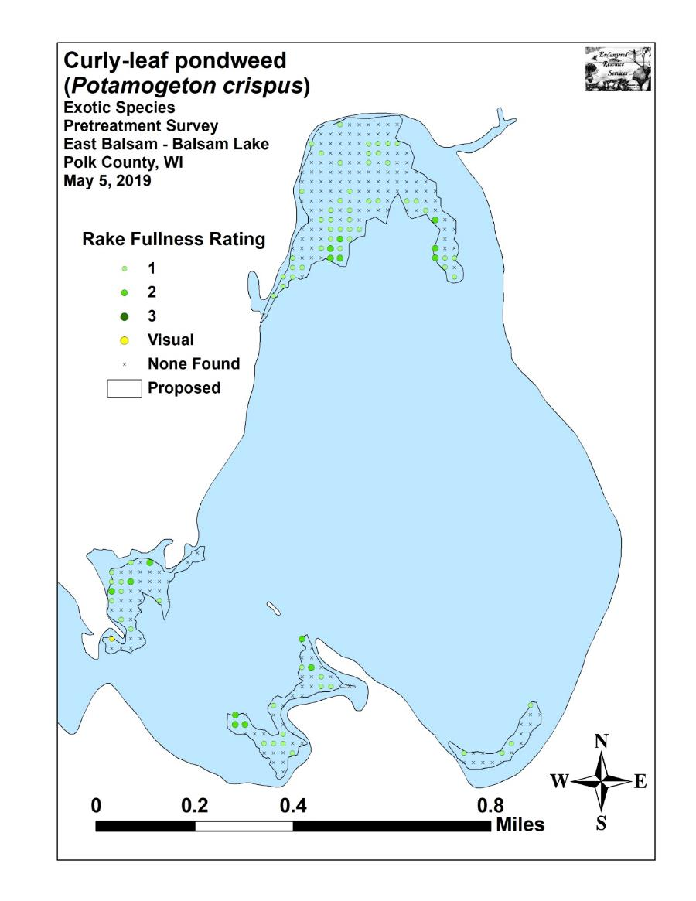
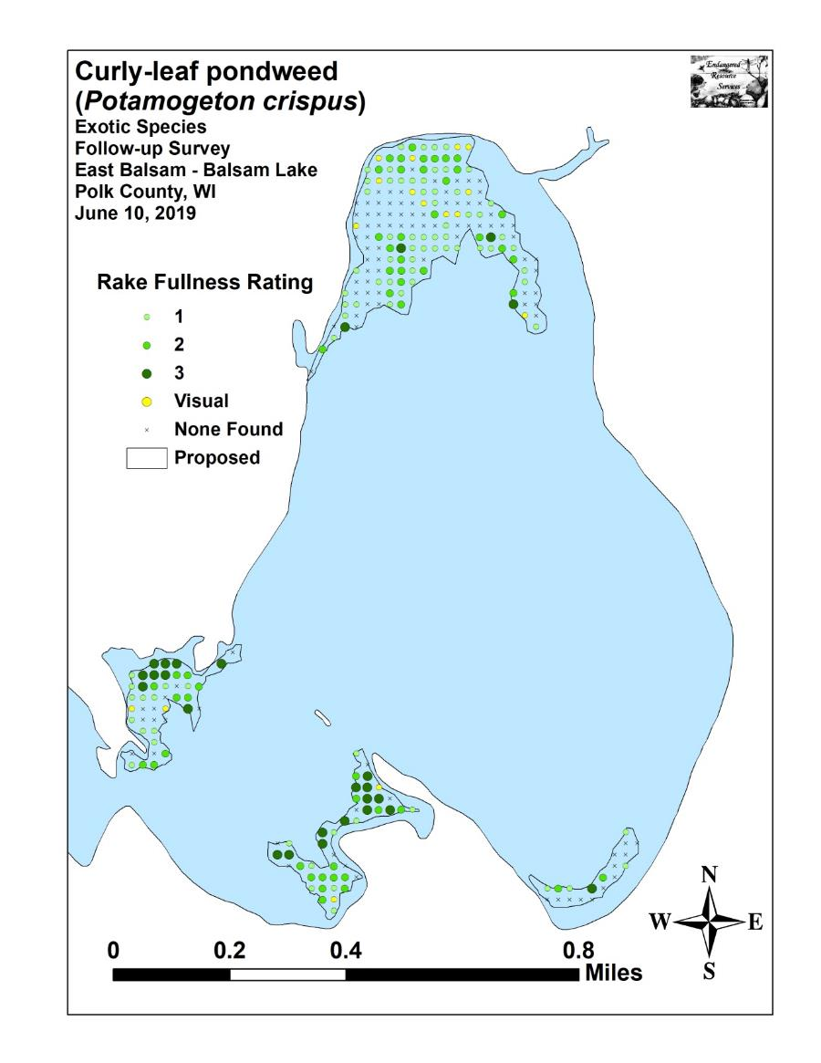

Appendix VI: Pretreatment Native Species Density and Distribution

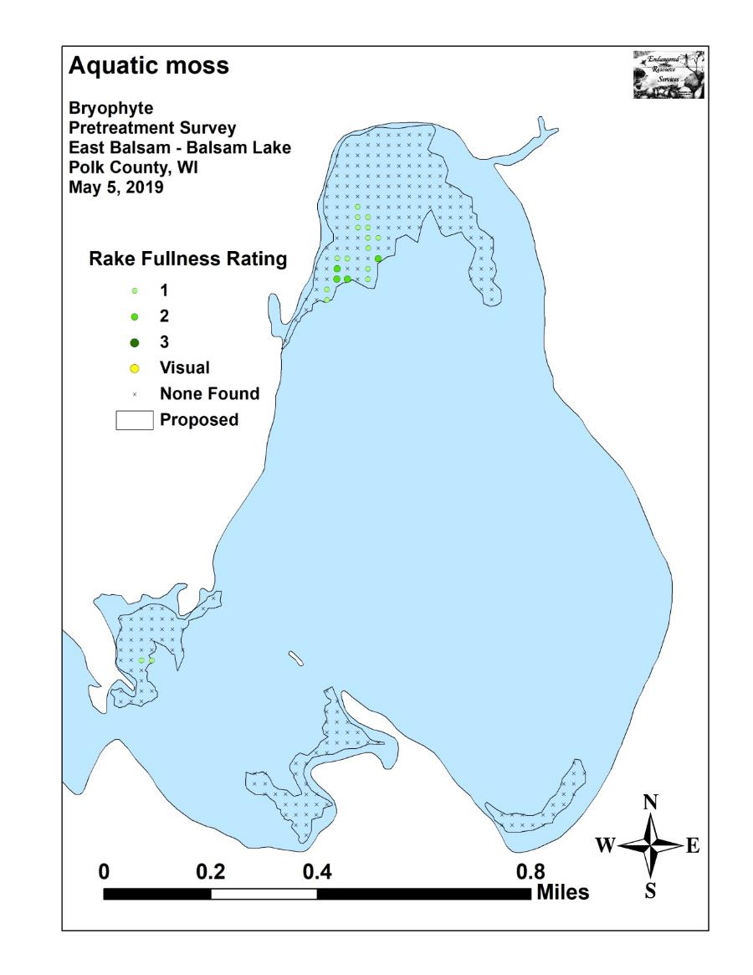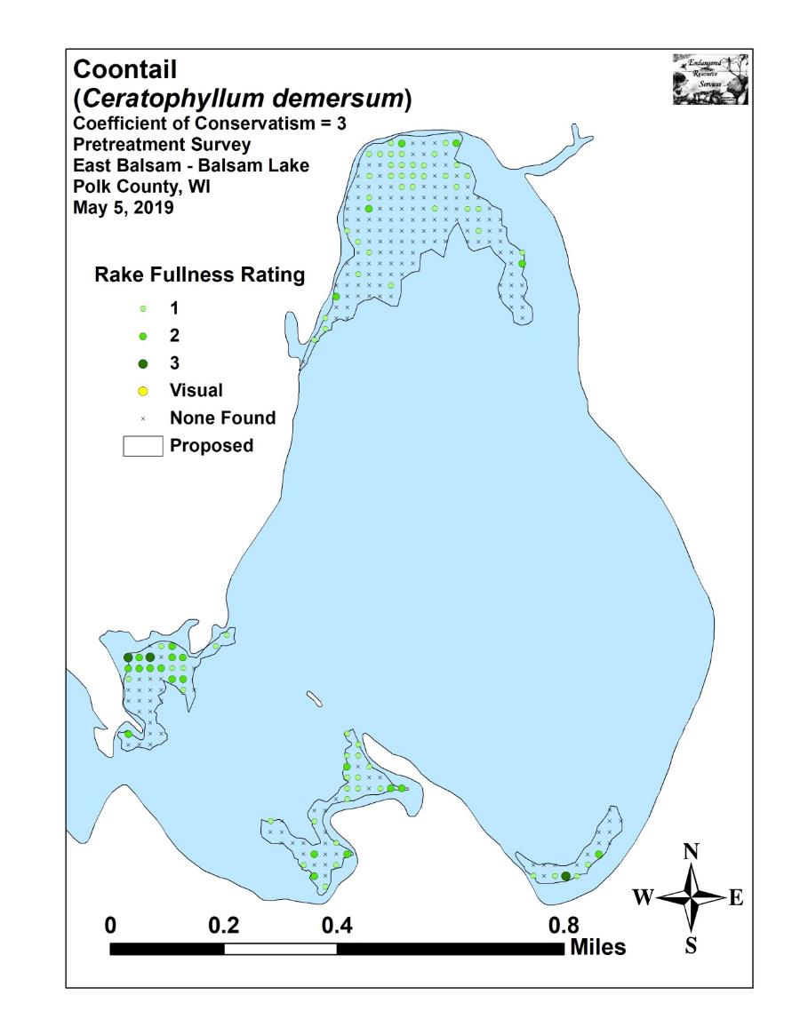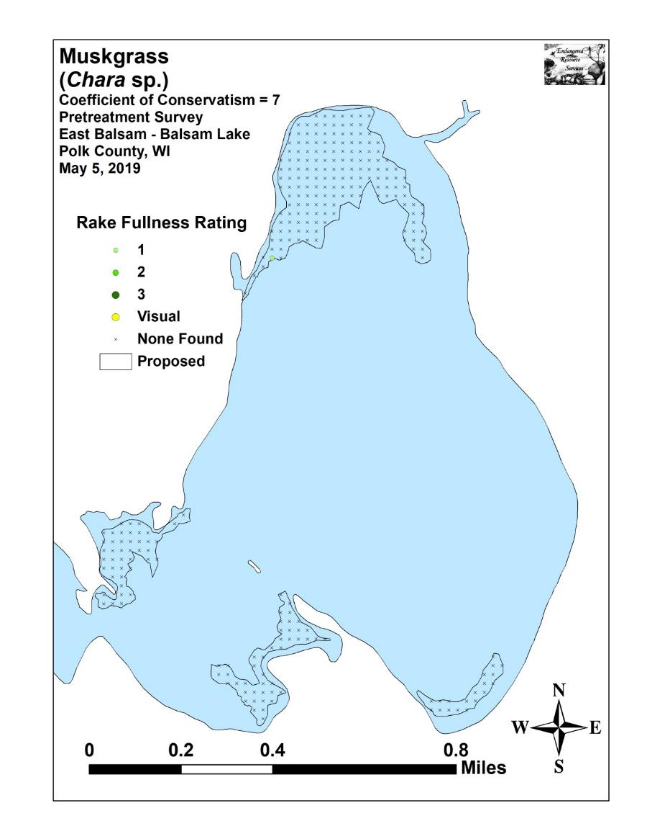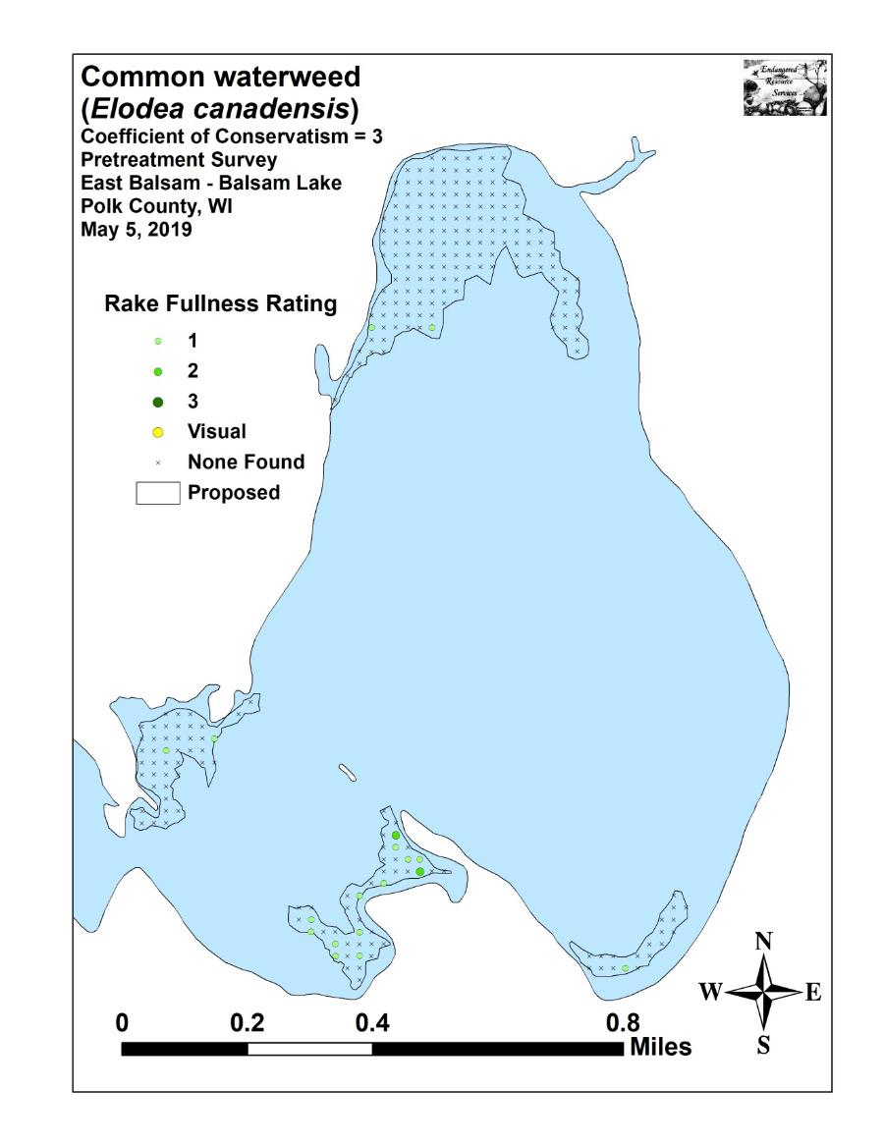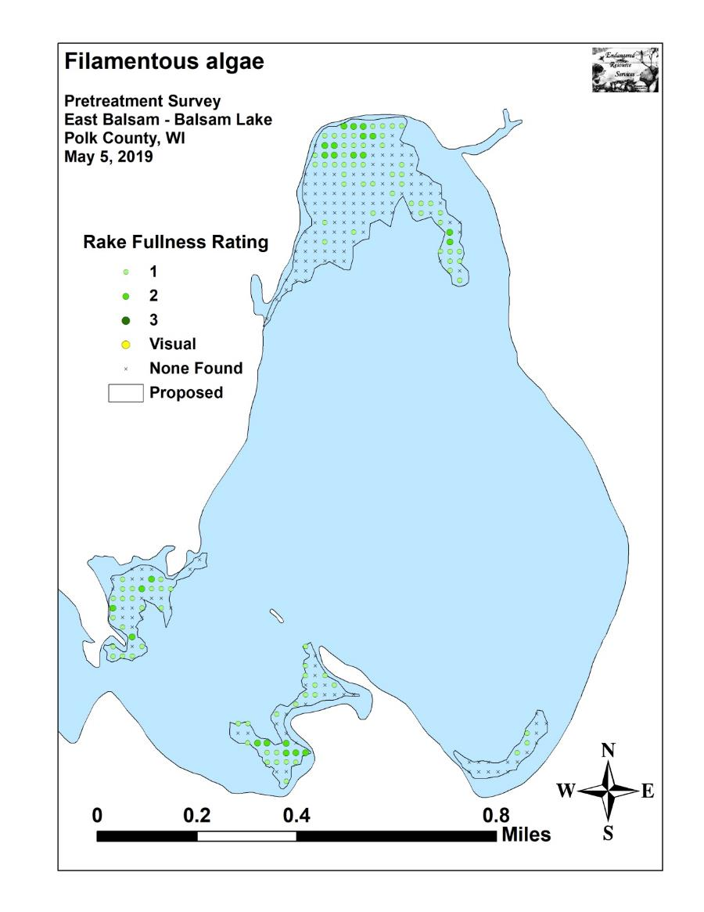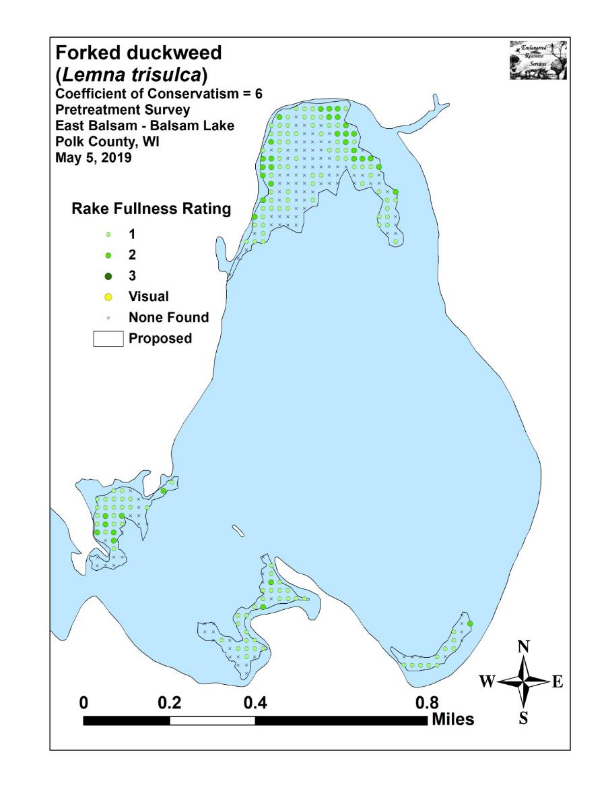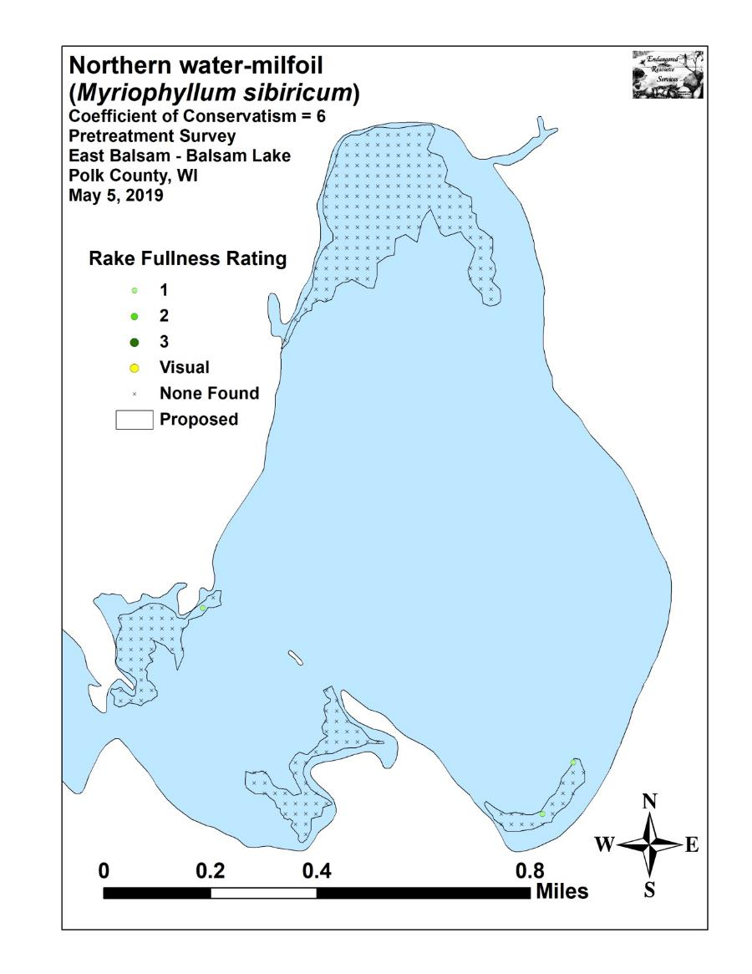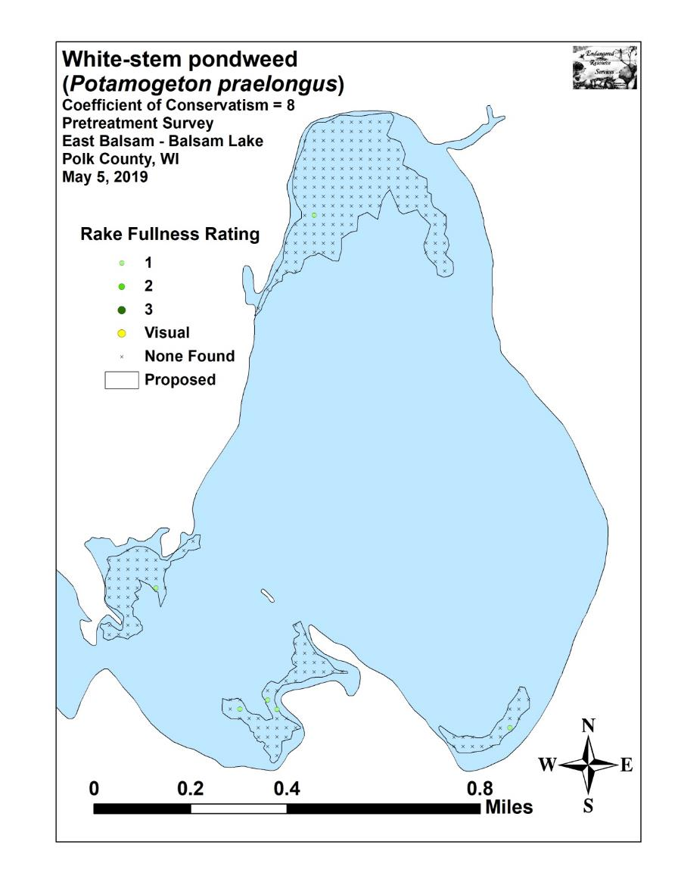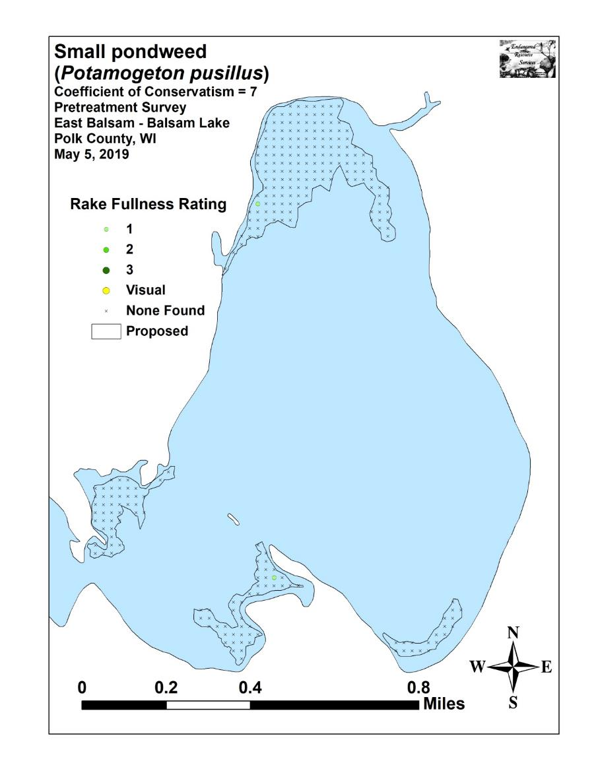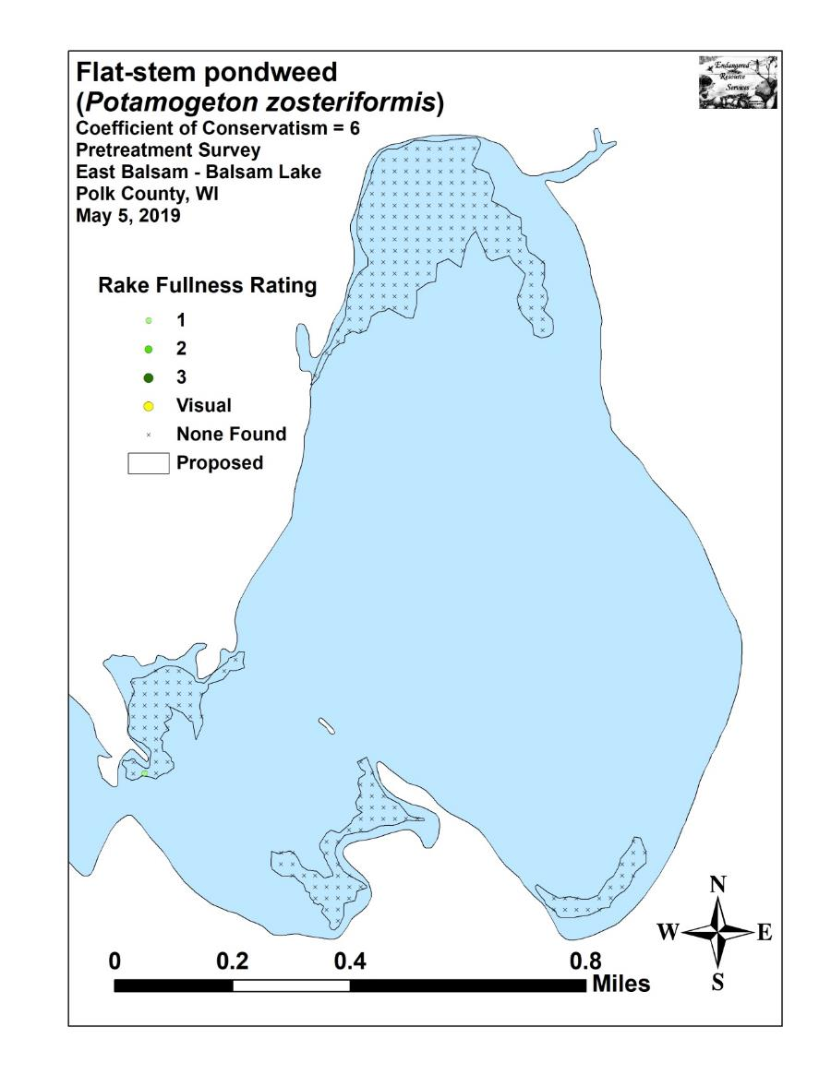

Appendix VII: Follow-up Native Species Density and Distribution

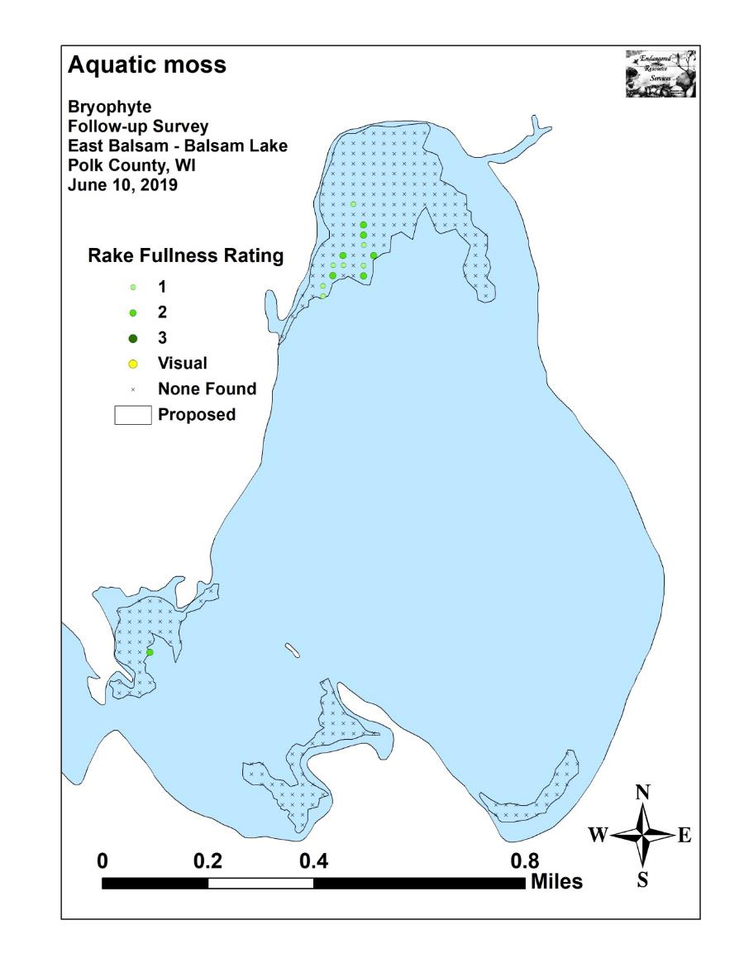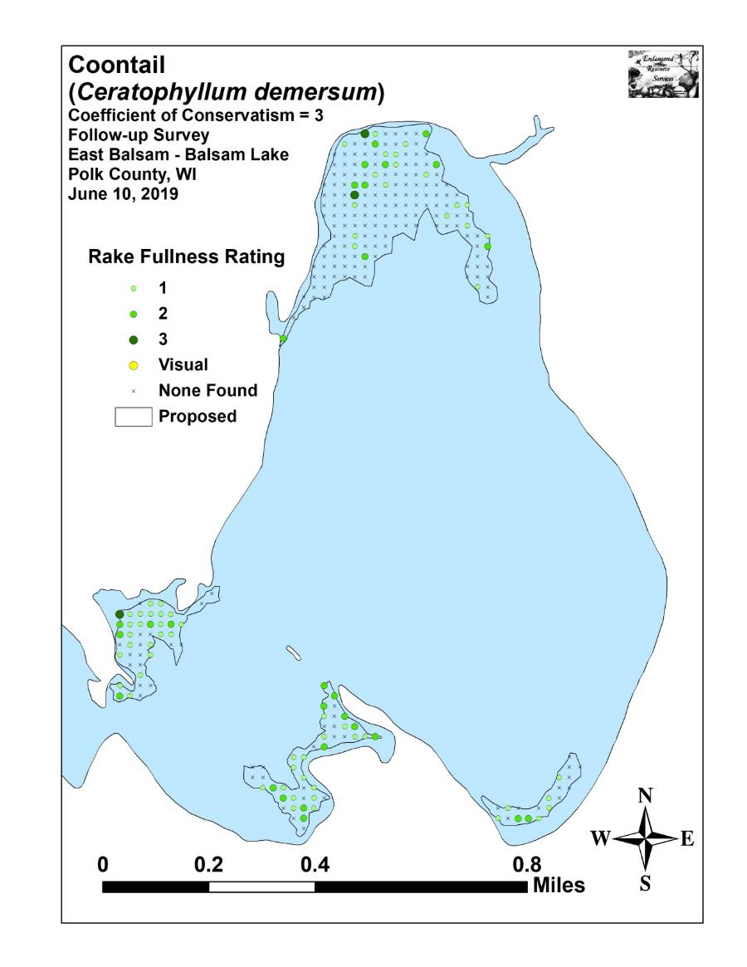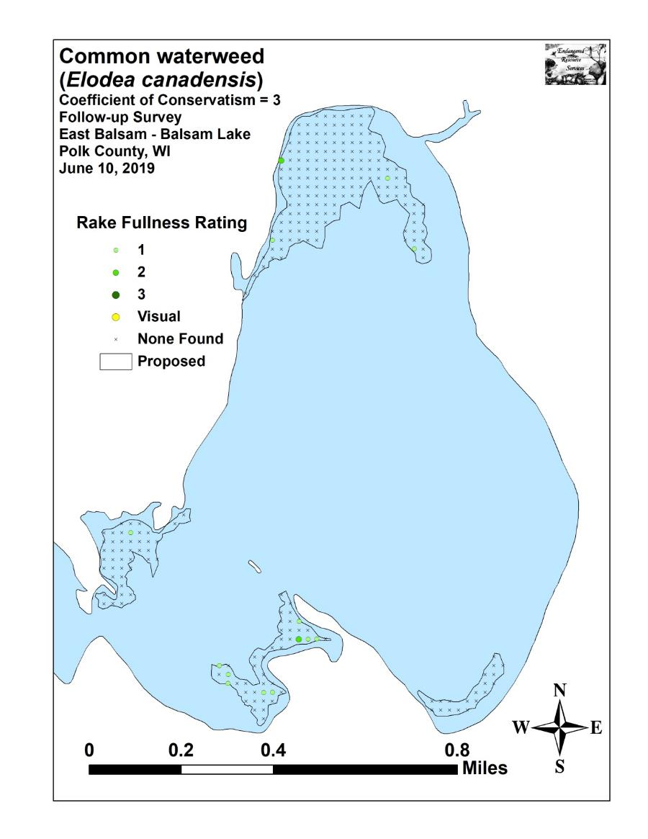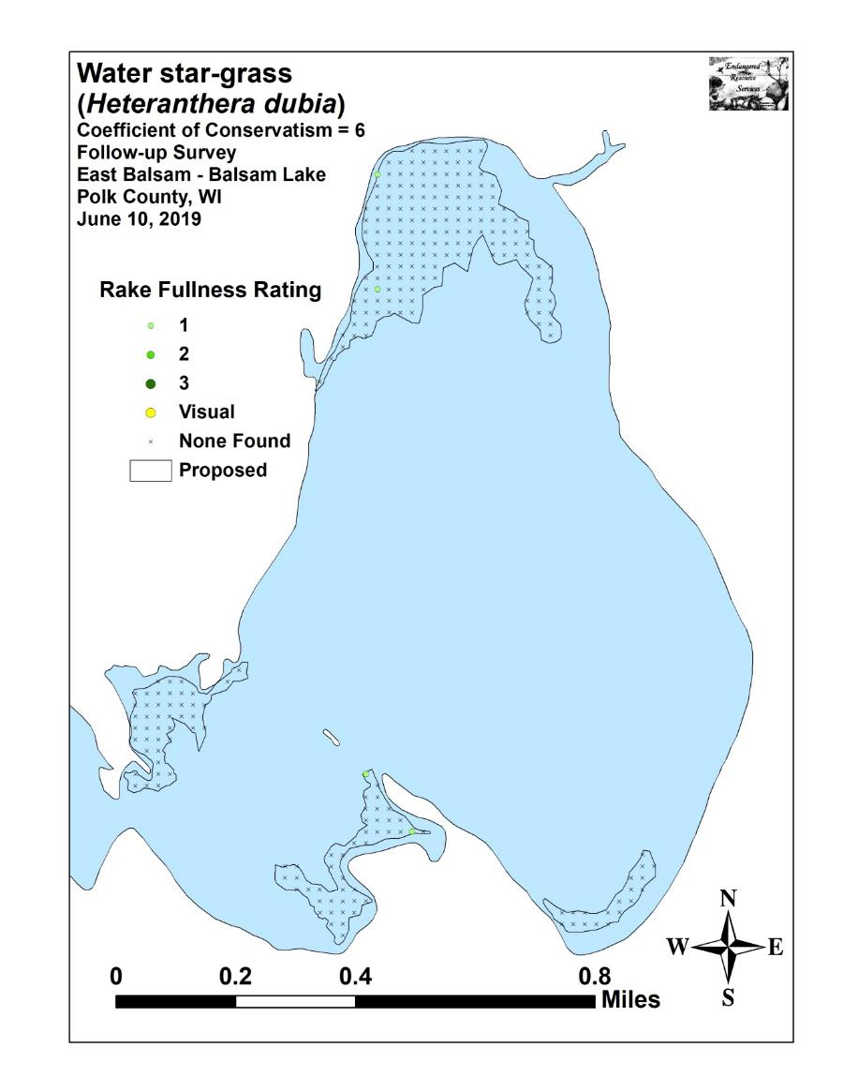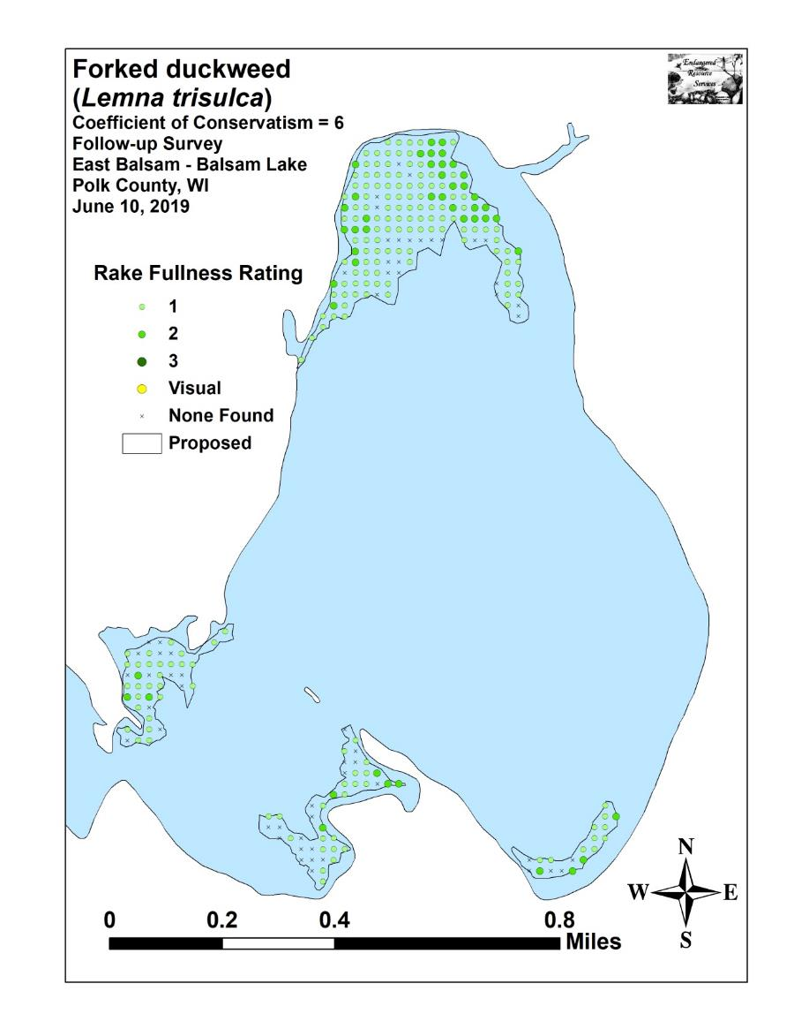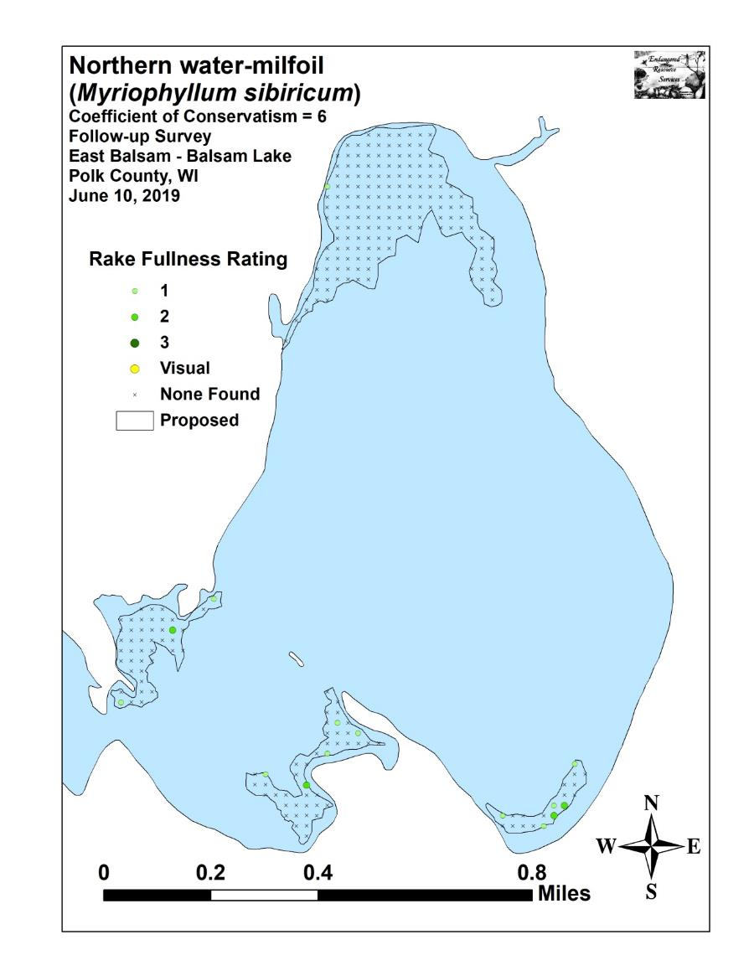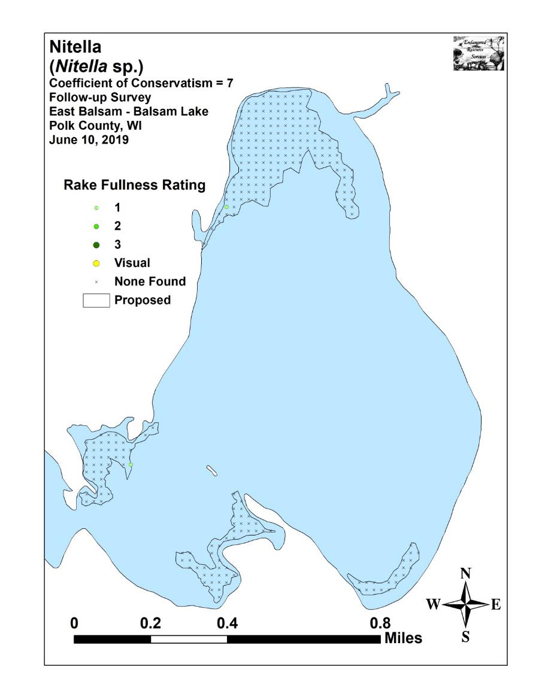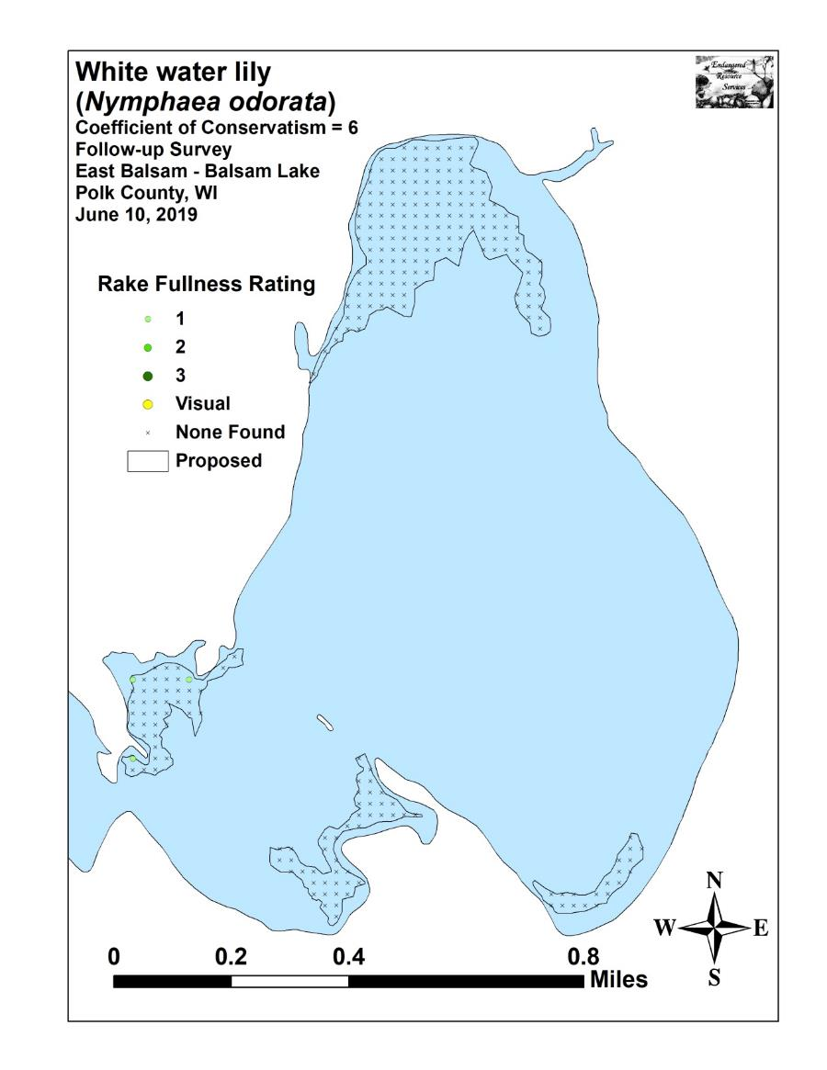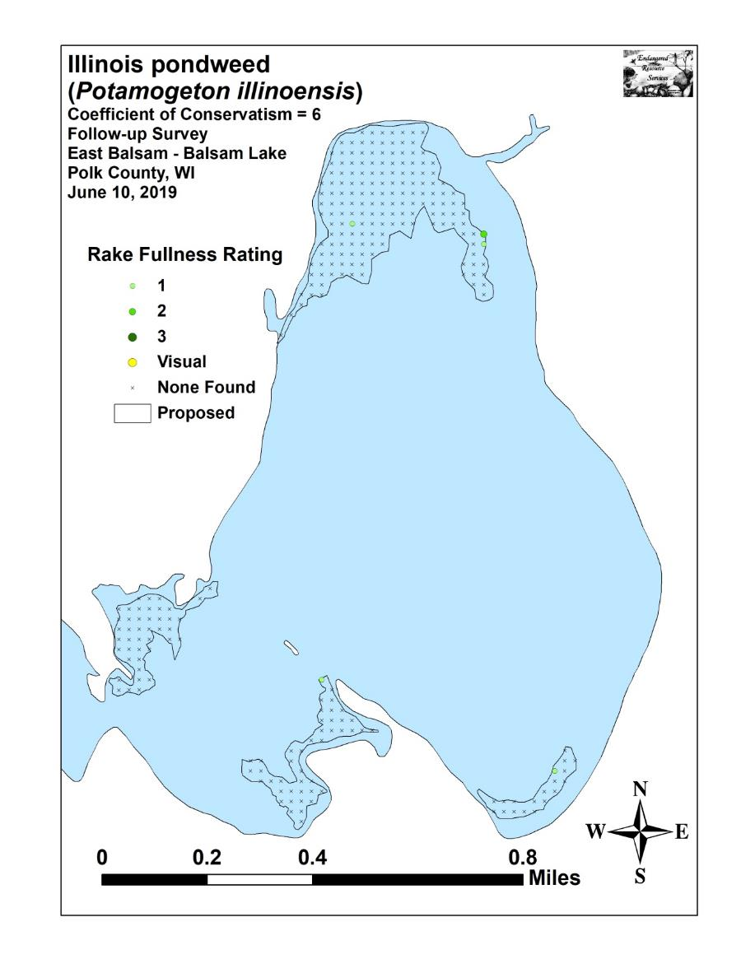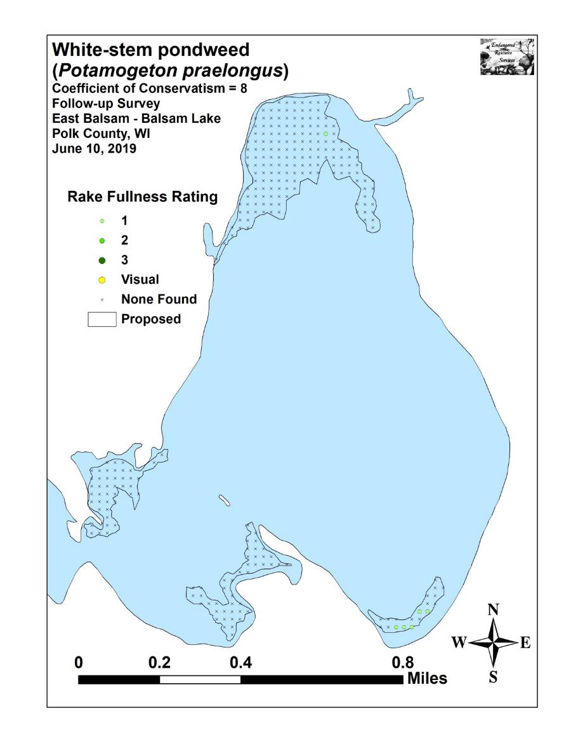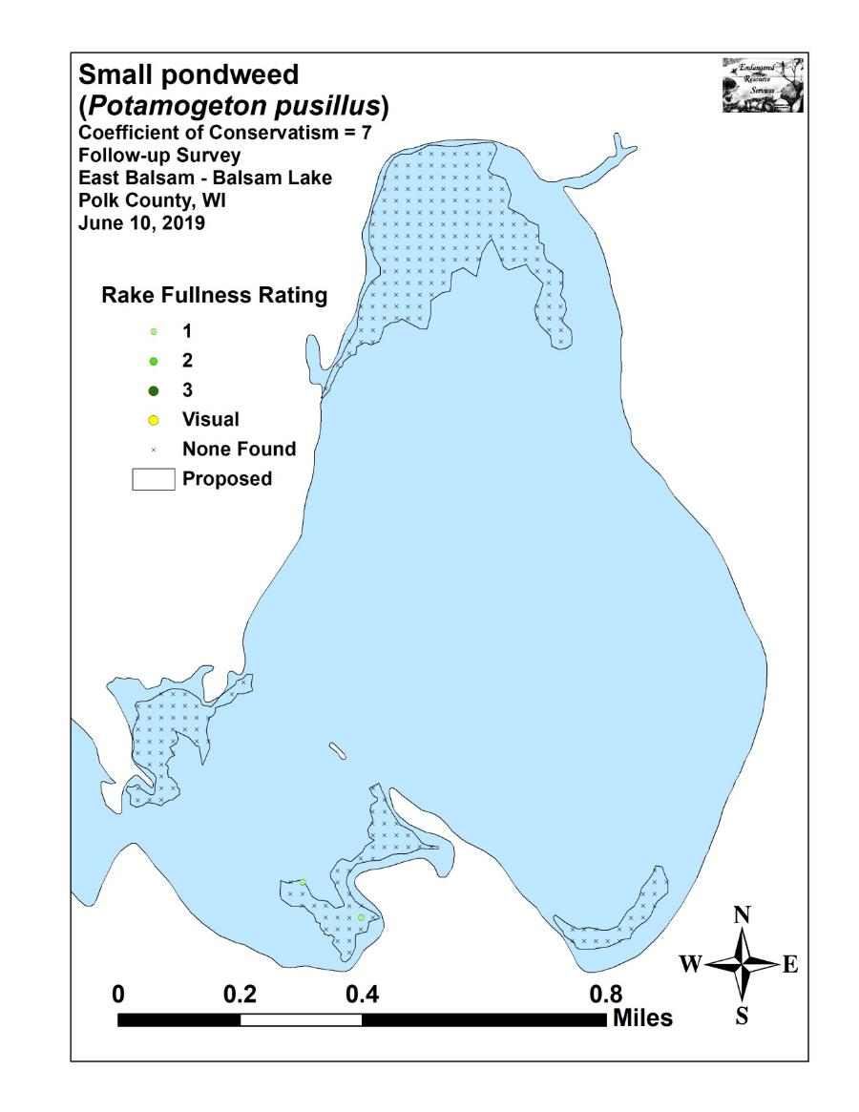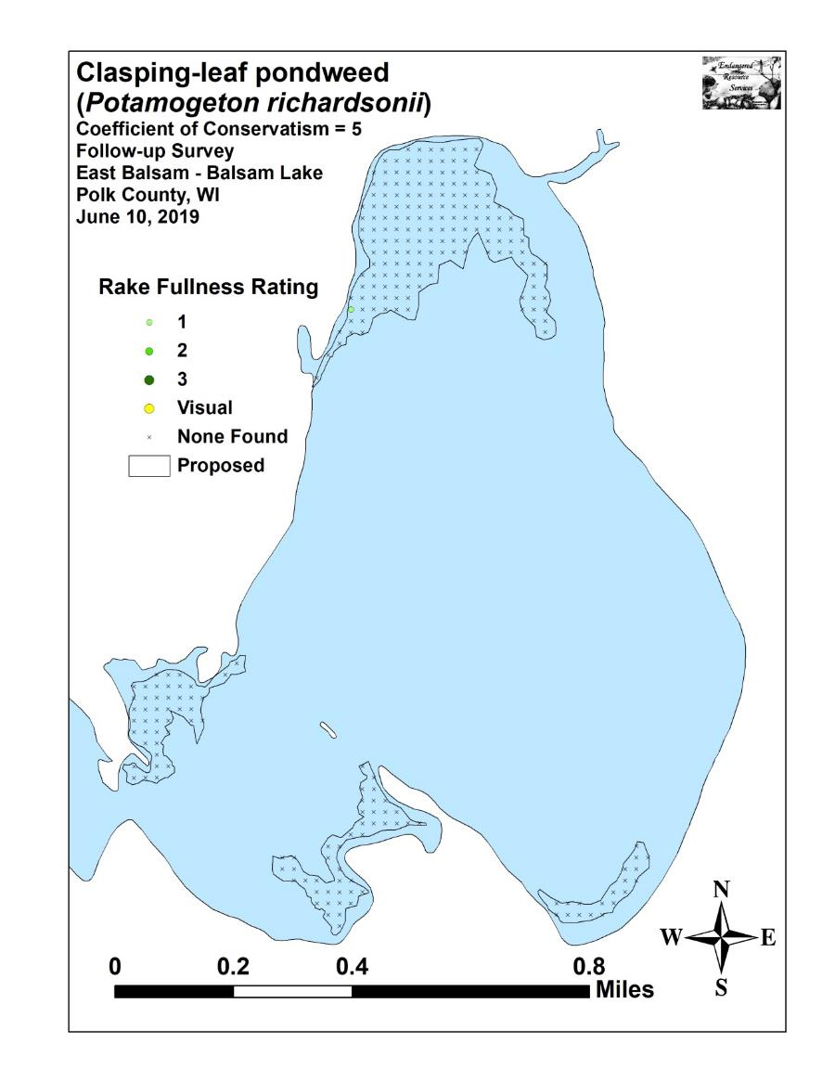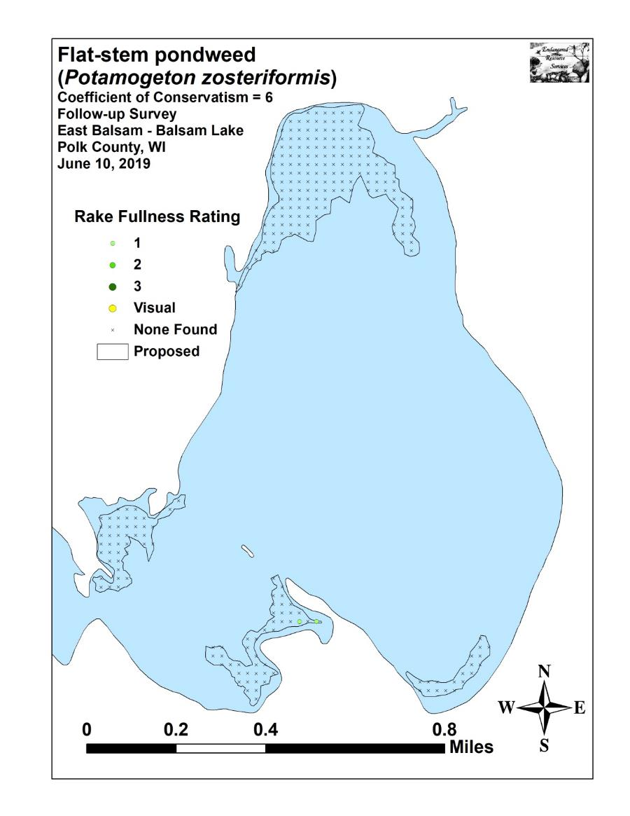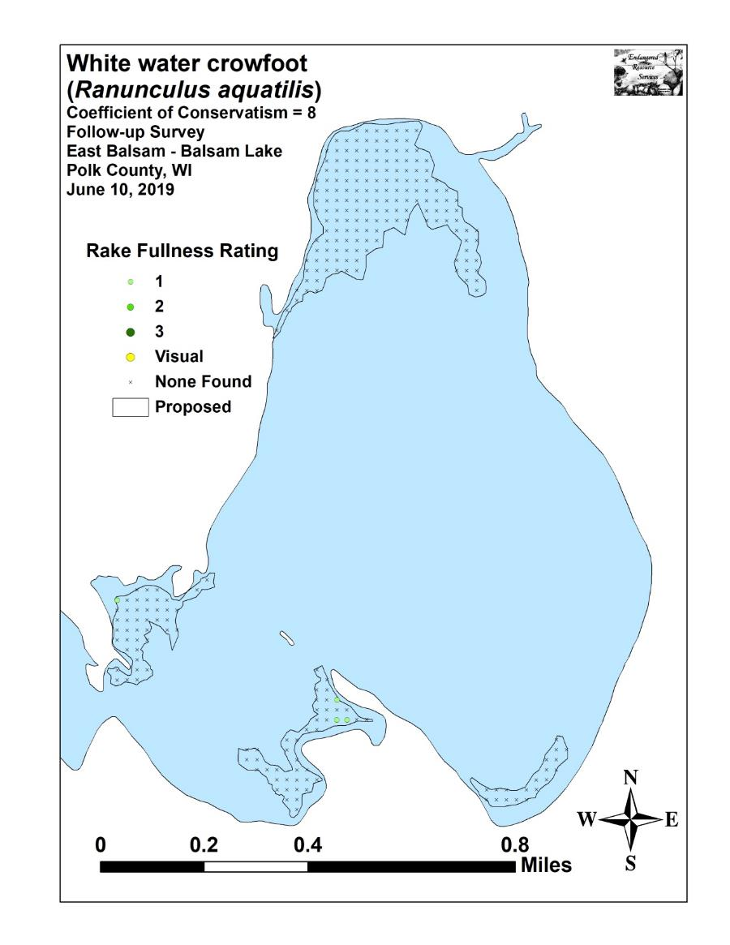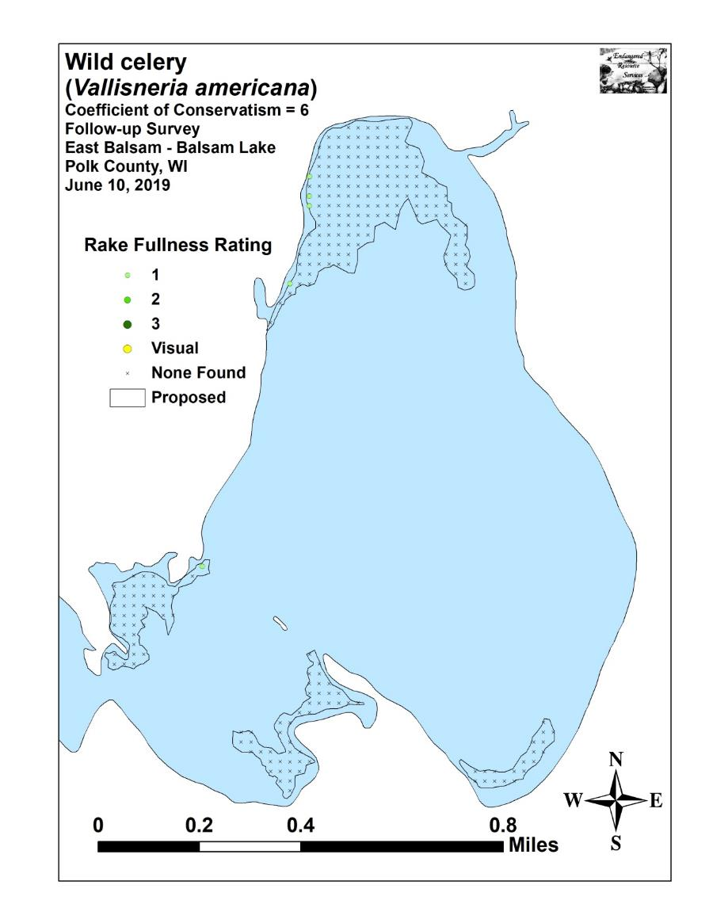

Appendix VIII: 2016, 2017, 2018, and 2019 Spring CLP Bed Maps

