Blue River Impaired Waters Evaluation Final Report
Author: Jean Unmuth, December 2014
Contributors: UW-Platteville Interns: Kevin Patterson, Thor Tackett, Lloyd Meng

Project Summary and Recommendations

The goal of this project was to collect data in order to evaluate whether the impaired segment of the Blue River should remain on the list or be delisted. A small tributary that flows into the Blue River in the impaired segment was also monitored to determine if it may be contributing to impairment.

The stream segment listed as impaired should be proposed for delisting. Sites monitored in the impaired and non-impaired segment showed no evidence of biologicial impairment. The six monthly total phosphorus results collected from near the mouth of the Blue River indicated that phosphorus levels clearly exceeded the threshold criterion of 75 ug/l. However, the phosphorus lower confidence limit (LCL) was less than 2 fold the criterion of 75 ug/l, and in that case biological information such as fish and macroinvertebrate indices (FIBI and MIBI) must be used to confirm impairment. The FIBI and MIBI data from this study indicates that ratings in the impaired segment (n=5) were fair to good, and thus did not confirm the fish and aquatic life use impairment.

The stream banks upstream of Edgington Road (impaired segment) were forested, and although the number of cattle grazing was low, stream banks were heavily trampled and manure was observed in the 100 meter segment between Edgington Road and the headwater erosion control structure which appears to hold water year around. The riparian area below the Edgington Road site was heavily grazed during year 2007, but by year 2011 appeared to have been abandoned, and the riparian area was healing. The unnamed tributary at Willow Springs Road has a fish migration block from the Blue River that is approx. 700 feet downstream of the site, due to a culvert perched approximately 0.90 m above the stream surface. The migration block, is the sole reason why no fish were captured in this stream segment.

Cooperate with Iowa County and the agricultural community on reducing agricultural runoff problems arising from cattle trampling in the stream and on the banks above Edgington Road. Cattle should be fenced away from the stream. Department staff should also work with Trout Unlimited and the Driftless Area Restoration Effort program as well as the township to replace the perched culvert on the unnamed tributary at Willow Springs Road, which would allow for fish migration. Much stream bank and habitat restoration has been done on the Blue River. These projects has been very successful in terms of reducing erosion, runoff and improving aquatic habitat and biota. Cooperative efforts should continue, especially in downstream segments where there are no current stream easements.

High nitrate levels of 24.9 mg/l were found in stream above Edgington Road, indicating that any nearby drinking water wells should be checked for high levels of nitrates in drinking water.
Introduction

Blue River (WBIC: 1211000) is a 35.21 mile long stream that runs through Iowa and Grant Counties. About 13.8 miles of the stream are Class II trout waters (WDNR. 1980), with some natural reproduction. The trout waters reach of the Blue River are considered exceptional resource waters. Within the area studied, from Edgington Road downstream to Shemak Road, the natural community designation ranges from cold headwater to cool-cold headwater in the upper stream reaches, and cool-cold mainstem in the lower reaches. There are 3.16 stream miles in the headwaters listed as impaired with the impairment of degraded habitat, and pollutants sediment/total suspended solids. The watershed is primarily (51.49%) agricultural.

Study Sites and Methods

A total of six sites were monitored in the Blue River, and one site in an unnamed tributary in the headwaters (Table 1.) Three Blue River sites monitored were located in the impaired section of stream; Edgington Road, 825 Willow Springs Road, and Meyer Property Willow Springs Road. Additionally three other sites monitored were located in the non-impaired section of stream; Blue River Road, Snowbottom Road, and Shemak Road. Fish and macroinvertebrates were sampled at all sites, and habitat collected at five of the sites. Many miles of stream bank and habitat have been restored in the vicinity of Willow Springs Road, Blue River Road, Snowbottom Road and Shemak Road. These stream stretches area available for public fishing through easements or are state natural areas.

Water chemistry was collected monthly from June through October at Edgington Road, Blue River Road and Shemak Road. Parameters collected were phosphorus, and suspended solids samples which were sent to the state lab of hygiene for analysis. Ammonia nitrogen, nitrate-nitrites and kjeldahl nitrogen were collected from the latter sites as well, but only during July. In addition six monthly total phosphorus samples were collected near the stream mouth at STH. 133 during the year of 2008. A YSI 556 multimeter, transparency tube, and Swoffer flow meter were used to collect water temperature, dissolved oxygen, % saturation, pH, conductivity, transparency and flows at all sites, except for the site at 825 Willow Springs Road.

Table 1. Blue River and tributary study sites
Survey Date | Swims ID | Station Name | Lyons Nat. Comm.
6-6-2007 | 10020556 | Unnamed Trib.Willow Springs Rd | Cold Headwater
6-22-2007  6-27-2011 | 10021058 | Blue R. Edgington Rd. | Macroinvertebrate
8-10-2007 | 10021311 | Blue R. 825 Willow Springs Rd. | Cool-Cold Headwater
8-10-2011 | 10034148 | Blue R. Meyer Property Willow Springs Rd. | Cool-Cold Headwater
7-15l-2011 | 10022585 | Blue R. Blue R. Rd | Cool-Cold Mainstem
7-14-2011 | 10022507 | Blue R. Snowbottom Rd. | Cool-Cold Mainstem
7-7-2011 | 10033437 | Blue R. Shemak Rd. | Cool-Cold Mainstem

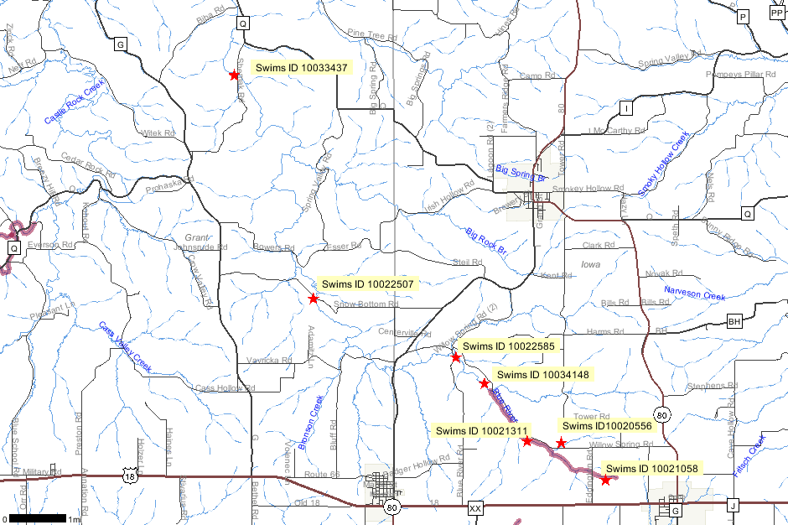
Figure 1. Blue River project SWIMS station locations.

Fish IBI Results

The FIBI ratings for the Blue River were good in the impaired segment (n=2), and excellent in the non-impaired segment (n=4) (Figure 2). However, it should be noted that this stream has been stocked nearly every year since the 1970’s, with brook, brown and rainbow trout, and in years 2010 and 2011 over 10,000 fish were stocked. This may greatly influence FIBI results. Fish indexes of biotic integrity (FIBI) could not be calculated for the Blue River at Edgington Road or the Tributary stream. The stream segment at Edgington Rd. is listed as a macroinvertebrate natural community, which was confirmed as there were no fish captured during two years of monitoring. No fish were collected in the unnamed tributary stream at Willow Springs Road though it is listed as a coldwater natural community. While water quality attributes of this stream segment show that the stream may be able to support fish, there is a perched culvert just downstream of that is a physical block to fish migration from downstream to upstream.
Figure 2. Blue River and Tributary Cool - Cold Fish IBI Scores.

Habitat Results

Quantitative habitat scores for the Blue River showed that habitat ranged from fair to good in the impaired segment (n=2), and good to excellent in the non-impaired segment (n=3) (Figure 3). The fair rating at Edgington Road was due to a high amount of bank erosion from cattle trampling in the stream and on the banks, sediment on top of gravel, and a lack of pools and fish cover, when compared to the other sites. Cattle had caused the stream to widen, and depths were very shallow.
Figure 3. Blue River Quantitative Habitat scores
Macroinvertebrate Results

Macronvertebrate IBI (MIBI) samples collected in the impaired segment of the Blue River ranged from fair to good (n=3), while in the non-impaired segment MIBI ratings were fair (n=3). Ratings do not appear to be influenced by habitat or substrate, in fact for the Shemak Road site which had the highest quality habitat score, the MIBI score was fair, while the Edgington Road site which had the lowest habitat score, also had MIBI scores of fair and good. Substrates at both sites were fairly similar. The tributary stream also had an MIBI rating of fair.

Figure 4. Blue River and Tributary Macroinvertebrate IBI Scores

Water Quality Results

The median of six monthly samples for phosphorus collected near the mouth of the Blue River was 145.0 ug/l in 2008, and clearly exceeded the criterion of 75 ug/l. However, since the lower 90% confidence interval (LCL) was less than two fold the criterion, biological confirmation must be used to confirm impairment.

In addition to the latter samples, five phosphorus samples were collected from one site in the impaired stream segment, and two sites in the non-impaired segment. Median values for phosphorus were lowest in the impaired segment at 43 ug/l, and slightly increased in the segments downstream, with the highest median value of 67 ug/l, however, it should be noted that the May samples were never collected, and thus this data could not be used to determine if TP was above the criterion of 75 ug/l within any given stream segment (Table 1).

The median of five monthly suspended solids in the impaired segment at Edgington Road was 24 mg/l, and was higher than in the non-impaired segments (Table 1). The two highest values at Edgington Road were collected in July at 57 mg/l and September at 63 mg/l, and were not associated with rain and runoff events, but instead were associated with cows trampling the stream bed immediately upstream in an approximately 100 meter stretch of stream (Table 1). Turbidity was < 10 NTU’s in the impaired and non-impaired segments.

Ammonia nitrogen, nitrate-nitrite and kjedahl nitrogen were collected from Edgington Road (Impaired segment), Blue River Road and Shemak Road (non-impaired segments) during July only. Nitrate-nitrites were highest in the impaired segment at a level of 24.9 mg/l, and warrant having drinking wells in the vicinity checked for nitrate levels (Table 1). Nitrates were also somewhat elevated at Blue River Road (7.23 mg/l), but lower at Shemak Road at 3.47 mg/l. Conversely, Kjeldahl Nitrogen was low, even at Edgington Road site where nitrates were high. This suggests that the small erosion control structure which appears to maintain water even during dry years, is a collection point for nitrogen, which accumulates in the soil below the basin, and leaches into the springs in this area. Ammonia was low or non-detectable at all three sites.

Water temperatures, dissolved oxygen and pH were adequate in both the impaired and non-impaired stream segments. Temperatures were cold, ranging from 11.1-19.0 degrees C, dissolved oxygen ranged from 9.2 – 13.6 mg/l, and pH ranged from 7.6-8.3 (Table 1).

Table 1. Water Chemistry Data for Blue River 2011, Summary by Jean Unmuth
Suspended Solids mg/l
SWIMS ID | Location | June | July | August | September | October | Median
10021058 | Edgington Rd | 10 | 57 | 24 | 63 | 11 | 24
10022585 | Blue River Rd. | 17 | 13 | 12 | 6 | 4 | 12
10033437 | Shemak Rd. | 22 | 20 | 11 | 7 | 4 | 11
Turbidity (NTU)
SWIMS ID | Location | June | July | August | September | October
10021058 | Edgington Rd | <10 | <10 | <10 | <10 | <10
10022585 | Blue River Rd. | <10 | <10 | <10 | <10 | <10
10033437 | Shemak Rd. | <10 | <10 | <10 | <10 | <10
Phosphorus mg/l
SWIMS ID | Location | June | July | August | September | October
10021058 | Edgington Rd | 0.038 | 0.048 | 0.07 | 0.095 | 0.029
10022585 | Blue River Rd. | 0.082 | 0.079 | 0.058 | 0.059 | 0.061
10033437 | Shemak Rd. | 0.084 | 0.08 | 0.067 | 0.055 | 0.037
Phosphorus ug/l
SWIMS ID | Location | June | July | August | September | October | Median
10021058 | Edgington Rd | 38 | 48 | 70 | 95 | 29 | 48
10022585 | Blue River Rd. | 82 | 79 | 58 | 59 | 61 | 61
10033437 | Shemak Rd. | 84 | 80 | 67 | 55 | 37 | 67
10021415 | STH 133 |  |  |  |  |  | 145
Water Temp C
SWIMS ID | Location | June | July | August | September | October | Range
10021058 | Edgington Rd | 11.1 | 15.1 | 13 | 12.7 | 13 | 11-14
10022585 | Blue River Rd. | 13.5 | 18 | 15.4 | 13.9 | 10.7 | 10-18
10033437 | Shemak Rd. | 16.1 | 19 | 17.8 | 15.9 | 8.9 | 8-19
Dissolved Oxygen mg/l
SWIMS ID | Location | June | July | August | September | October | Range
10021058 | Edgington Rd | 10.5 | 9.2 | 9.9 | 10 | 9.4 | 9-10
10022585 | Blue River Rd. | 11.3 | 10.6 | 10.1 | 11.3 | 12.4 | 10-12
10033437 | Shemak Rd. | 11.9 | 7.7 | 11.1 | 13.1 | 13.6 | 7.7-13.6
pH
SWIMS ID | Location | June | July | August | September | October | Range
10021058 | Edgington Rd | 7.8 | 8 | 7.9 | 7.6 | 8 | 7.6-8.0
10022585 | Blue River Rd. | 7.9 | 8 | 7.5 | 7.7 | 7.9 | 7.5-8.0
10033437 | Shemak Rd. | 8.3 | 8.1 | 8.3 | 8.3 | 7.9 | 7.9-8.3
Ammonia N
SWIMS ID | Location |  | July
10021058 | Edgington Rd |  | Non-detectable
10022585 | Blue River Rd. |  | Non-detectable
10033437 | Shemak Rd. |  | 0.025
Nitrate-Nitrite mg/l
SWIMS ID | Location |  | July
10021058 | Edgington Rd |  | 24.9
10022585 | Blue River Rd. |  | 7.23
10033437 | Shemak Rd. |  | 3.47
Kjeldahl Nitrogen mg/l
SWIMS ID | Location |  | July
10021058 | Edgington Rd |  | 0.54
10022585 | Blue River Rd. |  | 0.21
10033437 | Shemak Rd. |  | 0.17
Rain Events
Wunderground BR | Inches
May 29-June 2 | 0.1
July 3-July 7 | 0.05
Aug 13-Aug 17 | 0.15
Sept 10-Sept 14 | 0.01
Oct 20-Oct 24 | 0.16

C:\Streamdata\IowaCo\BlueRiver\BlueRiverFinalReport.doc

