<Insert Authorizing resolution >
Big Round Lake Protection and Rehabilitation District has agreed to submit this grant application and will act as the fiscal agent. The Big Round Lake District Treasurer will receive, track, and distribute grant funds.

<Insert other Letters of support>
The organizations listed below are interested in supporting this 3 year grant program.
Georgetown Township
St. Croix Chippewa Indians of Wisconsin
Polk County Land and Water Resources Department
Polk County Association of Lakes and Rivers
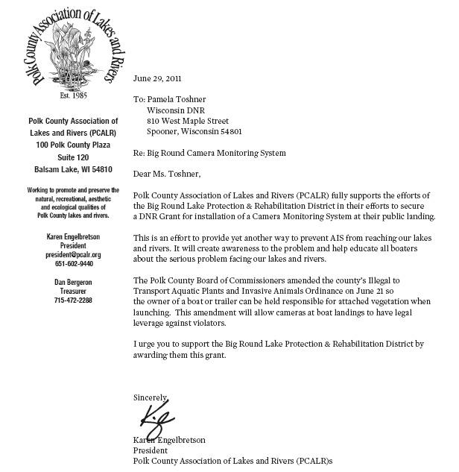

Big Round Lake District, Polk County
Aquatic Invasive Species Plan Implementation

August 2, 2011

Proposed Project Area

Description of project area
Big Round Lake in Polk County is the focus of this project and is a priority lake to include in a preventive strategy due to its size, risk factors, and interest in supporting this project. It is bordered by Balsam Lake and Bone Lake, both of which have Curlyleaf Pondweed.

Aquatic Invasive Species (AIS) such as Eurasian Watermilfoil, Zebra Mussels, and Curlyleaf Pondweed have been spreading to increasing numbers of lakes in Wisconsin. With over 450 Wisconsin lakes identified as having been infested with Eurasian Watermilfoil and over 100 with Zebra Mussels the threat to non-infested lakes increases.

This grant application is for a 3 year boat launch monitoring program at Big Round Lake that will include:
- 200 hours of Clean Boats Clean Waters trained inspection seasonally
- Acquisition and installation of an automated education and inspection system (ILIDS)
- Increased signage at the boat launches
- Educational materials for visitors, AIS monitors, lake association
- Education of District members for AIS monitoring and identification

Public Access and Use
There is one main launch on the west side of Big Round Lake that has approximately 20 parking spaces available as well as a dock. There is a lesser used launch on the Indian reservation on the East side of the lake.

Big Round Lake is estimated to have over 1700 boat launches each year and is a popular local fishing destination. There is no inspection or monitoring at the boat launch at this time.

The Lake District has a website which holds much of the past lake stewardship information.
http://www.bigroundlake.com/

Budget
Big Round Lake - 2011 CBCW & I-LIDS Grant Pricing |  |  |  |  | # of I-LIDS
 | Year 1 | Year 2 | Year 3 | Total | 1
ILIDS Startup (non-grant eligible)
Establish Footing | 800 |  |  | 800 | 800
Wireless Antenna | 400 |  |  | 400 | 400
Installation/Test | 500 |  |  | 500 | 500
First Year - Sensor/camera callibration | 200 |  |  | 200 | 200
Parts supplies (gaskets, lenses) | 100 |  |  | 100 | 100
Subtotal | 2000 | 0 | 0 | 2000 | 2000
ILIDS Seasonal ($4000 eligible)
Equipment purchase (include audio) | 7500 | 0 | 0
No Depreciation | 7500 | 0 | 0 | 7500 | 7500
Monthly Operation (6 month season) | 200 | 200 | 200 | 3600 | 3600
Seasonal removal/install insurance | 600 | 600 | 600 | 1800 | 1800
Video Review | 0 | 0 | 0 | 0 | 0
Travel allowance | 200 | 200 | 200 | 600 | 600
Subtotal | 9500 | 2000 | 2000 | 13500 | 13500
Total for ILIDS | $11,500 | 2000 | 2000 | $15,500 | 15500
Total ILIDS Grant Eligible | $4,000 | $0 | $0 | $4,000 | 4000
Non-ILIDS (Grant Eligible)
In-person inspection hours per season | 200 | 200 | 200 | 600 | 0
Paid Inspectors ($12/hour) | $2,400 | $2,400 | $2,400 | $7,200 | 7200
CBCW Supplies (Shirts, hats, training) | $100 | 100 | 100 | $300 | 300
Education brochure | $500 | $0 | $0 | 500 | 500
Education and outreach | $200 | $200 | $200 | 600 | 600
Signage | $300 | $0 | $0 | 300 | 300
AIS early identification | $200 | $0 | $0 | 200 | 200
ESP CBCW Administration | $480 | $480 | $480 | 1440 | 1440
Subtotal | $4,180 | $3,180 | $3,180 | $10,540 | 10540
Total Grant Request | $8,180 | $3,180 | $3,180 | $14,540 | 14540
Association Match Required | $2,699 | $1,049 | $1,049 | $4,798 | $4,798
Volunteer Contribution (Match)
DSL costs to Association | 0 | 0 | 0 | 0 | 0
Launch Install Support (Association) | 640 |  | 0 | 640 | 640
Launch Install Support (ESP) | 292 | 0 | 0 | 292 | 292
ESP CBCW Administration | 240 | 240 | 240 | 720 | 720
Volunteer Contribution | 1400 | 840 | 840 | 3080 | 3080
Subtotal | 2572 | 1080 | 1080 | $4,732 | 4732
Association Funding | $7,500 | $2,000 | $2,000 |  | 11500
Requested Reimburse % | 75%

Special Lake Designations
The maps below show that Big Round Lake has sensitive areas and that it is classified as an Area of Special Natural Resource Interest.

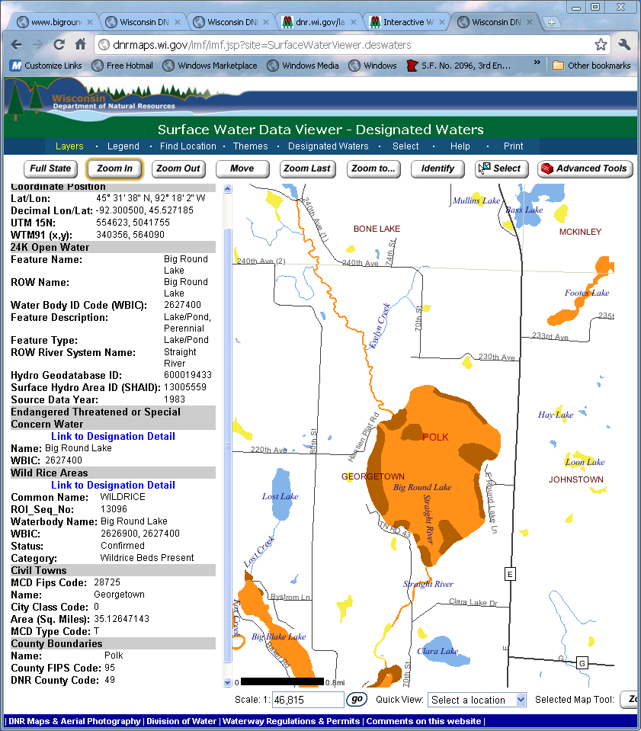

Curlyleaf Pondweed
This invasive plant has been in Big Round Lake for over 8 years and is being monitored by the District to determine whether it is spreading. Plant surveys are conducted on a regular basis.

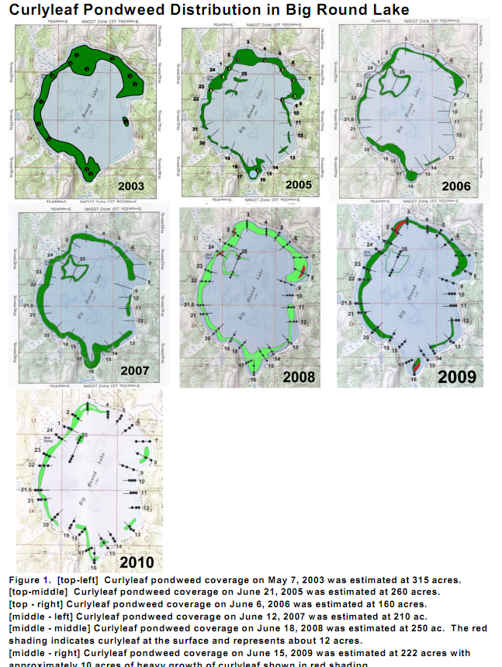

Nearby Water Body Infestations

Eurasian water milfoil
Eurasian watermilfoil is not found on Big Round Lake or any water bodies within five miles. However, Beaver Dam Lake has an infestation of EWM and it has been spreading from Cumberland 10 miles away to other nearby lakes.

Wisconsin DNR has identified EWM in Burnett county (Ham Lake, Shallow Lake, and Round Lake); Barron (Beaver Dam, Horseshoe, Sand, Kidney, Shallow, Duck, and Echo lakes); and St. Croix (Bass, Goose Pond, Little Falls, Lake Mallalieu, and Perch). In Polk County EWM is found in Long Trade and Horseshoe Lakes.

Zebra Mussels
Zebra mussels have now been discovered on Bass Lake in St. Croix and are present in the St. Croix River.

Ongoing Invasive Species Control and Education
This project will continue efforts of Big Round Lake to manage existing Aquatic Invasive Species and prevent new species from infesting the lake.

Past studies to manage the lake ecology have included:
- 2009, 2010 Aquatic Plant Surveys for Curlyleaf Pondweed (Bluewater Science)
- 2008 Aquatic Macrophyte Survey (Polk County Conservation Department)
- 2011 AIS Management Guidelines based on lake characteristics (Bluewater Science)
- 2007 Paleoecological Study (WI DNR, Bureau of Integrated Science Services)
- 1999 Lake Sensitive Area Survey (DNR Cornelius/Cahow)

Studies have shown that there has been limited spread of CLP within the lake in recent years. The 2011 AIS Management Guidelines predict there are areas that would provide good to medium habitat for an infestation of Eurasian watermilfoil. Recommendations for inspections at the boat ramp are made here.

No control projects have been undertaken with respect to CLP.

Lake District Education and AIS Prevention Activities
Education of District members occurs through the website www.bigroundlake.com and at annual meetings where speakers provide overviews of the studies conducted including water clarity, fishery, surveys of CLP, and prevention of AIS.

Clean Boats, Clean Waters
The District has sought volunteers to staff the boat launch to perform preventative inspections but it has not been successful in finding volunteers despite best efforts.

Map of project location and boundaries

The public boat access site is shown below on the map.
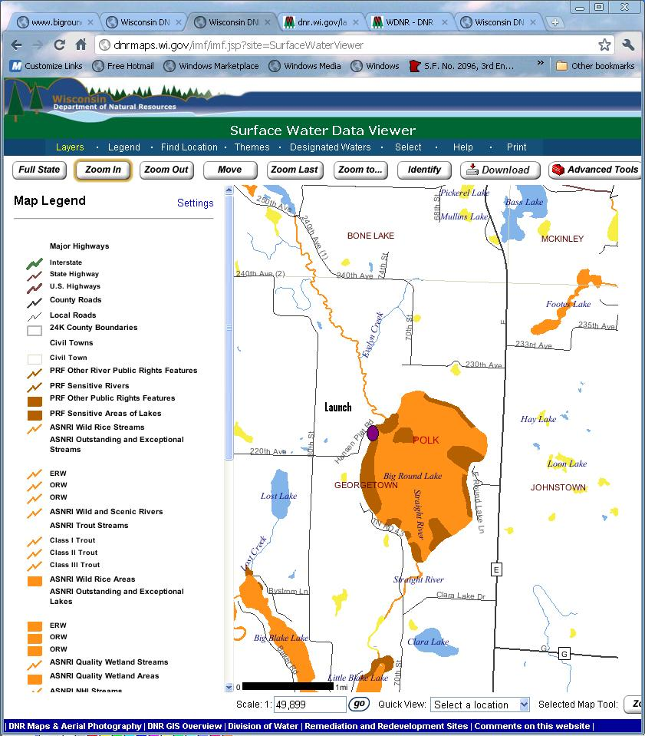

Problems to be Addressed

Eurasian watermilfoil and Zebra mussels threaten this lake

Curlyleaf pondweed may be spread from this lake to other lakes

There is a lack of comprehensive launch inspection

Boaters need to be educated on cleanoff behaviors

Volunteer resources are unavailable to perform inspections at boat launch

There has been a lack of enforcement of AIS laws in Polk County

Project Goals and Objectives

Goal: Educate the public on prevention and early detection of invasive species

Objectives:
- Residents can identify curly leaf pondweed, Eurasian water milfoil, and other aquatic invasive species
- Engage members to participate in AIS prevention including monitoring
- Develop awareness amongst visiting boaters of AIS prevention
- Public understands the methods needed to prevent the spread of aquatic invasive species

Goal: Prevent the establishment of Eurasian watermfoil and other aquatic invasive species

Objective:
- Integrate CBCW paid inspectors, association volunteers, and I-LIDS automated monitoring for comprehensive boat launch inspections. This will allow inspections of watercraft at the public access to prevent spread of invasive species into or from project lake.
- Document compliance of visitors with removal of AIS and identify violations
- Enlist support of county enforcement in the processing of obvious violations
- Work with Bone Lake and Balsam Lake CBCW programs in sharing data and practices

Project Methods and Activities

Education
Acquire AIS educational materials for distribution to lake residents and visitors. Leverage Winkelman template with Polk County map. Distribute Milfoil educational material at District meetings, boat landing, and county bait shops.

Train Big Round Lake District volunteers to identify EWM and conduct surveillance monitoring for early detection. Acquisition of Aqua-scopes, AIS ID materials, and training session.

Develop a 3 year Clean Boats, Clean Waters access inspection program to
- educate boaters entering and leaving the launch for at least an average of 200 hours per season
- provide for voluntary inspection
- allow for boat and trailer cleaning when plants or organisms are seen
This program would:
  - Fund paid inspectors. Identify resource that would provide for training, scheduling, insurance, and W2 payment. Identify supplemental resources from full time residents or local civic groups.
  - Fund and implement an ongoing training program for inspectors when normal CBCW training is no feasible for new inspectors.
  - Complete inspection reports and enter into SWIMS database.
  - Acquire materials to support inspectors such as hats, shirts, launch signage, banner.
  - Establish processes for communicating AIS violations to enforcement.

Write and distribute newsletter articles providing AIS information to District.
- Issue press releases to county paper

Monitoring and Assessment

Implement I-LIDS monitoring at boat launch for 3 years to capture video of all launches and store on remote database. This system would:
- Be implemented by the District to be operational during boating seasons to complement CBCW in person inspection activities
- Review the videos to identify violations or cleanoffs and notify appropriate personnel
- Provide audio educational reminder to boaters as they launch or leave to clean off their boat
- Capture statistical frequency of usage based on time of the day to identify periods of greatest use and plan volunteer staffing at launch

CBCW inspectors and I-LIDS will check for presence of EWM and plants at launch.

Evaluation
Success will be measured by contacts made as documented in SWIMS and summary I-LIDS video review reports. Both will use standard documentation and reported under the grant.

Products or deliverables / data collected
- Boat launch monitoring (6600 hours of inspections at the boat launch over 3 years)
- Trained citizen watercraft inspectors
- Watercraft inspection results (SWIMS and I-LIDS reports)
- Workshops and presentations
- Statistical summary of data from monitoring systems to identify trends for peak usage of lakes to more effectively schedule volunteer inspectors
- Identification of AIS violators with evidence that can be used for investigation or issuance of citation of AIS launch laws
- Babe Winkelman educational brochure for Polk county
- Capture of Flash video chronology of launches
- Archive of launches by date/time/lake
- Web portal to enable association monitoring of videos so all launches are reviewed

Existing and Proposed Partnerships
- Polk County Lakes and Rivers Association
- County Sheriff (enforcement support for violations)
- Big Round Lake District Board
- Polk County Land and Water staff (AIS education, lake ecology information)
- Environmental Sentry Protection, LLC

Volunteer Matching Activity
Big Round Lake District will be providing volunteer matching resources in several different areas:
- Clean Boats Clean Waters training and launch inspections
- CBCW paid inspector coordination
- Educational outreach to membership and flyer distribution
- ILIDS installation support

Environmental Sentry will contribute non-billable hours per site for site planning, reporting, and intern specific training. An educational workshop will be given to Big Round Lake District to share information about AIS and prevention strategies.

Video review is not a matching activity at this time. ESP will review 200 videos/month for the district. The Big Round Lake District will coordinate review of the balance of the launch videos.

Existing Plans or Management Efforts (how is project consistent with these)
AIS prevention through education is a priority of the Polk County Land and Water Plan as shown in the goal and activity below.

Goal 3: Preserve, protect, and enhance riparian areas, wetlands, and aquatic and upland plant communities. Prioritize these sites to preserve the most pristine sites.

E. Control invasive species to protect the integrity of resources.
1. Work with other agencies to coordinate programs and distribute information.
2. Conduct eradication training to landscapers and public.

Polk County recently passed a stronger Do Not Transport Ordinance which now holds the registered boat owner liable if their boat is seen violating the previous ordinance. This will enable County enforcement to leverage the I-LIDS videos of violations captured.

The Wisconsin Department of Natural Resources (WDNR) and the St. Croix Partner Basin Team identify the prevention and control of invasive species as a high priority issue in the St. Croix Basin Plan.

Recent and imminent introductions of exotic and out of place endemic species threaten ecological balance and the very existence of many native species at all trophic levels. The growing list of exotic species and their expanding range may prove to be an insurmountable obstacle to maintain healthy natural aquatic systems.

Polk County Land and Water Resources Department’s aquatic macrophyte survey in 2008 recommended:

Future management goals should include maintaining the lakes’ native community, and assess the nutrient load coming into the system, continued education and boat monitoring through the State’s “Clean Boats/Clean Water” program, and consideration to monitor Eurasian water milfoil (Myriophyllum spicatum) populations in transects parallel to the shore where known populations exist in order to document spread or decline.

Discussion of role of project in planning and/or management of lake
- Focuses associations on preventative AIS risk reduction strategies
- Educate lake residents on identification of invasive species on the lake
- Education of regional boating visitors
- Focus inspection efforts on peak times of launch usage
- Heighten level of AIS clean-off responsibilities, awareness to associations/visitors/residents/fishermen
- Measures effectiveness of and reactions to automated monitoring system
- Provide continuous monitoring for extended periods of time to reinforce clean-off behaviors

Project Timeline
The project will be implemented over 3 years. The project timeline is below.

Initial installation of I-LIDS Spring 2012
Re-Installation of I-LIDS Spring 2013, 2014
Inspector Training Summer 2012, 2013, 2014
Volunteer Monitoring Summer 2012, 2013, 2014
Educational workshops Summer 2012, 2013, 2014
CBCW Inspection Program Summer 2012, 2013, 2014

Plan for sharing project results
- CBCW survey data input, DNR Clean Boats/Clean Waters program personnel have access to website for launch information detail
- Annual report including usage data prepared by ESP
- Online website for video access. DNR, County, and Associations have access to website to review video of launches captured and identify potential violations
- Identification of violations

Roles and Responsibilities

Environmental Sentry Protection, LLC
- Project coordinator
- CBCW and grant reimbursement administration
- Performs onsite project management for I-LIDS implementation and ongoing operation
- Communications with County Conservation and Enforcement

Big Round Lake District
- Coordinate with ESP to identify a resource that will provide trained CBCW inspectors
- Letter of resolution to participate
  - Submits grant request prepared by ESP to DNR for approval
  - Raise appropriate funding to escrow out of pocket and reimbursable expenses
  - Volunteer resources and report hours volunteered
  - Review balance of captured videos
- Releases payments to providers based on invoices or receipts from Project Coordinator
- Approves Project Coordinator Reimbursement request to DNR for grant expenditures and provides limited financial reports as needed

Big Round Lake

Big Round Lake (WBIC 2627400) is a 1014 acre (410 ha) drainage lake in north-eastern Polk County. In 2008, the Big Round Lake Protection and Rehabilitation District commissioned a systematic point intercept macrophyte survey as a step in possibly developing an aquatic plant management plan.

Beginning in 2002 Big Round Lake began a concerted effort to better understand and manage the natural resource we all had a interest in keeping a valuable resource for all of the people who wanted to use and appreciate this wonderful lake.

Over the past few years the Lake District has organized and planned for the management of Big Round Lake.

We have hired Steve McComas of Blue Water Science to help us manage our Aquatic Plants and Water Quality. We have conducted since 2003 two plant surveys ever year.

We have conducted water sampling in conjunction with the St.Croix Tribal Community for the past 7 years. The Tribal Group has monitored the fishing life of our lake every spring doing fish counts and milking Walleyes for fish reproduction. They have stocked the lake with fish for many, many years.

They have conducted fish pathology test on fish in the lake to provide everyone with a report on the health of our fish.

We have annual meetings between the Lake District and the Tribal Group to review and share data collected each year, and the programs and projects for the year ahead.

We conducted a 200 year core sample project with the DNR and University of Wisconsin to provide us with past history of the lake to guide us in the future management of the lake.

Polk County Land and Water conducted a Point Intercept project two years ago to guide us in future management programs.

We have worked closely with the Fisheries Department of the DNR to better manage our fish inventory. We have a five year plan in progress to stock the lake with 3000 6 to 8 inch Walleyes, we are in year three of that program. The DNR will conduct a 2012 fish survey of the lake.

We also provide lake maps with educational information on AIS control and laws about the proper use of public landings. Signs have been installed providing information and guidelines about the laws for AIS control.

A fish sensitivity study was conducted about eleven years ago and we use this as a guidance for programs and projects that may have adverse affects on this valuable resource.

Internet-Landing Installed Device Sensor (I-LIDS)

Environmental Sentry Protection, LLC (ESP) offers an automated inspection system to monitor boat launches, educate boaters of need to clean off, and capture videos of the launch. It addresses the needs of lake constituents for consistent boat inspection, education, and capturing compliance. It is a tamper-proof, stand-alone system to protect lakes from the extensive impact of new exotic species. By automatically capturing a video of each launch to a remote website, boaters understand they will need to inspect their boats for weeds before launching.

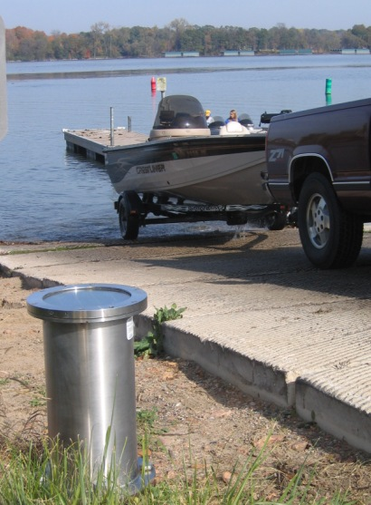
Continuous boat landing monitoring and education
System senses when a vehicle is using the boat landing and records video of the boat and trailers condition before launch. It can optionally play an audio clean-off message.

Vehicle and User Identification
Video images capture license plate, boat registration numbers for possible follow-up. Users can also be seen.

Data and Evidence Collection
Database archiving of the video images allows access to videos based on date, time, and location. Videos can clearly show aquatic plants and fragments.

Internet enabled, Remote management
Secure wireless transmission thru an established Wireless Access Point to a remote server enables real-time access and remote management of I-LIDS.

Continuous Duty. The LIDS device requires no human intervention to capture, transmit, process, and store videos. It is always on duty addressing more than 2450 hours that the launch may be used.

Standalone deployment. The system can operate without the use of wired power or network connections through optional solar energy and power saving efficient circuit design.

Other I-LIDS Specifications:
- Steel mounting plate on pier foundation allows rotation for changing video angle
- Tamper proof bolts require specialized key to gain access to system
- Photovoltaic Array (Solar Panel) power generation recharges battery
- Impact resistant stainless steel with bullet-proof dome and lens material
- Proprietary circuit sensor detects vehicle or trailer within 20 feet
- Maintenance window with clock for daily check of operation
- Optional power over Ethernet or low voltage power source if available
- Optional direct lighting for night launch captures
- Optional recorded voice message for playback

