SPINY WATER FLEA DENSITIES
IN THE GILE FLOWAGE
2006

Craig Roesler – DNR, Hayward

Background Information

The Gile Flowage is a 3,384 acre impoundment in Iron Co. Wisconsin. It has a maximum depth of 25 feet. It is the first inland lake in Wisconsin found to contain spiny water fleas (Bythotrophes cederstroemi). Spiny water fleas (SWF’s) are an exotic species of zooplankton native to northern Europe. SWF’s are predaceous, feeding on other zooplankton. Their long spiny tails prevent them from being eaten by juvenile or small fish. They cause shifts in the native zooplankton community. They may also impair recruitment of juvenile fish into the adult population by competing for their food supply. They were first found in the Gile Flowage in the late summer of 2003.

Monitoring Methods

The flowage was monitored again during 2006 to assess the population of SWF’s present. Four sites were sampled (figure 1). Sites were sampled monthly from June to October. At each site four vertical tows were made from two feet off the bottom to the surface. A 0.5 m diameter plankton net with a 253 micron screen was used. Surface water temperature was measured. Water elevation was also recorded, using the gage at the dam.

Monitoring Results

A previous report, “Spiny Water Flea Densities in the Gile Flowage 2004-2005” provides the monitoring results and discussion for those years. Monitoring results for 2006 are summarized below:

SWF’s/m³ Water Water
Date Mean +/- 90% confidence interval Level (ft)* Temp (ºC)
6-19-06 7.1 +/- 8.6 1487.8 20.6
7-24-06 12.5 +/- 4.2 1485.0 23.3
8-29-06 7.0 +/- 3.3 1484.9 19.4
9-18-06 32.3 +/- 9.1 1484.0 15.0
10-19-06 12.9 +/- 4.6 1483.8 2.8

*1490.0 ft. is considered full pool

Detailed sampling results are presented in tables 1 – 5. Spiny water flea densities for 2006 are graphed in figure 2. Figure 3 combines the density data for all three years of monitoring to facilitate a comparison.

Mean SWF density was fairly low on all sampling dates in 2006 except September 18th, when a significantly higher density was present (mean = 32.3 SWF’s / m³). There was no apparent correlation with water level or water temperature. Water level dropped 4.0 feet between June 19th and October 19th. While the temperatures measured on the sampling dates aren’t above normal, July was a very warm month, with 12 days having high temperatures > 90ºF. It is likely that higher July water temperatures occurred at times. Water temperatures above 25ºC (77ºF) have been observed to cause declines in SWF populations elsewhere.

Seasonal patterns of SWF density were different in all 3 years monitored (figure 3). However, annual mean densities were similar in all 3 years and ranged from 11.3 to 14.4 SWF’s / m³.

Small copepods were the most numerous form of zooplankton on all dates in 2006. Holopedium continued to increase in abundance, with large numbers of individuals present in the June through September samples. Holopedium has a gelatinous bivalved mantle that probably protects it from predation by SWF’s and provides it with a competitive advantage. Leptodora, a large native predaceous zooplankter, which was commonly observed in 2004 and 2005 was nearly absent in 2006, with only a single individual observed in August. Leptodora populations have been observed to decline elsewhere following the introduction of SWF’s.

A large transfer of bluegills and pumpkinseeds from Mercer Lake to the Gile Flowage was made during June 12th -22nd, 2006. 16,258 bluegills and 3,329 pumpkinseeds were transferred. Sizes ranged from 3.6 to 5.9 inches. A similar transfer of bluegills had previously been made in June 2005. The local DNR fish manager, Jeff Roth, also reported that exceptional bluegill fishing occurred in 2006, with numerous bluegills being caught in the 8-11 inch range. It is suspected this may be a response to the availability of SWF’s as a food source for larger bluegills. The bluegills stocked in 2005 would not have reached this size range.

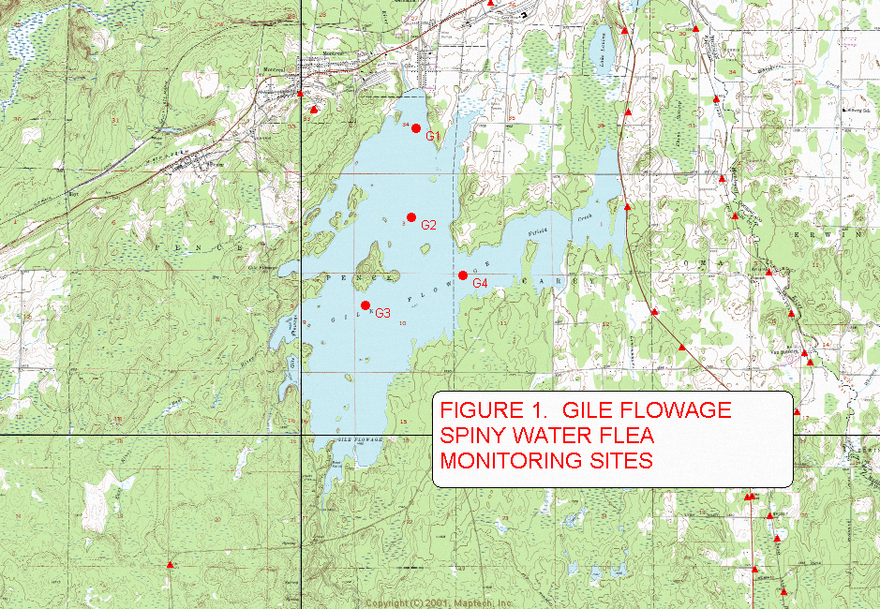

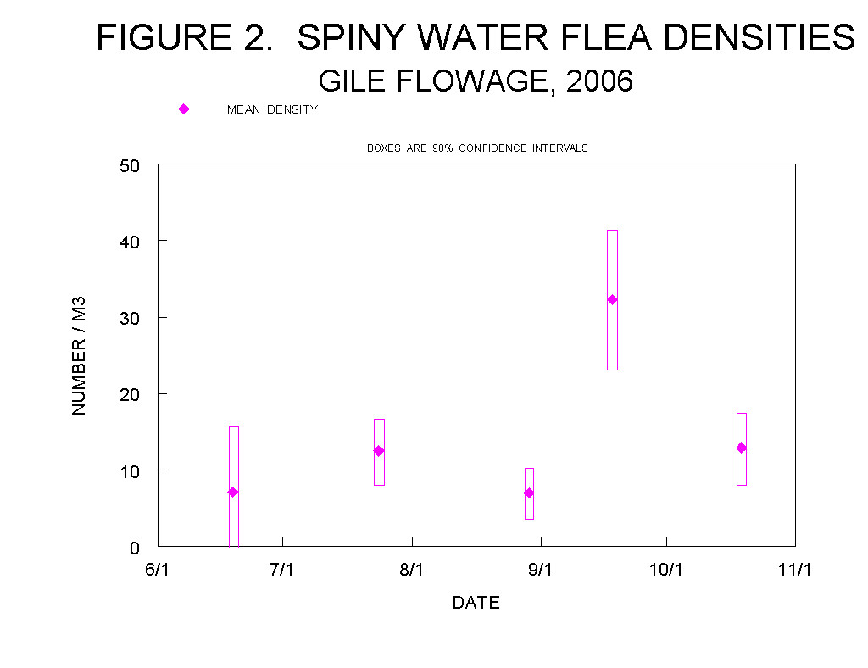

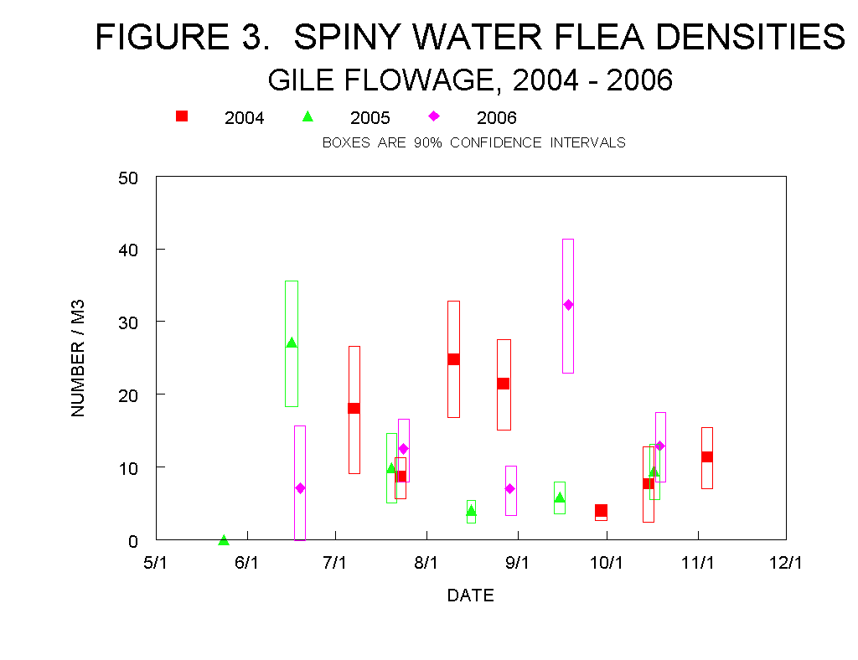

TABLE 1. | 2006 GILE FLOWAGE SPINY WATER FLEA MONITORING RESULTS, JUNE 19th
 | A plankton net with a 0.5 m diameter and 253 micron screen was used
 | to make 4 vertical tows at each of 4 sites.
 |  | DATE = | 19-Jun-06
 | SITE 1 | N46 25 12.0, W90 13 31.5
 | Water Depth (ft) = |  | 22 | Vertical tow depth (ft) = |  | 20
 | TOW | NO. SWF'S | SWF'S/m2 | SWF'S/m3
 | A | 8 | 40.8 | 6.7
 | B | 16 | 81.6 | 13.4
 | C | 6 | 30.6 | 5.0
 | D | 11 | 56.1 | 9.2
 | SITE 2 | N46 24 24.9, W90 13 35.0
 | Water Depth (ft) = |  | 22 | Vertical tow depth (ft) = |  | 20
 | TOW | NO. SWF'S | SWF'S/m2 | SWF'S/m3
 | A | 0 | 0 | 0.0
 | B | 7 | 35.7 | 5.9
 | C | 2 | 10.2 | 1.7
 | D | 15 | 76.5 | 12.6
 | SITE 3 | N46 23 38.2, W90 14 10.5
 | Water Depth (ft) = |  | 16 | Vertical tow depth (ft) = |  | 14
 | TOW | NO. SWF'S | SWF'S/m2 | SWF'S/m3
 | A | 7 | 35.7 | 8.4
 | B | 3 | 15.3 | 3.6
 | C | 10 | 51 | 12.0
 | D | 2 | 10.2 | 2.4
 | SITE 4 | N46 23 54.4, W90 12 54.9
 | Water Depth (ft) = |  | 12 | Vertical tow depth (ft) = |  | 10
 | TOW | NO. SWF'S | SWF'S/m2 | SWF'S/m3
 | A | 5 | 25.5 | 8.4
 | B | 5 | 25.5 | 8.4
 | C | 7 | 35.7 | 11.7
 | D | 3 | 15.3 | 5.0
 | MEAN = | 6.7 | 34.1 | 7.1
 | STANDARD DEV. = |  | 23.2 | 4.1
 | 90% CONF. INTERVAL = |  | 41.4 | 8.6
 | OTHER DATA, COMMENTS
 | Small copepods numerous; Holopedium abundant with estimates of 100
 | to greater than 200 per tow samle.
 | Leptodora not observed.
 | Water elevation at dam gage = 1487.8 ft.
 | Surface temp = 69 F

TABLE 2. | 2006 GILE FLOWAGE SPINY WATER FLEA MONITORING RESULTS, JULY 24th
 | A plankton net with a 0.5 m diameter and 253 micron screen was used to make 4 vertical tows
 | at each of 4 sites
 |  | DATE = | 24-Jul-06
 | SITE 1 | N46 25 12.0, W90 13 31.5
 | Water Depth (ft) = |  | 19 | Vertical tow depth (ft) = |  | 17
 | TOW | NO. SWF'S | SWF'S/m2 | SWF'S/m3
 | A | 12 | 61.2 | 11.8
 | B | 22 | 112.2 | 21.7
 | C | 9 | 45.9 | 8.9
 | D | 7 | 35.7 | 6.9
 | SITE 2 | N46 24 24.9, W90 13 35.0
 | Water Depth (ft) = |  | 18 | Vertical tow depth (ft) = |  | 16
 | TOW | NO. SWF'S | SWF'S/m2 | SWF'S/m3
 | A | 16 | 81.6 | 16.7
 | B | 7 | 35.7 | 7.3
 | C | 7 | 35.7 | 7.3
 | D | 31 | 158.1 | 32.4
 | SITE 3 | N46 23 38.2, W90 14 10.5
 | Water Depth (ft) = |  | 14 | Vertical tow depth (ft) = |  | 12
 | TOW | NO. SWF'S | SWF'S/m2 | SWF'S/m3
 | A | 14 | 71.4 | 19.5
 | B | 9 | 45.9 | 12.6
 | C | 12 | 61.2 | 16.7
 | D | 23 | 117.3 | 32.1
 | SITE 4 | N46 23 54.4, W90 12 54.9
 | Water Depth (ft) = |  | 10 | Vertical tow depth (ft) = |  | 8
 | TOW | NO. SWF'S | SWF'S/m2 | SWF'S/m3
 | A | 3 | 15.3 | 6.3
 | B | 0 | 0 | 0.0
 | C | 0 | 0 | 0.0
 | D | 0 | 0 | 0.0
 | MEAN = | 10.8 | 54.8 | 12.5
 | STANDARD DEVIATION = |  | 45.3 | 10.2
 | 90% CONF. INTERVAL = |  | 18.6 | 4.2
 | OTHER DATA, COMMENTS
 | Small copepods common. Less Holopedium than in June, about 25 / tow. Leptodora not observed.
 | Water elevation at dam gage = 1485.0 ft.
 | Surface water temp. = 74 F

TABLE 3. | 2006 GILE FLOWAGE SPINY WATER FLEA MONITORING RESULTS, AUGUST 29th
 | A plankton net with a 0.5 m diameter and 253 micron screen was used to make 4 vertical tows
 | at each of 4 sites
 |  | DATE = | 29-Aug-06
 | SITE 1 | N46 25 12.0, W90 13 31.5
 | Water Depth (ft) = |  | 18 | Vertical tow depth (ft) = |  | 16
 | TOW | NO. SWF'S | SWF'S/m2 | SWF'S/m3
 | A | 3 | 15.3 | 3.1
 | B | 1 | 5.1 | 1.0
 | C | 2 | 10.2 | 2.1
 | D | 2 | 10.2 | 2.1
 | SITE 2 | N46 24 24.9, W90 13 35.0
 | Water Depth (ft) = |  | 18 | Vertical tow depth (ft) = |  | 16
 | TOW | NO. SWF'S | SWF'S/m2 | SWF'S/m3
 | A | 8 | 40.8 | 8.4
 | B | 3 | 15.3 | 3.1
 | C | 2 | 10.2 | 2.1
 | D | 5 | 25.5 | 5.2
 | SITE 3 | N46 23 38.2, W90 14 10.5
 | Water Depth (ft) = |  | 14 | Vertical tow depth (ft) = |  | 12
 | TOW | NO. SWF'S | SWF'S/m2 | SWF'S/m3
 | A | 4 | 20.4 | 5.6
 | B | 1 | 5.1 | 1.4
 | C | 3 | 15.3 | 4.2
 | D | 0 | 0 | 0.0
 | SITE 4 | N46 23 54.4, W90 12 54.9
 | Water Depth (ft) = |  | 10 | Vertical tow depth (ft) = |  | 8
 | TOW | NO. SWF'S | SWF'S/m2 | SWF'S/m3
 | A | 10 | 51 | 20.9
 | B | 7 | 35.7 | 14.6
 | C | 4 | 20.4 | 8.4
 | D | 14 | 71.4 | 29.3
 | MEAN = | 4.3 | 22.0 | 7.0
 | STANDARD DEVIATION = |  | 19.1 | 8.1
 | 90% CONF. INTERVAL = |  | 7.8 | 3.3
 | OTHER DATA, COMMENTS
 | Small copepods common. Holopedium abundant with estimates of 50
 | to over 200 per tow sample. 1 Leptodora observed.
 | Water elevation at dam gage = 1484.9 ft.
 | Surface water temperature = 67 F

TABLE 4. | 2006 GILE FLOWAGE SPINY WATER FLEA MONITORING RESULTS, SEPTEMBER 18th
 | A plankton net with a 0.5 m diameter and 253 micron screen was used to make 4 vertical tows
 | at each of 4 sites
 |  | DATE = | 18-Sep-06
 | SITE 1 | N46 25 12.0, W90 13 31.5
 | Water Depth (ft) = |  | 16 | Vertical tow depth (ft) = |  | 14
 | TOW | NO. SWF'S | SWF'S/m2 | SWF'S/m3
 | A | 32 | 163.2 | 38.3
 | B | 24 | 122.4 | 28.7
 | C | 24 | 122.4 | 28.7
 | D | 3 | 15.3 | 3.6
 | SITE 2 | N46 24 24.9, W90 13 35.0
 | Water Depth (ft) = |  | 16 | Vertical tow depth (ft) = |  | 14
 | TOW | NO. SWF'S | SWF'S/m2 | SWF'S/m3
 | A | 12 | 61.2 | 14.3
 | B | 26 | 132.6 | 31.1
 | C | 8 | 40.8 | 9.6
 | D | 13 | 66.3 | 15.5
 | SITE 3 | N46 23 38.2, W90 14 10.5
 | Water Depth (ft) = |  | 13 | Vertical tow depth (ft) = |  | 11
 | TOW | NO. SWF'S | SWF'S/m2 | SWF'S/m3
 | A | 37 | 188.7 | 56.3
 | B | 24 | 122.4 | 36.5
 | C | 13 | 66.3 | 19.8
 | D | 15 | 76.5 | 22.8
 | SITE 4 | N46 23 54.4, W90 12 54.9
 | Water Depth (ft) = |  | 10 | Vertical tow depth (ft) = |  | 8
 | TOW | NO. SWF'S | SWF'S/m2 | SWF'S/m3
 | A | 9 | 45.9 | 18.8
 | B | 38 | 193.8 | 79.5
 | C | 17 | 86.7 | 35.6
 | D | 37 | 188.7 | 77.4
 | MEAN = | 20.8 | 105.8 | 32.3
 | STANDARD DEVIATION = |  | 57.0 | 22.1
 | 90% CONF. INTERVAL = |  | 23.4 | 9.1
 | OTHER DATA, COMMENTS
 | Small copepods common. Holopedium abundant with estimates of 150 to 200 per tow sample.
 | Leptodora not observed.
 | Water elevation at dam gage = 1484.0 ft.
 | Surface water temperature = 59 F

TABLE 5. | 2006 GILE FLOWAGE SPINY WATER FLEA MONITORING RESULTS, OCTOBER 19th
 | A plankton net with a 0.5 m diameter and 253 micron screen was used to make 4 vertical tows
 | at each of 4 sites
 |  | DATE = | 19-Oct-06
 | SITE 1 | N46 25 12.0, W90 13 31.5
 | Water Depth (ft) = |  | 18 | Vertical tow depth (ft) = |  | 16
 | TOW | NO. SWF'S | SWF'S/m2 | SWF'S/m3
 | A | 6 | 30.6 | 6.3
 | B | 13 | 66.3 | 13.6
 | C | 26 | 132.6 | 27.2
 | D | 17 | 86.7 | 17.8
 | SITE 2 | N46 24 24.9, W90 13 35.0
 | Water Depth (ft) = |  | 18 | Vertical tow depth (ft) = |  | 16
 | TOW | NO. SWF'S | SWF'S/m2 | SWF'S/m3
 | A | 20 | 102 | 20.9
 | B | 11 | 56.1 | 11.5
 | C | 5 | 25.5 | 5.2
 | D | 4 | 20.4 | 4.2
 | SITE 3 | N46 23 38.2, W90 14 10.5
 | Water Depth (ft) = |  | 14 | Vertical tow depth (ft) = |  | 12
 | TOW | NO. SWF'S | SWF'S/m2 | SWF'S/m3
 | A | 3 | 15.3 | 4.2
 | B | 4 | 20.4 | 5.6
 | C | 2 | 10.2 | 2.8
 | D | 2 | 10.2 | 2.8
 | SITE 4 | N46 23 54.4, W90 12 54.9
 | Water Depth (ft) = |  | 10 | Vertical tow depth (ft) = |  | 8
 | TOW | NO. SWF'S | SWF'S/m2 | SWF'S/m3
 | A | 6 | 30.6 | 12.6
 | B | 16 | 81.6 | 33.5
 | C | 1 | 5.1 | 2.1
 | D | 17 | 86.7 | 35.6
 | MEAN = | 9.6 | 48.8 | 12.9
 | STANDARD DEVIATION = |  | 39.2 | 11.1
 | 90% CONF. INTERVAL = |  | 16.1 | 4.6
 | OTHER DATA, COMMENTS
 | Small copepods numerous. Holopedium greatly reduced with a single specimen present
 | in each of 5 tow samples. Leptodora not observed.
 | Water elevation at dam gage = 1483.8
 | Surface water temperature = 37 F

