2011 Milwaukee River Round Goby Survey

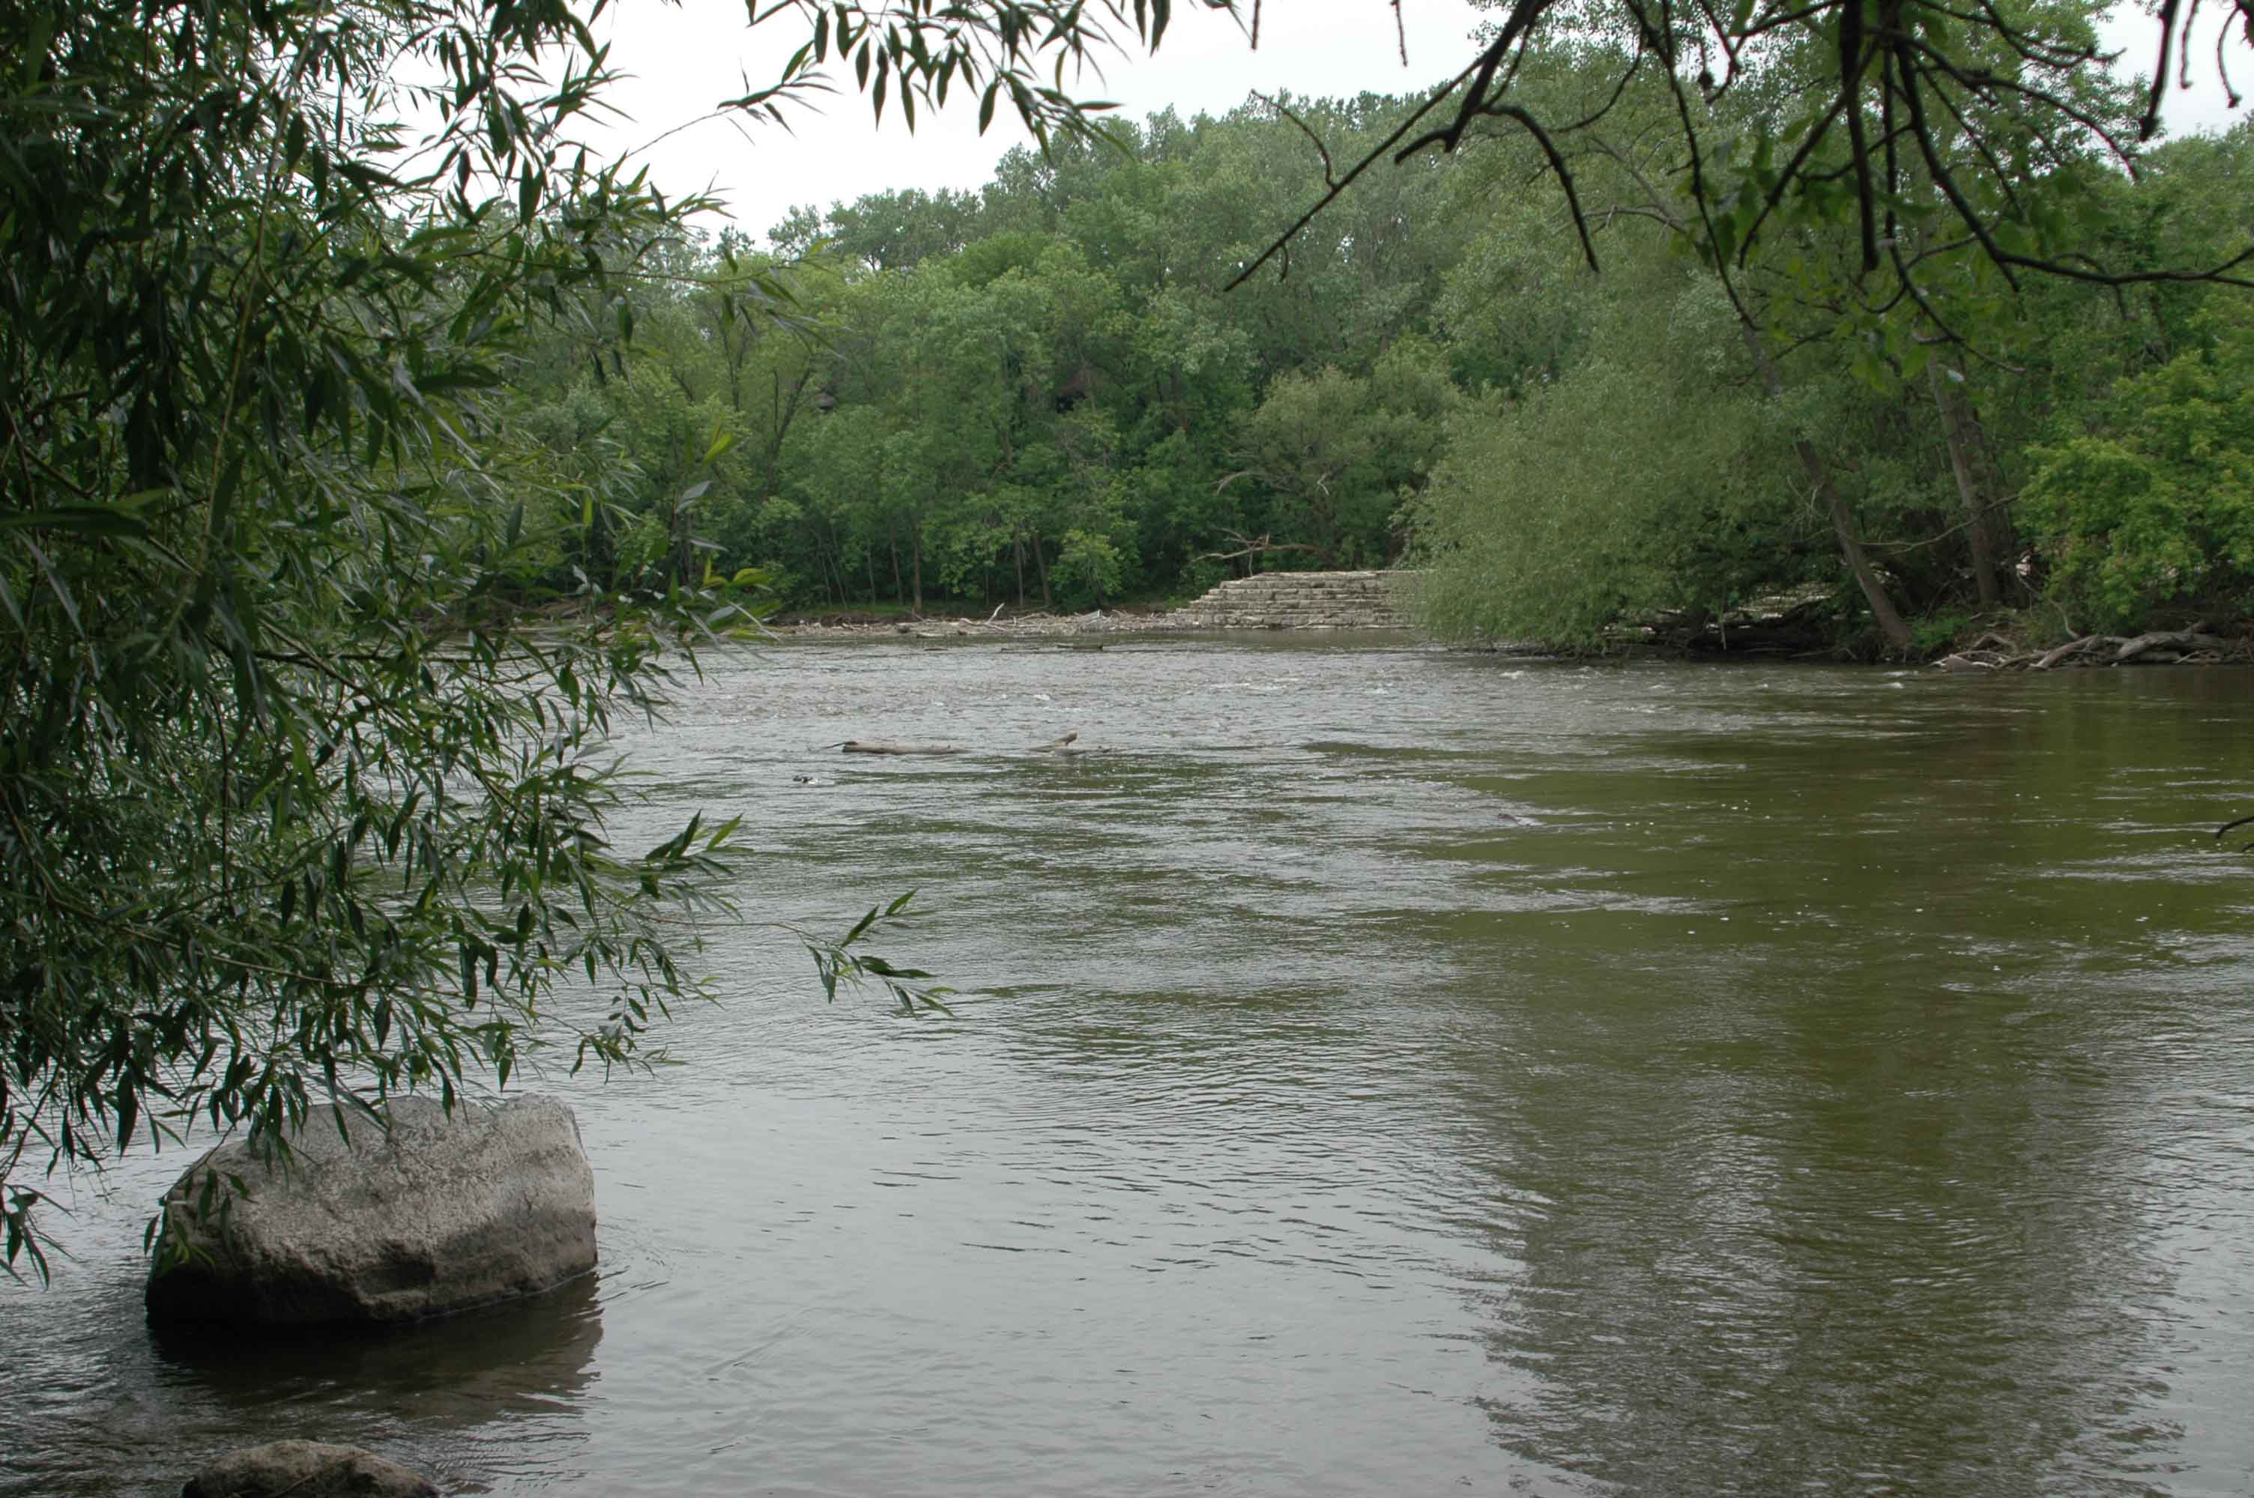
Milwaukee River, Milwaukee Co., WI, below Estabrook Dam (Site 2; River Mile 6.9), June 15, 2011, showing an area occupied by round goby. Photo by John Lyons, Wisconsin DNR.

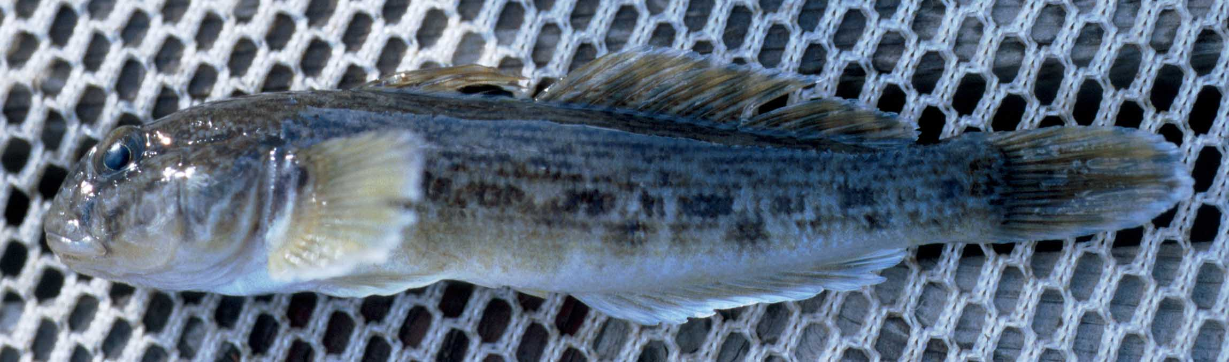
Round goby from Superior Harbor, Douglas Co., WI, May 24, 1999. Photo by John Lyons, Wisconsin DNR.

John Lyons
Fisheries and Aquatic Research Section
Wisconsin Department of Natural Resources
Madison
July 27, 2011
Summary
On June 15-16, 2011, biologists from the Wisconsin Department of Natural Resources (WDNR) conducted an electrofishing survey of the distribution and relative abundance of the exotic invasive round goby (Neogobius melanostomus) in the lower 33 miles of the Milwaukee River. Thirteen discrete sites were sampled, and round goby were encountered at three of the lowermost, below Estabrook Falls (River Mile 5.9, N=4 round goby), below the Estabrook Dam (RM 6.9, N=21), and below the Kletzsch Dam (RM 10.4, N=1). Several sites above the Kletzsch Dam had good or excellent round goby habitat but lacked round goby, indicating that at present the round goby is likely limited to the lower 10 miles of the Milwaukee River.

Background
The round goby (Neogobius melanostomus) is a small, bottom-dwelling fish native to the Black and Caspian Sea basins of Europe and Asia. It invaded the Great Lakes during the early 1990’s, probably via the ballast water of ocean-going ships, and it has become abundant and widespread (Jude et al. 1992; Kornis and Mercado-Silva 2011). In Wisconsin, the round goby is now found along the entire Lake Michigan shoreline of Wisconsin as well as western shoreline of Lake Superior (Lyons et al. 2000) and has recently begun invading Lake Michigan tributary streams and rivers (Kornis and Vander Zanden 2010). The round goby was first observed in the Milwaukee River above the harbor area in 2010 (D. Sullivan, U.S. Geological Survey, and W. Wawrzyn, WDNR, 2010, personal communication).

The round goby poses a threat to native fish communities. It is aggressive and territorial and has been shown to out-compete and displace native bottom-dwelling species such as sculpins and darters in the Great Lakes (Jude et al. 1995; French and June 2001; Janssen and Jude 2001; Balshine et al. 2005). As the round goby invades Great Lakes tributaries, there is growing concern that it will reduce or eliminate populations of native bottom-dwelling sculpins, darters, minnows, suckers, and catfishes (Carman et al. 1996; Kornis and Vander Zanden 2010). These native species are particularly diverse and play key ecological roles in tributary streams and rivers.

The Milwaukee River appears to have long stretches of suitable habitat for the round goby. In Great Lakes tributaries, the round goby is most likely to be found in medium to large rivers with low to moderate gradients and cool to warm summer water temperatures (Kornis and Vander Zanden 2010), and the Milwaukee River is a medium-sized, moderate-gradient, warm-water river. Within suitable tributaries, the round goby prefers rocky riffles and shallow runs with large amounts of cobble, boulder, woody debris, or other types of “cover” (Carman et al 2006; Kornis and Mercado-Silva 2011). Rocky riffles and runs are common over the length of the Milwaukee River.

Given the potential for the round goby to invade the Milwaukee River and to disrupt the native fish community, Wisconsin Department of Natural Resources (WDNR) biologists concluded that it was necessary to document the current status of the round goby in the river and to estimate its potential for expansion. Accordingly, in June 2011, a standardized round goby survey was conducted over the lower 33 miles of the Milwaukee River. Findings and conclusions of that survey are described in this report.

Survey Procedures
For survey purposes, 13 discrete sampling sites were delineated over the lower 33 miles of the Milwaukee River and numbered from downstream to upstream (Table 1; Figure 1). The two lower-most sites, below Estabrook Falls at RM 5.9 and below the Estabrook Dam at RM 6.9, were at or near locations where round goby had been collected in 2010. The upper-most site, at river mile (RM) 32.1, was upstream of the Bridge Street Dam in Grafton (RM 30.7), designated by statute as the first complete barrier on the river to upstream fish movement. The intervening 10 sites were chosen based on access, habitat suitability, and proximity to other dams that might act as impediments to round goby expansion.

Sites were surveyed in a standardized manner (Rabeni et al. 2009). Each site was sampled with a single upstream pass of a pair of pulsed-DC backpack electroshockers with output adjusted to maximize fish catch. Sampling was restricted to riffle or run areas less than 1 m deep. The length and width of river sampled varied depended on habitat attributes (Table 2), but a minimum of 270 m² of bottom area was surveyed at each site. An attempt was made to collect all round goby that were observed, and other fish species that were encountered were noted and enumerated. All captured round goby were measured to the nearest mm for total length. The potential habitat at each site was classified as excellent, good, fair, or poor based on criteria in Carman et al. (2006) and Kornis and Mercado-Silva (2011).

Findings
Round goby were found at three of the lowermost four sites surveyed (Table 2; Figure 1). Four individuals were collected from below Estabrook Falls (Site 1, RM 5.9), 21 from below Estabrook Dam (Site 2, RM 6.9), and one from below Kletzsch Dam (Site 4, RM 10.4). These three sites had good or excellent round goby habitat. The Estabrook Dam and Kletzsch Dam sites had similar and excellent habitat, but the round goby catch per unit area was about 44 times higher at the Estabrook Dam site, indicating a much larger population there. No round goby were collected from the Apple Blossom Lane area (Site 3, RM 9.9) not far downstream from the Kletzsch Dam site, but round goby habitat there was poor, with no large rock or woody cover and fine gravel, sand, and silt substrate. Round goby were not collected from the nine sites above Kletzsch Dam even though six of the sites, including the three immediately above the Kletzsch Dam (RM 11.5, 11.9. 13.0), had excellent or good round goby habitat.

The round goby that were collected varied substantially in size (Figure 2), ranging from 58-106 mm total length. Based on a comparison of the size distribution with age and growth data from other parts of the Great Lakes (Macinnis and Corkum 2000; French and Black 2009; Kornis and Mercado-Silva 2011), ages of Milwaukee River round goby could have been from 1 to 5, and most of the fish were probably adults capable of reproduction.

The survey yielded 33 species of fish, 31 of which were native to the river (Table 3; Appendix). The most common and widely distributed species were common shiner, rock bass, smallmouth bass, and green sunfish. Round goby was the ninth-most common species. Twelve native benthic species were encountered, including seven greater redhorse, a Wisconsin threatened species. Seven rosyface shiner, a proposed Wisconsin special-concern species, were also collected

Conclusions
Survey results indicated that the round goby is likely established in the lower 10 miles of the Milwaukee River, but has not invaded areas further upstream. Round goby densities equaled or exceeded 1 per 100 m² at the lowermost two sites, Estabrook Falls (RM 5.9) and Estabrook Dam (RM 6.9), and multiple age classes of mature adults were present, implying a viable population. Round goby were also captured downstream of the Estabrook Dam in 2010. Upstream of the Estabrook Dam, which currently has its spill gates raised and is not a barrier to upstream movement, no round goby were captured at Apple Blossom Lane (RM 9.9), which had poor round goby habitat, and only a single round goby was taken below the Kletzsch Dam (RM 10.4) despite excellent habitat. The density of round goby below the Kletzsch Dam was low (0.16/100 m²), suggesting a small population that had perhaps only just invaded this area of the river. No round goby were collected upstream of the Kletzsch Dam, even though most sites had excellent or good round goby habitat. Thus, at present, the Kletzsch Dam is probably the upper limit of round goby distribution in the Milwaukee River.

Dams may impede further upstream colonization of the Milwaukee River by the round goby. The round goby has minimal ability to leap over vertical barriers and may have difficulty moving upstream through currents stronger than 0.75-1.25 m/s (Hoover et al. 2003; Tierney et al. 2011). Consequently, even low-head dams may slow its expansion. At normal river levels, the Kletzsch Dam (RM 10.4) probably prevents round goby upstream movement, but during floods it may become passable as high flows eliminate the vertical drop of the dam and turbulent currents create pockets of relatively slow water velocities along the bottom through which round goby can advance. The Mequon-Thiensville Dam (RM 19.7) may also be a barrier to upstream round goby movement, but a fishway, completed in 2010, now allows fish to bypass the dam. The Bridge Street Dam (RM 30.7) is listed by statute as the first complete barrier to upstream fish movement in the Milwaukee River, and likely would block the round goby at all river levels. A fishway has been proposed for this dam to allow for upstream fish passage, but the WDNR has denied a necessary permit because of concerns over the potential for the spread of non-native aquatic invasive species, including the round goby.

The survey identified many native fish species in the Milwaukee River that might be impacted by the round goby. Twelve native benthic species, including the Wisconsin threatened greater redhorse, were encountered, and these species might compete with the round goby for habitat or food. Additionally, many of the remaining native species spawn on or near the bottom and could have their reproduction disrupted (Kornis and Mercado-Silva 2011) if the round goby becomes common in the river.

Given the environmental impact of the round goby on the Great Lakes, the recent appearance and apparent establishment of the species in the lowermost 10 miles of the Milwaukee River is a major concern. Whether round goby will expand their range and numbers in the river is uncertain, but the potential threat of a widespread and abundant round goby population is significant. I recommend repeating the round goby survey at regular intervals to document and track changes in distribution and relative abundance.

Acknowledgments
Thanks to Tom Burzynski, Brad Eggold, Paul Kanehl, Dave Schindelholz, and Dan Walchak for conducting the survey, and to Tom Burzynski for help with Figure 1. Support for this work was provided in part by a grant from Federal Aid in Sport Fish Restoration Project F-95-P, study SSOT.

References
Balshine, S., A. Verma, V. Chant, and T. Theysmeyer. 2005. Competitive interactions between round gobies and logperch. Journal of Great Lakes Research 31:68–77.

Carman, S. M., J. Janssen, D. J. Jude, and M. B. Berg. 2006. Diel interactions between prey behaviour and feeding in an invasive fish, the round goby, in a North American river. Freshwater Biology 51:742–755.

French, J. R. P., III, and M. G. Black. 2009. Maximum length and age of round gobies (Apollonia melanostomus) in Lake Huron. Journal of Freshwater Ecology 24:173–175.

French, J. R. P., III, and D. J. Jude. 2001. Diets and diet overlap of nonindigenous gobies and small benthic native fishes co-inhabiting the St. Clair River, Michigan. Journal of Great Lakes Research 27:300–311.

Hoover, J. J., S. Reid Adams, and K. J. Kilgore. 2003. Can hydraulic barriers stop the spread of the round goby? U.S. Army Corps of Engineers, Aquatic Nuisance Species Research Program, Technical Note ERDC/TN ANSRP-03-1 (published online: http://el.erdc.usace.army.mil/elpubs/pdf/ansrp03-1.pdf); accessed on July 26, 2011.

Janssen, J., and D. J. Jude. 2001. Recruitment failure of mottled sculpin Cottus bairdi in Calumet Harbor, southern Lake Michigan, induced by the newly introduced round goby Neogobius melanostomus. Journal of Great Lakes Research 27:319–328.

Jude, D. J., J. Janssen, and G. Crawford. 1995. Ecology, distribution, and impact of the newly introduced round and tubenose gobies on the biota of the St. Clair and Detroit Rivers. Pages 447–460 in M. Munawar, T. Edsall and J. Leach, editors. The Lake Huron ecosystem: ecology, fisheries, and management. Ecovision World Monograph Series. SPB Academic Publishing, Amsterdam.

Jude, D. J., R. H. Reider, and G. R. Smith. 1992. Establishment of Gobiidae in the Great Lakes basin. Canadian Journal of Fisheries and Aquatic Sciences 49:416–421.

Kornis, M. S., and N. Mercado-Silva. 2011. Round goby, Neogobius melanostomus. Online account in: J. Lyons, editor. Fishes of Wisconsin E-book. Wisconsin Department of Natural Resources, Madison, and U.S. Geological Survey, Middleton, WI. http://www.fow-ebook.us; accessed on July 26, 2011.

Kornis, M. S., and M. J. Vander Zanden. 2010. Forecasting the distribution of the invasive round goby (Neogobius melanostomus) in Wisconsin tributaries to Lake Michigan. Canadian Journal of Fisheries and Aquatic Sciences 67:533–562.

Lyons, J., P. A. Cochran, and D. Fago. 2000. Wisconsin fishes 2000. Status and distribution. University of Wisconsin Sea Grant, Madison.

MacInnis, A. J., and L. D. Corkum. 2000. Age and growth of round goby Neogobius melanostomus in the upper Detroit River. Transactions of the American Fisheries Society 129:852–858.

Rabeni, C., J. Lyons, J. Peterson, and N. Mercado-Silva. 2009. Sampling fish in wadeable warmwater streams. Pages 43-58 in S. Bonar, D. Willis, and W. Hubert, editors. Standard methods for sampling North American freshwater fishes. American Fisheries Society, Bethesda, Maryland.

Tierney, K. B., A. V. Kasurak, B. S. Zielinski, and D. M. Higgs. 2011. Swimming performance and invasion potential of the round goby. Environmental Biology of Fishes. Published online June 4, 2011. DOI: 10.1007/s10641-011-9867-2 (http://www.springerlink.com/content/r61227585673p286/); accessed on July 26, 2011.

Table 1 – Locations (downstream end) of the 13 sites sampled during the 2011 Milwaukee River round goby survey. DS = downstream. Latitudes and longitudes were determined with a hand-held Garmin III GPS unit (Map datum WGS 84). River bank was determined looking upstream.

____________________________________________________________________________________________

River Field Field River
Site Location County mile latitude (N) longitude (W) bank
____________________________________________________________________________________________

1 200 m DS Estabrook Falls Milwaukee 5.9 43.0971 -87.9056 Left

2 150 m DS Estabrook Dam Milwaukee 6.9 43.1017 -87.9111 Right

3 Apple Blossom Lane access Milwaukee 9.9 43.1254 -87.9166 Right

4 100 m DS Kletzsch Dam Milwaukee 10.4 43.1325 -87.9285 Left

5 Green Tree Road Bridge Milwaukee 11.5 43.1427 -87.9257 Left

6 Good Hope Road Bridge Milwaukee 11.9 43.1474 -87.9302 Left

7 Bradley Road access (Milw. CC) Milwaukee 13.0 43.1622 -87.9339 Right

8 100 m DS Mequon-Thiensville Dam Ozaukee 19.6 43.2309 -87.9799 Left

9 Mequon-Thiensville Dam Fishway Ozaukee 19.7 43.2311 -87.9795 Both

10 County Trunk Highway C Bridge Ozaukee 26.2 43.2799 -87.9425 Left

11 250 m below Lime Kiln Dam site Ozaukee 29.6 43.3036 -87.9965 Left

12 150 m below Bridge Street Dam Ozaukee 30.6 43.3172 -87.9487 Left

13 Bike Path (RR) Bridge off CTH O Ozaukee 32.1 43.3350 -87.9466 Right
____________________________________________________________________________________________
Table 2 – Sampling attributes and round goby catch from the 13 sites – 2011

_______________________________________________________________________________________________

Round Round goby Round goby
Sampled Sampled Sampled goby catch per habitat
Site Date length (m) width (m) area (m²) catch 100 m² quality
_______________________________________________________________________________________________

1 June 15, 2011 100 3 300 4 1.33 Good

2 June 15, 2011 50 6 300 21 7.00 Excellent

3 June 15, 2011 100 6 600 0 0 Poor

4 June 15, 2011 100 6 600 1 0.16 Excellent

5 June 15, 2011 85 6 510 0 0 Excellent

6 June 15, 2011 100 6 600 0 0 Excellent

7 June 16, 2011 100 6 600 0 0 Good

8 June 15, 2011 100 6 600 0 0 Fair

9 June 15, 2011 90 3 270 0 0 Fair

10 June 16, 2011 100 6 600 0 0 Fair

11 June 16, 2011 100 6 600 0 0 Excellent

12 June 16, 2011 100 6 600 0 0 Excellent

13 June 16, 2011 100 6 600 0 0 Good
_______________________________________________________________________________________________

Table 2b – Sampling attributes and round goby catch from the 9 sites – 2012

_______________________________________________________________________________________________

Round Round goby Round goby
Sampled Sampled Sampled goby catch per habitat
Site Date length (m) width (m) area (m²) catch 100 m² quality
_______________________________________________________________________________________________

4 Sept. 17, 2012 100 6 600 2 0.33 Excellent

5 Sept. 17, 2012 85 6 510 0 0 Excellent

6 Sept. 17, 2012 100 6 600 0 0 Excellent

7 Sept. 17, 2012 100 6 600 0 0 Good

8 Sept. 17, 2012 100 6 600 0 0 Fair

9 Sept. 17, 2012 90 3 270 0 0 Fair

10 Sept. 17, 2012 100 6 600 0 0 Fair

11 Sept. 17, 2012 100 6 600 0 0 Excellent

12 Sept. 17, 2012 100 6 600 0 0 Excellent

_______________________________________________________________________________________________
Table 3 – Total catch of all fish species, listed in order of abundance. Non-native species are in bold. The greater redhorse is a Wisconsin threatened species, and the rosyface shiner is proposed as a special concern species. Native benthic species are indicated by an asterisk. The catch per site is given in the Appendix.
________________________________________________________
Number of Number of
Rank Species individuals sites
________________________________________________________

1 Common shiner 134 10
2 Rock bass 124 11
3 Smallmouth bass 113 12
4 Green sunfish 106 11
5 Hornyhead chub 67 8
6 Golden redhorse 47 9
7 Spotfin shiner 46 8
8 Largescale stoneroller* 36 7
9 Round goby 26 3
10 Sand shiner 25 3
11 Bluegill 22 6
12 Mimic shiner 19 3
13 Logperch* 16 4
14 Bluntnose minnow* 15 5
15 White sucker* 10 3
16 Shorthead redhorse* 9 4
17 Pumpkinseed 8 5
17 Johnny darter* 8 3
19 Common carp 7 4
19 Greater redhorse* 7 3
19 Rosyface shiner 7 3
19 Fathead minnow 7 3
23 Blackside darter* 5 5
23 Blackstripe topminnow 5 3
25 Yellow bullhead* 4 3
25 Black crappie 4 1
27 Yellow perch 3 3
27 Silver redhorse* 3 2
29 Stonecat* 2 2
29 Black bullhead* 2 1
31 Golden shiner 1 1
31 Northern pike 1 1
31 Central mudminnow 1 1
________________________________________________________
Figure 1 – Map of the study area, showing sampling sites and goby catches.

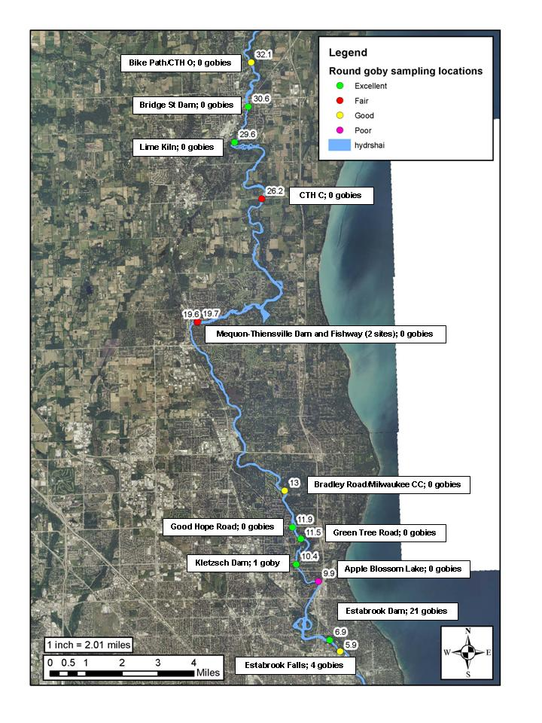

Figure 2 – Length frequency histogram (total length in mm) for round goby collected during the Milwaukee River survey. The crosshatched bars represent individuals from Estabrook Falls (Site 1), the solid bars Estabrook Dam (Site 2), and the open bar Kletzsch Dam (Site 4).

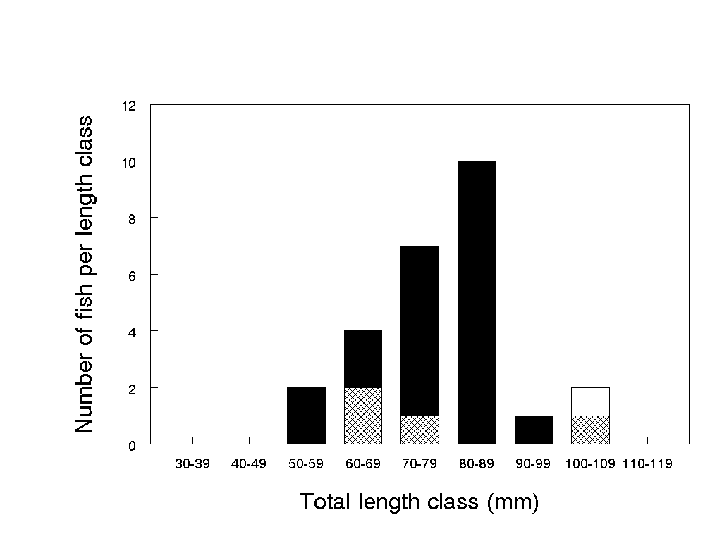
Appendix – Fish catches from the 13 survey sites - 2011

Site 1: 3 bluntnose minnow, 1 fathead minnow, 20 green sunfish, 3 smallmouth bass, 4 round goby

Site 2: 2 largescale stoneroller, 2 hornyhead chub, 10 common shiner, 2 spotfin shiner, 1 bluntnose minnow, 1 golden redhorse, 1 stonecat, 1 yellow bullhead, 10 rock bass, 10 smallmouth bass, 21 round goby

Site 3: 1 common carp, 2 silver redhorse, 1 golden redhorse, 7 rock bass, 2 pumpkinseed, 7 bluegill, 10 smallmouth bass

Site 4: 12 largescale stoneroller, 8 hornyhead chub, 1 golden shiner, 6 common shiner, 15 spotfin shiner, 8 mimic shiner, 6 bluntnose minnow, 1 white sucker, 1 silver redhorse, 1 golden redhorse, 1 shorthead redhorse, 1 stonecat, 9 rock bass, 22 green sunfish, 1 pumpkinseed, 4 bluegill, 15 smallmouth bass, 2 logperch, 1 blackside darter, 1 round goby

Site 5: 6 largescale stoneroller, 8 common shiner, 1 bluntnose minnow, 1 golden redhorse, 8 rock bass, 15 green sunfish, 6 smallmouth bass, 1 johnny darter, 1 blackside darter

Site 6: 6 largescale stoneroller, 3 common carp, 8 hornyhead chub, 10 common shiner, 1 spotfin shiner, 2 sand shiner, 8 white sucker, 20 golden redhorse, 21 rock bass, 8 green sunfish, 8 smallmouth bass

Site 7: 20 hornyhead chub, 50 common shiner, 1 rosyface shiner, 4 golden redhorse, 4 shorthead redhorse, 10 rock bass, 15 green sunfish, 15 smallmouth bass, 1 blackside darter

Site 8: 2 largescale stoneroller, 2 common carp, 6 common shiner, 15 spotfin shiner, 5 fathead minnow, 1 golden redhorse, 3 shorthead redhorse, 1 greater redhorse, 1 yellow bullhead, 1 blackstripe topminnow, 15 rock bass, 6 green sunfish, 2 pumpkinseed, 5 bluegill, 10 smallmouth bass, 4 black crappie, 1 yellow perch, 5 logperch

Site 9: 2 spotfin shiner, 2 black bullhead, 2 yellow bullhead, 3 blackstripe topminnow, 6 green sunfish, 1 pumpkinseed, 4 bluegill, 2 smallmouth bass, 1 yellow perch

Site 10: 1 central mudminnow, 1 northern pike, 4 hornyhead chub, 1 common shiner, 2 spotfin shiner, 12 sand shiner, 6 golden redhorse, 1 shorthead redhorse, 2 greater redhorse, 1 blackstripe topminnow, 18 rock bass, 10 green sunfish, 16 smallmouth bass, 1 blackside darter, 6 johnny darter

Site 11: 5 largescale stoneroller, 15 hornyhead chub, 15 common shiner, 4 rosyface shiner, 8 spotfin shiner, 1 sand shiner, 1 mimic shiner, 1 white sucker, 10 rock bass, 1 green sunfish, 2 pumpkinseed, 1 bluegill, 8 smallmouth bass, 1 johnny darter, 1 logperch

Site 12: 3 largescale stoneroller, 1 common carp, 2 hornyhead chub, 25 common shiner, 1 spotfin shiner, 12 golden redhorse, 4 greater redhorse, 6 rock bass, 1 green sunfish, 1 bluegill, 10 smallmouth bass, 1 yellow perch, 8 logperch, 1 blackside darter

Site 13: 8 hornyhead chub, 3 common shiner, 2 rosyface shiner, 10 sand shiner, 10 mimic shiner, 4 bluntnose minnow, 1 fathead minnow, 10 rock bass, 2 green sunfish

Appendix – Fish catches from the 9 survey sites - 2012

Site 4: 2 round goby

Site 5: common shiner, green sunfish, smallmouth bass, johnny darter

Site 6: common shiner, rock bass, green sunfish, smallmouth bass, blackstripe topminnow, blackside darter, johnny darter

Site 7: sand shiner, smallmouth bass, johnny darter, white sucker

Site 8: common carp, common shiner, spotfin shiner, pumpkinseed, bluegill, smallmouth bass, yellow perch, logperch, green sunfish, channel catfish, white sucker, Bluntnose minnow

Site 9: green sunfish, pumpkinseed, bluegill, smallmouth bass, yellow perch, silver redhorse, common carp, white sucker, spotfin shiner, common shiner, and bluntnose minnow

Site 10: hornyhead chub, shorthead redhorse, rock bass, green sunfish, smallmouth bass, common carp, log perch, black crappie, and bluntnose minnow

Site 11: smallmouth bass

Site 12: hornyhead chub, common shiner, rock bass, smallmouth bass, logperch, white sucker

