Directions to make floating bags for containing EWM while hand-pulling
Contact Paul Skawinski, Golden Sands RC&D

Materials include:
6 - 24" zip ties
2 – 50” foam noodles
1 – 23” wide burlap sack
1 - short section of rope (~9ft)
Tape
Box cutter knife

Step 1) Cut foam noodles to correct size. Step 2) Tape noodles into ring shapes. Then
stack noodles and tape them together.
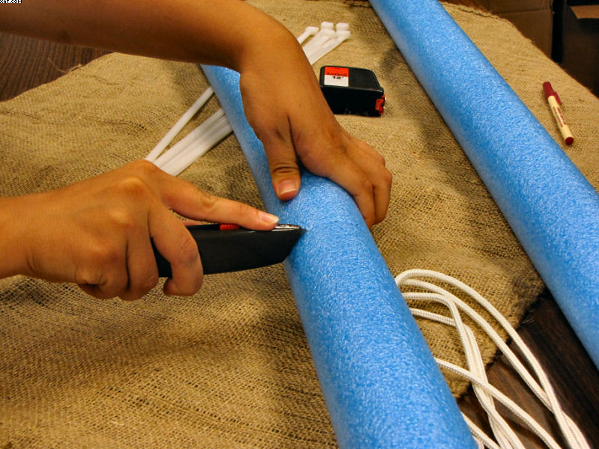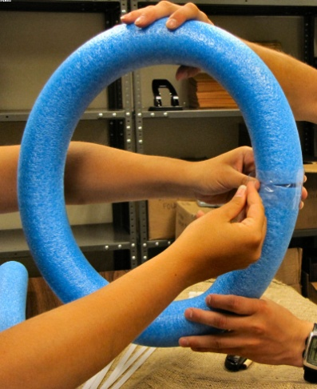
Step 3) Push open end of burlap sack downward Step 4) Push zip ties through the burlap and
through the rings, and pull edges back up. around the noodles and zip tight.
Fold them in around the inside of the noodles.
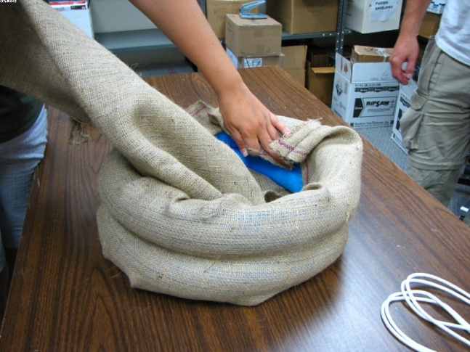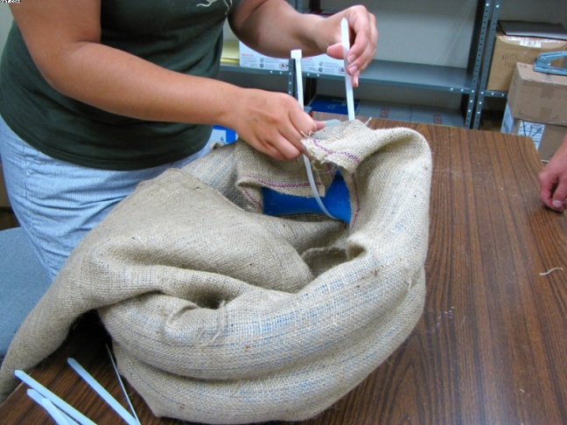

Your bag should now look like this: Step 5) Cut off excess zip-ties, and thread a section of
rope underneath all of the zip ties.
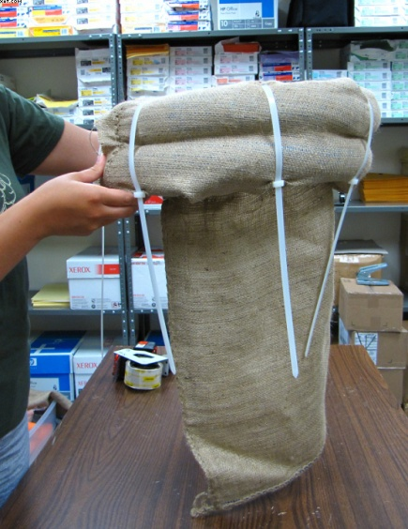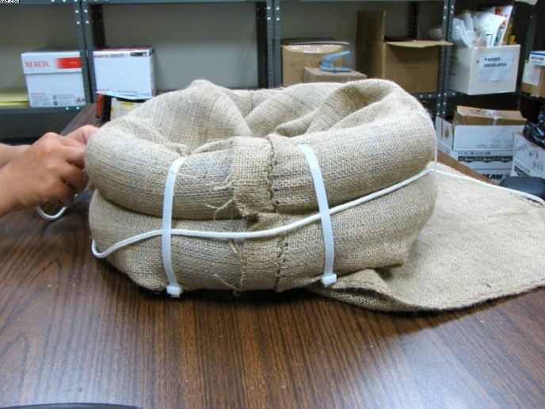
Step 6) Tie a knot in the rope, leaving 5-6ft of extra rope. This rope will be tied to the boat, kayak, etc. These bags could be used by themselves without rope, or could be tied to just about anything. Anchoring them in a spot or tying them to a tree would also work (with more rope). I hope others will find this idea as helpful as we have!
