April 26th, 2010

Fred Kawell
Erik Sande
DNR Department of Administration

Gentlemen,

At last years Namakagon Lake Association meeting the association elected to participate in a now funded DNR AIS Clean Boats/Clean Waters grant. This grant is being administered by State of Wisconsin/Department of Natural Resources and is managed by Environmental Sentry Protection, LLC & the Namakagon Lake Association. It incorporates automated video monitoring at two new boat launches to reduce the risk of boats launching invasives into lakes. Unbeknownst to any of us, the DNR had plans to revamp the ramp at County D. We’ve held off on implementing any installation until we could coordinate with your department.

The ILIDS installation plan would include installing a concrete footing to house a footing plate at ground level. This would be a 18” diameter and 3-4 feet deep. The I-LIDS housing would be mounted to this during each boating season. There would be a low voltage line from the neighboring property to accommodate power and data connections. This line would only have to be 6-8” deep and could be placed inside conduit. The sign show “Namakagon Lake Association”.

Some background on AIS if you’re not familiar with it:
Aquatic Invasive Species (AIS) include:
- Eurasian Watermilfoil and Curlyleaf Pondweed grow 2”/day and dominate depths from 0-25’ of water. These invasives can carpet lakes and overtake native aquatics.
- Zebra Mussels cling to everything fouling engine intakes and killing native clams. Female mussels reproduce 600,000 mussels in a season quickly carpeting the bottom of lakes and littering beaches with razor sharp edges.

Invasive species have had profound impact on nearby lakes (Chippewa Flowage, Minong Flowage) costing tens of thousands of dollars in ongoing control treatments. Already Wisconsin has lost 400 lakes to Eurasian Watermilfoil, Curlyleaf Pondweed and 100 have Zebra Mussels. Boats visiting more than one lake a day can easily transport invasives past un-monitored boat launches. This equipment would not restrict the boat launch use in any way. The installation location would comply with OHWM setback.

Please advise on what questions you may have and how we can integrate our plans. I know Namakagon Lake Association would like to see the lake protected beyond the existing 2 ILIDS systems in place at this time.

Sincerely,

Eric Lindberg
Environmental Sentry Protection, LLC

Cc: D. Dupras
Sample sign to be posted near I-LIDS device. 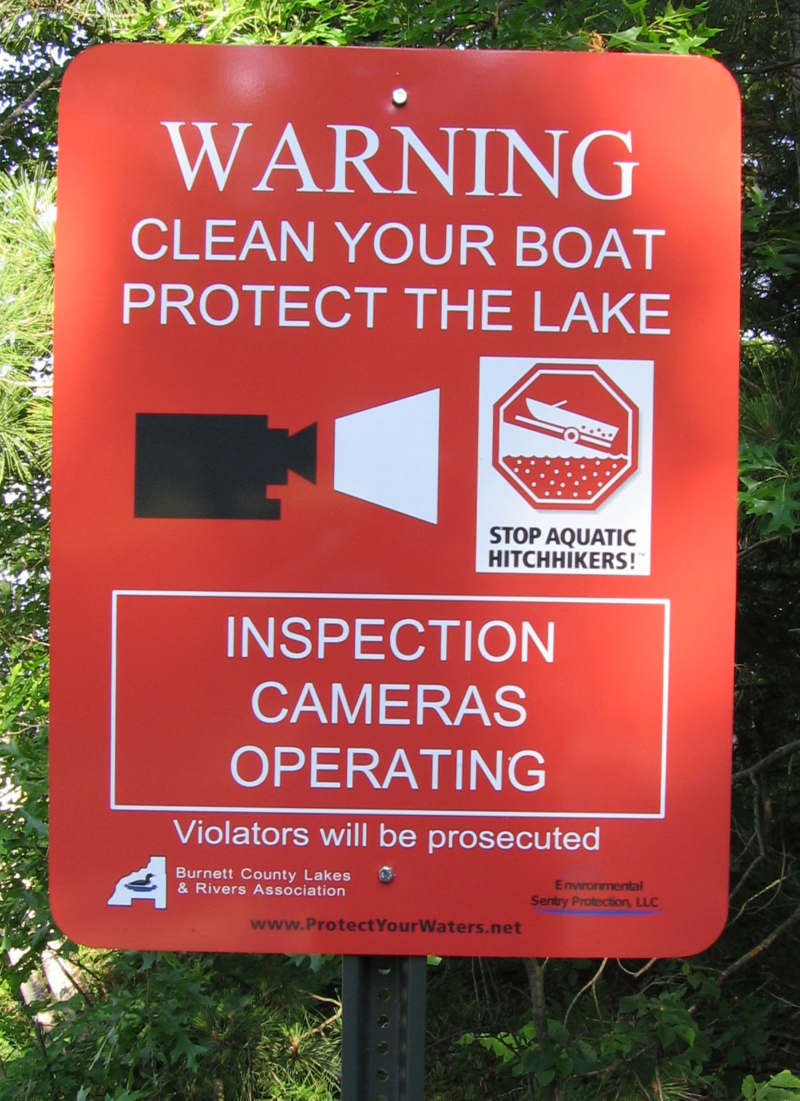
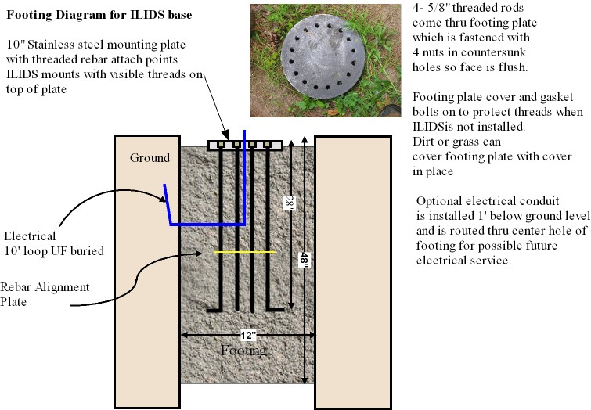
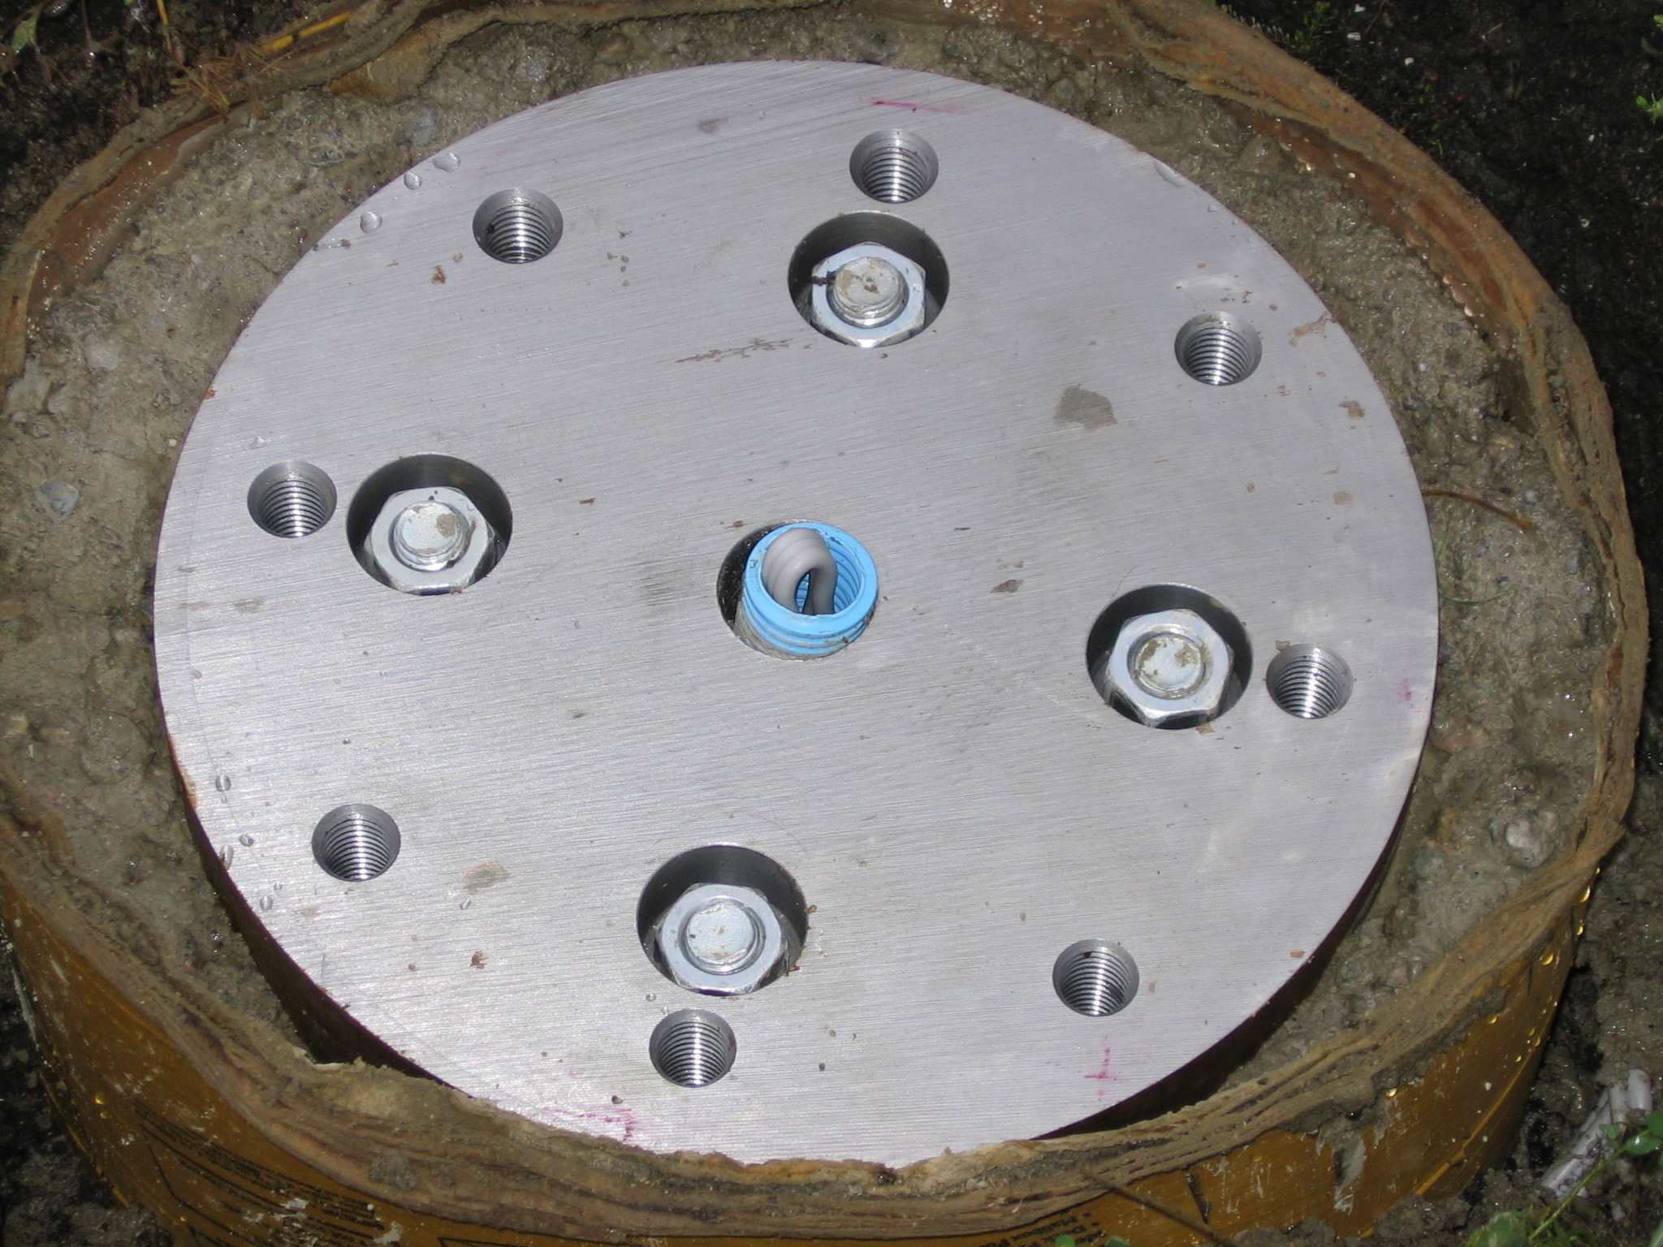
I-LIDS Footing, I-LIDS Device, and Boat Launch Plan

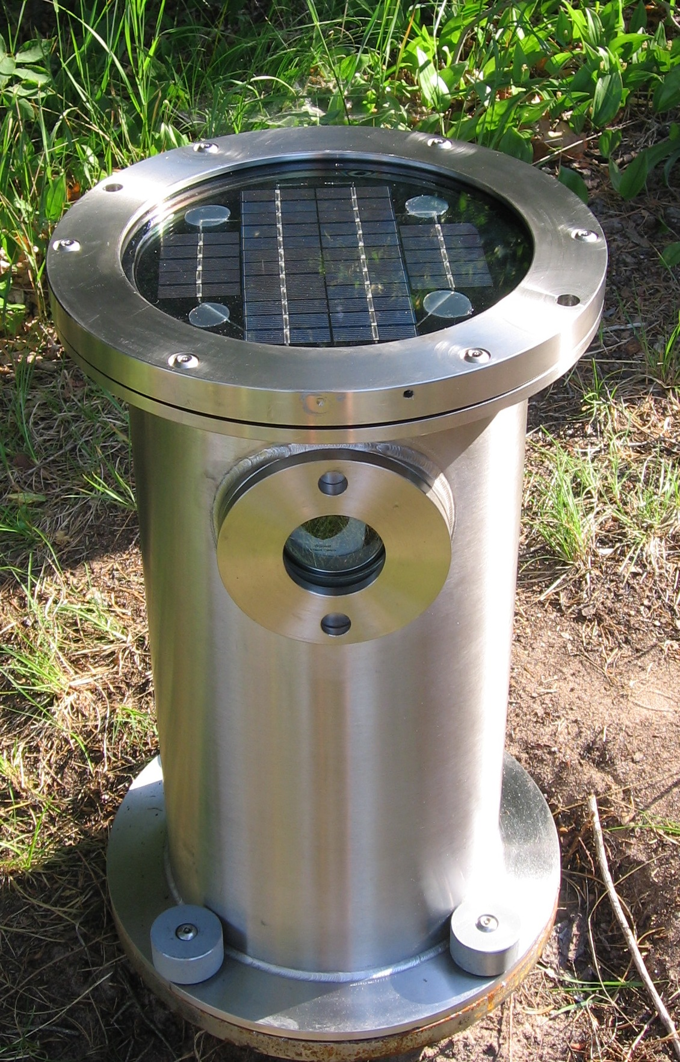
Internet Landing Installed Device Sensor (I-LIDS)

