GUIDANCE ON CONDUCTING WATERSHED ASSESSMENT PILOT PROJECTS

CONTENTS

BACKGROUND ON PILOT PROJECTS
1. Pilot Study Objectives
2. Water Division Data and Information Needs
3. Background on the Pecatonica-Gordon Creek Watershed (Example)
4. Problem Definition

PROCEDURE FOR SETTING UP PILOT PROJECTS
1. Identification of Study Watershed
1.a. Defining the watershed boundary

2. Sampling Point Selection
2.a. Sampling Point Types:
2.a.1. Geometric
2.a.2. Gap
2.a.3. Targeted (point source)
2.b. Geometric Site Placement Method
2.b.1. Selecting geometric size classes
2.b.2. Locating geometric sampling sites
2.b.3. Snapping geometric sites
2.b.4. Dropping geometric sites
2.b.5. Gap site placement method
2.b.6. Targeted (point source) site placement method

3. Setting up Project: SWIMS, Mapping, Naming
3.a. Establishing SWIMS stations
3.b. Creating project station IDs
3.c. Preparing for data management

4. Setup of Chemistry Sampling
4.a. Selection of parameters to sample
4.b. Coordination with State Lab of Hygiene
4.c. Coordination with other labs
4.d. Selection of procedures
4.e. Limitations on sampling frequency
4.f. Equipment prep

5. Work Plan: Scheduling Chemistry Sampling
5.a. Differentiate between parameters in terms of sampling frequency
5.b. Determine sampling frequency & number for group 1 parameters
5.c. Scheduling sampling
5.d. Communicate with SLH

6. Field Procedures: Holding Times and Shipping
6.a. Holding Times
6.b. Shipping
6.b.1. Determine shipping locations
6.b.2. Plan work days around shipping

FIGURES AND TABLES

Figure 3. The Pecatonica-Gordon Creek Watershed.
Box: More Technical Details: Procedure for Step 2.b.2 (placing geometric sites) in GIS
Box: Procedure for step 2.b.3. (snapping geometric sites) in GIS
Table 3.c.1. Example of a summary table listing site names, locations, types, and access notes.
Table 3.c.2. Sample chemistry data table, listing site name, sample date, and parameters sampled for each visit.
Table 4.b. Names and contact information for SLH staff as of summer 2010.
Table 4.b.2. SLH 2010 costs for parameters that were considered for sampling in Pecatonica pilot project.
Table 5.b. Sampling frequency for Pecatonica chemistry parameters that were sampled at every site.
Table 5.c.1. Panels sampled during each of 6 rounds of chemistry for Pecatonica pilot.
Table 5.c.2. Work schedule for Pecatonica pilot.
Table 6.a. Holding times for EPA Region V Lab and SLH in 2010
Table 6.b.1. Example FedEx and UPS locations, hours, and costs for shipping from Madison to Chicago.

BACKGROUND ON PILOT PROJECTS

The U.S. Environmental Protection Agency (USEPA) and the Wisconsin Department of Natural Resources (WDNR) are working together to characterize the physical, biological and chemical conditions of watersheds in Wisconsin. They will initially perform pilot studies on two watersheds in 2010 and 2011. This assessment will : 1) develop a process to identify and prioritize local, state, and federal water resource and land management data needs within the watersheds being monitored, 2) use stratified - random and targeted sampling designs to collect the desired data, and 3) use the resulting assessment information to evaluate watershed conditions, identify degraded stream sites, reaches, or streams, and direct management actions to reduce land use impacts and restore aquatic resources.

Overview

The U.S. EPA, the Midwest Biodiversity Institute, and the Bureau of Watershed Management have begun collaboration on watershed assessment pilot studies to determine if the proposed sampling design can efficiently provide more complete information for a wide breadth of Water Division stream assessment and management activities. The overall goals of the pilot studies are to identify and prioritize Water Division stream information needs, develop a sampling design that integrates these local, regional, state, and federal needs into locally-focused assessment efforts; and develop a systematic process for data analysis, and resource assessment and reporting that better facilitates direct actions to protect and restore Wisconsin’s stream resources.

This manual describes pilot study objectives, background on the Pecatonica river- Gordon Creek Watershed pilot study area, and the procedure for setting up future pilot studies based on experience from the Pecatonica.

1. Pilot Study Objectives

The U.S. EPA is encouraging the Bureau of Watershed Management to develop a stream monitoring strategy that addresses as many local, state, and federal watershed management program information needs as practical into a single integrated assessment effort. It is desired that the monitoring efforts are focused on “short – term” (2 – 3 years), “small” spatial scale (200 – 300 square mile watersheds) efforts, that promote problem identification and direct management actions; versus having a variety of different stream monitoring efforts that lack integration, and where direct stream and watershed management actions are primarily achieved through a variety of ad hoc special projects.

Before stream sampling is conducted the reasons for sampling should be clearly and unambiguously stated since monitoring programs benefit from having clearly documented and prioritized data needs. Monitoring efforts should address high priority program needs that promote direct management actions and should have clear descriptions of quantifiable program outcomes and timelines for completion. Primary objectives of the Pecatonica Pilot Project were to describe Water Division information needs and program priorities, and to describe how the sampling design applied and subsequent data analyses and reporting can be used to meet various program needs in an integrated, efficient, and cost-effective manner.

2. Water Division Data and Information Needs

Stream monitoring data can and should provide information for resource assessment and management at multiple spatial scales and for a variety of program needs. Watershed management and restoration activities can occur at spatial scales ranging from site-specific regulatory actions (e.g. correct a poorly managed barnyard), to identification and prioritization of land and water management activities at broader geographic (watershed) scales; to longer-term efforts to educate the public and legislature on the condition of the State’s water resources and direct management agencies to enact laws to protect or restore aquatic resources at statewide or national scales.

A comprehensive stream sampling strategy should provide information to answer the following questions:
1. What is the overall quality of Wisconsin’s streams?
2. Are stream conditions changing over time?
3. Which stream reaches, streams, or stream populations, are degraded?
4. What factors are degrading streams at reach, individual, and population scales?
5. Which high quality streams are at risk and need additional protection?
6. What management actions are needed to restore or protect streams?
7. How effective are local, regional, state, or federal, efforts and policies at protecting or restoring streams?

3. Background on the Pecatonica-Gordon Creek Watershed (Example)

The 221 square mile East Branch Pecatonica and Gordon Creek Watershed is located in southwestern Wisconsin, primarily in Iowa and Dane counties with small portions of the watershed in Lafayette and Green counties. The major land use within the watershed is agricultural (71% of land area), followed by forest (22%) and urban and suburban development (6%). Previous watershed and stream assessment work done by WI DNR and on-going research conducted by the University of Wisconsin suggests that sediment and nutrients from cropland run-off are the primary factors degrading the quality of the streams in the watershed. Manure run-off from barnyards and discharge from seven publically-operated wastewater treatment plants add to stream nutrient loads. While no concentrated animal feeding operations (CAFOs) are found within this watershed, there are a number of large dairy and beef cattle operations that are under the 1,000 animal-unit threshold that defines CAFOs in Wisconsin. Livestock access to stream channels and cropping close to streambanks degrade riparian and in-stream habitat. Recent stream survey work conducted by the WDNR has resulted in segments of four streams being added to the Impaired (303(d)) Waters List because of turbidity and sedimentation problems.

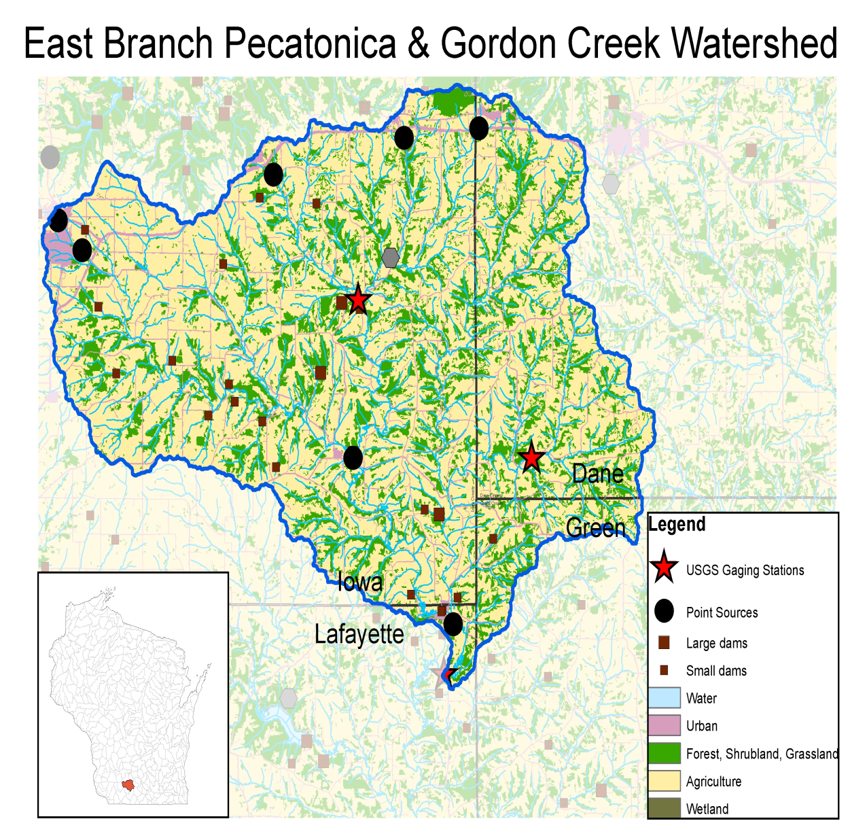
Figure 3. The Pecatonica-Gordon Creek Watershed.

Current work that is being done in East Branch Pecatonica and Gordon Creek Watersheds includes the Wisconsin Buffer Initiative (WBI), a collaborative effort among university, county, state, and private organizations with the primary goal of using high spatial - resolution cropland and live stock density data to identify and manage crop fields that are the major sources of nutrients and sediment to Pleasant Valley Creek, located within a 20 square mile watershed within the East Branch Pecatonica and Gordon Creek Watershed. An automated USGS water quality monitoring station is located at the pore. point of the Pleasant Valley Watershed and the Ridgeway Branch which is a similarly-sized control watershed where no additional agricultural best management practices will be implemented over the course of the study which currently has funding until 2015. Land use and continuous water quality data being generated by the WBI study will be used to locate sub-watersheds that contribute high nutrient and sediment loads to help identify potential targeted monitoring sites, and evaluate the utility of the instantaneous water quality (electronic meter) and water chemistry (grab sample) data being collected for the East Branch Pecatonica and Gordon Creek Watershed.

This study will document the existing status of the rivers and streams in the East Branch Pecatonica and Gordon Creek watersheds within Dane, Iowa, Green and Lafayette counties in Wisconsin. The study will emphasize the direct assessment of biological assemblages by sampling fish and macroinvertebrates using standardized sampling and watershed assessment methodologies. In addition to determining status, the study will also ascertain the associated causes and sources associated with biological impairments by using allied chemical, physical, and other stressor data and information within a systematic analytical process detailed in a comprehensive plan of study.

4. Problem Definition

Monitoring and assessment of aquatic resources should provide data and information to characterize the physical, chemical, and biological conditions of water resources, and to direct management actions and evaluate the effectiveness of management programs. Primary goals of the East Branch Pecatonica and Gordon Creek Watersheds Assessment Project are to:
- Apply a geometric sampling design to assess stream resources in a cost effective and statistically valid fashion.
- Use biological indicator data to assess stream conditions.
- Use physical habitat, water chemistry, and land use data to identify stream stressors and streams or reaches most impacted by poor land management or other sources.
- Improve the use and reporting of stream assessment data to increase monitoring program efficiency and effectiveness.

PROCEDURE FOR SETTING UP PILOT PROJECTS

1. Identification of Study Watershed

The first step in the geometric sampling design is to delineate the study watershed. Ideally the watershed should be approximately 200 miles² since the number of resulting stream assessment sites can typically be sampled in one season by a 3 or 4 person field crew.

1.a. Defining the watershed boundary

Much of the watershed selection process can be done within the Department’s WT Webviewer. The candidate watershed should be based on one or more HUC-10 watersheds. To check its drainage area and land use, a pour point should be marked using the Purdue custom watershed delineation tool under “advanced tools” in the WT Webviewer. Size, shape, and land use data can then be downloaded for the watershed. The pour point should be relocated (snapped) to the nearest roadway whenever possible. .

After the watershed’s pour point is identified, it is redrawn in ArcGIS. Relevant layers can be downloaded into ArcGIS from the DNR GIS library or SDE, including: DNR watersheds, hydrologic units (HUC-10), land use (NASS 2010), point sources (SWAMP), roads, dams, counties, municipalities, aerial photographs, national hydrography data set (NHD), perennial and intermittent streams, and USGS gaging stations (from coordinates obtained in the USGS website).

Occasionally there may be artificial breaches (i.e. ditches) that cross the watershed boundary and connect two separate basins. Breaches should be investigated through topographical maps, aerial photographs, and discussions with DNR regional staff. Based on their flow, direction, and general impact, the project manager can choose to include breaches, or ignore them and maintain the original HUC-10 watershed boundary.

2. Sampling Point Selection

Sampling Design

Within the study watershed, sampling sites include stratified-random (geometric) and hand-picked (gap and targeted) locations. Geometric and gap sites characterize overall conditions and targeted sites characterize and site-specific conditions of streams throughout the watershed. The sampling stratification is by drainage area size: stream sampling sites are systematically selected at the drainage outlets (pour points) of specifically-sized catchments. This sampling design is referred to as a “geometric” design since the size of the drainage areas selected for random sampling depend on the size of the most previously-selected drainage area.

2.a. Sampling Point Types

2.a.1. Geometric: Sites selected via a stratified-random sampling method, based on drainage area (described below).

2.a.2. Gap: Hand-picked sites placed to fill in geographic gaps in the watershed drainage not covered by geometric sites. After determining placement of geometric sites, look to see if there are significant drainage areas that are not being assessed by the geometric sampling sites. These may be key river confluences that did not fit the geometric criteria, 303(d) streams that got missed, etc. Gap sites are single sites (as opposed to targeted sites, which are often in pairs, upstream and downstream of point sources).

2.a.3. Targeted (point source): Hand-picked, often paired sites, to measure conditions up and downstream of potential point sources and other localized impacts in the watershed. Point sources ideally will include all major suspected sources of impact, such as wastewater treatment facilities, urban stormwater areas, CAFOs, non-CAFO high-impact farms, dams, etc.

2.b. Geometric Site Placement Method

Geometric sampling sites are located at the drainage outlets (pour points) of specific catchment sizes. Catchment sizes are derived from the initial size of the watershed. Approximately 7-8 size classes are developed, ranging from the full watershed area down to sub-watersheds around one to three square miles.

2.b.1. Selecting geometric size classes

The initial watershed's area will be your first size class, and ½ the watershed area will be the second size class. This area is divided in half again to derive the third size class, and so on until the drainage area is small, approximately o 1.5 square miles. For simplicity, these numbers should be rounded to 0 or 1 decimal place for each size class.

Example: The Pecatonica-Gordon Creek Watershed is 221.4 mi². The size classes for the Pecatonica pilot study were therefore:

Size class 1 = 221.4 mi²
Size class 2 = 110.7 mi²
Size class 3 = 55.5 mi²
Size class 4 = 27.7 mi²
Size class 5 = 13.8 mi²
Size class 6 = 7.9 mi²
Size class 7 = 3.4 mi²
Size class 8 = 1.7 mi²

For chemistry sampling, the number of site visits will be determined partly by the size class. Size classes are organized into “panels,” which are given a specific sampling frequency (particularly for chemistry visits). For instance, there are usually few sites in the largest size classes, and these classes can be combined into one panel. For the Pecatonica study, the panels contained the following size classes:

Panel 1: 221.4 mi², 110.7 mi², 55.5 mi²
Panel 2: 27.7 mi²
Panel 3: 13.8 mi²
Panel 4: 7.9 mi²
Panel 5: 3.4 mi²
Panel 6: 1.7 mi²

2.b.2. Locating geometric sampling sites

Locate a geometric sampling site at the pour point of all catchments that have drainage areas approximately equal to any of the size classes, +10% (e.g. panel 6 drainages deviate up to 10% from 1.7 mi², ranging from 1.53 mi² to 1.87 mi²). First, locate a geometric sampling site at the outlet of the study watershed (size class 1). Next, follow the river network upstream until you reach a subwatershed with the area of size class 2. Locate a geometric sampling site at all subwatersheds fitting this size class. There may be many or no subwatersheds that meet this size range; in the latter case, do not locate any geometric sites in this size class. After establishing the sampling site locations for size class 2, follow the same procedure for all smaller catchment size classes (panels).

There will generally be many more small-catchment geometric sites (headwaters) than large geometric sites (mainstems).

More Technical Details: Procedure for Step 2.b.2 (mapping geometric sites) in GIS

- Download the NHD dataset (http://www.horizon-systems.com/nhdplus/) for region 4 and/or region 7, depending on the area of the state. Within the NHD dataset you find everything you need for the process.

The NHD flowline shapefile contains unique numerical ID ("COMID") segments for all flowing waters within the region.

    - "Join attributes from a Table" based on the "COMID" between the "flowline" and the "flowlineattributesflow".
    - Create a new field, labeled something appropriate (i.e. Drain_miles). This field will represent the drainage area at the base of each stream segment in the shapefile.
    - Use the Field Calculator in the flowline attribute table to convert the Cumdrainage field from the appended table into the main flowline table (remembering to convert square meters to square miles).

- Delineate the watershed of interest, using the "Basin" and "Catchment" within the NHD download. Clip the streams of interest for visualization.

- Turn on Labels in the flowline layer, labeling by drainage (e.g. Drain_miles) for visualization.

Note the meaning of the labels. Each label applies to the downstream end of a stream segment; segments are usually bounded by the confluence of two streams. Each label applies to the upstream drainage area at the point on the segment just above the bottom of the segment (usually just above the confluence). This means that, just below each confluence, the drainage area can be calculated by combining the two upstream numbers (see diagram below).

Sometimes, two labels appear along a stream reach that has no perennial tributaries entering. In these cases, use the Select tool to select the reach, and you will see that the reach is broken into multiple segments. As always, the labels refer to the drainage area at the bottom of each stream segment.

In the diagram below, the stream is flowing from NW to SE. Look at the number 5.50, just above the first confluence. This number indicates that just above that confluence, the drainage area of the watershed is 5.50 mi². A tributary enters that drains 1.5 mi², so just below that confluence, the drainage area will be 7.00 mi² (5.50 + 1.50). At the next confluence downstream, a tributary enters that drains 2.00 mi². Just before that confluence, the drainage area is 10.00 mi², as shown by the 10.00. This means that between the first and second confluence, there is a 3 mi² difference (10.00 - 7.00) in watershed drainage area. Just after this second confluence, the drainage area will be 12.00 (10.00 + 2.00).
10.00
2.00
5.50
1.50
Figure 2.b. Sample watershed with NHD flowline labeling of drainage miles. Numbers represent the drainage area (mi²) upstream of each confluence.

- Create a new point layer for your geometric survey design points. Using "Create new feature" under the editor menu, start with the largest drainage values and work your way through each tributary, assigning geometric points and entering size class values into a new field in the geometric point attribute table.

To determine geometric site placement, choose points along stream segments where the size class occurs. In the diagram above, if a size class falls between 7.00 and 10.00 square miles, a point may be placed along the stream segment between these two confluences. Estimate the approximate placement based on the appropriate size class. If the desired size class is closer to 10.00 mi², place the point closer to that end of the stream reach.

If the size class does not occur anywhere along a stream, skip it. In this example, if a size class is between 5.5 and 7 or between 10 and 12, it does not occur. For instance, if the desired size class is 6.3 mi², as you move upstream there is never a point where the stream drains 6.3 mi², or even within 10% of 6.3 mi² (5.7-6.9 mi²). Below the NW confluence, the drainage area is 7.00 mi², whereas above it the area is 5.5 mi². In this case, do not place a point here—note that the size class has been skipped, and if the confluence seems important, locate a targeted sampling point here in a later step.

In this same example, if another size class is 11, there are no points where the drainage area is exactly 11 mi². However, there are points that are within 10% of 11 mi² ; this size class ranges from 10.9-12.1 mi². A geometric point would thus be placed either just up or just down from the SE confluence, at the discretion of the mapper.

2.b.3. Snapping geometric sites

After locating all geometric sites, snap them to road crossings and existing SWIMS stations. It may be most efficient to do this snapping as you go, to avoid revisiting all the locations. If you wish to do this, read through this entire mapping section before beginning to create sites in ArcGIS.

Note that the 10% flexibility in site placement often allows sites to be moved to the nearest SWIMS station, road crossing or driveway without changing size classes. If a site cannot be snapped without changing its size class, then it should not be moved and the original site location should be evaluated for sampling feasibility. Issues include: distances over 500 m to the nearest road, difficult terrain, landowner sensitivities or access denial. If sampling is not feasible, the site should be dropped.

Data management may be easier and more interesting if sites fall on sites that have been sampled for previous studies. For the Pecatonica project, a data layer was developed that represented all SWIMS stations in this watershed that had had data collected within the past ~15 years. Where feasible, geometric site locations were matched to the previous SWIMS stations.

Procedure for step 2.b.3. (Snapping geometric sites) in GIS

    - Create a new shapefile that is a copy of your original sampling points shapefile. Rename the copy, for example “SamplePointsSnapped”.

    - Start an editing session & set the snapping preferences (View-->Toolbars-->Editing; Editor-->Start Edit Session (choose SamplePointsSnapped); Editor-->Snapping: check the options you want. We checked nhdflowline: vertex, edge, and end and Roads: vertex, edge, and end in that order. You can drag the layer of 1st priority above the layer of 2nd priority; we thought nhdflowline was 1st priority, so we put it above Roads.)

    - Snap points to the nearest road crossing, regardless of whether the crossing is upstream or downstream, as long as it doesn’t dramatically change the size class. That is, if the size class would have increased or decreased more than one class, do not move the point.

Create new columns in the SamplePointsSnapped Attribute Table: SnpSizeCls and Alteration. SnpSizeCls = the approximate new size class of the snapped watershed (following the same calculation method as before snapping). We used Alteration to indicate one of several categories, so that we could later go back and look at how many points we had moved and how. The categories were: 1) “Unchanged” = point not moved because point wouldn’t remain in same or similar size class. 2) “Unchanged; ok already” = point not moved because already at road crossing. 3) “Same class” = point moved, but still in same size class as prior to snapping.

2.b.4. Dropping Geometric Sites

Use watershed roadway maps to determine whether some geometric sites would not be easily sampleable. Drop any sites that will be unfeasible to sample. Generally, for the Pecatonica project it was decided that if a site was more than 500 meters from the nearest road or driveway, it was not feasible to sample and would be dropped.

It is also important to keep in mind the overall feasibility of the number of sampling sites that can be sampled in a field season. If, for some reason, the above process has turned up 200 sampling sites, some sites would need to be dropped simply due to time constraints.

Determine a maximum number of geometric sampling sites—70 sites were sampled in one field season in the Pecatonica Watershed, approximately 50 of which were geometric. (Note that for statistical significance you want a minimum of 40-50 geometric sampling sites.) If the number of possible geometric sites exceeds your maximum number, then drop presumably less-important sites. For consistency, record your criteria for determining site importance. One useful criterion for dropping sites is size. To use the size method, after determining your maximum number of sites, list geometric sites in order from largest to smallest. Count down the list until you have reached your maximum number of sites, e.g. 50. Note the size of the 50th site, and drop all sites that are smaller than that size (and thus farther down the list). An alternative would be to sample a random subset of the small catchments to characterize the overall condition of the small catchments, or target small catchments that are of specific interest.

Another alternative to dropping sites would be to reduce sampling frequency (discussed later).

Perform field reconnaissance to drop any additional sites that are not sampleable , e.g. due to dry stream channel, lack of access, or the site not being wadeable.

2.b.5. Gap Site Placement Method

Some areas of the watershed may not be characterized by geometric sampling, i.e. when a size class must be skipped. You may later decide to fill in these holes with gap sites. For instance, if size class 2 must be skipped because subwatersheds do not exist at that size, the geometric sites may not cover confluences between major tributaries within the watershed. You may want to locate gap sites just above the outlet of major tributaries, so that sampling will capture differences between these major tributaries' effects on measurements at the watershed outlet.

Like geometric sites, gap sites may be snapped to the nearest SWIMS station or road crossing.

After determining the location of a gap site, determine its catchment size and assign it to a panel based on that size. Each site needs a panel in order to be assigned a frequency of chemistry sampling (see “5.b. Determine sampling frequency and number for group 1 parameters”). If the gap site’s catchment area falls in between two size classes, use best professional judgment to assign it to the most appropriate panel. For example, in the Pecatonica study, one gap site’s catchment area was 38 mi², which was in between Panel 1 (55.5 mi²) and Panel 2 (27.7 mi²). The site was placed in Panel 2, but could also have been placed in Panel 1.

2.b.6. Targeted (point source) Site Placement Method

To locate targeted sites, first develop a list of potential point sources or other potentially high-impact sources in the watershed. After developing this list, targeted sites will be placed upstream and downstream of these sources.

The first step in locating point sources takes place in SWAMP, where permitted discharges can be found. First, go into the WT Webviewer, and press the SWAMP tab to begin downloading SWAMP onto your computer. Then, enter SWAMP by double-clicking its desktop icon. Search for “facility,” press “search,” then make an “advance search” by watershed and press “find now” (you may first have to identify your watershed’s official DNR name in the WT Webviewer). A list of permitted facilities should appear on your screen. To find outfall locations, go to “options” and press “permit information” and “open.” If geographic coordinates are available, they can be found under the “Sample Point” tab. Check that coordinates belong to an active surface water outfall. If any location information is missing, you should contact the facility operator (go to “options,” press “facility,” “open,” and press the contact tab).

Note that SWAMP's placement of point source outfall locations is not always accurate, and the Regional Wastewater Engineer or the facility operator should be contacted to verify actual outfall locations. For example, in the Pecatonica study, it was determined that the city of Barneveld's WWTP outfall is actually located 3 miles south of Barneveld and is not accurately located in SWAMP. The targeted (point source) sampling site locations were moved accordingly to correct the error. Also, because the SWAMP facility search was done by DNR watershed—not by HUC-10 watershed—there may be slight differences in the searched area which exclude a point source. Look closely at the HUC-10 boundary to ensure that it has a close overlap with the DNR watershed, and, if necessary, check bordering DNR watersheds to find facilities in non-overlapping areas.

Once all permitted discharge facilities are located in SWAMP, you should follow up to ensure that no other point source problems of interest in the watershed are overlooked. WWTF operators should be contacted, as well as DNR staff involved with waste water permits, stormwater outfalls, utilities, non-point source pollution, and regional projects. County conservation staff can help with the identification of CAFOs and high impact non-CAFOs, offer livestock density information, and provide general insights about the watershed.

After developing a list of point sources that you wish to assess, place targeted sites upstream and downstream of each of these point sources. Upstream sites should be as close as possible to the point source without being affected by the point source. Downstream sites should be at least 50 m down from the point source. Note that systematic guidance still needs to be developed on distance of downstream targeted sites from the point source. Ideally, a standard distance will be developed based on flow and pollutant recovery rate.

Targeted sites can sometimes be snapped to the nearest SWIMS station or road crossing, provided that upstream sites are still relatively near the point source and downstream sites are no closer than 50 m and not so distant as to avoid capturing the point source’s impact.

Targeted sites do not need to be assigned to a panel; they are in their own panel and will be sampled with maximum frequency.

3. Setting up Project: SWIMS, Mapping, Naming

After locating and finalizing all sites that will be in the project, a summary table should be created that will be the basis for data organization. For every point, fields should include SWIMS ID, SWIMS station name, project station ID, latitude, and longitude. It is also helpful to include data such as Waterbody ID Code (WBIC), waterbody name, SWIMS status, location description, and most recent sampling date.

3.a. Establishing SWIMS stations

Some sampling site locations will at this point already have SWIMS stations, having been snapped to already-existing stations. Others will need new SWIMS stations. Contact the SWIMS database administrator (i.e. Lisa Helmuth) to set up a new SWIMS project. In that SWIMS project, use latitudes and longitudes to create new stations for the new sampling sites. Record the station names and SWIMS IDs of those sites in the table you are building.

- Remember that in SWIMS, the station naming convention is Waterbody at Road, i.e. Kittleson Valley Creek at CTH K. If the station does not fall at a road crossing, stick as close to the convention as possible while being descriptive enough that the site could be located by name alone. Example: Dodge Branch 400 m N of HWY 39 0.5 km E of HWY 39 and CTH K.

- Tip: Do not use the “&” symbol in SWIMS station names—it sometimes confuses the Fisheries Management Database (FMDB) program when transferring data back and forth.

3.b. Creating project station IDs

* Note: This step may be done earlier, when establishing sites in GIS.

At this point, each site now has 2 identifiers: its SWIMS ID and its SWIMS station name. However, neither of these is ideally useful in the field. SWIMS IDs can be long and very similar to each other, resulting in recording errors. SWIMS station names can also be very long and cumbersome. Typically, in most DNR field work, waterbody names can be used when speaking about different sites. However, with this geometric sampling strategy there are multiple sites on the same waterbody, and/or there are many unnamed waterbodies.

In the Pecatonica Pilot, it was useful to create short, intuitive names as shorthand for sites. When filling out paperwork and bottle labels in the field, both the project station ID and the SWIMS station ID were used. That way, if the SWIMS ID was recorded wrong, it could be confirmed with the project station ID. And when speaking to each other or taking notes about the site, the project ID could be used.

The Pecatonica project naming convention for a site was the site’s catchment size followed by an abbreviation for its major subwatershed. Our three major subwatersheds were Gordon Creek, West Pecatonica, and Upper Pecatonica. Most sites, therefore, had the abbreviation “g,” “wp,” or “up.” Sites lower in the watershed that didn’t fall in any of the three were simply labeled “p.” Coupled with catchment size, some of our site names looked like this: 57.5p, 3.4g, 1.7up. Often, sites in the same size class would end up with the same name: 1.7up described several sites. In these cases, we added an additional digit onto the end of the name to distinguish similar sites: 1.7up1, 1.7up2, 1.7up3… We generally numbered such sites from west to east in a subwatershed.

Our naming convention was not perfect—it was still easy to mix sites up with each other, and it was a little sloppy because names sometimes had an end digit (1.7up1) and sometimes did not (3.4g). But it helped. We recommend discussing whether our naming convention is acceptable to you, or whether you have ideas that will better fit your project.

3.c. Preparing for data management

One of the lessons learned in the Pecatonica pilot project was that early preparation for data management can save a great deal of time when compiling data later on. Due to the volume of samples collected—multiple samples at each site, with multiple parameters—it can be nearly impossible to keep track of missing data if it hasn’t been tracked properly during sampling.

Based on experience from the Pecatonica study, it is recommended to establish three main tables for managing data. (You may determine additional or more useful methods; these recommendations are intended to help you get started.) The first table is the attribute table in ArcGIS, which is part of the shapefile created when mapping your sites. The second will be a summary table, summarizing all important information about your sites. Our summary table looked like this:

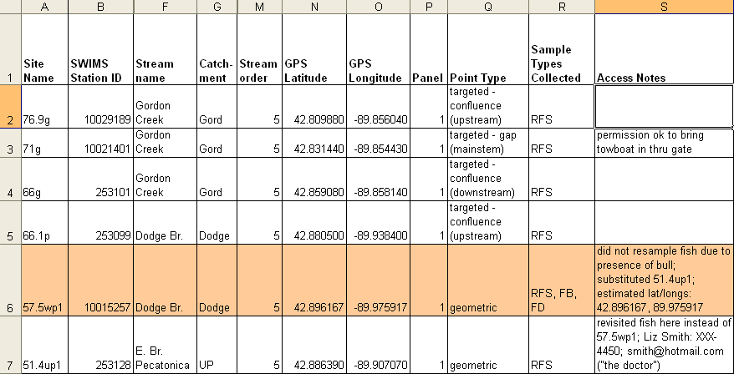
Table 3.c.1. Example of a summary table listing site names, locations, types, and access notes. This table was very useful in the field for the Pecatonica Pilot, and was updated regularly (weekly or every other week).

This table was useful in the field for recalling which sites were “dup/blank” sites (shaded area in Table 3.c.1.), which sites required landowner contact ahead of time, the lat/long of each site, etc. It was important to update this field as often as new information was gathered, such as phone numbers or access information. Generally, the field crew leader took notes on her copy of the table and reprinted an updated table for each new round of chemistry sampling, every 2 weeks.

Finally, we highly recommend creating a chemistry data management table, with a format similar to the following:

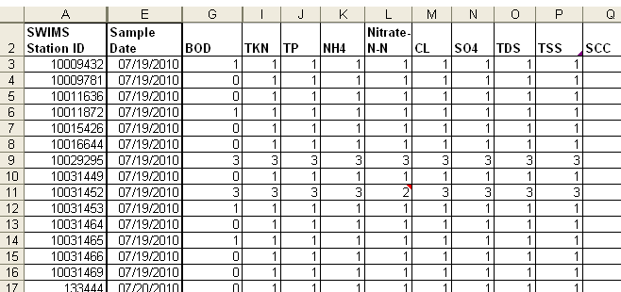
Table 3.c.2. Sample chemistry data table, listing site name, sample date, and parameters sampled for each visit. Each chemistry parameter should have a column, and each site visit should have a row. Field crew should update this or a similar table daily or weekly, which will save weeks of work during data compilation.

This table should be updated as often as possible during chemistry sampling by the field crew leader (or a delegated crew member who is good at keeping track of data). It should be filled out daily during chemistry sampling, at least by hand, and should be updated electronically at a minimum of once a week. It will save weeks of work on the back end of the project trying to locate any data that may be missing from the lab.

Because you will be storing data in these three places, it is important to update all three tables when making site adjustments such as changes in lat/long. If you and your field crew are comfortable using databases (as in Microsoft Access), a database would be preferable to a spreadsheet program like MS Excel, to avoid the problem of needing to update multiple tables. Recognizing that most people are more comfortable with Excel than with databases, we’ve made these recommendations based on the assumption that you’ll be using Excel.

4. Setup of Chemistry Sampling

4.a. Selection of parameters to sample

Determine which chemistry parameters will be sampled in the watershed. Compile a list of all chemical parameters that may adversely affect biota in the watershed: nutrients, demand parameters (BOD/COD), solids, pesticides, PAHs, metals, sediment nutrients, etc. Add any additional parameters that are important to the project.

4.b. Coordination with State Lab of Hygiene

Contact the State Lab of Hygiene (SLH) to verify that all desired parameters can be processed there. Questions for SLH:

- What is the cost of analysis for this analyte?
- What is the procedure code for analysis?
- Are there preferred procedures that should be used for field sampling?
- What is the procedure code for field sampling; where can I find a copy of the procedure?
- What is the maximum volume and frequency of samples you can handle for this parameter?
- Who can I contact during the sampling season regarding lab questions?
- What are the logistics of delivering samples to SLH: hours of SLH, person to contact, lab slips required, acquisition of bottles, shipping of coolers (e.g. can the lab ship coolers back after receiving samples)?

Contacts at SLH:

Contacts | Name | Phone | Email
SLH Water - General |  | 1-888-494-4324 x 2 (or 608-224-6277)
SLH Inorganics | Graham Anderson
SLH Metals | DeWayne Kennedy-Parker | 224-6282 | fess@mail.slh.wisc.edu
SLH Trace Metals Clean Lab | Pat Gorsky | 224-6226
SLH Trace Metals Clean Lab | Al Cleary | 224-6294
SLH Organics | Steve Geis | 224-6269
SLH Biomonitoring | Sharon Kluender | 224-6266
SLH (UW?) Algal Toxins | Dawn Perkins
SLH B.O.D. | Pat Gorsky | 224-6226
SLH B.O.D. analyst | Graham Anderson
 | Tony | 224-6281
Table 4.b. Names and contact information for SLH staff as of summer 2010.

Costs of lab analysis:

Chemical_parameter | SLH Cost per Sample (2010)
BOD (5-day) | $62.08
TP | $23.60
TDP | $23.60
TKN (w/ CuSO4) | $32.99
NH3-N | $25.89
Nitrate plus Nitrite-N | $27.89
TSS (total suspended solids) | $18.80
TDS | $17.13
Chloride | $22.31
Sulfate | $32.97
Trace_Metals_Ca, Mg, Cu, Cd, Fe, Zn, Pb_(ICP) | $200.93
Metals_Ca, Mg_(ICP) | $46.35
Metals_Cu, Cd, Fe, Zn, Pb (0.45 um-filtered) | $128.43
Metals_Ca, Mg, Hardness, Cu, Cd, Fe, Zn, Pb (unfiltered) | $128.43
Chlorophyll-a | $24.52
Pesticides (including Atrazine) | ?
Bacteria_E.Coli | $35.56
Sediment metals (Cu, Cd, Fe, Zn, Pb): analysis | 107.25
Sediment metals (Cu, Cd, Fe, Zn, Pb): digestion
Sediment_Hg | $50.05
Sediment organics (TOC) | $104.75
Sediment Organics --pesticides | $242
Sediment organics (atrazine) | ?
Sediment organics (PAHs--polynuclear aromatic hydrocarbons) | $383.20
Table 4.b.2. SLH 2010 costs for parameters that were considered for sampling in Pecatonica pilot project.

4.c. Coordination with other labs

If SLH does not analyze essential parameters on your list, determine where they can be analyzed and obtain the above information from your lab of choice.

4.d. Selection of procedures

Some parameters, such as chlorophyll-a, have multiple sampling procedures from which to choose. When possible, choose the procedure that will place the least burden on the field crew. Since this type of project requires hundreds of chemistry sampling visits, long field procedures can hinder the ability of the crew to get all the work done. We elected to not field filter chl-a, but instead to have it lab-filtered at SLH in order to save time in the field. We also chose to sample unfiltered metals rather than trace level metals, which would have been extremely time-consuming and required different sampling equipment. The project manager should weigh costs, time, and importance of each parameter to make sure adequate data is collected within the constraints of the field season and budget.

4.e. Limitations on sampling frequency

There will be a few different factors that will determine the frequency with which you conduct chemistry sampling. First, if you are sampling to address impairment criteria, there may be strict guidelines. For example, to be used for 303(d) listing or delisting, total phosphorus (TP) must be sampled monthly during the six-month growing season (May-Oct.). Contact Nikki Clayton (608-266-0152; nicole.clayton@wisconsin.gov) for information on listing criteria.

Additionally, SLH may have limitations on how many samples they can handle at a time. For example, in the Pecatonica pilot most analysis was done at the EPA Region V Lab in Chicago. That lab could only handle 10 BOD samples per day, which meant that on days when we sampled more than 10 sites, we had to make sure that BOD analysis was only requested for up to 10 sites.

4.f. Equipment Prep

Early in the process—ideally by March—obtain and review all procedures for field sampling of all chemistry parameters. Make sure that procedures are clear and that all equipment is ready; purchase additional equipment that may be needed; and schedule any training that may be needed for the field crew.

Also make sure that field chemistry equipment (i.e. YSI meters and pH probes) will be ready by the field season. Review the manuals for equipment in case you will need to purchase calibration solutions, membrane kits, cleaning kits, or probe replacements. For example, pH probes typically have a lifespan of 1.5 years, regardless of use. It may be necessary to purchase a new pH probe or replace the pH probe on your YSI; do this early to avoid delaying field work.

5. Work Plan: Scheduling Chemistry Sampling

Invertebrates will be sampled in the fall towards the end of the field season, and fish will be sampled in between rounds of chemistry sampling until mid-September. However, chemistry sampling must be scheduled in detail to ensure that the appropriate frequency requirements are met during each round of visits.

We found it simplest to separate chemistry sampling from fish and invertebrate sampling. Although this meant more site visits, it was easiest for the crew to be in either “chemistry mode” or “fish/invert mode,” instead of keeping track of all paperwork and procedures for all parameters on the same day.

5.a. Differentiate between parameters in terms of sampling frequency

In the Pecatonica pilot study, we divided chemistry parameters into three groups:
- Parameters to sample during every visit at all sites (e.g. nutrients, suspended solids)
- Parameters to sample only once, at all sites (e.g. metals, pesticides)
- “Special” parameters to sample only at a few sites (i.e. PAHs—only at urban sites), or at a different frequency (i.e. BOD, due to lab limitations at EPA Regional lab)

5.b. Determine sampling frequency & number for group 1 parameters

Chemistry parameters in group 1 included TP, TKN, NO₃NO₂N, TSS, TDS, and SSC. For each of these parameters, the catchment size (panel number) of a site determines how many times it is sampled:

Panel | Fish | Inverts | Qualitative Habitat | Chemistry
1 | 1 | 1 | 1 | 6
2 | 1 | 1 | 1 | 6
3 | 1 | 1 | 1 | 6
4 | 1 | 1 | 1 | 4
5 | 1 | 1 | 1 | 4
6 (geo, gap) | 1 | 1 | 1 | 2
6 (point source) | 1 | 1 | 1 | 6
Table 5.b. Sampling frequency for Pecatonica chemistry parameters that were sampled at every site. Sites in the largest size classes and point source sites were sampled most frequently.

5.c. Scheduling sampling

We divided chemistry sampling into six rounds, and listed which sites would be sampled in each round:

Panel # | # sites | Round 1 | Round 2 | Round 3 | Round 4 | Round 5 | Round 6
1 | 13 | Basic | Basic | Basic | Basic | Full Suite | Basic
2 | 7 | Basic | Basic | Basic | Basic | Full Suite | Basic
3 | 7 | Basic | Basic | Basic | Basic | Full Suite | Basic
4 | 6 | Basic | Basic | --- | Basic | Full Suite | ---
5 | 11 | Basic | Basic | --- | Basic | Full Suite | ---
6 (geo) | 21 | Basic | --- | --- | --- | Full Suite | ---
6 (point source) | 7 | Basic | Basic | Basic | Basic | Full Suite | Basic
Table 5.c.1. Panels sampled during each of 6 rounds of chemistry for Pecatonica pilot. All sites were sampled in Rounds 1 and 5; fewer sites were sampled in the other rounds. “Basic” indicates rounds in which only nutrients and solids were collected; “Full Suite” indicates the round in which metals, pesticides, and other parameters were also sampled.

For the Pecatonica Project, Rounds 1 and 5 were chosen as the two rounds in which all sites would be sampled. Rounds 1 and 5 were selected for a few reasons. First, we wanted to visit all sites in Round 1 because it would be early in the summer and would serve as an additional recon visit—we could make any adjustments to site locations, etc. early on in the summer. Because the smallest sites would only be sampled in Round 1 and in one other round, we decided to move the other “big round” until late in the summer in order to capture possible variation in those small sites. But we did not place the other “big round” as late as Round 6, in case the high volume of work caused us to fall behind and drop Round 6.

For parameters that only needed to be sampled once at all sites, we added those on to Round 5, since we would be visiting all sites in that round. We decided not to sample them during Round 1: this would give the field crew time to become familiar with sampling the frequent parameters (e.g. nutrients) and to become familiar with the watershed.

After determining which parameters will be sampled in each round, create a rough work schedule based on the estimated amount of time taken for chemistry sampling. Ours looked like this:

Week of… | Tasks | Samples to EPA Lab: Sample Type (#) | Samples to SLH
14-Jun | recon | ---
21-Jun | finish recon, training | ---
28-Jun | fish | ---
05-Jul | chem round | Nutrients, BOD (72 sites)
12-Jul | fish | ---
19-Jul | chem round 2 | Nutrients, BOD (51 sites)
26-Jul | fish | ---
02-Aug | chem round 3 | Nutrients, BOD (34 sites)
09-Aug | fish | ---
16-Aug | chem round 4 | Nutrients, BOD (51 sites)
23-Aug | chem round 5 (full suite) | Nutrients, BOD, Organics, Metals, Sediment Organics, Sediment Metals (72 sites) | Chl a, E. coli (72 sites)
30-Aug | chem round 5 (full suite) |  | Chl a, E. coli (72 sites)
06-Sep | chem round 5 (full suite) |  | Chl a, E. coli (72 sites)
13-Sep | fish | ---
20-Sep | fish | ---
27-Sep | chem round 6 | Nutrients, BOD (34 sites)
04-Oct | inverts | ---
11-Oct | inverts | ---
18-Oct | fudge time | ---
Table 5.c.2. Work schedule for Pecatonica pilot.

If unforeseeable factors (e.g. weather) limit the completion of sampling, the schedule could be extended.

5.d. Communicate with SLH

It is important to notify SLH of the approximate sampling schedule so that they know the volume of samples to expect, and to confirm which days the lab will accept specific samples.

6. Field Procedures: Holding Times and Shipping

6.a. Holding Times

It is crucial to note the maximum holding time for each chemistry parameter sampled. Some (e.g. metals) can be held for six months, while others (e.g. BOD and chl-a (lab filtered)) must be analyzed within 48 hours of being collected. E. coli bacteria samples are even more extreme; samples are flagged if held for more than six hours, and must be analyzed within 24 hours. 2010 holding times are listed in the table below. The project manager should contact SLH to confirm current holding times for each parameter.

Chemical Parameter | EPA holding time | WI holding time
Bacteria_E.Coli | 6 hours | 6 hours (not possible, so flagged)
BOD (5-day) | 48 hours
Chlorophyll-a (lab filtered) | 48 hours | "promptly"
TDP | 48 hours
TDS (180 C) | 7 days
TSS (total suspended solids) | 7 days
Pesticides_4,4-DDD, 4,4-DDE, 4,4-DDT, Total DDT, Aldrin, alpha-BHC, beta-BHC, Dieldrin, Endrin, Gamma-BHC (Lindane), gamma-Chlordane, Heptachlor epoxide, Methoxychlor, Alachlor ESA, Acetochlor, Acetochlor ESA, Acetochlor OA, Atrazine, Metolachlor ESA, Metaloachlor OA, Simazine | 7 days until/ 40 days after extraction | 14 days (same as EPA according to Steve Geiss)
Sediment organics (PAHs--polynuclear aromatic hydrocarbons) |  | 14 days (same as EPA according to Steve Geiss)
Sediment Organics --pesticides_4,4-DDD, 4,4-DDE, 4,4-DDT, Total DDT, Aldrin, alpha-BHC, beta-BHC, Dieldrin, Endrin, gamma-BHC (Lindane), gamma-Chlordane, Heptachlor epoxide, Methoxychlor, Alachlor ESA, Acetochlor, Acetochlor ESA, Acetochlor OA, Atrazine, Metolachlor ESA, Metaloachlor OA, Simazine | 14 days/40 days for extracts
Chloride | 28 days
Chlorophyll-a (field filtered) | 28 days | 30 days
NH3-N | 28 days
Nitrate plus Nitrite-N | 28 days
Chemical Parameter | EPA holding time | WI holding time
Sediment organics (TOC) | 28 days | 14 days (same as EPA according to Steve Geiss)
Sulfate | 28 days
TKN (w/ CuSO4) | 28 days
TP | 28 days
Metals_Ca,Mg,Hardness_(ICP) | 6 months
Sediment metals (Cu, Cd, Fe, Zn, Pb): analysis | 6 months
Sediment metals (Cu, Cd, Fe, Zn, Pb): digestion | 6 months
Sediment_Hg | 6 months | 28 days
Trace_Metals_Cu, Cd, Fe, Zn, Pb, digestion, bottleprep, ICPMS setup_(ICP) | 6 months
Metals_Cu,Cd,Fe,Zn,Pb (0.45 um-filtered) | 6 months (w/ HNO3)
Metals_Ca, Mg, Hardness, Cu, Cd, Fe, Zn, Pb (unfiltered) | Unknown | Unknown
Table 6.a. Holding times for EPA Region V Lab and SLH in 2010. Blank SLH times are assumed to match EPA times, but were not confirmed with SLH. Peach color indicates not sampled in 2010 pilot project; light blue indicates short holding time.

6.b. Shipping

Holding times, and shipping location hours, may dictate the hours of field sampling on chemistry days. Some parameters may need to reach the lab the day after being sampled.

6.b.1. Determine shipping locations

If you will need to ship samples to a lab, locate the FedEx or UPS locations nearest the watershed. Call them and determine approximate shipping costs, as well as shipping hours. Determine, from each location, how long it will take shipped coolers to reach the lab—some locations may not have air transport nearby. Decide on which locations to ship from, based on shipping cost and shipping office hours of operation.

If air transport is an option, it may be necessary to ship parameters with short holding times by air, and send all other samples by ground to save money (~$75 per cooler by air, ~$15 by ground). We’ve included an example of the FedEx and UPS locations, hours, and costs for shipping coolers from Madison to Chicago, approximately the same distance from Marshfield (the site of the Yellow River Pilot) to the Wisconsin SLH.

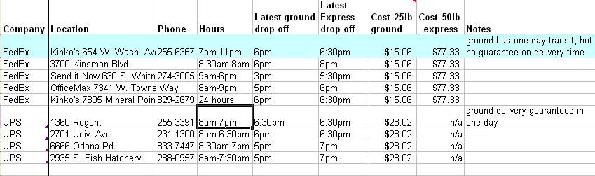 Table 6.b.1. Example FedEx and UPS locations, hours, and costs for shipping from Madison to Chicago.

6.b.2. Plan work days around shipping

Determine the approximate time the field crew will need to leave the watershed in order to ship samples to the lab by the last FedEx/UPS shipment. Keep in mind that the crew will need to buy and pack ice into the coolers, and carefully record which parameters were sampled, where, and at what times. This process takes between 45 and 75 minutes per day.

For example, in the Pecatonica Pilot, we worked 4 10-hour work days per week. The last FedEx shipment from our chosen location was at 6pm. We typically met at 7:30am, drove 1 hour to the watershed, and finished sampling around 3:00. We drove 45 minutes to a gas station near Madison, where we bought and packed ice and recorded the day’s sampling. Around 4:45, we would drive the rest of the way into Madison (through rush-hour traffic), reaching FedEx around 5:15, and be finished with work at 5:30.

For any shipping method, it is best to create an account before beginning any work in the field. With an account, you can print a few weeks’ worth of prepaid shipping labels that can be attached to coolers, saving the crew up to 30 minutes per day in work time.

