White Clay, Mud Lake, and Shawano Lake water Quality
In
Shawano Lake Tributary Assessment
1986 - to Current

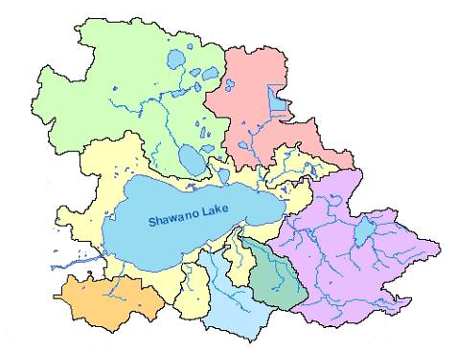

Data for Shawno Lake Collected by:

Bob Hynek
Dave Kranjac
Brenda Nordin

Methods

Monitoring was conducted at the deep hole of 3 lakes, White Clay Lake, Mud Lake, and Shawano Lake in Shawano County. White Clay and Shawano Lake are Long Term Trend Lakes and have data dating back to 1986. Monitoring for Mud Lake only consists of data from 2013 and 2014. During each visit, basic water quality parameters including water temperature, conductivity, dissolved oxygen, Ph, water clarity, Phosphorus, and Chlorophyll were collected. The samples were taken four times per year, once at ice out, then once in June, July, and August. Water clarity was taken more frequent by the volunteers (Bob Hynek and Dave Kranjac). The samples were taken at the deep hole using a hydrolab and an integrated sampler.

Lake Impairment Assessment for Total Phosphorus (TP) and Chlorophyll a (Chl a)

Phosphorus is one of Wisconsin’s most common pollutants for lakes. In 2010, Wisconsin developed numeric criteria for (Total Phosphorus) TP and corresponding protocols for listing waterbodies for TP as a pollutant. Algal biomass, as measured by Chlorophyll a (Chl) concentrations, is one of the most common response metrics to increased phosphorus concentrations. For the purpose of assessing water quality against impairment thresholds, in-lake TP values and Chl concentrations are calculated using automated programming packages that draw from Department data in SWIMS (Surface Water Integrated Monitoring System). These packages are referred to as the TP Package and Chl Package. Results from the packages are provided to biologists to use in their assessments; biologists may use professional judgment in assessing package results.

TP and Chl have separate thresholds for Recreational (REC) impairments and for Fish & Aquatic Life (FAL) impairments. Therefore, there are four distinct packages that are run to report the needed calculations: TP REC, TP FAL, CHL REC, and CHL FAL. The calculations used are almost identical for TP REC, TP FAL, and CHL FAL. The parameters that the samples need to fall between are described below in Tables 1 and 2. Once the package results are available, the TP and Chl results are assessed separately and in combination with one another to determine whether a lake should be listed as impaired, and if so, in what category. Because algae and aquatic plants are biological metrics that respond to phosphorus, they are used as biological confirmation of impairment related to phosphorus concentrations. A complete data set consists of at least 6 samples per lake.

Lake Classification and Assessment Methods

WDNR classifies or groups similar lake types based upon physical data. Specifically, lake size, stratification characteristics, hydrology and watershed size are identified as the primary influences on a lake and, to a large degree, these characteristics determine the natural biological communities each lake type supports. Using this information, lakes should fall into one of ten natural community types listed below:

Natural Lake Community Types

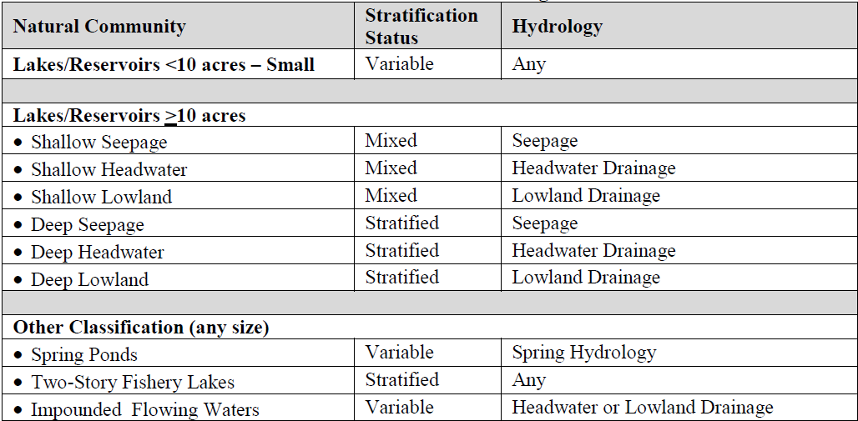

The WDNR recognizes that lakes may vary geographically. Spatial data are available for each of the lakes. Regional differences in soils, climate and land use may explain additional variation in the bioindicator metrics used in the classification of lakes. However, WDNR has determined that lake size, hydrology and depth are more critical factors for initial classification of lakes, and that regional differences are secondary. For most lakes, the WDNR’s automated data packages determine which natural community and which impairment thresholds are appropriate based on the parameters described below. However, if the biologist has information to suggest that a lake’s automatically assigned natural community is inaccurate or not representative of the lake, a change to the natural community may be made if reasons for the change are documented. If a Partial Lake Listing is being considered, a different Natural Community may be assigned to the portion of the lake being considered for a Partial Lake Listing, based on site characteristics that are significantly different from those in the rest of the lake.

Lake Classification

White Clay Lake is classified as Deep Lowland Lake. The samples collected from 1986 – present indicate that both the Phosphorus and Chlorophyll concentrations have exceeded the standards for Recreation (see Table 3). White Clay lake was added to the 2012, 303d Impaired Waters List.

Mud Lake is classified as a Shallow Lowland lake. The samples collected from 2013 -2014 indicate that the Phosphorus concentrations have exceeded the standards for Recreation (see Table 4). Mud Lake will be listed as impaired during the next listing cycle in 2016.

Shawano Lake is classified as a Shallow Lowland Lake. The samples collected from 1986 – present indicate that the Phosphorus concentrations have exceeded the standards for Recreation (see Table 5). Shawano Lake was added to the 2014, 303d impaired waters list.

Table 1 – Impairment Thresholds for Fish and Aquatic Life

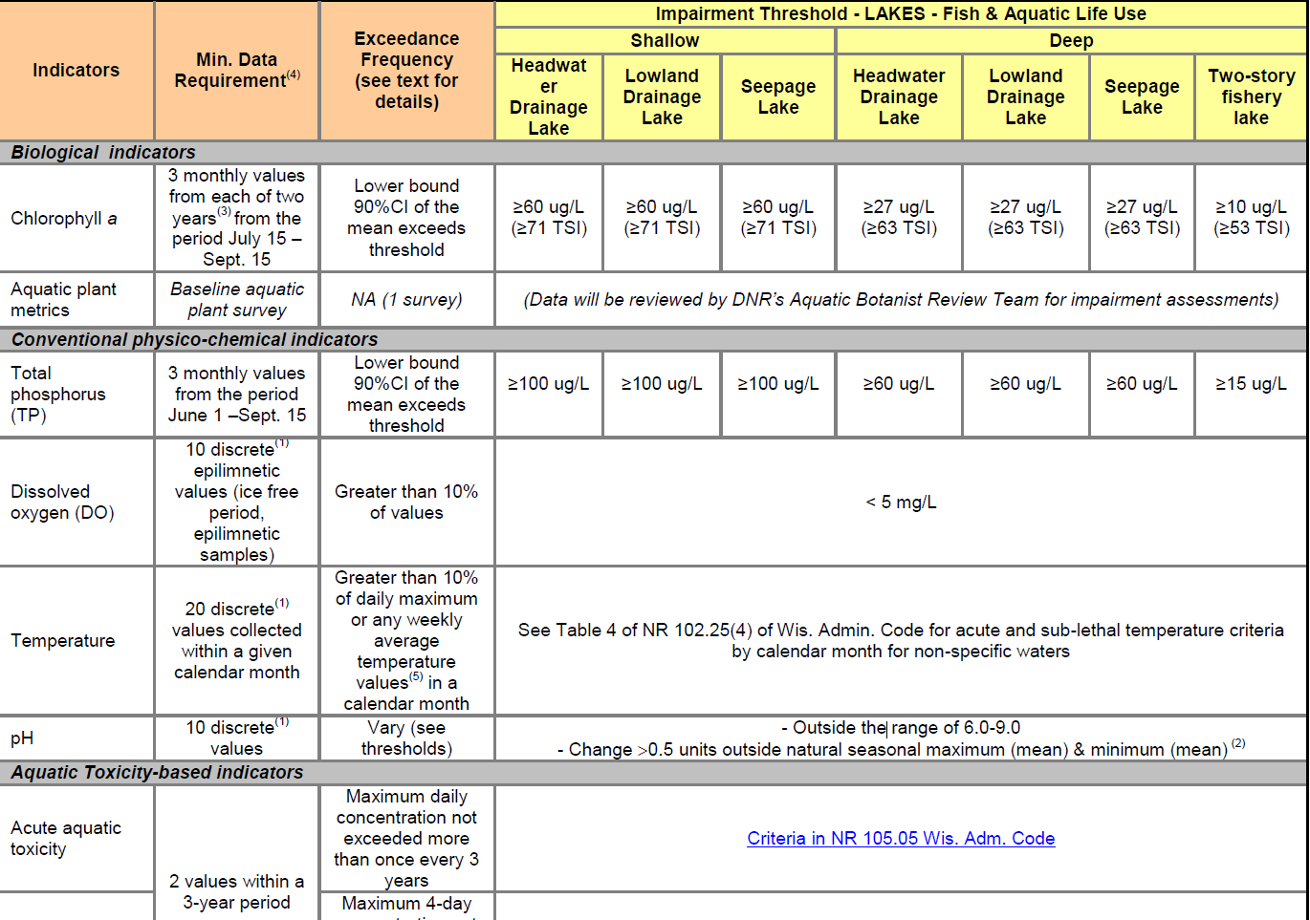

Table 2 – Impairment Thresholds for Recreation

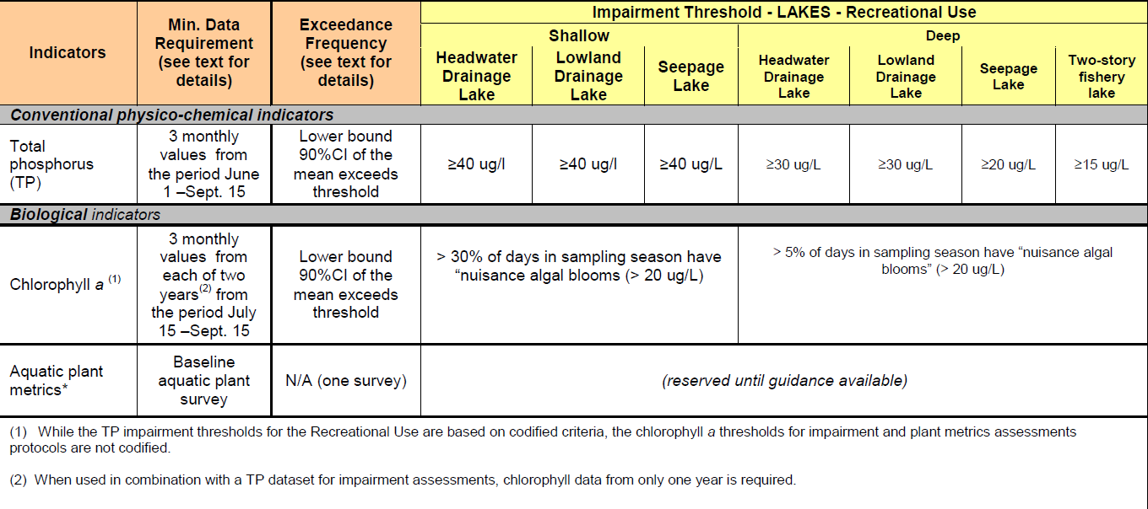

Table 3 – White Clay Lake 1986 – Present Trophic State Index

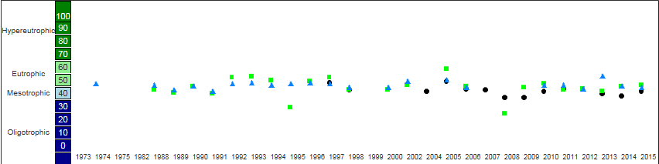

*Phosphorus and Chlorophyll concentrations have exceeded Recreational Parameters
established in Table 2.

Table 4 – Mud Lake 2013-2014 – Trophic State Index

Trophic State Index is 67 ug/L. This falls within the eutrophic category.

*Phosphorus and Chlorophyll concentrations have exceeded Fish and Aquatic Life and Recreational Parameters established in Tables 1 and 2.

Table 5 – Shawano Lake 1986 – Present Trophic State Index Results

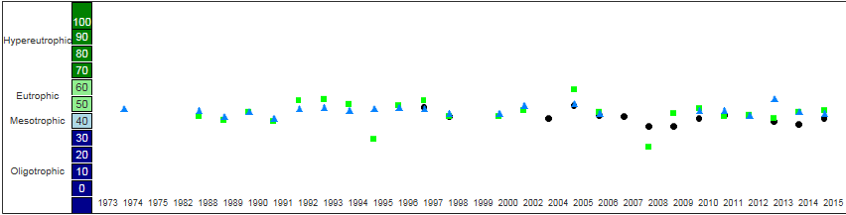

*Phosphorus and Chlorophyll concentrations have exceeded Recreational Parameters
established in Table 2.

Summary and Conclusions for Shawano Lake (Turyk N., Foster K., Hoverson D., McGinley P. 2008. Watershed Assessment of Shawano Lake, Shawano County, WI. UWSP Center for Watershed Science and Education)

- No single, clear phosphorus source. A watershed-scale management approach should be conducted
- Shawano Lake’s ecosystem in flux due to introduction of non-native aquatic organisms: curly-leaf pondweed, eurasian water milfoil, and zebra mussels.
- Greatest contributor of TP is internal sediment release and Curlyleaf Pondweed; difficult and expensive to manage.
- Redistribution (spring/fall turnover) of nutrients enables aquatic plant and algae growth.
- No single, clear phosphorus source, a watershed-scale management approach should be conducted
- Shawano Lake’s ecosystem in flux due to introduction of non-native aquatic organisms: curly-leaf pondweed, eurasian water milfoil, and zebra mussels.
- Greatest contributor of TP is internal sediment release and Curlyleaf Pondweed; difficult and expensive to manage.
- Redistribution (spring/fall turnover) of nutrients enables aquatic plant and algae growth.
- Reduction of phosphorus in Shawano Lake will reduce frequency of algae blooms and excessive plant growth.
- 20% reduction may result in decreasing nuisance algae blooms from 17 days to 6 days.
- In general, Shawano Lake has relatively good water quality for a shallow drainage lake, however we are seeing an upward trend toward euthrophic.

Recommendations (Turyk N., Foster K., Hoverson D., McGinley P. 2008. Watershed Assessment of Shawano Lake, Shawano County, WI. UWSP Center for Watershed Science and Education)

- Natural areas and wetlands improve water quality acting as natural filters - protect these areas.
- Establish more natural vegetation around lake.
- Take measures to reduce runoff and increase infiltration.
- Homeowners should have their soil tested to determine if fertilizer additions are necessary.
- Use expertise of the Local Resource Professionals to investigate the value of a partial drawdown.

Definitions

- Trophic State Index (TSI) - A measure of nutrient enrichment in the lake using secchi, P, and Chl calculations. TSI provides the biological condition of a waterbody.

References

- Turyk N., Foster K., Hoverson D., McGinley P. 2008. Watershed Assessment of Shawano Lake, Shawano County, WI. UWSP Center for Watershed Science and Education.

