BIG BLAKE LAKE AQUATIC INVASIVE SPECIES MANAGEMENT PLAN
2007-2011
Amended May 2016

Ford Elliott (Big Blake Lake District), Pamela Toshner (Wisconsin Department of Natural Resources) and Jeremy Williamson (Polk County Land & Water Resources Department)

Big Blake Lake (Figures 1 & 2) is a 216 acre shallow and eutrophic drainage lake with a relatively large watershed (61:1 watershed to lake ratio), located in Polk County. The max depth is 14 feet, and mean depth is approximately 9 feet. The Blake Lake Protection and Rehabilitation District (District) was formed in 1976 in response to concerns about algae blooms and aquatic plant problems. For more detailed information on the studies that describe Big Blake Lake, please see the following references:

Williamson, J. 2006. Blake Lake Aquatic Macrophyte Monitoring 2006. Polk County
Land and Water Resources Department, Balsam Lake, WI.

Strasser, N.D. and J.E. Britton. 2005. 2004 Big Blake Lake Aquatic Plant Survey Technical Report and Management Plan. Aquatic Engineering and The Limnological Institute, Lacrosse, WI.

Strasser, N.D. and J.E. Britton. 2005. 2004 Big Blake Lake Water Quality Monitoring Technical Report. Aquatic Engineering and The Limnological Institute, Lacrosse, WI.

Rattei, M. 1998. Blake Lake Macrophyte Surveys and Management Plan. Barr Engineering Company, Minneapolis, MN.

Cornelius, R. 1999. Fish Survey, Blake Lake (2627000), Polk Co. – 1998. Wisconsin Department of Natural Resources, Spooner, WI.

Although the District has invested in previous plans and studies, the recommendations were either not implemented, or the plans were not acceptable for implementation purposes. The purpose of this interim AIS Management Plan (Plan) is to pull together existing information, incorporate the results of scoping/planning meetings that took place in 2006, and integrate the information into one cohesive Plan for implementation with partial funding from an AIS Established Infestation Control Grant. Should the AIS grant be awarded, a required deliverable will be the integration of this AIS Plan into an updated comprehensive Aquatic Plant Management Plan that includes native species (primarily coontail) management.

GOALS AND OBJECTIVES

The goals of the Big Blake Lake AIS Management Plan are to decrease curlyleaf pondweed (CLP) frequency and/or density and promote substantial recovery of the native aquatic plant community over a five-year period (2007-2011) while restoring reasonable uses of the lake. Additional goals are to protect sensitive areas from disturbances caused by harvesting or herbicide applications, improve water quality, and increase community involvement and education. If attained, these goals will lead to restoration of the beneficial uses of the aquatic ecosystem, as well as improved community participation and education.

The objectives for goal attainment were selected by the 2006 scoping committee, which included District members (Ford Elliott and Loey Weber), Polk County Land and Water Resources Department staff (Amy Kelsey and Jeremy Williamson), and Wisconsin Department of Natural Resources staff (Pamela Toshner, Heath Benike, and Frank Koshere). The objectives are based on the extent and density of the current CLP and native plant community, as well as realistic goal attainment. Should the monitoring indicate that the Plan is exceeding these quantitative objectives, the scoping committee will adjust them as necessary. The baseline for these objectives will be measured in the 2007 plant surveys. Specifically, the measurable objectives are as follows:

- Reduce CLP average density rating to “1” by year-five OR
- Reduce lakewide CLP sample site frequency of occurrence by 60% in harvested areas by year-five AND
- Increase FQI by 4 units (from 2006 FQI of 16 to 20) to the regional mean by year five

Big Blake Lake experiences two separate plant growth problems. In the spring, the lake has dense curlyleaf pondweed beds. These beds have increased 18% in lake coverage from 65 acres in June 1997 to 110 acres in 2004. The spring growth of curly-leaf pondweed severely restricts the use of the lake until the middle to end of June. Then in mid-July, Big Blake Lake experiences nuisance plant growth and algae blooms that again restrict the use of the lake. These mid- to late-summer plants include coontail, which floats most densely in the bays and in the north and south ends of the lake and restricts almost all navigation and recreation.

By mechanically harvesting these plants, Big Blake Lake will experience season-long control to allow watercraft to more easily maneuver around the lake and improve fish community movement. Additionally, early season CLP harvesting will remove nutrient-rich biomass from the lake and limit additional spreading of turions. Mechanical harvesting is the best option to make more of the lake recreationally useful to the public while simultaneously improving the native plant community. Additionally, the District has determined harvesting to be a more cost-effective option. AIS grant dollars will be used only for the large-scale, early season curlyleaf pondweed harvesting program and associated monitoring and education.

The District recognizes that native species are an important component of the ecosystem and that a healthy native plant community may help protect the lake from future invasive aquatic plants like Eurasian watermilfoil. Therefore, this Plan includes information and education elements to promote awareness of AIS and the importance of native plants.

EXISTING CONDITIONS

In general Big Blake Lake is shallow, eutrophic drainage lake on the Straight River. The lake rarely stratifies. Existing conditions in Big Blake Lake are discussed as follows: fisheries (Cornelius 1999); water quality, watershed and aquatic plants ((Rattei 1998) and (Strasser and Britton 2004)); aquatic plants (Polk County Land and Water Resources Department 2006). Of note is that the lake experiences an increase in algae blooms and nuisance native plant growth July through September, and the panfish community appears to be stunted. These phenomena may be related to dense and extensive curlyleaf pondweed beds and/or the associated plant die-back and nutrient release.

ANALYSIS

The analyses of previous studies and follow-up planning have resulted in three actions for implementation on Big Blake Lake. These actions were developed from the District’s efforts to improve their Aquatic Plant Management Plan in 2004-2005 to be eligible for a harvesting permit and thus purchase of the harvester, as well as scoping sessions in fall of 2006.

Limited or No Action
Three sensitive area sites on Big Blake have been identified by DNR staff (Figure 1). There will be no active management in Site A over the course of this 5-year project, and this site will serve as reference site for measuring the changes where active management occurs. Navigation channels will be allowed in Site B. These navigational channels will be cut the week before Memorial Day and will be no more than 25 feet wide. The channels will consist of a mainstem that breaks off to serve individual properties. Site C will be avoided in the first year (2007) of the project so that wild rice beds can be mapped and communication with the Great Lakes Indian Fish and Wildlife Commission (GLIFWC) Voight Task Force can be completed. In subsequent years a navigational channel that parallels the shoreline may be implemented in Site C, provided wild rice is not impacted or GLIFWC and the Department have no concerns. Individual herbicide applications will not be allowed in any sensitive area site, and harvesting operations within these sites is not reimbursable through the AIS grant.

Nuisance Relief
Big Blake Lake experiences a mid-summer surge in nuisance native plant coverage and density. The nuisance is primarily caused by coontail. The District actively harvests these nuisance plants. This harvesting activity is not reimbursable through the AIS grant. Furthermore, the native plant control activities should be incorporated into an updated Aquatic Plant Management Plan by 2011.

Restoration of Reasonable Use
The goals of the curlyleaf pondweed harvesting program are to reduce curlyleaf pondweed coverage and density while promoting recovery of the beneficial native plant community and restoring reasonable uses of the lake. The 2004 frequency of occurrence (~98% of sample sites) and density (mean=3) of CLP in Big Blake Lake are very high. Thus, a true whole-lake restoration of the native plant community is probably not a reasonable goal (at least within five years), but substantial recovery is. The restoration of reasonable uses is also realistic. These reasonable uses include fish community recruitment and growth, navigation, natural scenic beauty, and floristic diversity (relative to current to current diversity). There are distance-from-shore and depth restrictions that will prevent the harvesting from harming important fish spawning and nursery habitat (Figure 1 & 2). These restrictions also prohibit routine nuisance control along riparian shorelines. The curlyleaf pondweed harvesting program follows current best management practices including early season, lakewide harvesting (with the exception of Sensitive Area sites) to cut and collect plants before turion formation and deposition. The early-season curlyleaf pondweed harvesting program is the only active management recommendation that is reimbursable with an AIS grant.

MANAGEMENT ALTERNATIVES

The primary alternative that the District considered was large-scale herbicide application. The annual costs of chemically treating Big Blake Lake were discussed in the 5 August 2005 meeting of the District’s APM committee with Department and Aquatic Engineering staff. Costs estimates follow:

Chemical Treatments
31 Acres: 25k-26k per year (on average) incl. monitoring

The annual cost of harvesting Big Blake Lake is a result of harvesting data compiled from two lakes in the area and is based on their average costs for labor, maintenance, and supplies (e.g. gas):

Harvesting
90 Acres in the Spring
35 Acres of Navigational Channels in the Summer
$ 11, 745.00 per year

Individual riparian landowners may contract with a private chemical treatment company to chemically control their vegetation in areas that are not within the sensitive areas outlined in Figure 1. These applications must be approved by Department staff and must follow NR 107 permit requirements. The Big Blake Lake P & R District will be the first level clearing house of chemical permit requests and will monitor the requests for compliance with our written plan. This information will be used by the Department to issue any permits.

The privately owned chemical treatment company will provide GPS locations of all individuals who receive that company’s services to the District who will then be responsible for noting those locations on a map. This map will be made available to any citizen who wishes to review these locations. This map will also be onboard the harvester for the operator to avoid during the appropriate timelines.

The private chemical control applicator will prepare and distribute a set of guidelines to be followed by individual riparians for plant controls. These guidelines will include timing, species targeted, and method of control allowed. The private chemical control applicator will be responsible for preparing an annual map showing the locations, sizes, names of property owner, and pesticides to be used along with the permit for such activity. The District will provide a map of sensitive area sites to the applicator and make him/her aware that chemical control will not be allowed in these sites.

In order to apply for a chemical control permit, this information will be collected and submitted to the Department in the chemical control permit application a minimum of three weeks before such chemical controls are anticipated to be applied. The Department will base its review of the chemical control permit application on this Plan. If the Department receives separate individual requests for chemical control, they will be directed to the District to be included in the next season’s permit, provided they meet the guidelines set by the District and standards approved in this Plan.

MANAGEMENT RECOMMENDATIONS

Early-season, Large-scale Curlyleaf Pondweed Harvesting
The harvesting season will begin each spring based on a visual observation. Harvesting will begin when the CLP can effectively be harvested. This is expected to occur when the plants can be efficiently harvested and the harvester blades can effectively cut and harvest. The plan is to clear-cut 80 of the existing 110 acres of curlyleaf pondweed in the spring prior to the maturation of the CLP, to within 100 feet of the shoreline. Harvesting may occur in water as shallow as 36 inches, with the exception of Sensitive Area Site B. Navigational channels are allowed in Site B, but they are not reimbursable through the grant. Harvesting will continue as needed during all CLP growth periods, and particularly to harvest CLP over specific broad areas (to be later monitored) to reduce turion deposition and work towards the five-year goals of CLP reduction.

Big Blake Lake has a valuable fishery that is particularly beneficial for bass and panfish populations. Therefore, spawning and nursery areas must be protected. This Plan excludes areas within 100 feet of the shore (with the exception of Sensitive Area Site B and perhaps Site C in future years) from harvesting operations before June 15. The calendar dates of spring harvesting will vary year to year due to seasonal weather changes that affect the winter growth of plants. Once the ice is out and the plant growth can be determined to be efficiently harvested (within two feet of the lake’s surface) the harvesting will begin.

The selection of harvesting areas will be based on the maturation level of the plants in the approved areas. This can also vary year to year along the length of the lake due to seasonal changes. Some years have dense growth early on in the south end of the lake and more sparse growth in the north end and vice versa on other years. Therefore, each harvesting season must begin with a visual observation of plant maturation in the approved harvesting areas.

Monitoring
The Big Blake Lake AIS Management Plan includes an annual monitoring program to measure the goals and objectives. A 2006 partial survey of harvested areas by Polk County Land and Water Resources staff already indicates the early-season curlyleaf pondweed harvesting may be promoting native plant recolonization. Polk County LWCD staff will continue to monitor the lake through the course of the five-year project. The recommended monitoring includes:

Year 1 (2007): early season (i.e. ice-out) whole lake point-intercept survey to
to measure CLP and a summer (i.e. 15 July – 15 August) whole lake
point-intercept survey to measure the native plant community.
Years 2 through 4 (2008-2010): partial point-intercept surveys in actively
harvested areas. The point-intercept map will be overlaid on the
harvesting area, and those points that fall within it will be monitored.
Year 5 (2011): late June whole lake point-intercept survey to measure CLP and
native plant community.

Sensitive Area sites will serve as reference sites with little to no active management and will be monitored in years 1 and 5.

Water quality measurements are important because the trophic status of the lake may improve while the intensity and duration of algae blooms decreases. This is expected to occur because nutrient-rich CLP biomass will be removed from the lake and as native plants recolonize those areas, they may tie up remaining nutrients for the duration of the growing season. Therefore, the District will identify volunteers to begin monitoring as a part of the Citizen Lake Monitoring Network (CLMN). CLMN protocol will include secchi disk measurements, as well as the expanded water chemistry suite (phosphorous and chlorophyll a). Dissolved oxygen monitoring is not necessary.

Information and Education
The District intends to begin an information and education program. Polk County LWCD staff have agreed to assist with some of the I&E, including a workshop in partnership with nearby Bone Lake riparians. This workshop will include education about AIS, a Clean Boats Clean Waters (CBCW) training element, and a pontoon classroom. The District will recruit CBCW volunteers for watercraft inspections on weekend, holidays, and during fishing tournaments. The District’s newsletter, The Blake Lake Bugle, is a forum for I&E articles and will update readers on the progress of the AIS project. Signs that include the CBCW message and Eurasian watermilfoil identification tools will be constructed, and comment boxes will be attached to the signs.

Much of Big Blake Lake is highly developed, and there are many manicured lawns. Therefore, it is recommended that the District and partners also focus I&E efforts on shoreline stewardship practices. This is especially important if in future years, the AIS Plan is adapted for management closer to shore. The Department prefers to see commitment from lakefront property owners that they, too, will change their behaviors to protect and restore the lake. With the case of aquatic plants in particular, the latest research (Borman 2005) shows that immediate shoreline development is the most significant cause for increased and more nuisance plant growth.

IMPLEMENTATION CHECKLIST

What | Who | When
Adopt the AIS Plan | Blake Lake P&R District | August 2006 and again before 2007 harvesting
Apply for harvesting permit | Blake Lake P&R District | January 2007
Apply for AIS Established Infestation Control grant | Blake Lake P&R District | By 1 February 2007
Recruit CBCW and CLMN Volunteers | Blake Lake P&R District | Spring 2007
Pre-harvesting/ice-out whole lake point-intercept aquatic plant survey | Polk County LWCD | April – May 2007
Spring CLMN monitoring | Blake Lake P&R District | By 1 May 2007
Construct AIS signs and comment boxes | Blake Lake P&R District | Spring/summer 2007
I&E Workshop and CBCW training | Blake Lake P&R District, Bone Lake P&R District, Polk County LWCD | Spring/summer 2007
Implement CBCW program | Blake Lake P&R District | Boating season 2007-2011
Wild rice consultation with GLIFWC’s Voight Task Force | Wisconsin DNR | Spring/summer 2007
Early season CLP harvesting program | Blake Lake P&R District | 1 May – 15 June 2007-2011
Harvest navigational lanes in Sensitive Area Site B | Blake Lake P&R District | Week before Memoral Day 2007-2011
Harvest navigation lane in Sensitive Area Site C, if DNR and GLIFWC approve | Blake Lake P&R District | Week before Memoral Day 2008-2011
Summer whole lake point-intercept survey and wild rice mapping | Polk County LWCD and Wisconsin DNR | 15 July – 15 August 2007
Summer CLMN monitoring | Blake Lake P&R District | 15 July – 15 September 2007-2011
Partial point-intercept surveys in main lake harvested areas | Polk County LWCD | 15 July – 15 August 2008-2010
Whole lake point intercept survey | Polk County LWCD | June 2011
Data analyses and reporting | Polk County LWCD  Wisconsin DNR  Big Blake P&R District | Annually  Final report fall/winter 2011
Updated APM Plan | Big Blake P&R District  Wisconsin DNR  Polk County LWCD | Completed by December 2011
Prohibit herbicide treatments in Sensitive Areas | Wisconsin DNR  Blake Lake P&R District | Continuously

MONITOR AND MODIFY

This AIS Management Plan includes robust, frequent, and independent monitoring that will help measure the overall goals. Should monitoring indicate the goals/objectives are not being met or are being exceeded the scoping committee will convene and adapt the goals and objectives as necessary. District members have indicated desires to harvest closer (i.e. less than 100 feet) to shore. While this was not part of the 2007-2011 AIS Plan, it is an activity that is now allowed after June 15 in areas with water depths of 30 inches or more.

Depending on member response, the District may also consider adapting their I&E program to offer more workshops, re-train volunteers, or expand the program to other lakes and the public in general. Furthermore, the District may develop additional strategies to protect and manage Big Blake Lake, including a large-scale shoreline restoration project. These strategies can be developed by the scoping committee under the guidance of additional partners if necessary.

Since this is potentially the first planned and measured curlyleaf pondweed harvesting program in the state, the scoping committee, including District members, are prepared to share progress and results updates at public meetings and conferences and through various media and publications. Indeed harvesting seems to be a viable alternative to other more common active management activities (e.g. herbicide applications). Therefore, the Big Blake Lake AIS Management Plan will provide valuable information and results that may shed new light on aquatic plant and invasive species management in Wisconsin.

ADDITIONAL REFERENCES

Borman, S. 2005. Lake Plants and Lakeshores of Northern Wisconsin: How Have They changed Over the Past 70 Year? North American Lake Management Society's 25th International Symposium, Madison, WI., November, 2005.

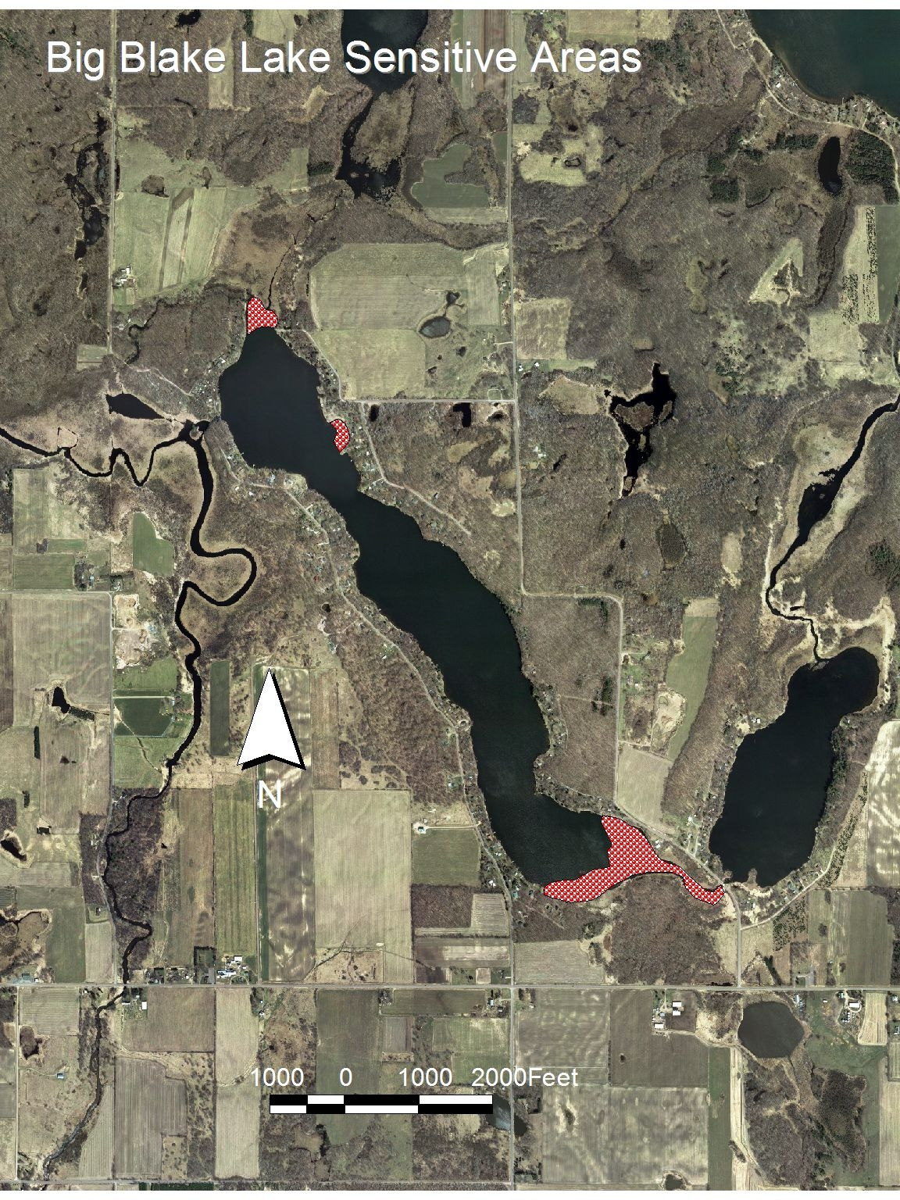
Figure 1. Big Blake Lake, Polk County. Sensitive Area A is the northern bay; Sensitive Area B is the eastern bay; and Sensitive Area C is the southern shoreline/bay.

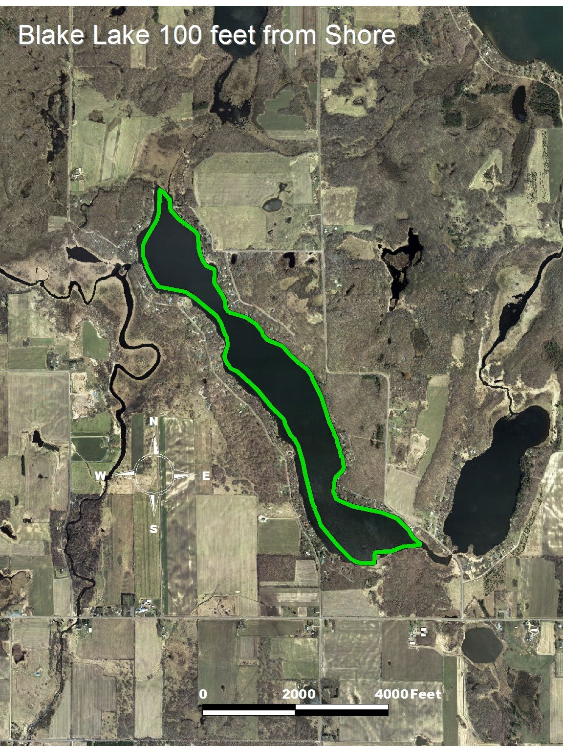
Figure 2. Area of early-season curlyleaf pondweed harvesting.

