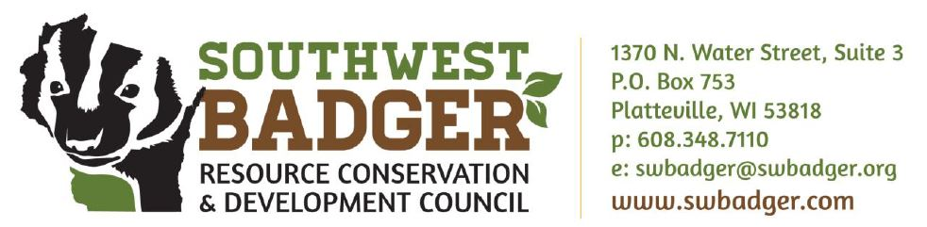
FOR IMMEDIATE RELEASE, March 19, 2018
Contact: Jeff Jackson, Stewardship Specialist, jeff.jackson@swbadger.org; phone (608) 348-7110
Weed Workshop to be held in Belmont, April 14, 2018
Platteville, WI –
Nobody like obnoxious weeds……but even more important, non-native invasive weeds can overtake native plants and reduce the amount of food and cover available for our native animals and insects. Southwest Badger RC&D will host a Weed Workshop in Belmont on April 14, 2018 to help citizens learn how to identify and manage terrestrial and aquatic invasive plants on their land and in their community. Attendees will also learn how to report what they find in order to assist state invasive species coordinators generate comprehensive data and maps. Restoring areas to a healthy natural state using native plants will also be discussed. If management costs are a concern, attendees can learn about cost-sharing programs to help them effectively control invasive plants on their land.
“Learning to identify and manage invasive weeds can help you protect your land and ensure that your pastures, and forests remain productive and stream banks contribute to healthy water quality,” said Jeff Jackson, Stewardship Specialist with Southwest Badger RC&D. “But it’s also interesting, and can make walks on your land or in your neighborhood more enjoyable.”
The workshop is set for Saturday, April 14, 2018, from 8:30 AM – 12:00 PM and will include light refreshments. It will be held at the Belmont Community Building, 222 S Mound Ave Belmont, WI 53510.

Please RSVP by April 9 to Jeff Jackson: jeff.jackson@swbadger.org
Event sponsors include Invasive Plants Association of Wisconsin (IPAW), Lafayette Environmental Action Group, Pecatonica Pride Watershed Association, Wisconsin First Detector Network, and the University of Wisconsin-Extension.
Southwest Badger Resource Conservation & Development Council, Inc. is a 501(c)(3) non-profit organization working in the Southwest Wisconsin region. The organization’s mission is to implement natural resource conservation that enhances rural economic development through direct assistance to landowners and communities in the areas of invasive species, agriculture, grasslands, forests, and surface waters. Visit swbadger.org for more information.

