Harpt Lake Monitoring Report

Amelia McReynolds and Stefan Tucker
University of Wisconsin-Green Bay
December 20, 2017

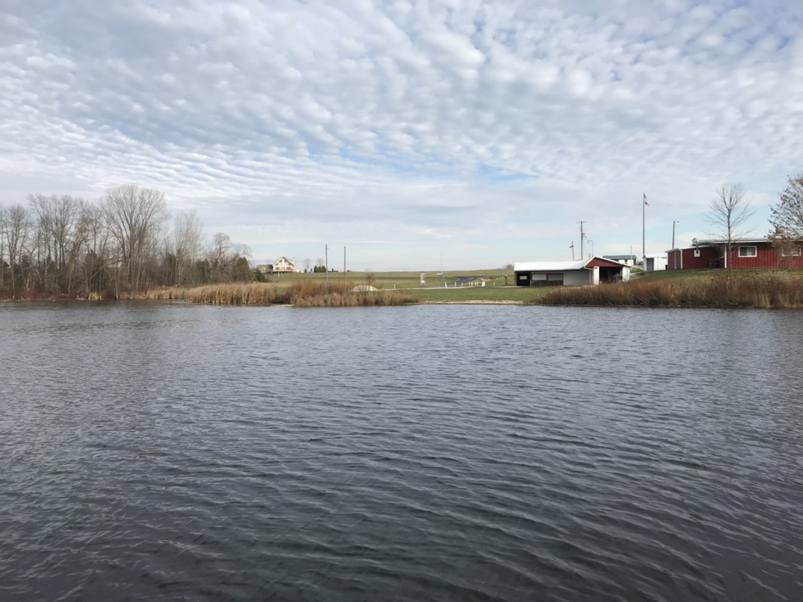

Introduction
Harpt Lake is a 32-acre inland lake located in Manitowoc County, Wisconsin. The surrounding agricultural landscape heavily influences the lake as a major nutrient input. Harpt Lake is a round, deep, eutrophic lake (maximum depth of 54 feet) with a sand, silt, gravel substrate and little direct shoreline development. The lake has been a target for water quality and fishery improvements to benefit users and sport fisherman. Recent surveys have been conducted by the Wisconsin Department of Natural Resources (WI DNR) and Onterra, LLC, an environmental consulting firm, to monitor water quality, invasive species and fish communities within the lake. The Larabee Sportsman’s club, located near the lake, has stocked walleye over the past several years and has added habitat structures to improve the fishery. Our objective was to survey Harpt Lake during the late summer and early fall of 2017 to characterize lake morphology, trophic state, and biotic communities.
Water Quality
Three points in Harpt Lake were monitored weekly from September 18 to November 13, 2017 (Fig. 1). Readings were taken at one site, “Master”, each week while full monitoring of all three points occurred on three dates encompassing lake turnover. On four dates, a water sample was taken from the epilimnion (1 m depth) and hypolimnion (14 m depth) by van Dorn sampler to analyze total suspended solids (USGS protocol) and soluble reactive phosphorus (Lachat FIA 8500, ammonium molybdate method, detection limit 0.01 mg P/L). During each weekly sampling event, a Secchi disk reading was also taken. A vertical profile of dissolved oxygen and temperature was taken throughout the water column (1m intervals) using a HydroLab QuantaG temperature and dissolved oxygen probe calibrated each day of fieldwork.
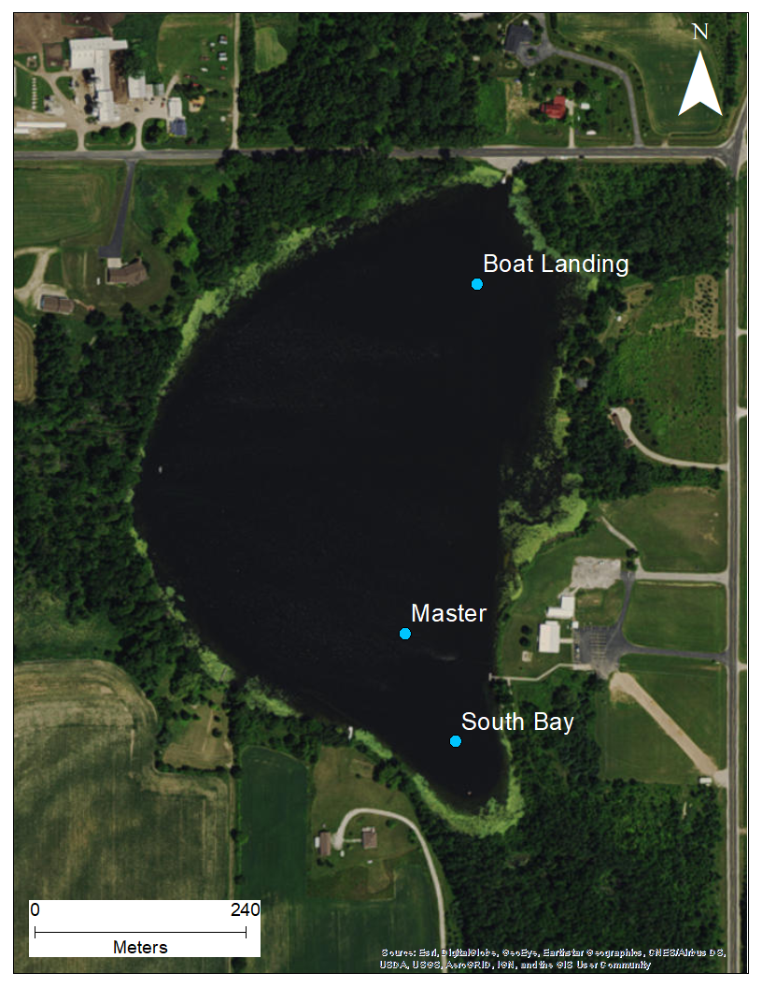
Fig. 1. Water quality monitoring points sampled in fall 2017. Master point was sampled weekly, with additional measurements made periodically at South Bay point and Boat Landing point.

Lake Volume
Lake volume was calculated and displayed in a hypsographic curve (Fig. 2), by calculating the sum of water volume at each depth strata using the equation:
Where, D=change in depth between contours, SA₁ is surface area at depth 1 and SA₂ is surface area at depth 2. Each depth strata was then converted to a percent of total lake volume as shown in Fig. 2. Based on the hypsographic curve and dissolved oxygen data (Appendix 1), approximately 54% of Harpt Lake is hypoxic during summer stratification. The littoral area, where light is sufficient to support plant communities, comprises approximately 9% of lake bottom area.
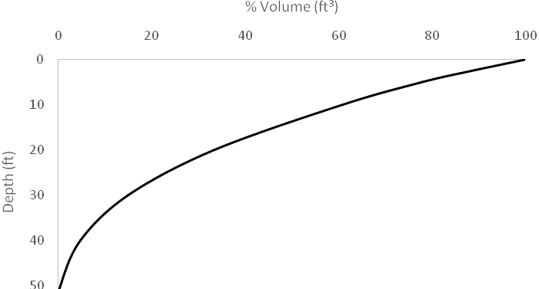
Fig. 2. Cumulative lake volume by depth in Harpt Lake, Manitowoc County, WI.

Temperature and Dissolved Oxygen Profiles
Harpt Lake was stratified from the initial sampling date on September 18th to October 23rd (Appendix 1). Dissolved oxygen and temperature were relatively high in the epilimnion, with a thermocline present around 3-4 m. At the theromcline, oxygen and temperature rapidly decreased to form an area of hypoxic water in the hypolimnion. A positive heterograde curve, as observed on September 18, 2017, at the South Bay point (Fig. 3), is likely correlated to high phytoplankton abundance and increased photosynthesis activity near the thermocline. The lake experienced turned over in the week between October 23rd and November 13th, when all three monitoring points showed evidence of mixing (Fig. 4). After mixing, the entire water column was fairly cool (5.53 to 5.94°C) but little dissolved oxygen was present—all measurements were below 4 mg O₂/L. This limitation in dissolved oxygen may restrict the amount of habitat available for fish and invertebrates.
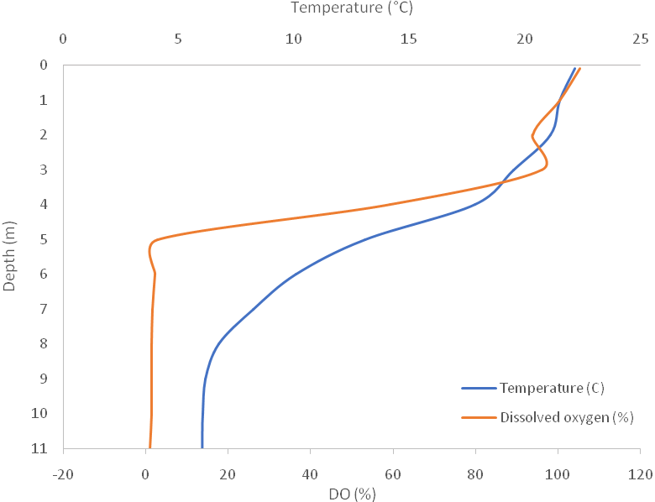
Fig. 3. Representative temperature and dissolved oxygen profile taken during summer stratification at South Bay monitoring point on September 18, 2017.
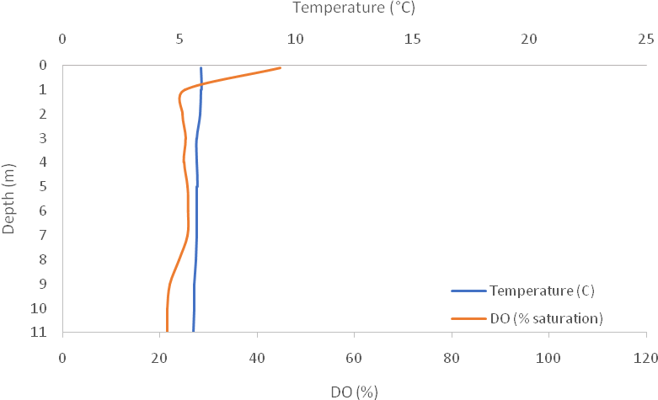
Fig. 4. Representative temperature and dissolved oxygen profile taken after mixing at Master point on November 13, 2017.
Phosphorus Loading
The most significant phosphorus inputs to Harpt Lake are estimated to be internal loading (99 lbs/yr, 38%), row-crop agriculture (77.2 lbs/yr, 29%), and mixed agriculture (52.9 lbs/yr, 20%) (Hoyman and Cibulka 2012). Internal phosphorus loading happens when oxygen is depleted in the hypolimnion of a lake, releasing sediment-bound phosphorus into the water column. During spring and fall mixing, this phosphorus is released into the epilimnion.
Soluble reactive phosphorus (SRP) is the fraction of total phosphorus which is bioavailable to phytoplankton and may contribute to algal blooms in lakes. The Wisconsin DNR considers lakes to be at risk of algal blooms at total phosphorus concentrations above 0.02 mg/L; in 2017, the summer total phosphorus averaged 0.0287 mg/L (WI DNR 2017). During fall 2017, SRP concentrations were higher in the hypolimnion than in the epilimnion (Fig. 5). The epilimnion concentrations were below the detection limit for the first three sampling events, but on November 13th SRP was observed at 0.053 mg/L. Two factors likely influence this increase in phosphorus: a seasonal decline in phytoplankton and internal mixing of orthophosphate released from lake sediments.

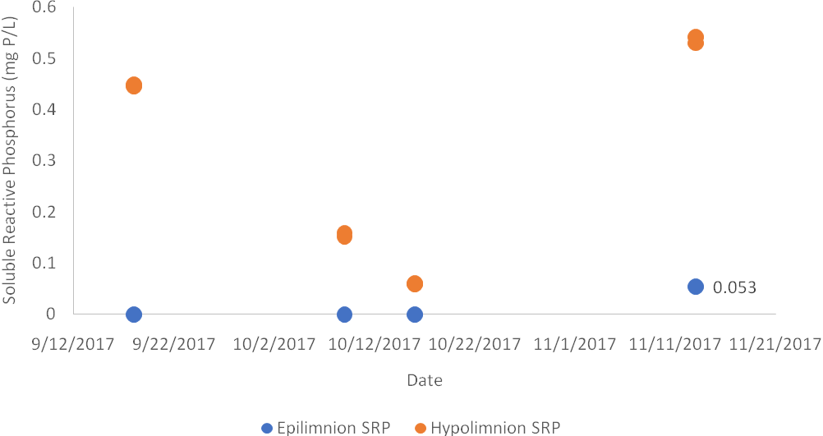
Fig. 5. Soluble reactive phosphorus concentrations in the epilimnion and hypolimnion of Harpt Lake during fall 2017. Epilimnion SRP concentration was below detection limit of 0.01 mg P/L during the first three sampling events.

Total Suspended Solids
Total suspended solids (TSS) is a measurement of the mass of particulate (>0.5 um diameter) organic and inorganic matter in a known volume of water. The hypolimnion of Harpt Lake had higher TSS than the epilimnion during the first three water sampling events on 9/18, 9/25, and 10/18; however, the trend was reversed after mixing (Fig. 6). Differences in TSS between the lake strata decreased after mixing, indicating homogenization of the water column. Often TSS is used as a rough indicator of eutrophication/impact to a lake ecosystem as it incorporates both plankton abundance and sediment load.
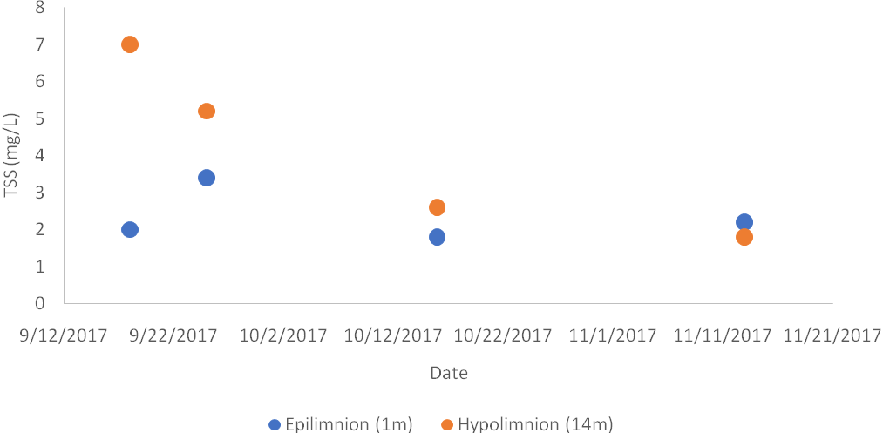Fig. 6. Total suspended solids in Harpt Lake during fall 2017.

Secchi Depth
Secchi depth is a measure of water clarity based on light penetration through the water column. Bodies of water with lower average Secchi depths have more turbid water, usually associated with high productivity and a eutrophic state. The Secchi depth in Harpt Lake ranged from 2 m to 4.5 m, with the minimum depth observed after mixing on November 13th and the maximum depth observed on September 25th (Fig. 7). The calculated Trophic State Index (TSI) based on the average Secchi depth of 3.175 m is 43.35 (Carlson and Simpson 1996). This value indicates fair water quality in a deep seepage lake, with potentially hypoxic conditions in deep water during summer. It is within the range of historical observations of 42 to 51 units Secchi-based TSI (WI DNR 2017).
Light extinction (K) was calculated for Hart Lake as, 1.7/Secchi Depth, which resulted in an average K of 0.57. This value indicates turbid lake conditions, likely caused by eutrophic status and high productivity in Harpt Lake. This limited light penetration is evident when observing macrophyte growth within the lake, which is constrained to a narrow littoral zone (9% total lake bottom area), where light can penetrate the water column.
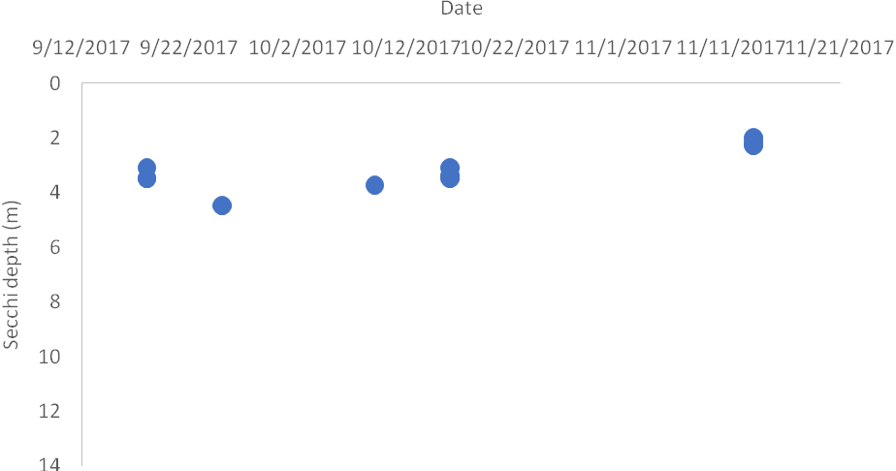
Fig. 7. Secchi disk depth of Harpt Lake reflects relatively turbid water conditions.
Invertebrates
Zooplankton
A qualitative analysis of planktonic communities was conducted in October 23, 2017. Three, paired vertical tows (epilimnion 5m and whole water column), were conducted with a standard, micro-mesh plankton net at each of the three monitoring points. A diversity of planktonic orders were encountered, including common phytoplankton and their zooplankton predators. Future identification, especially of the diatom community, can be used to determine ecosystem state through an index of biotic integrity. Phantom midge larvae (Chaoborus spp.) were found in the hypolimnion at the Master point. These aquatic larvae exhibit diel vertical migration patterns to avoid predatory fish and can serve as indicators of predation pressure in a lake.

Macroinvertebrates

Aquatic macroinvertebrates were surveyed on October 9, 2017 at 4 points along the nearshore vegetated area. Dip nets were used to collect samples in submerged aquatic vegetation (SAV, n=3) or emergent vegetation (EV, n=1). Sampling of emergent vegetation was limited by presence of appropriate sampling locations. Aquatic insects were picked in the field for 30 person-minutes per sample, preserved in ethanol, and identified to order in the laboratory. Ten Aquatic insect orders were present in our samples. Harpt Lake appears to have a diverse aquatic invertebrate community; however, further taxonomic identification of insects would be beneficial to gain detailed insight on the tolerance level of species present.

Table 1. Aquatic invertebrate orders collected in Harpt Lake on October 9, 2017.
 | SAV 1 | SAV 2 | SAV 3 | EV 1
Chironomidae | 3
Odonata | 16 | 9 | 35 | 11
Trichoptera | 3 |  | 5
Ephemeroptera | 1 | 2 | 2
Coleoptera | 1 | 1 |  | 5
Amphipoda | 3 | 3 | 4 | 4
Ocarina |  | 2
Mollusca |  |  | 1
Annelida |  |  | 1 | 1
Hemiptera |  |  |  | 2
TOTAL | 27 | 17 | 48 | 23

Aquatic Plants
Macrophytes serve as important habitat and food for invertebrates and fish. Aquatic plants can also indicate ecosystem quality in lakes, whether through presence of sensitive species or nuisance invasive species. In Harpt Lake, low water clarity restricts plants to a littoral zone that makes up 9% of the available lake bottom area. The most recent vegetation surveys were conducted in 2009 and 2011 by Onterra, LLC at a spatial resolution of 17 m including 446 points. 22 species were found, including one non-native species. Simpson’s Diversity was 0.83, with an average coefficient of conservatism of 5.0 (Hoyman and Cibulka 2012).
We sampled 11 locations within the littoral zone of Harpt Lake on September 25,2017 (Fig. 8). Eleven species were encountered, including the invasive Eurasian water milfoil (Myriophyllum spicatum, EWM) (Table 2). Coefficients of conservatism listed indicate a plant’s ability to tolerate impacted environments; a higher coefficient of conservatism indicates a less-tolerant plant. The average conservatism was 5.8 in 2017, compared to a state average of 5.3 (Hoyman and Cibulka 2012). In 2009, some dominant stands of EWM were detected along the east shore of the lake with single plants scattered along the east and west shores. In 2011, smaller dominant stands on the east shore were accompanied by fewer individuals on the west shore (Hoyman and Cibulka 2012). Three of our sampling points were inside the historical areas of EWM, and we encountered EWM at one point (Fig. 8). This finding indicates that the invasive species is still present in the lake and warrants further monitoring. However, a 1994 record of EWM presence in Harpt Lake indicates a long period of establishment with few dramatic impacts observed (Hoyman and Cibulka 2012).
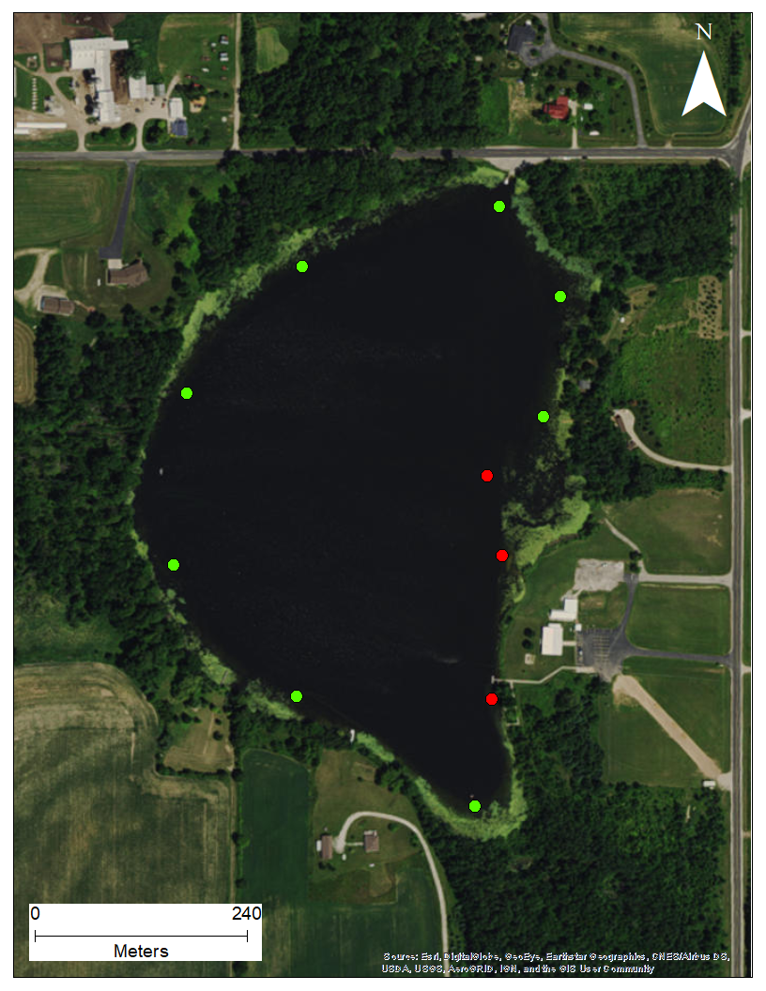
Fig. 8. Vegetation survey points in Harpt Lake 2017. Green dots indicate absence of Eurasian water milfoil in 2009 and 2011 surveys, while red dots indicate previous occurrences of EWM. The red circle shows the point where we found EWM where historically present.

Table 2. Submerged and free-floating plant species encountered during 2017 plant survey.
Latin name | Common name | Coefficient of Conservatism
Chara sp. | Muskgrass, stonewort | 7
Ceratophyllumdemersum | Coontail | 3
Heteranthera dubia | Water star grass | 6
Lemna trisulca | Forked duckweed | 6
Myriophyllum heterophyllum | Variable-leaf water milfoil | 7
Myriophyllum spicatum | Eurasian water milfoil | Exotic
Myriophyllum sibiricum | Northern water milfoil | 7
Potamogeton illinoensis | Illinois pondweed | 6
Potamogeton cf. illinoensis | Illinois pondweed, possible hybrid with P. nodosus | 6
Potamogeton nodosus | Longleaf pondweed | 7
Stuckenia pectinata | Sago pondweed | 3

Fish
We did not survey the fish community during our sampling in 2017. Previous surveys conducted by the WI DNR (2012) show Harpt Lake has a higher than state average growth rate for panfish (Bluegill, Lepomis macrochirus) which suggests the potential for a great panfish fishery. In 2017, stocking reports also show that fingerling Walleye (Sander vitreus) were stocked into the lake.However, based on our survey findings, available habitat may be limited for walleye and hypoxic conditions may be an issue for expansive fish communities through a restricted littoral zone and oxygenated area. We estimate that 54% of the lake becomes hypoxic during summer stratification and 100% of the lake becomes hypoxic during fall turnover, which greatly reduces areas of oxygen refuge to fishes seasonally.

Conclusion
Multiple metrics of lake health show Harpt Lake as a moderately-impacted, eutrophic lake. Water quality may be improved through addition of buffer strips in the primarily agricultural catchment (Hoyman and Cibulka 2012), which may facilitate more diverse and robust communities of macrophytes, invertebrates, and fish. Further monitoring efforts may assist in tracking the status of the non-native macrophyte Eurasian water milfoil and describing the current fish community in the lake. Higher levels of spatial and taxonomic resolution may be used to apply indices of biotic integrity to macroinvertebrate and plankton samples to describe the overall sensitivity of these communities. Based on available habitat and water quality, Harpt Lake currently has little ability to support a successful walleye fishery but shows potential for a successful panfish community. We suggest shifting efforts from stocking walleye towards improving water quality and panfish communities to increase recreational opportunities on Harpt Lake.

Acknowledgments
Thank you to Samantha Okhuysen, Rebecca Gliniecki, Angela Grimm and Danielle Radtke for assisting in the field. Many thanks to Dr. Patrick Forsythe, Dr. Kevin Fermanich and Dr. Jay Horn at the University of Wisconsin-Green Bay for advice and use of field and laboratory instruments.

References
Carlson, R.E. and J. Simpson. 1996. A Coordinator’s Guide to Volunteer Lake Monitoring Methods. North American Lake Management Society. 96 pp.
Hoyman, T. and D. Cibulka. 2012. Harpt Lake, Manitowoc County, Wisconsin Comprehensive Management Plan, April 2012. Submitted to the Larrabee Sportsmen Club by Onterra, LLC. De Pere, WI. 70 pages.
WI DNR. 2017. Harpt Lake, Manitowoc County Reports. http://dnr.wi.gov/lakes/waterquality/Station.aspx?id=363068

Appendix 1: Temperature and dissolved oxygen profiles
