2008 Impaired Waters Documentation Sheet |  |  |  |  | Date Prepared 8/20/07_______________________________________________
Author Erin Hanson____________________________________________________
Waterbody Name Baird Creek – Segment 2__________________________________ |  |  |  |  |  | Watershed_LF01 – East River_______________
WADRS ID | 10682 _____________ |  | WBIC 118100___________________ |  |  | Lower Fox
Choose One:
X_______ | Proposed 303d List Change (new water, delisting, new pollutants)
_______ | General 303d Documentation
TMDL/303D Listing Proposal
3.5______ | Start Mile | 13.1____ | End Mile | 9.6 miles | Size (Miles/Acres)
Current Assessment:
_________ | Current Fish & Aquatic Life (Aquatic Community) Use _WWFF____________________________________________________________
_________ | Attainable Fish & Aquatic Life (Aquatic Community) Use Warm___________________________________________________________
_________ | Designated Fish & Aquatic Life Use_DEFAULT________________________________________________________________________
_________ | Supporting Attainable Use = fully, partially, not meeting __NOT SUPPORTING_______________________________________________
_________ | Does a Specific Fish Advisory Exist? (Yes/No)
 | ________ | If so, what is the advice?
Pollutants & Impairments
X________ | Impairments (Circle One or More)
 | Degraded habitat = NEW |  | Acute Toxicity |  | Chronic Toxicity | Temperature (Water)
 | Contaminated Fish Tissue |  |  | Eutrophication |  | Excessive Aquatic Plant Growth
 | Aquatic Invasives (AIS) Infestation |  |  |  | Dissolved Oxygen, Low = NEW
 | Other ______________________________________________________________________
X________ | Pollutants (Circle One or More)
 | Total Phosphorus = NEW |  | Sediment = NEW | PCBs | PAHs | Creosote
 | NH3 (Ammonia) |  | Runoff Water (elevated temperatures) |  |  | Other _____________________________
 | Other ______________________________________________________________________
________ | Assessment Level (monitored site specific data less than 5 years old) versus evaluated (other)
________ | DNR Category (3, 4d (recommended), 5a, 5b, 5c)
Monitoring and Listing
X________ | Water Quality Exceedances (As applicable)  Dissolved Oxygen (DO) ≤ 5 mg/l  - Station 053498: 2.7 mg/l on 9/20/2001 & 2.9 on 7/12/2002  - UWM Sonde Data at USGS station 040851325, daily minimum DO ≤ 5 mg/l: 4/25/2005, 7 days in 6/05, 14 days in 8/05, 13 days in 9/05 (Station is at boundary between Baird Creek Segments 1 & 2, see map named 118100.pdf)
X________ | Assessment Parameters (M-IBI, FISH IBI, HBI)  - Warmwater IBI Integrity Rating: SWIMS Stations 10008235 “very poor” (14/8/2001), WDNR Fisheries Database  - Small Streams Habitat Rating: SWIMS Station 10008234 score = 73, rating “good” (14/8/2001), WDNR Fisheries Database  - Macroinvertebrate HBI max 10 = 5.111 (10/4/2001), “good” water quality rating & “some” degree of organic pollution (Lillie et al 2003), data in SWIMS
Stations/Dates/Metric/Scores ____________________________________________________________________________________
Stations/Dates/Metric/Scores ____________________________________________________________________________________
Attach any additional reports, analyses, etc. (Use Designation Survey, etc.)
Data in SWIMS:

See map titled 118100.pdf for sample station locations.
- Station 10008235, BAIRD CREEK- WOODSIDE RD (3): macroinvertebrate data 10/4/2001
Parameter | Result
HBI Max 10 | 5.111
INDEX OF BIOTIC INTEGRITY (IBI) | 2.96045

- Station 053498, BAIRD CREEK - AT NORTHVIEW RD: water quality data 5/1/1991 & 30 dates between 4/11/2001 & 7/2/2002
Parameter, units | Average | Min | Max | Count
TEMPERATURE FIELD, deg C | 8.2 | -0.2 | 25.8 | 23
DISSOLVED OXYGEN FIELD, mg/l | 9.4 | 2.7 | 14.8 | 23
FECAL COLIFORM, MEMBRANE FILTER, MFC AGAR, #/100ml | 5882 | 10 | 71000 | 29
NITROGEN KJELDAHL TOTAL, mg/l | 2.60 | 1.74 | 4.27 | 29
NITROGEN NH3-N DISS, mg/l | 0.18 | 0.03 | 0.871 | 28
NITROGEN NO3+NO2 DISS (AS N), mg/l | 0.80 | 0 | 4.87 | 29
PHOSPHATE ORTHO DISS, mg/l | 0.19 | 0.037 | 0.629 | 29
PHOSPHORUS TOTAL, mg/l | 0.32 | 0.101 | 0.742 | 29
RESIDUE TOTAL NFLT (TOTAL SUSPENDED SOLIDS), mg/l | 14.4 | 0 | 182 | 25
TURBIDITY, LAB NEPHELOMETRIC NTU | 1.6 |  |  | 1

Data from USGS: none

Data from other sources:
Excerpt from “BAIRD CREEK WATERSHED MANAGEMENT STUDY”, J. Reyburn WDNR Green Bay

“NORTHVIEW SITE
The water chemistry and flow stage measurements were taken at the Northview Road bridge crossing. Due to little or no flow at this site later in the year, the habitat and biological assessments were taken at a downstream crossing at Woodside Rd.

Habitat Study Section – The habitat evaluation section began 43.5m upstream of the Woodside Rd. bridge crossing and extended 108.8m upstream. The bottom was composed primarily of rubble and gravel with minor amounts of sand and silt. The section had 8 riffles totaling 41.5 m, 10 runs for 53.45m and 3 pools totaling 14m. The riparian land use within 5m of the stream was primarily shrubs, however the overall land use in this area is developed/agriculture. The minimum stream depth was 0.02 m and the maximum depth was 0.315m . The stream width ranged from 2.4m to 4.1m with a calculated mean stream width of 3.1m. The habitat rating score for this section was 52 indicating good habitat.

Discharge – Table 1 shows a calculated stream discharge at Northview Rd ranging from 35.7 on April 11, 2001 to no discharge on nine occasions. There was ice cover recorded 4 times preventing the recording of the stage. Average discharge over the study period was 9.28 cfs. In April of 2002, a section of the Northview bridge used as a reference point to measure stage collapsed into Baird Creek. A new reference point was established at the top of the middle culvert. This required additional flow measurements and development of a new discharge rating curve, adding variability to the discharge calculations. Discharge at this site was intermittent during the summer and fall of 2001 and 2002.

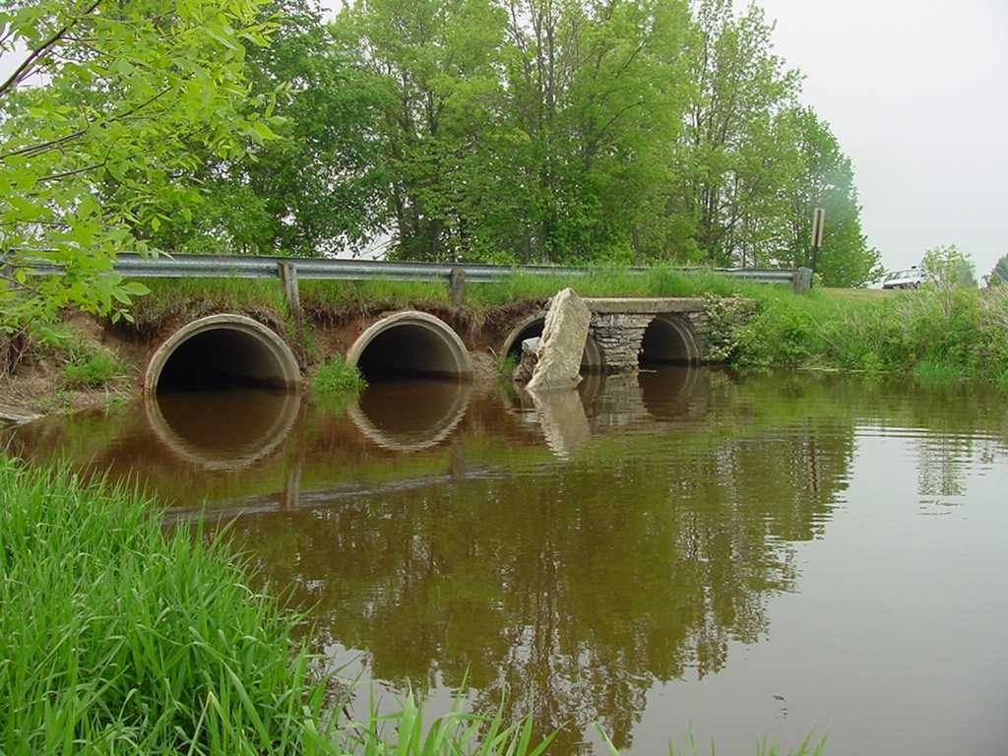 Figure 4 –Northview Rd.

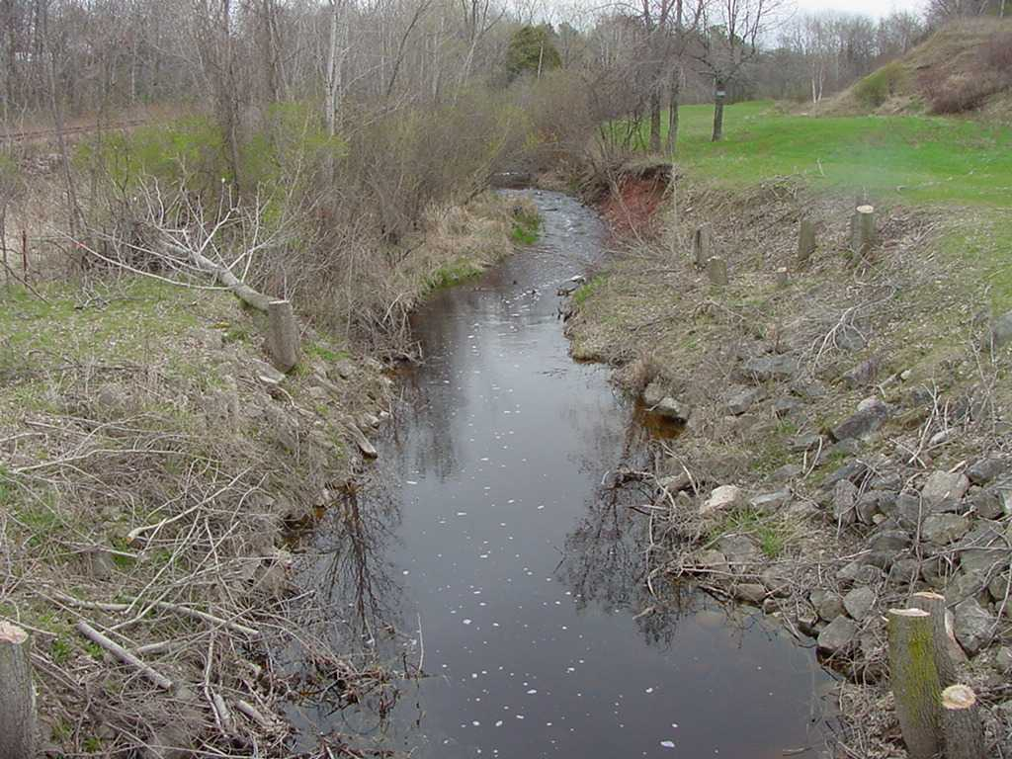 Figure 5 – Woodside Rd.

Water Quality - Water Chemistry and field measurements were not taken during periods of no flow. Dissolved oxygen levels were recorded below the standard of 5.0 ppm four times out of the twenty-eight times sampled. Coliform bacteria exceeded 400 counts six times and ranged from 10 counts/100ml to 71000 counts/ 100ml on June 4, 2002. Total phosphorous concentrations ranged from 0.10 mg/l on January 30, 2002 to 0.74 mg/l on August 23, 2001. The average total phosphorous value at this site for the study period was 0.42 mg/l. These values are considered very high compared to the statewide surface water phosphorous average of 0.065. Continuos water temperatures were not recorded at this site due to the intermittent flow. The suspended solids ranged from no detect on four occasions to a high of 182 mg/l on August 23, 2001. The average suspended solid concentration was 13.5 mg/l.. The discharge permit value of 45 mg/l was exceeded only once out of the 19 times sampled.

Biological Assessment – Invertebrate samples were collected on October 4, 2001 upstream of the Woodside Road bridge crossing. A
total of 23 taxa were identified and 143 individual organisms counted. The orders Tricoptera (50 organisms) and Coleopetera ( 35
organisms) comprised the majority of the macro invertebrates found. The Hilsenhoff biotic index value of 4.867 was calculated
indicating good water quality.

A total of 206 fish representing 12 native species were collected on August 14, 2001 (see Table 4). Seven specimens of redside dace
(Clinostomus elongatus) were collected. This species is identified as rare or uncommon in Wisconsin. The IBI score for the
woodside site is 32 indicating fair biotic integrity.”

Comments below provided by:
Kevin Fermanich (Co-Director of the Lower Fox River Watershed Monitoring Program)
Associate Professor, Earth and Environmental Sciences Natural and Applied Sciences
ES317 University of Wisconsin--Green Bay 2420 Nicolet Drive Green Bay, WI 54311-7001
920-465-2240 Fax: 920-465-2376
fermanik@uwgb.edu

Quotation from 7/1/2006 email from Kevin Fermanich to Carolyn Betz (WDNR Impaired Waters Coordinator) and others:

“Based on our programs work on Baird Creek during the last three years, I recommend that all segments of Baird Creek be included on the 303d list rather than just the lower 3.5 miles as listed in the proposed 2006 303d list. Work by Dr. Tim Ehlinger's group at UWM shows that Index of Biotic Integrity (IBI) rankings for the main stem of Baird Creek above Superior Road and for the north and south branches of Baird Creek above Huron Road are poor to very poor. These same sites also had invertebrate FBI scores that were fair to poor. Clearly these upstream segments of Baird Creek are impaired. See the attached file for a more complete summary of the biotic data.

A 2003-2004 study of the impacts of urbanization on Baird Creek by Jessie Fink, a UW Green Bay graduate student, showed a disproportionate amount of sediment and phosphorus coming from the Sourth Branch of Baird Creek. The South Branch and adjacent tributaries are expereincing rapid urbanization and had a significant portion of land under construction during her study. Segments of tributary channels upstream of Superior Road were shown to be undergoing scour and widening, presumably in response to increased and flashy flows from additonal impervious areas. A summary and a complete report of the Baird Creek urbanization study can be accessed at: http://www.uwgb.edu/watershed/REPORTS/Thesis/baird_JFink.htm”
Stream Monitoring: http://www.uwgb.edu/watershed/data/UWM.htm
The above website also contains links to fish and macroinvertebrate data from the 2003 to 2005 sampling seasons.

