Draft: Long Lake, Polk County
Endothall Concentration Monitoring Summary, 2013

04 January 2014

John Skogerboe

Long Lake has an area of 273 acres, a maximum depth of 17 ft and a mean depth of 11 ft. The lake is classified as a seepage lake on the WI DNR Lake Finder web site. On 28 May 2013, a number of areas totaling 26.6 acres were treated with a liquid formulation of endothall (Aquathol K) to control curly-leaf pondweed (Potamogeton crispus) (Figure 1).

The endothall was applied at a target concentration of 2000 ug/L (2.0 mg/L) active ingredient (ai) to treatment area 1, and 2500 ug/L ai (2.5 mg/L ai) to the remaining treatment areas. Endothall application rates are specified as active ingredient (ai) in the product label, while endothall chemical analysis is specified as acid equivalent (ae). A concentration of 2000 ug/L ai is equal to 1420 ug/L ae and 2500 ug/L ai is equal to 1774 ug/L ae. Water sample sites were established in treatment areas L1, L2, L3, L4, and L5 to monitor endothall concentrations and exposure times (Figure 2). Treatment areas ranged from 2.5 to 9.7 acres. Water temperatures were reported to be 58ºF (14.4ºC) in the Aquatic Plant Management Herbicide Treatment Record, and the wind was reported to be 0 to 4 mph from the southeast. Wind for Clintonville was reported to be 4 mph from the east at www.underground.com.

Treatment | Treatment
Site | Area, acres
L1 | 9.7
L2 | 5.0
L3 | 3.3
L4 | 6.1
L5 | 2.5

Water samples were collected from each sample site using an integrated water sampler which collects water from the entire water column. Water samples were collected at sample intervals of 1, 2, 4, 24, 48, and 72 hours after treatment (HAT). Samples were taken to shore after completion of each sample interval, and 3 drops of muriatic acid were added to each sample bottle to fix the endothall and prevent degradation. Samples were then stored in a refrigerator, until shipped to the US Army Engineer Research and Development Center (ERDC) laboratory in Gainesville, FL for analysis of endothall.

Mean endothall concentrations in samples collected 1 to 4 HAT from treatment areas L1, L2, L3, and L4 ranged from 1216 to 1855 ug/L ae compared to the target concentrations of 1420 and 1774 ug/L ae (Figure 3). Endothall concentrations at 72 HAT ranged from 181 to 388 ug/L ae compared the a base line concentration of 100 ug/L ae. Herbicide concentration data indicate that the herbicide exposure times were longer than have frequently been recorded in other small treatment areas monitored in WI. Herbicide from these sites may have dissipated into a larger treatment area on the west side of the lake. Winds on treatment day were from the east, southeast which may also have helped to hold the herbicide on the west side of the lake.

The mean endothall concentrations in samples collected 1 to 4 HAT from treatment area L5 was 863 ug/L ae compared to the target concentration of 1774 ug/L ae (Figure 3). The endothall concentration in the sample collect at 1 HAT was only 61 ug/L ae indicating that the herbicide had not completely mixed. Endothall concentrations in samples collected at 48 HAT were less than the base line concentration of 100 ug/L ae. Exposure times in samples collected from sample site L5 were shorter than from other sample sites, but were also longer than typically observed for small spot treatments.

Figure 1. 2013 Long Lake (Polk Co.) Endothall Treatment Areas
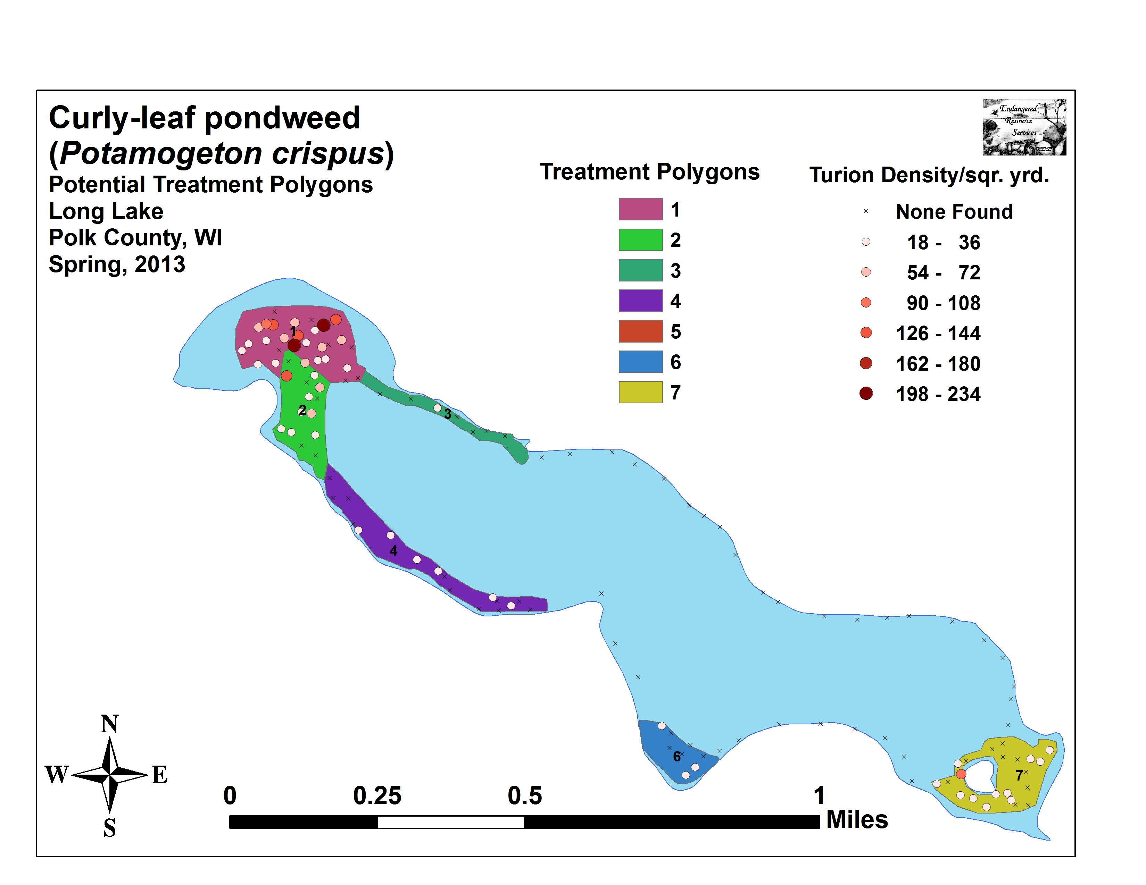

Figure 2. 2013 Long Lake (Polk Co.) Endothall Water Sample Sites
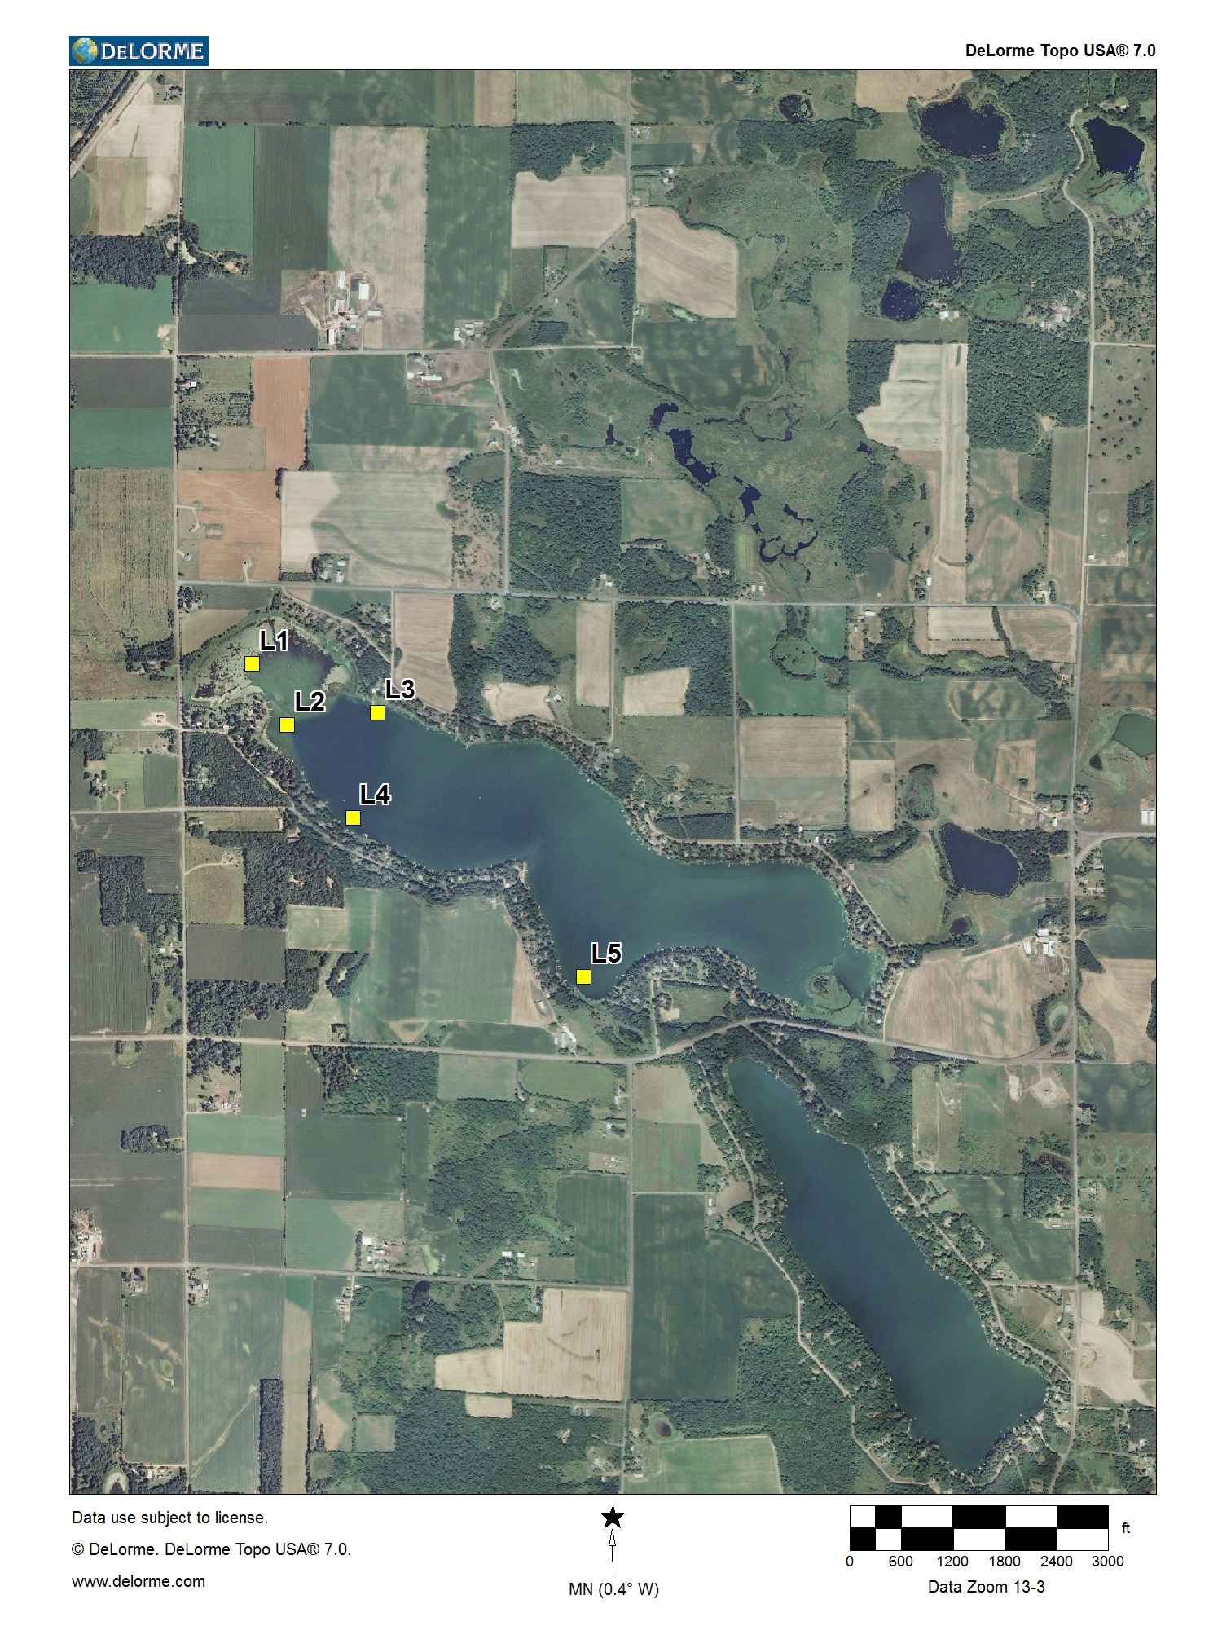

Figure 3

