Scott Walker, Governor
Cathy Stepp, Secretary

State of Wisconsin
DEPARTMENT OF NATURAL RESOURCES
2801 Progress Rd.
Madison WI 53716

July 30, 2026

MCLA and Spring Lake residents,

On August 5, 2014, an aquatic plant survey was conducted on Spring Lake in Manitowoc County. This letter is let you know the results of that survey and genetic testing that has been done on the milfoil species from Spring Lake.

Milfoil plant samples have been collected three times now on Spring Lake and genetically tested using DNA analysis.
In July 2012, two milfoil samples were submitted to the lab. One came back as northern water milfoil (Myriophyllum sibiricum) and the other came back as Eurasian water milfoil (Myriophyllum spicatum).
In August 2013, two milfoil samples were submitted and both came back as whorled water milfoil (Myriophyllum verticillatum).
In September 2014, five milfoil samples were submitted to the lab and all five came back as whorled water milfoil.

So I think it safe to say, three species of milfoil co-exist in Spring Lake. Eurasian water milfoil was not detected during the 2014 aquatic plant survey.

Importance of Aquatic Plants
Aquatic plants form the foundation of healthy lake ecosystems. They not only protect water quality, but also produce life-giving oxygen. Aquatic plants are a lake's own filtering system, helping to clarify the water by absorbing nutrients like phosphorus and nitrogen that could stimulate algal blooms. Plant beds stabilize soft lake bottoms and prevent shoreline erosion by reducing the effect of waves and currents. Healthy native aquatic plant communities help prevent the establishment of invasive non-native plants such as Eurasian water milfoil and curly-leaf pondweed. Native aquatic plants also provide important reproductive, food, and cover habitat for fish, invertebrates, and wildlife. By leaving or restoring a natural buffer area of emergent vegetation along the shoreline, property owners can reduce erosion, help maintain water quality, and provide habitat and travel corridors for wildlife.

Point-Intercept Sampling Method
Based on area and depth specific to Spring Lake, we mapped a 91-point sampling grid over the entire lake surface. Using a GPS, we navigated by boat to each of the pre-determined grid points. At each point we used a two-sided rake to sample approximately 1 foot along the bottom. After pulling the plants to the surface, the overall rake as well as individual species on the rake were assigned a fullness rating of 1, 2 or 3 to estimate density of plant growth (see Figure 1 for descriptions of rake fullness ratings). We also recorded visual sightings of species within six feet of the sample point, as well as any additional species seen in the lake during a general boat survey. For more detailed information on the point-intercept sampling method and how data were collected please visit:
http://www.uwsp.edu/cnr-ap/UWEXLakes/Documents/ecology/Aquatic%20Plants/PI-Protocol-2010.pdf

Species frequencies of occurrence reflect the percentage of times a species was found out of the total number of points sampled. Littoral frequency of occurrence (given in Table 1) indicates how often a species was found considering only areas of the lake that are capable of supporting plant growth (known as the “littoral area”). The maximum depth of plant growth is the deepest depth at which plants were found in the lake. Species richness is a count of the total number of different plant species found in a lake. The Floristic Quality Index (FQI) is a metric that evaluates the closeness of the flora in a lake to that of an undisturbed condition. The higher a FQI value, the closer that plant community is to an undisturbed ecosystem. Statewide and ecoregion averages are calculated from a subset of approximately 250 lakes across Wisconsin.

Table 1: Species Present
% Frequency of Occurrence (Littoral): This estimation of frequency of occurrence is calculated by taking the total number of times a species is detected in a lake divided by the total number of points in a lake at which the growth of plants is possible.

Common Name | Scientific Name | Growth Form (Floating, free floating, submerged, emergent) | % Frequency of Occurrence
Muskgrasses | Chara spp. | Submergent | 92.1
Northern water milfoil | Myriophyllum sibiricum | Submergent | 48.9
Illinois pondweed | Potamogeton illinoensis | Submergent | 20.5
White water lily | Nymphaea odorata | Floating | 8.0
Hardstem bulrush | Schoenoplectus acutus | Emergent | 2.3
Slender naiad | Najas flexilis | Submergent | 1.1
Aquatic moss |  | Submergent | 1.1
Whorled water milfoil | Myriophyllum verticillatum | Submergent | Visual
Spatterdock | Naphar variegata | Floating | Visual
Water marigold | Bidens beckii | Submergent | Visual
Pickerelweed | Pontederia cordata | Emergent | Visual

Survey Summary
 | SPRING LAKE | STATEWIDE  AVERAGE | SWTP ECOREGION AVERAGE
Littoral Frequency of Occurrence (%) | 94.3 | 74.3 | 79.0%
Maximum Depth of Plant Growth (ft) | 21.8 | 15.3 | 15.4
Species Richness | 6 | 16.8 | 15.0
Floristic Quality Index (FQI) | 15.1 | 24.1 | 20.0

Figure 1: Maps of the approximate location of aquatic plants.

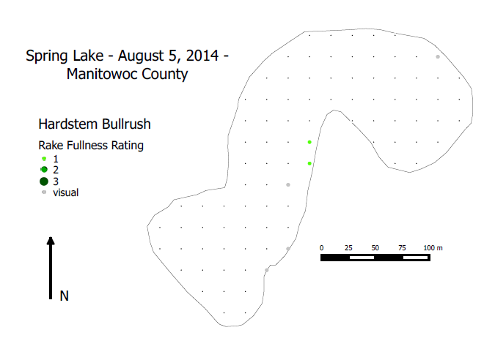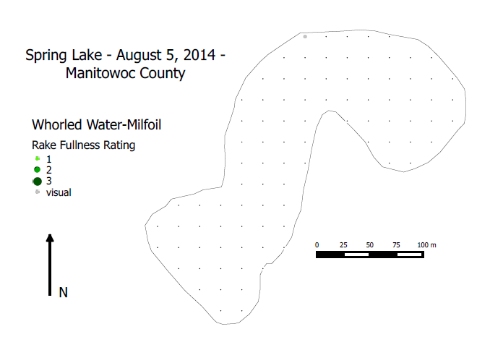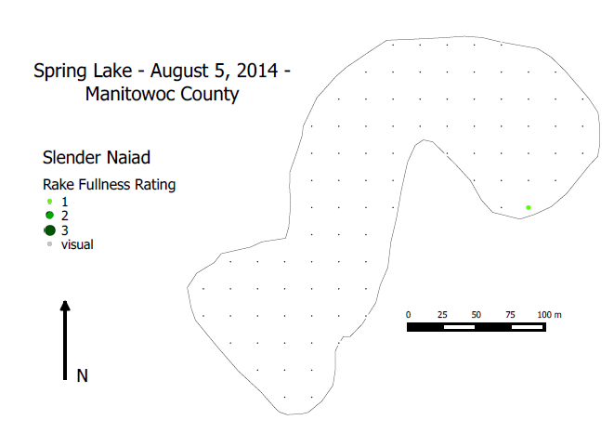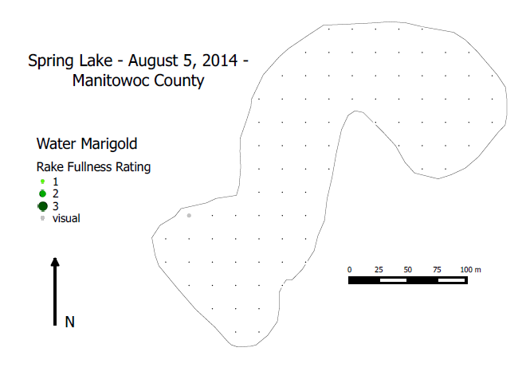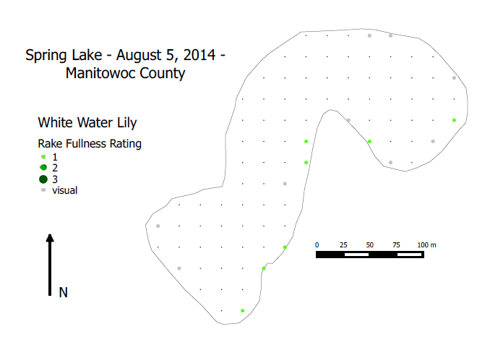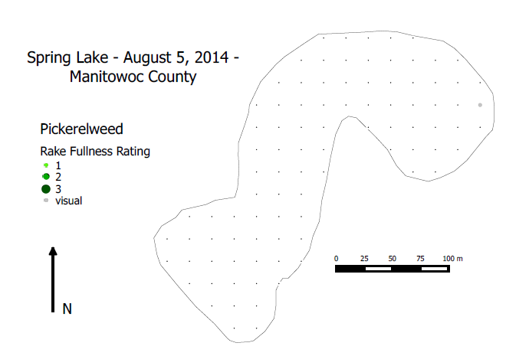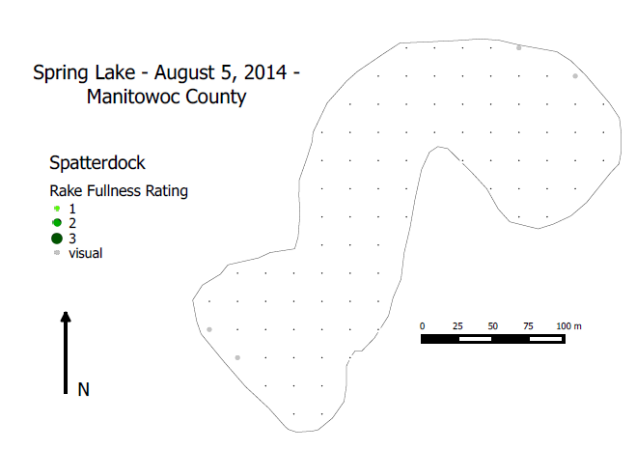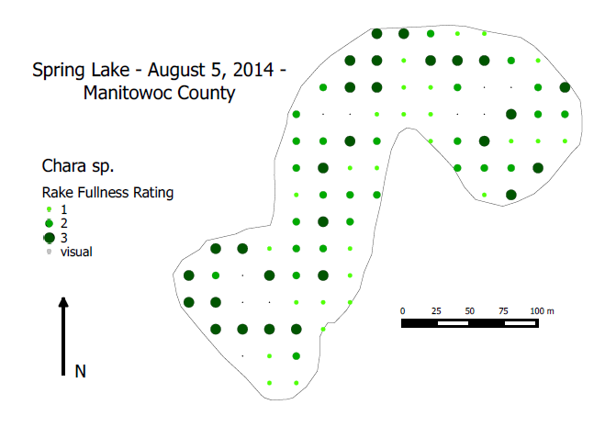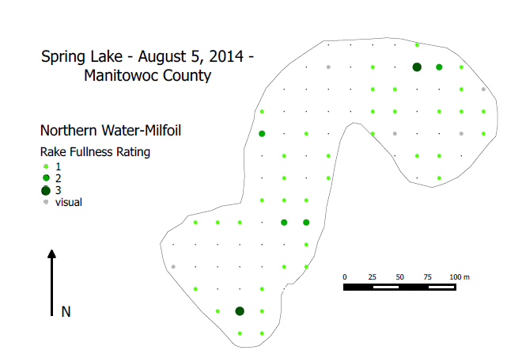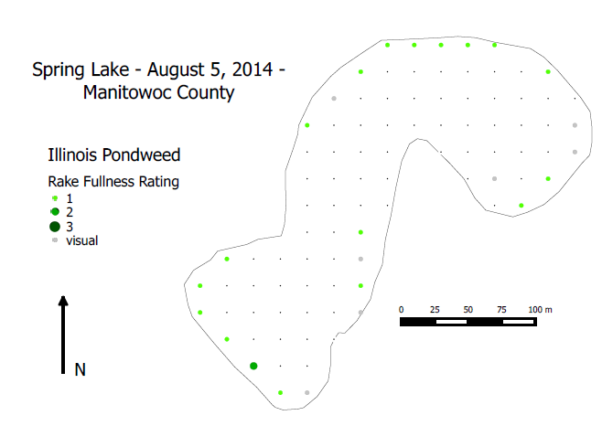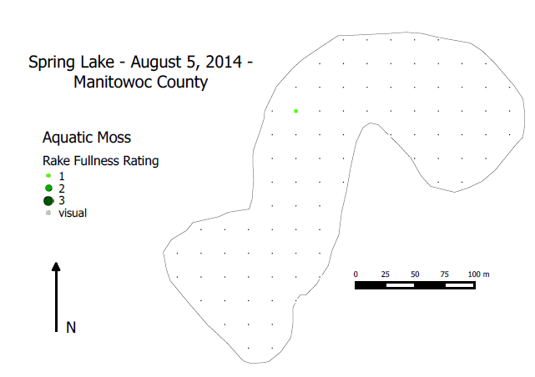

If you have any additional questions regarding the aquatic plant survey on Spring Lake, please feel free to contact me at 920-662-5489 or at mary.gansberg@wisconsin.gov.

Sincerely,

Mary Gansberg
Water Resources Management Specialist
Wisconsin Department of Natural Resources

