An Assessment

of

German Valley Creek

WBIC = 909200

Dane County, WI

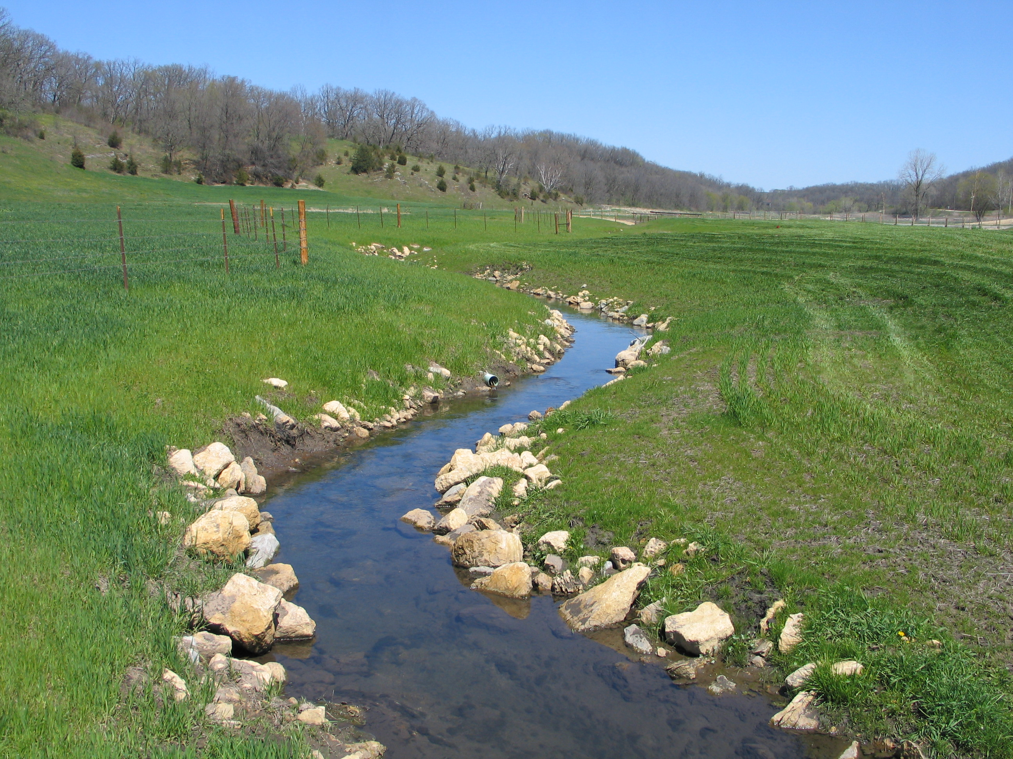

A proposal for delisting from the state’s 303(d) list of impaired waters

In fulfillment of SP12 projects SCR02_09 and SCR04_10

January, 2011

By
Jim Amrhein
Water Quality Biologist
South Central Region

Introduction
German Valley Creek is a 7 mile long stream on the south slope of Military Ridge. The spring-fed stream has its headwaters southwest of Mount Horeb and joins Big Spring Creek (also known as Blue Mounds Branch) to form Gordon Creek. German Valley Creek is currently classified as a default warm water fishery. While the upper half of the stream can generally be regarded as a “cool” water system, the lower half, augmented by higher spring flow, generally has colder water temperatures than the upper half. It is on the state’s 303(d) list of impaired waters because of habitat degradation caused by sedimentation due to cropland and bank erosion, stream bank grazing, and barnyard runoff.

History and Land Use
Almost half of the land cover in the Gordon Creek watershed is used for agriculture. However, more intensive agricultural uses declined as more land was set aside to conservation and due to increased “hobby farming” and rural home development (WDNR, 2004). Wet meadows that were formerly pastured are now in set aside including 140 acres of wet meadow near the mouth. Additionally, the watershed is encompassed by the Conservation Reserve Enhancement Program’s Grassland Project which looks to restore 10,000 acres of grassland in south central Wisconsin. Additionally, The Nature Conservancy is actively involved in a grassland restoration project in the upper portion of the watershed. Each of these projects have likely improved habitat for grassland birds and have the additional benefit of increasing infiltration of rainfall and subsequently increase the base flow of area streams (Ibid).

During the late 1990s and early 2000’s, landowners in the watershed enrolled 525 acres in conservation programs such as the Conservation Reserve Program (CRP). Data collected in 2001 and 2002 showed temperature and dissolved oxygen levels that were consistent with those supporting a coldwater resource. Indeed, subsequent fish monitoring conducted during that same period showed the presence of cold and cool water indicator species such as brown trout, mottled sculpin, and American brook lamprey. These survey results indicated that the lower reaches had the potential to support a productive trout fishery if steps were taken to improve habitat. Because German Valley Creek is an important tributary to Gordon Creek, resource managers felt that habitat restoration would likely expand trout fisheries in the watershed and lead to the removal of German Valley Creek from the state’s impaired waters list.

In the mid-1970’s to mid-1990’s, surveys showed German Valley Branch contained several species of cool-warm transitional species (Lyons, et. al., 2009) and was dominated by habitat tolerant species such as white sucker and creek chub (Table 1). The stream corridor was shrouded with box elder trees leading to substantial bank erosion. The stream was wide, shallow and the bottom mostly made up of soft sediment. Even in surveys conducted shortly after the millennium, while cold and cool water species were becoming present, the fishery assemblage was still dominated by these same species tolerant to disturbed habitat.

Stream Rehabilitation
Landowners along German Valley Creek expressed their support for improving the stream and the fishery. In 2003, the Dane County Land and Water Conservation Department (LWCD) received the first of four Targeted Runoff Management (TRM) grants from the state to improve a 1.5 mile long section of stream from CTH Z to Mayflower Road (Figure 1). Cost share money was received from a county conservation
fund, Wildlife Habitat Improvement Program (WHIP), U.S. Fish and Wildlife (USFWS) funds as well as volunteer labor from non-profit organizations such as Trout Unlimited (TU) and the Upper Sugar River Watershed Association (USRWA). The LWCD subsequently received 3 additional TRM grants for rehabilitating a total of over 4 miles of stream (Table 2).

The water quality objective of the project was to reduce stream bank erosion by 90% resulting in an overall reduction of sediment load of over 7300 tons/year over the whole area of the project. In all, almost 50,000 feet of stream bank was shaped and stabilized, and over 600 fish habitat structures (LUNKERS and weirs) were added to the stream.

Table 1: Historic Fish Data for German Valley
Upstream Downstream | Stream Site  (Year) | Species | Number
Upstream Downstream | CTH Z | Creek Chub | 44
Upstream Downstream | (1976) | White Sucker | 36
Upstream Downstream |  | Johnny Darter | 9
Upstream Downstream |  | Western Blacknose Dace | 2
Upstream Downstream |  | Central Stoneroller | 1
Upstream Downstream |  | American Brook Lamprey | 1
Upstream Downstream | Private Drive | Brook Stickleback | 100
Upstream Downstream | SW ¼ SE ¼  Sec. 21 T6N R6E | Johnny Darter | 3
Upstream Downstream | (1994) | White Sucker | 29
Upstream Downstream |  | Fantail Darter | 70
Upstream Downstream |  | Creek Chub | 260
Upstream Downstream | CTH E – upper | Stonerollers | 54
Upstream Downstream | (1976) | White sucker | 39
Upstream Downstream |  | Brook Stickleback | 25
Upstream Downstream |  | Creek Chub | 22
Upstream Downstream |  | Central Stoneroller | 3
Upstream Downstream |  | Johnny Darter | 2
Upstream Downstream | CTH E -upper | Fantail Darter | 20
Upstream Downstream | (1994) | Brook Stickleback | 20
Upstream Downstream |  | Johnny Darter | 1

Table 2: German Valley Creek Stream Improvement Projects
Year | Stream Segment | BMPs and other installations | Funding (Dollars)
2004 | CTH Z to  Mayflower Road | 20,000 feet of shaping and seeding w/ habitat  26 acres of critical area seeding  394 fish habitat structures (291 LUNKERS and 103 weirs) | DNR TRM = 132,661  In-kind labor and funds:  WHIP = 50,000  TU (labor) = 58,200
2005 | Downstream Blue Rock Road to CTH E | 14,000 feet of shaping and seeding w/ habitat  11 acres of critical area seeding  181 fish habitat structures (127 LUNKERS and 54 weirs)  1 acre wastewater treatment strip  1 acre grassed waterway  1500 ft of fencing  300 feet livestock crossing | DNR TRM = 136,271  In-kind labor and funds:  Dane Co. = 25,000  TU (labor) = 10,700  USRWA (labor) = 10,700
2006 | Confluence with Blue Mounds Branch to CTH Z | 900 feet of shaping and seeding w/ habitat  0.5 acre critical area seeding  13 fish habitat structures (10 LUNKERS and 3 weirs) | DNR TRM = 4,900  In-kind labor and funds:  Labor = 2,100
2008 | Mayflower Road to downstream Blue Rock Road | 14,600 feet of shaping and seeding w/habitat  11 acres of critical seeding  100 fish habitat structures (44 LUNKERS and 56 weirs) | DNR TRM = 92,620  In-kind labor and funds:  Dane Co = 17,380  USFWS = 15,000  Labor = 44,115

Macroinvertebrate samples were generally taken prior to the start of the project (Table 3). In general, the Hilsenhoff (1987) Biotic Index (HBI) showed values from 4.5 to 5.5 or “good” on the index scale. The macroinvertebrate index of biotic integrity (MIBI) developed by Weigel (2003) was more varied with values from 2.4 to 8.2 or “poor” to “excellent”. Most values ranged from 2.5 to 5.8 or “fair” to “good”. These data indicated that the water quality and status of the watershed was such that a rehabilitation project would likely be successful.

Table 3: Macroinvertebrate Data for German Valley Creek
Site | Date | HBI | MIBI
Upstream of North Perry Road | 11/01/2001 | 2.9 (Excellent) | 8.2 (Excellent)
Upstream Mayflower Road | 05/11/1994 | 4.4 (V. Good) | 5.2 (Good)
Upstream Mayflower Road | 05/17/1995 | 4.5 (V. Good) | 3.5 (Fair)
Upstream Mayflower Road | 04/22/2001 | 5.2 (Good) | 3.7 (Fair)
Upstream Mayflower Road | 04/17/2002 | 5.2 (Good) | 3.2 (Fair)
Upstream Mayflower Road | 04/22/2005 | 4.8 (Good) | 2.4 (Poor)
Upstream of CTH E (downstream crossing) | 11/01/2001 | 3.0 (Excellent) | 5.2 (Good)
Upstream of CTH E (second crossing) | 10/09/1987 | 5.0 (Good) | 2.9 (Fair)
Upstream of CTH E (3rd crossing) | 11/01/2001 | 3.6 (V. Good) | 5.8 (Good)

More recent surveys were conducted on various stream segments prior to, and after, stream rehabilitation had taken place. In some cases, the station length varied, so the calculation of trout/mile and the coldwater Index of Biotic Integrity (IBI) developed by Lyons, et. al.(1996) were used as metrics to normalize the data (Tables 4a – e). A full compilation of fish surveys can be found in the Appendix.

Table 4a: Fish Assemblage at CTH Z
 | Pre-rehabilitation |  |  | Post-rehabilitation
Year | 2001 | 2002 | 2003 | 2005 | 2006 | 2009
Mottled Sculpin | 228 | 311 | 145 | 538 |  | 194
Creek Chub | 81 | 55 | 3
Brown Trout | 78 | 78 | 59 | 68 | 96* | 18
Brook Trout |  |  |  |  |  | 1
White Sucker | 57 | 51 | 8 | 2 |  | 5
American Brook Lamprey | 10 | 19 | 1 | 6
Brook Stickleback | 1 |  |  |  |  | 3
Trout/mile | 87 | 87 | 66 | 78 | 107 | 115
Coldwater IBI | 40 (Fair) | 50 (Fair) | 70 (Good) | 60 (Good) | N/A | 70 (Good)
* Gamefish run only
Table 4b: Between North Perry Road and Mayflower Road
 | Pre-rehabilitation | Post-rehabilitation
Year | 2001 | 2005 | 2006 | 2008 | 2009
Mottled Sculpin | 301 | 2082 |  | 400 | 120
Creek Chub | 196 | 20 |  | 1
White Sucker | 151 | 47
Brown Trout | 22 | 109 | 66* | 14 | 17
American Brook Lamprey | 0 | 3
Fathead Minnow |  |  |  | 1
Trout/mile | 21 | 124 | 296 | 136 | 141
Coldwater IBI | 20 (Poor) | 60 (Good) | N/A | 50 (Fair) | 50 (Fair)
* Gamefish survey only

Table 4c: Upstream of Mayflower Road
 | Pre-rehabilitation | Post-rehabilitation
Year | 2008 | 2009
Mottled Sculpin | 2 | 165
Brown Trout | 7 | 14
White Sucker | 3
Creek Chub | 2 | 1
Trout/mile | 92 | 184
Coldwater IBI | 40 (Fair) | 50 (Fair)

Table 4d: Upstream CTH E (furthest downstream CTH E crossing)
 | Pre-rehabilitation | Post-rehabilitation
Year | 2001 | 2008 | 2009
Brook Stickleback | 103
White Sucker | 27 |  | 1
Creek Chub | 13 |  | 7
Fantail Darter | 111
Johnny Darter | 5
Bluegill | 1
Brown Trout |  | 10 | 11
Brook Trout |  |  | 3
Mottled Sculpin |  | 815 | 800
Trout/mile | 0 | 70 | 98
Coldwater IBI | 0 (Very Poor) | 50 (Fair) | 70 (Good)

Table 4e: 0.3 mile Upstream CTH E (machine crossing in field)
 | Pre-rehabilitation | Post-rehabilitation
Year | 2001 | 2008 | 2009
Brown Trout | 3 | 9 | 17
White Sucker | 53
Creek Chub | 27 | 8 | 4
Brook stickleback | 75
Fantail Darter | 14 | 10
Johnny Darter | 24
Central Stoneroller | 8
Mottled Sculpin |  | 288 | 200
Brook Stickleback |  | 2
Trout/mile | 51 | 76 | 145
Coldwater IBI | 0 (Very Poor) | 50 (Fair) | 50 (Fair)

Quantitative habitat surveys (Simonson et. al., 1994) were also conducted prior to and after rehabilitation. Measurements of stream width, bank erosion, width-to-depth ratio, riffle and/or pool ratio, percent soft sediment, and fish cover are incorporated into this metric. The habitat surveys are summarized in Table 5.

Table 5: Habitat Surveys for German Valley Creek – value (score)
Station Name | Buffer | Erosion | Pools | W/D Ratio | Riffle or Bends* | %  Fines | Fish Cover | Score/  Rank
CTH Z | 10.0 (15) | 0.59  (5) | 0  (0) | 11.5  (10) | (5) | 88.1  (0) | 8.9  (5) | 40  Fair
 | 10.0  (15) | 0.46  (10) | 0  (0) | 5.64  (10) | (15) | 83.8  (0) | 54.8  (15) | 65  Good
Perry Rd | 8.3  (10) | 0.21  (10) | 21.8 (3) | 7.33  (10) | (15) | 93.9  (0) | 32.9  (15) | 63  Good
 | 10.0 (15) | 0.06  (15) | 14.1 (3) | 3.21  (10) | (15) | 38.3  (5) | 32.5  (15) | 78  Excellent
Mayflower Road | 5.8  (10) | 0.43  (10) | 3.3  (0) | 9.82  (10) | (15) | 91.1  (0) | 6.7  (5) | 50  Good
 | 9.8  (10) | 0.65  (5) | 0  (0) | 14.7  (10) | (0) | 83.8  (0) | 3.5  (0) | 25  Fair
 | 10.0 (15) | 0.48  (10) | 0  (0) | 6.76  (10) | (15) | 88.8  (0) | 3.9  (0) | 50  Good
 | 10.0 (15) | 0.05  (15) | 12.1 (3) | 4.77  (10) | (15) | 67.9  (0) | 31.9  (15) | 73  Good
CTH E | 5.7  (10) | 0.25  (10) | 6.83 (0) | 5.73  (10) | (5) | 61.9  (0) | 20.9  (15) | 50  Good
 | 10.0 (15) | 0  (15) | 4.57 (0) | 3.50  (10) | (15) | 26.7  (5) | 38.0  (15) | 75  Excellent
Before rehabilitation
After rehabilitation
* Only the score is reported as the higher of the two measures is included in the final score

Discussion
Fisheries surveys were conducted on various segments of German Valley before and after rehabilitation. Historically, there were no cold water or cool water species present in the surveys conducted prior to the turn of the century. The stream contained cool water transitional species and was dominated by species tolerant to disturbed habitat. During the mid-1990’s, a large amount of land was enrolled in the CRP program. The result was more infiltration and higher base flows. This subsequently led to cooler water temperatures. Marshall (2005) documented summer water temperatures from 2001 through 2003 that fell within the coldwater thermal regime as defined by Lyons (2008) with maximum daily mean summer temperatures that do not exceed 69.3ºF (20.7ºC). Resource managers felt the main agricultural sources of pollution were being addressed, and that habitat limitation due to high sedimentation from bank and bed load sources was the greatest impediment to the stream reaching its attainable use as a cold water stream.

The improved habitat is immediately noticeable in the improved metrics that make up the habitat scores (Figure 2). The mean buffer width was already good and was one of the reasons managers felt the chances of success with the project were reasonably good. Banks were stabilized and erosion reduced as evidenced by the improved erosion scores. This was an important aspect in meeting the goals of the project. While the score for the width to depth ratios was unchanged, the actual ratio decreased from an average of 9.3 to 4.3, indicating a narrower, deeper channel which is generally more favorable to fish habitation. The score for percent fines did not increase appreciably; however, the percentage of fines decreased from an average of 84.6% before the projects to 54.2% after. The placing of rock and log weirs as well as LUNKER structures led to improved fish habitat. Overall habitat scores improved from “fair” and “good” to “good” and “excellent”.

Figure 2: Habitat Surveys on German Valley Creek Before and After Rehabilitation

Fishery assemblages that were already showing improvement because of improved water quality and lower temperatures likewise responded almost immediately to the improved habitat. Coldwater IBIs and trout densities increased at all sites. Some coldwater IBIs were suppressed by the fact that mottled sculpin, an intolerant cool water indicator species, became so prevalent that their numbers dwarfed the trout populations, and thus caused the coldwater IBI to be about 10 points lower because the top level carnivore species metric was suppressed by the high numbers of sculpin. Another indication of the transition to cold water is the decrease in the number of species found in the stream. Prior to the environmental and stream improvements, there were from 6 to 7 species present, most of which represented warm-cool transitional species and most tolerant of habitat disturbance. Surveys conducted over the past 3 years showed a dramatic drop in the number of such species, especially white sucker. The stream now contains almost exclusively brown trout and mottled sculpin with an occasional white sucker or creek chub. Brown trout have been stocked since 2004 and annually since 2007. Multiple year classes of trout indicate adequate survival from one year to the next. In 2009 brook trout were stocked into the stream. However, even before this stocking, brook trout were showing up in the surveys, likely migrating up from Gordon Creek.

I should be noted that in fall, 2004, a fish kill occurred on a portion of the stream that had already been improved. This partial kill led to the identification of a source of runoff that was eventually addressed in the 2005 improvement project.

Macroinvertebrates
The HBI values showed that there was low organic loading to the system which could lead to excessive macrophyte growth and potential low dissolved oxygen levels. The macroinvertebrate IBIs ranged from poor to excellent, with most values reflecting a “fair” rating. This probably reflects the aggregation of the local watershed stressors on the stream including some nutrient loading and poorer habitat caused by sedimentation. While there is still intense agricultural land use in this sub-watershed, there is also been a great deal of land placed in set aside. Additionally, the stream already had good buffers in certain sections of the stream either from natural features (wetlands or wooded hillsides) or through the benevolence of riparian landowners. The most recent macroinvertebrate sample, taken upstream from Mayflower Road in 2009, showed an HBI of 2.5 or “excellent” water quality. The macroinvertebrate IBI has not yet been calculated.

Conclusions
The streams classification model (Lyons, 2008) predicts that, based on watershed size (flow) and temperature, German Valley Creek would likely be a cool-cold transitional stream for its entire length. Based on actual temperature data and fish assemblage, the stream is more likely a cold water resource. In 2010, fisheries management designated the entire German Valley Branch as a “Class II” trout stream, meaning that the stream may have some natural reproduction, but not enough to utilize available food and space. Therefore stocking is required to maintain a desirable sport fishery. These streams have good survival and carryover of adult trout.

Therefore, it is recommended that German Valley Creek be removed from the state’s list of impaired waters.
References

Hilsenhoff, William L. 1987. An Improved Biotic Index of Organic Stream Pollution. The Great Lakes Entomologist. 20(1): 31-39.

Lyons, John. L. Wang, and T. Simonson. 1996. Development and Validation of an Index of Biotic Integrity for Coldwater Streams in Wisconsin. North American Journal of Fisheries Management. 16: 241-256.

Lyons, John. 2008. Using the Wisconsin Stream Model to Estimate the Potential Natural Community of Wisconsin Streams. Wisconsin Department of Natural Resources, Fish and Aquatic Research Section. November, 2008 DRAFT.

Lyons, John. T. Zorn, J. Stewart, P. Seelbach, K. Wehrly, and L. Wang. 2009. Defining and Characterizing Coolwater Streams and Their Fish Assemblages in Michigan and Wisconsin, USA. North American Journal of Fisheries Management. 29: 1130-1151.

Marshall, David. 2005. Fish and Aquatic Life Designated Use Form. Proposed Stream Re-classification for German Valley Creek. 01/18/2005.

Simonson, Timothy D. J. Lyons and P. Kanehl. 1994. Guidelines for Evaluating Fish Habitat in Wisconsin Streams. United States Department of Agriculture. Forest Service. General Technical Report NC-164.

WDNR. 2004. Sugar and Pecatonica Rivers Basin Report. Wisconsin Department of Natural Resources. South Central Region.

Weigel, Brian M. 2003. Development of stream macroinvertebrate models that predict watershed and local stressors in Wisconsin. Journal of the North American Benthological Society. 22(1): 123-142.

