BADGER ARMY AMMUNTIONS PLANT FINAL REPORT
WI-DNR WATER RESOURCES
JEAN UNMUTH

Introduction

DNR water resources staff and interns sampled one unnamed stream and two ponds during early August 2011 at locations shown in Figure 1 within the boundary of the Badger Army Ammunitions Plant (BAAP) We also intended to sample the unnamed tributary located East of the Kerns wetland pond but the stream was dry. Fish, quantitative habitat, aquatic macroinvertebrates and water quality grab samples were collected from the stream site, and used to assess stream condition, and to classify attainable and designated uses. Fish presence/absence and water quality grab samples were collected from the two ponds to collect baseline information, and to determine if the Ballistics E area pond is meeting the designated use. Additionally, staff sought to determine if any rare, threatened, endangered, state special concern or species of greatest conservation need (SGCN) were present in any of the waterways.

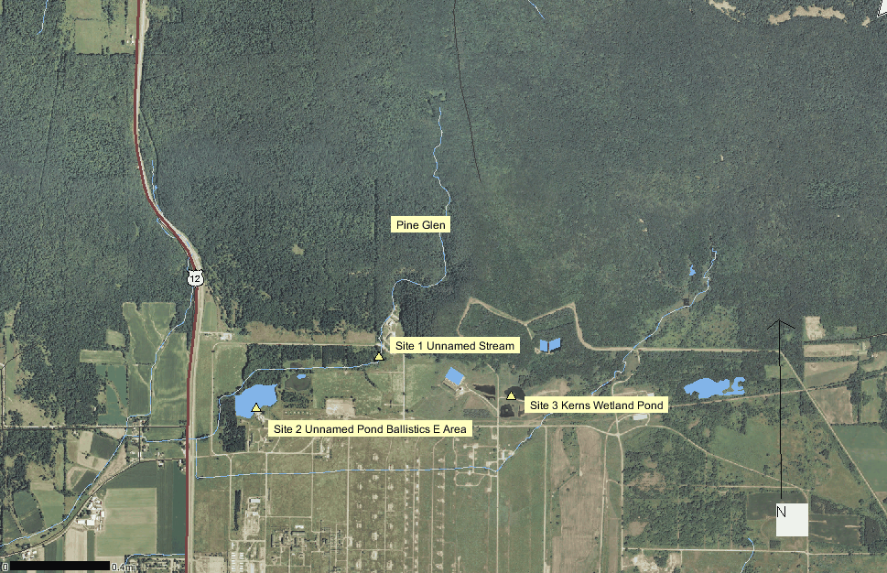
Figure 1. BAAP stream sites sampled by DNR Water Resources staff in August 2011

Site 1: Results Unnamed Stream Pine Glen
This is a first order stream that was originally 3.98 miles long, and according Original Government Land Survey maps (1835-1840) flowed out of Pine Glen and meandered in a south and slightly easterly direction through the entire section 35 of the township, and then appears to end just at the section line. However the stream has been ditched, forced to flow in a westerly direction at the bluff base, and now flows into an unnamed pond in the Balllistics E area. The rerouting of this stream has reduced stream miles by half. The stream is not classified; no use designation had been established. The natural community is listed as cold headwater with expectations that the stream temperatures are cold (20.2 C or less), and coldwater fishes abundant.
The stream appears to be perennial, arising from springs in Pine Glen which is located in the southern boundary of Devil’s Lake State Park. Springs were visibly noticeable during the August sampling. Instantaneous water temperature was 19.6 degrees C, and within the acceptable range to support coldwater fish species. Water was very clear with a transparency of <10 NTU. pH was neutral at 7.0 which is the level of pure drinking water. Specific conductivity was low at 136 umhos/cm, but within the range expected due to the geology of the Baraboo Range which is mainly rhyolite and quartzite. Stream dissolved oxygen was 8.7 mg/l, well within the range to support coldwater fish. Stream macroinvertebrates were collected using a D-frame kicknet and the sample sent to UWSP for analysis. Sample results will not be available for evaluation for at least 4-5 months.
A quantitative habitat assessment of the stream showed a score of 65 or a rating of good habitat, but the stream still has some habitat issues. The stream reach sampled was within an area that appeared to have been ditched more than 40 years ago, was not immediately adjacent to development other than a roadway, and had good riparian bank cover. However, we observed downstream reaches that had much less cover and the reach immediately upstream was developed (hard paved and buildings) right up to the east bank. The stream showed strong evidence of intensive scouring during rain events, exacerbated by ditching. When specific habitat parameters were teased out they revealed that while vegetated buffers, riffles and stream substrate was excellent, bends and instream fish cover, were lacking, bank erosion was fair and sedimentation was higher than optimal for brook trout. Stream flow was not collected due to the lack of channel depth in runs and riffles, however observationally velocity appeared to be extremely low, and in some areas riffles were so shallow that fish were isolated into pools between the riffles. Perched culverts also appeared to block normal flow.
Backpack electrofishing was used to sample 120 meters of stream. A total of 532 fishes were caught representing 8 fish species (Figure 2). No trout or coldwater fish were captured, and all fish were either tolerant or intermediate in tolerance to pollution. In terms of their temperature rating, five fish species were warmwater eurythermal and three species were transitional (warm to cool) eurythermal. No rare, threatened, endangered, special concern or SGCN fish were caught, yet all were native to the state. Water quality information and habitat assessment indicates that the stream should be able to support coldwater fish; not necessarily trout due to low flow, but at least coldwater forage fish. However, the sampling site was just below a developed area of the BAAP, and the stream has been ditched and connected to the pond in Ballistics E area. Bluegill and pumpkinseed, both warmwater fishes not normally found in streams are obviously migrating from the Ballistics pond up and into the stream. Both coldwater and intermittent stream indexes of biotic integrity (IBI) were calculated, and scores of zero, and 60 respectively indicate that the stream is in poor to fair condition, and stream restoration is the recommended approach to management. Poor fish diversity is also likely due to an abundance of panfishes running out of the pond and up into the stream for both better water quality and to prey on small stream fishes.
Figure 2. Number of fish caught from unnamed stream (WBIC: 1259400) in the Pine Glen area of BAAP.

Site 2. Results Unnamed Pond Ballistics East Area
The pond is classified as fish and aquatic life water. The unnamed stream flowing out of Pine Glen is now entirely connected to this pond, whereas Bordner Survey maps from 1830, and the Original Govt. Land Survey maps from 1840-1845 do not show this pond even existed. Instantaneous water temperature was 29.7 degrees C, well within the range acceptable for warmwater fish. Conductivity was extremely low at 88 umhos, which was lower than the stream from Pine Glen and the wetland pond. Water was extremely turbid at a level of >240 NTU, and both floating and bluegreen algae were abundant. The pond appears to be in a hypereutrophic state, and no submerged or floating leafed plants were observed, due to heavy algal blooms shading out plants. pH was extremely high (10.2), which is as alkaline as ammonia. At this high level of pH, the ammonia-nitrogen (NH₃-N) present in the pond is toxic. The pH is well above the criteria for fish and aquatic life waters as described in State Statutes NR 102. The high level of pH in the pond likely stems from the high rate of photosynthesis occurring from abundant algal blooms. Dissolved oxygen was 15.1 and % saturation was high at 201, indicating the pond is supersaturated with oxygen, which is harmful to aquatic life. It is likely that the pond experiences big oxygen swings from high during the day to low at night, increasing the susceptibility of aquatic animals to ammonia toxicity . Excessive nutrient loads to the pond do not appear to be coming in from the unnamed stream flowing from Pine Glen, but rather from a small spring tributary and sedge meadow wetland that is located just to the north of the pond on private property. Cattle were present in the wetland, and manure was evident in the small spring stream flowing from the private property and into the pond.

A towboat electrofishing unit was used to collect fish from the pond. A total of 79 fish were caught in a 25 meter pass at the north edge of the pond. The catch was entirely made up of small panfish (Figure 3). The majority of fish had bulging eyes, and some had loss of eyesight. This disease is likely due to a combination of gas bubble disease resulting from high daytime algal photosynthesis; causing oxygen super saturation of the water with high nitrogen gas, and from the ammonia toxicity.

Figure 3. Fish caught from unnamed pond in Ballistics E area of the BAAP.

Site 3. Results Wetland Pond Kerns NE
This pond was dug about 9 years ago to increase wetland habitat on BAAP property. The Original Government Land Survey shows a small spring somewhere in the vicinity of this pond. The spring likely flowed into the original stream that arose from Pine Glen. Instantaneous water temperature in the pond was 30.3 degrees C. Water was very clear at <10 NTU, and algae was low. Submerged and floating leafed plants were observed, and green herons were perched on an island and in trees adjacent to the pond. pH was slightly high at 9.0, but not nearly as high as the level found in the pond at Ballistics E area. Conductivity was 445, a high level often associated with wetlands and springs. Dissolved oxygen was 11.8, and % saturation was 156, which is within the range expected in shallow small ponds. Only 3 fish - brook stickleback were captured along 25 meters of shoreline on the ponds south side.

Recommendations for Further Study and Management
- The objective of further study would be to determine the biotic health of waterbodies, and how they could be improved and managed for public use.
- Monitor the pond in Ballistics E area, and a smaller adjacent pond that are both connected to the unnamed stream in Pine Glen using sondes for a period of one week and temperature meters from spring to fall to collect temperature, dissolved oxygen, pH, and conductivity.
- Monitor unnamed stream in Pine Glen, and small spring stream flowing into Ballistics E area pond using sonde for a period of one week, and temperature meter from spring to fall to collect oxygen, conductivity, temperature and pH.
- Reconnaissance of two other streams flowing into BAAP lands at the northern edge of the property, and if there is enough flow, sample for fish, quantitative habitat and aquatic insects.
- Do not allow angling or recreational use in Ballistics E area pond until water quality has been improved
- Use a boomshocker to survey fish in the Ballistics E area pond.
- Work with DNR staff and other agencies in developing recommendations to improve in stream fish cover, reduce scouring and improve water quality.
- Stream restoration should help improve water quality and fishes. Restore stream meanders and general direction. Disconnect the stream flowing from Pine Glen from the pond. Note that the pond would likely revert to wetlands as it is also fed by a small spring on private property to the north. The pond does not appear on Original Government Land Survey Maps (1840-1845) or Bordner Wisconsin Land Surveys (1830’s). The stream does appear on Original Government Land Survey Maps and in field notes. It appears that it arises from section 26, T11N, R6E in Devil’s Lake State Park, flows mainly in a southerly and slightly easterly direction all the way through section 35 to the southern section line where it appears to end. Historically, the stream was ditched at the base of the bluffs and flowed across BAAP lands, and under STH. 12, where it emptied into an unnamed tributary of Otter Creek to the west of BAAP land. More recently, the stream was rerouted to flow into the unnamed dug pond in Ballistics E area.
- Retrofit perched culverts in the unnamed stream to properly pass baseflow which will help improve streamflow.

C:\mydocuments\streamdata\saukcounty\baap\unmuthbadgerarmyammunition waterways\finalreport2011.doc

