DATE: 7-5-2022 FILE REF: NA

TO: Mike Polkinghorn, Limits Calculator

FROM: Kristi Minahan, Water Quality Standards; Eric DeVenecia, Compliance Engineer; Jon Kleist, Stream Biologist; Diane Figiel, Limits Calculation Coordinator

SUBJECT: Drummond Sanitary District 1 permit reissuance and classification of receiving waters: Unnamed bog/wetland (no WBIC), into wetland/ephemeral overland flow (no WBIC), to Weso Lake (unnamed lake WBIC 2798600)”
Bayfield County

Overview of issue
Staff were asked to review the receiving waters for Drummond Sanitary District 1 prior to its permit reissuance scheduled for 9/30/2023. This was a desktop review of previously gathered information, as it was determined that there was sufficient previous information and a site visit was not needed. In Drummond’s previous permits, it has been receiving limits based on LAL and downstream protection of Weso Lake (warmwater). Staff were asked to review the classifications of the receiving waters to determine if it was appropriate to continue these limits in its upcoming permit. Because it is a discharge to a wetland (bog), a specific question was whether or not there is a channel through the wetland that it discharges to that should be treated as a stream instead of a wetland.

Summary of recommendations
- Segment 1 (most upstream): Bog
  - Description: From the facility, effluent flows through a pipe to a bog used for treatment. In the bog, effluent flows through a perforated pipe that releases diffused effluent. There is no channel in the bog. At the outlet of the bog is a weir that releases a trickle of water or is dry.
  - Codified designated use: Wetland
  - Classification used for previous permit issuance: LAL-Wetland
  - Previous stream class recommendations: In the 2003 ch NR 104 recommended updates, the following were recommended to be added to NR 104 as LAL:
  - “Drummond SD: Long Lake Branch, Wetland and Intermittent Tributary to:
    - A. Wetland from the WWTP outfall spreader in the SE1/4 SW1/4 and SW1/4 SE1/4 T45N R7W S28 to the outlet weir in the SE1/4 SW1/4 T45N R7W S28
    - B. Intermittent tributary from the wetland outlet weir to the entrance to Weso Lake.”
  - Modeled Natural Community: None
  - New recommended Natural Community and Designated Use (including whether LAL/LFF may be appropriate): LAL-Wetland

- Segment 2: Wetland/Ephemeral overland flow between weir and Weso Lake
  - Description: This appears to be a wooded area that is a mix of wetland and ephemeral overland flow. The Surface Water Data Viewer map shows “wetland indicators” throughout that stretch.
  - Codified designated use: Because this is a wetland, LAL
  - Classification used for previous permit issuance: LAL
  - Previous stream class recommendations: See above: LAL
  - Modeled Natural Community: NA (wetland rather than stream)
  - New recommended NC & DU (including whether LAL/LFF may be appropriate): LAL-Wetland

- Segment 3: Weso Lake
  - Description: Small unnamed lake, WBIC 2798600 (sometimes incorrectly referred to as “Wesco” lake in earlier emails). It is only 4.1 acres, so it is considered a “small lake” and TP criteria do not apply.
  - Codified designated use: Warmwater (small lake <5 acres)
  - Classification used for previous permit issuance: Warmwater Sport Fish
  - Previous classification recommendations: NA
  - New recommended classification: Small lake; Warmwater Designated Use

- After Weso Lake: There is a small occasional outlet from Weso Lake but it is unclear where the small occasional flow goes from there. It does not appear to reach any other downstream water, such as Long Lake Branch or Drummond Lake.

No additional monitoring is needed at this time.

Site overview map
- Map provided by Eric DeVenecia. The general flow path is shown with a black line, though the actual flow path between the bog and Weso Lake is likely more meandering than shown.

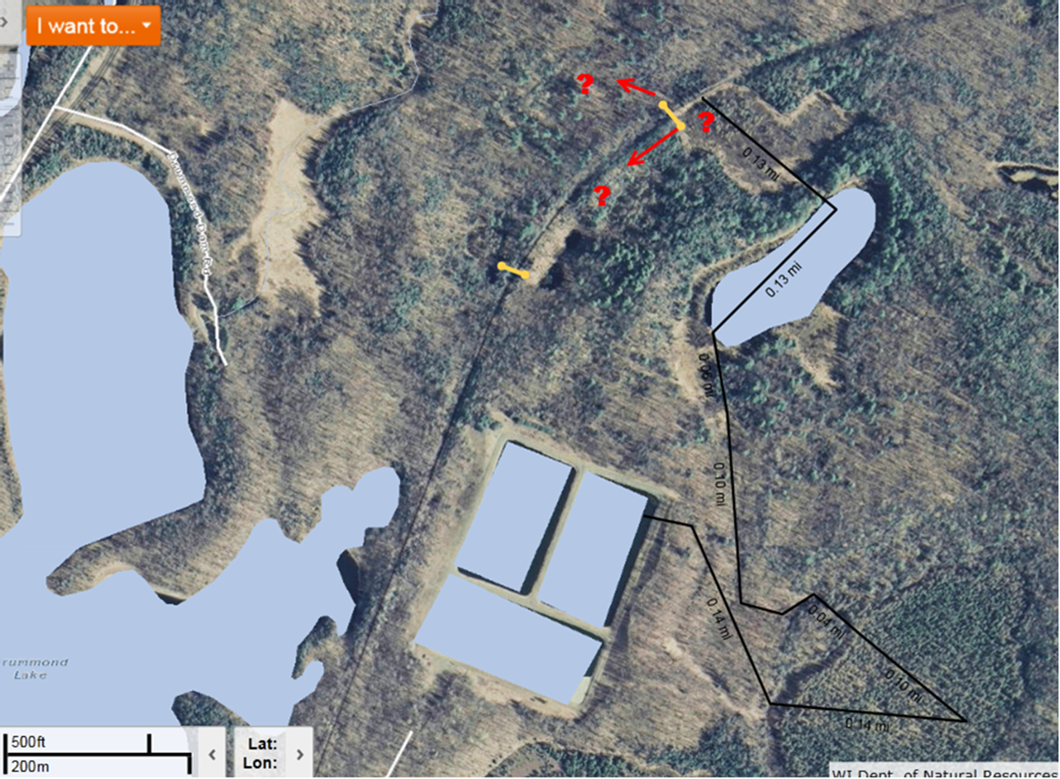
Long Lake Branch
Drummond Lake
Perforated pipe in bog
Weir at bog outlet
Bog area
Pipe to bog
“Weso Lake” WBIC 2798600
Wetland/stream

Discussion:
Note: Recommendations from this site visit are shown at the top of this memo.
- There is a lot of information on this site and photo documentation from email chains between Craig Roesler (former stream biologist) and Lonn Franson (former compliance engineer), and Eric DeVenecia (current compliance engineer) and others, from 2015. Additional work was done by Craig Roesler before that time. From that documentation:
  - Before the treatment system was built, a lot of work was done to evaluate the site & potential impacts. They installed a perforated pipe into a bog system so that the effluent would be diffused into the bog. Water exits the bog through a weir, then flows into a small unnamed lake referred to as Weso Lake (in some documentation, incorrectly called Wesco Lake). From previous visits it appears the flow probably doesn’t reach another waterbody.
  - Because it’s a perforated pipe into the wetland, the diffuse discharge does not form a channel. The bog is a type of wetland and is appropriately considered LAL.
  - The wooded area between the weir and Weso Lake is a wetland area with ephemeral overland flow. LAL is also appropriate for this area.
  - Weso Lake is appropriately considered a warmwater lake. At 4.1 acres, it is considered a small lake.

- Current facility info:
  - Annual average design flow is 40,000 gal/day, and it has most recently operated as fill and draw. The actual average effluent flow rate being diffusely discharged to the wetland/bog over the last 5 years is 11,000 gal/day.
  - They have a monitoring requirement but no limits for phosphorus, because the lake is smaller than 5 acres so phosphorus criteria don’t apply.

- Recommendation: No site visit needed for permit reissuance due to the existing documentation discussed above. We recommend that permit limits continue to be based on LAL for the bog and the wetland/ephemeral overland flow after the weir, and then apply downstream protection for Weso Lake (warmwater).
  - Although this site is not listed as LAL in the current ch. NR 104, wetlands are clearly stated to be considered LAL per ch. NR 104.02(3)(b)1., which states that the Limited Aquatic Life subcategory “shall be applied to all surface waters classified as effluent channel, wetland or diffuse surface water.”
  - This site should be considered for addition to ch. NR 104 as LAL during a future code revision (unless it is determined that wetland sites don’t need to be listed individually in code because of the previously cited language stating that all wetlands are LAL).

- Note: Craig Roessler’s 2013 email with water quality data showed very high total phosphorus concentrations at the weir & in lake. However, because phosphorus criteria don’t apply to the lake or wetlands, we would not likely evaluate this against phosphorus criteria for assessment purposes.

Photos – next page

Photos (all photos are from Eric DeVenecia, taken 9-27-2012)

Photo 1: Sign that was installed to explain the discharge scenario (also shows location of the weir/gauging station).

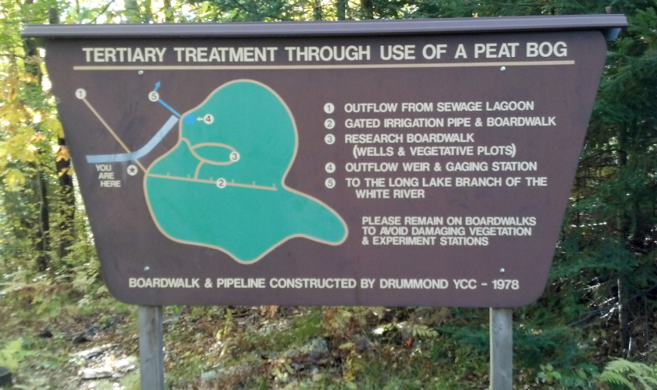

Photo 2: Perforated pipe through bog. Note that land is dry; no channel.

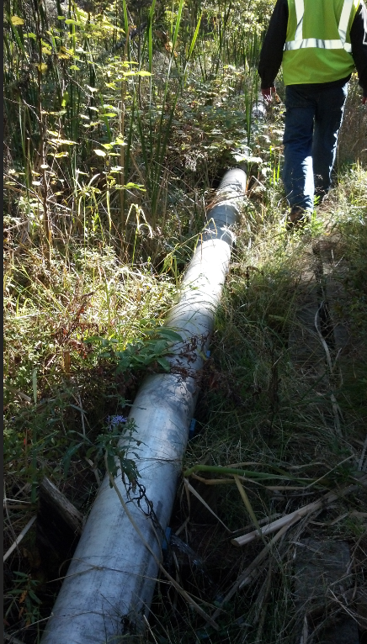
Photo 3: Photo of weir/gauging station installed to monitor flow out of the wetland/peat bog. Weir is typically either dry or with just a trickle of water.
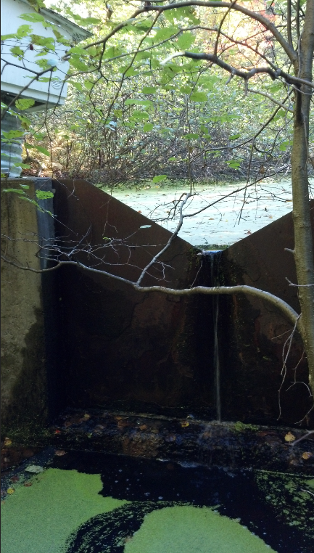

Photo 4: Photos of Weso Lake.
