Follow-up Assessment of

Water Quality

In

The Lower Oconto River Watershed

2013

Oconto, Menominee and Shawano Counties, Wisconsin

Project 2013 NER_05_CMP14-Year 2

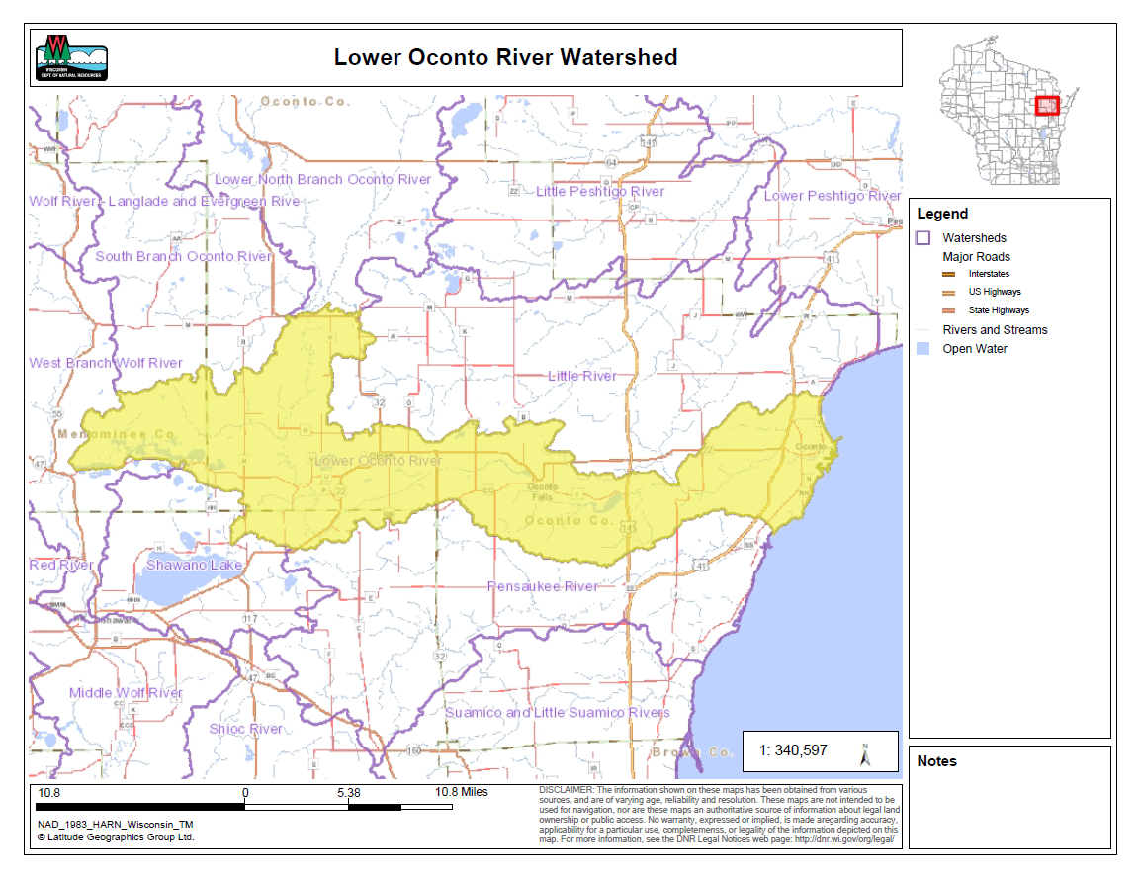

By Andrew Hudak
Water Quality Biologist – Water District East
March, 2014
Lower Oconto River Watershed Follow-Up Monitoring Report

By Andrew Hudak

Introduction

The Lower Oconto River Watershed is a 196 square miles that lies in central Oconto County with small portions of the watershed extending into northern Shawano and eastern Menominee counties. The communities of Oconto. Oconto Falls, Gillett and Suring lie within the watershed. Streams within the watershed range from those that are intermittent to perennial named streams. Natural community model classifications of these streams are variable. The streams sampled are mostly classified as cool-warm and cool-cold transitional headwater streams that flow into the main branch of the Oconto River which is classified as a warm water river. Three hydroelectric dams operate in this watershed along the Oconto River. The Wisconsin Electric Power Company and Scott Paper Company dams at Oconto Falls operate with run-of-river flows. The Oconto Electric cooperative dam at Stiles operates as a modified peaking operation.

Land use in the watershed is primarily agricultural (36.06%), forest (32.05%) and a mix of wetland (22.90%) and other uses (8.98%). Agriculture consists of a mixture of dairying and cash cropping. Three concentrated animal feeding operations (CAFOs) operate within the watershed. The main cultivation and agricultural areas occur between Hwy 41 in Oconto and Hwy 141 in Stiles and generally west of Oconto Falls to the town of Underhill. Permitted public wastewater treatment facilities are located in Oconto, Oconto Falls, Gillette and Suring and discharge to the Oconto River. Other permitted point source dischargers include Seneca Foods Corporation in Gillette and ST Paper LLC in Oconto Falls. The Lower Oconto River played an important role in the lumbering history of Wisconsin. Suring was at the epicenter located at the convergence of the North Branch of the Oconto, the South Branch of the Oconto, and Peshtigo Brook. Historic log drives occurred annually in spring from Suring to sawmills in Oconto. Intensive forestry activities occur in the 3,100 acres of Oconto County forests within the watershed along the Machickanee Flowage and on smaller private tracts throughout the watershed. Approximately 685 acres of forestland are enrolled in the Managed Forest Law program in the watershed that are open to public recreation and there are many more acres enrolled in the closed program.

There are 314 stream miles in the watershed with 108 miles of named streams. There are 61.5 miles of classified trout waters in the watershed of which 17.4 are Class I, 10.2 are Class II, and 12.7 are Class III trout streams. The 35.3 miles of the main branch of the Oconto River that flows through the watershed can be considered a warm water sport fishery consisting of smallmouth bass, largemouth bass, walleye, northern pike panfish, carp, and great lakes salmon and trout. Annual runs of walleye, white suckers, and great lakes salmon and trout occur in the lower section of the river up to the dam at Stiles. Lake Sturgeon, from the great lakes, have also been documented spawning or attempting to spawn below the dam at Stiles. The majority of remaining named stream miles in the watershed are likely considered “cool water transition” waters, that is, they have summer temperatures that are suitable for both warm and cool water species. There are almost 200 miles of small perennial and intermittent unnamed streams located throughout the watershed.

The lower segment of the Oconto River up to the Stiles dam and the Machickanee impoundment are the only impaired waters on the state’s 303(d) list of impaired waters. Both have elevated levels of atmospheric deposition of mercury and contaminated sediments from the Scott Papermill and pulp factory located on the river in Oconto Falls. There are 17.4 miles of streams on the state’s Exceptional Resource Waters (ERW) list because of their importance as a Class I natural reproducing, self-sustaining trout stream. They include Brehmer Creek and two of its unnamed tributaries, Coopman Creek, Dump Creek, and a segment of Linzy Creek.

An original assessment was completed to gather current biological and physical data on streams in the Lower Oconto River Watershed in 2012 for the purposes of determining current water quality conditions of the Oconto River and various other streams in the watershed. The assessments focused on the current physical habitat conditions and the biological communities present to help aid in making management decisions and identify potential streams that may need additional monitoring to evaluate impairment status. Follow-up monitoring was proposed at 5 sites in 2013 where degraded biological conditions were suspected based on surveys conducted in 2012.

Methods
Water quality monitoring was conducted at 31 wadeable sites throughout the watershed in the spring, summer, and fall of 2012. Following initial monitoring and evaluation of the biological and habitat data collected, 5 sites within the Lower Oconto River Water were selected to conduct confirmation sampling of degraded biological conditions. (Table 1). During each field visit, basic water quality parameters including air temperature, water temperature, conductivity, dissolved oxygen, dissolved oxygen percent, pH, flow, and water clarity were collected. No nutrient sampling or other water chemistry sampling was completed at this time.

Site Selection – Sites were selected where the fish index of biotic integrity was poor or a low fair when the correct IBI was applied for that streams’ s natural community. At that time, natural community verification was in its infancy so it was not known, but may have been suspected that the natural community model for the streams selected or ones that were not selected, were entirely accurate.

Fish Surveys- Fish surveys were completed through the identified sample station and was replicated as close as possible to the sample station from 2012. A direct current electrofishing backpack shocker or tow behind stream shocker was used to collect all fish possible through an upstream pass through the sample station. Typically the back pack units were used on streams up to 3 meters with a single probe and the stream shockers were used with a generator and 2 probes on the remainder of sites over 3 meters. All fish were collected, identified, and counted. All gamefish were measured. All other WDNR sampling protocols were used to assess the fish community for purposes of calculating the index of biotic integrity.

Macroinvertabrate Sampling- A second year of Macroinvertebrate samples were obtained by kick sampling a collection using a D-frame net at the 5 sites in the watershed in fall. At the time of follow-up site selection, it was not known the scores and rating of the initial Macroinvertabrate index of biotic integrity. The second year of samples was sent to the University of Wisconsin-Stevens Point for taxonomic classification, analysis, and computation of a Macroinvertabrate (M-IBI).

Table 1: Follow-up site survey locations in the Lower Oconto River Watershed

Waterbody | WBIC | Location | Order
UN Trib to Oconto River | 441100 | Downstream CTH J | 2
Coopman Creek | 449000 | Downstream of Road CCC | 2
UN Trib to Oconto River | 449600 | Downstream of Hwy 22 | 1
UN Trib to Oconto River | 449700 | Upstream of Gray Lake Road | 1
UN Trib to Newton Lake | 450500 | Downstream of Hwy 32 | 1
UN Trib to Oconto River | 5010405 | Upstream of S Knapp Street | 2

SUMMARY RESULTS DISCUSSION

Results for the fisheries surveys are summarized in Table 2 and 3. The natural communities model (Lyons, 2008) indicates that 4 out of the 5 streams sampled for follow-up conditions are cool headwaters and thus the cool water Index of Biotic Integrity was applied. (Lyons 2009) Based on the natural community verification draft guidance, the Unnamed Tributary to Newton Lake is likely miss-classified. Continuous temperature readings during 2012 can also confirm that this stream should be classified as a Coldwater stream and not a cool-warm headwater.

Macroinvertabrate samples were collected at all sites and evaluated with the Hilsenhoff Biotic indices (HBI, Hilsenhoff, 1987), Family level Biotic Indices (FBI, Hilsenhoff 1988) and the Macroinvertebrate index of biotic integrity (MIBI, Weigel, 2003). Results varied throughout the streams sampled and rating were poor to good. (See Table 4 and 5)

DISCUSSION

The evaluation of biological stream conditions in subsequent years provided the needed information necessary to make management and listing recommendations for the State’s 303(d) list of impaired waters.

Unnamed Tributary to the Oconto River- Hwy J
The Unnamed tributary to the Oconto River should be a candidate for listing on the state’s 303(d) list of impaired waters with pollutant unknown. Monthly total phosphorous samples could be collected in the future to identify if Total Phosphorous concentrations exceed the standards established for streams at 0.075 mg/l. Two years of biological data collection has indicated that the fish community is dominated by tolerant species that when applied to the cool-warm IBI yield a poor or fairly poor fish community assemblage. The Macroinvertabrate IBI has also confirmed that the benthic community is comprised of tolerant taxa that are able to sustain organic pollution and degraded habitat. Although habitat scores for this stream segment scored at fair to good, the watershed is highly dominated by agriculture and upstream impacts are likely limiting this waterways attainable use. This stream will benefit from maintaining or re-establishing riparian buffers where applicable and eliminating livestock access to the streams. Barnyard and nutrient management should be a high priority to prevent excess sediment and nutrients from entering the tributary and making their way downstream to the Oconto River.

Coopman Creek CTH CCC
Coopman Creek at CTH CCC is listed as Class 1 trout waters according to the 1987 trout book. Although no trout were sampled, the segment of stream below CTH CCC is the beginning headwaters and springs to the lower segments of Coopman Creek where a healthy trout population was sampled. The current condition of the stream at this location is fair to good based on both fish IBI and Macroinvertabrate IBI scores. Upstream of CTH CCC is likely intermittent based on 2012 and 2013 survey notes but a spring originates approximately 150 meters downstream from CTH CCC The downstream segments are rated as both excellent for fish and Macroinvertabrate scores. Although stream conditions appeared to be impacted by the intermittent nature of the stream at this location, the natural community is likely accurate and biological conditions observed in the stream do not warrant impairment listing on the state’s 303(d) list of impaired waters. Coopman Creek is a unique resource with excellent water quality. Maintain buffers along agricultural fields in the upper watershed, managing application of manure and nutrients, and ensuring impacts to cold-water springs downstream of CTH CCC are vital to maintaining this resource.

Unnamed Tributary to the Oconto River- STH 22
The Unnamed tributary to the Oconto River should be a candidate for listing on the state’s 303(d) list of impaired waters with pollutant unknown. Monthly total phosphorous samples could be collected in the future to identify if Total Phosphorous concentrations exceed the standards established for streams at 0.075 mg/l. Two years of biological data collection has indicated that the fish community is dominated by tolerant species that when applied to the cool-warm IBI yield a poor or fairly poor fish community assemblage. There was a significant alteration to the crossing during the summer of 2012 following the fish survey. A large open bottom box culvert was replaced and following construction a large plunge pool was present during the 2013 sample events. This pool was not existent in 2012 and may have biased the number of individuals and species surveyed in 2013. The Macroinvertabrate IBI has also confirmed a poor benthic biological community comprised of tolerant taxa that are able to sustain organic pollution and degraded habitat. Habitat scores for this stream segment rated fair, the watershed is highly dominated by agriculture and low flow conditions likely limit this waterways attainable use. This stream will benefit from maintaining or re-establishing riparian buffers where applicable and ensuring nutrient management is practices on adjacent agricultural fields.

Unnamed Tributary to Newton Lake- STH 22
The Unnamed tributary to Newton Lake was modeled as a cool-warm headwater stream. Continuous temperature readings in 2012 combined with the fish community sampled, indicate this stream is conducive to support a cool-cold to cold water fish community. Two years of biological sampling have indicated this stream displays good water quality and should not be considered impaired. When applying the cool-cold headwater IBI, the ratings indicate an excellent fish community with the intolerant Mottled Sculpin as the most abundant species. Although daily summer average temperatures could identify this stream as a coldwater system, the fish community observed in 2012 and 2013 likely indicates a cool-cold headwater would be the most appropriate natural community type. This stream also showed adverse impacts from the reconstruction of STH 22 during 2012. In 2013, a plunge pool below a tributary culvert was filled with large riprap and a large natural pool that existed approximately 20m before the end of the station had silted in from sediment laden runoff from the construction project. Even with the alteration noted above, the habitat rating of Good would not have been impacted. The Macroinvertabrate IBI has confirmed a good benthic biological community in 2012 but only indicated a fair community during 2013. The watershed of this stream is dominated by agriculture upstream of STH 22 but natural downstream. This stream will benefit from maintaining adequate buffers upstream and preventing further sedimentation into stream.

Unnamed Tributary to the Oconto River- Knapp Road
The Unnamed tributary to the Oconto River is a small, likely intermittent stream. Monthly total phosphorous samples could be collected in the future to identify if Total Phosphorous concentrations exceed the standards established for streams at 0.075 mg/l however Macroinvertabrate IBI’s did not indicate that a degraded community is present. Two years of biological data collection has indicated that the fish community is dominated by tolerant species that when applied to the cool-warm IBI yield a poor community assemblage however this is based on an inadequate number of indivuals sampled. The habitat was rated as fair, however the upper portions of this stream flow through agricultural dominated land use with a tight cluster of center pivot irrigation. Currently it is not recommended that this stream be listed on the state’s 303(d) list of impaired waterways but future surveys may be warranted to examine nutrient concentrations, and fish IBI metrics. One young of the year Brown Trout was sampled in this stream during 2012 so it may be likely this stream could support cold water species; however groundwater contributions to this stream may be experiencing alterations from center pivot irrigation causing low flow conditions throughout the summertime growing season.

Table 2. Fisheries Surveys and Index of Biotic Integrity Scores in the Lower Oconto River Watershed 2012 and 2013

2013  Stream - Site | UNT Oconto River | DS CTH J | Coopman Creek | DS CTHCCC | UNT to Oconto River | DS STH 22 | UNT Newton Lake | STH 22/32 | UNT to Oconto River | US Knapp Rd
Stream Order | 2 |  | 2 |  | 1 |  | 1 |  | 3
Mean Stream Width | 1.5 |  | 2.5 |  | 1.2 |  | 3 |  | 2.7
Station Length | 100 |  | 100 |  | 100 |  | 240 |  | 100
Nat. Comm. Classification | CWHW |  | CCHW |  | WHW |  | CWHW |  | CWHW
Fish Species
Blacknose Dace |  |  | 18
Blacknose Shiner |  |  |  |  | 3
Bluegill |  |  |  |  | 1
Bluntnose Minnow | 5
Brook Stickleback |  |  | 3 |  | 18 |  | 1 |  | 3
Central Mudminnow | 5 |  |  |  | 70 |  | 1 |  | 8
Common Shiner | 496
Creek Chub | 8 |  | 7 |  | 1 |  | 1
Emerald Shiner | 105
Fathead Minnow |  |  |  |  | 2 |  |  |  | 1
Golden Shiner | 2
Hornyhead Chub | 91
Mottled Sculpin |  |  |  |  |  |  | 28
Northern Redbelly Dace |  |  | 4 |  |  |  |  |  | 1
Pearl Dace |  |  | 9
White Sucker | 10 |  | 15
Yellow Perch | 97
Total # Fish Sampled | 819 |  | 56 |  | 95 |  | 31 |  | 13
Total # Species | 9 |  | 6 |  | 6 |  | 4 |  | 4
IBI Score
Coldwater | - |  | - |  | - |  | F |  | -
Coolwater (CC) | - |  | - |  | - |  | - |  | -
Coolwater (CW) | F |  | F |  | - |  | G |  | P
Warmwater | - |  | - |  | F |  | - |  | -
Small Stream | - |  | - |  | - |  | - |  | -

2012  Stream - Site | UNT to Oconto River | DS CTH J | Coopman Creek | DS CTHCCC | UNT to Oconto River | DS STH 22 | UNT Newton Lake | STH 22/32 | UNT to Oconto River | US Knapp Rd
Stream Order | 2 |  | 2 |  | 1 |  | 1 |  | 3
Mean Stream Width | 1.5 |  | 2.5 |  | 1.2 |  | 3 |  | 2.7
Station Length | 100 |  | 100 |  | 100 |  | 110 |  | 100
Nat. Comm. Classification | CWHW |  | CCHW |  | WHW |  | CWHW |  | CCHW
Fish Species
Black Bullhead | 1
Blacknose Dace |  |  | 30
Bluegill | 2 |  |  |  | 1
Bluntnose Minnow |  |  |  |  |  |  | 6
Brook Stickleback |  |  | 68 |  | 1 |  | 26 |  | 12
Brown Trout |  |  |  |  |  |  |  |  | 1
Central Mudminnow | 111 |  | 1 |  | 13 |  | 7 |  | 1
Common Shiner | 1 |  |  |  |  |  | 2
Creek Chub | 23 |  | 18 |  |  |  |  |  | 1
Fathead Minnow | 6 |  | 1
Mottled Sculpin |  |  |  |  |  |  | 13
Northern Redbelly Dace |  |  |  |  |  |  | 2
Pearl Dace |  |  | 24
White Sucker |  |  | 4
Total # Fish Sampled | 144 |  | 146 |  | 15 |  | 56 |  | 15
Total # Species | 6 |  | 7 |  | 3 |  | 6 |  | 4
IBI Score
Coldwater | - |  | - |  | - |  | - |  | -
Coolwater (CC) | - |  | G |  | - |  | E |  | -
Coolwater (CW) | VP |  | - |  | - |  | G |  | VP
Warmwater | - |  | - |  | P |  | - |  | -
Small Stream | - |  | - |  | - |  | - |  | -

CW= Cool-Warm E= Excellent
CC= Cool-Cold G= Good
W- Warmwater F= Fair
C= Coldwater P= Poor
VP= Very Poor
Red value represents verified natural community score.

Table 4. Macroinvertabrate Ratings in the Lower Oconto Watershed 2012 and 2013

2012  Stream - Site | UNT to Oconto River | DS CTH J | Coopman C reek | DS CTH CCC | UNT Oconto River | DS STH 22 | UNT Newton Lake | STH 22/32 | UNT to Oconto River | US Knapp Road
Stream Order | 2 |  | 2 |  | 1 |  | 1 |  | 1
Mean Stream Width | 1.5 |  | 2.5 |  | 1.2 |  | 3 |  | 1
Station Length | 100 |  | 100 |  | 100 |  | 110 |  | 100
Nat. Comm. Classification | CWHW |  | CCHW |  | WHW |  | WHW |  | CWHW
HBI Rating ¹ | P |  | F |  | VP |  | VG |  | VG
HBI Score ¹ | 7.48 |  | 5.82 |  | 9.42 |  | 4.07 |  | 4.09
FBI Rating ¹ | P |  | FP |  | P |  | G |  | G
FBI Score ¹ | 7.02 |  | 6.07 |  | 6.87 |  | 4.29 |  | 4.30
MIBI Rating ² | P |  | F |  | P |  | G |  | G
MIBI Score ² | 1.99 |  | 4.77 |  | 2.34 |  | 6.06 |  | 6.33
2013  Stream - Site | UNT to Oconto River | DS CTH J | Coopman C reek | DS CTH CCC | UNT Oconto River | DS STH 22 | UNT Newton Lake | STH 22/32 | UNT to Oconto River | US Knapp Road
Stream Order | 2 |  | 2 |  | 1 |  | 1 |  | 1
Mean Stream Width | 1.5 |  | 2.5 |  | 1.2 |  | 3 |  | 1
Station Length | 100 |  | 100 |  | 100 |  | 110 |  | 100
Nat. Comm. Classification | CWHW |  | CCHW |  | WHW |  | WHW |  | CWHW
HBI Rating ¹ | P |  | F |  | G |  | VG |  | VG
HBI Score ¹ | 8.00 |  | 6.01 |  | 4.87 |  | 3.97 |  | 4.48
FBI Rating ¹ | P |  | FP |  | G |  | G |  | G
FBI Score ¹ | 7.43 |  | 5.94 |  | 4.85 |  | 4.46 |  | 4.49
MIBI Rating ² | P |  | F |  | P |  | F |  | F
MIBI Score ² | 2.01 |  | 3.51 |  | 2.10 |  | 3.15 |  | 3.38
- E= Excellent (0-3.5)
VG= Very Good (3.51-4.50)
G= Good (4.51-5.50)
F= Fair (5.51-6.50)
F= Fairly Poor (6.51-7.50)
P= Poor (7.51-8.50)
VP= Very Poor (8.51-10)

- E= Excellent (7.5-10)
G= Good (5.0- 7.49)
F= Fair (2.51- 4.99)
P= Poor (0- 2.5)

