**LNRP Newsletter: Summer 2015**

**Friends of the Manitowoc River Watershed**

Committed to connecting people in the region to the Manitowoc River, the Friends of the Manitowoc River Watershed (FMRW) have accomplished a lot since inception. Over the last couple of years, the group has brought in many new and old volunteers from the community to steward the Manitowoc River and Lake Michigan beaches by both cleaning up trash and enjoying relaxing paddles on the river.

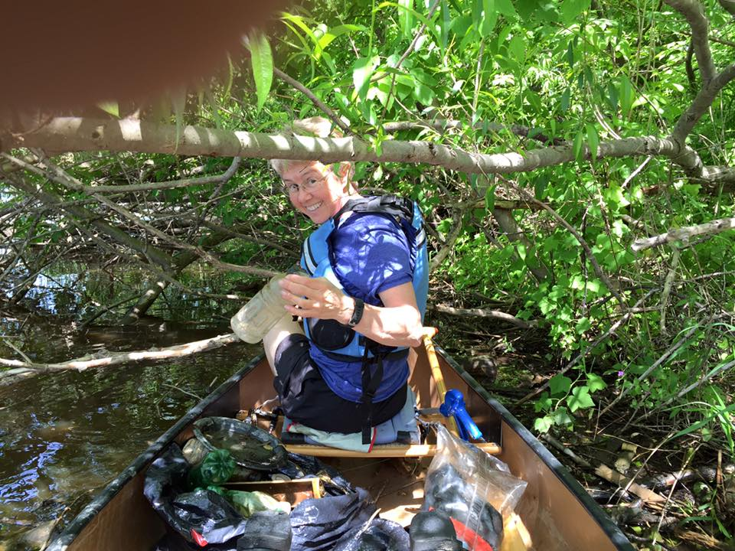With the group’s efforts, stewardship continues to become stronger in Manitowoc County. The Wisconsin Maritime Museum once again offered its popular annual Watershed Ambassadors Camp for kids under 18, where campers learn awareness of the outdoors and appreciation of the natural resources that surround them. This priceless week of enriching experiences hopes to raise leaders who will continue to mentor and teach stewardship to their peers over their lifetime.

The Manitowoc River Guide pamphlets continue providing a great way to educate and share the history and stories of the river (a perfect addition for a paddle in a kayak or canoe). If you have not seen these wonderful resources, please check them out here (<http://lnrp.org/friends-of-the-manitowoc-river-watershed/>).

The group also hopes to complete installation of the new kayak launch at Schuette Park by late summer. Please stay tuned for the official opening.

Upcoming FMRW events include the annual fall beach clean-up on September 19th and a seminar on groundwater at the Wisconsin Maritime Museum, October 14th. Two rain barrels will be offered as raffle prizes at the October groundwater seminar. Contact [fmrwinfo@gmail.com](mailto:fmrwinfo@gmail.com) for more information.

The group strongly encourages you to share YOUR stories about your experiences in the watershed. These interesting stories are a great help in seeking grant funding and sponsorships to help improve your experiences on or along the river. Become a volunteer, a member, and a steward today!