**Here is from the Natural Community Analysis Tool:**

|  |  |  |  |  |  |  |  |
| --- | --- | --- | --- | --- | --- | --- | --- |
| Request Date | Request Type | Original Modeled Natural Community | Natural Community | Station Seq | Station Name | Request Status | Reviewer Name |
| 09/06/2007 | Modeled NC Correct | COOL-COLD HEADWATER | COOL-COLD HEADWATER | 51200- 10016917 | Apple Br. - Alt. Site #19 - Hwy 81 Bridge downstream Side | M-NC Confirmed | Fish DB NC Review |
| 08/19/2014 | Modeled NC Valid (Tolerance) | COOL-COLD HEADWATER | COOL-COLD HEADWATER | 51200-10016917 | Apple Br. - Alt. Site #19 - Hwy 81 Bridge downstream Side | M-NC Confirmed | Fish DB NC Review |
|  |  |  |  |  |  |  |  |
| 08/19/2014 | Modeled NC Not Verified (No Alt) | COOL-COLD HEADWATER | COOL-COLD HEADWATER | 101972682-10042621 | Apple Branch at Private drive off Apple Br Rd | NC Change Needs Review |  |
| 09/13/2007 | Modeled NC Not Verified (No Alt) | COOL-COLD HEADWATER | COOL-COLD HEADWATER | 19728090-10021935 | Apple Branch At Nall Road Bridge | NC Change Needs Review |  |
| 09/09/2008 | Modeled NC Not Verified (Alt < 9) | COOL-COLD HEADWATER | COOL-COLD HEADWATER | 26007638-10029230 | Apple Branch first riffle upstream of Spore Road | NC Change Needs Review |  |
|  |  |  |  |  |  |  |  |
| 08/19/2014 | Modeled NC Not Verified (Alt 9 of 9) | COLDWATER | COOL-COLD HEADWATER | 50889-10016606 | Apple Br. - Spore Rd. | NC Change Approved | AMRHEIN, JAMES |
| 09/09/2008 | Modeled NC Not Verified (Alt < 9) | COLDWATER | COOL-COLD HEADWATER | 50889-10016606 | Apple Br. - Spore Rd. | NC Change Approved | AMRHEIN, JAMES |
| 08/08/2013 | Modeled NC Not Verified (Alt < 9) | COOL-COLD HEADWATER | COOL-COLD HEADWATER | 50195 | Apple River - 45 M Upstream Of Bridge At Second bridge Upstrm Of Mouth At Cth W | NC Change Needs Review |  |

|  |  |  |
| --- | --- | --- |
| Database Key | Station ID | Station Name |
| 51200 | 10016917 | Apple Br. - Alt. Site #19 - Hwy 81 Bridge downstream Side |
| 51056 | 10016773 | Apple Br. - Apple Grove Ch Rd. |
| 101972682 | 10042621 | Apple Branch at Private drive off Apple Br Rd |
| 19728090 | 10021935 | Apple Branch At Nall Road Bridge |
| 26007638 | 10029230 | Apple Branch first riffle upstream of Spore Road |
| 50889 | 10016606 | Apple Br. - Spore Rd. |
| 5456 | 333217 | Apple Branch - Nall Rd. Sec. 32 |

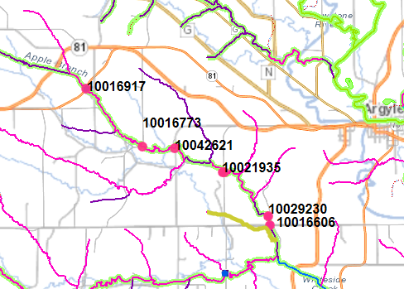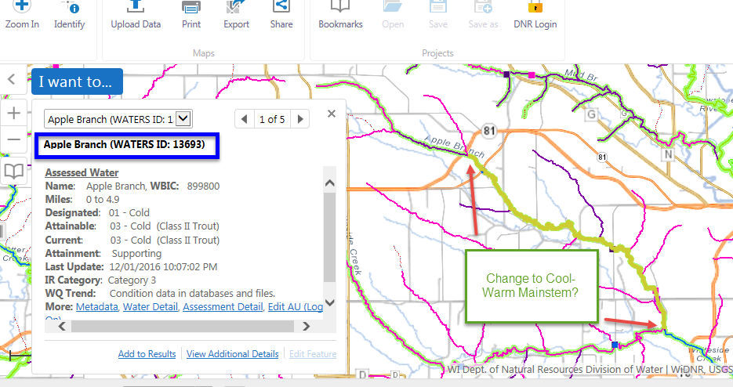

**From:** Amrhein, James F - DNR   
**Sent:** Friday, March 10, 2017 1:25 PM  
**To:** Helmuth, Lisa D - DNR  
**Cc:** Dickmann, Jacob C - DNR  
**Subject:** RE: change in NC from 2016 data and NC model output

This is a toughy.

The upper sites (10016917; 10042621) were confirmed cool-cold.

The middle site (10021935) is a tweener, it has too many cold numbers to be cool-warm, but too many warm numbers to be cool-cold.  I usually default to the model in that case.

Same for sites 10029230 and 10015506.  They are definitely not cold, but don’t fit to well in either cool-cold or cool-warm (except for 2014 sample).

The one confounding thing about this data is that the 2008 dataset is abnormal in that those were wet years and we had an inordinate amount of northern pike coming up from the Pecatonica and skewing the fish numbers.  The one thing that is consistent is that we find decent numbers of mottled sculpin (a coldwater indicator species) at all sites and in decent numbers.

Therefore, I hesitate to deviate too far from cool-cold.

So, I would say we **leave this section as cool-cold**.

**We are committed to service excellence.**

Visit our survey at <http://dnr.wi.gov/customersurvey> to evaluate how I did.

Jim Amrhein

Phone: 608-275-3280

[James.amrhein@wisconsin.gov](mailto:James.amrhein@wisconsin.gov)