A 2018 Assessment

of the

Sawmill Creek (and Erickson Creek) Watershed

HUC 12 (070900030801)

In fulfillment of Water Resources Targeted Watershed Assessment Project

South_TWA_1_2018

Green and Lafayette Counties

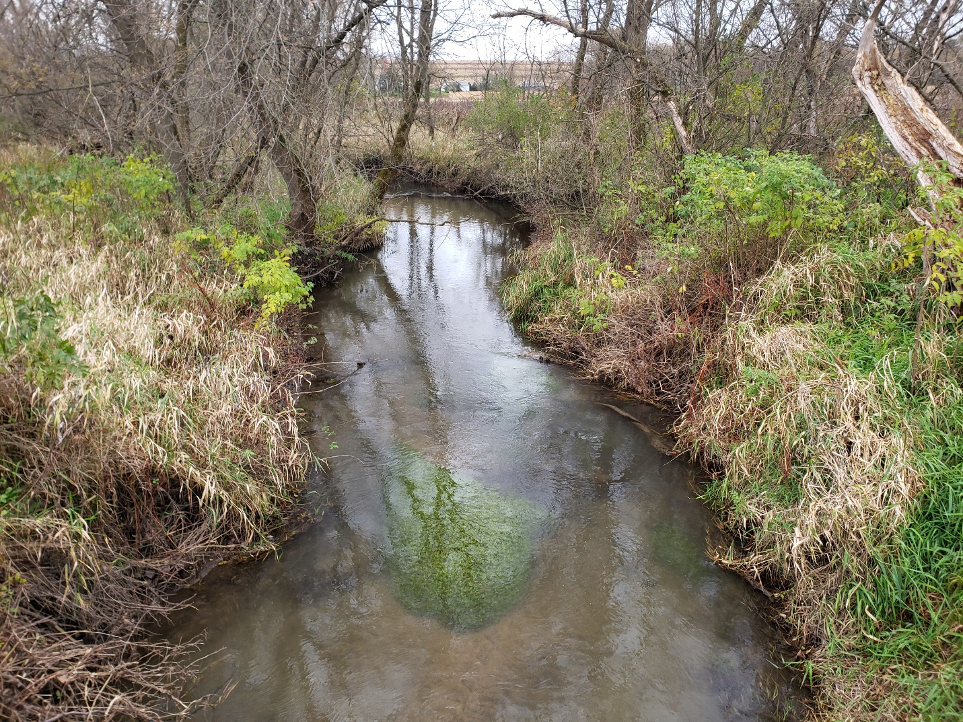

Erickson Creek looking downstream from Gould Hill Road

By James Amrhein

Water Quality Biologist, South District

January, 2020

Sawmill and Erickson Creeks are two trout streams that have their origin northwest Green County, west of Postville. They flow southwest toward Lafayette County. Erickson Creek joins Sawmill Creek at the Green/Lafayette County line and Sawmill Creek then flows another 2.5 miles into Lafayette County where it has its confluence with the East Branch Pecatonica River 3 miles south of Blanchardville. The Sawmill Creek HUC (Hydrologic Unit Code) 12 subwatershed is part of the larger Lower East Branch Pecatonica HUC 10 watershed (Figure 1). The Sawmill subwatershed comprises 14, 676 acres, with the Erickson Creek watershed making up a 4,464 acre subset of that area.

The lower 8.7 miles of the 12-mile-long Sawmill Creek are designated as Class II trout water. Likewise, Erickson Creek is 5.74 miles long and is also a Class II trout water for its entirety.

The Lower East Branch Pecatonica Watershed was part of a priority watershed project from 1991 to 2001 (WDNR, 1992). As such, certain conservation practices were enacted in the watershed through the help of grants. It is uncertain how many of these practices were put in place in the Sawmill Creek subwatershed or how many are still in place. Streambank rip-rapping was a popular bank stabilization practice and evidence of that can still be seen on the 2 streams today. Several properties had fish habitat improvement structures, specifically Little Underwater Neighborhood Keepers Encompassing Rheotactic Salmonids, or LUNKERS structures, incorporated into the stream banks.

In recent years, there has been interest from a local watershed group and landowners to improve water quality for the streams. Concurrently, department fisheries staff have interest in obtaining fishing easements along both waterbodies. Because of this, water resource biologists wanted to conduct monitoring on both systems to determine contemporary conditions of the streams and watershed, and to gather data to use as a baseline for future management decisions and actions.

**Figure 1**: Sawmill and Erickson Creeks Watershed

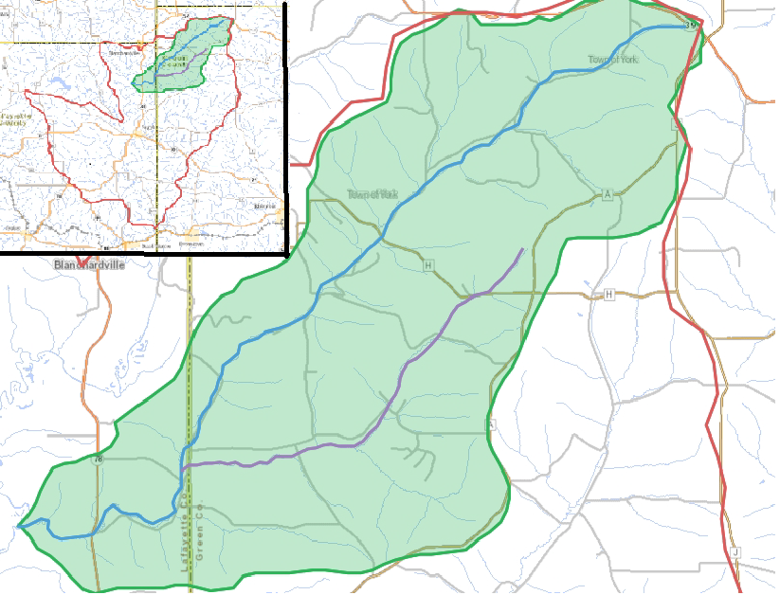

Sawmill Creek in blue; Erickson Creek in purple

Methods

In 2018, the department surveyed 21 sites in the watershed. Twelve sites were surveyed on Sawmill Creek, 7 on Erickson Creek and 1 each on 2 unnamed tributaries. For all sites, the fisheries assemblage was determined by electroshocking a section of stream with a minimum station length of 35 times the mean stream width (Lyons, 1992). A stream tow barge with a generator and two probes was used at most sites. A backpack shocker with a single probe was used at sites generally less than 2 meters wide. All fish were collected, identified, and counted. All gamefish were measured for length. At each site, qualitative notes on average stream width and depth, riparian buffers and land use, evidence of sedimentation, fish cover and potential management options were also recorded. Qualitative habitat surveys were conducted at each site according to Simonson, et. al. (1994). Macroinvertebrate samples were obtained at 9 sites by kick sampling and collecting using a D-frame net in fall, 2018 and sent to the University of Wisconsin-Stevens Point for analysis.

Water chemistry sampling was conducted by volunteers on both streams at Gould Hill Road. Grab water samples were taken monthly from May through October in 2017 and 2018. The samples were analyzed for total phosphorus.

Results

Brown trout and mottled sculpin were the most predominant species found in the watershed (Table 1). Mottled sculpin were found at all sites sampled, and brown trout found at all but 3 sites. White suckers were another common species. Eight other transitional or warmwater species were also encountered in the surveys, but in low numbers. Rainbow trout, another coldwater species, were found at several sites, mostly in low numbers. Most sections of these streams were purported to be either coldwater or cold-transitional according to the Wisconsin streams model (Lyons, 2008). The natural community verification process (WDNR, 2019a) showed all but one of the sites to be cold according to the species assemblage. As such, the coldwater index of biotic integrity (IBI) (Lyons, et. al., 1996) was applied to those data. The cold IBIs were consistently between 40 and 60, or “fair”. Overall, scores ranged from 20 (poor) to 70 (good).

Total qualitative habitat scores (Table 2) varied widely ranging from 15 (Poor) to 80 (Excellent), but many fell in the “good” range. Except for riparian buffer width which was consistently excellent, the other metrics varied from site to site. There was generally a lack of pools and sedimentation was moderate to high at the majority of sites.

Total phosphorus samples that were collected on each stream on a monthly basis during the growing seasons of 2017 and 2018 showed a wide range of concentrations (Table 3). The median concentration is compared to the state phosphorus standard of 0.075 mg/L. Sawmill Creek saw phosphorus concentrations range from 0.05 to 0.34 mg/L. The median was below the state standard. Erickson Creek’s phosphorus concentrations ranged from 0.06 to 2.86 mg/L with a median value of 0.081 mg/L which is above the standard.

Historically the macroinvertebrate index of biotic integrity (MIBI) (Weigel, 2003) ranged from 4 to 6 (Fair to Good) in both systems (WDNR, unpublished data). The 2018 data (Table 4) was very similar except for the very headwaters of Sawmill Creek and an unnamed tributary (WBIC=906100) which had “excellent” IBIs. The Hilsenhoff Biotic Index (HBI) (Hilsenhoff, 1987) ranged from 2.13 (Excellent) to 5.26 (Good) indicating no to some organic pollution.

**Table 1:** Fish Assemblage, Natural Community, and IBI for streams in the Sawmill Creek Subwatershed – 2018



**Table 2:** Qualitative Habitat Assessment of Streams in the Sawmill Creek subwatershed – 2018

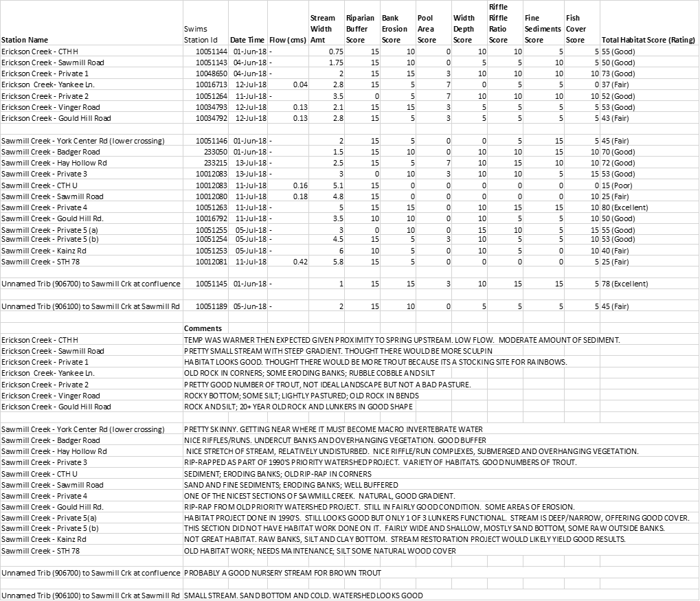

**Table 3**: Total Phosphorus for Growing Season 2017 and 2018 Erickson and Sawmill Creeks



All Concentrations in mg/L

**Table 4**: Macroinvertebrate Data for the Sawmill and Erickson Creeks Watershed



Discussion

The fish assemblage of both Sawmill and Erickson Creeks were dominated by coldwater species, specifically brown trout and mottled sculpin. Brown trout were present essentially from the headwaters of Sawmill Creek to its mouth and mottled sculpin were found at all 21 sites in the watershed survey. This contrasts with monitoring conducted on Sawmill Creek in 2004 and 2007 where mottled sculpin were virtually absent in the surveys (WDNR, 2004; WDNR, unpublished data). In fact, the 2007 survey conducted at STH 78 showed the presence of 19 species, most of them transitional or warmwater species (Lyons, et.al., 2009). This is in contrast to a coldwater system which typically has only a few species and is dominated by cold water fish (Lyons, et. al., 1996). In 2018, the survey at STH 78 showed the presence only 3 species – 2 coldwater and 1 transitional species. The cause of this transformation isn’t certain. Both Sawmill and Erickson Creeks were already considered trout streams due to their good sources of spring flow (WDNR, 2003). It may be due to increased baseflows over the years caused by higher precipitation which augments groundwater tables. It could be due to implementation of best management practices (BMPs) designed to promote infiltration of water and reduce runoff. The addition of rip-rap to stabilize banks in the 1990’s added hard substrate which is more favorable to sculpin. However, the sculpin didn’t show up - in low numbers – until 2010. There were still many areas that were high in silt. The difference in substrate would not explain the absence of other warm or transitional species which prefer hard substrate. Since water temperature data is lacking, the is no way to definitively answer this question.

As shown in Table 5, fall fingerling browns are stocked annually in Sawmill. However, no stocking occurred in 2017. This means that all the young-of-the-year (YOY) browns found in 2018 must be the result of natural reproduction. The site at Hay Hollow Road contained the highest number of YOY brown trout at 33, or 43% of the trout captured. It also incidentally had one of the highest habitat scores. All other sites contained a few to a dozen YOY.

In spring, 2017, 500 adult brook trout were stocked in Erickson Creek. None were found in the summer, 2018 surveys. Likewise, rainbow trout have been stocked annually in the stream. While many are yearling fish at 9 to 10 inches, there have been stocking of small fingerlings as well. Only 13 rainbows were captured at the Erickson Creek sites in 2018. Interestingly, 14 were captured in Sawmill Creek just downstream of the confluence with Erickson. The most recent stockings of brown trout in Erickson have been adult fish. There was very little in the way of evidence of natural reproduction in Erickson Creek during the 2018 surveys. Only 7 YOY were captured, and those were all at the Vinger Road site. However, there are multiple year classes of trout captured in the stream, so there must be some reproduction occurring or they migrate up from Sawmill Creek. Whether the absence of brook trout, rainbow trout, and even YOY brown trout in Erickson Creek is because of water temperature, water quality, habitat, or a combination of these has yet to be determined.

From a size structure and density standpoint, both Sawmill and Erickson Creeks are generally below the 50th percentile of trout waters in the driftless area (Table 6). There were certain sections of Sawmill and Erickson that saw YOY production in the upper 50th percentile. The headwaters area of Sawmill was better for production of fish than the lower half. Erickson Creek only had 1 site where there were any YOY trout. Perhaps not surprisingly, larger fish (>8”) were scarce in the very upper most sections of both creeks and populations generally increased the farther down one proceeds on both systems.

There are two sites on Sawmill Creek that have been sampled with enough regularity to explore population trends (WDNR, 2019b). Catch rates of trout across all size classes at Sawmill Road have remained relatively stable. The 2013 survey showed increased from 2004 but declined in 2018 to rates similar to the 2004 survey (Figure 2). This decline in 2018 is not unique to Sawmill Creek and was noted throughout the region – likely a result of weather/climate conditions that were counter-productive to trout survival (WDNR, unpublished data). At CTH H, catch rates of yearling, adult, and quality size classes have increased since 2004 and the YOY catch rates have remained relatively stable (Figure 3). The mean relative weight of brown trout in Sawmill Creek is 92.8, indicating the trout are in excellent body condition. Only eleven fish (5%) were in poor body condition - below the relative weight index score of 75. (Figure 4). Erickson Creek fish were slightly less robust (Figure 5), but still healthy with the mean relative weight of brown trout in Erickson Creek at 86.1, indicating the trout are in good body condition. Fourteen fish (15%) were in poor body condition. (WDNR, 2019b). One could describe the population/density structure of both streams as adequate but not remarkable. Although these streams are currently functioning as the coldwater systems, they are not pristine. The next most predominant fish species is white sucker, which are a thermally transitional and tolerant species (Lyons, et. al., 2009). They are quite prevalent in the lower sections of both Erickson and Sawmill Creeks, owing to their ability

**Table 5**: Stocking Records for Sawmill and Erickson Creeks since 2012



**Table 6**: Brown Trout Population and Size Structure for Sawmill and Erickson Creeks in Comparison to

other Driftless Area Trout Streams



**Figure 2**: Size Specific Catch Rates of Brown Trout in Sawmill Creek at Sawmill Road 2004-2018

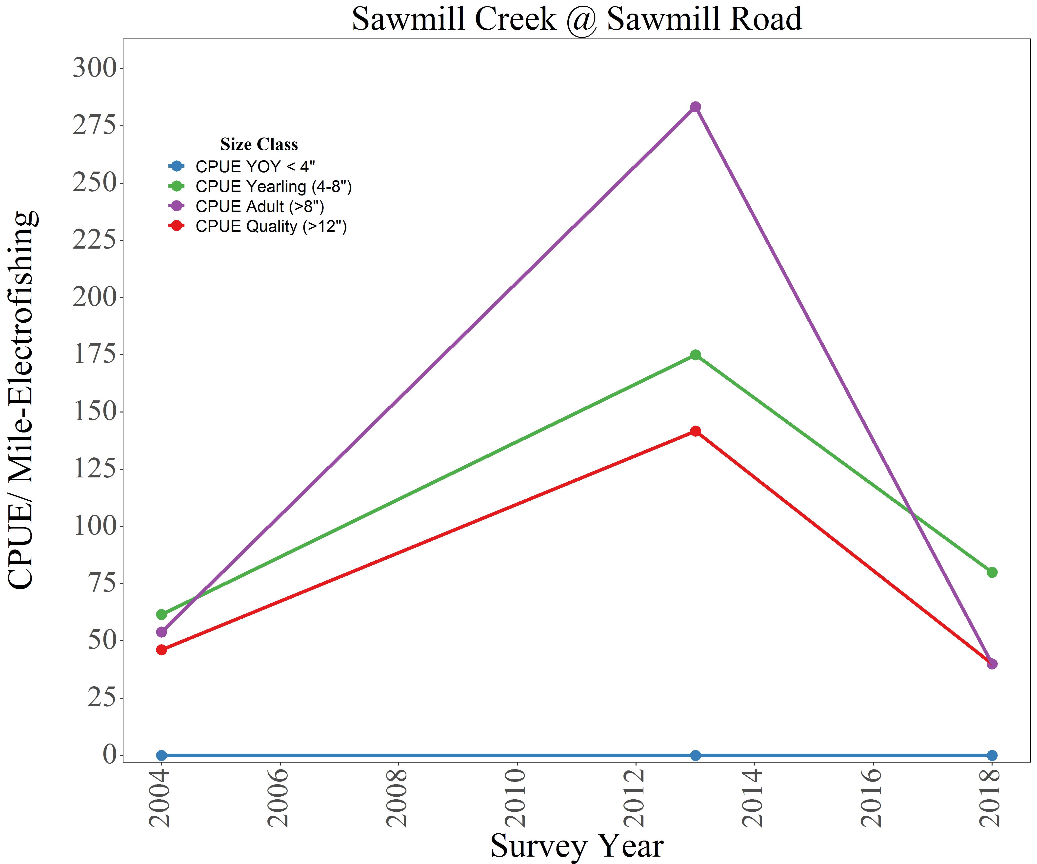

**Figure 3**: Size Specific Catch Rates of Brown Trout in Sawmill Creek at CTH H 2004-2018

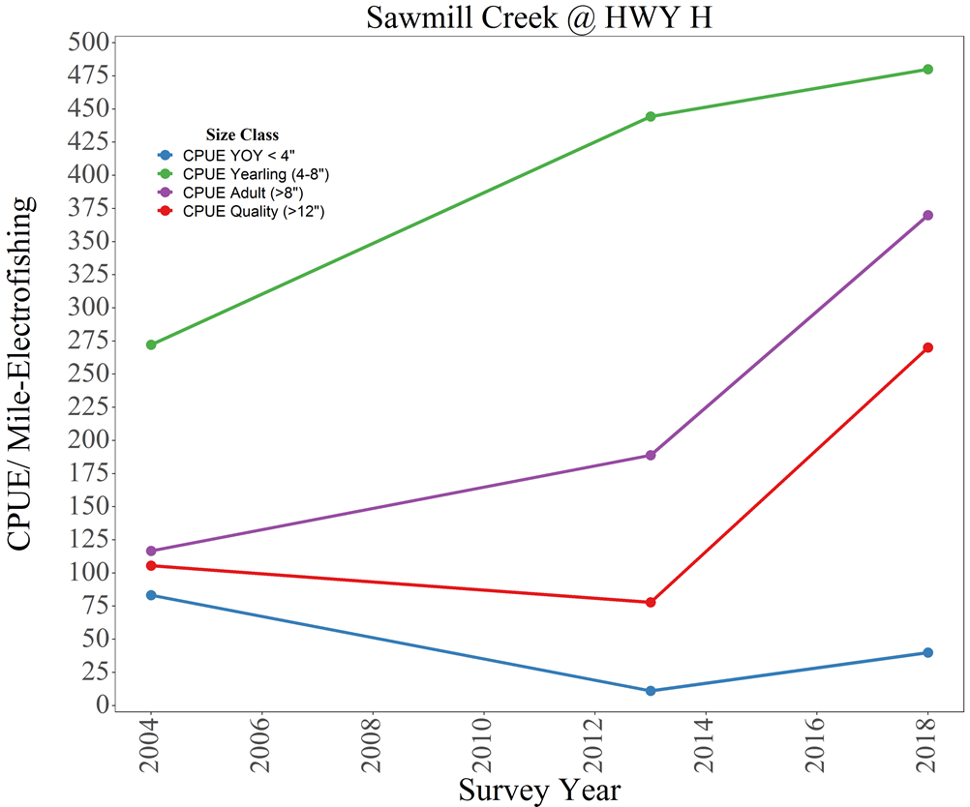

F**igure 4:** Relative Weights of Brown Trout Collected in Sawmill Creek in 2018

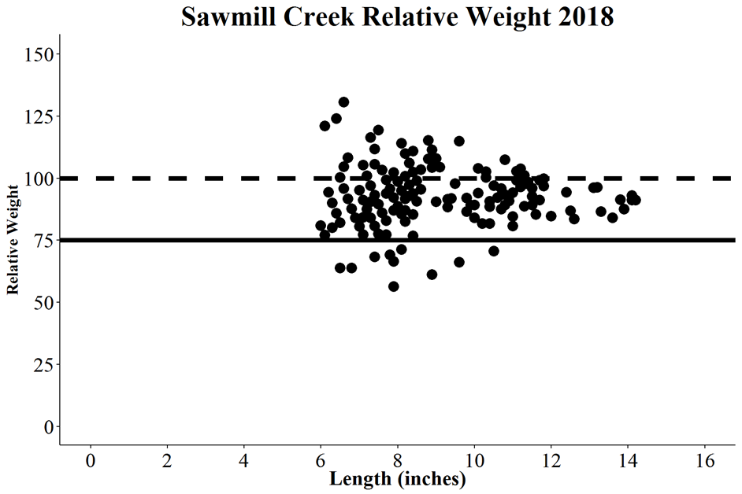

A relative weight value greater than 100 (dashed line) indicated a fish in excellent condition while a relative weight value less than 75 (solid line) indicates a fish in poor condition

**Figure 5**: Relative Weights of Brown Trout Collected in Erickson Creek in 2018

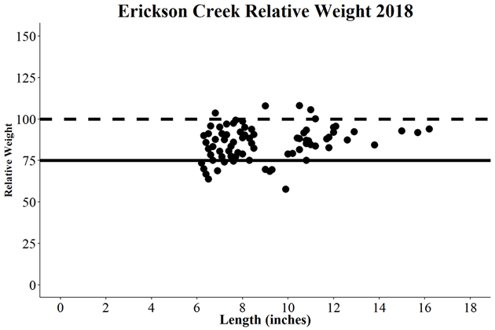

A relative weight value greater than 100 (dashed line) indicated a fish in excellent condition while a relative weight value less than 75 (solid line) indicates a fish in poor condition

to tolerate less than desirable conditions, including marginal habitat, hydrologic manipulation, siltation and turbid conditions. There are still many sites on both streams where bank erosion is an issue. Nearly half of the sites sampled had poor or fair bank erosion scores. Fine sediments were the predominant substrate at 13 of 21 sites.

As was noted in the results section, overall habitat scores and individual metrics were highly variable and site dependent. However, both streams are consistently well buffered, either in wet meadow or woodland. There are sections in the headwaters of Sawmill Creek, especially upstream of Badger Road, that flow through a large wet meadow. This area has good gradient, and hard substrate. These sections likely serve as spawning areas for trout. Old rip-rap and habitat projects are in various state. Rip-rapped corners are fairly stable. Some habitat (LUNKERS) structures are still functioning while others have become inundated with sediment or even rock. Many sections would benefit from habitat improvement and bank stabilization projects. Stream narrowing could help with scour of sediment.

Phosphorus samples taken in 2017 and 2018 showed concentrations to be near or above the state standard of 0.075 mg/L. Because volunteers take samples on a set day, weather conditions prior to and during the sample event are uncontrolled. Therefore, samples may represent a range from baseflow concentrations to event concentrations. The highest concentration on Erickson Creek in 2018 was observed during a 1+ inch rain event in May, when crops have been planted, but a stable canopy is not yet able to deflect the impact of rain, thus fields are vulnerable to runoff. The samples on Sawmill Creek were taken upstream of the confluence with Erickson to get an idea of how they compare relative to one another. In almost all cases, the concentration in Sawmill Creek was less than Erickson Creek. This could indicate that the concentration of phosphorus in Sawmill Creek is lower than Erickson, although not significantly. Precipitation was above normal for most of the growing season period (Wisconsin State Climatology Office, 2018). The volunteers continued to collect samples in the 2019 growing season. Similar results were noted. In combining results from 2017 through 2019, the median concentration for Sawmill Creek remained at 0.071 mg/L while the median concentration of Erickson Creek rose to 0.091 mg/L. According to the Wisconsin Consolidated Assessment and Listing Methodology (WDNR, 2020), Erickson Creek would be placed on the state’s 303(d) list of impaired waters for phosphorus.

The macroinvertebrate data seemed to represent the overall conditions of the watershed. Weigel (2003) reported that the macroinvertebrate IBI reflected the combination of watershed land cover and local riparian and instream conditions strongly influence one another. While watershed and local variables explain a significant portion of variance among sites, Weigel found that in the driftless region, localized stressors were of greater importance to explain the IBI than in other parts of the state. As discovered in the habitat surveys, the streams of the watershed generally have a good buffer, but streambank erosion and sediment deposition vary by segment. There are still some defined localized sources of sediment and nutrients. The HBI, another macroinvertebrate metric related to the level of organic pollution, showed little in the way of this type of stressor, which would most likely be in the form of manure.



Sawmill Creek looking upstream from Gould Hill Road

Conclusion

It is a pleasant surprise that Sawmill and Erickson Creeks have moved more toward cold water systems they are purported to be. Whereas less than 20 years ago, coldwater species were absent from these systems save for the trout planted there, the trout and mottled sculpin – both coldwater indicator species – now dominate the species assemblage. There is also evidence of natural reproduction in Sawmill Creek. This should be a source of pride to residents in the watershed.

The transition to a colder community could be the result of colder water temperatures. This could be due to increased precipitation resulting in a more enhanced water table and thus discharge to these systems. It could also be the result of better farming practices which have allowed for better infiltration of water and reduced runoff. There are progressive farmers and landowners in the watershed.

* The department, Green and Lafayette county staff should work with these partners to promote agricultural practices such as no-till and cover crops which promote infiltration of water.

District fisheries management has spent considerable time pursuing fishing easements in the district. There has been some are interest in further habitat improvement/easements in the watershed.

- Fisheries management should continue to work with landowners in this area (See summary below for specific fisheries management goals)

Additional recommendations are as such:

* The department should conduct temperature monitoring to determine the contemporary thermal regime of these streams.

- Erickson Creek should be placed on the state’s 303(d) list of impaired waters due to phosphorus.

References

Fish Management Goals and Objectives for Sawmill and Erickson Creeks

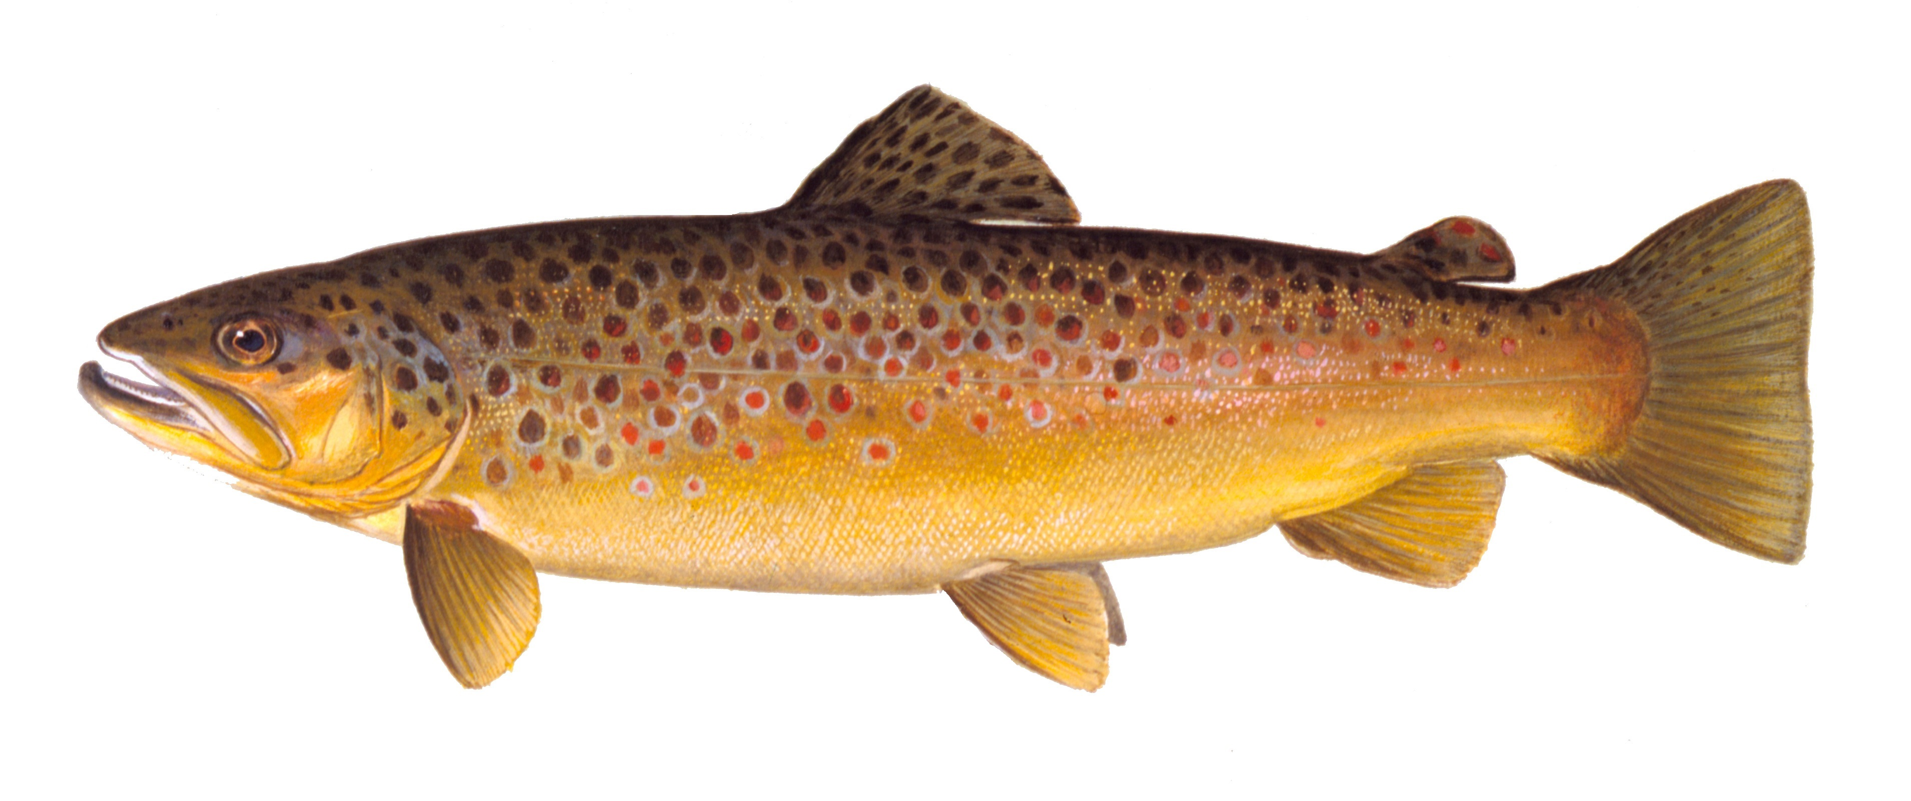

1. *Maintain the trout Class II designation for the watershed* while working towards improving the Yearling and Adult survival and YOY capacity of the brown trout fishery. There are many locations with underperforming or non-existent trout populations; increasing the trout population within the watershed is a high priority.

*Increase catch rates of Yearling and Adult brown trout to the Driftless median levels*. Improving the physical habitat (added depth, woody additions, scouring holes, and gravel riffles) through habitat improvement projects should result in increased trout abundance of all sizes.

**Management goal**: Increase Yearling and Adult brown trout catch rates to 213 and 62 per mile, respectively.

1. Public angling opportunities are severely lacking in the watershed and increasing public access through easements and acquisitions is a high priority. *WDNR should continue to support and work with local organizations such as Trout Unlimited, Pecatonica Pride, Green County staff, and other willing partners to increase public access and awareness of the cold-water fishery in Green and Lafayette Counties.* Lands enrolled in public access programs like stream bank easements open the door for future stream bank and trout habitat improvement funds to be invested within the watershed. For example, WDNR Trout Stamp funds are surcharges on trout stamp license fees. These funds are spent improving trout habitat but can only be utilized on lands open to the public.

**Management goal**: Enroll at least 1 mile of stream bank easements or fee title acquisitions for public access before the next watershed assessment. Conduct at least ½ mile of stream bank improvement projects on newly acquired easements or lands to improve the fishery.

1. *Continue stocking program of large fingerling brown trout at appropriate levels and locations that we have documented survival*.
   1. Do not stock small fingerling fish due to poor survival
      1. Stock large fingerlings, yearling, and brood stock size classes
   2. Do not stock put-and-take rainbows in places anglers are not likely to utilize
   3. Do not stock areas with high natural reproduction
   4. Do not stock brook trout due to poor history of survival

**Management goal**: evaluate angler exploitation of brown trout fishery within the watershed planning group with angler creel survey.

1. *Maintain harvest opportunities with current regulation of 8” minimum, 3 daily bag limit*

From: WDNR. 2019. Comprehensive Fishery Survey of Sawmill Creek Watershed. Green County, Wisconsin 2018. By Dan Oele, Fisheries Biologist, WI DNR. (Draft)

Hilsenhoff, William L. 1987. An Improved Biotic Index of Organic Stream Pollution. The Great Lakes Entomologist. 20: 31-39.

Lyons, John. 1992. Using the Index of Biotic Integrity (IBI) to Measure Environmental Quality in Warmwater Streams of Wisconsin. United States Department of Agriculture. General Technical Report NC-149.

Lyons, John, L. Wang, and T. Simonson. 1996. Development and Validation of an Index of Biotic Integrity for Coldwater Streams in Wisconsin. North American Journal of Fisheries Management. 16:241-256.

Lyons, John. 2008. Using the Wisconsin Stream Model to Estimate the Potential Natural Community of Wisconsin Streams (DRAFT). Wisconsin Department of Natural Resources Fish and Aquatic Life Research Section. November 2008.

Lyons, John, T. Zorn, J. Stewart, P. Seelbach, K. Wehrly, and L. Wang. 2009. Defining and Characterizing Coolwater Streams and Their Fish Assemblages in Michigan and Wisconsin, USA. North American Journal of Fisheries Management. 29: 1130-1151.

Simonson, Timothy D., J. Lyons, and P.D. Kanehl. 1994. Guidelines for Evaluating Fish Habitat in Wisconsin Streams. U.S. Department of Agriculture. Forest Service. General Technical Report NC-164.

WDNR. 1992. A Nonpoint Source Control Plan for the Lower East Branch Pecatonica River Priority Watershed Project. Wisconsin Nonpoint Source Water Pollution Abatement Program. June 1992. Publication WR-307-92.

WDNR. 2003. The State of the Sugar and Pecatonica River Basins. Wisconsin Department of Natural Resources.

WDNR. 2019a. Aquatic Life Use Designation through Natural Community Verification. WDNR Streams Technical Team Guidance Document. (DRAFT) V.1, Revised 2/20/2019.

WDNR. 2019b. Comprehensive Fishery Survey of Sawmill Creek Watershed. Green County, Wisconsin 2018. By Dan Oele, Fisheries Biologist, WI DNR. (Draft)

WDNR. 2020. Wisconsin 2018 Consolidated Assessment and Listing Methodology (WisCALM). Clean Water Act Section 305(b), 314, and 303(d) Integrated Reporting. Wisconsin Department of Natural Resources. Bureau of Water Quality Program Guidance. September 2017.

Weigel, Brian. 2003. Development of Stream Macroinvertebrate Models That Predict Watershed and Local Stressors in Wisconsin. Journal of the North American Benthological Society. 22(1): 123-142.

Wisconsin State Climatology Office. 2018: <http://www.aos.wisc.edu/~sco/clim->history/7cities/madison.html#Precip