**2011 Sheboygan River AOC Herptile Survey and Habitat Assessment.**

**Schuchardt Property Herptile Inventory.**

**Conducted for WI DNR Bureau of Endangered Resources**

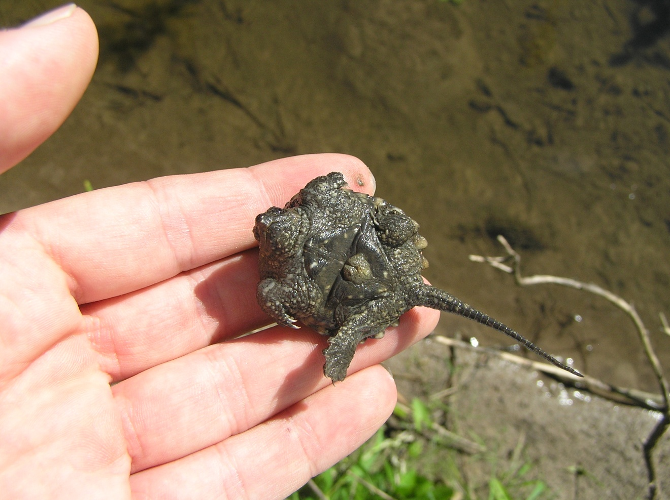

By Jason Dare

Dare Ecosystem Management, LLC

N3935 Liberty St, Sullivan, WI 53717

**Schuchardt Property Herp Inventory**.

Sheboygan Co. August 25th 2011

Six categories (in parenthesis)

1Present (on Aug 25, 2011)

2High probability

3Moderate probability

4Low probability but possible

5Possible but highly unlikely

6 No associated habitat

***Target Species:***

*Blandings turtle:* (closest moderate to high probability population is most likely the Kohler lands of Black wolf run) Area A (4) Area B (4) Area C (4) Area D (4) but good suitable habitat in this unit. Area E (4)

*Northern Watersnake*: Area A (3) (good water flow, good water clarity with minnow population, good frog population and crayfish are present). B (2) (same as unit A, plus stream reaches the Sheboygan river here and there is a large green frog population and crayfish are present. C (3) With (stream/ditch) present there could be possible habitat and prey to support them. D (4) E (4) However there is some channelization formed within the wetland complex, and watesnakes can be found in these types of wetlands.

*Pickerel frog:* A (5) water is cool but adjacent habitat is poor. B (5) C(4) coming off the wooded slopes to the east are multiple seeps. I could possibly see the associated wetlands being able to harbor this species. If a search on the site was completed this is where efforts should be prioritized (in the wetland seeps at the base of the wooded slope). D (5) E (5) possibly at the beginning of the channelization within the wetland at the base of the slopes to the north.

*Bullfrog:* (no bullfrogs were heard within the AOC in 2011 although decent habitat for this species is south of the street (PP) at the Lutheran High school and the Kohler property west of Hwy 43. A (4) B (4) C (4) D (4) best chance on the site is in this unit.

E (4).

*N Cricket frog:* (Some spots along the Sheboygan River have suitable habitat and would be worth looking at if a focused study was done. But for this site the chances a slim they would be found here. All units (5)

*Mudpuppy:* A (6) B (5) possibly where the stream reaches the Sheboygan river. C (6) D (6) E (6).

*Four toed salamander:* A(6) B( 5) C( 4) there are some shrubby areas with hummocks that are a possibility adjacent to the upland woods. D (4) E (4) possibly in the shrubby parts of the wetland.

*Spotted salamander:* A(6) B (5) C (4) if any ephemeral wetlands can be found adjacent to the associated upland woods the probability could be higher. These wetlands near these decent quality upland woods would need to be fishless. I think one place to look will be at the base of the uplands woods in hope that some spring ponding can occur without the presence of fish. D (3) Decent wetland with some associated upland woods. If stickleback and mud minnows are in the wetland I would drop this down. E (5)

*Red-backed salamander:* A (6) B (5) C (4) There is a moderate quality Northern Mesic Forest (tension zone) to the northeast of this unit. On this preserve this is one area where I could see this species possibly being present. There is decent size and amount of fallen logs (coarse woody debris) and many of them are paper/white birch. D (5) Not much CWD in the adjacent woods E (6) not much adjacent habitat (uplands)

***Present:***

*Green frogs*: Unit A, B, C, D.

*Snapping turtle*: Unit A, B.

*Toad*: Unit A.

*Eastern Common gartersnake*: Unit D.

***High Probability***:

*Blue spotted salamander* Woods adjacent to units C and D

*Tiger salamander.* Upland open habitat adjacent to unit D

*Eastern Grey tree frog*. Adjacent and in unit D.

*Leopard Frog*. In adjacent open meadow habitat adjacent to Unit D.

*Spring Peeper*. Unit D

*Chorus frog*. Unit D

*Painted turtles*. Unit B where the stream flows into the Sheboygan river.

*Milk snake.* Throughout site

*Brown Snake.* Throughout site

*Red belly snake*. Throughout site

***Moderate probability:***

*Wood Frog* (if there was more upland forested habitat I would put in this species in higher category) Look within the Northern mesic woods adjacent to C and D.

Newt. Forested uplands near unit C and D.

*Copes Gray Tree frog*. Unit D

***Low probability but possible:***

*Stinkpot*. Unit B were it meets the Sheboygan River. There are no records of this species in Sheboygan County. But it is possible that it could use the Sheboygan River.

*Spiny soft-shell*. Unit B stream reaches Sheboygan River. Could possibly be in Sheboygan River.

*Green snake.* Unit D. adjacent wet meadow habitat could support them. At this time there are no records in the AOC.

*Northern Rigneck Snake.* There is good adjacent habitat in the Northern Mesic forest adjacent to unit C.

***Small possibility but highly unlikely:***

*Eastern ribbon snake*: No available habitat on site

*Fox snake*. Not enough available habitat but possible

***Information unavailable:***

*Butler’s gartersnake and Plains gartersnake:* contact WI DNR Bureau of Endangered Resources for information regarding these species distribution.

Historical data was obtained for the following sources:

WI Natural heritage Inventory

WI Herp Atlas

***Upland Areas of Importance:***

U1: Open wet meadow and open/shrubby uplands- This area will have a high density of snakes and is open available habitat for frogs and the tiger salamander.

U2: Adjacent severely degraded mesic forest- Very little coarse woody debris. However it is adjacent upland habitat for forest dependant species.

U3: Good quality Northern Mesic forest- best place to look for species like ringneck snake, wood frog, red backed salamander. There may be even more high quality woods on the site but this was discovered during the rapid site visit.

U4: South facing slopes- This would be a decent spot to search for snake species in any future inventory.