Clam River Transparency Measurements and Observations
on September 13, 2013

In 2012 and 2013 several reports/complaints of green water in the Clam River were received. A plume of green water in the St. Croix River below the mouth of the Clam River was also reported.
Multiple sites on the Clam River and two small tributaries were observed and photographed on September 13, 2013. Transparency measurements at ten sites were made using a transparency tube (below and figures 1 and 2).

Transparency measurement sites and transparencies
- Clam River @ Lynch Bridge Rd - >120 cm
- Clam River @ Clam Lake Narrows (STH 70) – 39 cm
- Clam River @ Clam Lake dam – 36 cm
- Clam River @ STH 35 – 45 cm
- Clam River @ Old 35 Rd – 40 cm
- Black Brook @ CTH D – 24 cm
- Clam River @ Icehouse Bridge Rd – 47 cm
- Dody Brook @ South River Rd - >120 cm
- Clam River @ CTH F (Clam River Flowage) – 41 cm
- Clam River below Clam River Flowage dam – 42 cm

Transparency tube measurements can be influenced by various suspended particulates such as planktonic algae, suspended sediment, and iron precipitates, as well as dissolved organic matter. Observations of the Clam River on Sept. 13th made it fairly obvious that planktonic algae was the dominant influence over transparency. Transparency measurements provided a simple and useful way to obtain a preliminary assessment of the sources and transport of planktonic algae in the river.

A severe blue green algae bloom was occurring in Clam and Lower Clam Lakes. The blue green algae was being carried by the Clam River downstream to the Clam River Flowage with minimal attenuation. A slight increase in blue green algae appeared to be occurring in the Clam River Flowage where some additional holding time is provided. The water leaving the Clam River Flowage on its way to the St. Croix River had only a slightly lower algae content than the water leaving Lower Clam Lake about 28 river miles upstream.

Clam River transparency was good (>120 cm; > 3.9 ft) upstream of Clam Lake (site 1, fig. 1). Planktonic algae were not obvious in the stream (photo 1). There are a few small, upstream lakes that drain to the Clam River that are potential sources of planktonic algae at this site.

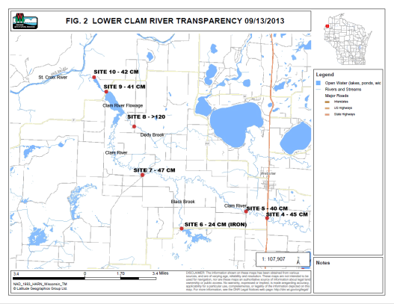
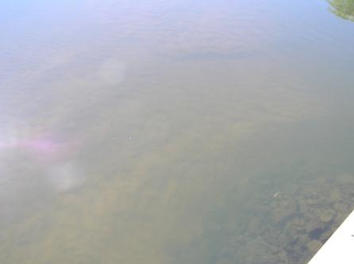
Photo 1. Site 1 Clam River @ Lynch Bridge Rd.
Upstream of Clam Lake
Transparency > 120 cm; >3.9 ft

A severe blue green algae bloom was occurring in Clam and Lower Clam Lakes (photos 2-4). Transparency at the Clam Lake outlet (site 2) was 39 cm (1.3 ft), and at the Lower Clam Lake outlet (site 3) was 36 cm (1.2 ft).

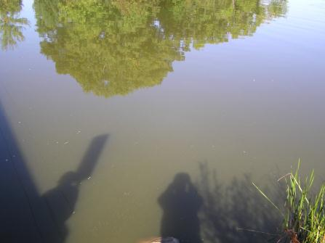
Photo 2. Site 2 Clam River @ STH 70
Clam Lake Narrows
Transparency 39 cm; 1.3 ft
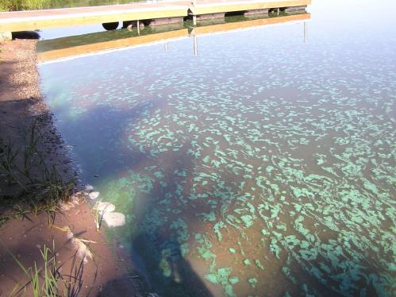
Photo 3. Lower Clam Lake @ STH 70 Boat Landing
Showing characteristic of blue green algae bloom

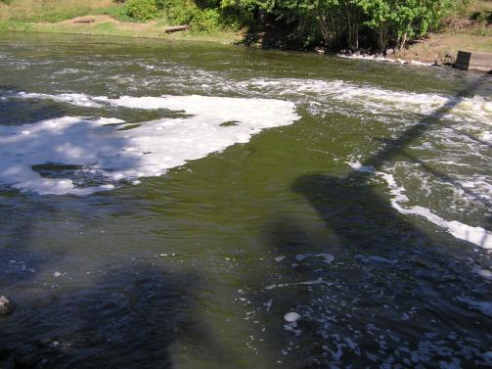
Photo 4. Site 3 Lower Clam Lake outlet below
Clam Lake dam
Transparency 36 cm; 1.2 ft
The Clam River showed only minor improvements in transparency moving downstream from the Lower Clam Lake outlet. Sites 4,5, and 7 had transparencies ranging from 40 – 47 cm (1.3 – 1.5 ft). See photos 5 - 6 below.

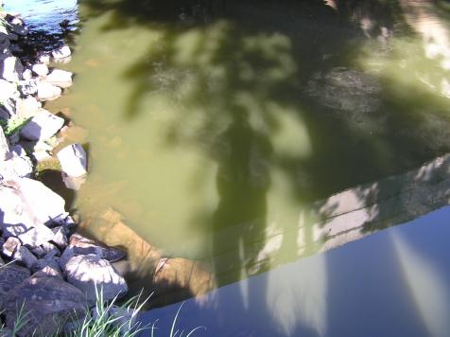
Photo 5. Site 4 Clam River @ STH 35
Transparency 45 cm; 1.5 ft
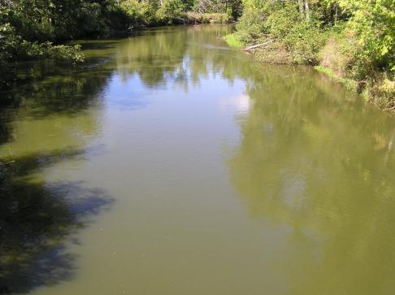
Photo 6. Site 7 Clam River @ Icehouse Bridge Rd.
Transparency 47 cm 1.5 ft
Black Brook (site 6), a tributary to the Clam River had a very low transparency, 24 cm (0.8 ft). However, this was due to the presence of iron precipitates in the water. Planktonic algae was not noticeable. A shallow wildlife impoundment is located just upstream of this site.

Dody Brook (site 8) is another tributary to the Clam River. Transparency was good, >120 cm (>3.9 ft), with no planktonic algae noticeable.

Transparency at the Clam River Flowage (site 9; 41 cm (1.3 ft))(photo 7) was slightly poorer than the closest upstream site on the Clam River (site 7; 47 cm (1.5 ft)). This suggests some additional production of blue green algae may be occurring in the Flowage. This might be expected since some additional holding time is provided for algae to reproduce.

Transparency below the Clam River Flowage dam (site 10)(photo 8) was 42 cm (1.4 ft) and very similar to site 9. The Clam River flows into the St. Croix River less than a mile downstream of the dam. The site below the Clam River Flowage dam was re-visited on October 2nd. A high density of blue green algae was still present.

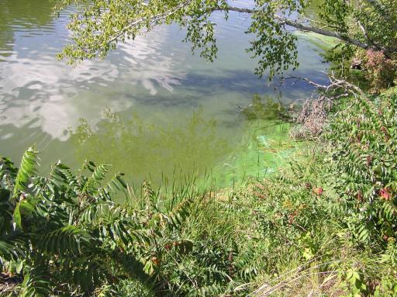
Photo 7. Clam River @ CTH F
Within Clam River Flowage
Transparency 41 cm; 1.3 ft

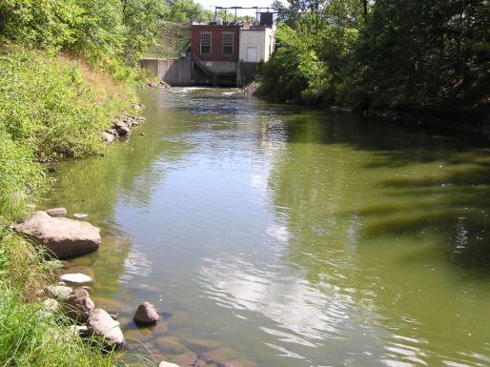
Photo 8. Clam River below Clam River Flowage dam
Transparency 42 cm; 1.4 ft

Blue green algae blooms in Clam and Lower Clam Lakes are the primary cause of “green” water in the Clam River, at least at the time this assessment was made. Algae blooms in the Clam Lakes may have intensified in recent years due to a major expansion of the carp population. Carp can increase algae blooms by reducing aquatic macrophytes and promoting the recycling of sediment phosphorus into the water column. A large year class of carp reached adult size about 2009 and aquatic macrophyte abundance in the lake declined greatly. Aquatic plant harvesters were operated for many years primarily to control curly leaf pondweed. Harvester operation was discontinued in 2010 due to a lack of plants.

Existing data will be collected and reviewed to determine whether export of algae from Clam Lakes has increased in recent years. Potential management options to reduce Clam Lake algae blooms will be identified and pursued.

