Citizen Lake Monitoring Network
Volunteer Lake Level Monitoring Protocol
Table of Contents
I. Program Contacts 1
II. Project Background and Goals 2
III. Volunteer Time Commitment 2
IV. Volunteer Duties 3
V. Equipment 3
VI. Safety 3
VII. Lake Level Monitoring 4
VIII. Data Management 8
IX. Quality Assurance 13
X. Aquatic Invasive Species 13
XI. References 15
Appendix A. Volunteer Lake Level Monitoring Instructions – Quick Sheet 16
Appendix B. Volunteer Lake Level Monitoring Datasheet 17
Appendix C. Citizen Lakes Monitoring Network (CLMN) Liability Form 18
Appendix D. DOA-3009 Volunteer Agreement Form 19

Program Contacts

Lindsey Albright
Water Action Volunteers (WAV) Stream Monitoring Program Level 2 and 3 Coordinator
Volunteer Lake Level and Streamflow Monitoring Coordinator
lindsey.albright@wisconsin.gov
Phone: (608) 266-3599

Catherine (Katie) Hein
Lakes Monitoring Technical Lead
catherine.hein@wisconsin.gov
Phone: (608) 264-8533

Jennifer Filbert (Database Questions) Physical Address for Contacts:
Lakes/AIS – Database and Website Wisconsin Department of Natural Resources
jennifer.filbert@wisconsin.gov 101 S. Webster Street
Phone: (608) 267-2376 Madison, WI 53703

Project Background and Goals

Record low water levels in some areas of Wisconsin affect both the health and recreation of lakes. In some inland lakes, low water levels have stranded nearshore habitat, left piers hundreds of feet from shore and rendered boat landings unusable. To address the growing concern for lake health brought on by drought, changing climate, and groundwater withdrawals, the Wisconsin Department of Natural Resources and the University of Wisconsin-Extension have developed a citizen-based, statewide lake-level monitoring effort.
Although long-term water level records exist, current monitoring efforts do not cover all areas of the state. With over 15,000 lakes, partnerships with local volunteers, nonprofit groups, and county staff are crucial for filling gaps in the current water level records. This effort builds upon the existing network of volunteers participating in the Citizen Lake Monitoring Network (CLMN) and was piloted at approximately 15 lakes in 2015. Following the completion of the pilot study in 2016, interested lake groups may join the water level monitoring network if they can invest in their own equipment and contract a surveyor to install and survey the staff gage and reference marks.
Citizen volunteers will take lake level measurements by visually reading a staff gage, which is scale (made out of enameled steel and marked in feet and tenths) placed in the lake bed to show the elevation of the water surface. The staff gage is calibrated by referencing the numbered height on the gage to the surveyed elevation of the water surface at the time of installation (Harrelson et al., 1994). Volunteers will also enter their lake level data into the Surface Water Integrated Monitoring System (SWIMS) database. Trained professionals will install the staff gage and perform all surveys (following installation, mid-season, and at removal) of the staff gage. They will also be responsible for removing the gage and entering all survey data into SWIMS each year.

Volunteer Time Commitment

Lake level monitoring volunteers must attend an 1 hour training in its entirety prior to participating in this monitoring project. Once trained, most volunteers will monitor lake levels on a weekly basis.
The monitoring season begins once the staff gages are installed and surveyed (between April and June) and continues through the summer and early fall until the gages are removed in late October or early November. In most cases, lake level monitoring can be performed in conjunction with other CLMN responsibilities, but the increased monitoring frequency will add to volunteers overall time commitment. In order to limit the amount of time required to monitor lake levels, staff gages will ideally be placed on public property in locations that are easily accessible by the volunteer (either near a boat launch or walking path).
All told, it is estimated that volunteers will spend 15-30 hours per field season monitoring lake levels in addition to their other CLMN monitoring responsibilities.

Volunteer Duties

In the spring, CLMN volunteers will be trained how to read lake levels and how to enter lake level data into the SWIMS database. Lake levels should be recorded once a week on the same day (e.g. every Monday) at approximately the same time of day under calm conditions. Less error will be introduced to your lake level readings if there are not large waves or white caps.
For each monitoring event, a visual reading of the lake level should be recorded on the datasheet and a photograph of the water level on the staff gage should be taken and submitted to the statewide coordinator or uploaded to SWIMS as part of the quality assurance process. Volunteers are asked to enter their field data into the SWIMS database following each survey event so that extreme water level changes (> 4/10ft in one week) can be documented as soon as possible. If you are unable to enter your data online, please contact Lindsey Albright or Jennifer Filbert for assistance. In addition to the water level reading, the bubble levels attached to the staff gage need to be checked to verify that the staff gage has not shifted since the previous monitoring activity.
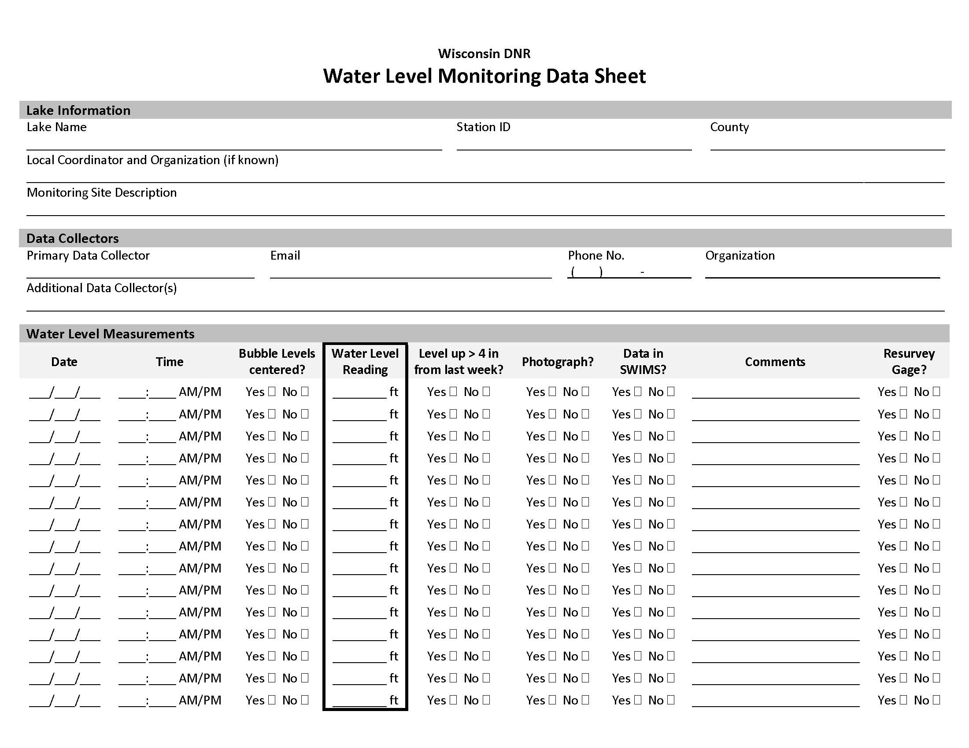
Volunteers are not responsible for installing the gage, surveying it, or removing it from the monitoring location at the end of the season. This will be carried out by professional surveyors.

Equipment

- Lake Map (with staff gage location marked)
- Lake Level Monitoring Datasheet
- Clipboard and pen or pencil
- Watch
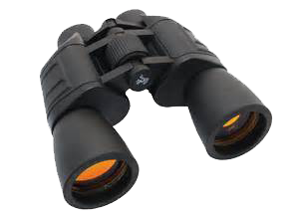
- Camera or cell phone (camera enabled)
- If monitoring from a boat:
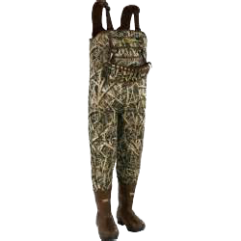
  - Boat
  - Life Jackets and paddles
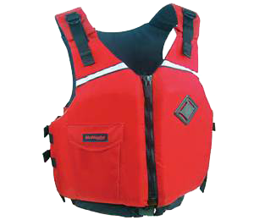
  - Anchor and rope

  - Binoculars
- If monitoring in the water:
  - Chest or hip waders
  - Life Jackets
- If monitoring from land:
  - Binoculars

Safety

Safety precautions of a general nature should be recognized when monitoring lake levels. Monitoring lake levels in extremely hot and humid weather carries the risk of dehydration and heat stroke. Never monitor during electrical storms or high wind events. A personal flotation device (PFD) should be worn if monitoring lake levels from a boat or while wading in the water. If using binoculars to read the staff gage from land, do so from a safe location and be aware of noxious plants. Please carry a first aid kit with you while out on the water.
In general, CLMN participants (regardless of Level of participation) are not considered DNR volunteers and must complete the program-specific liability waiver (Appendix C). In the case of this project, the CLMN participant is monitoring for the purpose of collecting data for a project that would have used a DNR staff person to collect the data and the DNR is directing the work of the volunteer, meaning that all adult citizen monitoring volunteers, or anyone not being paid while participating with this program, must complete the DOA-3009 Volunteer Agreement form (Appendix D). All liability forms need to be returned to Lindsey Albright or Katie Hein at the conclusion of the lake level monitoring training.
Volunteers under the age of 16 must be accompanied by a parent or group leader who will be responsible for their actions if part of a group volunteer activity. Volunteers under 18 must have written permission from a Parent or legal guardian to participate. A completed Parent Permission and Acknowledgement Form or similar written permission should be submitted prior to participation.
If you feel unsafe at any time while you are out monitoring, please discontinue monitoring and return to land. Your health and safety is our priority. Please contact your CLMN regional coordinator or the statewide staff (Lindsey Albright or Katie Hein) if you have any questions!

Lake Level Monitoring

A lake gage should be read once per week at approximately the same time (e.g. every Tuesday morning around 9am). Please be sure that the weather and water conditions are ideal for monitoring: winds should be calm to breezy, there should not be white caps on the lake, and there should be no threat of thunderstorms. Monitoring lake levels during these conditions will allow the volunteer(s) to effectively and safely read the water level off of the staff gage. If the aforementioned weather conditions can’t be met on the regularly scheduled monitoring day, please suspend monitoring activities and reschedule the effort on a subsequent day within the week when lake conditions are calmer (as soon as possible). Continue with the normal monitoring schedule the following week. Please contact Lindsey Albright or Katie Hein if you have any questions about this!!
Please use the following protocol to properly read the water level on the staff gage:
- Fill out the top portion of the datasheet before conducting the first monitoring event of the season. Be sure to have a Station ID number specifically for the staff gage location (Figure 1).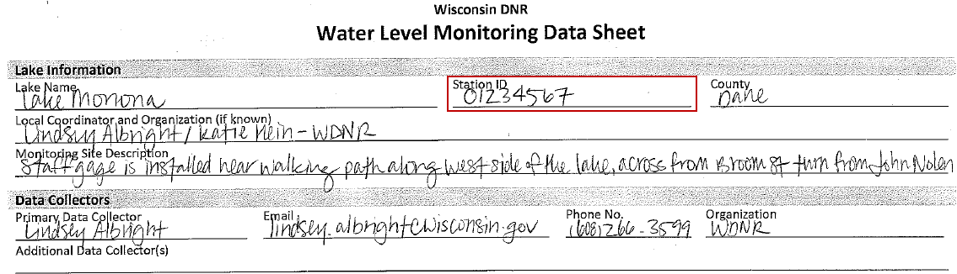
  - Contact your CLMN regional coordinator or the statewide staff if you have questions about attaining the Station ID number for the staff gage.
- Navigate to the staff gage using the lake map provided by your CLMN coordinator.
  - If monitoring from land, feel free to use binoculars for a better view of the staff gage.
  - If monitoring from a boat, please idle your engine or drop anchor and use binoculars for a better view of the staff gage.
    - Do NOT come into contact with the staff gage. Bumping up against the gage may cause the fence post to shift and make the results inaccurate.
- Record the date and time of the monitoring event on the datasheet (Figure 2).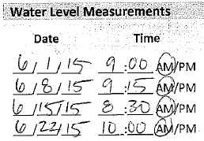
- Locate the two bubble levels on the staff gage (Figure 3).
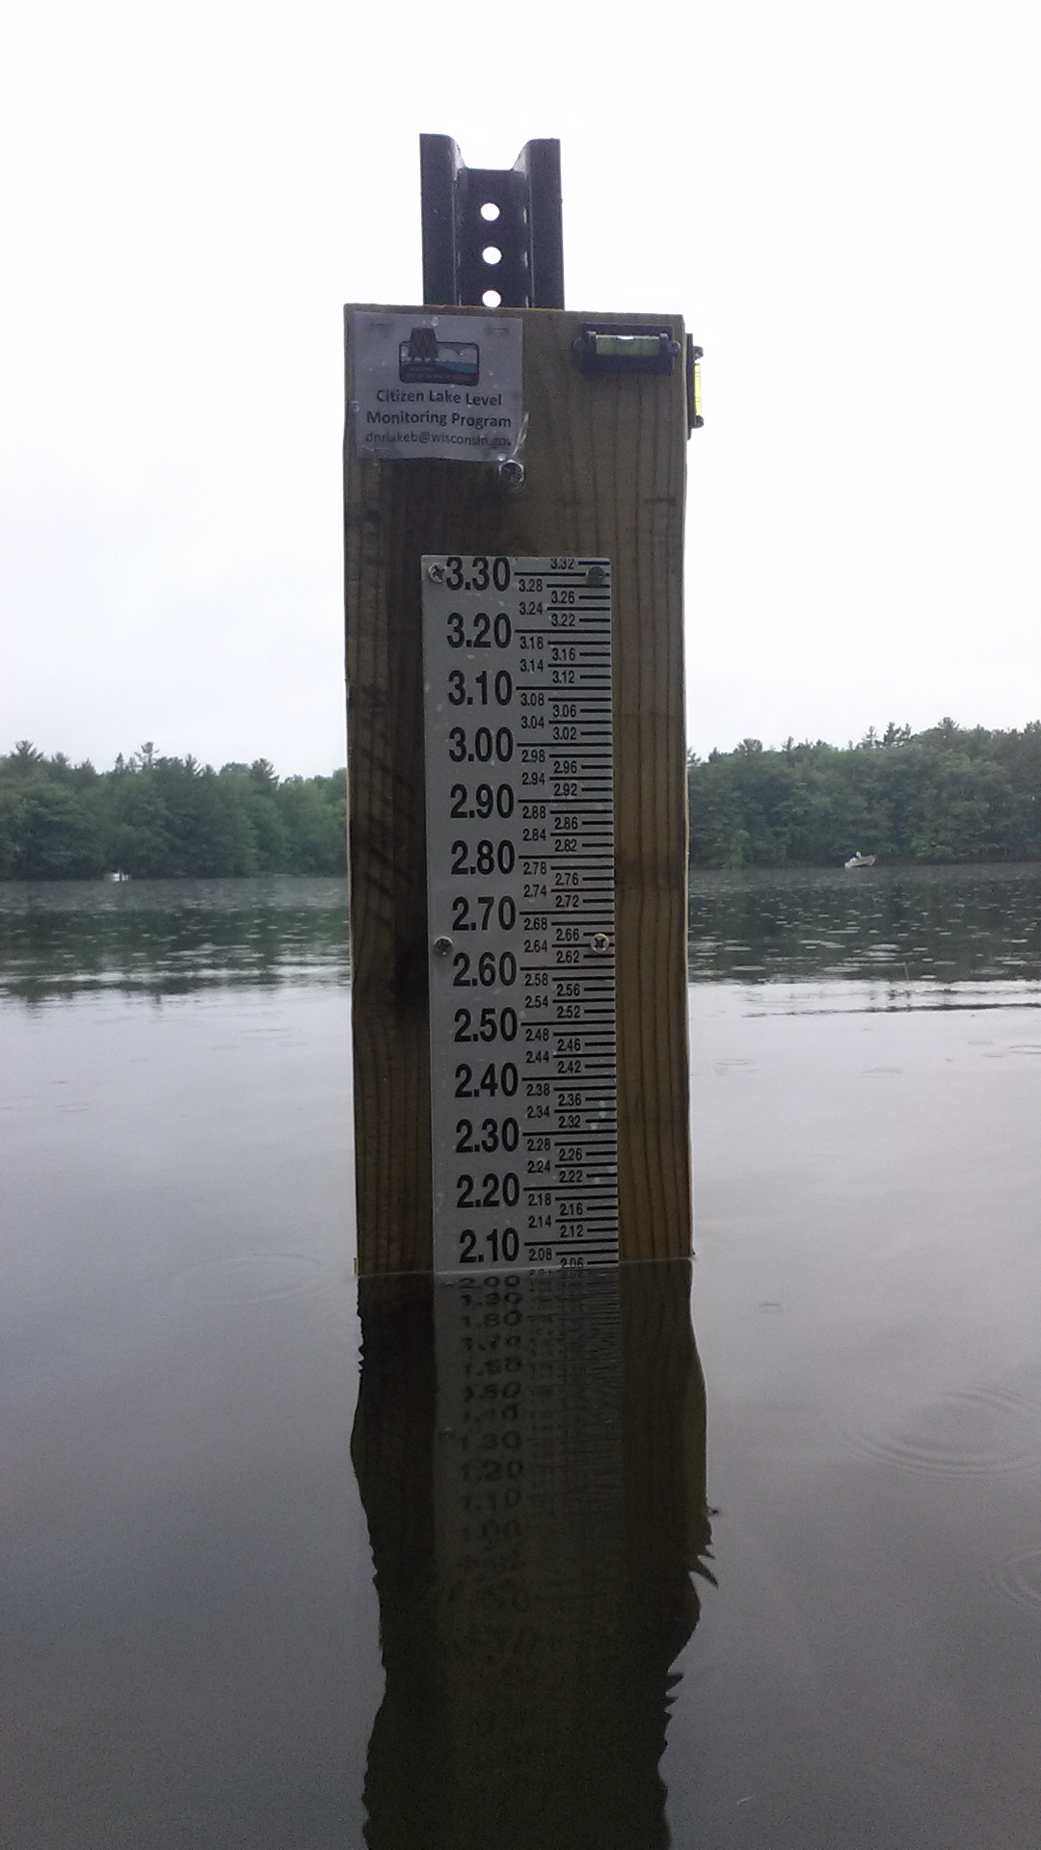
Record whether the staff gage is vertical by indicating that the bubble levels are centered (yes/no) on the datasheet. You may close one eye or use binoculars to get a more accurate reading.
  - Check ‘Yes’: if the bubble is perfectly centered between the lines (Figure 4).
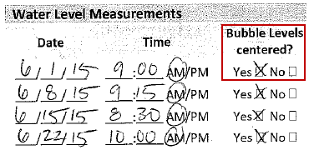
This means that the staff gage is vertical and does not need to be resurveyed. Select ‘No’ in the ‘Resurvey Gage’ column to indicate that the gage will need to be resurveyed (Figure 5).
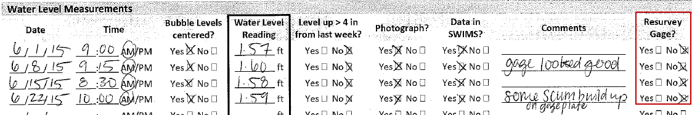
  - Check ‘No’ if any part of the bubble is to the right or left of the center box (Figure 6), the staff gage is not vertical.
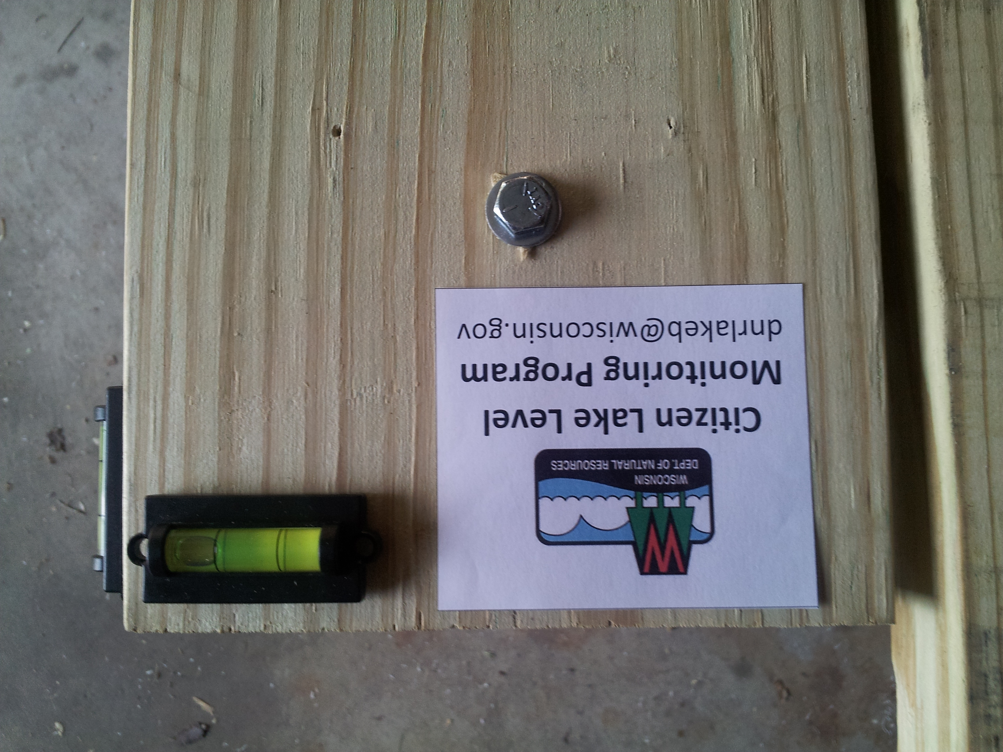
Please contact Lindsey Albright as the staff gage may have shifted and will need to be resurveyed. Select ‘Yes’ in the ‘Resurvey Gage’ column to indicate that the gage will need to be resurveyed (see above photo for reference).
    - Discontinue lake level monitoring until the gage is resurveyed by professionals.
- Read the water level on the gage to the nearest 0.02 ft (Figure 7).
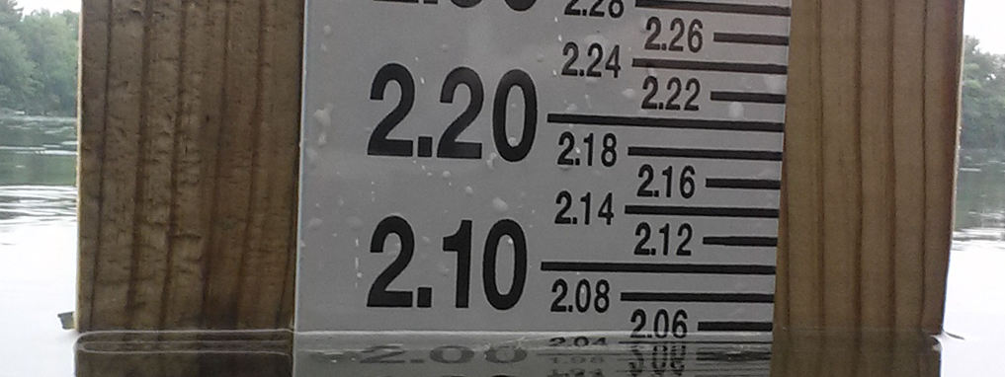
Record on the datasheet (Figure 8).
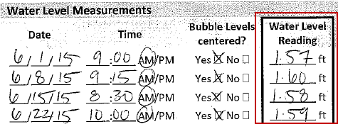

- Review the water level readings from the previous week. Indicate if the water level has changed more than 4/10 of a foot since the last reading on the datasheet (Figure 9). Please contact Lindsey Albright or Katie Hein if the water level has increased by that margin in one week.
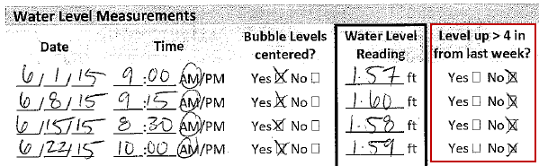
- Take a photograph of the water level on the staff gage and a separate photograph of the bubble levels. Use the datasheet to indicate that both photos were taken (Figure 10).
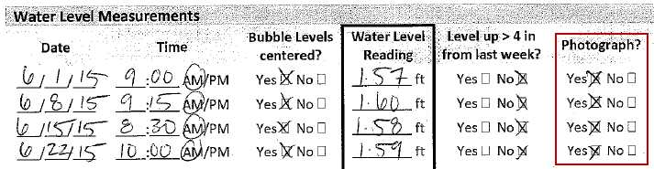
- Record any comments about the monitoring process or the status of the staff gage in the ‘Comments’ column (Figure 11).
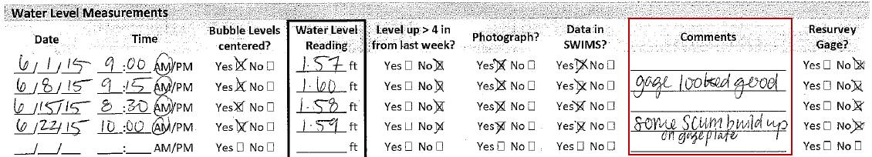

Data Management

After each lake level monitoring event, data must be entered into the SWIMS database (https://dnrx.wisconsin.gov/swims). This is done so that errors, such as a shift in the staff gage, can be rectified as soon as possible. If you are unable to enter your data online, please contact Lindsey Albright or Jennifer Filbert for assistance.
Because you already participate in the CLMN program, you or a member of your monitoring team already has an account and the necessary login permissions to enter data in the SWIMS database. If this is not the case, please go to https://on.wisconsin.gov/WAMS/SelfRegController to get a Wisconsin Web Access Management System (WAMS) User ID and password. Once you have the WAMS ID, please email Lindsey Albright or Jennifer Filbert to have your user profile set up in SWIMS.
Please use the following protocol to enter the lake level monitoring data into SWIMS:

- Check your data for accuracy:
  - Do you have the correct Station ID for the staff gage?
  - Is the date and time correct?
  - Is the lake level similar to previous readings?
- Open Internet Explorer and log into the SWIMS database (https://dnrx.wisconsin.gov/swims) with your WAMS ID and password.
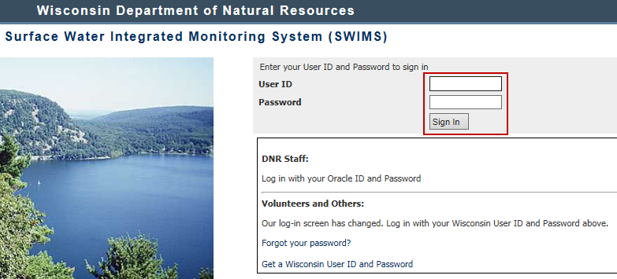

- Click on the ‘Submit Data’ tab at the top of the screen.
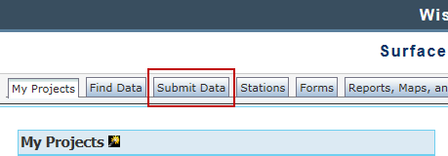
- Click the ‘Add New’ link in the second box on the screen.
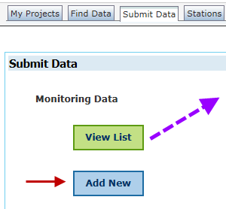
Use the ‘View List’ link in the top box to view and edit previously entered data.

- Select the Project and then the Station 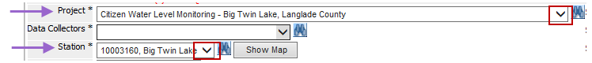
  - From the Project dropdown menu, you need to select the correct monitoring project for your lake. The project is called ‘Citizen Water Level Monitoring – YOUR LAKE NAME’.
  - Select the station you wish to enter data from the Station dropdown menu.
  - If your monitoring location is not listed in the Station dropdown menu, please do not enter your lake level data at this time, but instead contact Lindsey Albright or Jennifer Filbert to get your SWIMS account assigned to the correct station(s).
- Select yourself of your group of Data Collectors.
  - If the correct list of data collectors is not in the list, contact Lindsey Albright or Jennifer Filbert to get the correct collectors added to the dropdown menu.
- Click the ‘Select Date’ button to enter the Start Date. 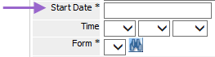
  - The monitoring date must be entered in the mm/dd/yyyy format
- Enter the Time that you started your data collection work.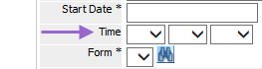
  - SWIMS requires the start time information (enter AM or PM) for all monitoring data.
- Select the Water Level Monitoring (Staff Gage) form.
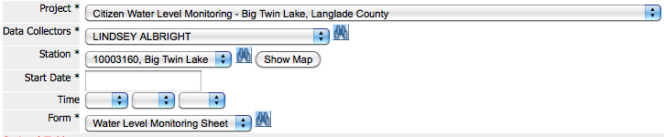
  - If it is not available, you will need to contact Lindsey Albright or Jennifer Filbert to correct this before you will be able to enter your monitoring data.
- You can ignore the End Date and Time field. It is not necessary that you enter this information.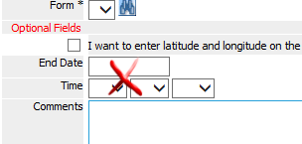
- Add any Comments you recorded from your field data sheet and then click Next to go to the field work data entry screen.
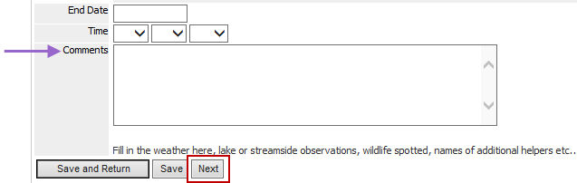
- Review your field datasheet and input the water level data accordingly :
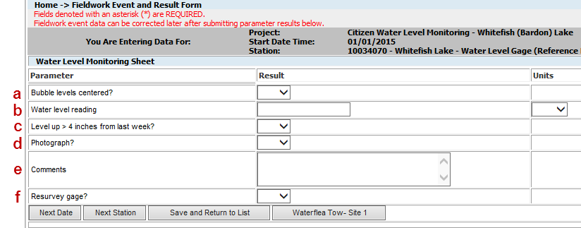
  - Bubble levels centered? Select either the ‘Yes’ or ‘No’ response
  - Water level reading Enter the value and select ‘Feet’ as the Units
  - Level up >4 inches from last week? Select either the ‘Yes’ or ‘No’ response
  - Photograph? Select either the ‘Yes’ or ‘No’ response
  - Comments Enter comments or field observations
  - Resurvey gage? Select either the ‘Yes’ or ‘No’ response
- Check the data you just entered against the field sheet to ensure you entered it correctly.
- The final step in the data entry process is to save your monitoring data. You have three options to save your data, depending if you have results from only one site and date to report or if you have multiple sites and/or dates from which to report data.
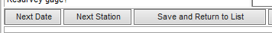
  - Click Next Date to enter more lake level data for same site. If you have data for several dates at the same site, choose this option.
  - Choose Next Station to enter data for a different site on the same date.
  - Click Save and Return to List to enter data for other sites. If you choose this option, you will see a list of all data you have entered for your sites.
- Please email photographs of the staff gage to Lindsey Albright. Please rename photographs using the following naming style “Lake Name_MMDDYY”
- After entering the lake level data in SWIMS check ‘yes’ on the datasheet to indicate that you successfully entered your lake level data, completing the monitoring event.
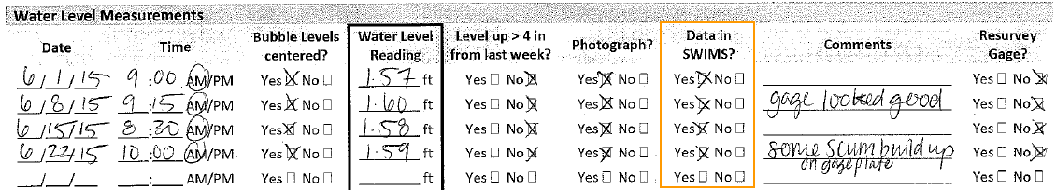
Please contact Lindsey Albright or Jennifer Filbert if you have any questions about or issues with the data entry process in SWIMS.
Please use the following protocol to edit your lake level monitoring data:

- Login to SWIMS at: https://dnrx.wisconsin.gov/swims
- Click the ‘Submit Data’ tab.
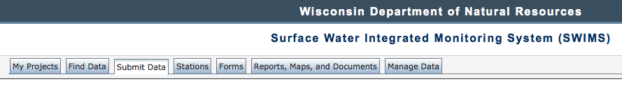
- Click ‘View List’.
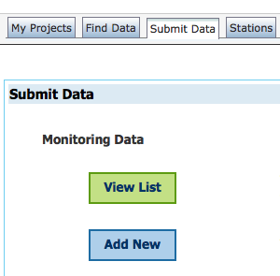
- Click the pencil for the date you want to edit.
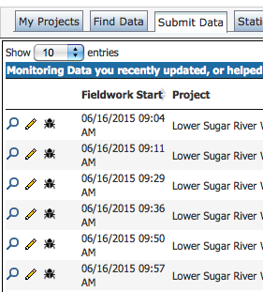
- You can edit comments, etc. on the first page, then click Next.
- You can edit results on this screen.
- Click Save and Return to List to save your changes.
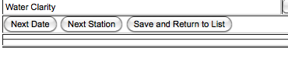
Please use the following protocol to view your lake level monitoring data:

- Login to SWIMS at: https://dnrx.wisconsin.gov/swims
- Click the ‘Submit Data’ tab.
- Click ‘View List’.
- Click the magnifying glass to view previously entered data.

Quality Assurance

Field Monitoring
To ensure that lake level data is high quality, DNR staff will conduct two in-field quality assurance checks on all volunteers during the 2015 field season. In June/July, a WDNR staff member will join the volunteer in the field, and each person will record independent lake levels and then compare results. Both readings need to be recorded in SWIMS (lake levels recorded by WDNR will be flagged as “duplicates”). In August/September, a WDNR staff will make an unannounced, solo visit to the staff gage and take an independent reading on the same day as the volunteer. These data will again be recorded in SWIMS as a “duplicate”. An acceptable margin of error between duplicate readings is 0.02 feet.
As a second quality assurance check, volunteers will email photographs of the water level on the staff gage and the bubble levels from each monitoring event. These photographs will be used to verify data entry errors or other suspect data points.
These quality assurance checks are particularly important in 2015 as we pilot the lake level monitoring program and verify the efficacy of our training sessions and protocols. They also provide external data users a measure of data accuracy.
Data Entry in SWIMS
Volunteers will use standardized CLMN lake level monitoring datasheets (see Appendix B) to record all water level data. Volunteers will be asked to check whether their data makes sense before entering it into the SWIMS database and to double check that they entered data correctly. At the conclusion of the field season, they will be asked to compare their field data sheets to the data report generated in SWIMS to identify data entry errors.
The statewide lake level coordinator will review lake level data in SWIMS monthly during the field season and again at the end of the field season. This review will include:
- Scans for data completeness
- Queries to search for outliers or extreme lake level changes (>4/10 ft in 1 week)
- Analysis of the quality assurance checks. Should suspect data be identified, the statewide coordinator will contact volunteers and/or compare to historical data if available.

Aquatic Invasive Species

Wisconsin has various laws in place to prevent the introduction and control the spread of aquatic invasive species (AIS) and diseases in Wisconsin. Please observe the regulations in NR 40.
The laws under NR 40 for aquatic invasive species:

- Prohibit the transportation of any vehicle, including boats and trailers, on a public highway with aquatic plants or aquatic animals attached.
- Require removal of aquatic plants and aquatic animals and draining of all water from any vehicles or equipment immediately upon removal from the water and before leaving any boat launch or parking area.
- Prohibit the placing of any boat, vehicle or equipment into waters of the state (statewide) if they have any aquatic plants or aquatic animals attached.

When exiting the lake, please be sure to take the following steps to prevent the spread of AIS:

- INSPECT your boat, trailer, and equipment.
- REMOVE any attached aquatic plants or animals (before launching, after loading, and before transporting on a public highway).
- DRAIN all water from boats, motors and all equipment.

Please go to http://dnr.wi.gov/lakes/invasives/ for more information about invasive species in the state of Wisconsin or contact your regional AIS coordinator (http://dnr.wi.gov/lakes/invasives/topics.aspx). For an updated list of regulated species and prohibited species, go to the following website: http://dnr.wi.gov/topic/Invasives/documents/NR40ListsSep292010.pdf

References

Elias, J. E, R. Axler, and E. Ruzycki. 2008. Water quality monitoring protocol for inland lakes.
Version 1.0. National Park Service, Great Lakes Inventory and Monitoring Network. Natural
Resources Technical Report NPS/MWR/GLKN/NRTR—2008/109. National Park Service,
Fort Collins, Colorado.

Harrelson, Cheryl C; Rawlins, C. L.; Potyondy, John P. 1994. Stream channel reference sites: an illustrated guide to field technique. Gen. Tech. Rep. RM-245. Fort Collins, CO: U.S. Department of Agriculture, Forest Service, Rocky Mountain Forest and Range Experiment Station. 61 p.

U.S. EPA. Best Practices for Continuous Monitoring of Temperature and Flow in Wadeable Streams (Final Report). U.S. Environmental Protection Agency, Office of Research and Development, National Center for Environmental Assessment, Washington, DC, EPA/600/R-13/170F, 2014.

Appendix A. Volunteer Lake Level Monitoring Instructions – Quick Sheet
A lake gage should be read once per week at approximately the same time (e.g. every Tuesday morning around 9am). Please be sure that the weather and water conditions are ideal for monitoring: winds should be calm to breezy, there should not be white caps on the lake, and there should be no threat of thunderstorms. Monitoring lake levels during these conditions will allow the volunteer(s) to effectively and safely read the water level off of the staff gage. Please contact Lindsey Albright or Katie Hein if you have any questions about this!!
Please use the following protocol to properly read the water level on the staff gage:
- Fill out the top portion of the datasheet before conducting the first monitoring event of the season. Be sure to have a Station ID number specifically for the staff gage location.
  - Contact your CLMN regional coordinator or the statewide staff if you have questions about attaining the Station ID number for the staff gage.
- Navigate to the staff gage using the lake map provided by your CLMN coordinator.
  - If monitoring from land, feel free to use binoculars for a better view of the staff gage.
  - If monitoring from a boat, please idle your engine or drop anchor and use binoculars for a better view of the staff gage.
    - Do NOT come into contact with the staff gage. Bumping up against the gage may cause the fence post to shift and make the results inaccurate.
- Record the date and time of the monitoring event on the datasheet.
- Locate the two bubble levels on the staff gage. Record whether the staff gage is vertical by indicating that the bubble levels are centered (yes/no) on the datasheet. You may close one eye or use binoculars to get a more accurate reading.
  - Check ‘Yes’ if the bubble is perfectly centered between the lines. This means that the staff gage is vertical and does not need to be resurveyed. Select ‘No’ in the ‘Resurvey Gage’ column to indicate that the gage will need to be resurveyed.
  - Check ‘No’ if any part of the bubble is to the right or left of the center box, the staff gage is not vertical.
  - Please contact Lindsey Albright as the staff gage may have shifted and will need to be resurveyed. Select ‘Yes’ in the ‘Resurvey Gage’ column to indicate that the gage will need to be resurveyed (see above photo for reference).
    - Discontinue lake level monitoring until the gage is resurveyed by professionals.
- Read the water level on the gage to the nearest 0.02 ft. Record on the datasheet.
- Review the water level readings from the previous week. Indicate if the water level has risen more than 4 inches since the last reading on the datasheet. Please contact Lindsey Albright or Katie Hein if the water level has increased by that margin in one week.
- Take a photograph of the water level on the staff gage and a separate photograph of the bubble levels. Use the datasheet to indicate that both photos were taken.
- Record any comments about the monitoring process or the status of the staff gage in the ‘Comments’ column.

Appendix B. Volunteer Lake Level Monitoring Datasheet
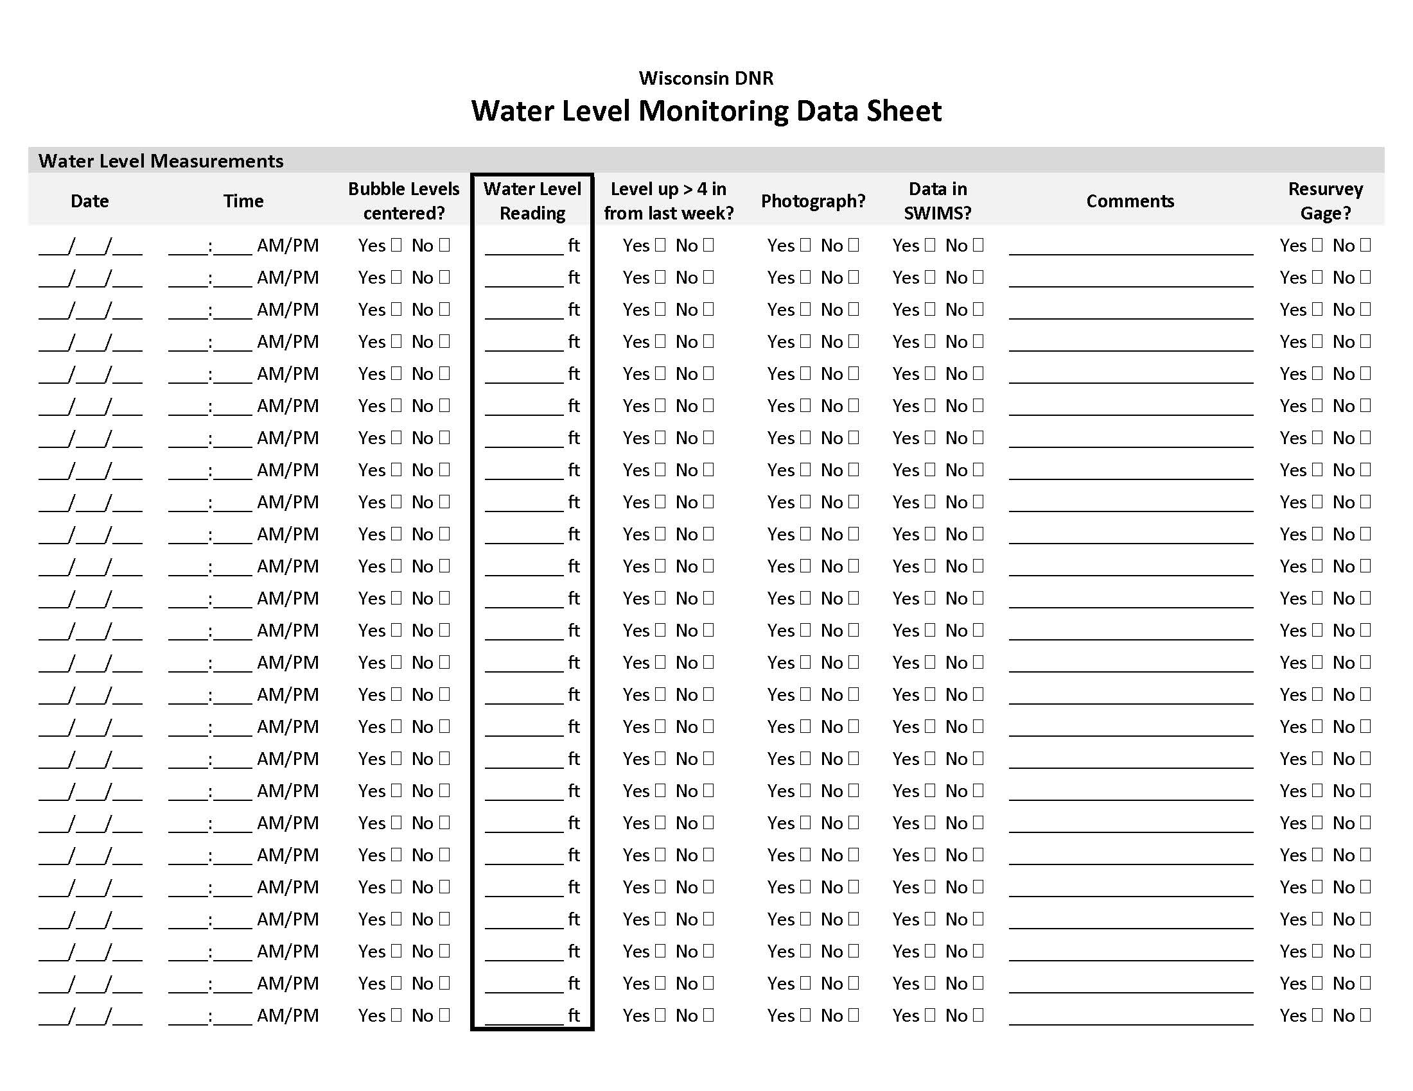

Appendix C. Citizen Lakes Monitoring Network (CLMN) Liability Form

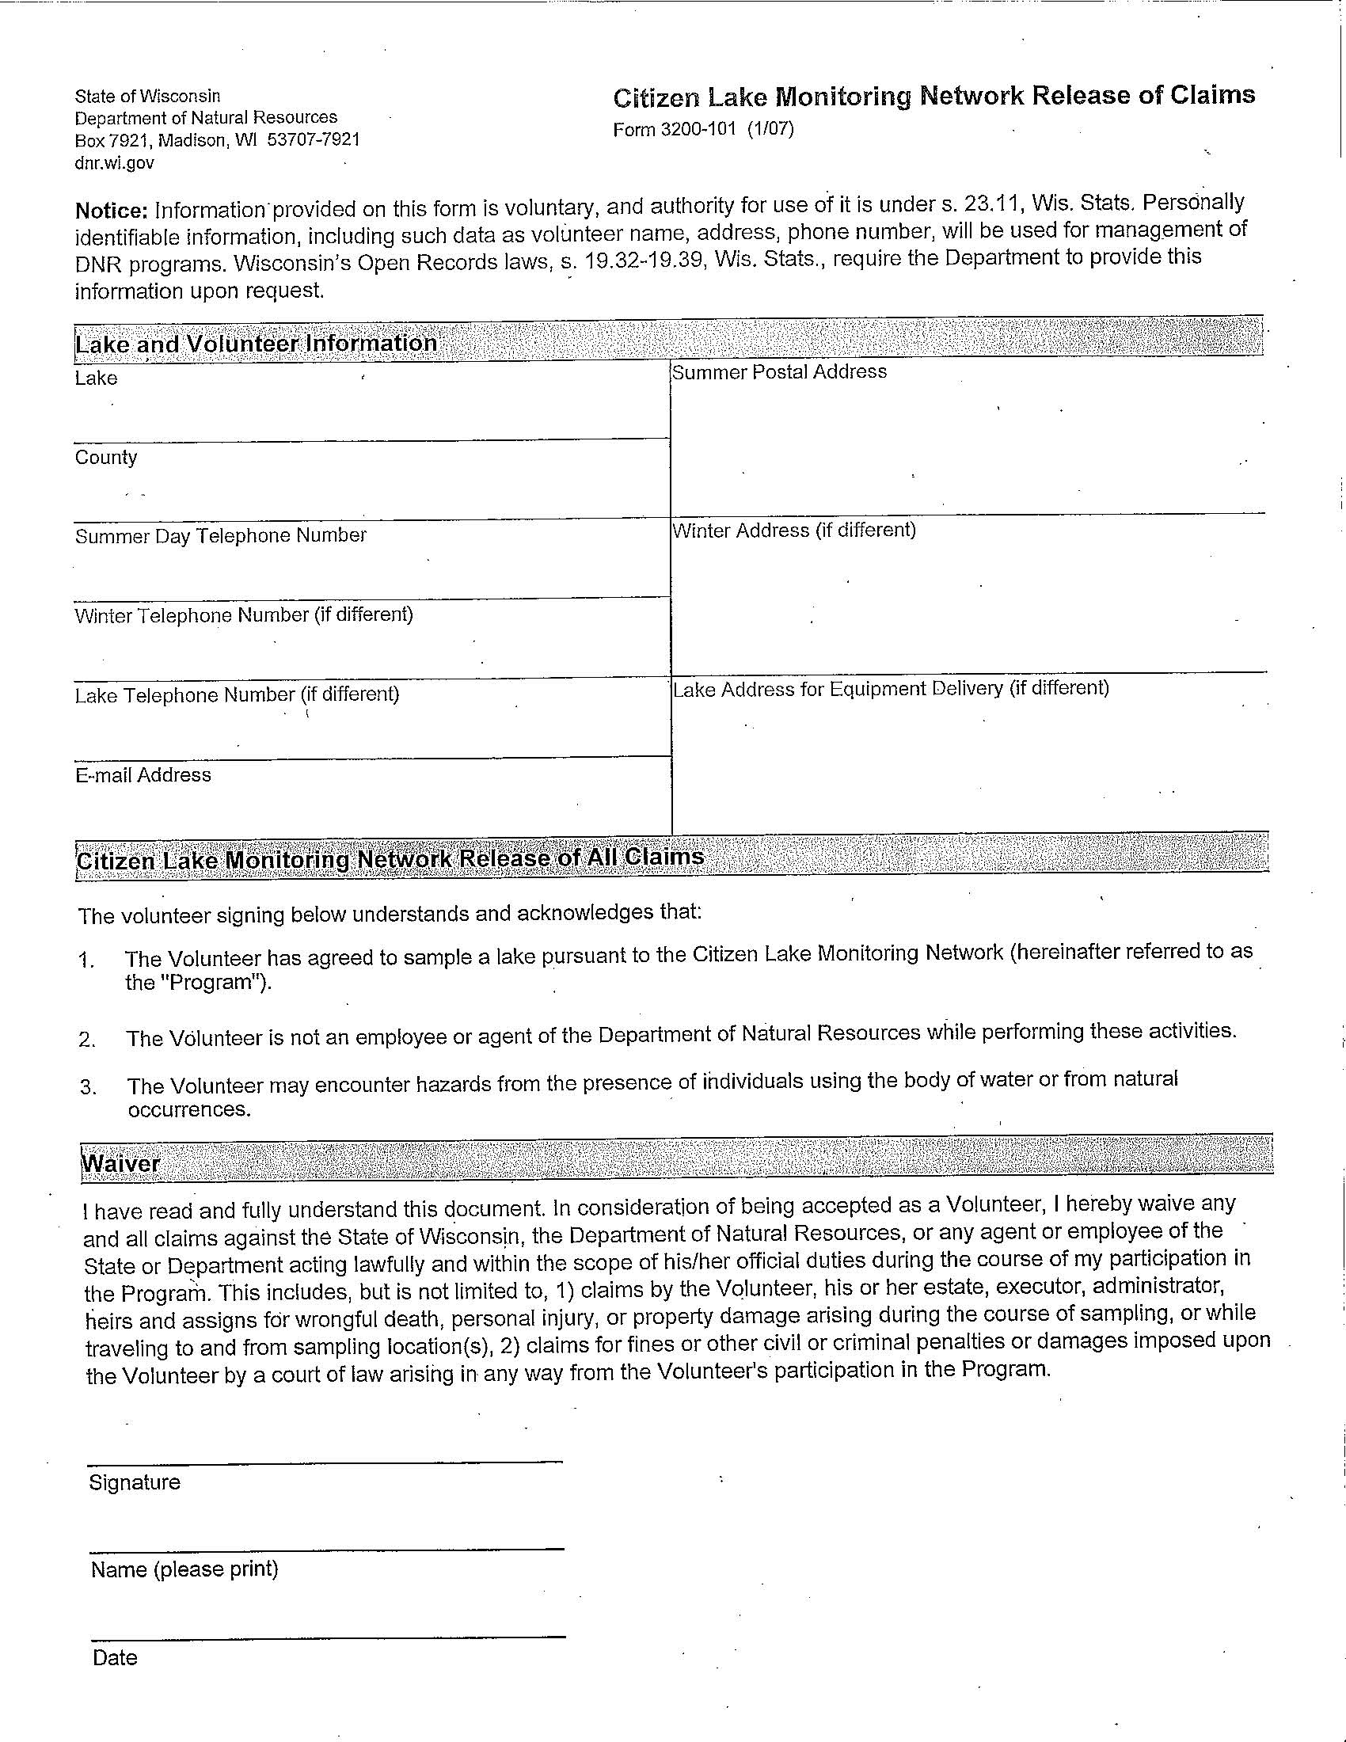

Appendix D. DOA-3009 Volunteer Agreement Form

