**LNRP Newsletter: Fall 2015**

**Restore the Shore Receives Significant Funding**

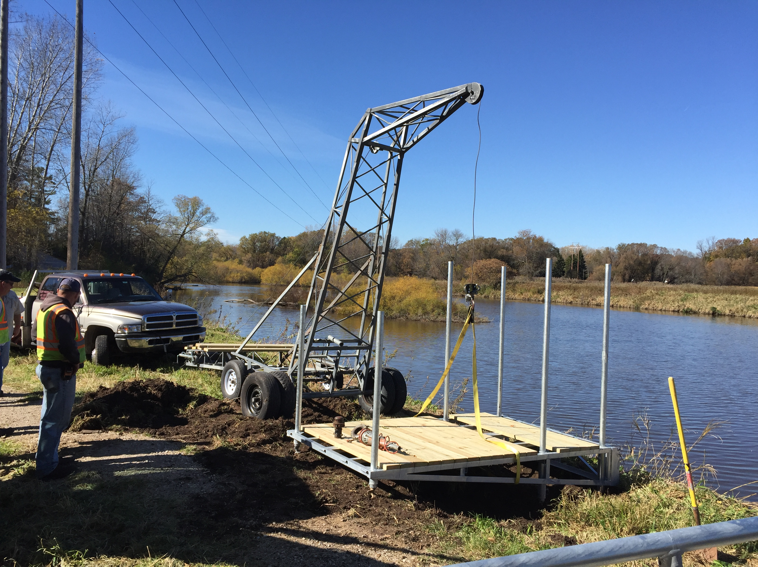The lands and waters of the Lakeshore recently received a boost of financial support when LNRP was awarded two grants for our Restore the Shore efforts. Freshwater Future and the USFWS Coastal Program contributed to our plans for invasive species management and restorative planting at Fischer Creek Park and Hika Park in southern Manitowoc County as well as supporting the efforts of our watershed partners.

Freshwater Future contributed $1,500 to support additional enhancements to the kayak launch that the Friends of the Manitowoc River Watershed installed at Lower Schuette Park on the Manitowoc River *(see related story in this issue)* and our work in restoring the coastal wetland of the Little Manitowoc River.

The USFWS contributed $25,000 for habitat enhancements for migratory birds on the Lake Michigan shoreline. The grant is in collaboration with the Woodland Dunes Nature Center in Two Rivers who received an additional $25,000.

This funding is designed to support the environmental community in the Great Lakes and protect and restore water quality and natural habitats in the Lake Michigan basin.