Mike and Holly Krieg Charlie and Lacey Robinson
Rain Garden and Rock Pit 1731 Tanglewood Trail
Rain Garden just planted: June 2015
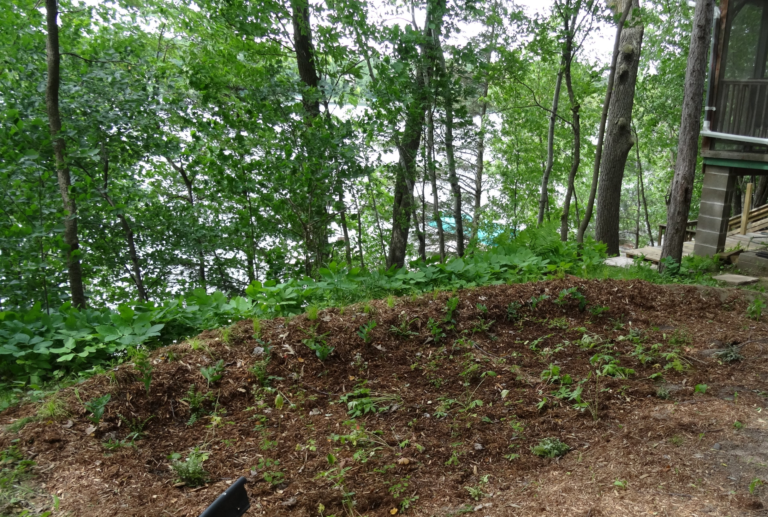
Rock Infiltration Area
Before
