Big Blake Lake

Aquatic Plant & Lake Management Plan Study Results 2014-2016
Polk County, Wisconsin
Date
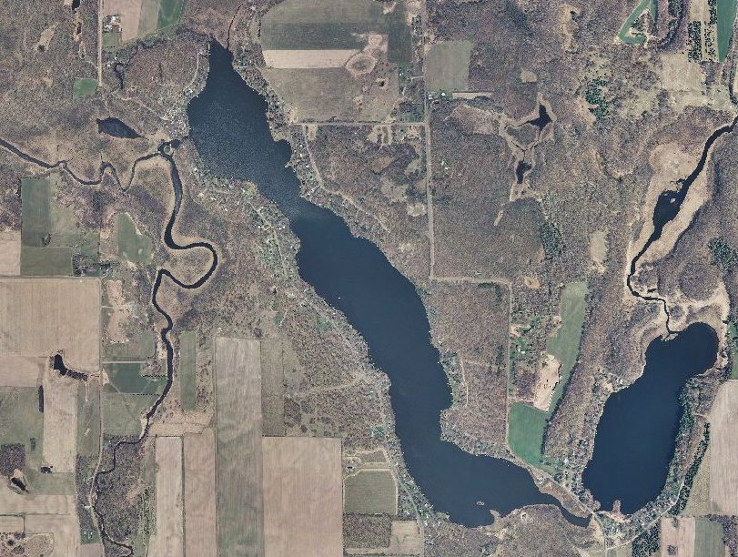
Prepared by
Polk County Land and Water Resources Department
100 Polk County Plaza-Ste 120
Balsam Lake, WI 54801
Funded by
Big Blake Lake Protection and Rehabilitation District
Wisconsin Department of Natural Resources Aquatic Invasive Species Education, Prevention, and Planning Grant AEPP-375-13
We would like to thank the following for their contributions to this project:
Sam Weber
Alex Smith
Jordan Petchenik
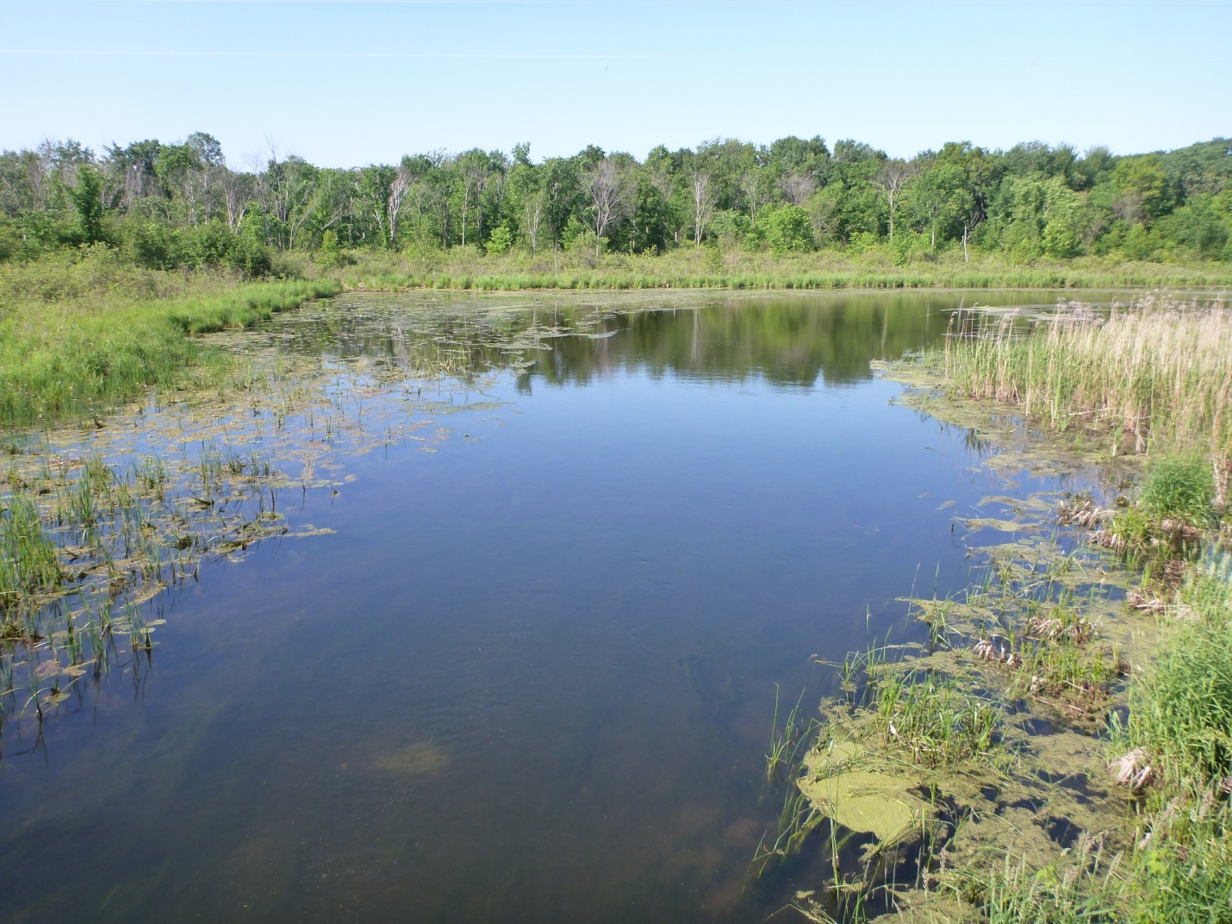

Purpose of the Study

Executive Summary

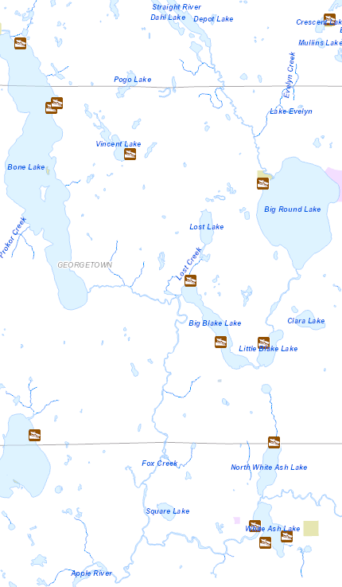
Introduction to Big Blake Lake
Big Blake Lake is located in the Town of Georgetown in Polk County, Wisconsin (T35N, R16 W, Sec. 22, 26, 27). The area of land that drains to a lake is called a watershed. Big Blake Lake is situated within the Upper Apple River Watershed, which is part of the St. Croix River Basin. The Upper Apple River Watershed is the largest watershed in Polk County, totaling approximately 125,074 acres in size.
On a smaller scale, the area of land that drains to Big Blake Lake, or the Big Blake Lake Watershed, is 15,369 acres in size. The drainage basin: lake area ratio (DB: LA) compares the size of a lake’s watershed to the size of a lake. If a lake has a relatively large DB: LA then surface water inflow (containing nutrients and sediments) occurs from a large area of land relative to the area of the lake. The DB: LA for Big Blake Lake is approximately 61:1 (Wisconsin Department of Natural Resources Office of Inland Lakes Renewal, 1981).
Water enters Big Blake Lake through two inlets and leaves through a single outlet. The main inlet is located on the southeast end of the lake. Water flowing through this inlet originates from the Straight River, which flows through Big Round Lake and Little Blake Lake, before reaching Big Blake Lake. The second inlet is located on the north side of the lake, with water originating from Lost Lake and entering Big Blake Lake through Lost Creek. The outlet is located on the northwest side of Big Blake Lake and flows to the Apple River via Fox Creek.
The residence time is the average amount of time water remains in a body of water. The residence time for Big Blake Lake is 0.10 year, meaning that water is replaced approximately every 36 days (Wisconsin Department of Natural Resources Office of Inland Lakes Renewal, 1981).

Lake Classification
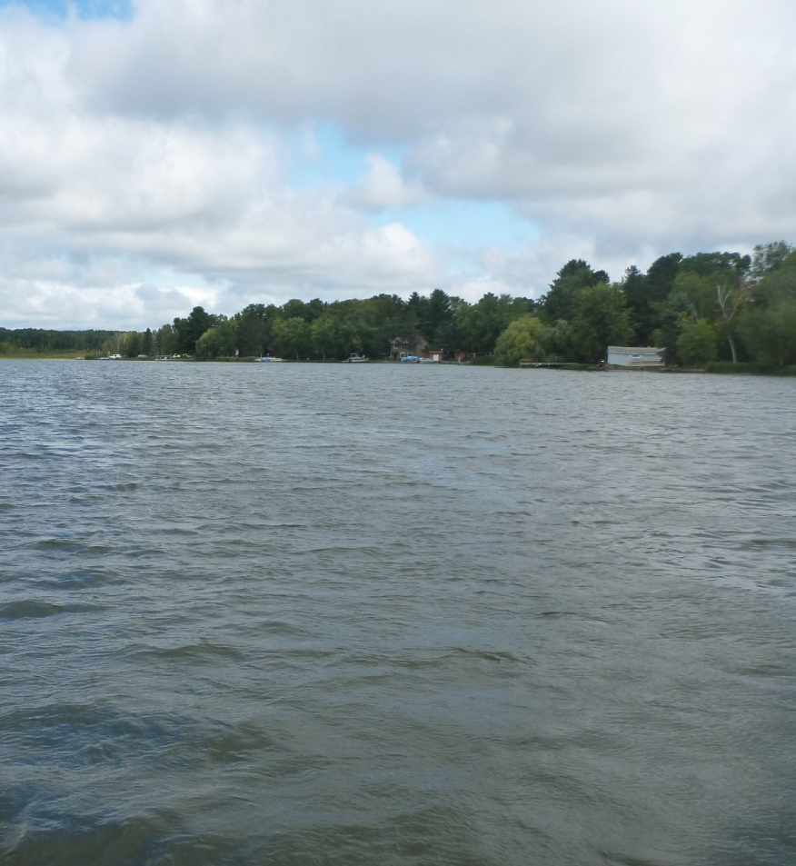
Lake classification in Polk County is a relatively simple model that considers:
- lake surface area
- maximum depth
- lake type
- watershed area
- shoreline irregularity
- existing level of shoreline development
These parameters are then used to classify lakes as class one, class two, or class three lakes.
Class one lakes are large and highly developed.
Class two lakes are less developed and more sensitive to development pressure.
Class three lakes are usually small, have little or no development, and are very sensitive to development pressure.
Big Blake Lake is classified as a class one lake.
The Big Blake Lake District includes two hundred twenty two residences. The majority of the shoreline property on Big Blake Lake is parceled into 100 foot lots, although a moderate tract of forested land remains on the east side of the lake.
There are two ramp public access sites on Big Blake Lake located on the northeast and southwest sides of the lake.

Big Blake Lake Characteristics
Big Blake Lake (WBIC: 2627000)
Area: 208 Acres
Maximum depth: 14 feet
Mean depth: 9 feet
Bottom: 55% sand, 0% gravel, 0% rock, and 45% muck
Hydrologic lake type: drainage
Total shoreline: 6.65 miles
Invasive species: Curly leaf pondweed, Chinese mystery snail, banded mystery snail
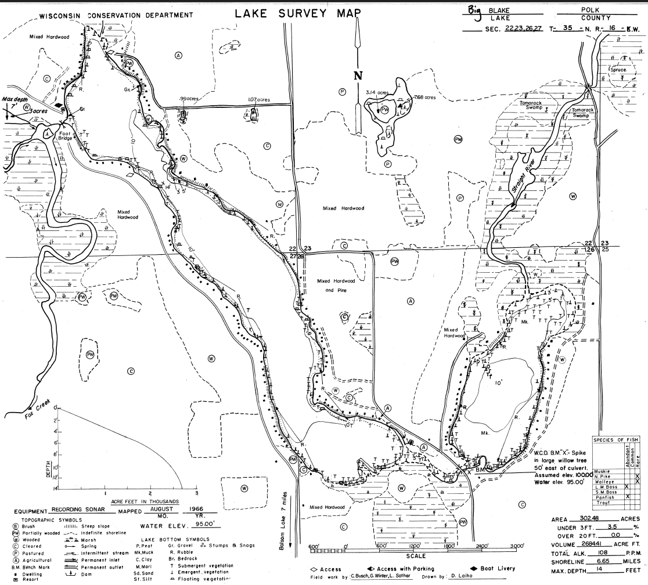

Designated Waters and Sensitive Areas
A designated water is a waterbody with special designations that affect permit requirements.
Big Blake Lake is designated as an Area of Special Natural Resource Interest (ASNRI) Endangered, Threatened, or Special Concern Lake. The Natural Heritage Inventory Program identifies waters or portions of waters inhabited by any endangered, threatened, special concern species, or unique ecological community indentified in the Natural Heritage Inventory.
An Integrated Sensitive Area Survey Report was completed for Big Blake Lake in August, 2000. This survey identified three areas of Big Blake Lake that merit special protection of aquatic habitat. Sensitive area A is located on the northern end of Big Blake Lake and covers approximately 400 feet of shoreline and extends out as far as 100 feet, sensitive area B is located at the northeastern end of Big Blake Lake and covers approximately 400 feet of shoreline and extends out as far as 150 feet, and sensitive area C is located at the southeastern end of Big Blake Lake and the southwestern end of Little Blake Lake and encompasses the channel between the two lakes (Wisconsin Department of Natural Resources, 2000).
Wild rice was documented in sensitive areas A and C. Big Blake Lake is recognized as a wild rice water in the Wisconsin Ceded Territory (David, March 2010). 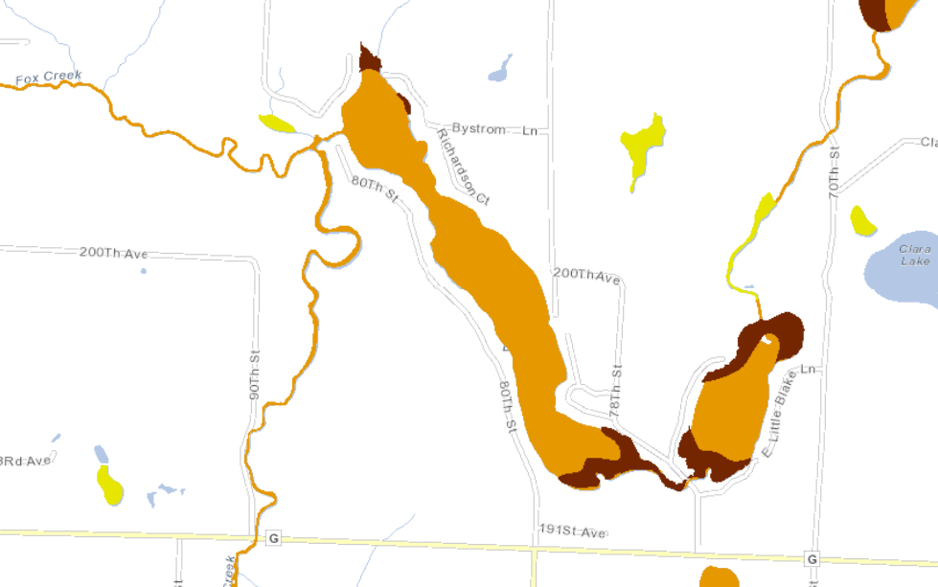
Impaired Waters
Wisconsin lakes, rivers, and streams are managed to determine if their conditions are meeting state and federal water quality standards. Water samples are collected through monitoring studies and results are compared to guidelines designed to evaluate conditions as compared to set standards. General assessments can place waters in four different categories: poor, fair, good, and excellent. The results of assessments can be used to determine which actions will ensure that water quality standards are being met (anti-degradation, maintenance, or restoration).
If a waterbody does not meet water quality standards it is placed on Wisconsin’s Impaired Waters List under the Federal Clean Water Act, Section 303(d). Every two years the State of Wisconsin is required to submit list updates to the United States Environmental Protection Agency for approval.
Waterbodies can be listed as impaired based on pollutants such as total phosphorus, total suspended solids, and metals.
The total phosphorus criterion for a body of water varies depending on lake type and whether or not a body of water stratifies. Big Blake Lake is classified as a drainage lake that does not stratify, with a total phosphorus water quality standard of 40 µg/L. Big Blake Lake is not currently listed as an Impaired Water.

Previous Lake Studies
Past studies on Big Blake Lake include:
- Blake Lake Polk County Feasibility Study Results; Management Alternatives, Wisconsin Department of Natural Resources Office of Inland Lake Renewal, 1981
- Blake Lake Macrophyte Surveys and Management Plan, Barr Engineering, 1998
- Blake and Little Blake Lake Sensitive Area Survey Report and Management Guidelines, Wisconsin Department of Natural Resources, 2000
- 2004Big Blake Lake Water Quality and Technical Report, Aquatic Engineering, Inc., 2005
- 2004 Big Blake Lake Aquatic Plant Survey Technical Report and Management Plan, Aquatic Engineering, Inc., 2005
Blake Lake Polk County Feasibility Study Results; Management Alternatives, 1981
The Big Blake Lake Protection and Rehabilitation District was formed in 1976 resulting in a two year study of Big Blake Lake and its watershed by the Office of Inland Lake Renewal, Wisconsin Department of Natural Resources (November 1978-October 1979).
The three main objectives of this study were to: define a nutrient budget, define a water budget, and characterize in-lake chemistry and biological processes for Big Blake Lake.
The following sources of phosphorus loading were identified in this study and used to develop a nutrient budget:
- Surface runoff: 1,190 kg/yr, 90%
  - Approximately 70% of this loading originates from the Straight River Watershed
- Groundwater: 72 kg/yr, 5%
- Septic system leachate: 38 kg/yr, 3%
- Atmospheric deposition: 30 kg/yr, 2%
Additionally, the study determined that the net release of phosphorus from sediments was 149 kg during the study period. Data indicated that the Big Blake Lake was over half full of sediment, with a maximum sediment thickness of 25 feet.
The study classified Big Blake Lake as a productive, eutrophic body of water based on total phosphorus, secchi depth, and chlorophyll a. Dissolved oxygen remained adequate throughout the winter months and thermal stratification was not recorded during the summer months. The nitrogen to phosphorus ratio was 13:1, indicating that phosphorus is the most important nutrient for limiting algae populations.
At the time of this study, Big Blake Lake contained a diverse group of macrophytes including eight submerged species, three emergent species, and six floating leaf species. With the exception of dense curly leaf pondweed in the northwest portion of the lake, macrophyte densities were light to moderate through June. However, by August macrophyte densities were elevated in many areas of the lake with curly leaf pondweed beds being replaced with coontail. Approximately 10% (25 acres) of Big Blake Lake was covered with aquatic macrophytes during the study.
Suggested management alternatives suggested in this study include: improving the water quality of Big Round Lake, chemically removing phosphorus from the Straight River, diverting the Straight River south to White Ash Lake, controlling weeds with herbicides or harvesting, and dredging.
Blake Lake Macrophyte Surveys and Management Plan, 1998
In 1996 the Big Blake Lake District approached the Wisconsin DNR to discuss options for plant management. In response, the DNR suggested that the District complete a macrophyte survey and a macrophyte management plan for the lake. As a result, Barr Engineering completed macrophyte surveys during June and July 1997.
Macrophytes were surveyed using a series of 29 transects at approximately 500 foot intervals along the shoreline. Each transect was divided into depth categories of 0-1.5 feet, 1.5-5 feet, and 5-10 feet (or the maximum rooting depth), with four rake samples taken at each depth category.
The study determined that the total area of macrophyte growth was 122 acres (49% of the lake surface area) in June and 120 acres (49% of the lake surface area) in July. This compares with macrophyte growth covering only 10% (25 acres) in 1979. In the 18 years between the two surveys, macrophyte coverage in Blake Lake increased nearly five-fold.
A total of 21 species were found in Big Blake Lake with approximately 8-9 species being found in each transect. In general, each plant had a low individual density, but because there were a large number of species found at each site, overall plant growth was moderate to high. The study determined that diversity was similar when comparing 1979 and 1997 data. In both June and July 1997, the diversity index was 0.89.
Curly leaf pondweed, the only invasive plant found in the survey, was found in approximately 52% of the sample transects during June and approximately 48% of the sample transects during July. In general, densities remained low, although occasionally curly leaf pondweed was found at higher densities. The study indicated that native species were relatively successful in competing with curly leaf pondweed.
In addition to completing two plant surveys, Barr Engineering also surveyed members of the Big Blake Lake District to determine: understanding of functions and values of aquatic plants, uses of the lake, perceived impairment of lake uses by aquatic plants, and aquatic plant management preferences. Seventy-seven responses were received (31% response rate).
Most respondents (88%) recognized that aquatic plants have value, with high levels of importance for fish shelter and high to medium levels of importance for fish food. The primary uses for Big Blake Lake were fishing (94%), viewing (82%), swimming (70%), powerboating (47%), and canoeing (43%). The primary use impairments caused by plants were swimming (62%) and fishing (60%). Over half of respondents (56%) had removed or attempted to remove plants around their docks or along their shorelines. More respondents were opposed to the use of chemicals to remove aquatic plants from the lake (39%) as compared to mechanical harvesting of plants (23%). Over half of respondents (57%) indicated that the District should not own and operate a weed harvester.
The six aquatic plant management goals developed for Blake Lake include:
- Improve navigation within the lake through areas containing dense plant beds
- Remove or limit current exotic plants (i.e. curly leaf pondweed)
- Preserve native species and prevent introduction of additional exotic species
- Preserve and/or improve fish and wildlife habitat
- Protect and/or improve quality of the resources for all to enjoy (i.e., people, fish, wildlife)
- Minimize disturbance of sensitive areas (i.e. fish and wildlife)
The management plan developed for Big Blake Lake was based upon the need to provide reasonable access to the lake by residents living adjacent to very dense plant growths, control curly leaf pondweed growth, preserve the current macrophyte community, and prevent the introduction of additional species to Big Blake Lake.
The resulting management plan included:
- A harvesting plan for approximately 5 acres, with channel width restricted to 20 feet
- Herbicide treatment for approximately 60 acres of curly leaf pondweed
- Education programs to increase understanding of the function and roles of native plant communities and the threat that invasive species pose
- A plan to control the introduction of invasive species including boat inspections; littoral area inspections, informational meetings; and boat launch signage, bulletin boards and brochures with educational information
- Evaluation program to monitor the effectiveness of the plan and resurvey the plant community every five years
Blake and Little Blake Lake Sensitive Area Survey Report and Management Guidelines, 2000
A lake sensitive area survey was completed on Big Blake Lake on August 17th, 2000. The report indicated three sensitive areas in Big Blake Lake.
Sensitive area A is located at the Northern end of Blake Lake and covers approximately 400 feet of shoreline and extends out as far as 100 feet. The area encompasses the alder thicket and open/shallow water wetland area north of the boat launch. The majority of the shoreline in this area is considered “wild” with little or no development and high scenic beauty.
Sensitive area B is located at the northeastern end of Big Blake Lake and covers approximately 400 feet of shoreline and extends out as far as 150 feet. The majority of the length is dominated by a shallow or open water wetland which has protected the area from the negative impacts of improperly developed shorelines.
Sensitive area C is located at the southeastern end of Big Blake Lake and the southwestern end of Little Blake Lake and encompasses the channel between the two lakes. The majority of the length is dominated by deep marsh and shallow or open water wetland which has protected the area from the negative impacts of improperly developed shorelines. However, some developed shorelines with minimal buffers do exist in the area. It is recommended that these shorelines should create suitable vegetative buffers for approximately 35 feet.
All three sensitive areas provide important habitat for bass, panfish, and northern pike spawning and nursery areas, forage species, and wildlife. Additionally, loons, herons, waterfowl, songbirds, furbearers, turtles, and amphibians benefit from the valuable habitat in these sensitive areas.
Wild rice was documented in sensitive areas A and C and should be allowed to proliferate.
The report recommends that chemical treatment and mechanical harvesting not be allowed in sensitive area A, and that these actions be limited to navigational channels only in sensitive area B and C.
2004 Big Blake Lake Water Quality and Technical Report, 2005
In 2004, the District received a WDNR grant to monitor Big Blake Lake water quality. The purpose of the study was to collect basis physical and chemical water quality data, algae data, zooplankton data, and develop a phosphorus budget. The final report was prepared by Aquatic Engineering, Inc.
Data indicated that Big Blake Lake was eutrophic and did not thermally stratify. The TN:TP ratio was approximately 12.5:1. In July and September the most common algae division was cyanophyta, or blue green algae. In August and September the zooplankton community was dominated by rotifers.
The Big Blake Lake watershed was determined as 798.37 acres and summed for each functional category. This study determined the largest land uses in the Big Blake Lake Watershed as forest (385.8 acres) and grassland (144.6).
WiLMS was used to determine the most likely total annual phosphorus load to Big Blake Lake was 808 kg. This value includes 712 kg/year as point source load and 96 kg/year as non-point source load but does not include internal loading or groundwater interactions. The study determined that the single largest load in 2004 came from the Straight River (85% of the total load or 703.7 kg/year).
To improve the water quality of Big Blake Lake the study recommended: public education and implementation of butter strips and shoreline restoration, creating committee to improve the Straight River Watershed, working with Polk Count and townships as they create land use and zoning regulations, in lake data collection, reducing curly leaf pondweed biomass, and adopting and implementing the 2005 Aquatic Plant Management Plan goals and recommendations.
2004 Big Blake Lake Aquatic Plant Survey Technical Report and Management Plan, 2005
A second grant was awarded to the District to assess aquatic macrophytes and macroinvertebrates in 2004 in conjunction with the water quality study. Additional project activities included an assessment of riparian land use, a lake resident survey, and updates to the current lake management plan. The final report was prepared by Aquatic Engineering, Inc.
Macrophytes were surveyed in spring and summer using a series of thirty-four transects along the shoreline. Each transect was divided into depth categories of 0-1.5 feet, 1.5-5 feet, 5-10 feet, and 10 feet to the maximum rooting depth. Each sample area was divided into quadrants and sampled with a rake.
Seventeen species were identified in Big Blake Lake with 14 present in the spring and 12 present in the summer. The most common species found in the spring were curly leaf pondweed (56.9%), coontail (16.9%), and flat stemmed pondweed (12.1%) and in the summer were coontail (32%), flat stemmed pondweed (20.3%), and naiad (13.1%). The diversity value was 62.82 in the spring and 81.2 in the summer.
Curly leaf pondweed was found at 87% of the sites sampled in the spring and 20% of the sites sampled in the summer.
Macroinvertebrates were collected in June and July at three different site conditions: curly leaf pondweed dominated communities, moderate curly leaf pondweed communities, and native plant communities. In general, diversity and richness did not differ significantly across sites.
At each point where the macrophyte transect intersected the shoreline, the riparian area was classified as natural or disturbed. Approximately three quarters (79%) of the shoreline was classified as disturbed as compared to natural (21%).
A survey was distributed to all members of the District in the spring of 2005 to engage public participation and determine resident opinions and concerns. The survey had a 40% response rate (87 surveys completed out of 218). Over two-thirds of respondents (69%) are seasonal/part time residents. Respondents most frequently described their property immediately adjacent to the lake as moved lawn leading to a pier. Over half (60%) of respondents feel that fertilizers and weed killer is not necessary to maintain lawns around the lake. Clear water received the most rankings as the issue of greatest importance. In the time since respondents have lived on Big Blake Lake over half perceived the following conditions to have worsened: nuisance weed growth, algae growth, noise, personal watercraft traffic, motor boat traffic, and muckiness of lake bottom.
The vast majority of respondents felt that overall there are too many plants in Big Blake Lake (87%), that there are areas in the lake where aquatic plants become especially problematic (86%), and that the current weed management program is not effectively controlling nuisance plant growth (89%).
Over half of respondents believe that recreational activities and lake uses are occurring that are seriously jeopardizing the health and safety of Big Blake Lake (52%) and are in favor of expanding slow-no-wake times and/or locations to promote safety and protect sensitive habitat areas (56%).
The study outlines an implementation plan for Big Blake Lake which included immediate, short range, and long-range actions. Immediate actions include education campaigns to inform residents about the value of aquatic plants and what they can do to help improve water quality and short-range actions include harvesting curly leaf pondweed throughout the lake in the spring and native plants in designated navigational channels in the summer. Long range actions include improving water quality by implementing best management practices in the Straight River Watershed and promoting the growth of native plants in sensitive areas.

A drainage lake is fed by streams, groundwater, precipitation, and runoff and drained by a stream.
This study indicated that the Big Blake Lake Watershed was 798.37 acres in size. However, when all the land uses in the watershed are added the total equals 895.3 acres. Removing the lake surface area of 230 acres does not alleviate the discrepancy in acreage.
Percentages for frequency of occurrence, relative percent.

