Targeted Watershed Assessment

Water Quality

In

The North Branch Beaver Creek Watershed

2014

Marinette County, Wisconsin

Project ID East_TWA_4_2014
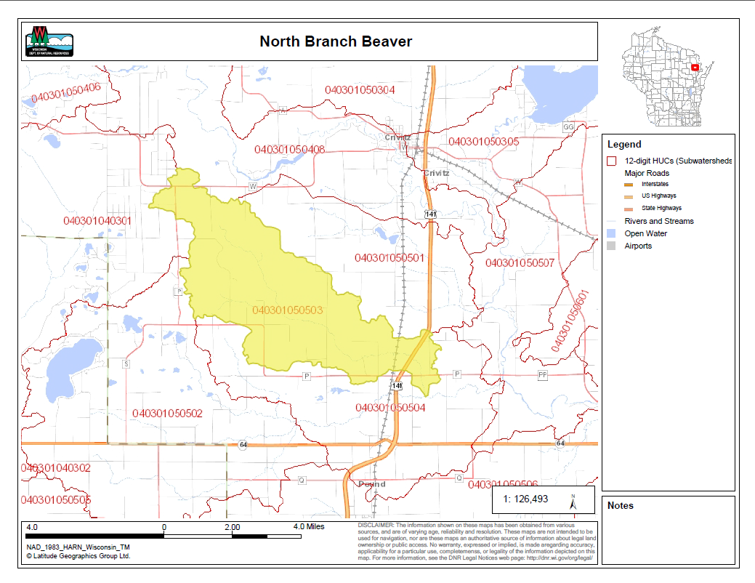
By Andrew Hudak
Water Quality Biologist – Water District East
December, 2015
North Branch Beaver Creek-Targeted Watershed Monitoring Report
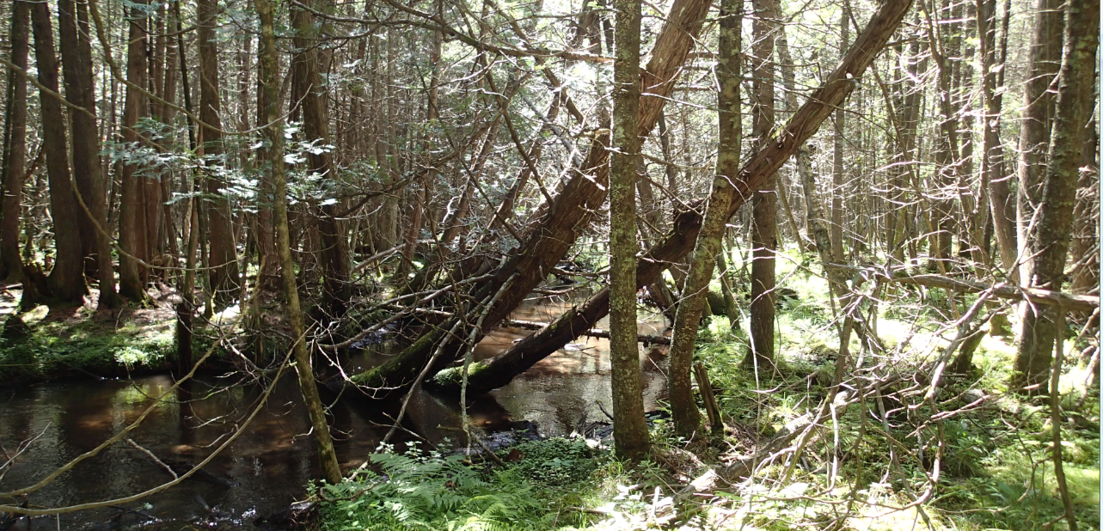

Introduction

The North Branch of Beaver Creek is an 11.86 mile long tributary to the Peshtigo River within the Little Peshtigo River watershed in southern Marinette County. The North Branch Beaver Creek sub-watershed is 20.8 square miles with streams that are mainly cool to cold water. The North Branch Beaver Creek is an excellent brown and brook trout stream with hard, clear, and slightly alkaline waters which are conducive to high productivity. Walker Creek, and a smaller unnamed headwater streams comprise the streams that all capable of supporting trout and mottled sculpin and are classified as Outstanding Resource Waters. There are no waterways listed as impaired in the sub-watershed.

Land use in the sub-watershed is primarily forested wetlands with some agricultural production located along the southern and northern borders of the watershed. The riparian corridor is largely conifer wetlands comprised of white cedar. Like most of other areas of southern Marinette County, early logging followed by fire and then agricultural development have led to legacy impacts to the stream. There are no permitted wastewater dischargers however one CAFO is located just outside the watershed boundary to the north. Conservation work to protect the stream dates back to the 1950’s when the first project to fence the stream occurred. Since that time, the state has acquired significant land ownership within the watershed and pressure from agricultural land uses in the immediate stream corridors has subsided. The headwaters and origin of the North Branch of Beaver Creek is of special importance. An initial spring, locally known as Williston Springs, followed by a series of spring seeps along the bank form the headwaters.

Methods
Water quality monitoring was conducted at 8 wadeable sites throughout the watershed in the spring, summer, and fall of 2014. During each field visit, basic water quality parameters including air temperature, water temperature, conductivity, dissolved oxygen, dissolved oxygen percent, pH, flow, and water clarity were collected. Total Phosphorous samples were collected by a citizen volunteer once per month throughout the growing season from May-October. A continuous temperature HOBO was installed at this site and collected continuous water temperature reading between May-October.

Site Selection – Sites were selected so data would not be biased toward stream order, location, or natural community; however sites may have been targeted based access, limited or outdated data for that particular stream reach. Sample stations were established to limit outside influences and set-up using DNR field procedures manuals of 35 times the mean stream width (Modified from Simonson, et al. 1994). Stations were no less than the minimum of 100 meters and no more than the maximum of 400 meters.

Continuous Water Temperature Monitoring- An Onset Hobo water temperature data logger was placed within the sample station used for fish and habitat survey at the station nearest the pour point upstream of CTH P. Temperature readings were collected every 15 minutes from May thru October. Temperature data will be used to determine relative thermal regimes for the sample station and to ascertain average daily summer time maximum temperatures.

Fish Surveys- Fish surveys were completed through the identified sample station. A direct current electrofishing backpack shocker or tow behind stream shocker was used to collect all fish possible through an upstream pass through the sample station. Typically the back pack units were used on the small streams up to 3 meters with a single probe and the stream shockers were used with a generator and 2 probes on the remainder of sites over 3 meters. All fish were collected, identified, and counted. All gamefish were measured. All other WDNR sampling protocols were used to assess the fish community for purposes of calculating the index of biotic integrity.

Habitat Surveys- At the established pour point station, a quantitative habitat evaluation was completed. A total of 12 transects were located equidistant throughout the station to sample representative available habitat. Quantitative habitat metrics were collected such as average stream width and depths, depths of fines, substrate, embeddedness of substrate, macrophyte or algal growth, canopy cover, riparian buffers, land use, stream bank erosion, and fish cover. The station length was established at a distance 35 times the mean stream width. The remaining stations had qualitative habitat assessment completed which utilize a condensed protocol to obtain the same habitat metrics as if complete quantitative habitat protocols were used.

Macroinvertabrate Sampling- Macroinvertebrate samples were obtained by kick sampling a collection using a D-frame net at all 8 sites in the watershed in fall. These samples were sent to the University of Wisconsin-Stevens Point for taxonomic classification, analysis, and computation of a Macroinvertabrate (M-IBI) and other usable metrics.

Table 1: Sample site survey locations in the North Branch Beaver Creek Watershed 2014

Waterbody | WBIC | Location | Order
NORTH BRANCH BEAVER CREEK | 520400 | Upstream CTH P | 4
NORTH BRANCH BEAVER CREEK | 520400 | Downstream 21st Road | 4
WALKER CREEK | 520700 | Downstream 37th Road | 3
NORTH BRANCH BEAVER CREEK | 520400 | Public Access Lands 37th Road | 2
WALKER CREEK | 520700 | Downstream 33rd Road | 3
NORTH BRANCH BEAVER CREEK | 520400 | Upstream Walker Creek Confluence | 3
UNNAMED TRIBUTARY TO BEAVER CREEK | 520800 | Upstream confluence with North Branch Beaver Creek | 1
NORTH BRANCH BEAVER CREEK | 520400 | Downstream of 25th Road | 4

Figure 1- North Branch Beaver Creek Watershed Sample Locations

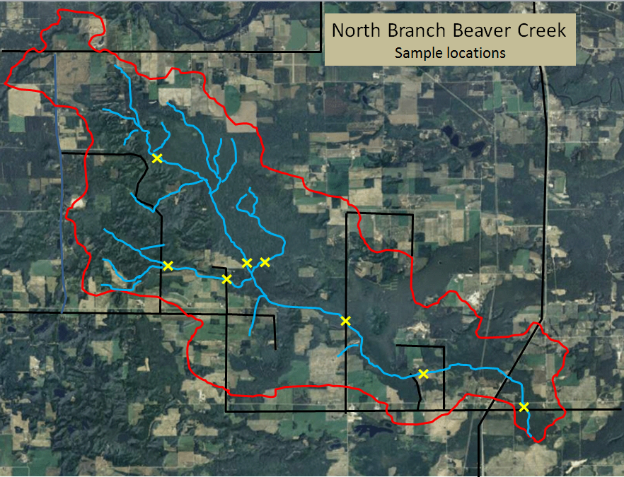

Summary Results

Results for the fisheries surveys are summarized in Table 2. The natural communities model (Lyons, 2008) indicates that the streams in the North Branch of Beaver Creek are a mix of Cool-Warm Headwater, Cool-Warm Mainstem, Cool-Cold Headwater, and Coldwater streams. Utilizing the natural community verification draft guidance, 7 of the 8 streams do not fit the modeled natural community based on the fish assemblages observed. All streams with the exception of the North Branch of Beaver Creek at CTH P best fit the thermal and size guild of species observed for Coldwater Streams. The stream reach at CTH P best fit a Cool-Cold Headwater however this is the furthest downstream segment and flows observed do not fit a headwater stream and as such the small stream/intermittent IBI should not be applied. The next most logical assumption is that the North Branch Beaver Creek is best evaluated as a Coldwater Stream.
.

Figure 2- Fish IBI scores for North Branch Beaver Creek Watershed Survey 2014
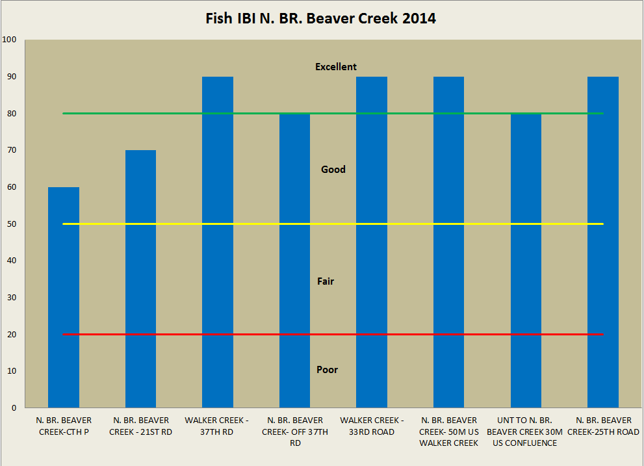

Macroinvertabrate samples were collected at all sites and evaluated with the Hilsenhoff Biotic indices (HBI, Hilsenhoff, 1987), Family level Biotic Indices (FBI, Hilsenhoff 1988) and the Macroinvertebrate index of biotic integrity (MIBI, Weigel, 2003). Results were fairly consistent among sites sampled and all sites were rated as good to excellent. (See Table 3)

Figure 3- M-IBI scores for North Branch Beaver Creek Watershed Survey 2014
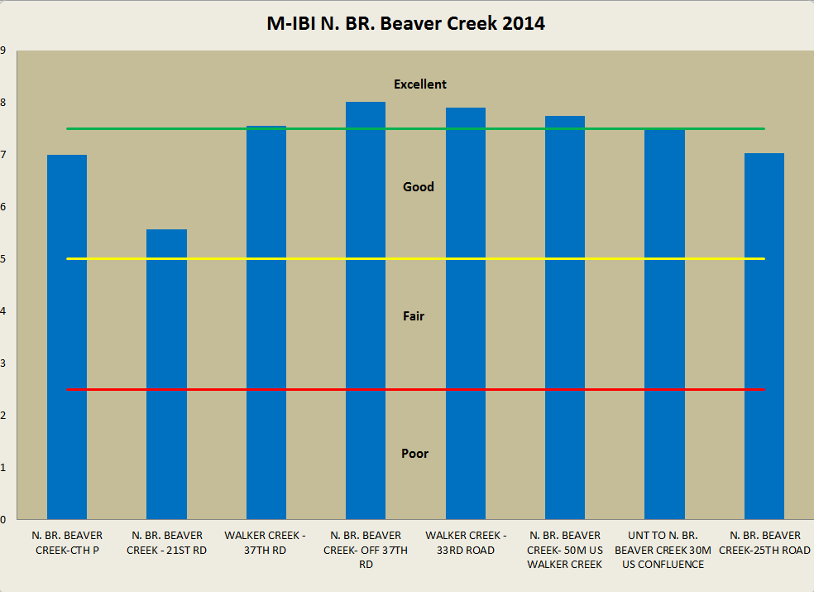

Monthly growing season, Total Phosphorous samples were collected from the furthest downstream pour point on the North Branch of Beaver Creek at CTH P. The results indicated that the state standards for total phosphorous were met and total phosphorous concentrations are below levels that would cause impairments within the stream.

Figure 4- Total Phosphorous Monitoring Results North Branch Beaver Creek @ CTH P 2014
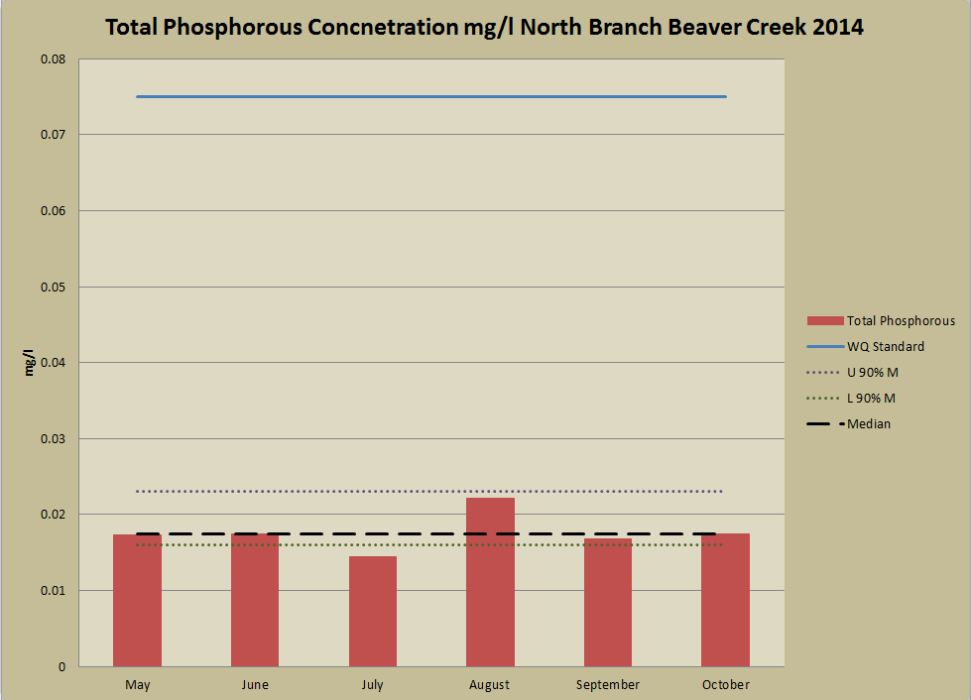

Figure 5- Continuous Temperature Reading- Walker Creek 33rd Road 2014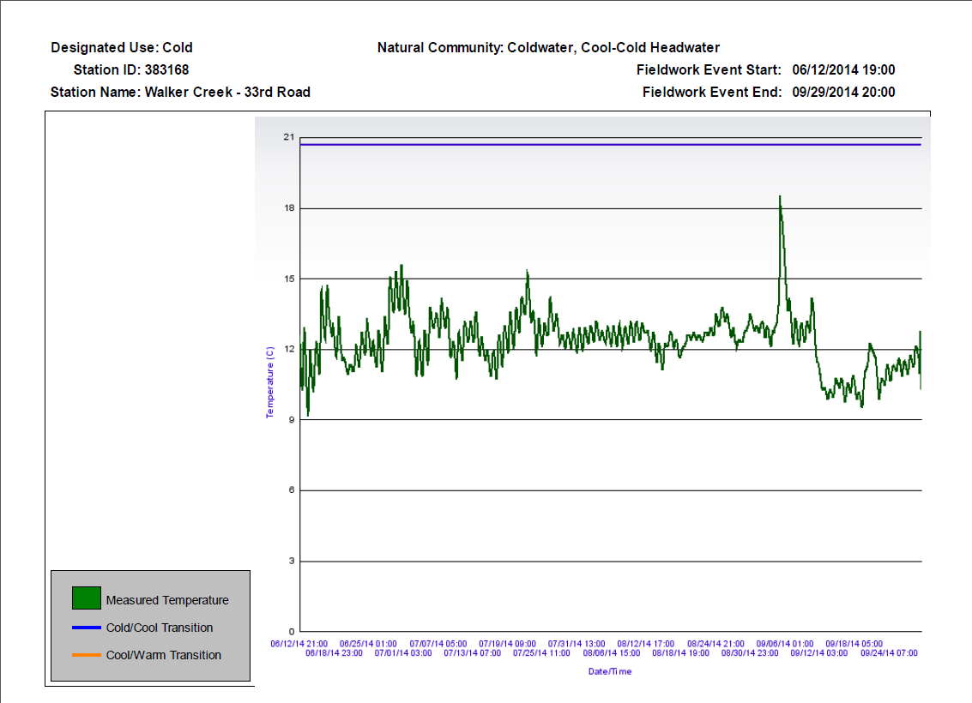

Figure 6- Continuous Temperature Reading- North Branch Beaver Creek 25th Road 2014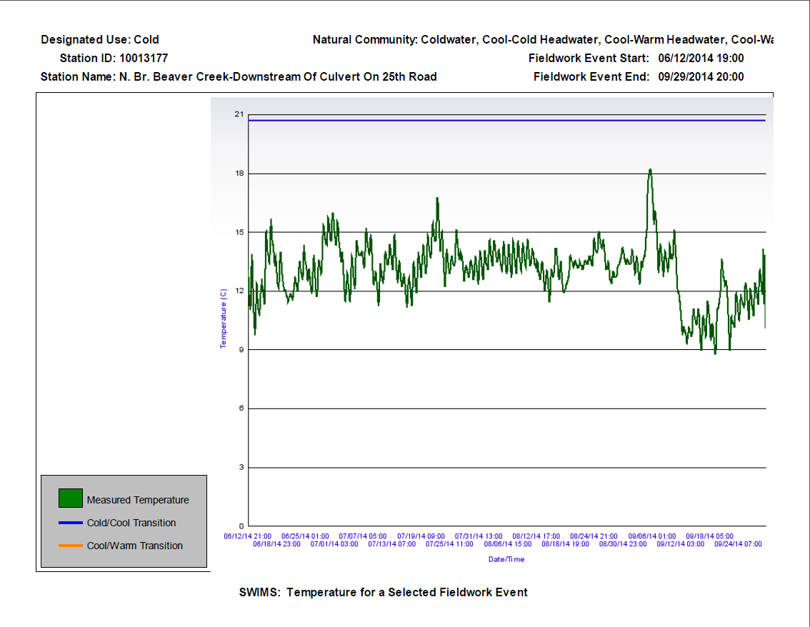

Figure 7-Continuous Temperature Reading- North Branch Beaver Creek 25th Road 2014
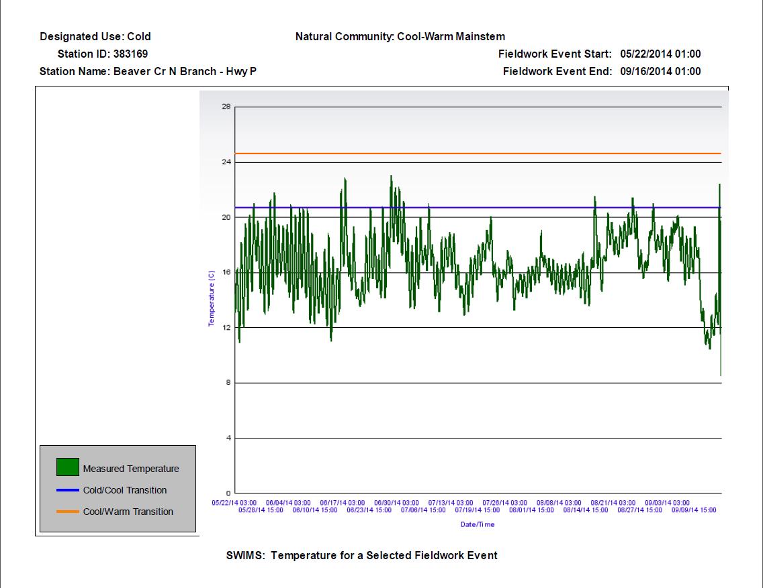

STREAM NARRATIVES

North Branch Beaver Creek
The North Branch of Beaver Creek is an excellent resource in Marinette County with good to excellent biology and other water quality characteristics. Continuous water temperature readings indicate cold water temperatures are maintained throughout the summer months. Water Chemistry results would suggest dissolved oxygen levels remains stable and nutrient concentrations meet state standards. The riparian corridor and buffer condition is in excellent conditions throughout the entire stream reach from the headwaters to the confluence with Beaver Creek. The corridor consists mainly of wooded coniferous swamps and tag alder thickets that provide excellent woody debris recruitment to the stream and shade that helps to maintain cold summer water temperatures. A large portion of this corridor is under public ownership and protected. Legacy impacts from past logging and agricultural are observed with the large extensive deposit of sand throughout the entire stream from headwaters to confluence. These extensive fines have the ability to easily cover rock riffles, fill in undercut banks, and bury log jam structures. In the mid 1980’s extensive artificial bank cover structures were installed to provide habitat and angling opportunities. These bank covers have been maintained as recently as the early 2010’s. A sand trap was excavated below 21st street to attempt to capture sands washed downstream from the removal of a large perched culvert upstream. It was noted by Department staff that this trap was completely filled after a minimal storm event. This trap was excavated only once and will likely be abandoned as an active management proposal in 2016/2017 for habitat improvements and angler access is constructed. Habitat availability and quality will continue to be a concern from the extensive sand deposits within the system for years to come.

Walker Creek
Walker Creek is 3 mile Coldwater tributary to the North Branch of Beaver Creek. It has excellent biology and habitat. Continuous water temperature readings indicate cold water temperatures are maintained throughout the summer months. The riparian corridor is in excellent condition and the stream is well buffered as it flows throughout mostly coniferous swamps and northern hardwood and coniferous woods. Public ownership throughout the stream corridor will ensure protection of this valuable resource into the future. Walker Creek is limited by its lack of deep pools and amount of fines. Legacy impacts from logging and agriculture are apparent; however the stream habitat still remains in excellent condition. To help improve conditions further, and help limit sand depositional movement downstream into the North Branch of Beaver Creek, a sand trap was installed above 33rd road. This trap has only been cleaned once since its installation in 2010.

Unnamed Tributary to Beaver Creek
The unnamed tributary to the North Branch of Beaver Creek just upstream of the confluence of Walker Creek and the North Branch of Beaver Creek is a small cold-water tributary. This stream had good biology with fair habitat. This tributary is flow and habitat limited. Extensive fins are a concern that has impacted the stream by increasing the width to depth ratio, covering coarse substrate, and filling in pools. Limited flow in this tributary has and continued to prevent these fines from transporting downstream and exposing coarse substrate and cutting new pools. However, with habitat being limited in this tributary, the importance for continual cold water base flow to the North Branch of Beaver Creek cannot be overlooked.

DISCUSSION

The North Branch Beaver Creek watershed is generally rated as good to excellent water quality for biology, habitat, and water chemistry. It was identified in the mid 1950’s that this watershed was a unique and outstanding trout fishing resource that needed protection and improvement. Legacy impacts from logging and agriculture have caused irreversible change to the stream. Logging cleared the ridges, woodlands and swamps in the late 1800’s and extensive erosion caused significant sedimentation to occur into the valley floors and waterways. Following logging, the general landscape in close proximity to the stream corridors was not entirely conducive to agricultural practices other than grazing, and as such these historic issues had been easily identified and corrected through conservation practices. Even with legacy impacts still impacting conditions today, the North Branch of Beaver Creek, Walker Creek and its unnamed tributaries are thriving and in good condition. Based on current land use, recreation, and likely development into the future, the biggest threats to water quality in the watershed include logging, rural development, aquatic invasive species, and high capacity wells.

The forestry industry is substantial in Wisconsin for both state and county managed forests and also private land ownership. To prevent significant impacts to streams within the watershed, all forestry activities should strictly follow Wisconsin’s Forestry Best Management Practices for Water Quality Field Manual. This manual should be used by loggers, landowners and land managers to plan and implement forestry best management practices to prevent degradation of the water resources in the watershed. Of special importance is the protection and preservation of the coniferous forested wetlands throughout the immediate stream corridor. Special silviculture practices for this forest type should be employed to ensure the preservation and regeneration of this forest type.

Wisconsin’s strong outdoor heritage leads to continual pressure from rural development in the form of seasonal cabins or secondary homes. Proper site planning and best management practices during construction for erosion control should be the standard. Highly erodible areas near stream banks, steep slopes, and springs should be avoided to prevent additional sedimentation downstream into the waterways and wetlands.

Aquatic invasive species are a continual threat to Wisconsin’s vast water resources. Of special concern, is the recently discovered New Zealand Mud Snail in a cold-water trout stream near Madison. While the New Zealand Mud Snail has not been discovered in other trout stream throughout the state, it is likely an easy to spread species. The likely vector for movement is fisherman. New Zealand mud Snails are prevalent out west and it is hypothesized that the Mud Snails were transported on waders or other equipment used by fisherman. Since the North Branch of Beaver Creek and Walker Creek are excellent trout fisheries, fisherman and other users should always prevent the spread if aquatic invasive species by cleaning and disinfecting gear between streams.

The local geology of the region and desire to maximize production on agricultural fields has increased demand for the installation and use of center pivot irrigation. Currently there are 4 operating center pivot high capacity wells located within the boundary of the North Branch Beaver Creek Watershed and an additional 10 located just to the north outside of the watershed. It currently does not appear that these wells are having any measurable impact to the flow or thermal regime to the streams in the watershed. Thorough evaluation of future proposed high capacity wells should ensure no impacts to the North Branch Beaver Creek, Walker Creek, their unnamed tributaries, or any springs will occur.

Table 2. Fisheries Surveys and Index of Biotic Integrity Scores in the North Branch Beaver Creek Watershed 2014

2014 | North Branch Beaver Creek | US CTH P | North Branch Beaver Creek | DS 21st Road | Walker Creek | DS 37th Road | North Branch Beaver Creek | Public Access Land 37th Road | Walker Creek | Downstream 33rd Road |  | North Branch Beaver Creek | US Walker Creek Confluence | UNT to North Branch Beaver Creek | US Confluence North Branch Beaver Creek |  | North Branch Beaver Creek | DS 25th Road
Stream - Site
Stream Order | 4 |  | 4 |  | 3 |  | 2 |  | 3 |  |  | 3 |  | 1 |  |  | 4
Mean Stream Width | 5 |  | 5 |  | 3 |  | 5 |  | 3 |  |  | 4 |  | 3 |  |  | 5
Station Length | 175 |  | 175 |  | 100 |  | 170 |  | 100 |  |  | 140 |  | 100 |  |  | 175
Modeled Natural Community | CWMS |  | CWMS |  | CCHW |  | CCHW |  | CW |  |  | CWHW |  | CWHW |  |  | CWMS
Verified Natural Community | CW |  | CW |  | CW |  | CW |  | CW |  |  | CW |  | CW |  |  | CW
Fish Species
Western Blacknose Dace | 5 |  |  |  |  |  |  |  |  |  |  |  |  |  |  | 1
White Sucker | 3 |  |  |  |  |  |  |  |  |  | 1
Mottled Sculpin | 27 |  | 43 |  | 18 |  | 46 |  | 12 |  | 49 |  |  | 30 |  | 25
Creek Chub | 2
Longnose Dace | 3
Central Mudminnow | 5 |  | 7 |  |  |  |  |  |  |  | 1 |  |  | 4 |  | 1
Burbot | 1 |  | 1 |  |  |  |  |  |  |  |  |  |  |  |  | 13
Brook Stickleback | 1
Lamprey (Ammocoete) | 1 |  |  |  | 1 |  |  |  |  |  |  |  |  |  |  | 2
Brook Trout | 7 |  | 12 |  | 34 |  | 19 |  | 23 |  | 29 |  |  | 7 |  | 20
Brown Trout | 13 |  | 9 |  | 43 |  | 6 |  | 25 |  | 15 |  |  |  |  | 23
Green Sunfish |  |  |  |  |  |  |  |  |  |  |  |  |  |  |  | 1
Total # of Fish | 68 |  | 72 |  | 96 |  | 71 |  | 60 |  | 95 |  |  | 41 |  | 86
Total # Species | 11 |  | 5 |  | 4 |  | 3 |  | 3 |  | 5 |  |  | 3 |  | 8
IBI Score
Coldwater | G (60) |  | G (70) |  | E (90) |  | G (80) |  | E (90) |  | E (90) |  |  | G (80) |  | E (90)
Coolwater (CC) | - |  | - |  | - |  | - |  | - |  | - |  |  | - |  | -
Coolwater (CW) | G (80) |  | G (60) |  | - |  | - |  | - |  | - |  |  | - |  | G (60)
Warmwater | - |  | - |  | - |  | - |  | - |  | - |  |  | - |  | -
Small Stream | - |  | - |  | F (40) |  | F (40) |  | - |  | F (40) |  |  | F (40) |  | -
Habitat Score
Small Stream < 10 m | F (40) |  | G (68) |  | E (77) |  | G (68( |  | E (77) |  | E (85) |  |  | F (43) |  | E (77)

CWMS= Cool-Warm Mainstem E= Excellent
CWHW= Cool-Warm Headwater G= Good
CCMS= Cool-Cold Mainstem F= Fair
CCHW= Cool-Cold Headwater P= Poor
W- Warmwater Green value represents verified natural community score
CW= Coldwater

Table 3. Macroinvertabrate Ratings in the North Branch Beaver Creek 2014
2014 | North Branch Beaver Creek | US CTH P | North Branch Beaver Creek | DS 21st Road | Walker Creek | DS 37th Road | North Branch Beaver Creek | Public Access Land 37th Road | Walker Creek | Downstream 33rd Road | North Branch Beaver Creek | US Walker Creek Confluence | UNT to North Branch Beaver Creek | US Confluence North Branch Beaver Creek | North Branch Beaver Creek | DS 25th Road
Stream - Site
Stream Order | 4 |  | 4 |  | 3 |  | 2 |  | 3 |  | 3 |  | 1 |  | 4
Mean Stream Width | 5 |  | 5 |  | 3 |  | 5 |  | 3 |  | 4 |  | 3 |  | 5
Station Length | 175 |  | 175 |  | 100 |  | 170 |  | 100 |  | 140 |  | 100 |  | 175
Modeled Natural Community | CWMS |  | CWMS |  | CCHW |  | CCHW |  | CW |  | CWHW |  | CWHW |  | CWMS
Verified Natural Community | CW |  | CW |  | CW |  | CW |  | CW |  | CW |  | CW |  | CW
HBI Rating ¹ | 3.03 |  | 3.61 |  | 3.33 |  | 3.34 |  | 2.71 |  | 3.49 |  | 5.39 |  | 4.29
HBI Score ¹ | E |  | VG |  | E |  | E |  | E |  | E |  | G |  | VG
FBI Rating ¹ | 3.5 |  | 3.88 |  | 3.51 |  | 4.19 |  | 3.34 |  | 4.04 |  | 5.01 |  | 4.19
FBI Score ¹ | E |  | VG |  | VG |  | VG |  | E |  | VG |  | VG |  | VG
MIBI Rating ² | G |  | G |  | E |  | E |  | E |  | E |  | E |  | G
MIBI Score ² | 7 |  | 5.57 |  | 7.55 |  | 8.02 |  | 7.9 |  | 7.74 |  | 7.52 |  | 7.03

- E= Excellent (0-3.5)
VG= Very Good (3.51-4.50)
G= Good (4.51-5.50)
F= Fair (5.51-6.50)
F= Fairly Poor (6.51-7.50)
P= Poor (7.51-8.50)
VP= Very Poor (8.51-10)

- E= Excellent (7.5-10)
G= Good (5.0- 7.49)
F= Fair (2.51- 4.99)
P= Poor (0- 2.5)

