Wolf Lake, Fond du Lac County (WBIC 60800)
Herbicide Sample Plan, 2014
John Skogerboe

Wolf Lake, Fond du Lac County is 75 acres with a maximum depth of 47 ft, and a mean depth of 19 ft. The lake is classified as a mesotrophic, seepage lake in the WI DNR lake finder web site.

Water samples will need to be collected at sites and depths listed below. A map of the herbicide sample site locations is attached and the coordinates are provided with the map. Data are in degrees and the datum is WGS84. The coordinates can also be emailed to you.

Wolf Lake Herbicide Sample Sites
Site | Sample Depth
WO1-10 | Integrated, 0-10
WO1-20 | 20 ft
WO1-30 | 30 ft
WO2 | Integrated
WO3 | Integrated
WO4 | Integrated

Samples will need to be collected at different time intervals throughout the project and are listed below.

Wolf Lake Herbicide Sample Intervals, 2013
Interval | Samples/interval | Total Samples
1 DAT | 6 | 6
3 DAT | 6 | 12
5 DAT | 6 | 18
7 DAT | 6 | 24
`14 DAT | 6 | 30
21 DAT | 6 | 36
28 DAT | 6 | 42
35 DAT | 6 | 48

- Water samples can be collected using an integrated water sampler. An example of how to construct an integrated sampling device using a sump pump check valve, a 2" to 1 1/2" coupler, and an 8 to 10 ft section of PVC pipe is provided below. I can provide one if necessary, but shipping the PVC is cumbersome. The materials can be purchased at a hardware store and are inexpensive. Water is collected by pushing the pipe straight down to within 1 ft of the bottom or as far as it will go in deep water. The pipe is brought to the surface and emptied into a bucket using a screw driver to push open the check valve.

- If you already have a water sampling device that you feel comfortable with, please use that instead of the integrated sample device.

- Sample site WO1 is over 40 ft deep and the lake will likely be stratified. Water samples will need to be collected at a range of depths (see sample data sheet) at this site using a different sampling device such as a van dorn water sampler. If the lake group does not have one, it can be supplied possibly by the WI DNR or myself. The site shown on the sample map approximates the location of an area > 40 ft deep. The site can be relocated to a site nearby if the depth is < 40 ft.

- Samples should be collected at each point using a GPS at each interval listed above. Sample bottles and labels will be provided. If you need a GPS please let us know.

- Please collect a temperature profile at site W01 each time samples are collected. Measure water temperature in degrees Celsius at each meter from top to within three feet of the bottom.

- Please record daily water temperatures if possible, and record the approximate wind direction and speed (ie 5 to 10 mph, W SW) on the data sheet.

- Water sample bottle kits, including a datasheet, will be sent to the sample collection coordinator along with directions for sample handling from the State Lab of Hygiene.

If you have and questions, please call or email one of us. We can be reached at the following:

Contacts:

Others

jskogerboe@comcast.net
651-328-0769 (cell phone/voice mail)

Wolf Lake Herbicide Sample Locations, 2014
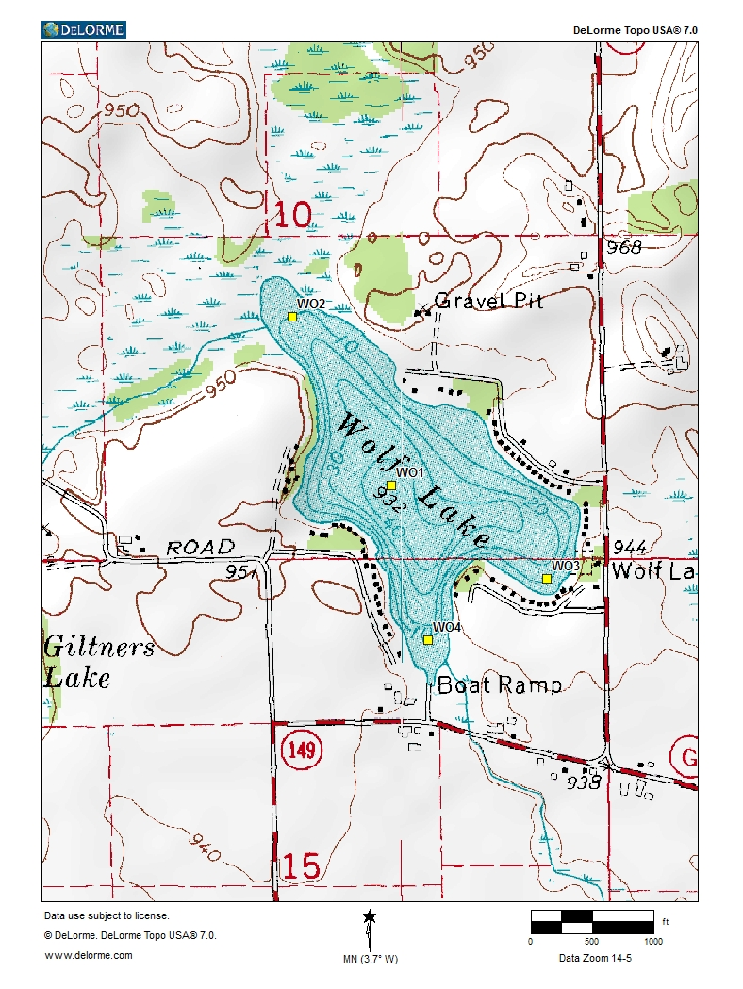

Wolf Lake herbicide sample site coordinates

North West Sample Site
43.864202 -88.208642 WO1
43.867936 -88.211678 WO2
43.862121 -88.203851 WO3
43.860769 -88.207511 WO4
Integrated Water Sample Device
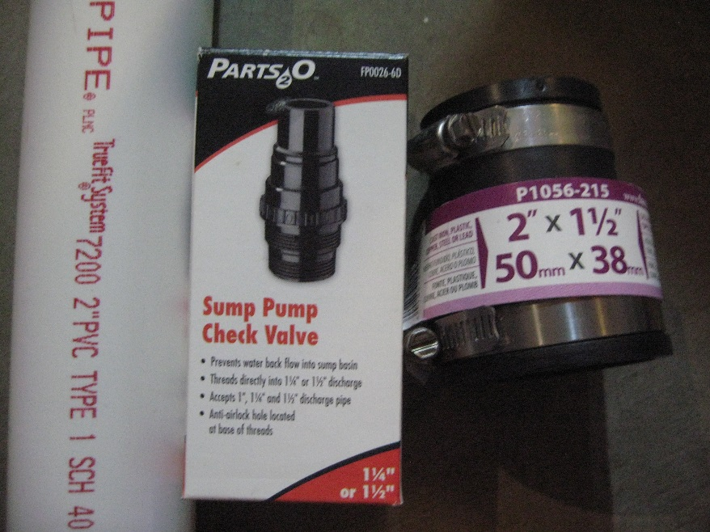
Integrated sampler requirements,
2"Pvc pipe, sump pump check valve, and 2"x 1 1/2"couping

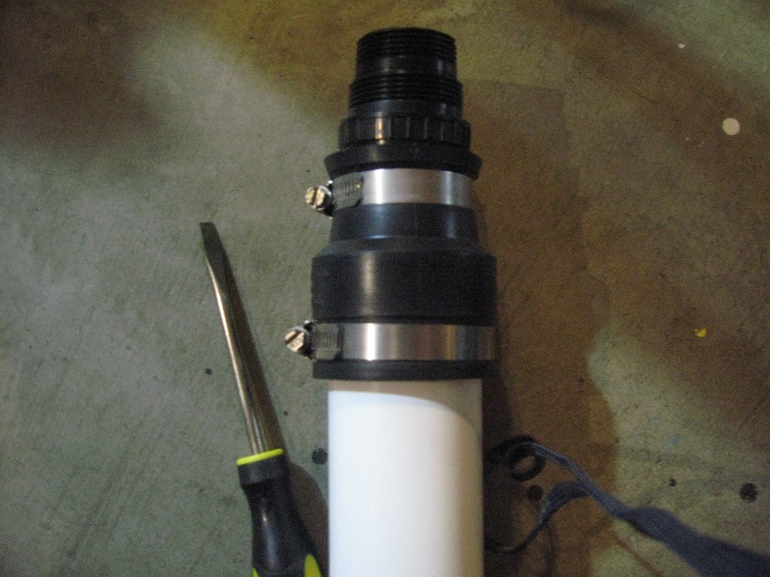
Assemble integrated sampler with a flathead screw driver.

