Final Report: Assessing the viability of phytoplankton and aquatic invertebrates in dredged river sediments of the Mississippi River

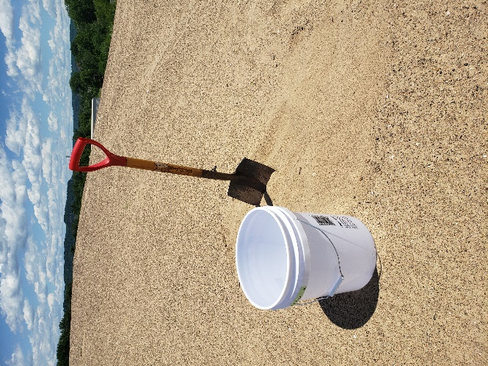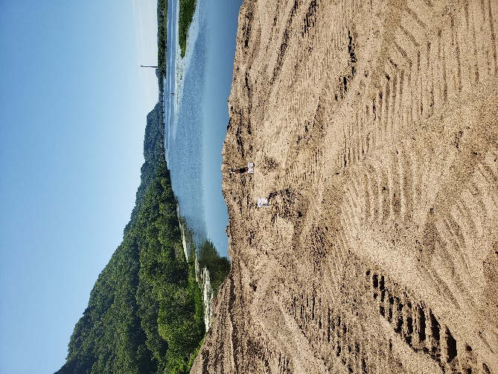

Authors:
Sarah Henkaus¹
Sara Strassman²
Ross Vander Vorste¹

Affiliations:
1 Biology Department, University of Wisconsin – La Crosse, 1725 State Street, La Crosse, WI, USA
2 Office of Great Waters, Environmental Management Division, Wisconsin Department of Natural Resources, 3550 Mormon Coulee Road, La Crosse, WI, USA

Contact:
Ross Vander Vorste, Biology Department, 3032 Cowley Hall, University of Wisconsin La Crosse, 1725 State Street, La Crosse, WI USA, rvandervorste@uwlax.edu
Abstract
River sedimentation is a longstanding environmental issue that can impair aquatic habitats and reduce navigation ability in large rivers. Dredging of river sediments is a widespread practice used to maintain navigation in the Upper Mississippi River. Beneficial use of material generated through dredging offers a disposal option that derives positive gains from excess material and reduces demands on new and existing placement sites. Beneficial use of material in waterbodies beyond the material source could pose a risk if aquatic organisms remain viable through desiccation-resistant forms. We assessed viability of aquatic organisms in dredged river sediments from four locations along the Upper Mississippi River. We artificially re-inundated sediments that had been dry for <1, 1–5, and 5–10 years and sampled phytoplankton, zooplankton, and macroinvertebrate for four weeks. We hypothesized that richness and density would be negatively affected by duration of drying. Although sediments with the shortest duration of drying did have the greatest observed richness and density of phytoplankton, zooplankton, and macroinvertebrates in the study, the effect was modest. Overall, richness and density of aquatic biota assessed was relatively low, especially following the first week of sediment re-inundation. Of the organisms that remained viable in dredged river sediments, we found no invasive species known to the waterbody. Our screening-level results suggest transporting stockpiled sand from main channel navigation dredging from the Upper Mississippi River to other waterbodies could be a feasible option to consider on a case-by-case basis.

Introduction
Sediments enter rivers naturally from eroding landscapes and create an important habitat for freshwater organisms (Meade and Parker 1984, Belmont et al. 2011), but excess sediment is the most common pollutant of rivers and streams (EPA 2006). Excess sedimentation of rivers can occur due to anthropogenic alteration of watersheds, impairing navigation of rivers by boats and potentially reducing biodiversity (Belmont et al. 2011). To facilitate commercial and recreational navigation of large rivers, sediments are removed to maintain navigation channels through the process of mechanical or hydraulic dredging (U.S. Army Corps of Engineers 1996). Dredged river sediments are often stockpiled on islands within the river floodplain or nearby riparian areas. Little is known about organisms that remain in these sediments throughout the dredging process. Therefore, the consequences of transporting dredged river sediments to new freshwater habitats for freshwater organisms remains an important question.

Many freshwater phytoplankton, zooplankton and macroinvertebrates have desiccation-resistant forms that allow persistence in habitats despite the loss of surface water (Stubbington and Datry 2013, Strachan et al. 2015). Desiccation resistance could enable individuals to survive periods of time when river sediments are humid or dry. However, survival rates of organisms decline in humid or dry sediments during prolonged periods of desiccation (Stubbington and Datry 2013). For example, Stubbington and Datry (2013) reported a steady decrease in taxonomic richness and abundance emerging from dry sediments as dry period duration increased from 0.1 days to 64 days in a meta-analysis of 10 previous studies in intermittent rivers. Desiccation resistance has also been found to be highly taxa and context dependent, suggesting community composition and site characteristics, such as drying duration and historic drying prevalence, can be important factors to consider in studies of desiccation resistance (Stubbington and Datry 2013). The potential presence of organisms in river sediments with desiccation-resistance forms indicates transporting river sediments from one waterbody to another may pose a risk of introducing novel invertebrate taxa to the receiving waterbody.

The objective of this study is to assess the viability of phytoplankton and aquatic invertebrates in dredged sediments. We quantified the abundance and taxonomic richness of phytoplankton, zooplankton and macroinvertebrates in dredged sediments of the Mississippi River following artificial rewetting. We hypothesized that time since dredging, i.e., sediment drying duration, would have a negative effect on the richness and abundance of organisms that emerge from sediments after re-inundation. This experiment will improve understanding of the risk of transporting invasive species in sediments from the Mississippi River to other locations by providing: 1) a taxa list of viable invertebrates from dredged sediments, 2) a comparison of invertebrate viability in relation to sediment time since rewetting and dredging location, and 3) a comparison of viable phytoplankton, zooplankton, and macroinvertebrates with lists of known invasive species.
Study area
The Upper Mississippi River System, comprising 2000 river kilometers from Minneapolis, MN to near Cape Girardeau, MO, is a large river system maintained to allow commercial navigation and other public and private uses (U.S. Army Corps of Engineers 2011). Commercial vessels follow a navigation channel maintained through a system of locks and dams and dredging. The dredged material from the main channel of the Mississippi River in Wisconsin is 95-99% sand (U.S. Army Corps of Engineers 1996). There is minimal silt and organic matter in the material suggesting that the material dries very quickly upon removal from the river. Once removed, the material is stockpiled into temporary or permanent stockpile sites to be made available for beneficial use. The primary upland uses of material stockpiled in the upper reaches of the river are general fill, winter road abrasive, and dairy bedding. The primary bottomland and aquatic uses of dredged material include habitat restoration and shoreline protection. To date, transporting dredged sediments has occurred within the Upper Mississippi River System exclusively, however, dredged material could service habitat restoration needs within other freshwater systems, including the Great Lakes. A key factor in material suitability for those purposes is the risk of introducing phytoplankton, zooplankton or macroinvertebrates, including known invasive species, into the receiving waters.
Within the study area, fresh, wet dredged material is stockpiled at beneficial use sites (Fig. 1) and is mechanically mixed through further site excavation and shaping. Well-drained, sandy material retains minimal moisture. Stockpiled dredge sediments can reach surface temperatures of 50°C, limiting the colonization by wind-blown seed or rhizomes. In some cases (Wabasha and Brownsville locations), sediment is moved hydraulically using river water to an upland site prior to beneficial use. This has two potential effects, first it provides a potential reintroduction of plankton in carriage water, which is expected to be minor based on the velocities, abrasive particles, and turbulence of the water in the pipeline. Second, the in-situ dredge material contains roughly 1-4% material less than 75um in size, which is further winnowed through hydraulic offload, reducing the in-situ values to roughly 0.5-1.2% (Coor and Ousley 2019, Strassman unpublished data).
Methods
Sediment collection
To assess invertebrate viability in dredged river sediments and account for potential differences in invertebrate viability caused by increased drying duration, we collected sediment samples (n=30) ranging in time since dredging (age groups: <1 year, 1-5 years, 5-10 years) and from four dredge stockpile locations (Wabasha, Alma, Brownsville, and La Crosse). A total of 5 replicate samples from each age class and dredge stockpile combinations were collected. Dredge piles were created from dredge cuts done in nearby areas on Pool 4 and Pool 8 of the upper Mississippi River (Fig. 1). We used a map generated by the Corps of Engineers (Machajewski, personal comm) to provide the age grades of materials within the Wabasha placement site. Sediments were collected on 14 June 2021 from precise coordinates at the four locations (Table 1).
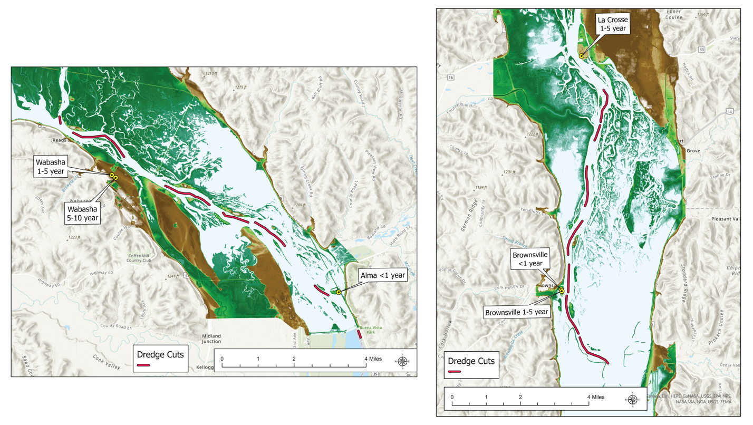
Figure 1. Location of dredged sediment storage sites and dredge cuts (site of dredging) along the Upper Mississippi River where sediments were collected for the sediment rewetting experiment.

Table 1. Attributes of dredge sites along the Mississippi River where sediments were collected for the sediment rewetting experiment.
Location Name | Navigation Pool | Year Class | Dredging Year | Latitude | Longitude
Alma | 4 | <1 year | 2021 | 44.3394416341 | -91.9287307763
Brownsville | 8 | <1 year | 2021 | 43.6921843949 | -91.2727086347
Brownsville | 8 | 1-5 year | 2016 | 42.6927665746 | -91.273101409
La Crosse | 8 | 1-5 year | 2020 | 43.7909656841 | -91.2579708892
Wabasha | 4 | 1-5 year | 2016 | 44.3819608463 | -91.0528642037
Wabasha | 4 | 5-10 year | 2011 | 44.386636194 | -92.0530125033

Three-liters of dredged river sediments were collected using a shovel by scooping sediments into food-safe plastic containers (capacity = 18.9 liters). We removed approximately the first 15-cm of dredge piles before sediment collection to avoid wind-deposited sediments and sediments directly exposed to ultraviolet light. Within 24-h of collection, the sediments were artificially re-inundated with filtered river water (see section below) and oxygenated using electric air pumps with air stones. The buckets were stored outside and were exposed to indirect light and ambient air temperatures ranging from 16-27 degrees Celsius.
Upper Mississippi River Water Collection and Nutrient Analysis
River water used to re-inundate sediments was collected along the main channel of the Mississippi River in La Crosse County, WI. Water was run through a 45μm sieve net attached to PVC piping to remove phytoplankton, zooplankton, and invertebrates. In the lab, water was further filtered using a 1.5μm glass mesh fiber filter (Whatman, 934-AH) to remove any remaining organisms. Project methods required us to choose between using filtered river water versus using a sterile water source that would not represent natural water chemistry supportive of growth and development of emerging organisms. We elected to use river water with a natural chemistry profile to provide the best analog for receiving water chemistry and elected to run a phytoplankton screening of our filtered water to ensure that biota had been effectively removed (BSA Environmental).
We analyzed chemical properties of the Mississippi River water to characterize environmental conditions for biota and facilitate comparisons with water chemistry in nearshore habitats of the Great Lakes (Appendix 6). Water chemistry from the Great Lakes is based on nitrogen and phosphorus availability in the water column (Great Lakes Water Quality Monitoring Program, National WQ Monitoring Council).
Phytoplankton, Zooplankton, and Macroinvertebrate sampling
Phytoplankton samples were taken from a subset of buckets (n=5) from two of our four test sites and collected after 48 hours of artificial re-inundation. Only <1yr and 1-5yr age classes were assessed for phytoplankton due to high sampling costs. For each sample, 200 mL of well-mixed water was poured from each bucket, without sediment agitation, into sample and preserved with 1 mL of Lugol’s Solution (potassium iodide crystals dissolved in water). These samples were then sent to BSA Environmental Services for processing and identification (https://www.bsaenv.com). Cell numbers of all identifiable phytoplankton taxa were quantified on a per milliliter basis using the Utermohl method (Lund et al. 1958) in accordance with American Public Health Association Standard Method 10200 (Standard Methods For the Examination of Water and Wastewater, 22nd Edition 2012). Samples were thoroughly mixed prior to subsampling an aliquot to ensure that the organisms will be evenly distributed. Utermohl counts were performed on a LEICA DMi1 or DMIL inverted microscope at 800X. Cell biovolumes of all identified phytoplankton taxa were quantified on a per milliliter basis. Biovolumes were estimated using formulae for solid geometric shapes that most closely matched the cell shape (Hillebrand et al., 1999). Biovolume calculations were based on measurements of 10 organisms per taxon for each sample where possible.
Zooplankton and macroinvertebrate samples were taken at 7, 14, 21, and 28 days after re-inundation on: 23 June, 30 June, 8 July, 14 July 2021. Samples were collected following thorough mixing of the water column and upper 5-cm of the sediment surface by hand. The water column was then poured through a 500-μm sieve to collect macroinvertebrates and then through a 60-μm sieve to collect zooplankton. Invertebrates were washed into glass jars and stored with 70% ethanol. Zooplankton were washed into glass jars and stored in a 10% Formalin solution (4% formaldehyde). In the lab, Rose Bengal solution in 70% ethanol were added to aid in counting small organisms, mainly zooplankton.
Statistical Analysis
Statistical analysis was performed using R: A Language and Environment for Statistical Computing (R Core Team, 2022).
Identification
Zooplankton and macroinvertebrates were identified to the lowest practicable taxonomic level (Haney et al. 2013, Merritt et al. 2019). Phytoplankton functional classification follows Reynolds, et al. 2002.

Quality assurance / quality control procedure
Each unique taxa identified were verified by trained taxonomists at the University of Wisconsin La Crosse or in the case of phytoplankton, BSA Environmental Services. Zooplankton and macroinvertebrates taxa are stored in a voucher collection at the University of Wisconsin La Crosse.

Results
Phytoplankton richness and biovolume
A total of 10 phytoplankton taxa were found after rewetting sediments that had been previously dry for <1 year and 1–5 years (Table 2). The 5-10 year class was not run due to cost. There was no difference in mean phytoplankton richness between the <1- (3 ± 2.2 taxa, mean ± s.d.) and 1–5-year (1.6 ± 0.9 taxa) age groups (ANOVA, df = 8, F = 1.69, p = 0.230). Mean total biovolume of phytoplankton cells across all subsamples was 7.73E+8 µm³/liter, with individual values ranging from zero to 6.6E+9 µm³/liter). There was no difference in mean phytoplankton biovolume between the <1- and 1–5-year age groups (ANOVA, df=8, F = 1.33, p = 0.283). There was no phytoplankton found in the control consisting of filtered river water. Research from 2006-2009 found biovolumes of phytoplankton in the main channel water column in Pool 8 to range from 3.4 to 21.4 mg/L. These water column ambient concentrations are sensitive to changes in flow, nutrient availability, temperature and seasons, so the range of concentrations and dominant functional groups can vary over space and time (Manier, et al. 2021).

Table 2. Phytoplankton taxa found after rewetting dredged sediments collected from Pool 4 and Pool 8 of the Upper Mississippi River that had been previously dry for <1 year and 1–5 years. ⁺Functional groups following Reynolds, C.S. et al., 2002.
Order | Family | Genus | Species/Taxonomic name | Functional group⁺
Thalassiosirales | Stephanodiscaceae | Cyclotella | Cyclotella sp. | Diatom
Fragilariales | Fragilariaceae | Diatoma | Diatoma sp. | Diatom
Cymbellales | Cymbellaceae | Encyonema | Encyonema sp. | Diatom
 | Gomphonemataceae | Gomphonema | Gomphonema sp. | Diatom
Naviculales | Naviculaceae | Navicula | Navicula sp. | Diatom
Chlorellales* | Oocystaceae | Chlorella | Chlorella sp. (2 species) | Green algae
Sphaeropleales | Microsporaceae | Microspora | Microspora sp. | Green algae
 | Selenastraceae | Monoraphidium | Monoraphidium griffithii | Green algae
Euglenales | Euglenaceae | Trachelomonas | Trachelomonas sp. | Euglenoid
*Two species of Chlorella are reported.

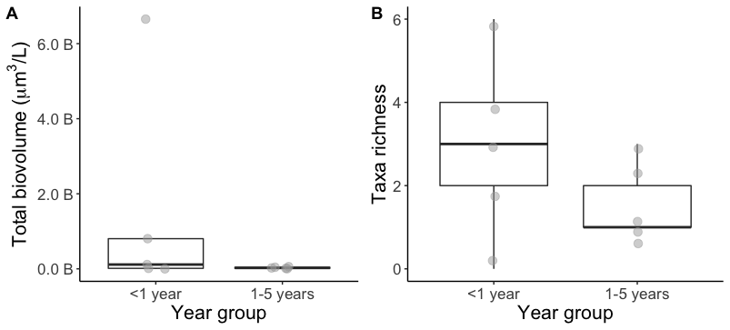
Figure 2. Phytoplankton taxonomic richness collected from re-inundated river sediments following dredging in Mississippi River with different duration of drying since dredging.

Zooplankton richness and density
A total of 2 zooplankton taxa (Rotifera and Copepoda) were found after rewetting sediments that had been previously dry for <1 year, 1–5 years, and 5-10 years. Across all samples (n=120), there were between 0–18 zooplankton individuals found per sample (1 ± 2.8 mean ± s.d.). There was no difference in mean zooplankton abundance between the <1 year (0.5 ± 0.9 taxa), 1–5 year (0.9 ± 3.0 taxa), 5–10 year (2.2 ± 4.2 taxa) groups (ANOVA, df = 117, F = 2.57, p = 0.081). Zooplankton abundance was similar in samples collected from Pool 4 (1.0 ± 2.6) and Pool 8 (0.9 ± 3.0; ANOVA, df = 118, F = 0.01, p = 0.898). Across all sample types, zooplankton emergence occurred immediately following rewetting, within the first week of rewetting. No organisms emerged in weeks 2-4.

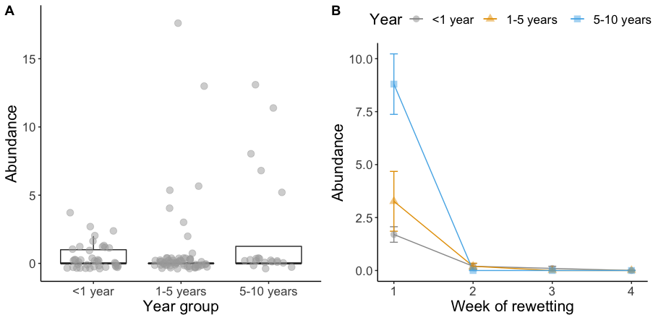
Figure 3. Zooplankton abundance collected from re-inundated river sediments following dredging in Mississippi River with different duration of drying since dredging (A) and timing of emergence following re-inundation (B).

Macroinvertebrate richness and density
A total of 18 macroinvertebrate taxa were found after rewetting sediments that had been previously dry for <1 year, 1–5 years, and 5–10 years. Across all samples (n = 120), there were between 0–102 macroinvertebrate individuals found per sample (7 ± 12.2; mean ± s.d.). Macroinvertebrate richness in <1- year and 5–10-year group were significantly higher than in 1–5-year samples (ANOVA, df = 117, F = 4.75, p = 0.010). Macroinvertebrate abundance in <1 year and 5–10-year samples were significantly higher than in 1–5-year samples (ANOVA, df = 117, F = 4.55, p = 0.013). Samples collected from Pool 8 had significantly higher macroinvertebrate richness (ANOVA, df = 118, F = 4.79, p = 0.031) and abundance (ANOVA, df = 118, F = 6.83, p = 0.010) compared to Pool 4.

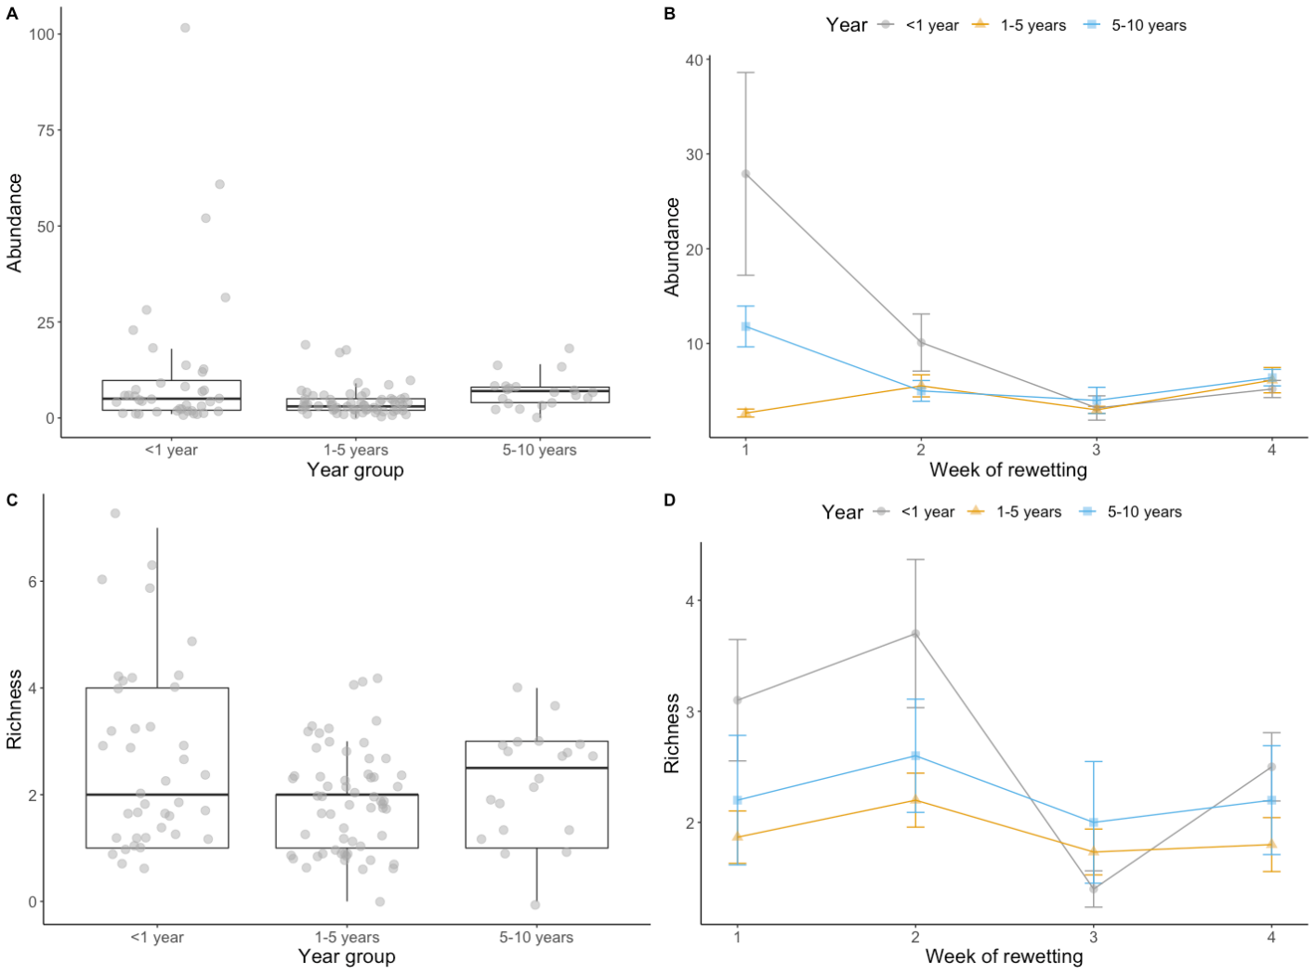
Figure 4. Macroinvertebrate abundance and taxonomic richness collected from re-inundated river sediments following dredging in Mississippi River with different duration of drying since dredging (A, C) and after 1−4 weeks of re-inundation (B, D).
Table 3. Macroinvertebrate taxa list. *Phylum and **Subclass.
Order | Family | Habitat | Percent of total macros | Peak Emergence
Araneae | Arachnida | Terrestrial | <1% | Weeks 2-3
Coleoptera | Unk. adult | Terrestrial | 12% | Weeks 1-4, steady
Diptera | Ceratopogonidae | Aquatic larvae, terrestrial adult | <1% | Weeks 1-4, steady
Diptera | Chironomidae | Aquatic larvae, terrestrial adult | 5% | Weeks 1-4, decline weekly
Diptera | Sciaridae | Terrestrial | <1% | Weeks 1-4, steady
Diptera | Simuliidae | Aquatic larvae, terrestrial adult | <1% | Weeks 1-2
Entomobryomorpha | Entomobryidae | Terrestrial | 26% | Week 4
Ephemeroptera | Leptohyphidae | Aquatic | <1% | Week 1,2
Ephemeroptera | Unk. larvae |  | 31% | Week 1,2
Hymenoptera |  |  | <1% | Week 4
Nematoda* |  | Aquatic | 17% | Weeks 1-4, decline weekly
Oligochaeta** |  | Aquatic | <1% | Week 1
Symphypleona | Sminthuridae |  | <1% | Week 2
Trichoptera | Leptoceridae |  | <1% | Week 2
Trichoptera | Hydroptilidae |  | <1% | Week 4
Trombidiformes |  |  | <1% | Week 2,4
Unk. Pupae | ? | ? | <1% | Week 1,3

Invasive aquatic invertebrate species in the Upper Mississippi River
Our literature review of invasive aquatic invertebrate found 30 species currently considered as exotic or native transplants in the Upper Mississippi River drainage (Appendix 1). We found none of the species considered invasive in rewetted sediments during this study.

Comparison of nutrients in the Upper Mississippi River to potential receiving water bodies
Nutrients in our filtered Mississippi River water were well above known thresholds for limited growth of phytoplankton. Nitrogen (as DIN) less than 0.1 mg/L and phosphorus (as TDP) less than 0.01 mg/L are typical limits. Our concentrations are 5-10x the necessary levels for growth (DIN 1.399 mg/L and orthoP 50.8 ug/L or 0.0508 mg/L; Dolman et al. 2016).
Trends in nutrient composition in the nearshore of Lake Michigan are summarized in Appendix 2. Lake Michigan at the lake-scale tends to be P-limited and there is some evidence that nearshore areas beyond the immediate influence of tributary loads to be net phosphorus sinks (Bootsma et al. 2012). However, because nutrient dynamics and biota have such high variability (Bootsma 2012, Giblin 2020) and because there are tributary and local sources of phosphorus in some areas where beneficial use may occur, we take the conservative position that there may be sufficient phosphorus in some nearshore areas to exceed strict biological limits to phytoplankton and we cannot rely on nutrient limitation alone to prevent emergence of phytoplankton. In recent decades, phosphorus levels have fallen for Lake Michigan tributaries, with many locations below the statewide river phosphorus water quality criterion of 0.1 mg/L (Wisconsin DNR, SWIMS), but while this has positive effects on water quality, it does not constitute a physiological limit for phytoplankton in most cases. The Lake Michigan phosphorus target is 0.007
Likewise, dissolved inorganic nitrogen totals are generally higher in the nearshore and tributary zones, where they may fall between 0.206–1.26 mg/L, which is well above the 0.1 mg/L limits for growth of phytoplankton (Wisconsin DNR, SWIMS). Unlike phosphorus, nitrate levels have risen in recent decades for many Lake Michigan tributaries, with locations such as the Manitowoc River seeing significant increasing trends in nitrate. Again, it is important to differentiate between lake-wide data and nearshore data. The U.S. EPA National Coastal Condition Assessment evaluated 225 shoreline sites throughout the Great Lakes in 2015 assigning a condition grade for Great Lake coastal areas with 95% confidence and 5% margin of error (NCCA/QAPP, 2015). The report found 62% of Lake Michigan coastal areas in “Good” condition for a Eutrophication Index (comprised of DO, clarity, Chl-a and TP parameters), but roughly 80% of those areas moderate to very high in total nitrogen concentrations (USEPA, 2015). By contrast, Lake Michigan lakewide phosphorus levels have been declining since the proliferation of the non-native zebra mussel (Dreissena polymorpha) to levels below the Great Lakes Water Quality Agreement targets of 7 ug/L, yet nearshore areas have biologically-mediated nuisance algae blooms (Bootsma, 2012).
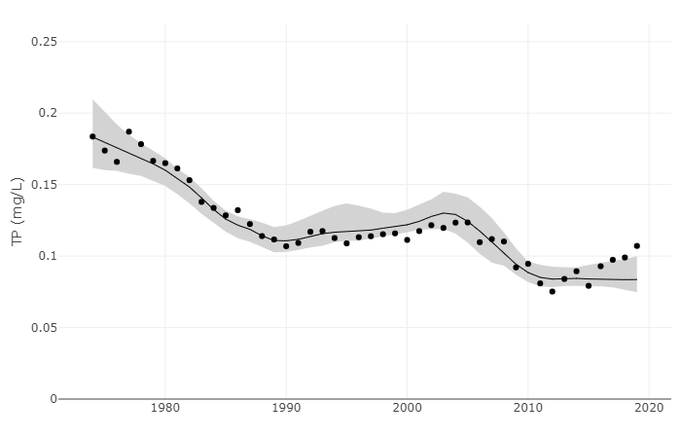
Figure 5. Wisconsin DNR long-term trends data for Milwaukee River total phosphorus.
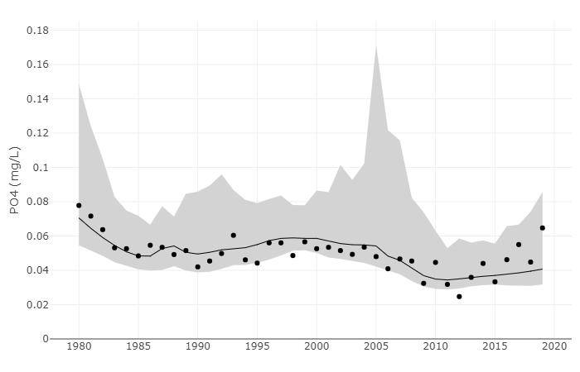
Figure 6. Wisconsin DNR long-term trends data for Milwaukee River orthophosphate.
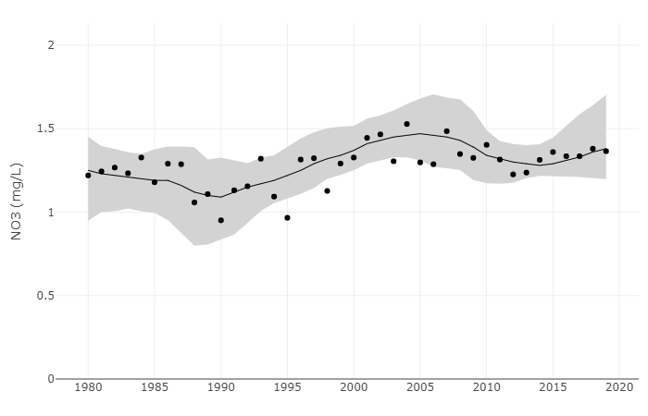
Figure 7. Wisconsin DNR long-term trends data for Milwaukee River nitrate.
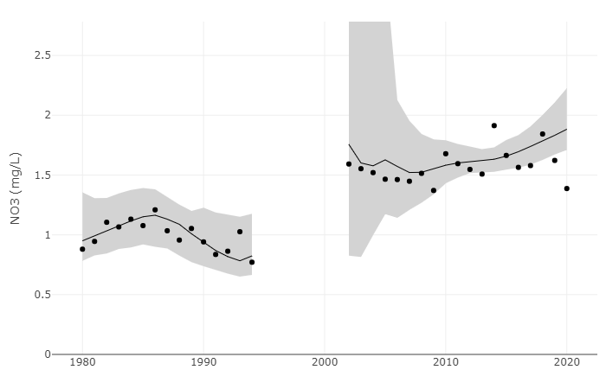
Figure 8. Wisconsin DNR long-term trends data for Manitowoc River nitrate
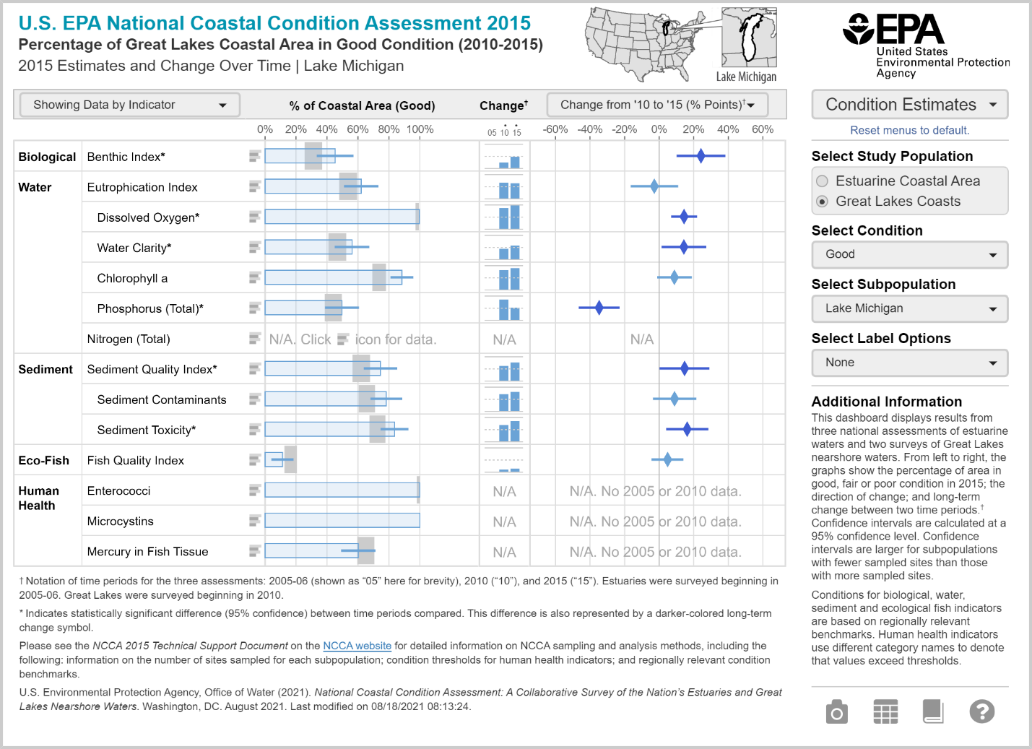
Figure 9. U.S. EPA National Coastal Condition Assessment Lake Michigan Eutrophication Index for 2010-15 reports 62% of Lake Michigan coastal areas in “Good” condition.

Discussion
In this study, we assessed the viability of phytoplankton (<1yr and 1-5yr classes) and aquatic invertebrates (<1yr, 1-5yr, 5-10yr) in stockpiled dredged sediments collected from two navigation pools in the Upper Mississippi River. We found a total of 10 phytoplankton, two zooplankton, and 18 macroinvertebrate taxa in relatively low densities after artificially rewetting sediments for up to four weeks. Based on overall low abundances of biota, we found limited support for our hypothesis that time since dredging (<1-year, 1−5-year, 5−10-year groups) would negatively affect richness and abundance of all three taxonomic groups. For example, phytoplankton richness was highest in the <1-year group compared to 5-10-year group, yet, there was no similar pattern found for phytoplankton biovolume, and zooplankton nor macroinvertebrate abundance and richness. Importantly, we found no invasive species in artificially rewetted sediments.
Previous literature suggests the duration of sediment drying plays an important role in the viability of aquatic organisms in dry sediments (Stubbington and Datry 2013). Our results only partially support that there is a negative relationship between duration of sediment drying and the abundance and richness of aquatic organisms emerging from rewetted sediments. Our highest levels of phytoplankton and macroinvertebrate richness and density were found in sediments dredged <1 year before rewetting. However, we found few significant correlations between richness or density and duration of sediment drying. This is likely due, in part, to the high amount of variability in richness and density found within each year group. This indicates viability of organisms may differ within sediments grouped together in our three age groups (<1-year, 1−5-year, 5−10-year). For example, one site (Brownsville) sampled in the <1-year group comprised sediments that were actively being deposited on shore from a dredge cut, whereas a replicate site (Alma) from the same year group comprised sediments collected approximately two weeks after dredging. Richness and density of macroinvertebrates in sediments collected from the Brownsville site were 1.7x and 5.4x, greater than those collected at Alma, respectively. Future efforts aiming to quantify the effect duration of sediment drying has on viability of aquatic organisms could select sediments along a continuous gradient of duration rather than categories as done in this study.
The presence of taxa with desiccation resistance forms in a biotic community may be context or habitat dependent (sensu Datry et al. 2017, Lair 2006) and therefore viability of aquatic organisms in sediments may differ across locations. When sample sizes allowed for comparison, we found sampling location had no effect on the richness and density of zooplankton and macroinvertebrates. This suggests that sediment stockpiles may not vary in the viability of aquatic organisms based on location alone. Contrastingly, Datry et al. (2017) found differences across sites in the proportion of macroinvertebrate taxa with desiccation-resistant forms in communities were positively correlated with increasing regional drying prevalence. From an evolutionary standpoint, riverine communities are shaped in correspondence to the environmental conditions they are exposed to (Lytle and Poff 2004). Therefore, there may be a higher prevalence of taxa that use desiccation-resistant forms in habitats that have historically faced drying conditions. In the context of our study, a location effect was deemed plausible due to the known effects of Lake Pepin as a plankton source (Burdis and Hirsch 2017). Ultimately a lack of location effect on our results may imply that localized site and habitat conditions may drive community composition, as supported by other studies (Lair 2006, Casper and Thorpe 2007). The communities inhabiting dredge cuts have likely experienced similar environmental conditions and freedom from the risk of desiccation.
Invasive species were not present in the artificially rewetted sediments sampled during this study. This result suggests that there is low risk of transplanting invasive species from sediments derived from the main channel dredge cuts in the Upper Mississippi River to other waterbodies. One possible explanation for not finding invasive species in rewetted sediments despite their presence in the Upper Mississippi River is that many known invasive species do not have desiccation-resistance forms. For example, most freshwater bivalves have limited ability to resist desiccation, including zebra mussels (Dreissena polymorpha) which were found to have a LT₉₉ of 42 h in desiccation experiments (Collas et al. 2014). However, most cladocerans (zooplankton), such as Daphnia lumholtzi, are known to use desiccation resistant forms (Panov and Caceres 2007, Strachan et al. 2015, Bogan et al. 2017). For those invasive species known to use desiccation-resistant forms, we suppose that many of the potential life history or environmental cues to utilize those forms have not occurred within the vicinity of the main channel dredge cuts in recent history (Strachan et al. 2015). Since the locks and dams were installed in the 1930-40s, the river has not experienced the impacts of a significant drought within the main channel. Furthermore, the mobile sands comprising dredge cuts are less likely to host invertebrate taxa with desiccation-resistance forms (Chester and Robson 2011) than from habitats with greater organic matter content (Stubbington and Datry 2013) or slower water velocities (Lair 2006, Shiozawa 1991, Richardson 1992).
Our results provide an initial assessment of the viability of aquatic organisms in dredged river sediments of the Upper Mississippi River. Although invasive species were not present after artificially rewetting main channel sand-dominated sediments, caution should still be used when transporting sediments to other waterbodies. When invasive species are known to inhabit the dredged waterbody, a cautious decision would be to ensure duration of sediment drying exceeds lethal thresholds for those species. The method presented here represents allows for replicated artificial re-inundation experiments with minimal equipment. Comparing habitat and water quality conditions between source and receiving waterbodies may also give an indication of the likelihood of invasive species becoming established after transplanting, assuming adequate data exists. Turbulence, velocity and residence time can limit establishment of some species, which presents a convenient nexus with beneficial use opportunities, which are often designed to remedy erosion impacts, indicating higher velocities and sheer forces are likely present at the proposed placement site. In addition to physical limitations at the proposed placement site, it may be possible to reduce viable biota concentrations through treatment processes (UV treatment) or active harvesting, such as rewetting sediments in a controlled setting and exchanging the overlying water after emergence has occurred (i.e. zooplankton abundance, Figure 3).
Finally, our results further support the hypothesis that the presence of desiccation-resistant forms in a community is positively correlated with drying prevalence (sensu Datry et al. 2017). To test this hypothesis, future studies should explore whether sediments from floodplain habitats subjected to wet/dry cycles may have greater viability of aquatic organisms compared to those found in the main river channel where dredging occurs.

Acknowledgments
We thank Wisconsin Department of Natural Resources Office of Great Waters, the Great Lakes Protection Fund and the University of Wisconsin La Crosse for providing funds to support this research. Our gratitude to the following reviewers: Rae-Ann MacLellan-Hurd, Shawn Giblin, John Manier, and John Kalas.

Literature cited

Belmont, P., K. B. Gran, S. P. Schottler, P. R. Wilcock, S. S. Day, C. Jennings, J. W. Lauer, E. Viparelli, J. K. Willenbring, & D. R. Engstrom, 2011. Large shift in source of fine sediment in the Upper Mississippi River. Environmental science & technology ACS Publications 45: 8804–8810.
Bogan, M. T., E. T. Chester, T. Datry, A. L. Murphy, B. J. Robson, A. Ruhi, R. Stubbington, & J. E. Whitney, 2017. Chapter 4.8 - Resistance, Resilience, and Community Recovery in Intermittent Rivers and Ephemeral Streams In Datry, T., N. Bonada, & A. Boulton (eds), Intermittent Rivers and Ephemeral Streams. Academic Press: 349–376, http://www.sciencedirect.com/science/article/pii/B9780128038352000139.
Bootsma, H.A., J.T. Waples, & Q. Liao. 2012. Identifying Major Phosphorus Pathways in the Lake Michigan Nearshore Zone. Final Report to Milwaukee Metropolitan Sewerage District. Contract with University of Wisconsin-Milwaukee. January 2012.
Burdis, R.M. & J.K. Hirsch, 2017. Crustacean zooplankton dynamics in a natural riverine lake, Upper Mississippi River. Journal of Freshwater Ecology 32:1, 240-258.
Burkholder, J. M., & R. G. Wetzel, 1989. microbial colonization on natural and artificial macrophytes in a phosphorus‐limited, hardwater lake. Journal of Phycology 25: 55–65.
Casper, A.F. & J.H. Thorpe, 2007. Diel and lateral patterns of zooplankton distribution in the St. Lawrence River. River Research and Applications 23: 73-85.
Chester, E. T., & B. J. Robson, 2011. Drought refuges, spatial scale and recolonisation by invertebrates in non-perennial streams. Freshwater Biology 56: 2094–2104.
Collas, F. P. L., K. R. Koopman, A. J. Hendriks, G. van der Velde, L. N. H. Verbrugge, & R. S. E. W. Leuven, 2014. Effects of desiccation on native and non-native molluscs in rivers. Freshwater Biology 59: 41–55.
Coor, J.L. & J.D. Ousley, 2019. Historical analysis of fines lost during beach nourishment. ERDC/CHL, CHETN-VI-50. Vicksburg, MS: U.S. Army Engineer Research and Development Center (ERDC).
Datry, T., R. Vander Vorste, E. Goïtia, N. Moya, M. Campero, F. Rodriguez, J. Zubieta, & T. Oberdorff, 2017. Context-dependent resistance of freshwater invertebrate communities to drying. Ecology and Evolution 7(9): 3201–3211.
Dolman, A. M., U. Mischke te, & C. Wiedner, 2016. Lake-type-specific seasonal patterns of nutrient limitation in German lakes, with target nitrogen and phosphorus concentrations for good ecological status. Freshwater Biology 61: 444–456.
Garrison, P.J., S.R. Greb, G. LaLiberte, 2008. Western Lake Michigan Nearshore Survey of Water Chemistry and Cladophora Distribution 2004-2007. Agency Report PUB-SS-1038 2008.
Giblin, S.M. & G.A. Gerrish. 2020. Environmental factors controlling phytoplankton dynamics in a large floodplain river with emphasis on cyanobacteria. River Research Applications 2020; 1-14.
Haney, J.F. et al., 2013. An-Image-based Key to the Zooplankton of North America version 5.0. University of New Hampshire Center for Freshwater Biology, cfb.unh.edu.
Hillebrand, H., C. Dürselen, D. Kirschtel, U. Pollingher, & T. Zohary, 1999. Biovolume calculation for pelagic and benthic microalgae. Journal of phycology Wiley Online Library 35: 403–424.
Lair, N, 2006. A review of regulation mechanisms of metazoan plankton in riverine ecosystems: Aquatic habitat versus biota. River Research & Applications 22: 567-593.
Lund, J., C. Kipling, & E. Le Cren, 1958. The inverted microscope method of estimating algal numbers and the statistical basis of estimations by counting. Hydrobiologia Springer 11: 143–170.
Lytle, D. A., & N. L. Poff, 2004. Adaptation to natural flow regimes. Trends in Ecology & Evolution 19: 94–100.
Maberly, et a. 2002. Nutrient limitation of phytoplankton and periphyton growth in upland lakes. Freshwater Biology 47(11): 2136-2152.
Manier, J.T., R.J. Haro, J.N. Houser, E.A. Strauss. 2021. Spatial and temporal dynamics of phytoplankton assemblages in the upper Mississippi River. River Research and Applications. 137(10): 1451-1462.
Meade, R. H., & R. S. Paker, 1985. Sediment in Rivers of the United States National Water Summary, 1984 Water Supply Paper. US Geological Survey, Reston VA, 40-60.
Merritt, R. W., K. W. Cummins, & M. Berg, 2008. An introduction to the aquatic insects of North America, 4th ed. Kendall Hunt, Dubuque, Iowa.
Panov, V. E., & C. Caceres, 2007. Role of diapause in dispersal of aquatic invertebrates Diapause in Aquatic Invertebrates Theory and Human Use. Springer: 187–195.
R Core Team, 2022. R: A Language and Environment for Statistical Computing. R Foundation for Statistical Computing. Vienna, Austria. https://www.R-project.org
Reynolds, C.S., et. al, 2002. Towards a functional classification of the freshwater phytoplankton. Journal of Plankton Research. 24(5): 417-428.
Richardson, W.B. 1992. Microcrustacea in flowing water: experimental analysis of washout times and a field test. Freshwater Biology 28: 217-230.
Shiozawa, D.K. 1991. Microcrustacea from the benthos of nine Minnesota streams. Journal of the North American Benthological Society 10(3): 286-299.
Sindt, A.R., M.C. Wolf. 2021. Spatial and temporal trends of Minnesota River phytoplankton and zooplankton. River Research Applications 2021; 1-20.
Standard methods for the examination of water and wastewater, 22nd edn. 2012. American Public Health Association, Washington, DC.
Strachan, S. R., E. T. Chester, & B. J. Robson, 2015. freshwater invertebrate life history strategies for surviving desiccation. Springer Science Reviews 3: 57–75.
Stubbington, R., & T. Datry, 2013. The macroinvertebrate seedbank promotes community persistence in temporary rivers across climate zones. Freshwater Biology 58: 1202–1220.
Stubbington, R., J. Gunn, S. Little, T. P. Worrall, & P. J. Wood, 2016. Macroinvertebrate seedbank composition in relation to antecedent duration of drying and multiple wet-dry cycles in a temporary stream. Freshwater Biology 61: 1293–1307.
US Army Corps of Engineers, 1996. Channel Maintenance Management Plan, 1996 https://www.mvp.usace.army.mil/Missions/Navigation/Channel-Maintenance/Channel-Maint-Mgmt/US Army Corps of Engineers, St. Paul District. Accessed April 2022.
U.S. Army Corps of Engineers, 2011. Upper Mississippi River System Ecosystem Restoration Objectives.https://www.mvr.usace.army.mil/Portals/48/docs/Environmental/UMRR/UMRR_Ecosystem_Restoration_Objectives_2009.pdf.
U.S. Environmental Protection Agency. 2015. National Aquatic Resource Surveys [National Coastal Conditional Assessment, 2015]. Available from U.S. EPA web page: https://www.epa.gov/national-aquatic-resource-surveys/data-national-aquatic-resource-surveys Date accessed 2022-05-20.
U.S. Environmental Protection Agency. 2016. National Aquatic Resource Surveys [National Coastal Conditional Assessment 2015 Quality Assurance Project Plan. Version 2.1 May 2016]. Available from U.S. EPA web page: https://www.epa.gov/national-aquatic-resource-surveys/data-national-aquatic-resource-surveys Date accessed 2022-05-20
Wisconsin Department of Natural Resources. 2022. Surface Water Integrated Monitoring System. Date accessed 2022-07-06.
Wisconsin Department of Natural Resources. 2022. Long-Term River Water Quality Trends in Wisconsin. https://wisconsindnr.shinyapps.io/riverwq/ Date accessed 2022-07-06.
Appendices

Appendix 1: Phytoplankton data

Rewetting Experiment_phytoplankton_data_27Jan22.csv

Appendix 2: Zooplankton data

Rewetting Experiment_zooplankton_data_27Jan22.csv

Appendix 3: Macroinvertebrate data

Rewetting Experiment_macroinvert_data_27Jan22.csv

Appendix 4: Invasive species list

Group | Family | Scientific Name | Common Name | Species Origin | Native Habitat
Bryozoans | Pectinatellidae | Pectinatella magnifica | magnificent bryozoan | Native | Freshwater
Crustaceans-Amphipods | Corophiidae | Apocorophium lacustre | a scud | Native | Marine
Crustaceans-Amphipods | Gammaridae | Echinogammarus ischnus | a scud | Exotic | Freshwater-Marine
Crustaceans-Amphipods | Gammaridae | Gammarus tigrinus | tiger scud | Native | Freshwater-Marine
Crustaceans-Cladocerans | Cercopagidae | Bythotrephes longimanus | spiny waterflea | Exotic | Freshwater
Crustaceans-Cladocerans | Cercopagidae | Cercopagis pengoi | fishhook waterflea | Exotic | Freshwater-Brackish
Crustaceans-Cladocerans | Daphniidae | Daphnia lumholtzi | a waterflea | Exotic | Freshwater
Crustaceans-Copepods | Argulidae | Argulus japonicus | Japanese fishlouse | Exotic | Freshwater-Marine
Crustaceans-Copepods | Temoridae | Eurytemora affinis | a calanoid copepod | Native | Freshwater-Marine
Crustaceans-Crayfish | Cambaridae | Faxonius immunis | calico crayfish | Native | Freshwater
Crustaceans-Crayfish | Cambaridae | Faxonius propinquus | Northern clearwater crayfish | Native | Freshwater
Crustaceans-Crayfish | Cambaridae | Faxonius rusticus | Rusty Crayfish | Native | Freshwater
Crustaceans-Crayfish | Cambaridae | Procambarus acutus acutus | White River Crayfish | Native | Freshwater
Crustaceans-Crayfish | Cambaridae | Procambarus clarkii | Red Swamp Crayfish | Native | Freshwater
Mollusks-Bivalves | Cyrenidae | Corbicula fluminea | Asian clam | Exotic | Freshwater
Mollusks-Bivalves | Cyrenidae | Corbicula largillierti | a freshwater clam | Exotic | Freshwater
Mollusks-Bivalves | Cyrenidae | Corbicula sp. Form D | a freshwater clam | Exotic | Freshwater
Mollusks-Bivalves | Dreissenidae | Dreissena polymorpha | zebra mussel | Exotic | Freshwater
Mollusks-Bivalves | Dreissenidae | Dreissena rostriformis bugensis | quagga mussel | Exotic | Freshwater
Mollusks-Bivalves | Pisidiidae | Eupera cubensis | mottled fingernail clam | Native | Freshwater
Mollusks-Gastropods | Bithyniidae | Bithynia tentaculata | mud bithynia, faucet snail | Exotic | Freshwater
Mollusks-Gastropods | Hydrobiidae | Potamopyrgus antipodarum | New Zealand mud snail | Exotic | Freshwater
Mollusks-Gastropods | Lymnaeidae | Radix auricularia | European ear snail | Exotic | Freshwater
Mollusks-Gastropods | Physidae | Physella acuta | Acute bladder snail | Native | Freshwater
Mollusks-Gastropods | Viviparidae | Cipangopaludina chinensis | Chinese mystery snail | Exotic | Freshwater
Mollusks-Gastropods | Viviparidae | Cipangopaludina japonica | Japanese mystery snail | Exotic | Freshwater
Mollusks-Gastropods | Viviparidae | Cipangopaludina sp. | mysterysnail | Exotic | Freshwater
Mollusks-Gastropods | Viviparidae | Viviparus georgianus | banded mystery snail | Native | Freshwater
Platyhelminthes | Bothriocephalidae | Schyzocotyle acheilognathi | Asian tapeworm | Exotic | Freshwater
Rotifers | Brachionidae | Brachionus forficula | a brachionid rotifer | Exotic | Freshwater

Appendix 5: Photographs of field and experiment procedures

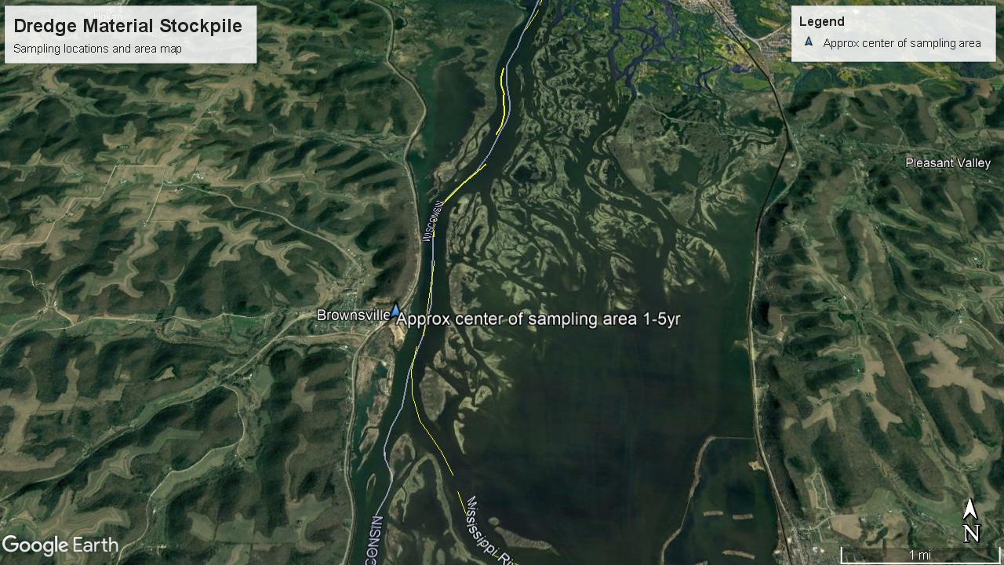
Figure S1: Dredge Stockpile site in Brownsville, MN with dredge cuts shown in yellow. Google Earth, 2022.
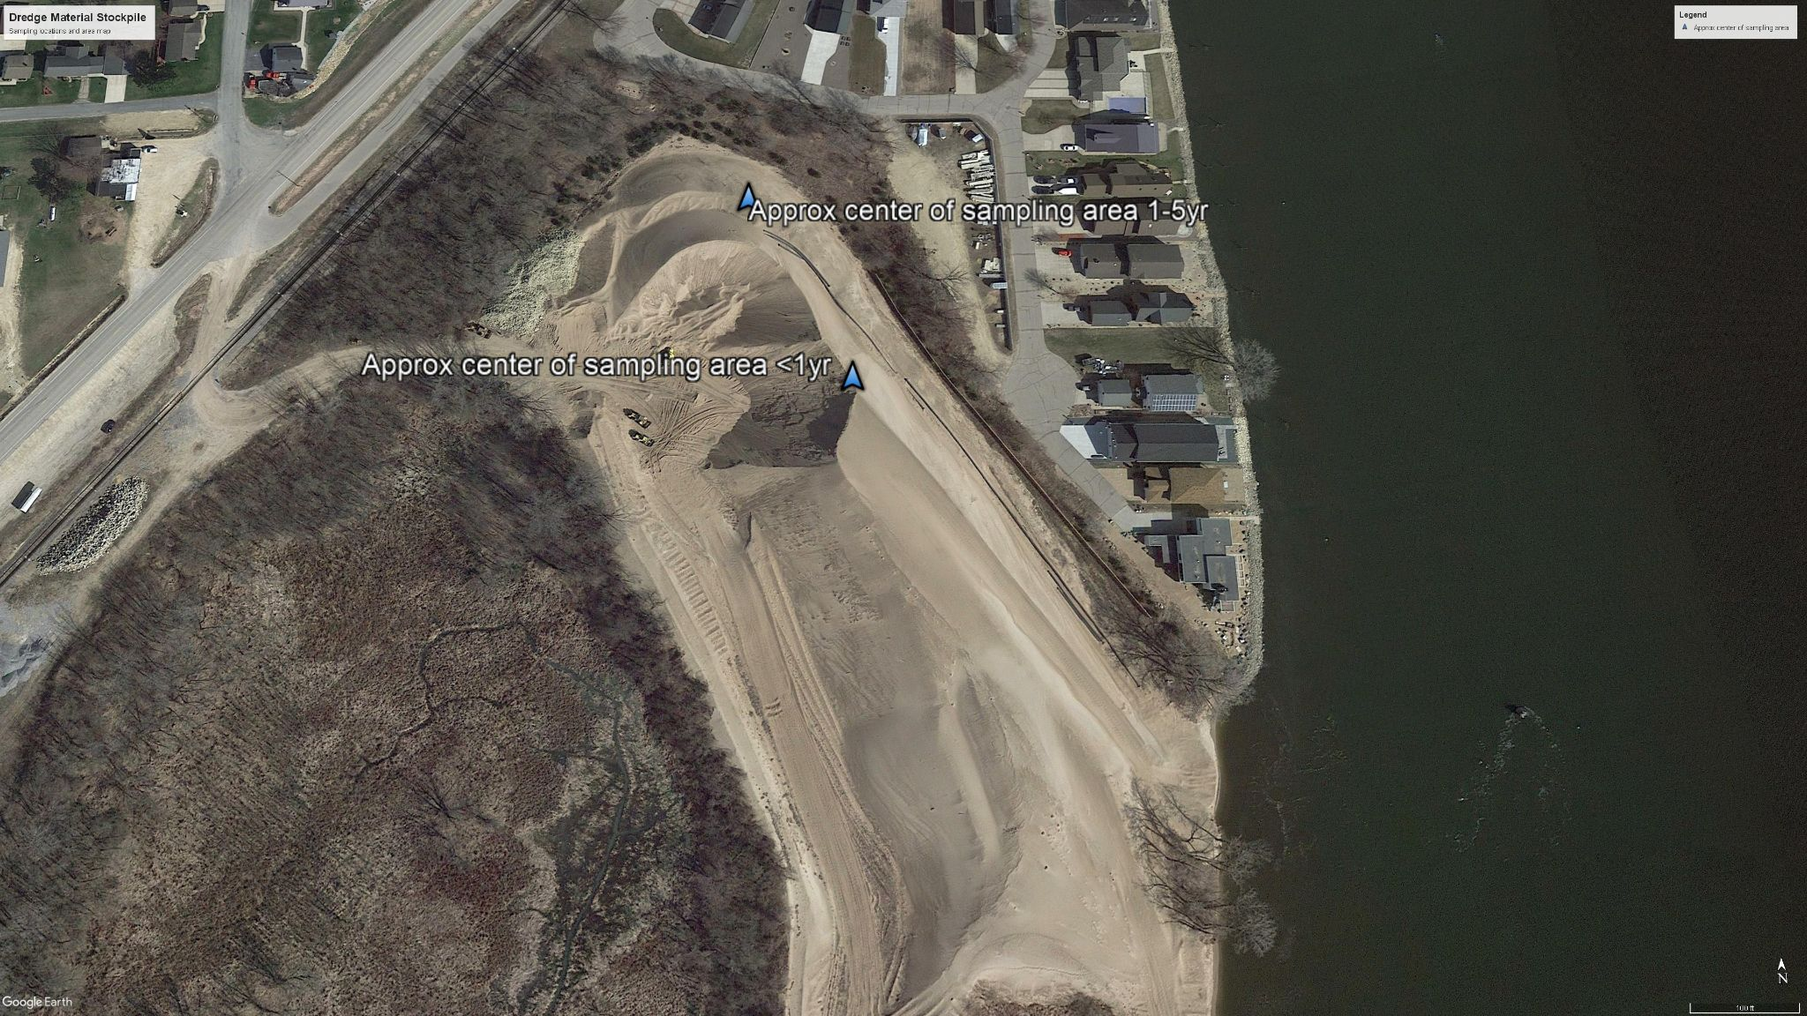
Figure S2: Aerial view of one of the dredge material stockpile sites in Brownsville, MN. Google Earth, 2022.

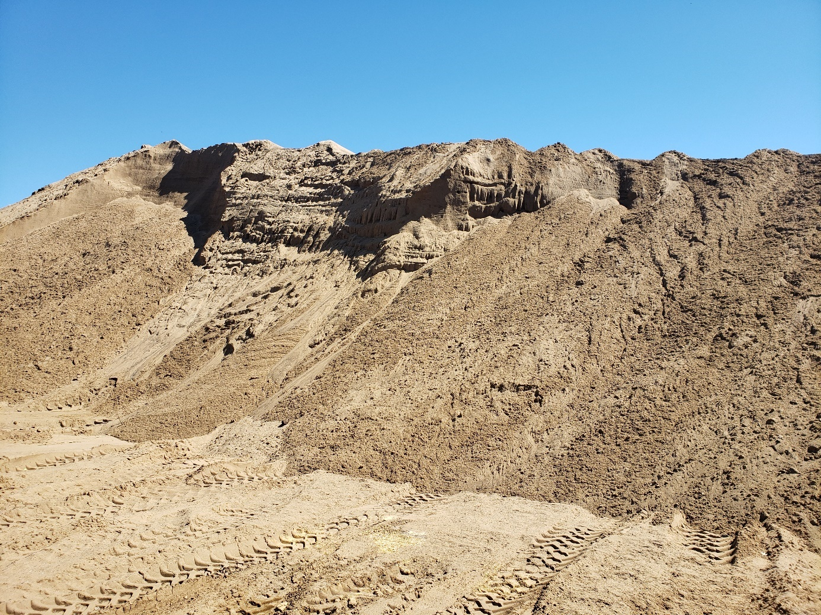
Photo 1: Alma Marina Dredged Material Placement Site. June 2021.

