DATE: 11/15/2021 FILE REF: MSI Express, Inc., Rosendale, WI

TO: WDNR Wastewater Program

FROM: David Bolha, WDNR Water Quality Biologist

SUBJECT: MSI Express, Inc., Rosendale, WI Receiving Water Site Visit

On November 15th, 2021, I conducted a site visit in Rosendale, WI, Fond du Lac Co., to assess the outlet of the discharge of MSI Express, Inc., located on the Southwest side of the intersection of Hwy 26 and Rose-Eld Road. Per our conversation, the MSI Express, Inc. effluent flows generally north through stormsewers prior to daylighting near Rose-Eld Road. Prior to arriving at the Rose-Eld Road crossing where the discharge flows under the road, I contacted the landowner/farmer on the North side of Rose-Eld Road to gain permission to follow the flow downstream. Randy from Rose-Eld Farms granted me access and met me at the culvert road crossing.

I collected water chemistry data on the downstream side of Rose-Eld Road at 12:30pm (Table 1, Photo 1). I observed a distinct channel with the flow from MSI Express, Inc. I could detect a slight sulfur odor and observed what appeared to sulfur-reducing bacterial growth in the channel. Additionally, I observed an Onset Tidbit thermistor connected to a chain in the flow.

Temperature (C) | 25.1
pH | 7.5
Dissolved Oxygen Concentration (mg/L) | 2.47
Dissolved Oxygen % Saturation | 30.1
Specific Conductivity (uS/cm) | 645
Table 1: Water Chemistry of the MSI Express, Inc. Effluent Discharge at Rose-Eld Road Collected on 11/15/2021.

Per the conversation with the landowner/farmer, the discharge historically flowed generally NNW through an old clay draintile until the previous owner severed the draintile. Currently, the discharge flows in the channel above ground for roughly 50 meters before disappearing into the cattail marsh to the north (Photo 2). There was no fish community within the channel downstream of Rose-Eld Road. The cattail marsh continues north until reaching an Unnamed Tributary to the West Branch of the Fond du Lac River (WBIC 134800). I proceeded along the outer edge of the cattail marsh northeast until I reached the Unnamed Tributary downstream of the cattail marsh. I followed the Unnamed Tributary upstream, generally westerly, until I observed an old draintile daylighting from the cattail marsh through which the flow from MSI Express, Inc., discharges ((N43.81725, W88.68245) (Photo 4)). A similar volume of flow discharging from the draintile was observed at the Rose-Eld Road crossing. There is not a distinct channel through the entire length of the cattail marsh; rather, I observed the effluent discharge travel via draintile to its confluence with the Unnamed Tributary.

I recommend there be no requirement for MSI Express, Inc. to meet WWSF thermal limits at Rose-Eld Road, but rather the Point of Compliance be at the confluence of the draintile outlet with the Unnamed Tributary (WBIC 134800).

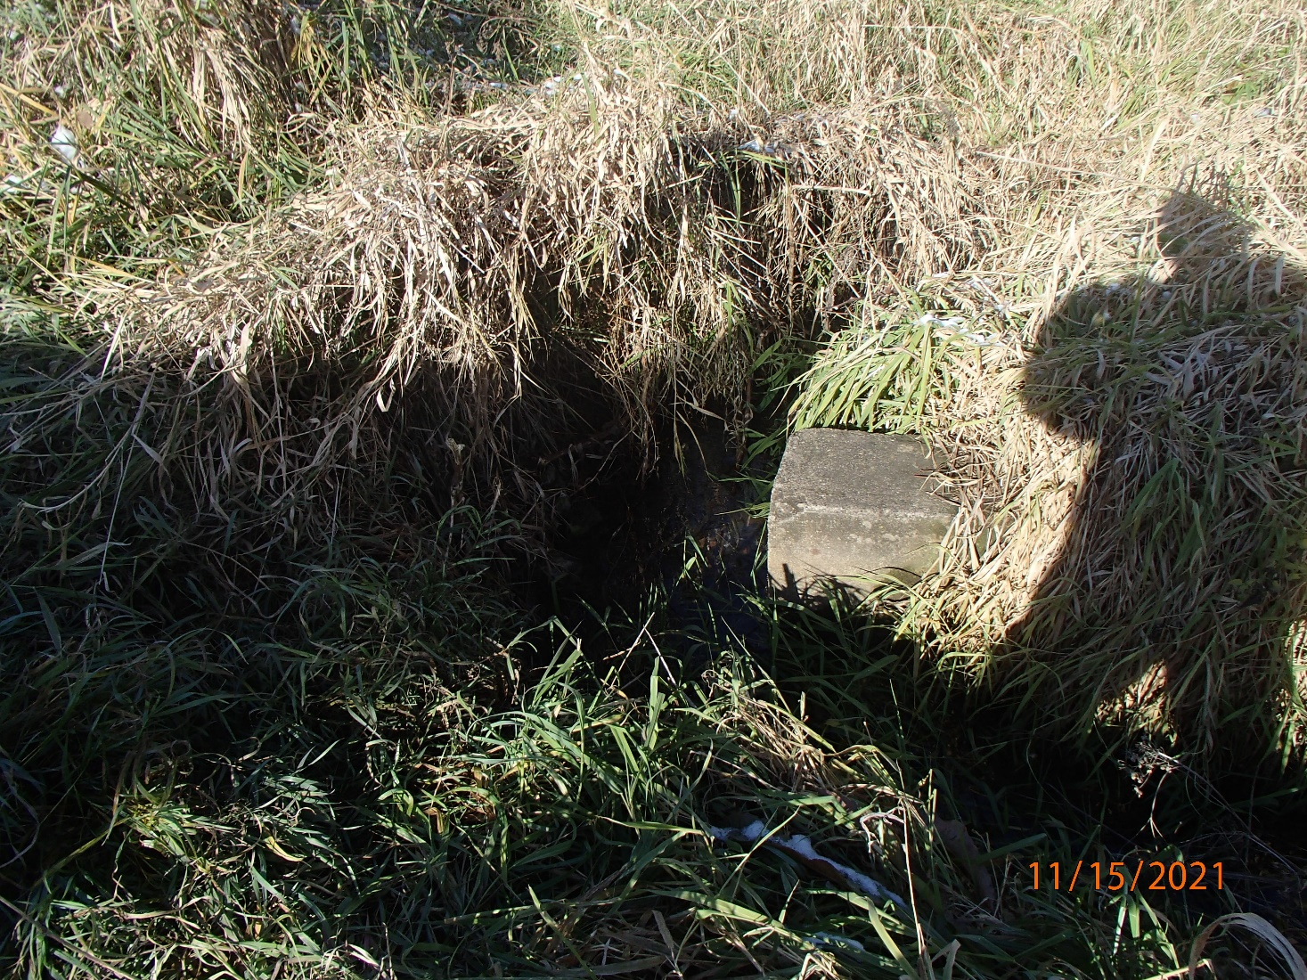
Photo 1: MSI Express Discharge Channel at Rose-Eld Road. Photo taken by D. Bolha on 11/15/2021.

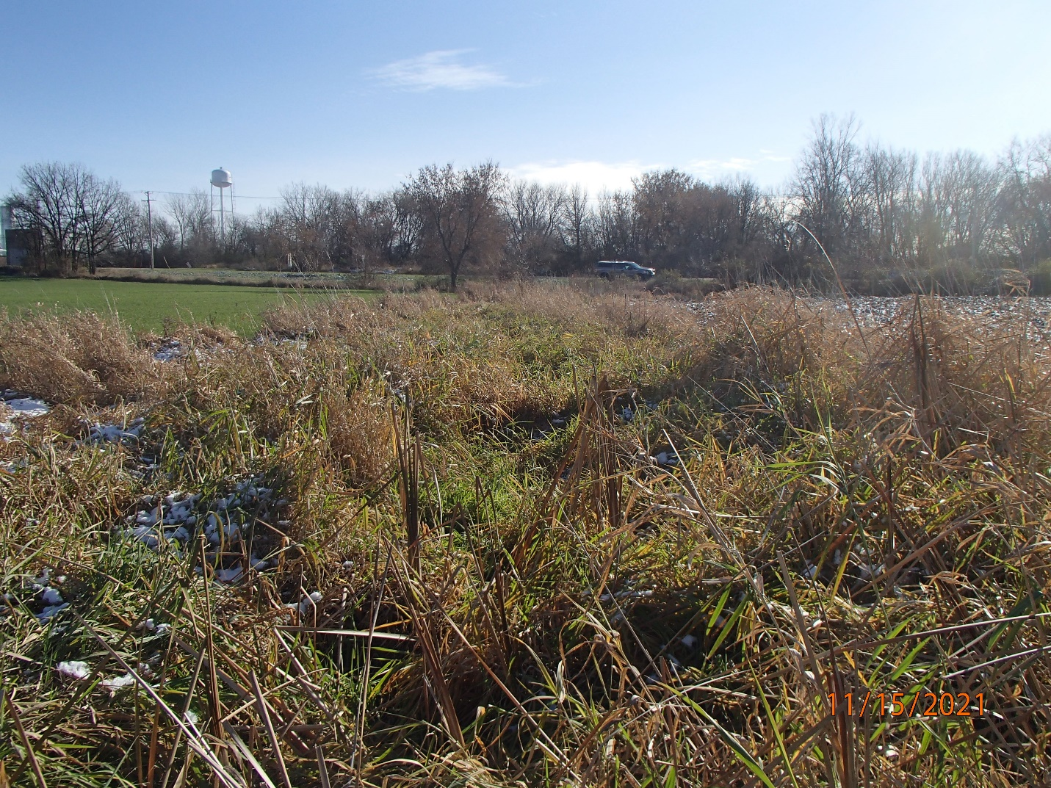
Photo 2: Location of Last Observed Surface Flow from MSI Express, Inc., Facing Upstream toward Rose-Eld Road. Photo taken by D. Bolha on 11/15/2021.

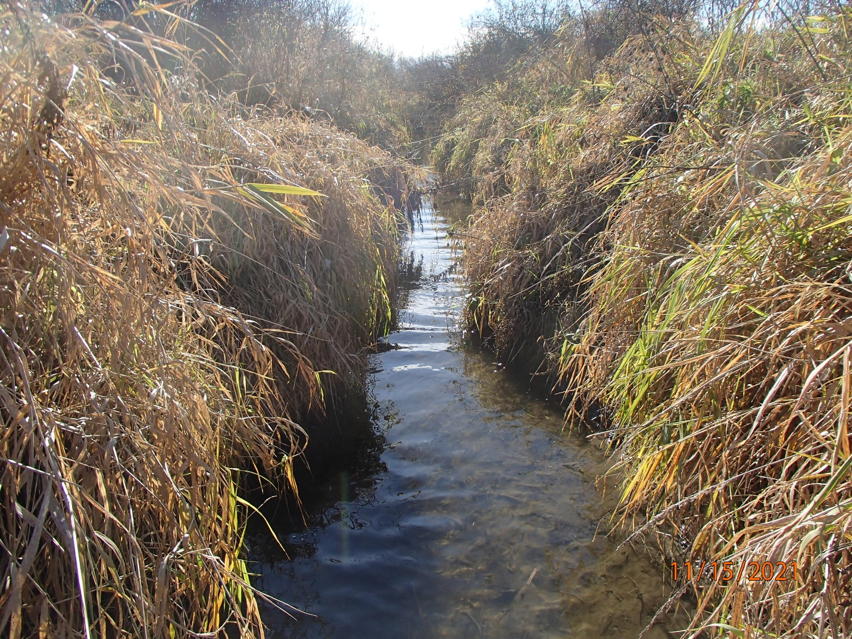
Photo 3: Unnamed Tributary to the West Branch of the Fond du Lac River Downstream of the MSI Express, Inc. Discharge Channel. Photo taken by D. Bolha on 11/15/2021.

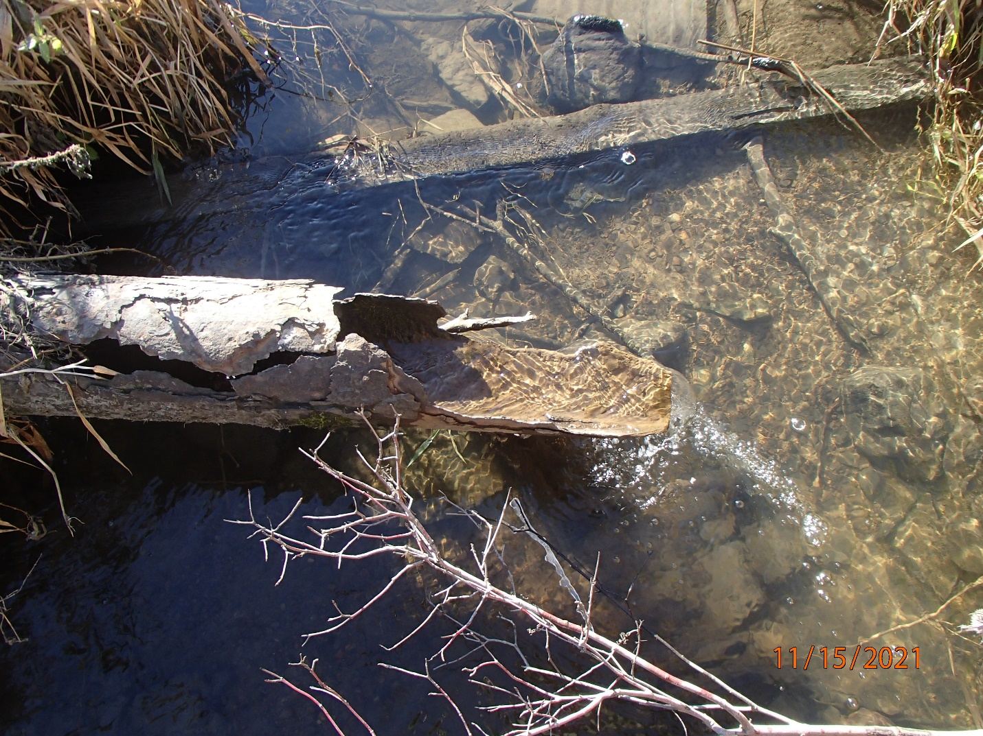
Photo 4: Draintile Outlet into the Unnamed Tributary to the West Branch of the Fond du Lac River. Photo taken by D. Bolha on 11/15/2021.

