Big Hollow Ditch, Hill Slough and Bear Creek Project Final Report
Project ID: SCR_13_CMP13
Jean Unmuth/DNR Water Quality Section – April 2014
Assistants: Liz Tanner, Jason Kaun, Russ Wolf and Matt Miller, UW-Platteville

Project Summary
Water quality collected from between the years of 2009 and 2013 indicates that Big Hollow Ditch generally had poorer water quality than Bear Creek and Hill Slough. Big Hollow Ditch contained high levels of Kjeldahl nitrogen, phosphorus, orthophosphate and nitrate-nitrite. Nitrate-nitrite in Big Hollow Ditch was in excess of 10 mg/l. High nitrate-nitrite levels above the standard for drinking water have been documented in many wells in the vicinity from 1988 – 2004, and the trend is increasing according to more recent groundwater studies. Notable in the Bear Creek water quality results was a very high level of TSS, indicative of erosion in a primarily agricultural and forested watershed. Cooperative efforts between landowners along Bear Creek, and conservation agencies to reduce soil erosion and improve water quality are currently underway. Dissolved oxygen (DO), pH, and temperature at all study sites were at acceptable levels except for DO levels in the Big Hollow Ditch that were just above the criterion of 5.0 mg/l for warm surface waters. The Big Hollow Ditch has drained storm water into Hill Slough during several rain events, and will eventually impact the exceptional resources waters of Hill Slough, which is connected to the Lower Wisconsin River. Toxicity tests showed that the Big Hollow Ditch failed the chronic or long term test for Ceriodaphnia dubia (waterflea). C. dubia adult survival was 50%, and reproduction was significantly reduced. The high nitrate-nitrite of 10.6 mg/l was inversely related to the low neonate production of C. dubia in the Big Hollow Ditch during 2012, when only groundwater, as opposed to storm water, flowed through the ditch. During 2013, toxicity results indicated that only the Hill Slough east sample showed statistically significant reductions in acute or short term survival of Ceriodaphnia dubia, with mean survival at 70%. No clear relationship between water quality parameters and acute survival of C. dubia was evident in Hill Slough.
Recommendations
Cooperative measures between the Department, other conservation agencies and the agricultural community should be undertaken to reduce the potential to negatively affect water quality of Wisconsin River sloughs. A manure, chemical fertilizer, and irrigation exclusion zone in fields near sloughs or adjacent to the Big Hollow Ditch may be one approach for water quality protection. Alternatively exclusion zones could be grazed on a rotational basis, as a way to keep them in farm production. No till-cover crop farming is another option to reduce fertilizer use, reduce erosion, and condition the soil, with side benefits to water quality. A broad buffer of native prairie vegetation adjacent to Big Hollow Ditch would help trap sediments, and reduce nutrients from flowing directly into Hill Slough. The common practice of row cropping across the upper segment of the Big Hollow ditch in the vicinity of CTH-JJ and CTH G, should be eliminated, and replaced by a grassed waterway.
The results of this study provide strong evidence that a ditch system proposed to drain the Lone Rock Airport and adjacent agricultural fields directly to Bear Creek, would negatively affect stream water quality. Bear Creek is currently not meeting the threshold of 75 ug/l phosphorus for warm water streams. The median of six samples recently collected from Bear Creek was 219 ug/l. The extremely high phosphorus in Big Hollow samples are evidence that a new ditch to Bear Creek would exacerbate already high levels of phosphorus. A ditch to Bear Creek would also increase sediment and other nutrients.
Further studies should include pesticide and herbicide monitoring, which may help explain the acute toxicity found in Hill Slough and the chronic toxicity found in Big Hollow Ditch. Water quality, fishery, macroinvertebrate and habitat studies should be conducted in sloughs with adjacent developed or agricultural lands, and compared to those sloughs with natural buffers of vegetation to better understand the influence of land use relationships to slough ecology and water quality.
Project Purpose and Description
In this study we sought to compare water quality between the Big Hollow Ditch, Hill Slough, and nearby Bear Creek, which drains to Cruson Slough. The purpose was to determine the potential for large agricultural drainage ditch systems to negatively impact water quality of Wisconsin River Sloughs, which are exceptional resource waters by statute, and classified as warm surface waters. Hill slough is used by anglers, and contains not only game and panfish, but also rare fish species. Bear Creek was included in the study, due to a proposal previously brought to the Department to build another drainage system in the vicinity of the Lone Rock airport. Bear Creek at CTH-JJ (the site sampled) is considered a warm water sport fishery. The Bear Creek watershed is 87,000 acres, and land cover is primarily agricultural crops (45%), and forested (41%).
Big Hollow drains approximately 7,345 acres of land that is primarily agricultural crops and forested. The unnamed stream (WBIC: 5033343), was historically ditched and is now referred to as Big Hollow Ditch. The Town of Spring Green received a commerce grant to extend the ditched stream for the purposes of reducing flooding of primarily agricultural lands, and a few structures. Construction of the ditch extension was completed in 2011. The ditch was further extended to an excavated pond area adjacent to state lands. The excavated pond area is in the vicinity of Hill Slough, a spring fed slough which drains to the Wisconsin River. During rain events of 3-4 inches in a 24 hour period, the excavated pond overtops, and water flows overland, into an old agricultural ditch that empties into the west end of Hill Slough.
Project Location and Monitoring Sites
Water quality monitoring was conducted for two years prior to the ditch extension, and two years post ditch extension at sites in Big Hollow Ditch, Hill Slough (WBIC: 1241200), and Bear Creek (WBIC 1234600) (Table 1). In addition, after extension of the ditch, ambient toxicity monitoring was conducted in Big Hollow Ditch, Hill Slough and Bear Creek during a drought year when waterbodies were at baseflow levels in 2012, and again during a rain and stormwater runoff event in 2013. The Bear Creek site is location in T9N, R2E,
Table 1. Monitoring locations for the study area.
Site | Waterbody Name | Location | WBIC | SWIMS Station
1 | Big Hollow Ditch | CTH-JJ, T9N, R3E | 5033343 | 10030012
2 | Big Hollow Ditch | CTH-G, T9N, R3E | NA (ditch extension) | 10030013
3 | Big Hollow Ditch | Kennedy Rd, T8N R3E | NA (ditch extension) | 10037286
4 | Bear Creek | CTH-JJ, T9N, R2E | 1234600 | 10021312
5 | Hill Slough East | Boat landing, T8N, R3E | 1241200 | 10030015
6 | Hill Slough West | Near ditch outlet, T8N, R3E | 1241200 | 10029030

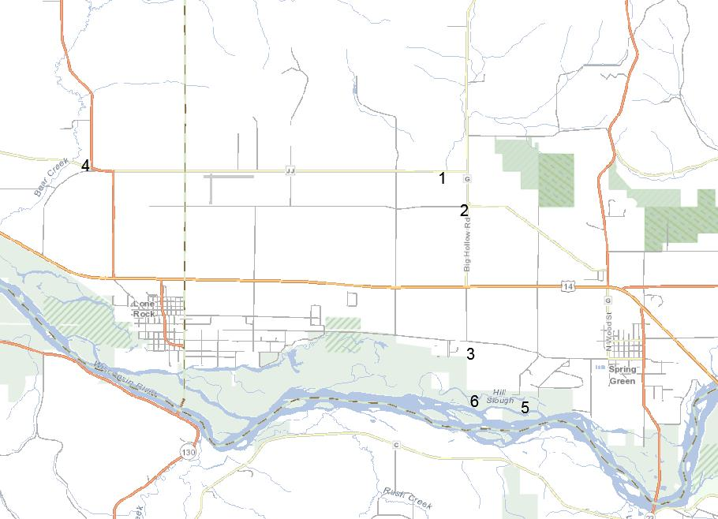
Map of sites monitored. Sites 1, 2, 3 are Big Hollow Ditch, site 4 is Bear Creek, Sites 5 and 6 are Hill Slough.

Project Methods
Prior to the ditch extension, water quality parameters were collected during 2009 and 2010 at all sites except Big Hollow Ditch at the Kennedy Road location, which did not exist at the time. After the ditch was extended, water quality monitoring was repeated during 2012 and 2013, but in Big Hollow Ditch, samples were only collected near the pour point at Kennedy Rd, and the two sites upstream at CTH-JJ and CTH-G were no longer monitored. A YSI 556 Proplus meter was calibrated prior to monitoring and used to collect temperature, dissolved oxygen, pH and conductivity. Water chemistry parameters sampled were nitrate-nitrite, ammonia nitrogen, pH, kjeldahl nitrogen, total suspended solids, total phosphorus, and orthophosphate . Orthophosphate was only monitored during 2012 and 2013, after the ditch was extended. All samples were iced, and transported to the SLOH for analysis.
Ambient toxicity monitoring was conducted at four sites on May 14, 2012 during normal or base flow water levels, when no rainfall had occurred during the week preceding the sampling. Sampling was repeated at the same sites on May 31, 2013 after a series of rain events over four days totaling 1.33 inches, which preceded the sampling effort. Big Hollow Ditch at Kennedy Road, Bear Creek at CTH-JJ, and both sites in Hill Slough were sampled (Table 1). All Rainfall amounts were taken from rainfall reported from nearby at the Lone Rock airport.
Results
Water Quality
The highest level of nitrate-nitrite of over 10.0 mg/l occurred in the Big Hollow Ditch at Kennedy Road, during a dry period (Figure 1). This reflects groundwater seepage flow carrying nitrate-nitrites to the ditch, primarily from agricultural fertilizers applied to croplands on sandy soils. The majority of nitrate inputs into groundwater originate from agricultural practices and legume cropping systems (Wisconsin Groundwater Coordinating Council 2011). By contrast, nitrate-nitrite levels at all other sites, during dry periods was 1.28 mg/l or less. High nitrate-nitrite at levels above the drinking water standard have been documented in many wells in the Spring Green to Lone Rock area from 1988 – 2004. During rain events, Big Hollow Ditch at Kennedy Road had the highest level of nitrate-nitrite at 4.7 mg/l while all other sites had nitrates of 2.25 mg/l or less. Minnesota suggested a chronic nitrate criteria of 4.9 mg/l for all streams except cold waters (Minnesota Pollution control Agency 2010). Based on a comprehensive literature review of nitrate toxicity to aquatic animals, Camargo et. al. 2005 suggested a nitrate criterion of 3 mg/l to protect sensitive aquatic life.
Ammonia nitrogen (NH3) levels were relatively low at all sites, and fall under the toxicity criteria for warm surface waters, given the pH levels at those sites (Figures 2 & 3). Levels were highest in Big Hollow Ditch at Kennedy Road, and in Bear Creek, at 0.23 mg/l and 0.14 mg/l, respectively. Higher amounts of NH3 occurred when samples were collected after a series of small spring rains totaling 1.33 inches over four days. Both sites at Hill Slough had very low levels of ammonia at 0.03 mg/l or less. The highest levels of total kjeldahl nitrogen (TKN) occurred at two sites in the Big Hollow Ditch during rain events of two to three inches, when TKN levels ranged from 2.1 to 2.6 mg/l (Figure 4). Higher levels of TKN indicate excessive soil erosion and runoff of manure as either fertilizer or from grazing operations. In this case, the land use is primarily row crops, so application of manure as fertilizer is likely the main source of TKN. For comparison purposes, the highest TKN levels collected during monthly monitoring over a four year period from the Lower Baraboo River, a largely agricultural watershed, were 1.01 and 1.75 mg/l. During a series of small rain events totaling just over an inch, TKN levels were highest in Bear Creek at 1.5 mg/l followed by Big Hollow Ditch at Kennedy Road 1.3 mg/l , but lowest at both sites in Hill Slough.
Total Suspended solids (TSS) were highest in Bear Creek at 166 mg/l (Figure 5), during a rain event. TSS in Big Hollow Ditch and Hill Slough was low at less than 40 and 20 mg/l, respectively. By comparison the median value for TSS from 55 streams in Richland County, collected during the same timeframe as this study, was only 27 mg/l, and only two streams had higher TSS values than Bear Creek. The high TSS in Bear Creek is evidence of excessive soil erosion from a mainly agricultural and forested watershed which is a much larger than Big Hollow. Efforts to reduce soil erosion through bank stabilization and vegetative buffers in the Bear Creek watershed are currently underway.
The highest phosphorus levels documented throughout the study were 1.27 mg/l (1,270 ug/l) and 1.03 mg/l (1,030 ug/l), collected from two sites in the Big Hollow Ditch, compared to 0.38 mg/l (380 ug/l) from Bear Creek (Figure 6). Phosphorus levels were lower and the similar for the two sites in Hill Slough at 0.07 and 0.09 mg/l ( 70 ug/l and 90 ug/l, respectively). Orthophosphates were five times higher in the Big Hollow Ditch at Kennedy Road than in Bear Creek, while orthophosphate levels at Hill Slough, and other ditch locations were low (Figure 7). High orthophosphate reflects runoff from agricultural fields from manure and fertilizers. The threshold for phosphorus in Bear Creek is set at 75 ug/l, and the median phosphorus collected from Bear Creek in year 2010 at CTH JJ was 219 ug/l, thus the stream is not currently meeting the threshold. Any additional phosphorus added via a ditch system to Bear Creek, would only increase stream phosphorus levels even higher than current levels, when the objective should be to reduce phosphorus to meet the standard.
Dissolved oxygen (DO) in the Big Hollow Ditch was very close to the lower limit for DO of 5.0 mg/l for warmwater streams, specifically during rain events (Figure 8). By contrast Bear Creek and Hill Slough had adequate DO at all times.
Toxicity Tests
Surface water samples passed all the acute and chronic toxicity tests during the 2012 monitoring, with the exception of Big Hollow Ditch which failed the chronic or long term test for Ceriodaphnia dubia (waterflea). C. dubia adult survival was 50%, and reproduction was significantly reduced. Excessively high nitrate-nitrite of 10.6 mg/l in the Big Hollow Ditch was inversely related to low C. dubia survival and reproduction (Figure 9). During 2013, toxicity results indicated that only Hill Slough east showed statistically significant reductions in acute or short term survival of C. dubia, with mean survival at 70%. No clear relationship between water quality parameters and reduced acute survival of C. dubia was evident in the Hill Slough east sample. Hill Slough east and west had very similar water quality, except for slightly higher nitrate-nitrite in the west end where acute survival of C. dubia was not affected. For chronic toxicity tests, all sampling locations during 2013 passed the tests.
Figures

Figure 1. Nitrate-nitrites results versus rainfall amounts at all project sites.

Figure 2. Ammonia results versus rainfall amounts at project sites

Figure 3. pH results versus rainfall amounts at project sites

Figure 4. Kjeldahl nitrogen results versus rainfall amounts at project sites.

Figure 5. Total suspended solid results versus rainfall amounts at project sites.

Figure 6. Total phosphorus results versus rainfall amounts at project sites.

Figure 7. Orthophosphate results versus rainfall amounts at project sites.

Figure 8. Dissolved oxygen versus rainfall amounts at project sites.

Figure 9. Chronic Ceriodaphnia dubia neonate reproduction versus nitrate-nitrites at project sites.

References
Aquatic Life Water Quality Standards Technical Support Document for Nitrate. Minnesota Pollution Control Agency. Draft November 12, 2010. Publication wq-s6-13.
Camargo, J. A., Alonso, A. & Salamanca, A. (2005) Nitrate toxicity to aquatic animals: a review with new data for freshwater invertebrates. Chemosphere, 58, 1255-1267.
Fiscal Year 2011 Report to the Legislature. (2011) Wisconsin Groundwater Coordinating Council .

