Eurasian Water-milfoil (Myriophyllum spicatum) and Curly-leaf Pondweed (Potamogeton crispus) June and Eurasian Water-milfoil Fall Bed Mapping Surveys
Minong Flowage - (WBIC: 2692900)
Washburn and Douglas Counties, Wisconsin

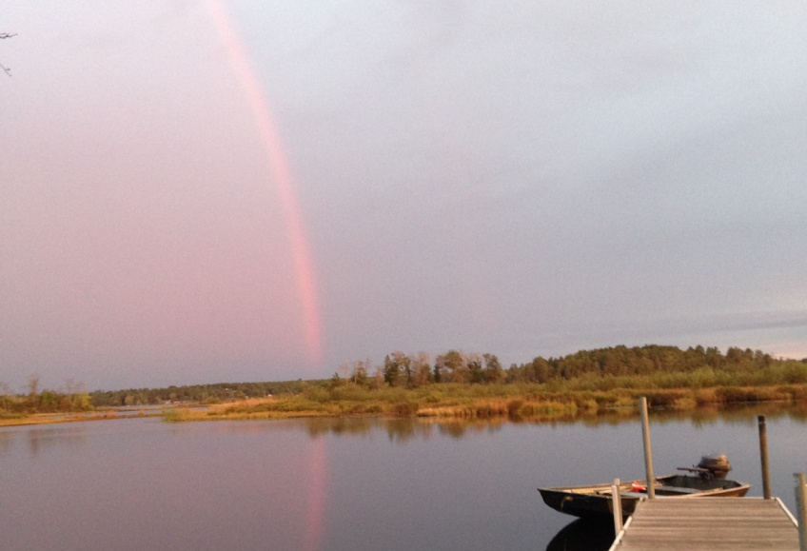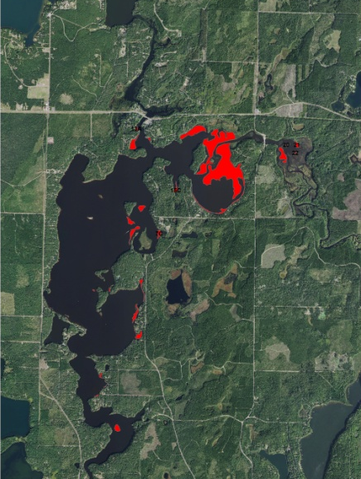
View from the East Side WDNR Landing 10/1/17 Fall 2017 EWM Beds
Project Initiated by:
Minong Flowage Association, Lake Education and Planning Services, LLC and the Wisconsin Department of Natural Resources
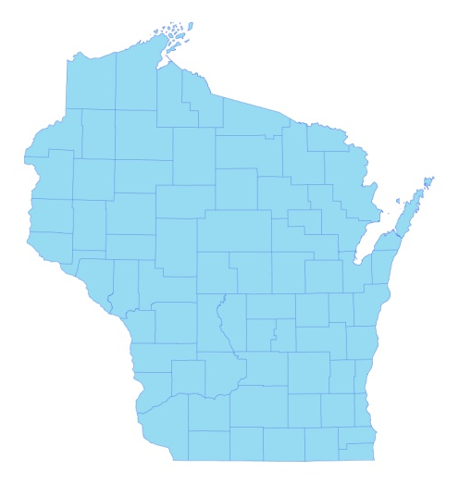
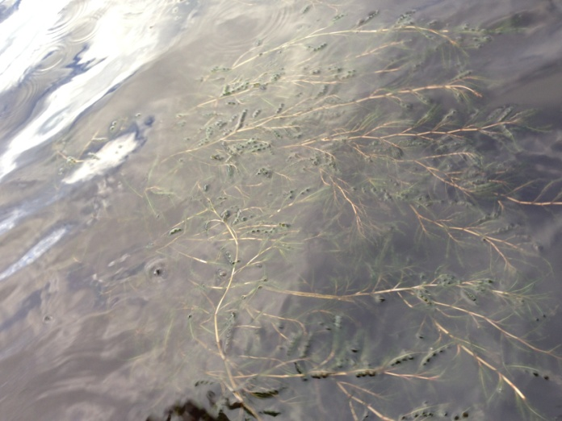

* Minong Flowage

Canopied CLP in the River Inlet 6/18/17

Surveys Conducted by and Report Prepared by:
Endangered Resource Services, LLC
Matthew S. Berg, Research Biologist
St. Croix Falls, Wisconsin
June 18, September 30, and October 1, 2017
TABLE OF CONTENTS

Page
LIST OF FIGURES AND TABLES.……..………………………………………………... ii

INTRODUCTION.…..……..………………………………………………………. 1
BACKGROUND AND STUDY RATIONALE…………………….……………... 1
METHODS………………………………… ………………………………………. 2
RESULTS AND DISCUSSION……………………………………………………………. 3

June Curly-leaf Pondweed Bed Mapping Survey.…………………………………. 3

Descriptions of June Curly-leaf Pondweed Beds…………………………………... 4

June Eurasian Water-milfoil Bed Mapping Survey…..…..………………………... 5

June Descriptions of Current and Former Eurasian Water-milfoil Beds.………….. 7

Fall Eurasian Water-milfoil Bed Mapping Survey………………………………… 8

Fall Descriptions of Current and Former EWM Beds…….……………………….. 11

LITERATURE CITED……….……………………….……………………………………. 12

APPENDIXES……….…….………………………………………………….……………. 13

I: June Curly-leaf Pondweed and Eurasian Water-milfoil Bed Maps...………………… 13

II: Fall 2015, 2016, and 2017 Eurasian Water-milfoil Bed Maps.……………….……… 16

LIST OF FIGURES AND TABLES

Page
Figure 1: 2016 Fall EWM Beds………………………...…………………….……….…… 1
Figure 2: Rake Fullness Ratings……………………………….…….…………………….. 2
Figure 3: Canopied CLP Facing Southeast/Southwest in the Delta……………………….. 3
Figure 4: Curly-leaf Pondweed Bed Map 6/18/17……..….………..……………………… 3
Table 1: June Curly-leaf Pondweed Bed Mapping Summary –
Minong Flowage, Washburn and Douglas Counties – June 18, 2017…..………………….. 4

Figure 5: Fall 2016 and June 2017 Eurasian Water-milfoil Bed Maps …………………… 5
Table 2: June Eurasian Water-milfoil Bed Mapping Summary –
Minong Flowage, Washburn and Douglas Counties – June 18, 2017…..………………….. 6

Figure 6: Fall 2013/2014/2015 and Fall 2016/June/Fall 2017 EWM Beds………………… 8
Table 3: Fall Eurasian Water-milfoil Bed Mapping Summary –
Minong Flowage, Washburn and Douglas Counties – September 30-October 1, 2017……. 9

Table 4: Fall Eurasian Water-milfoil Bed Mapping Summary –
Minong Flowage, Washburn and Douglas Counties – 2014-2017…………………………. 10

INTRODUCTION:
The Minong Flowage (WBIC 2692900) is a 1,564 acre eutrophic/mesotrophic drainage lake located in north-central Washburn County and south-central Douglas County, Wisconsin in the Towns of Minong and Wascott (T42N R13W S13 SW NE). It reaches a maximum depth of 21.5ft near the dam on the far south end and has an average depth of approximately 9ft. The bottom is predominately sand and sandy muck in the south basin and organic muck in the northern bays. Secchi disc readings from 1994-2017 have ranged from 2-6ft and averaged 4.1ft (WDNR 2017). This poor to very poor clarity produced a littoral zone that extended to a maximum of 7ft in 2017.
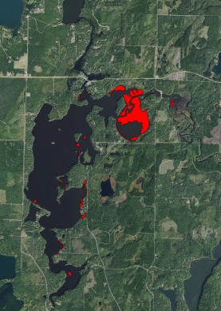
Figure 1: 2016 Fall EWM Beds

BACKGROUND AND STUDY RATIONALE:
Eurasian water-milfoil (Myriophyllum spicatum) (EWM) was first identified in the Minong Flowage in 2002. From 2009-2011, the Minong Flowage Association (MFA), under the direction of Dave Blumer (Lake Education and Planning Services, LLC - LEAPS), actively managed the infestation using herbicide treatments and manual removal as outlined in the flowage’s Wisconsin Department of Natural Resources (WDNR) approved Aquatic Plant Management Plan (APMP). Treatment was suspended in 2012, but the 5ft drawdown to repair the dam in spring 2013 and extended period of freezing over the winter appeared to have killed all surviving terrestrial EWM beds. The subsequent refill in spring 2014 also eliminated most surviving aquatic individuals as the flowage’s stained water prevented sufficient light penetration to allow these plants to survive. Unfortunately, EWM quickly began recolonizing shallow habitats that were now largely devoid of any native plants/competition. In fall 2014, we found and mapped ten EWM beds totaling 14.02 acres, and, by fall 2015, this had grown to 11 beds covering 90.36 acres. In 2016, the MFA used herbicides to treat a single EWM bed that covered 26.90 acres in the WDNR boat landing bay on the flowage’s east side. Although this area remained clear throughout the rest of the growing season, our fall mapping survey found 24 EWM beds covering 125.58 acres (8.03% of the flowage’s surface area) scattered around the rest of the flowage (Figure 1). Because most of this expansion occurred in the northeast bays, it was decided NOT to do any active management on the flowage in 2017.
In order to track EWM’s continued expansion and to see if and where Curly-leaf pondweed (Potamogeton crispus) (CLP), another exotic invasive species, was present on the flowage, the MFA requested three surveys in 2017. On June 18th, we conducted CLP and EWM bed mapping surveys. These were followed by a September 30-October 1 EWM bed mapping survey to determine if and where EWM control might be considered in 2018. This report is the summary analysis of these three field surveys.

METHODS:
Bed Mapping Surveys:
During the bed mapping surveys, we searched the lake’s entire visible littoral zone. By definition, a “bed” was determined to be any area where we visually estimated that Curly-leaf pondweed or Eurasian water-milfoil made up >50% of the area’s plants, was generally continuous with clearly defined borders, and was canopied, or close enough to being canopied that it would likely interfere with boat traffic. After we located a bed, we motored around the perimeter of the area taking GPS coordinates at regular intervals. We also estimated the rake density range and mean rake fullness of the bed (Figure 2), the range and maximum depth of the bed, whether it was canopied, and the impact it was likely to have on navigation (none – easily avoidable with a natural channel around or narrow enough to motor through/minor – one prop clear to get through or access open water/moderate – several prop clears needed to navigate through/severe – multiple prop clears and difficult to impossible to row through). These data were then mapped using ArcMap 9.3.1, and we used the WDNR’s Forestry Tools Extension to determine the acreage of each bed to the nearest hundredth of an acre.

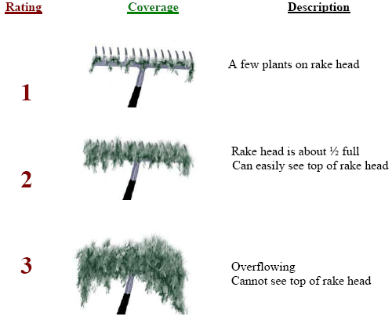
Figure 2: Rake Fullness Ratings

RESULTS AND DISCUSSION:
June Curly-leaf Pondweed Bed Mapping Survey:
Curly-leaf pondweed proved to be rare on the flowage post drawdown. We mapped three CLP beds in the delta region east of Smith’s Bridge; collectively, they totaled 6.86 acres or 0.4% of the flowage’s surface area (Table 1). They were canopied, at least moderately dense, and would have likely been an impairment to navigation except that few people live along these shorelines or travel upstream through this area (Figure 3). With the exception of patches of EWM, these beds were nearly monotypic at this point in the growing season.

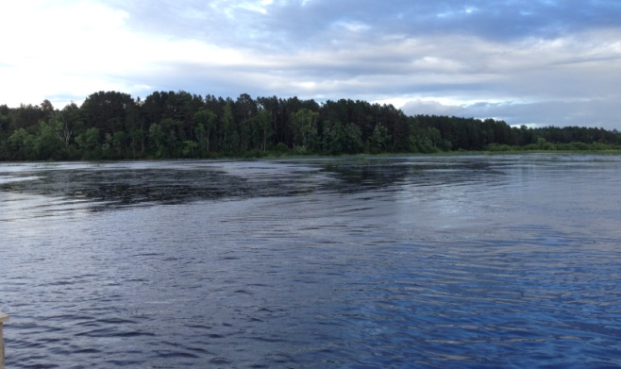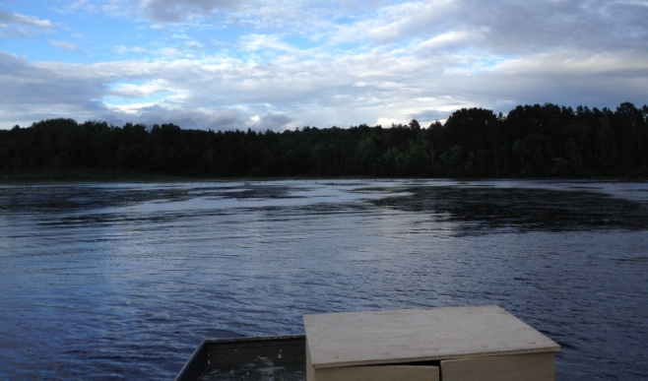
Figure 3: Canopied CLP Facing Southeast/Southwest in the Delta

Elsewhere, Curly-leaf pondweed was nearly absent. Throughout the entire rest of the flowage, we found just three other spots with any CLP at all. In each case, there were never more than a handful of plants, and, consequently, they were not a navigation issue (Figure 4) (Appendix I).
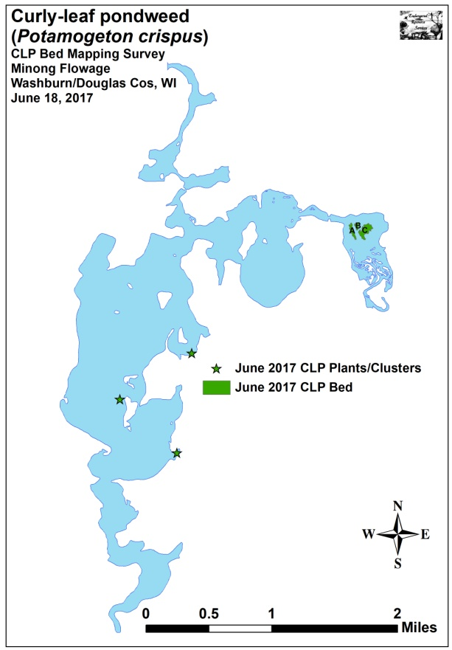
Figure 4: Curly-leaf Pondweed Bed Map 6/18/17
Table 1: June Curly-leaf Pondweed Bed Mapping Summary
Minong Flowage, Washburn and Douglas Counties
June 18, 2017

Bed  Letter | Area  in Acres | Depth Range  and Mean Depth | Est. Rake Range  and Mean Rake Fullness | Navigation Impairment | 2017 Field Notes
A | 1.69 | 2-4; 4 | <1-3; 2 | Moderate | EWM on Western Border
B | 0.78 | 2-4; 4 | <1-3; 2 | Moderate | Mixed with EWM
C | 4.39 | 2-4; 4 | <1-3; 2 | Moderate | Mixed with EWM
Total | 6.86

Descriptions of June Curly-leaf Pondweed Beds:
Bed A – The core of the bed was solid CLP, but it became fragmented and mixed with Eurasian water-milfoil on the west side before transitioning to mostly EWM. In general, this area had few native species other than scattered patches of Water smartweed (Polygonum amphibium). Unfortunately, Northern wild rice (Zizania palustris), which had been prevalent in this area prior to the high water event in 2016, was still almost completely absent from the north side of the delta.

Bed B – This area would have been continuous with Beds A and C, but small channel braids with visible flow appeared to be scouring the bottom. This higher flow also made for a patchier overall bed. We noted Long-leaf pondweed (Potamogeton nodosus) and Short-stemmed bur-reed (Sparganium emersum) were common along the channel edges just outside of the bed.

Bed C – This area was similar to Bed A in that it supported denser CLP at its core, but had expanding EWM around much of the periphery. Bordered by the main channel to the north and east and a minor channel to the west, the bed became increasingly fragmented to the south before disappearing completely in the emergents.

June Eurasian Water-milfoil Bed Mapping Survey:
Past studies have shown that Eurasian water-milfoil on the Minong Flowage typically declines in both density and distribution over the winter. Following typical dieback in shallow water (presumably due to ice/freeze-out) and along the outer edge of the littoral zone (presumably due to lack of light due to ice and snow), our June 2017 survey found 16 beds totaling 71.23 acres (4.55% of the flowage’s surface area) (Figure 5) (Appendix I). This represented a 43.28% decline from the 24 beds covering 125.58 acres we mapped in the fall of 2016 (Table 2). Although not quantitatively measured, most beds also appeared to have declined in density. Because of this, the only areas that appeared likely to cause at least moderate navigation impairment were beds 16 and 17 both of which occurred in stump fields in areas people were unlikely to travel through anyway.

The bulk of this pullback in the south basin occurred in sandy areas that were <3ft deep (Beds 1A-5D, 14-15B). In the northern bays, we noted most declines occurred on the littoral edge on the beds’ southern border (Beds 16-18). Eurasian water-milfoil that was growing in 3-5ft of water over more nutrient-rich organic muck seemed to survive the winter better than elsewhere, and many of these areas actually expanded (Beds 7A, 7B, 8, and 19). Significantly, we also noted that the WDNR public boat landing bay (Formerly Beds 6 and 7) remained free of EWM over a year posttreatment.

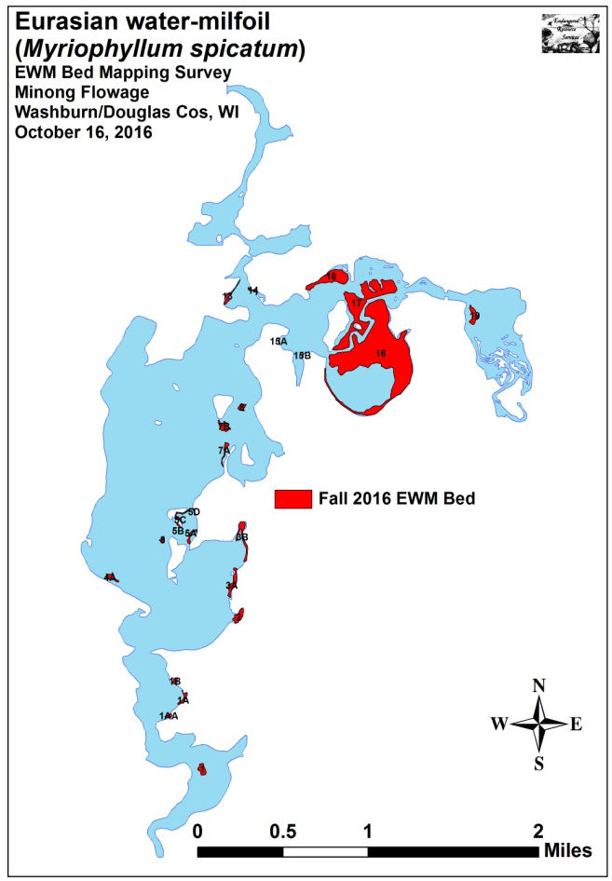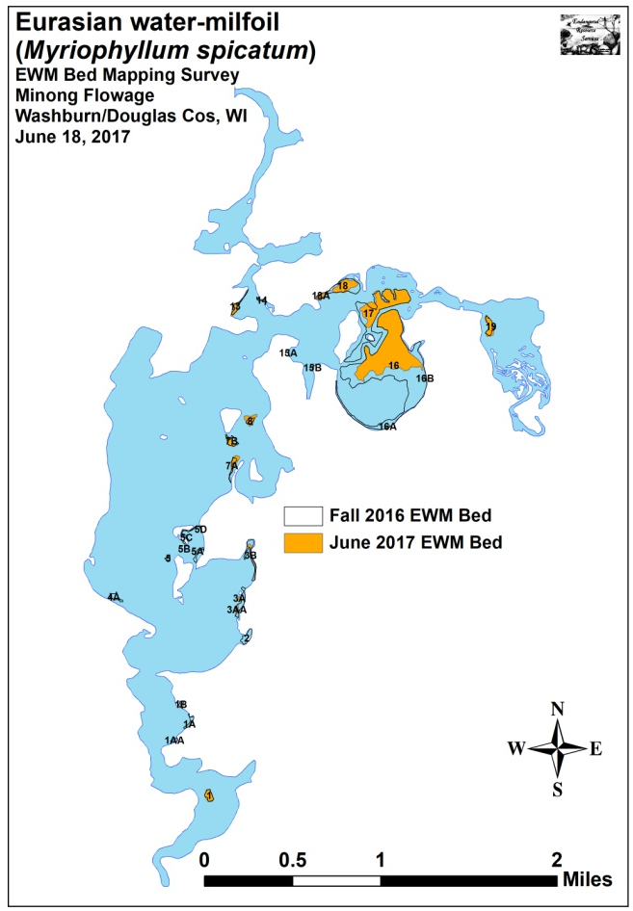
Figure 5: Fall 2016 and June 2017 Eurasian Water-milfoil Bed Maps

Table 2: June Eurasian Water-milfoil Bed Mapping Summary
Minong Flowage, Washburn and Douglas Counties
June 18, 2017
Bed Number | June 2017  Area in Acres | Fall 2016  Area in Acres | Overwinter  Change in  Acreage | Depth Range  and Mean Depth | Est. Rake Range  and Mean Rake Fullness | Navigation Impairment | June 2017 Field Notes
1 | 1.44 | 1.40 | 0.04 | 2-4; 3 | 1-3; 2 | Minor | Nearly monotypic.
1AA | 0 | 0.33 | -0.33 | - | 0 | None | No EWM found.
1A | 0 | 0.81 | -0.81 | - | 0 | None | No EWM found.
1B | 0.13 | 0.48 | -0.35 | 2-4; 3 | <<1-1; <1 | None | Monotypic low density.
2 | 0 | 1.80 | -1.80 | - | 0 | None | No EWM found.
3 | 0 | 0 | 0 | - | 0 | None | No EWM found.
3A and 3AA | 0.75 | 2.06 | -1.31 | 2-3; 2 | <<1-2; <1 | None | Monotypic low density.
3B | 0.74 | 2.55 | -1.81 | 2-3; 2 | <<1-2; <1 | None | Low density/mixed with Coontail.
4 | 0 | 0 | 0 | - | 0 | None | No EWM found.
4A | 0 | 1.05 | -1.05 | - | 0 | None | No EWM found.
5 | 0 | 0.30 | -0.30 | - | 0 | None | No EWM found.
5A, B, C, D | 0 | 1.49 | -1.49 | - | 0 | None | No EWM found.
6 | 0 | 0 | 0 | - | 0 | None | No EWM found.
7 | 0 | 0 | 0 | - | 0 | None | No EWM found.
7A | 1.47 | 0.75 | 0.72 | 2-4; 3 | <<1-2; <1 | None | Monotypic low density.
7B | 1.02 | 1.46 | -0.44 | 2-4; 3 | <1-2; 1 | None | Monotypic regular towers.
8 | 1.63 | 0.76 | 0.87 | 2-4; 3 | <1-2; 1 | Minor | Nearly monotypic regular towers.
9 | 0 | 0 | 0 | - | 0 | None | No EWM found.
10 | 0 | 0 | 0 | - | 0 | None | No EWM found.
11 | 0 | 0 | 0 | - | 0 | None | No EWM found.
12 | 0 | 0 | 0 | - | 0 | None | No EWM found.
13 | 1.00 | 0.85 | 0.15 | 2-6; 4 | <1-3; 2 | None | Mixed with natives near shore.
14 | 0 | 0.31 | -0.31 | - | 0 | None | No EWM found.
15 | 0 | 0 | 0 | - | 0 | None | No EWM found.
15A | 0 | 0.10 | -0.1 | - | 0 | None | No EWM found.
15B | 0 | 0.09 | -0.09 | - | 0 | None | No EWM found.
16 and 16A/B | 40.22 | 75.32 | -35.1 | 1-6; 4 | <<<1-3; 2 | Moderate | Regular dense clusters in areas <4ft.
17 | 15.70 | 24.27 | -8.57 | 2-6; 4 | <1-3; 2 | Moderate | Merging towers occasionally forming mat.
18 and 18A | 4.84 | 7.61 | -2.78 | 2-6; 4 | <<1-2; <1 | None | Regular canopied towers.
19 | 2.27 | 1.80 | 0.47 | 2-4; 3 | <<1-2; <1 | None | Regular expanding plants.
Total | 71.23 | 125.58 | -54.35

June Descriptions of Current and Former Eurasian Water-milfoil Beds:
Bed 1 – Moderate density EWM continues to cover the bar near the outlet. A minor impairment on the deeper edges, most of the bed is too shallow to motor through or be an issue.

Beds 1AA, 1A, 1B, and 2 – We found almost no plants of any kind in these shallow sand-bottomed areas. It appears all vegetation was eliminated by freeze-out.

Beds 3 and 4 – We found no EWM anywhere in these areas in the fall of 2016 or spring of 2017.

Beds 3A, 3AA, and 3B – The immediate shoreline areas were free of EWM, with most plants in 2-3ft. However, we noted pioneer plants growing from fragments were spreading into both shallower and deeper water.

Beds 4A, 5, and 5A-D – These shallow areas all supported low density beds in the fall of 2016. However, like many other areas in the southern basin, they appear to have winter killed.

Beds 6 and 7 – The 2016 treatment area in the WDNR landing bay continued to be EWM free.

Beds 7A, 7B, and 8 – Each of these three beds appeared to be expanding into water from 3-5ft. Although the shallow areas of 7B were knocked back, all other areas continued to expand. Bed 8 should be buoyed as it was likely to be hit by any boat leaving the public landing bay. Although only a minor navigation impairment, these prop-clipped fragments were likely seeding adjacent areas.

Beds 9, 10, 11, 12, and 15 – We found no EWM in any of these former beds in fall 2016 or June 2017.

Bed 13 – This area seems to have picked up where it left off in fall 2016 as it expanded further into the shallows to the southeast.

Beds 14, 15A and 15B – Each of these beds had regular plants in the fall of 2016, but we failed to locate more than a handful of individual EWM plants in any of these areas in June.

Beds 16 and 17 – The expansion into deep water seen in 2016 seems to have been blunted by a winter die-off. Raking in areas over 5ft produced nothing, and it appears poor water clarity helped push the bed back to its core in 4ft of water.

Beds 18A and 18 – These areas seem to have suffered die-backs on both the shallow and deep water sides of the beds. The only moderately dense growth was in the 3-4ft range.

Bed 19 – We again found that EWM was expanding east of Smith’s Bridge into areas formerly occupied by Northern wild rice.

Fall Eurasian Water-milfoil Bed Mapping Survey:
During the fall 2017 survey, we located and mapped 27 Eurasian water-milfoil beds that covered 112.88 acres or 7.22% of the flowage’s surface area (Figure 6) (Appendix III). This was an increase of 41.65 acres (+58.47%) over the 71.23 acres mapped in June of 2017 (Table 3). As expected, beds delineated in June showed expansion in both area and density. The only exception to this was Bed 8 which declined in area by 0.08 acre; potentially due to +/- error range of the GPS. Most of the 13 additional beds that we found during the fall survey likely represent recolonization as we noted floating EWM fragments were abundant along the entire eastern shoreline of the flowage as well as in the delta area east of Smith’s Bridge where EWM continued to expand into areas that former supported Northern wild rice. Several of these new beds appeared in areas that haven’t supported EWM since before the drawdown. Even with the expansion since June, the fall 2017 beds covered 12.70 acres (-10.11%) less than the 125.58 acres mapped during the fall 2016 survey (Table 4). Most of this year-over-year loss occurred in Serenity Bay (Bed 16) where areas over 6ft that had supported plants in 2016 had almost none in 2017. Although this overall decline was a positive, it was still more than the 90.36 acres mapped in 2015 or the 14.02 acres mapped in 2014. Interestingly, areas on the western shoreline of the flowage that supported sizable beds of EWM prior to the drawdown remained EWM free; unfortunately, they also continued to have almost no native vegetation.

Many of the flowage’s EWM beds in the north bays have increased to the point that boats navigating through them would likely experience minor to moderate impairment (Table 3). Fortunately, most of the worst areas occur among the stump fields or along shorelines that have few residents. In the southern basin, most beds are still quite low density and unlikely to significantly impair navigation.

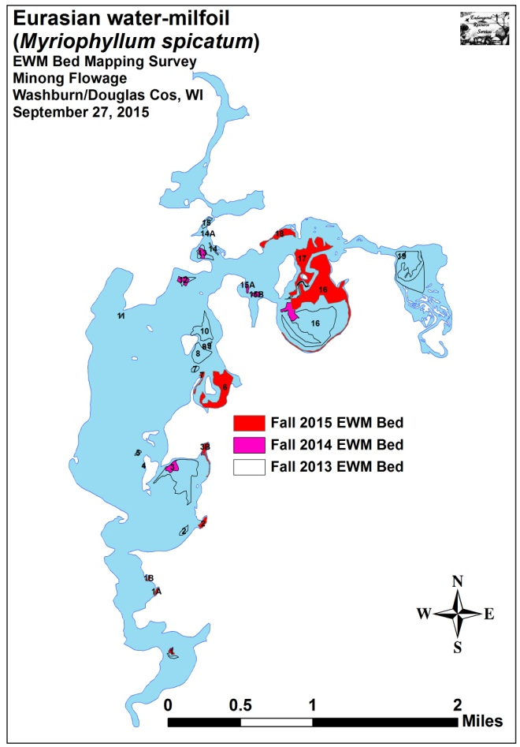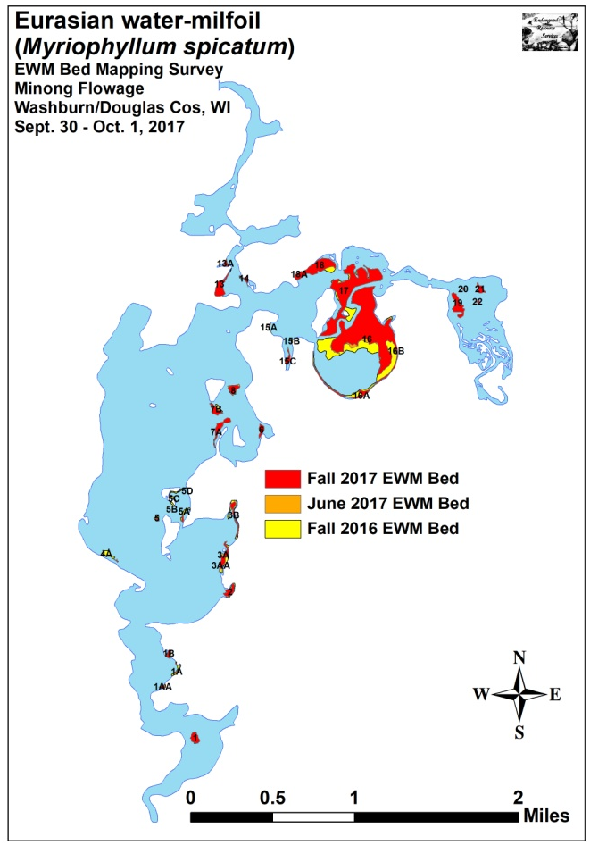
Figure 6: Fall 2013/2014/ 2015 and Fall 2016/June/Fall 2017 EWM Beds

Table 3: Fall Eurasian Water-milfoil Bed Mapping Summary
Minong Flowage, Washburn and Douglas Counties
September 30-October 1, 2017
Bed Number | Fall 2017  Area in acres | June 2017  Area in acres | Summer Change in Acreage | Depth Range/ Mean Depth | Est. Rake Range/ Mean Rake Full. | Navigation Impairment | Fall 2017 Field Notes
1 | 1.62 | 1.44 | 0.18 | 1-4; 3 | 1-3; 2 | Minor | Too shallow to be a sig. issue/monotypic.
1AA | 0.23 | 0 | 0.23 | 2-4; 3 | <<1-2; <1 | None | More of a High Density Area/monotypic.
1A | 0.22 | 0 | 0.22 | 2-4; 3 | <<<1-2; <<1 | None | More of a High Density Area/monotypic.
1B | 0.47 | 0.13 | 0.34 | 1-4; 3 | <1-3; 2 | Minor | Too shallow to be an issue-50/50 Coontail/EWM.
2 | 1.66 | 0 | 1.66 | 1-4; 2 | <1-3; 2 | Minor | Too shallow to be an issue-50/50 Coontail/EWM.
3 | 0 | 0 | 0 | - | 0 | None | No EWM found.
3A and 3AA | 1.93 | 0.75 | 1.18 | 2-4; 3 | <<<1-2; <1 | None | Nearly monotypic – nearly continuous towers.
3B | 1.27 | 0.74 | 0.53 | 2-4; 3 | <1-3; 1 | None | Most monotypic, but 50% Coontail in the bay.
4 | 0 | 0 | 0 | - | 0 | None | No EWM found.
4A | 0.09 | 0 | 0.09 | 2-4; 3 | <<1-2; <1 | None | Monotypic - More of a High Density Area.
5 | 0.15 | 0 | 0.15 | 2-4; 3 | <1-2; 1 | None | Monotypic low density towers.
5A, B, C, D | 0.27 | 0 | 0.27 | 1-3; 2 | <<<1-1; <1 | None | Most monotypic – some Coontail/Pondweeds.
6 | 1.06 | 0 | 1.06 | 1-4; 3 | <<<1-2; <1 | None | High Density Area – Some Coontail/Pondweeds.
7 | 0 | 0 | 0 | - | 0 | None | No EWM found.
7A | 2.41 | 1.47 | 0.94 | 2-4; 4 | <1-2; 1 | None | Monotypic regular towers.
7B | 1.50 | 1.02 | 0.48 | 2-4; 4 | <1-2; 1 | None | Monotypic regular towers.
8 | 1.55 | 1.63 | -0.08 | 2-4; 3 | 1-3; 2 | Minor | Monotypic continuous towers.
9 | 0 | 0 | 0 | - | 0 | None | No EWM found.
10 | 0 | 0 | 0 | - | 0 | None | No EWM found.
11 | 0 | 0 | 0 | - | 0 | None | No EWM found.
12 | 0 | 0 | 0 | - | 0 | None | No EWM found.
13 | 3.11 | 1.00 | 2.11 | 1-5; 3 | <1-3; 1 | Minor | Rake 3 near shore – becoming < with depth.
13A | 0.45 | 0 | 0.45 | 1-4; 3 | <<<1-2; <1 | None | Scattered towers mixed with Coontail/Pondweeds.
14 | 0.47 | 0 | 0.47 | 1-5; 3 | <1-3; 1 | None | Mixed with Coontail/Pondweeds.
15 | 0 | 0 | 0 | - | 0 | None | No EWM found.
15A | 0.18 | 0 | 0.18 | 1-4; 3 | <<1-1; 1 | None | Scattered low density towers.
15B and 15C | 0.88 | 0 | 0.88 | 1-4; 3 | <<1-2; <1 | None | Spreading; denser near shore.
16 and 16A/B | 54.45 | 40.22 | 14.23 | 1-7; 4 | <<1-3; 2 | Moderate | Variable – nearly monotypic – thickening.
17 | 26.05 | 15.70 | 10.35 | 1-4; 4 | <1-3; 1 | Minor | Stump field – mixed with natives.
18 and 18A | 8.00 | 4.84 | 3.16 | 1-4; 3 | <1-3; 3 | Moderate | Becomes patchier in deeper water.
19 | 3.51 | 2.27 | 1.24 | 2-4; 3 | <<1-3; 1 | Minor | Mixed with Coontail/Pondweed/VERY few rice.
20, 21, and 22 | 1.37 | 0 | 1.37 | 2-4; 3 | <<1-3; 1 | Minor | Pioneering area – widely scattered rice plants.
Total | 112.88 | 71.23 | +41.65

Table 4: Fall Eurasian Water-milfoil Bed Mapping Summary
Minong Flowage, Washburn and Douglas Counties
2014-2017
Bed Number | 2017  Area in Acres | 2016  Area in Acres | 2015  Area in Acres | 2014  Area in Acres | 2017 Fall  Change in  Acreage
1 | 1.62 | 1.40 | 0.50 | 0.32 | 0.22
1AA | 0.23 | 0.33 | 0 | 0 | -0.10
1A | 0.22 | 0.81 | 0.58 | 0 | -0.59
1B | 0.47 | 0.48 | 0.31 | 0 | -0.01
2 | 1.66 | 1.80 | 1.40 | 0 | -0.14
3 | 0 | 0 | 0 | 2.68 | 0
3A | 1.93 | 2.06 | 0 | 0 | -0.13
3B | 1.27 | 2.55 | 1.96 | 1.42 | -1.28
4 | 0 | 0 | 0 | 0 | 0
4A | 0.09 | 1.05 | 0 | 0 | -0.96
5 | 0.15 | 0.30 | 0 | 0 | -0.15
5A, B, C, D | 0.27 | 1.49 | 0 | 0 | -1.22
6 | 1.06 | 0 | 16.39 | 0 | 1.06
7 | 0 | 0 | 1.23 | 0 | 0
7A | 2.41 | 0.75 | 0 | 0 | 1.66
7B | 1.50 | 1.46 | 0 | 0 | 0.04
8 | 1.55 | 0.76 | 0.18 | 0 | 0.79
9 | 0 | 0 | 0 | 0 | 0
10 | 0 | 0 | 0 | 0 | 0
11 | 0 | 0 | 0 | 0 | 0
12 | 0 | 0 | 0 | 1.90 | 0
13 | 3.11 | 0.85 | 0 | 1.57 | 2.26
13A | 0.45 | 0 | 0 | 0 | 0.45
14 | 0.47 | 0.31 | 0 | 0.05 | 0.16
15 | 0 | 0 | 0 | 0 | 0
15A | 0.18 | 0.10 | 0 | 0.57 | 0.08
15B and 15C | 0.88 | 0.09 | 0 | 0.85 | 0.79
16 | 54.45 | 75.32 | 43.08 | 4.58 | -20.87
17 | 26.05 | 24.27 | 19.43 | 0 | 1.78
18 | 8.00 | 7.61 | 5.30 | 0 | 0.39
19 | 3.51 | 1.80 | ----- | 0.10 | 1.71
20 | 0.14 | 0 | 0 | 0 | 0.14
21 | 1.04 | 0 | 0 | 0 | 1.04
22 | 0.19 | 0 | 0 | 0 | 0.19
Total | 112.88 | 125.58 | 90.36 | 14.02 | -12.70

Fall Descriptions of Current and Former Eurasian Water-milfoil Beds:
Bed 1 – Despite years of herbicide treatments and manual removal, EWM on the bar near the outlet always seems to have recovered to about the same moderate density by the end of the growing season – 2017 was no exception.

Beds 1AA, 1A, and 1B – After disappearing almost completely over the winter, a narrow ribbon of mostly low density EWM had recolonized much of the eastern shoreline in this small side bay.

Bed 2 – We found moderate amounts of EWM and Coontail (Ceratophyllum demersum) had recolonized much of this very shallow bay.

Beds 3 and 4 – EWM was not present in these areas during any of the 2016 or 2017 surveys.

Beds 3A, 3AA, and 3B – Very low density EWM had recolonized much of the immediate shoreline areas. We also found that it was radiating out into 4ft+. In general, all of these beds were thicker than in June, but the beds are so narrow that they are unlikely to be a significant navigation issue.

Beds 4A, 5, and 5A-D – We found very low density EWM scattered throughout these beds. None were likely to impact navigation, and each was probably better described as a “High Density Area” than a true bed although they were all monotypic or nearly monotypic.

Beds 6 and 7 – Although the area formerly occupied by Bed 7 remained clear of EWM, we found pioneer plants scattered in the “Bed 6” area and floating fragments were common in the bay. Because of this, it seems likely that EWM will spread throughout this area by the end of next summer suggesting the 2016 herbicide treatment bought about 2-3 years of control in this location.

Beds 7A, 7B, and 8 – We expect Beds 7A and 7B will continue to expand down the shoreline and around the island. However, Bed 8 is likely about as big as it can be unless water clarity improves as it now completely covers areas <5ft deep on the rock bar.

Beds 9, 10, 11, 12, and 15 – We found no EWM in these former beds in 2016 or 2017.

Bed 13 – This area has the potential to become a significant navigation impairment in the near future much like it was prior to initial herbicide treatments and the drawdown. EWM now extends all the way to the shoreline and continues to expand in all directions including into water >5ft deep.

Bed 13A – EWM seems to have gotten a toehold in this bay that was formerly dominated by native species. Density was still very low, and it was barely even a High Density Area. However, as we have never seen EWM here before, we felt it was worth mapping.

Beds 14 and 15A – We noted each of these shoreline areas had been recolonized by low-density EWM.

Bed 15B – We didn’t see any surviving EWM in this area during either of the 2017 surveys.

Bed 15C – During our first survey on the flowage in 2008, “Thumb Bay” was a solid mat of EWM. Several herbicide treatments coupled with poor water clarity all but eliminated the bed by 2012. This expansion marks the first EWM has been present here since then. Much like Bed 13, we believe this area has the potential to become a significant navigation impairment in the near future without management.

Beds 16 and 17 – Similar to the June survey, we found raking in areas over 5ft produced nothing suggesting the summer’s poor water clarity largely prevented recolonization in deep water. Despite this, floating fragments were abundant in Serenity Bay, and most areas <4ft deep that had been free of EWM in June had recolonized.

Beds 18A and 18 – These areas merged back together to form one of the densest EWM beds on the flowage. However, and somewhat surprisingly, plants in this area were still not regularly found in water deeper than 4ft.

Bed 19 – EWM in this bed continues to expand south along the main channel among the emergents and into more areas formerly occupied by Northern wild rice.

Beds 20-22 – Likely seeded by fragments from Bed 19, EWM was expanding along the edges of the braided channels in the north end of the delta. We noted that EWM was now found in some areas that CLP had covered during the June survey. Unfortunately, rice density in all of these areas continued to be extremely low.

LITERATURE CITED

Pokorny, N., C. Busch, L. Sather, and C. Holt. [online]. 1966. Minong Flowage Map. Available from http://dnr.wi.gov/lakes/maps/DNR/2692900a.pdf (2017, October).

WDNR. [online]. 2017. Minong Flowage - Citizen Lake Water Quality Monitoring Database. Available from http://dnr.wi.gov/lakes/lakepages/LakeDetail.aspx?wbic=2692900&page=waterquality (2017, October).

Appendix I: June Curly-leaf Pondweed and Eurasian Water-milfoil Bed Maps
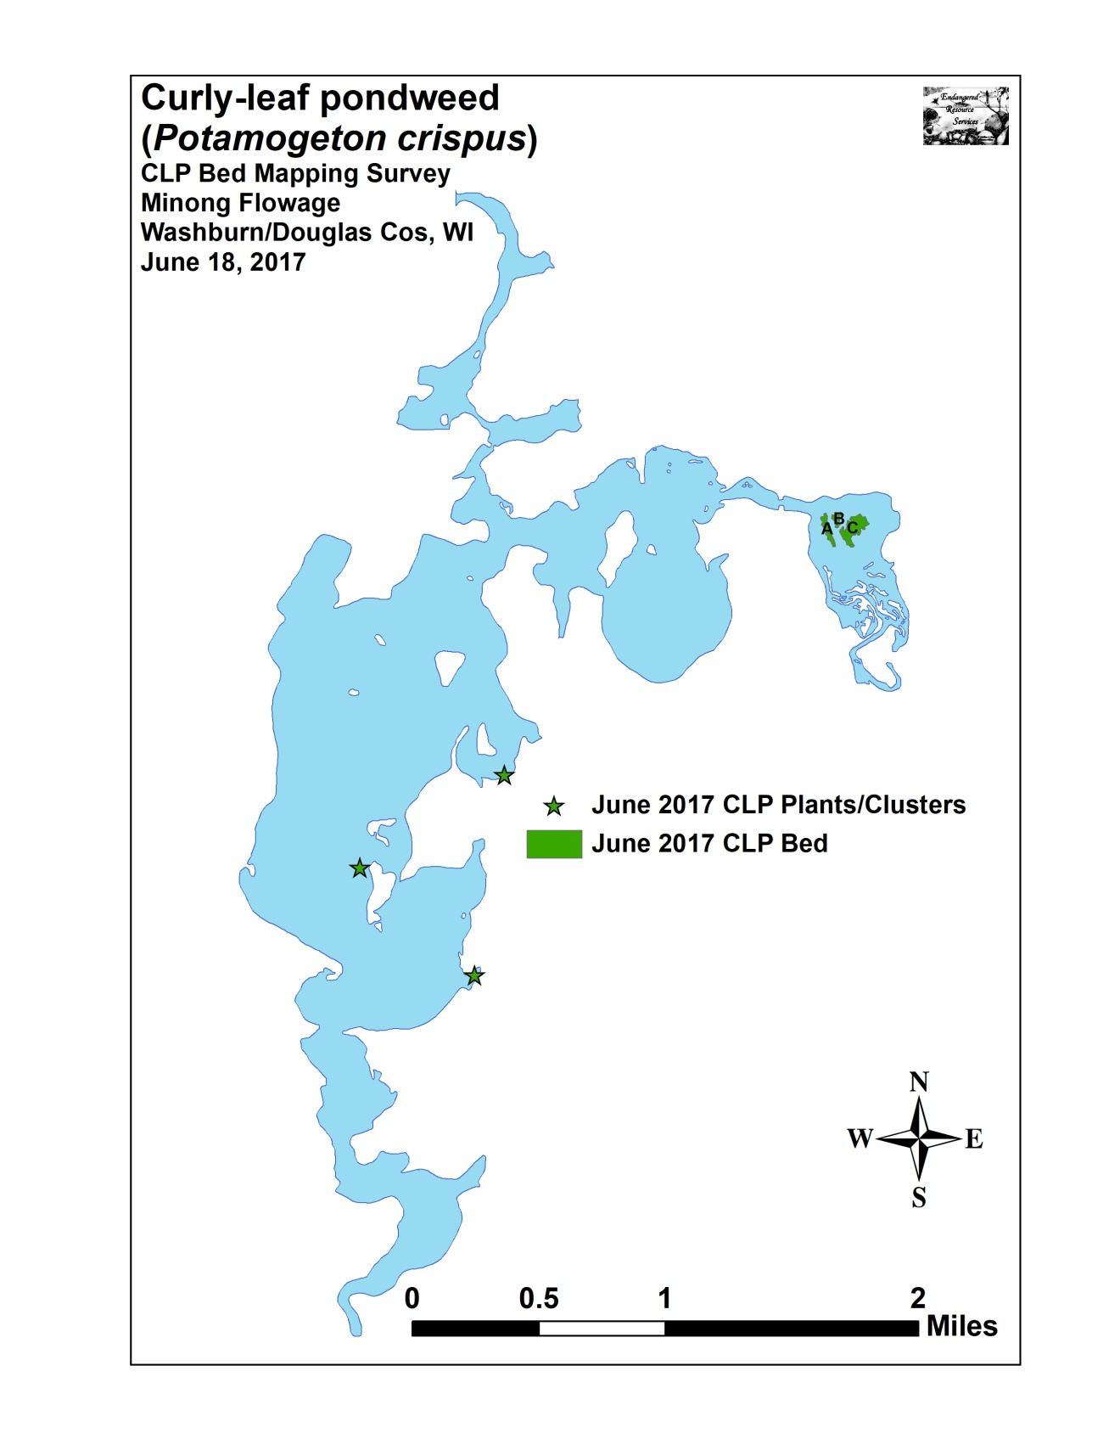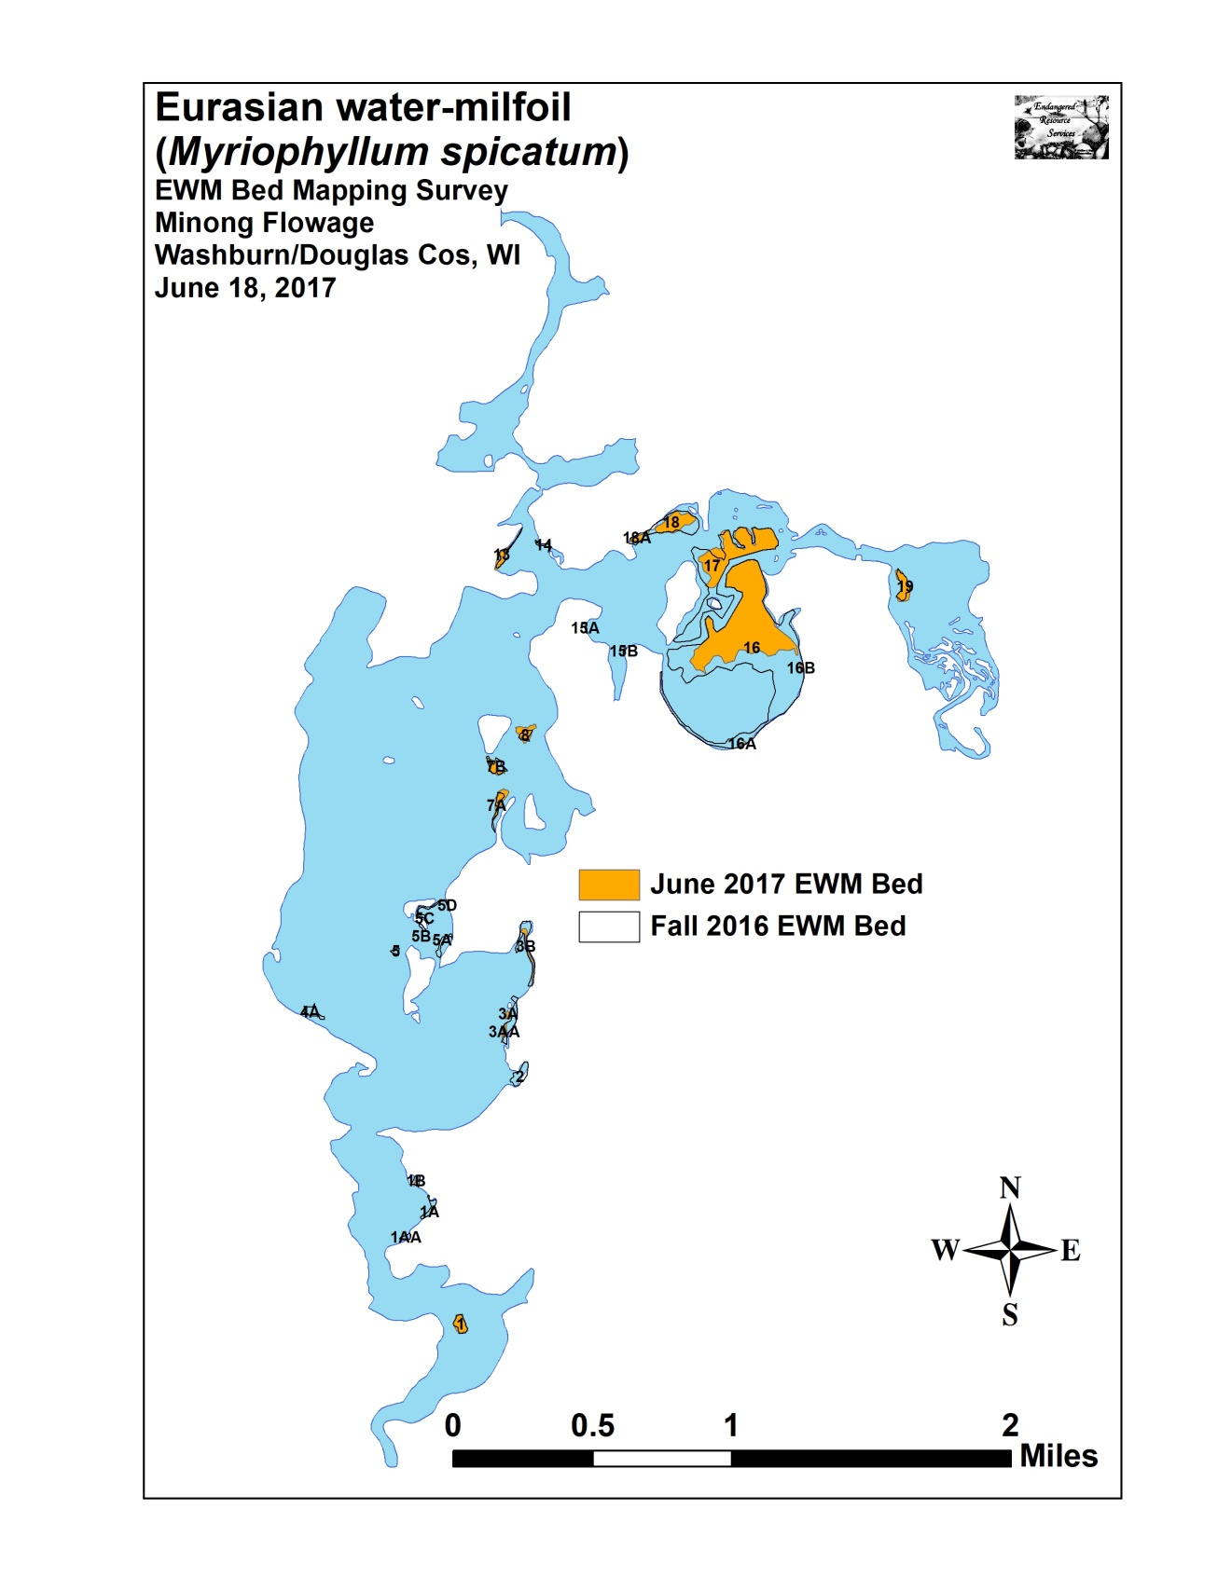

Appendix II: Fall 2015, 2016, and 2017 Eurasian Water-milfoil Bed Maps
