Northern Wild Rice (Zizania palustris) and
High Density Macrophyte Bed Mapping Survey
Amnicon Lake (WBIC: 2858100) - Douglas Co., WI

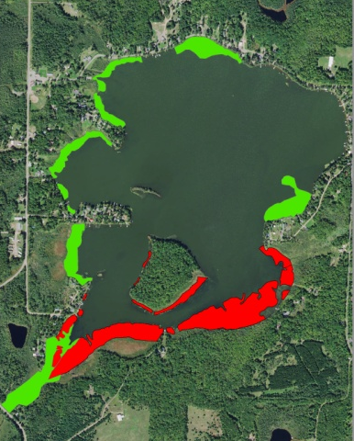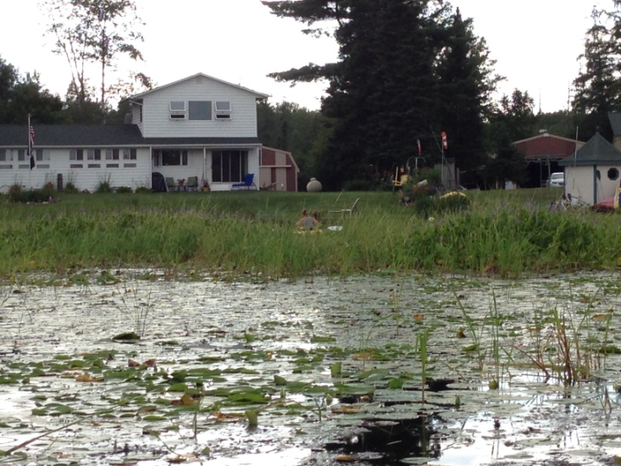
Amnicon Rice (Red) /High Density Plants (Green) Impenetrable Emergent and Floating-leaf Vegetation Near the Lake Outlet 7/31/16

Project Initiated by:
Amnicon Dowling Lake Management Dist., Lake Education and Planning Services, LLC. and the Wisconsin Department of Natural Resources

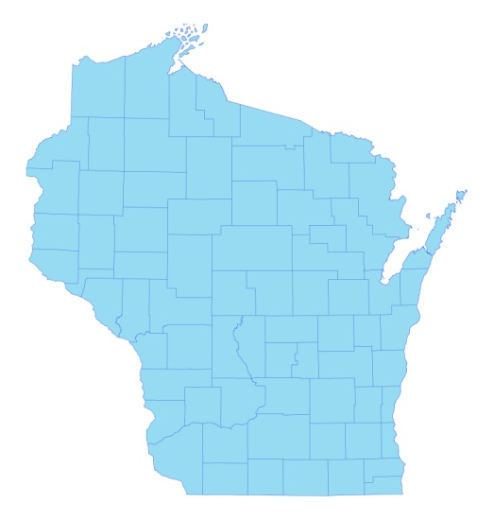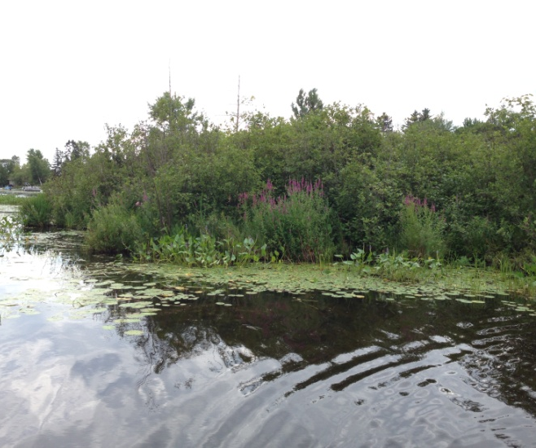
* Amnicon
Lake
Purple Loosestrife Near Amnicon Landing 7/31/16

Survey Conducted by and Report Prepared by:
Endangered Resource Services, LLC
Matthew S. Berg, Research Biologist
St. Croix Falls, Wisconsin
July 31, 2016
TABLE OF CONTENTS

Page
LIST OF FIGURES AND TABLES..……………………………………………… ii
INTRODUCTION.…..……..………………………………………………………. 1
BACKGROUND AND STUDY RATIONALE…………………………………… 1
METHODS……………………..………..…………………………………………. 2
RESULTS.……………………..………………………………………………….... 3
Northern Wild Rice Bed Mapping Survey….………….……………..……. 3
Descriptions of Rice Beds.……………..……………….………….………. 5
High Density Plant Bed Mapping Survey……………….…………………. 9
Descriptions of High Density Plant Beds.……………….…………………. 10
Aquatic Invasive Plant Species Survey……….……………………….….... 13
DISCUSSSION AND CONSIDERATIONS FOR MANAGEMENT..….………... 14
LITERATURE CITED ……………………….…………………………….…….… 15
APPENDIXES. …….…………………………………………………….…………. 16
I: 2012 Northern Wild Rice Density and Distribution..………….……………... 16
II: 2016 Northern Wild Rice Beds.……………………………………………… 18

III: 2016 High Density Plant Areas...………………….…………………………. 20

LIST OF FIGURES AND TABLES

Page #

Figure 1: Amnicon Lake Bathymetric Map…………….………………………….. 1

Figure 2: Rake Fullness Ratings..………………………………………………….. 2

Figure 3: Northern Wild Rice Density and Distribution 8/3-4/12…..……………... 3

Figure 4: Typical Low Density Rice South of Tomahawk Island 8/4/12.…….…… 3

Figure 5: Northern Wild Rice Beds – Mean Density – 7/31/16…………………… 4

Table 1: Northern Wild Rice Bed Summary
Amnicon Lake, Douglas County – July 31, 2016………….……………………….. 5

Figure 6: Rice Bed 2 – Facing South – Scattered Among Docks…..…….………... 5

Figure 7: Rice Bed 3 – Facing North Toward Tomahawk Island………………….. 6

Figure 8: Rice Bed 5 – Facing North Toward Tomahawk Island………………….. 6

Figure 9: Rice Beds 6/7 – Ribbon West of Tomahawk Island..………………...…. 6

Figure 10: Rice Bed 8 – Ribbon Southwest of Tomahawk Island…....…….……... 7

Figure 11: Rice Bed 9 – Southeast of Tomahawk Island…..……….……………... 7

Figure 12: West Side of Rice Bed 11..………………………………………….…. 7

Figure 13: East Side of Rice Bed 11…………….…………………………………. 8

Figure 14: Severe Navigation Impairment in Rice Bed 12…………....………...…. 8

Figure 15: Rice Bed 13 – Facing North Toward Tomahawk Island…….…………. 8

Figure 16: Rice Bed 14 – Facing North Around the Southeast Bay…..….………... 9

Figure 17: High Density Plant Areas – Mean Density 7/31/16……………………. 9

Table 2: High Density Non-rice Bed Summary
Amnicon Lake, Douglas County – July 31, 2016………….……………………….. 10

Figure 18: HDA A – East Shore Facing South to Lake Outlet..…………..……..… 10

Figure 19: HDA A – West Shore Facing West in the Lake Outlet….…………..…. 10

Figure 20: HDA A – Impenetrable Vegetation on the West Shore.…...................... 11

Figure 21: HDA B – South and North Shorelines…………………………………. 11

Figure 22: HDA C – Floating-leaf Bur-reed/HDA D – Watershield........................ 11

Figure 23: HDA E – Dense Watershield in the West Central Bay..………….……. 12

Figure 24: HDA F – Moderately Dense Watershield – Northwest Bay….……..…. 12

Figure 25: West End of HDA G Near the Boat Landing………….……….………. 12

Figure 26: Bulrush Beds on the North End of HDA G……………………….……. 13
INTRODUCTION:
Amnicon Lake (WBIC 2858100) is a 390 acre stratified drainage lake located in the Town of Summit in west-central Douglas County (T46N R14W S14 SE NE). The lake reaches a maximum depth of 31ft near the north-central shore and has an average depth of 10ft (WDNR 2009) (Figure 1). The lake is mesotrophic bordering on eutrophic in nature with summer Secchi readings that averaged 5.5ft from 1988-2016 (WDNR 2016). This fair water clarity produced a littoral zone that extended to at least 9ft in July 2016. The lake’s bottom substrate is predominantly organic muck in the sheltered bays of the south and west, and a mixture of sand, rock, and sandy muck on the north and east shorelines, midlake bars, and around Little and Tomahawk Islands (Ginder et al. 1971).

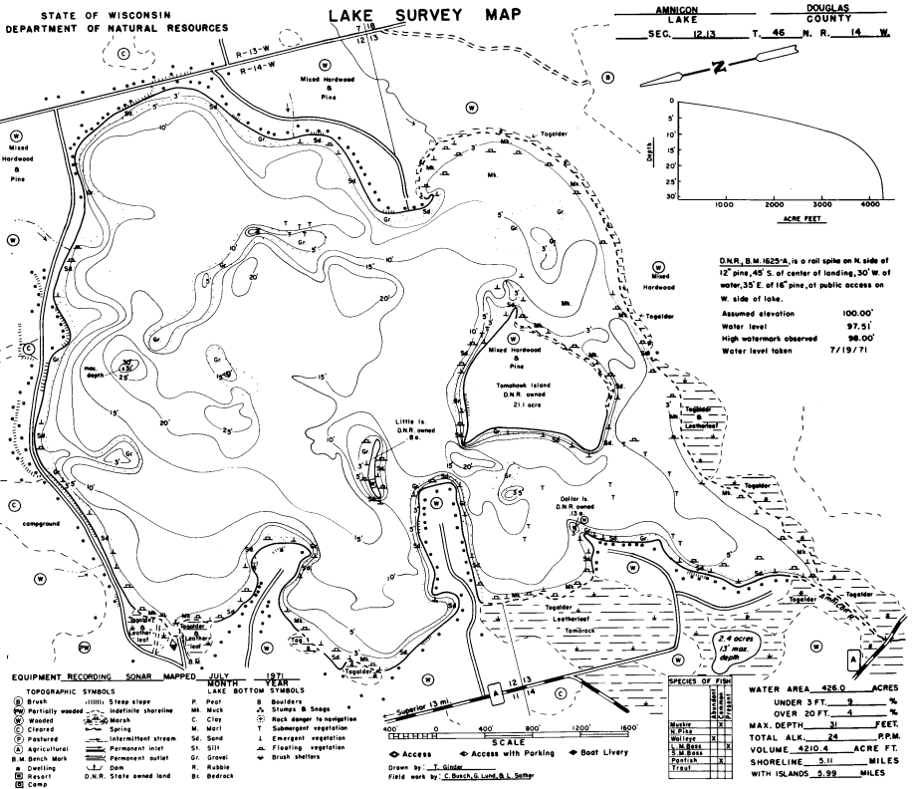
Figure 1: Amnicon Lake Bathymetric Map

BACKGROUND AND STUDY RATIONALE:
The Amnicon Dowling Lake Management District (ADLMD), Lake Education and Planning Services, LLC (LEAPS), and the Wisconsin Department of Natural Resources (WDNR) requested a Northern wild rice (Zizania palustris) and high-density plant bed mapping survey in response to concerns from residents about plants making it difficult or, in some cases, impossible to access open water from their lakeshore. The immediate goals of the survey were to define the total acreage covered by wild rice, and to assess the level of impairment caused by plant growth. Because the survey required searching the visible littoral zone of the lake, it also served as an Aquatic Invasive Species (AIS) survey to determine if Eurasian water milfoil (Myriophyllum spicatum) (EWM), or any other exotic plant had invaded the lake since the original point-intercept surveys conducted in 2012. These data will be used to update the lake’s Aquatic Plant Management Plan (APMP). This report is the summary analysis of the survey conducted on Amnicon Lake on July 31, 2016.
METHODS:
Northern Wild Rice and High Density Plant Bed Mapping Survey:
By definition, a “bed” was determined to be any area where we visually estimated that plants were generally continuous with clearly defined borders, and they were canopied or close enough to being canopied that they would potentially interfere with normal boat traffic. During the survey, we searched the lake’s entire visible littoral zone. After we located a bed, we motored around the perimeter of the area and took GPS coordinates at regular intervals. We also estimated the rake density range and mean rake fullness of the bed (Figure 2), and the impact it was likely to have on navigation (none – easily avoidable with a natural channel around or narrow enough to motor through/minor – one prop clear to get through or access open water/moderate – several prop clears needed to navigate through/severe – multiple prop clears and difficult to impossible to row through). In the case of Northern wild rice, we also estimated the bed’s human harvest potential (none – only scattered plants/little – regular plants, but low density/medium – regular plants of moderate density/high – continuous high density plants). These data were then mapped using ArcMap 9.3.1, and we used the WDNR’s Forestry Tools Extension to determine the acreage of each bed to the nearest hundredth of an acre.

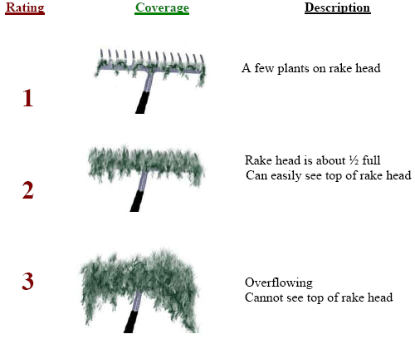
Figure 2: Rake Fullness Ratings (UWEX, 2010)

Aquatic Invasive Plant Species Survey:
To increase the chances of detection, the survey was conducted on a calm day. During the survey, we meandered back and forth throughout the lake’s visible littoral zone spacing transects close enough that our field of view overlapped from one transect to another. The most likely places for a new infestation to occur are the public boat landing and, in the case or Eurasian water-milfoil, along the far north shoreline of the lake where prevailing winds tend to carry plant fragments. Because of this, we surveyed especially slowly in these areas. We also paid special attention to the areas around docks and lifts as it is not uncommon for EWM to establish in these areas after becoming entangled in propellers.
RESULTS:
Northern Wild Rice Bed Mapping Survey:
During the 2012 point-intercept survey, we found Northern wild rice was widely scattered throughout the bays and narrows south of Tomahawk Island (Figure 3). Present in the rake at 17 points, none had a rake fullness value of 3, three were a 2, and the other 14 were a one for a mean rake fullness of 1.18 (Appendix I). We also recorded rice as a visual at six points. In 2012, although rice plants were essentially continuous in many areas, even at its highest densities, it was extremely patchy and not fit for human harvest (Figure 4).
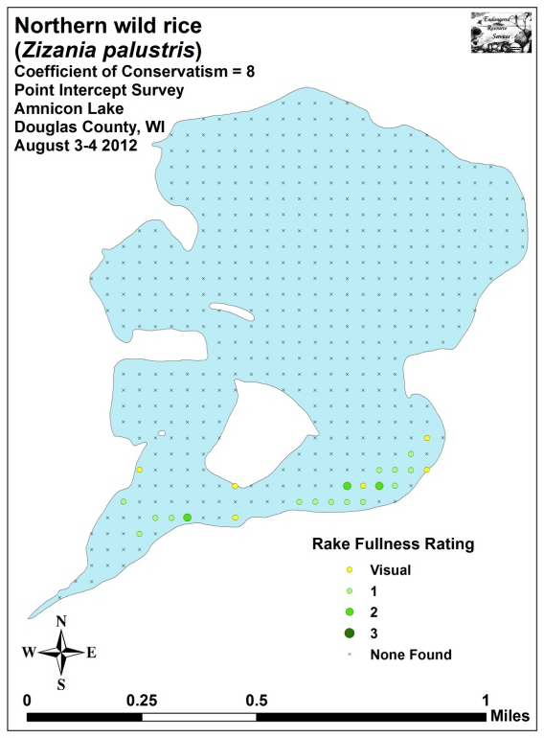
Figure 3: Northern Wild Rice Density and Distribution 8/3-4/12

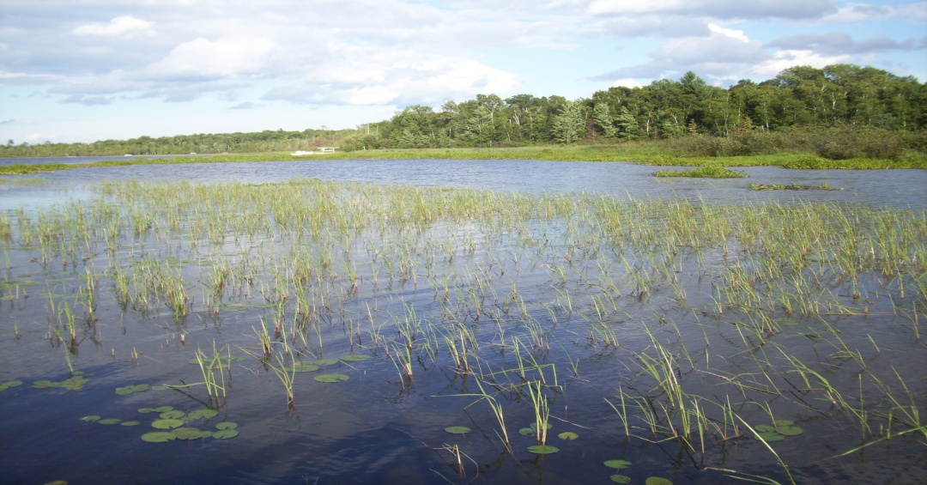
Figure 4: Typical Low Density Rice South of Tomahawk Island 8/4/12
During the July 31, 2016 survey, we mapped 14 beds that contained at least regular wild rice plants (Figure 5) (Appendix II). Collectively, they covered 35.55 acres with the biggest (Bed 11) totaling 14.66 acres, and the smallest (Bed 7) being just 0.08 acre (Table 1). Most of these areas had no human harvest potential as the rice was either very low density (Beds 1-4, 6-7, 10, 12, and 14) or were mixed with other emergents and floating mud bogs (Bed 8) making it difficult to impossible to navigate a canoe through the area. In areas that did have medium harvest potential (Beds 5, 11, and 13), the best areas were on the outer edges of the beds as the majority of nearshore areas were mixed with other emergents.

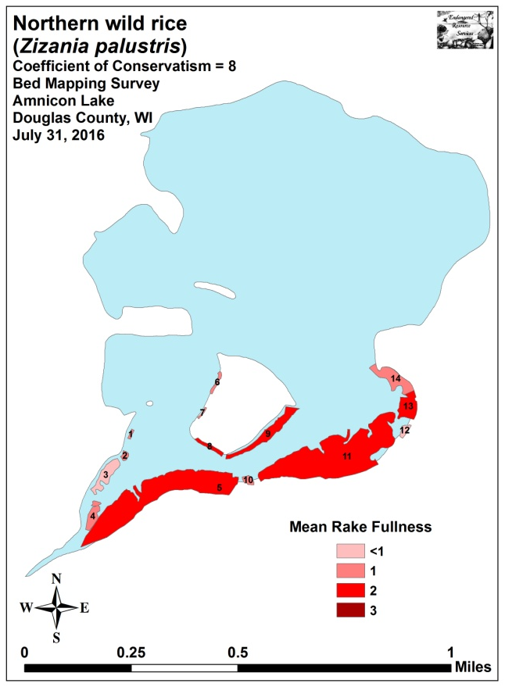
Figure 5: Northern Wild Rice Beds - Mean Density - 7/31/16

Table 1: Northern Wild Rice Bed Summary
Amnicon Lake, Douglas County – July 31, 2016

Bed Number | Acreage | Rake Range | Mean  Rake Fullness | Potential Navigation Impairment  Level | Human Harvest Potential
1 | 0.10 | <1-2 | 1 | Minor | None
2 | 0.18 | <1-2 | 1 | Minor | None
3 | 1.25 | <1-2 | <1 | Severe | None
4 | 0.81 | <1-1 | 1 | None | None
5 | 12.11 | <1-2 | 2 | None | Medium
6 | 0.22 | <1-1 | 1 | None | None
7 | 0.08 | <1-1 | 1 | None | None
8 | 0.39 | 1-2 | 2 | None | Little
9 | 1.99 | <1-3 | 2 | None | Medium
10 | 0.27 | <1-2 | 1 | None | None
11 | 14.66 | <1-3 | 2 | Severe | Medium
12 | 0.29 | <1-1 | <1 | Severe | None
13 | 1.44 | 1-3 | 2 | Moderate | Medium
14 | 1.76 | <<1-2 | 1 | Minor | None
Total Acres | 35.55

Descriptions of Rice Beds:
Beds 1 and 2: These small low density patches of rice had navigation channels cut through them where people accessed their docks (Figure 6). Although some patches were moderately dense, repeated boat traffic likely meant their navigation impairment was minor.
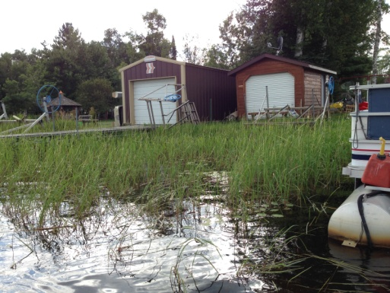
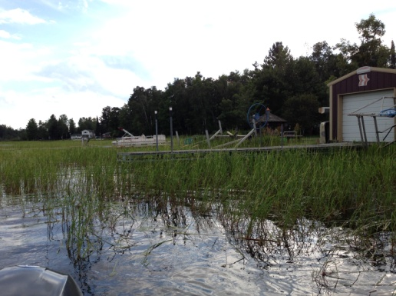
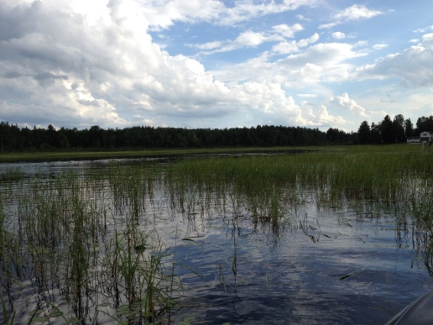

Figure 6: Rice Bed 2 - Facing South - Scattered Among Docks

Bed 3: Rice in Bed 3 was fragmented and very low density as the area was dominated by other emergents and Watershield (Brasenia schreberi) (Figure 7). Many residents have given up trying to access the lake in this area as plant growth is so dense.
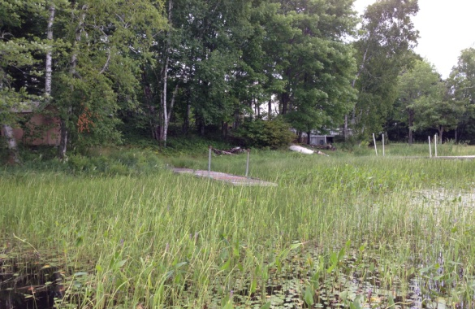
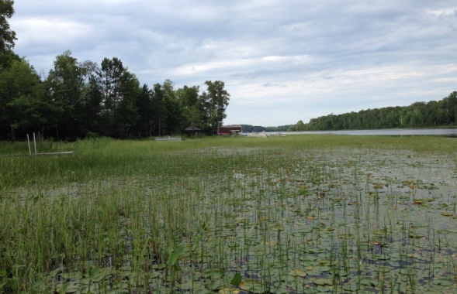
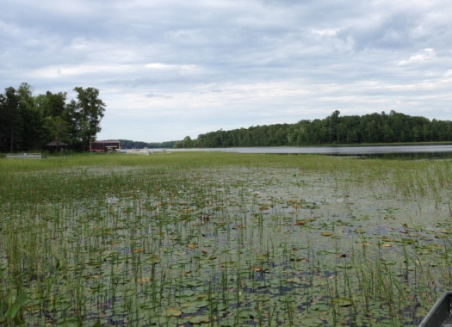

Figure 7: Rice Bed 3 - Facing North Toward Tomahawk Island

Beds 4 and 5: Located west of the outlet channel, Bed 4 was more a collections of low density patches. Bed 5 was, however, moderately dense over the majority of its area (Figure 8). Although the numerous floating mud bogs in the central and southwestern side of the bed would have made for difficult canoeing, the northeast corner of the bed had at least some potential for human harvest.

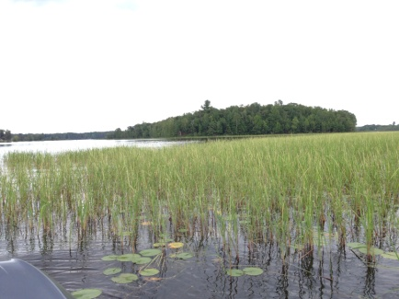
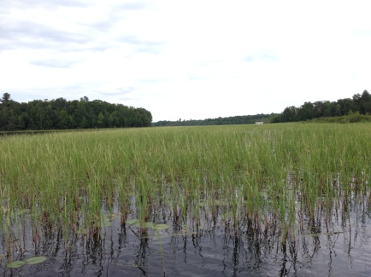
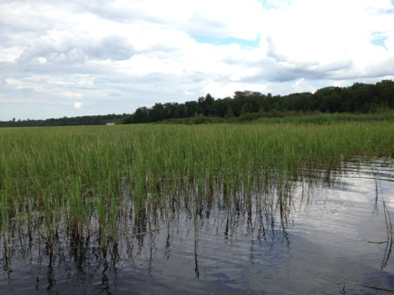
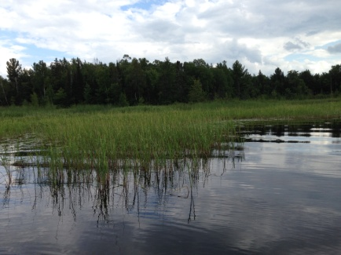
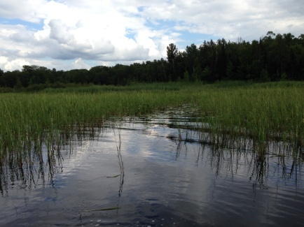
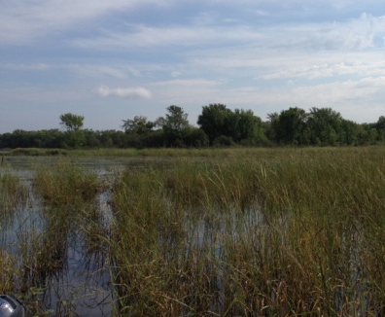

Figure 8: Rice Bed 5 - Facing North Toward Tomahawk Island

Beds 6 and 7: Located on the western side of Tomahawk Island, these two small narrow beds were established over nutrient-poor sandy muck. The plants themselves were a lime green and appeared to be in poor health. This, coupled with their low density, made them a non-issue in terms of both harvest and navigation (Figure 9).

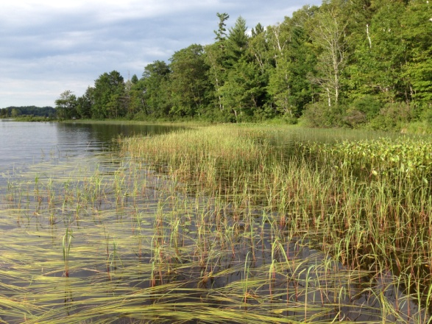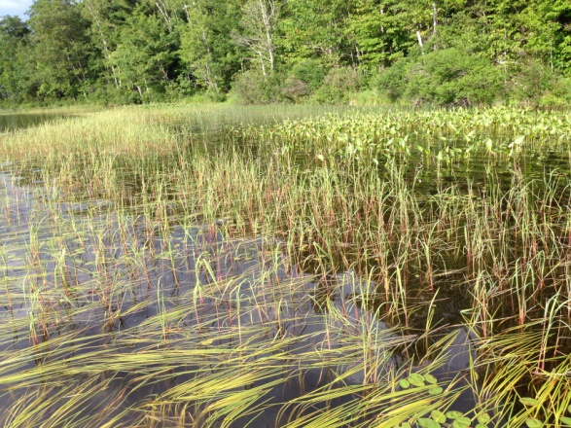
Figure 9: Rice Beds 6/7 – Ribbon West of Tomahawk Island
Bed 8: Slightly denser than Beds 6/7, Bed 8 was essentially a continuation of these beds over more nutrient rich sediment. Although it was patchy on the eastern side, the west end would have allowed for a couple of moderately productive canoe passes (Figure 10).
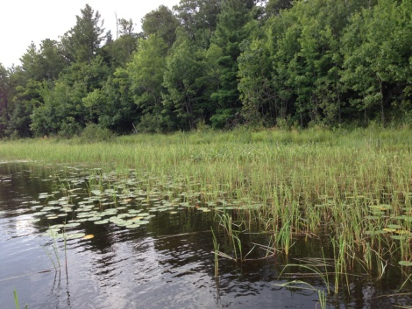
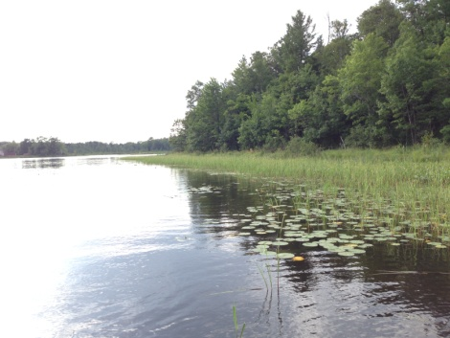
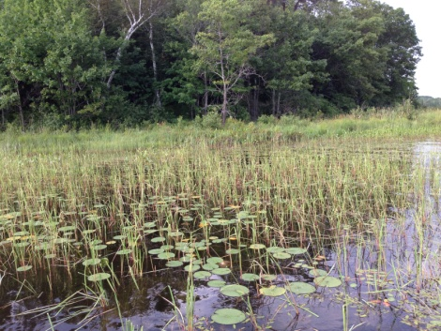
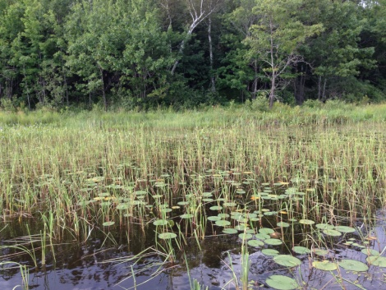

Figure 10: Rice Bed 8 - Ribbon Southwest of Tomahawk Island

Bed 9: More so than the other beds around the island, Bed 9 offered some human harvest potential. It widened and thickened moving from the southern tip of the island towards the northeast. Here, it became mixed with other emergent species before disappearing entirely near the island’s eastern tip (Figure 11).
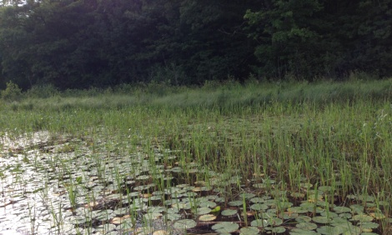
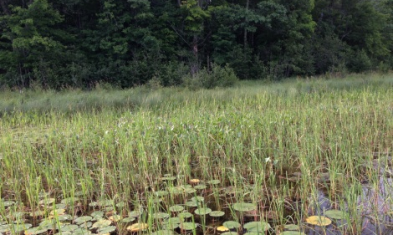
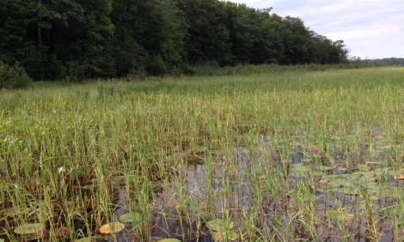
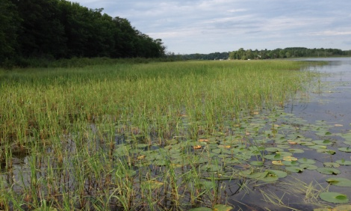

Figure 11: Rice Bed 9 - Southeast of Tomahawk Island

Bed 10: This bed was essentially continuous with Beds 5 and 11, but two residents accessing the lake had created navigation channels, and we chose to divide the beds. The density of this micro bed was smaller than the surrounding areas as well; presumably because of in/out boat traffic.

Bed 11: Bed 11 was the biggest and densest rice area on the lake. On the west side, the majority of rice in the center of the bed was pure, and there were many areas that offered at least moderate harvest potential (Figure 12). Closer to shore, rice tended to mix with other emergent species.
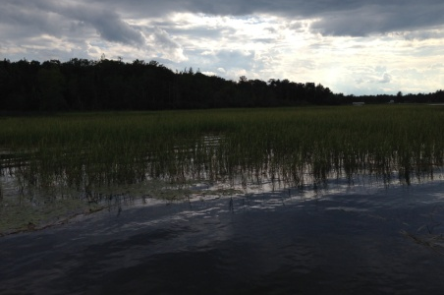
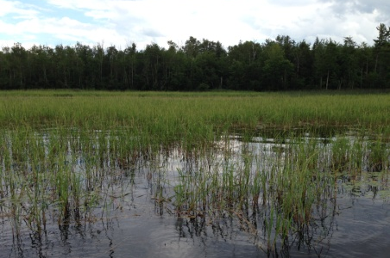
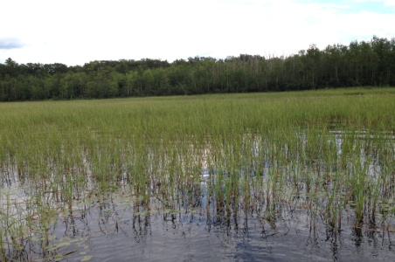
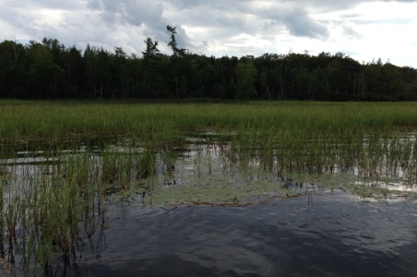

Figure 12: West Side of Rice Bed 11
Many areas on the eastern side of the bed were especially dense, and residents were forced to cut their way through to access open water (Figure 13).
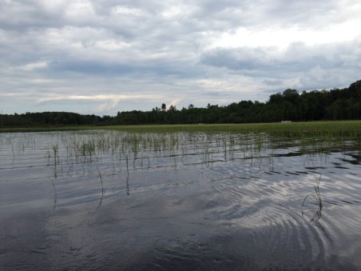
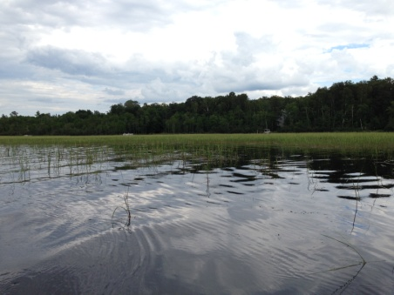
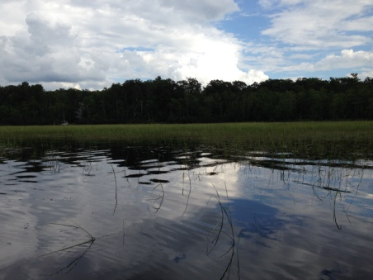
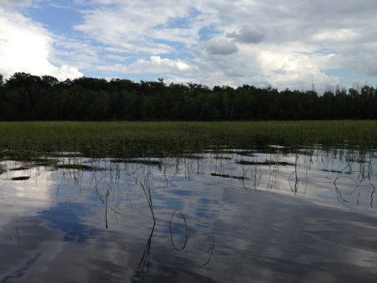
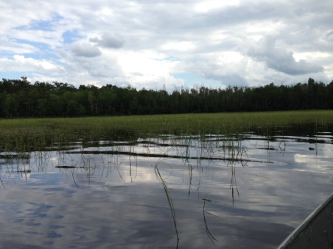

Figure 13: East Side of Rice Bed 11

Bed 12: Although it was continuous, rice in Bed 12 was very low density and not fit for harvest anywhere. Unfortunately, when combined with dense Watershield and Pickerelweed (Pontederia cordata), vegetation in this area made accessing open water almost impossible for residents (Figure 14).
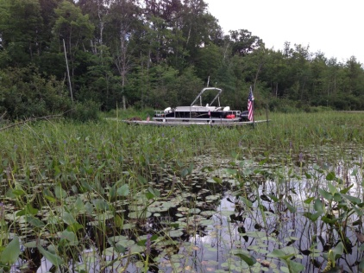
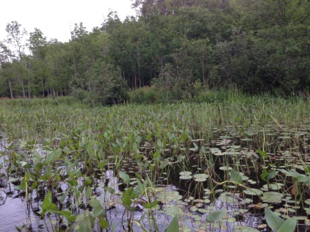
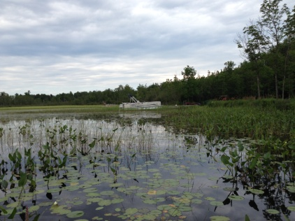

Figure 14: Severe Navigation Impairment in Rice Bed 12

Bed 13: This bed was moderately dense with areas of nearly pure rice at its core (Figure 15). Around the edges, the bed became fragmented and mixed with Watershield making access for some residents at least moderately difficult.
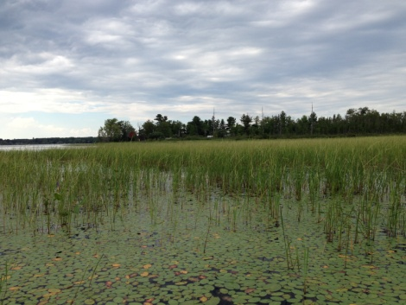
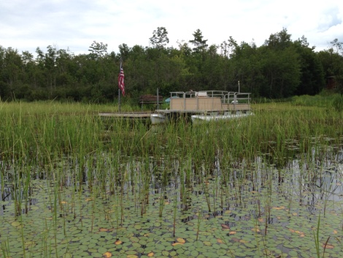
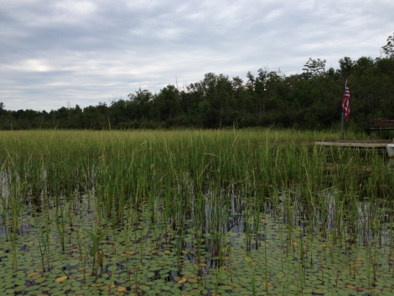
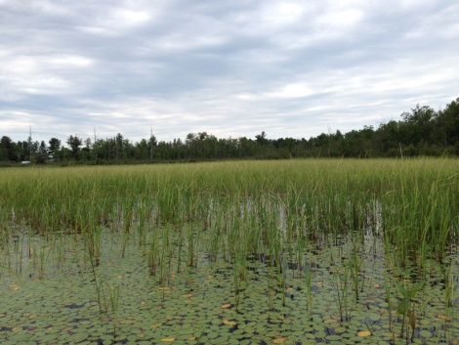

Figure 15: Rice Bed 13 - Facing North Toward Tomahawk Island
Bed 14: We found Bed 14 to be low density and not fit for human harvest as most of the area was dominated by other plant species (Figure 16). On the inner margin, it was bordered by a Sedge (Carex spp.) and Cattail (Typha spp.) wetland. Within the bed, there were large numbers of Watershield and White water lily (Nymphaea odorata), while the outer edge was dominated by a diverse community of submergent native vegetation.
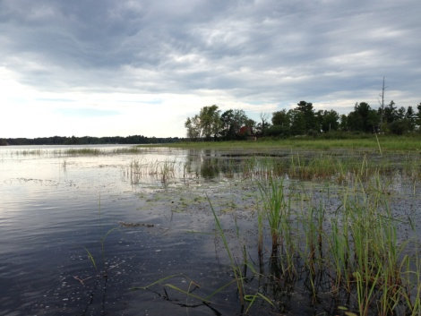
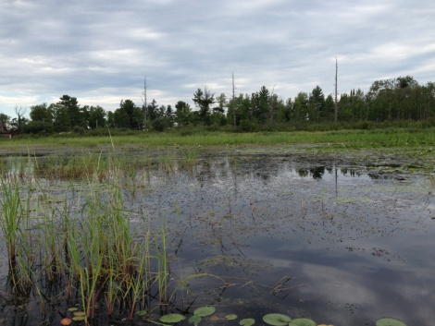
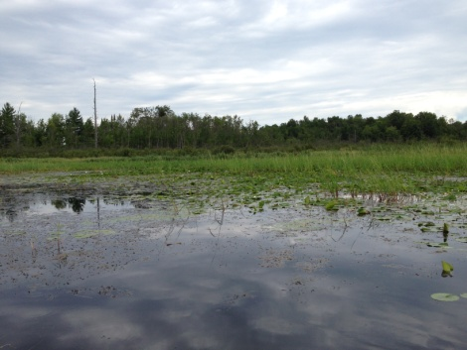
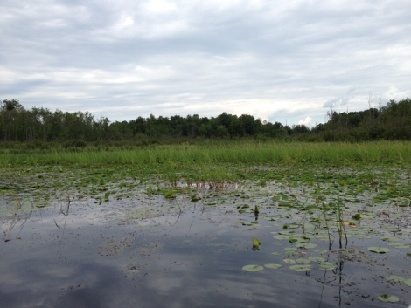

Figure 16: Rice Bed 14 – Facing North Around the Southeast Bay

High Density Plant Bed Mapping Survey:
In addition to the 14 wild rice areas, we mapped nine additional beds that could have caused at least some navigation impairment (Figure 17) (Appendix III). Coincidentally, they also cover 35.55 acres (Table 2).
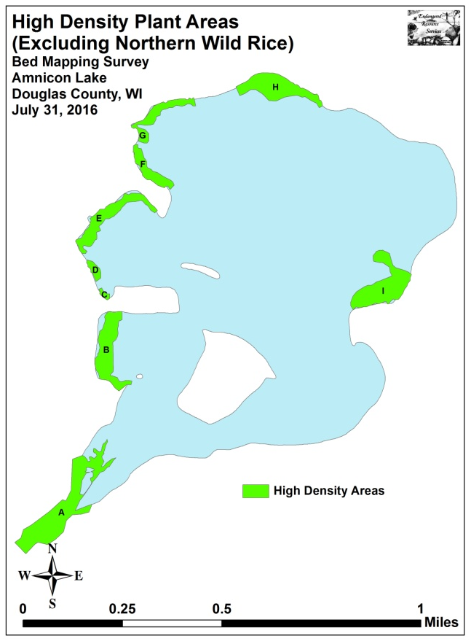
Figure 17: High Density Plant Areas - Mean Density 7/31/16

Table 2: High Density Non-rice Plant Bed Summary
Amnicon Lake, Douglas County – July 31, 2016

Bed Letter | Acreage | Rake Range | Mean  Rake Fullness | Potential Navigation Impairment  Level
A | 9.93 | 1-3 | 3 | Severe
B | 4.97 | 1-3 | 3 | Minor
C | 0.25 | 1-2 | 2 | Minor
D | 0.62 | 1-2 | 2 | Minor
E | 3.97 | 1-3 | 3 | Moderate
F | 2.10 | 1-2 | 2 | Minor
G | 2.51 | 1-2 | 2 | Minor
H | 5.16 | 1-3 | 2 | Minor
I | 6.04 | 1-3 | 2 | Minor
Total Acres | 35.55

Descriptions of High Density Plant Beds:
HDA A: This high density area encompassed the entire lake outlet. On the east shoreline, there weren’t residences so management is likely not necessary in this area (Figure 18). However, the western shoreline was the worst place on the lake in regards to restricting resident access with many people having no way to get any kind of watercraft out to open water (Figure 19).
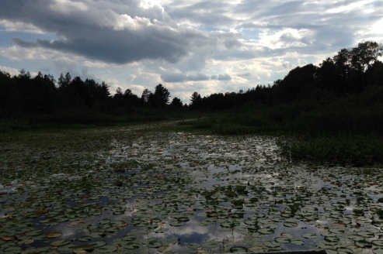
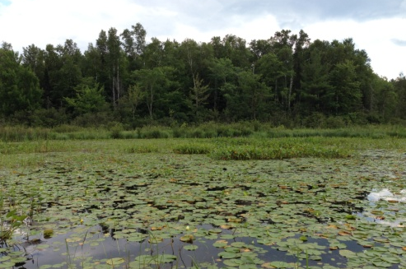
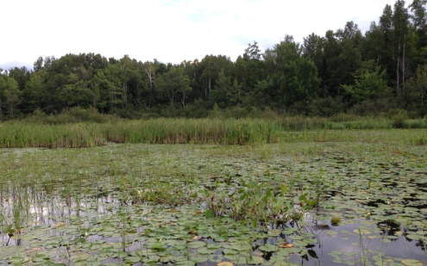

Figure 18: HDA A - East Shore Facing South to Lake Outlet
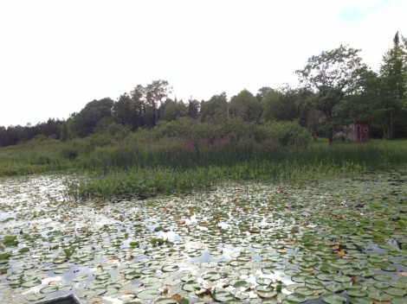
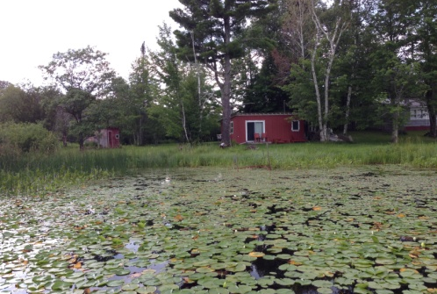
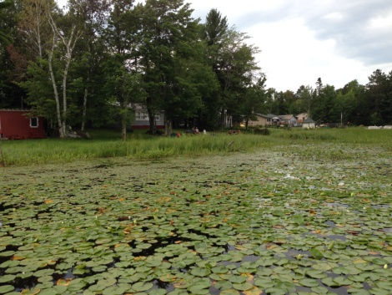
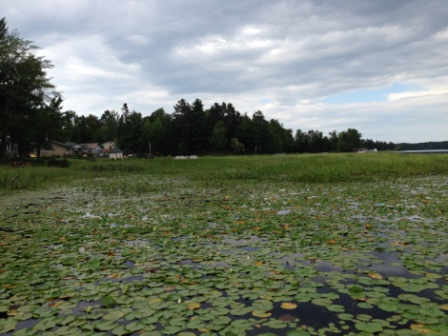

Figure 19: HDA A - West Shore Facing West in the Lake Outlet

Some residents were spending incredible amounts of time trying to open up channels through a literal wall of vegetation, but even getting a kayak out was difficult (Figure 20).
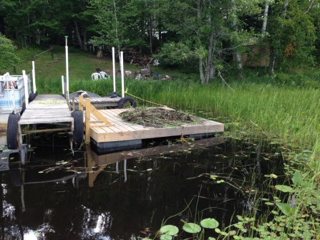
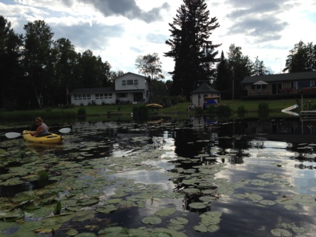
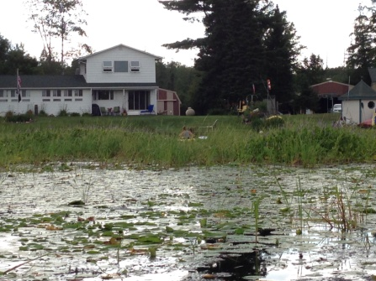

Figure 20: HDA A - Impenetrable Vegetation on the West Shore

HDA B: The majority of residents along this area were keeping reasonable navigation channels open with regular boat traffic. This likely means the plants in this area were only a minor navigation impairment. The south shoreline was slightly worse than elsewhere; apparently due to minimal boating activity (Figure 21 - left). The west side of the area was bordered by a large bog/sedge meadow with no residences making it a non-issue. Residents on the north side appeared to have no real issues other than the house in the northwest corner which could have claimed moderate impairment (Figure 21 - right).
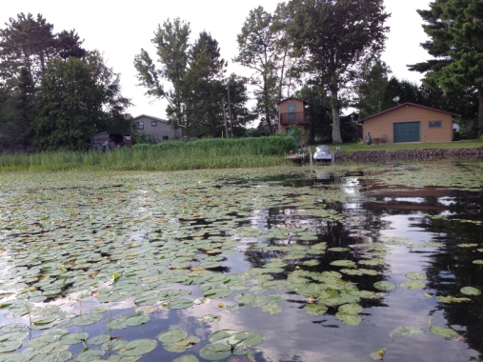
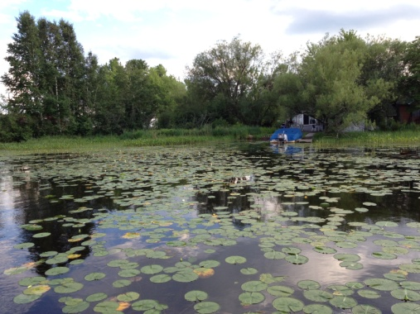

Figure 21: HDA B – South and North Shorelines

HDA C and D: Along the southwest shore of the west-central bay, HDA C was dominated by Floating-leaf bur-reed (Sparganium fluctuans) – a highly desirable and sensitive native species that, if possible, would be best left alone (Figure 22 – left). HDA D contained scattered Watershield that was likely only a minor impairment (Figure 22 – right).
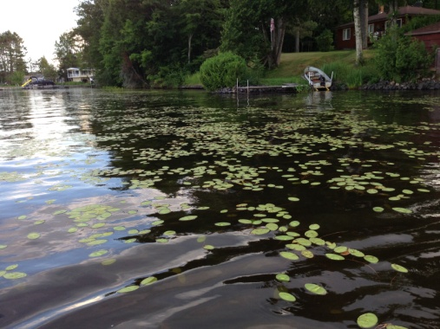
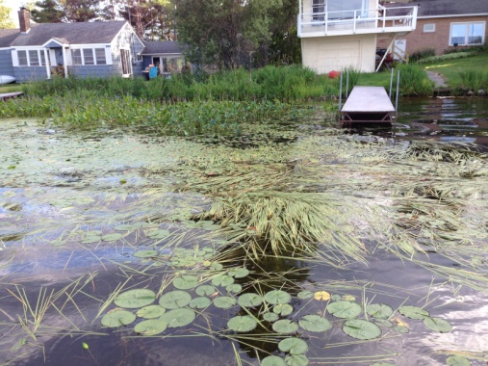

Figure 22: HDA C – Floating-leaf Bur-reed/HDA D - Watershield
HDA E: Outside of the outlet, this was the worst non-rice navigation area on the lake. Residents were likely having at least some issue cutting through the dense Watershield that extended far out into this shallow bay (Figure 23).

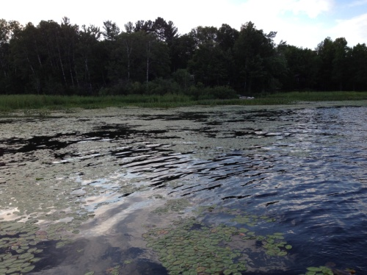
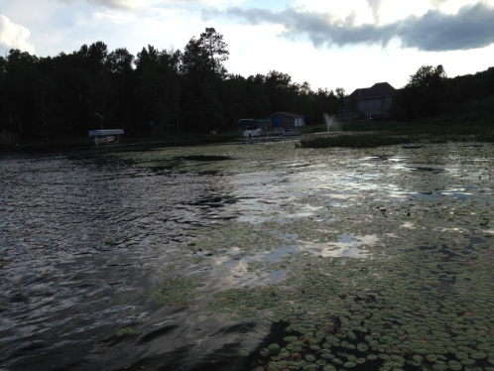
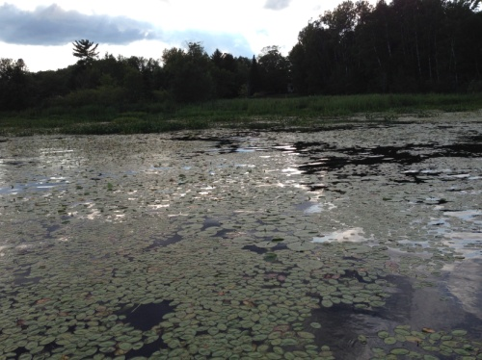

Figure 23: HDA E – Dense Watershield in the West Central Bay

HDA F: This area had enough Watershield that it might have cause minor navigation impairment. However, most residents seemed to be having minimal trouble keeping navigation channels open with regular boat traffic (Figure 24).
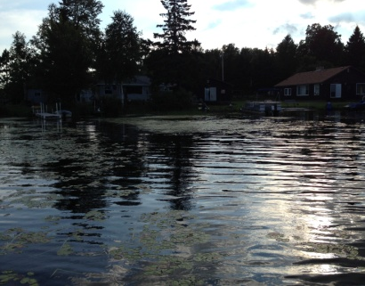
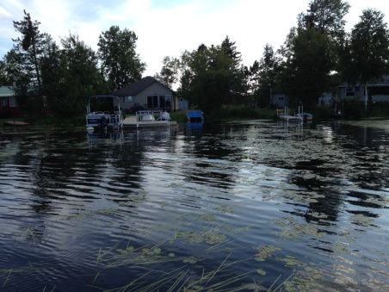
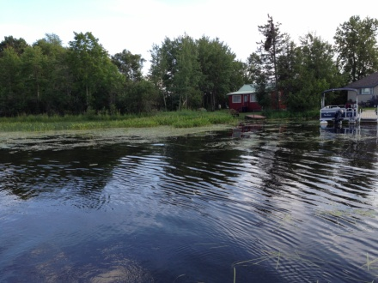
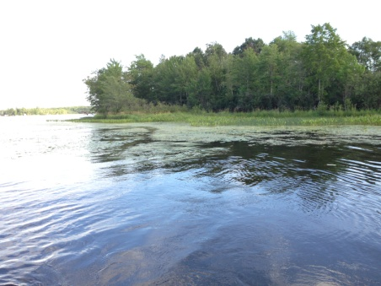

Figure 24: HDA F – Moderately Dense Watershield - Northwest Bay

HDA G: The west end of Area G was similar to Area F in that it had moderate levels of Watershield and Floating-leaf bur-reed, but most residents again seemed to be having no trouble keeping boating lanes open (Figure 25).
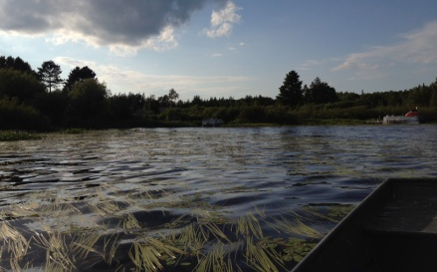
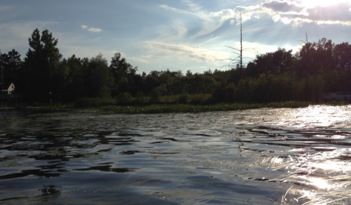
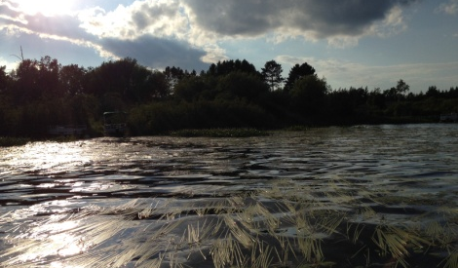
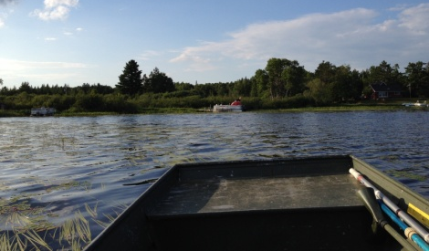

Figure 25: West End of HDA G Near the Boat Landing

On the north end of Area G, there were few floating-leaf species, but residents did have to navigate through beds of Hardstem bulrush (Schoenoplectus acutus) (Figure 26). Although this species can be really difficult to extract from a motor propeller, it is extremely important fish habitat; especially during the spawning season. Because of this, any efforts to remove these plants should be limited to the minimum amount needed to access open water.

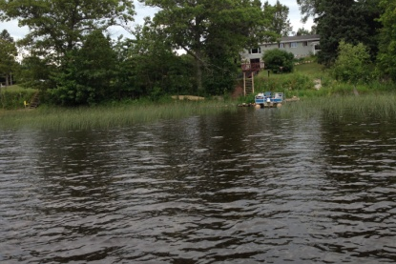
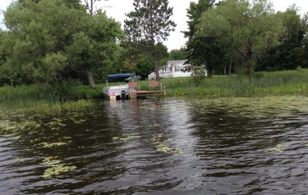
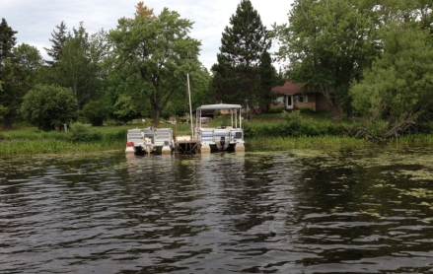

Figure 26: Bulrush Beds on the North End of HDA G

HDA H: This area was the highest quality submergent bed on the north end of the lake. Species rich and diverse, it likely wasn’t causing any more than minor navigation impairment. Ideally, it would be completely left alone as it undoubtedly provides important fish habitat.

HDA I: Similar to Area H, this was the best submergent bed in regards to fish habitat on the lake’s east side. Although large, it wasn’t particularly dense, and the bed probably wasn’t much of an impairment if it was at all.

Aquatic Invasive Plant Species Survey:
Other than species that were previously known to exist on the lake like Curly-leaf pondweed (Potamogeton crispus) and Purple loosestrife (Lythrum salicaria), we did not find any evidence of new exotic plant species on Amnicon Lake. The vast majority of Curly-leaf pondweed plants in a lake senesce by early July, and, as expected, we saw only a handful of CLP plants sprinkled in with other native submergent species. Purple loosestrife continues to be regularly encountered in lowland areas along the lakeshore. It was especially common near the public boat landing.
DISCUSSION AND CONSIDERATIONS FOR MANAGEMENT:
Northern Wild Rice and Other Dense Vegetation Areas:
There is no question that some rice beds along the south shore of the lake and high density beds near the outlet and in the west central bay were at least a nuisance and at worst a complete impairment to watercraft navigation in 2016. If plant control occurs in the future to relieve these impairments, we encourage residents to remember these emergent and floating-leaf communities are critical habitat for the lake’s fish and other wildlife. Because of this, management would ideally limit removal to only what is necessary to for residents to access open water.

Purple Loosestrife:
Purple Loosestrife is widely established along the Amnicon Lake shoreline. In the past, we found Galerucella beetles were common, widespread, and keeping it from becoming invasive. In 2016, we saw little evidence of beetle damage. It may be that the population will recover on its own, but, if further monitoring doesn’t show a rebound, releasing more beetles may be necessary to keep the loosestrife in check. Regardless of the beetle population, residents are encouraged to remove any loosestrife plants they find, bag them to prevent seed dispersal, and dispose of them away from the lake. August and September are the best times to do this as the bright fuchsia candle-shaped flower spikes are easily seen. Because the plants have an extensive root system, care should be taken to remove the entire plant as even small root fragments can survive and produce new plants the following year.

Yellow Iris:
Although we didn’t see Yellow iris (Iris pseudacorus) on Amnicon Lake, its presence and apparent rapid spread on Dowling Lake is troubling and likely means it is only a matter of time before plants start to show up. Because no biological control agents currently exist for Yellow iris, we STRONGLY encourage residents to watch for and eliminate plants on their property before a minor problem becomes a significant one. As with Purple loosestrife, plants should be bagged to prevent seed dispersal, and disposed of well away from the lake. June is the best time to look for this iris as the bright yellow fleur-de-lis are most common at this time. At other times of the year when it is not in bloom, its leaves could be confused with Northern blue flag (Iris versicolor) – a native and non-invasive species.

LITERATURE CITED

Ginder, T., C. Busch, G. Lund, and L. Sather. [online]. 1971. Amnicon Lake Bathymetric Map. http://dnr.wi.gov/lakes/maps/DNR/2858100a.pdf (2012, August).

WDNR. [online]. 2016. Wisconsin Lake Citizen Monitoring Data for Amnicon Lake, Douglas County. Available from http://dnr.wi.gov/lakes/CLMN/Station.aspx?id=163120 (2016, December).

WDNR. [online]. 2009. Wisconsin Lakes. PUB-FH-800 2009. Available from http://dnr.wisconsin.gov/lakes/lakebook/wilakes2009bma.pdf (2016, November).

Appendix I: 2012 Northern Wild Rice Density and Distribution

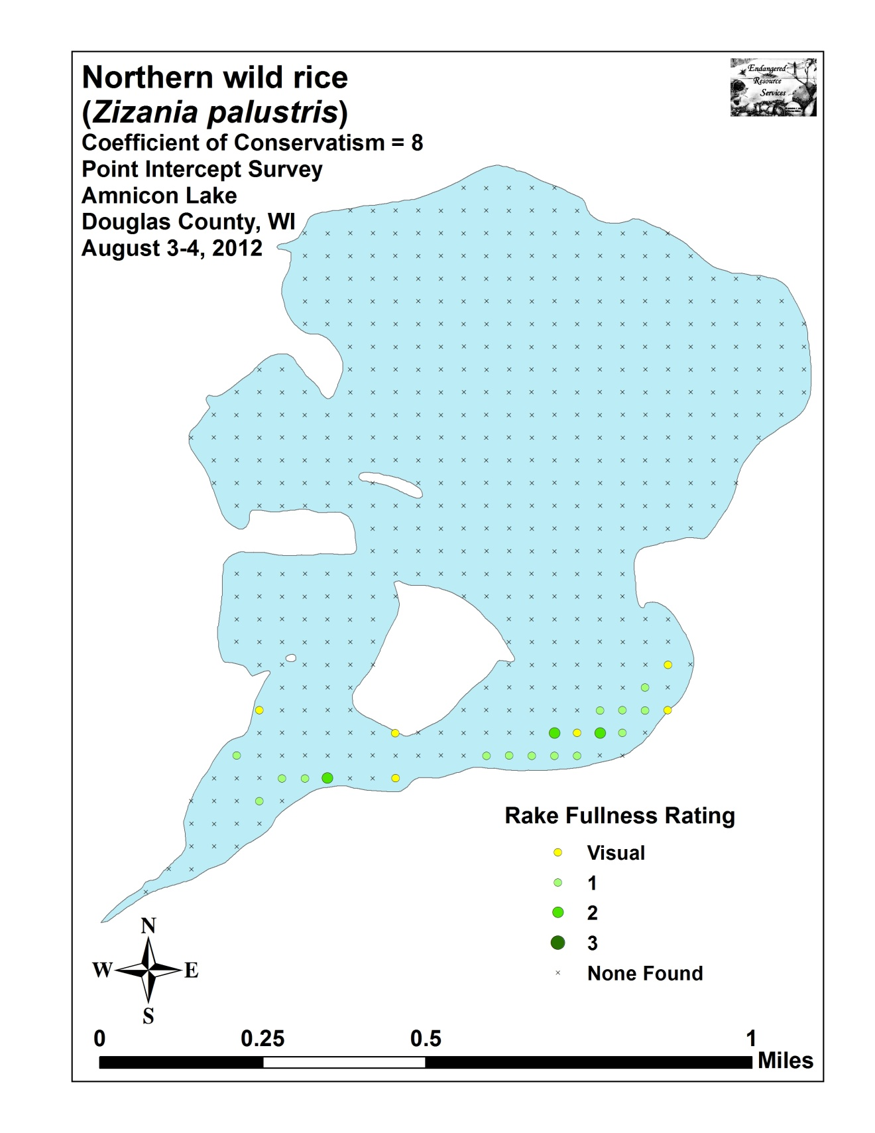

Appendix II: 2016 Northern Wild Rice Beds

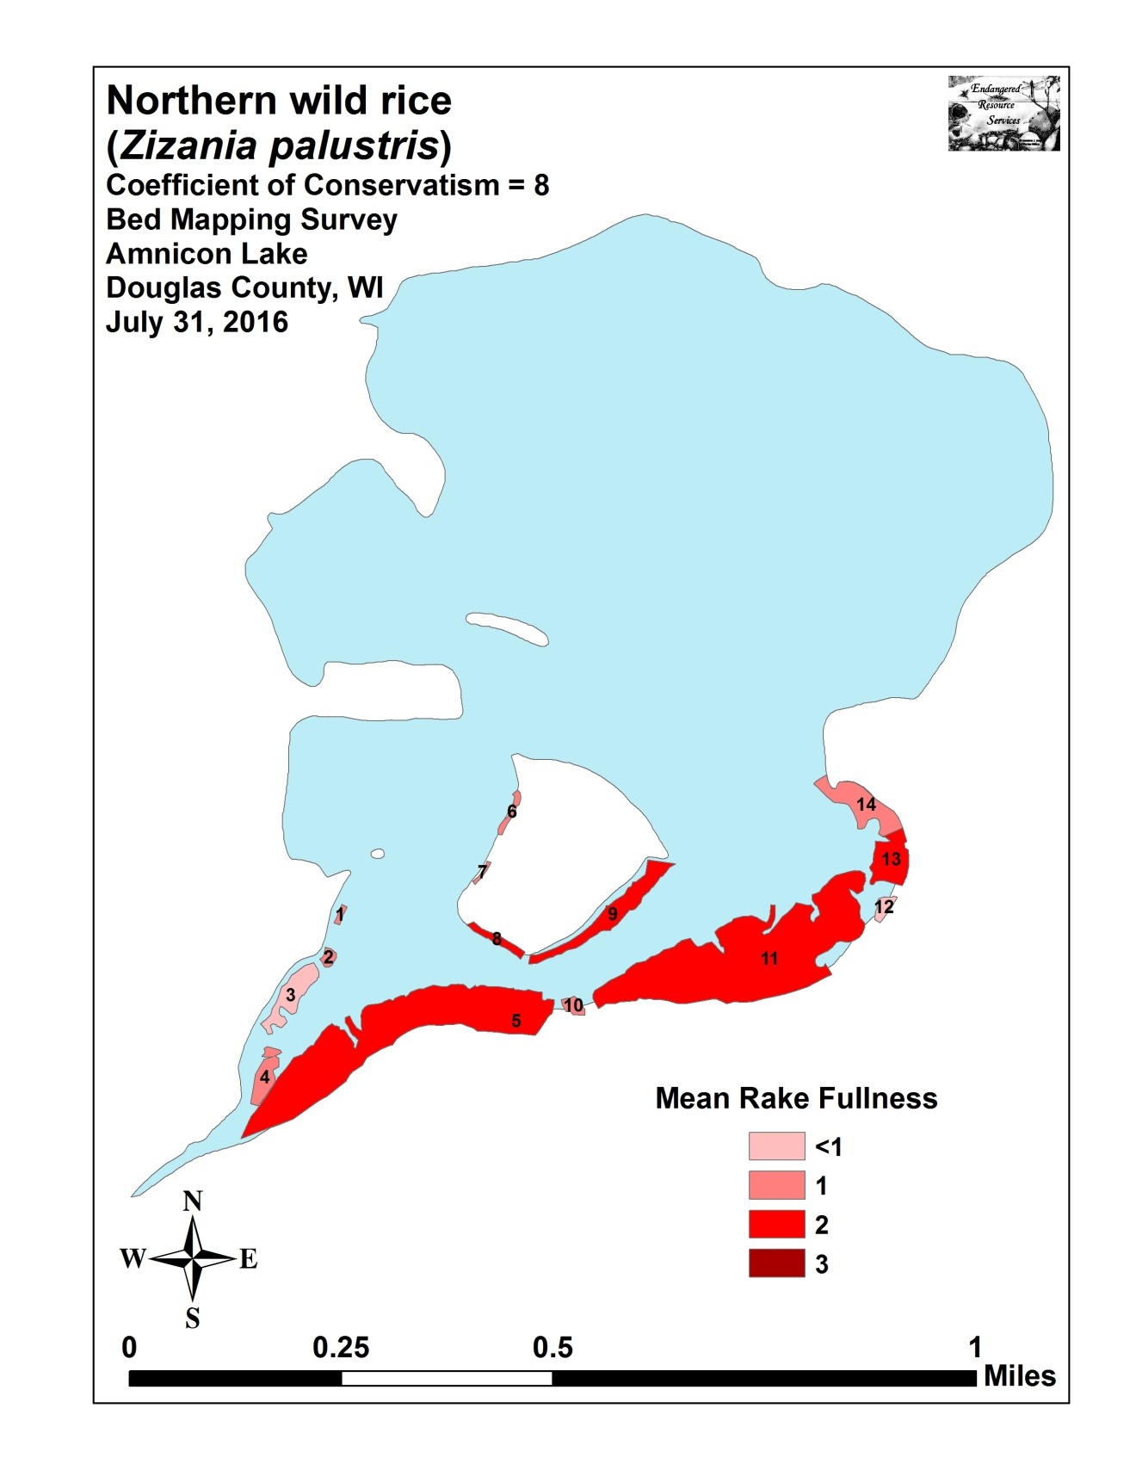

Appendix III: 2016 High Density Plant Areas

