LNRP Newsletter: Spring 2015
Beach Clean Up
Friends of the Manitowoc River Watershed (FMRW), hosted area residents for the spring clean up of 10 area beaches along Lake Michigan on Saturday, April 25.
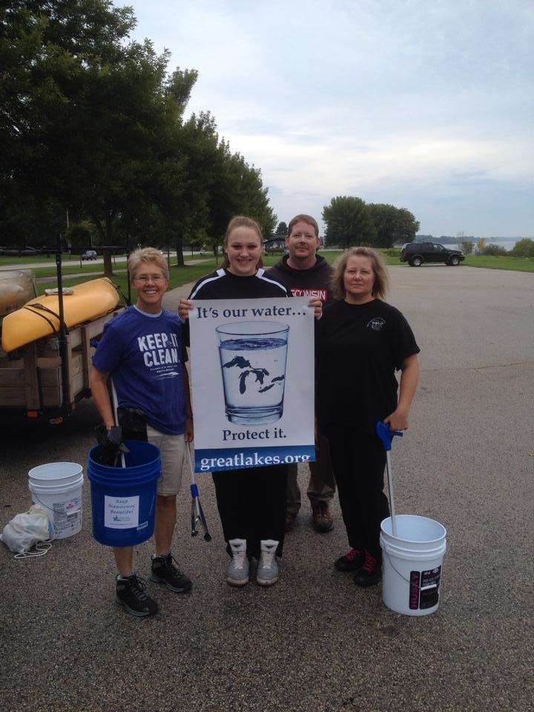
The group conducts beach clean ups in the spring and fall each year and has collected hundreds of pounds of litter since they first started in 2013. The event in spring helps celebrate Earth Day and reminds us of our obligations to be good stewards.
“We gather to clean up our area’s beaches each spring and fall,” said FMRW co-founder Kim Kettner. “We want to make a difference in an on-going effort to support water quality issues in our Lake Michigan watershed and enhance people’s recreational enjoyment. To date, more than 600 volunteers have collected more than 1500 pounds of litter from our beaches at five events.”

