Targeted Watershed Assessment Report
for Taycheedah Creek,
Fond du Lac County, Wisconsin

March 2020

David Bolha-Water Quality Biologist-Oshkosh

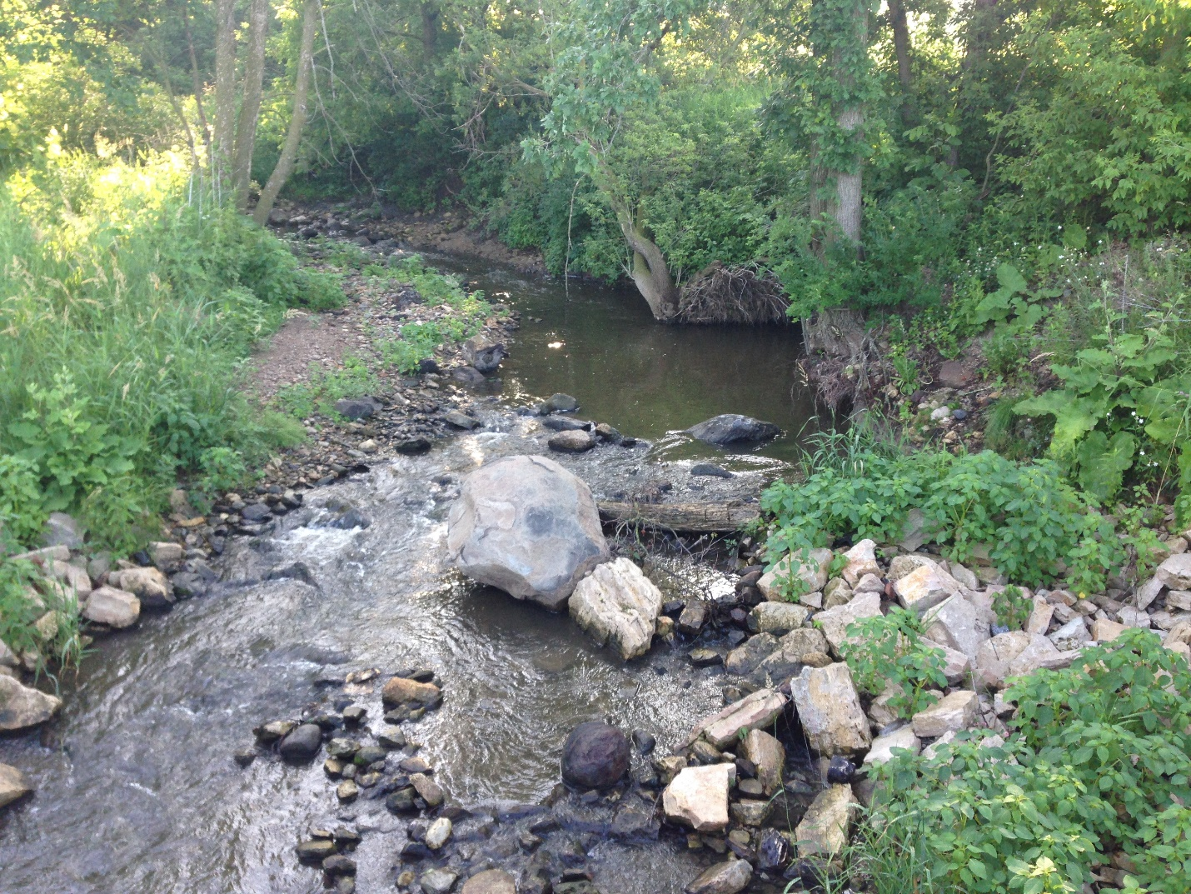

Purpose

This Targeted Watershed Assessment provided the water quality assessment to complete a Nine Key Element Plan and provide baseline data to evaluate the effectiveness of future Best Management Practices in the Taycheedah Creek Watershed on the South side of Lake Winnebago. This TWA addressed needs for baseline water quality monitoring of Taycheedah Creek by collecting Total Phosphorus (TP), qualitative habitat, fish, and aquatic macroinvertebrate information. This creek and its contributing watershed are included as part of one of the 10% highest yielding watersheds of phosphorus and sediment in the Upper Fox-Wolf River Basin.
Methods
During the growing season of 2019, TP samples were collected at 4 locations once per month in May through August (Table 1, Map 1). All samples were collected using the standard WDNR grab sampling method for a total of 16 samples (WDNR 2015). Neither baseflow nor storm or snowmelt event samplings were targeted during this project, following the protocol of Wisconsin Consolidated Assessment and Listing Methodology (WisCALM 2018). All nutrient samples were shipped to Wisconsin State Laboratory of Hygiene (WISLOH) for analysis. The WISLOH entered all sample analysis data into the WDNR Surface Water Integrated Monitoring System (SWIMS) database.
SWIMS Station ID | Site Name
10016964 | Taycheedah Up #57 - 47 M Us Hwy Uu
10015824 | Taycheedah Creek Above Co. Tr. K
10010826 | Taycheedah Creek Below Saint Mary’s Confluence
10052414 | Taycheedah Creek at Peebles Trail
Table 1: Total Phosphorus Monitoring Sites Sampled in Taycheedah Creek May Through August 2019.
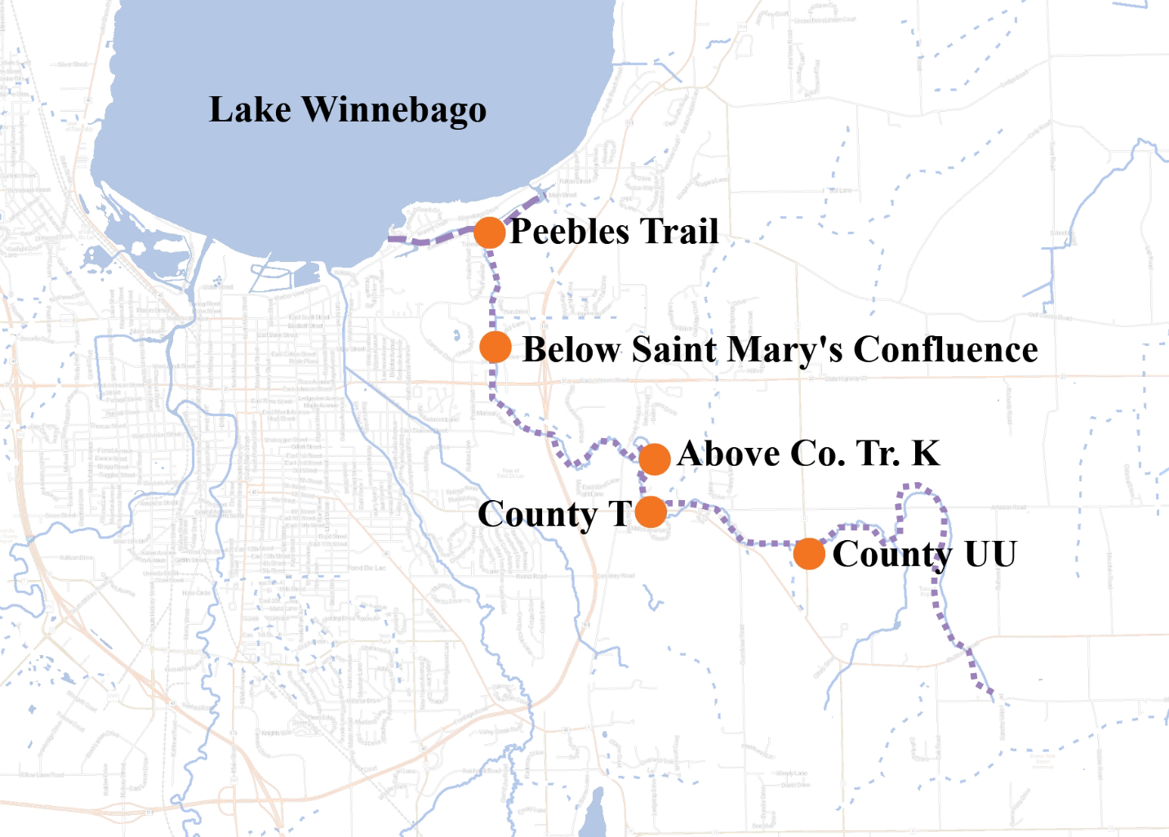Map 1: Taycheedah Creek Sample Locations in 2019.

Four locations were sampled for aquatic macroinvertebrates in October 2019 (Map 1, Table 2). All sites were sampled using the WDNR Guidelines for the Standard Collection of Macroinvertebrate Samples from Wadable Streams v2.0 (WDNR 2017). A D-shaped kicknet with 600-micron mesh was used at all sites by standing upstream from the net and placing it firmly on the stream bed while digging into the substrate with the heel or toe to free the macroinvertebrates from the substrate. Riffles were targeted at each of the sites, but if none were present then, available gravel, overhanging vegetation, woody debris, or other vegetation would be sampled. For a representative sample of the aquatic macroinvertebrate community, a minimum of 100 aquatic macroinvertebrates collected in each sample was targeted. The aquatic macroinvertebrates were preserved in a 70-80% ethanol solution inside quart “Mason” jars. If necessary, multiple “Mason” jars were used per sample depending upon how much sediment and organic material was collected with the aquatic macroinvertebrates. Within the next 24 hours, the samples were re-preserved with another 70-80% ethanol solution. Samples were taken to the UWSP Aquatic Biomonitoring Laboratory (ABL) for lowest possible taxonomic identification. Staff at the ABL entered the data into the SWIMS database.

SWIMS Station ID | Site Name
10016964 | Taycheedah Up #57 - 47 M Us Hwy Uu
10015824 | Taycheedah Creek Above Co. Tr. K
10010826 | Taycheedah Creek Below Saint Mary’s Confluence
10052414 | Taycheedah Creek at Peebles Trail
Table 2: Aquatic Macroinvertebrate Locations Sampled in Taycheedah Creek in 2019.
Between July and August 2019, wadable fish surveys were conducted at 5 sites (Map 1, Table 3). The 5 wadable fish surveys were conducted following the WDNR Guidelines for Assessing Fish Communities of Wadable Streams in Wisconsin v2.0 (WDNR 2018). All 5 wadable sites were surveyed during the guidance-recommended summer time survey period. The wadable fish survey stations were a minimum of 35 times the mean stream width (overall minimum of 100 meters, overall maximum of 400 meters). A 12 Volt, 18 Amp Hour battery-powered backpack shocker was used for 2 of the 5 sites based upon the streams’ smaller width and depth. An otter sled stream shocker with a 4000 Peak Watt generator was used for 3 of the 5 sites with appropriate stream width and/or depth. Catch per effort sampling procedures were used for this project (no particular species was targeted, all captured). A single upstream pass was made using 0.125-inch mesh nets to collect the fish. At the end of the station, captured fish were identified and counted and all game fish were measured for length. Once all data was collected, the fish were returned to the creek. Fish survey data was entered into the WDNR Fisheries and Habitat Management Database (FHMD) by WDNR Water Resources staff.
SWIMS Station ID | Site Name
10016964 | Taycheedah Up #57 - 47 M Us Hwy Uu
10010824 | Taycheedah Creek at Hwy T
10015824 | Taycheedah Creek Above Co. Tr. K
10010826 | Taycheedah Creek Below Saint Mary’s Confluence
10052414 | Taycheedah Creek at Peebles Trail
Table 3: Wadable Fish Survey Locations Sampled in Taycheedah Creek between July and August 2019.
Onset Hobo Pendant thermistors were deployed to collect temperature data from May through October at 4 locations in Taycheedah Creek (Table 4, Map 1). Temperature measurements were taken once per hour at each location from May through October. Temperature measurements were taken with an Onset Hobo Pendant thermistor attached to a fence post driven into the stream bed of the creek. The thermistor was attached to the fence post in such a manner as to suspend the thermistor in the water column low enough to stay under water in low flow conditions and high enough to not get buried in bottom substrate (~ 6 inches above the bottom). The thermistor was placed in a shaded location when possible. Temperature data were uploaded into the SWIMS database by WDNR Water Resources staff.
SWIMS Station ID | Site Name
10016964 | Taycheedah Up #57 - 47 M Us Hwy Uu
10015824 | Taycheedah Creek Above Co. Tr. K
10010826 | Taycheedah Creek Below Saint Mary’s Confluence
10052414 | Taycheedah Creek at Peebles Trail
Table 4: Temperature Monitoring Locations in Taycheedah Creek Sampled From May through October 2019.
Qualitative habitat surveys were conducted at 5 locations in Taycheedah Creek between July and August 2019 (Table 5, Map 1). All sites were surveyed following the WDNR Guidelines for Evaluating Habitat of Wadable Streams (2002). Each qualitative habitat survey station length was 35 times the mean stream width of the survey station. Qualitative habitat surveys rapidly assess characteristics such as bank erosion, width to depth ratio, % fine sediments, and cover for fish. WDNR Water Resources staff entered the qualitative habitat data into the FHMD.
SWIMS Station ID | Site Name
10016964 | Taycheedah Creek US Hwy UU
10010824 | Taycheedah Creek at Hwy T
10015824 | Taycheedah Creek Above Co. Tr. K
10010826 | Taycheedah Creek Below Saint Mary’s Confluence
10052414 | Taycheedah Creek at Peebles Trail
Table 5: Qualitative Habitat Survey Locations in Taycheedah Creek Conducted between July and August 2019.
Results
The 2019 TP sample analysis results in Taycheedah Creek ranged from 0.0363 mg/L above County Trunk K in May to 0.163 mg/L below Saint Mary’s (tributary) Confluence in July (Table 6, Chart 1). The average TP concentrations for the 4 sites in this project ranged from 0.101 mg/L above County Trunk K to 0.108 mg/L below Saint Mary’s Confluence (Table 6, Chart 1).

Sample Event  Month | Taycheedah Creek US Hwy UU | Taycheedah Creek Above Co. Tr. K | Taycheedah Creek Below Saint Mary’s Confluence | Taycheedah Creek at Peebles Trail
May | 0.0625 | 0.0363 | 0.0502 | 0.0546
June | 0.122 | 0.122 | 0.111 | 0.112
July | 0.132 | 0.143 | 0.163 | 0.147
August | 0.0968 | 0.104 | 0.109 | 0.108
Avg. | 0.103 | 0.101 | 0.108 | 0.105
Table 6: Total Phosphorus Concentrations and Averages of Samples Collected in Taycheedah Creek in 2019.
Chart 1: Total Phosphorus Concentrations and Averages of Samples Collected in Taycheedah Creek in 2019.
Aquatic macroinvertebrate communities were sampled at 4 locations in October 2019 (Table 2). Some aquatic macroinvertebrate species are tolerant of environmental degradation, while some species are moderately tolerant, and some others are intolerant. Based upon the representative macroinvertebrate sample collected and their associated tolerance to environmental degradation, an Index of Biotic Integrity (MIBI) was calculated to indicate the water quality condition of Taycheedah Creek (Table 7, Chart 2). In general, the higher the MIBI score, the better the water quality rating for a wadable stream in Wisconsin. The MIBI scores in Taycheedah Creek ranged from 4.08 below St. Mary’s Confluence to 5.49 upstream of County UU (Table 7, Chart 2). The water quality condition categories based upon the macroinvertebrate community for the 4 sites ranged from Fair to Good. The Taycheedah Creek samples demonstrated a macroinvertebrate community indicating some slight (Good) to likely substantial impact from environmental degradation (Fair).

SWIMS Station ID | Stream Name and Location | Macroinvertebrate IBI Score | Condition Category
703070 | Taycheedah Creek US Hwy UU | 5.49 | Good
703106 | Taycheedah Creek Above Co. Tr. K | 5.35 | Good
703071 | Taycheedah Creek Below Saint Mary’s Confluence | 4.08 | Fair
703047 | Taycheedah Creek at Peebles Trail | 5.22 | Good
Table 7: Aquatic Macroinvertebrate Survey Results in Taycheedah Creek Conducted in 2019.

Chart 2: Macroinvertebrate Index of Biotic Integrity Scores and Condition Categories in Taycheedah Creek Conducted in 2019.

Between July and August 2019, 5 sites in Taycheedah Creek were surveyed for representative fish communities. Some fish species are tolerant of environmental degradation, while some species are moderately tolerant, and some others are intolerant. Based upon the representative fish collected during the survey and their associated tolerance to environmental degradation, an Index of Biotic Integrity (FIBI) was calculated to indicate the water quality of the creek (Table 8, Chart 3). The FIBI scores ranged from 40 at County T to 90 at Peebles Trail (Table 8, Chart 3). The water quality Condition Category for Taycheedah Creek ranged from Fair to Excellent, indicating no apparent to significant environmental degradation (more results interpretation later in Discussion Section).
Each fish community surveyed was used to verify or update the modeled Natural Community for that stream segment. Verifying or changing the modeled Natural Community was important since the Natural Community determines which FIBI was used to determine the water quality of that stream segment. To verify or update a Natural Community based upon the representative fish community sampled, the water quality of the stream must be in fair enough condition to accurately assess the Natural Community. For example, if the percentage of tolerant fish dominates the sample without any intolerant fish collected, the water quality is too degraded to verify or update the Natural Community. In this situation, the modeled Natural Community is used to calculate the FIBI score. The lack of intolerant and dominance of tolerant fish at Hwy T meant the Natural Community could not be updated or verified.
SWIMS Station ID | Site Name | Fish IBI Score | Condition Category | Natural Community
10016964 | Taycheedah US Hwy UU | 60 | Fair | Cool-Warm Headwater
10010824 | Taycheedah Creek at Hwy T | 40 | Fair | Cool-Cold Headwater
10015824 | Taycheedah Creek Above Co. Tr. K | 60 | Fair | Cool-Warm Headwater
10010826 | Taycheedah Creek Below Saint Mary’s Confluence | 80 | Excellent | Cool-Warm Mainstem
10052414 | Taycheedah Creek at Peebles Trail | 90 | Excellent | Cool-Warm Mainstem
Table 8: Fish Survey Results in Taycheedah Creek Conducted in 2019.
Chart 3: Fish Survey Results in Taycheedah Creek Conducted in 2019.
Water temperature data was collected from May through October 2019 at 4 locations in Taycheedah Creek (Table 4, Map 1). Monthly average temperatures were reported for months with complete data only. The average monthly temperatures ranged from 60.8F below Saint Mary’s Confluence in May to 69.7F above County Trunk K in July (Table 9, Chart 4). The Maximum Daily Averages (MDM) in Taycheedah Creek ranged from 73.1F below Saint Mary’s Confluence to 75.3F in its headwaters (Table 9, Chart 4).
Location | June Average (F) | July Average (F) | August Average (F) | September Average (F) | Maximum Daily Average (F)
Taycheedah US Hwy UU | 62.2 | 69.4 | 64.7 | 62.1 | 75.3
Taycheedah Creek Above Co. Tr. K | 62.1 | 69.7 | 65.7 | 62.7 | 75.3
Taycheedah Creek Below Saint Mary's Confluence | 60.8 | 67.5 | 64.1 | 62.1 | 73.1
Taycheedah Creek at Peebles Trail | 61.1 | 68 | 64.5 | 62.2 | 73.3
Table 9: Monthly Average and Maximum Daily Average Temperatures in Taycheedah Creek Watershed in 2019.
Chart 4: Monthly Average and Maximum Daily Average Temperatures in Taycheedah Creek in 2019.
Between July and August 2019, qualitative habitat surveys were conducted at 5 locations in Taycheedah Creek (Table 5, Map 1). The qualitative habitat surveys were conducted at the same locations as the fish sample locations. Based upon the habitat information collected during the 2019 surveys, a habitat rating was calculated for the 5 locations in Table 5. The habitat scores ranged from 28 at Peebles Trail to 53 upstream of County UU (Table 10, Chart 5). Four sites had a Condition Category of Fair and 1 site had a Condition Category of Good, with no sites rated as excellent or poor (Table 10, Chart 5).

SWIMS Station ID | Site Name | Qualitative Habitat Score | Condition Category
10016964 | Taycheedah Creek US Hwy UU | 53 | Good
10010824 | Taycheedah Creek at Hwy T | 33 | Fair
10015824 | Taycheedah Creek Above Co. Tr. K | 48 | Fair
10010826 | Taycheedah Creek Below Saint Mary’s Confluence | 32 | Fair
10052414 | Taycheedah Creek at Peebles Trail | 28 | Fair
Table 10: Qualitative Habitat Survey Scores and Condition Categories for Taycheedah Creek in 2019.

Chart 5: Qualitative Habitat Survey Scores and Condition Categories for Taycheedah Creek in 2019.
Discussion
This project provided baseline water quality data in support of the Fond du Lac County Land and Water Conservation Department’s and other partners’ efforts to write an EPA Nine Key Element Plan (9KE) and their efforts to reduce nutrient and sediment runoff within the watershed. “Watershed plans consistent with EPA’s 9KE provide a framework for improving the contributing causes and sources of non-point source pollution, involve key stakeholders and prioritize restoration and protection strategies to address water quality problems” (WDNR 2018). Having an approved 9KE plan can increase opportunities for federal and state funding for the installation of agricultural and urban best management practices (BMPs), which focus on reducing the discharge of non-point source pollutants into the surface waters of the watershed. The monitoring during this project provided the current water quality conditions of the surface waters in the watershed and data that can be compared to the water quality conditions after BMPs have been installed. The monitoring conducted in Taycheedah Creek indicates the need and opportunity for water quality improvements. The nutrient, macroinvertebrate, and fish monitoring in this project demonstrated that the water quality in Taycheedah Creek is between fair and excellent condition.

The Taycheedah Creek Watershed drains a 19,154-acre area, on the South side of Lake Winnebago, near Fond du Lac, Wisconsin. Taycheedah Creek flows about 10 miles from South to North. The East side of Lake Winnebago, including the Taycheedah Creek watershed, is dominated by agricultural land use (74%). Typically, as increases in agricultural land use occur, there is a correlating increase in TP concentrations in creeks in the watersheds in Wisconsin. The monitoring of this project indicated high concentrations of TP in Taycheedah Creek (Table 6, Chart 1). High TP concentrations in streams have been correlated with poorer fish and macroinvertebrate community integrity in Wisconsin (USGS 2006). The TP concentrations in Taycheedah Creek are above response thresholds (USGS 2006) and the Wisconsin Administrative Code ch. NR 102.06(3) standard (0.075 mg/L growing season median) for streams in Wisconsin. Response thresholds are concentrations of pollutants where small increases in concentration can have a large impact on the biotic indices, such as fish and macroinvertebrate communities (USGS 2006). Decreasing the concentration of TP within Taycheedah Creek would positively benefit the fish and aquatic life within the creek.

The aquatic life habitat within Taycheedah Creek was fair to good (Table 10, Chart 5). The most common rating items negatively affecting the habitat score were bank erosion, fine sediments, and riffle:riffle or bend:bend ratios, especially the further downstream observations were made. Highly eroded and erodible banks were observed throughout the stream which contributed to the high amount of fine sediments observed on the streambed (Photo 1-2). This limits the habitat available for fish and macroinvertebrates. High amounts of suspended solids cover fish gills, reduces predator fishes’ ability to catch food and warms the water through absorbed sunlight. Sedimentation and ditching lowers the riffle:riffle and bend:bend ratios which lowers habitat diversity within the creek. The fish and macroinvertebrate communities have been impacted by the sedimentation and limited habitat available in Taycheedah Creek. Decreasing the sediment load into Taycheedah Creek would provide the opportunity for a more diverse and balanced fish and macroinvertebrate community.

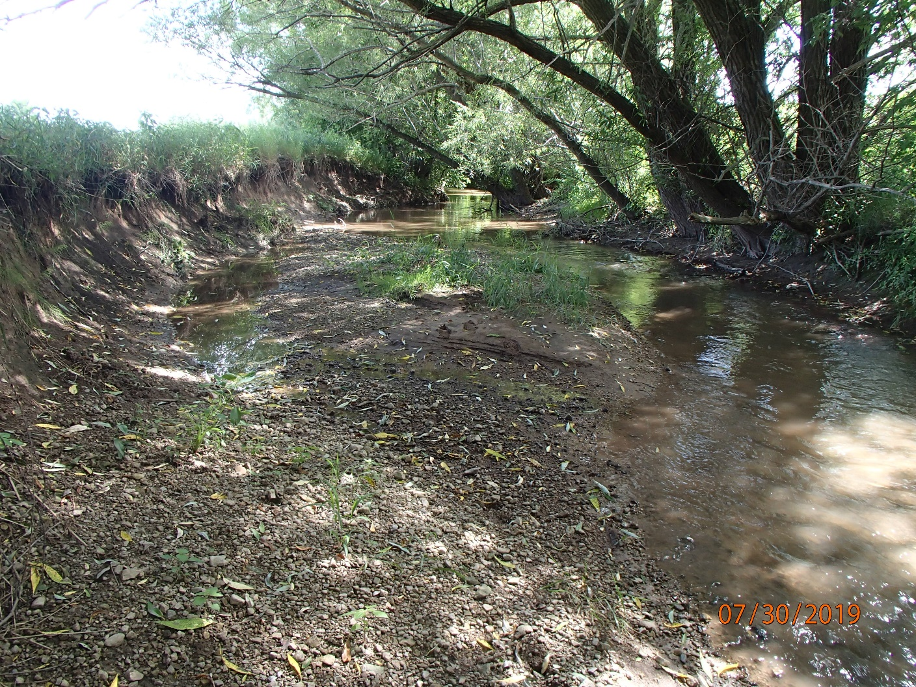
Photo 1: Eroded streambank along Taycheedah Creek. Photo taken by D. Bolha on July 30th, 2019.
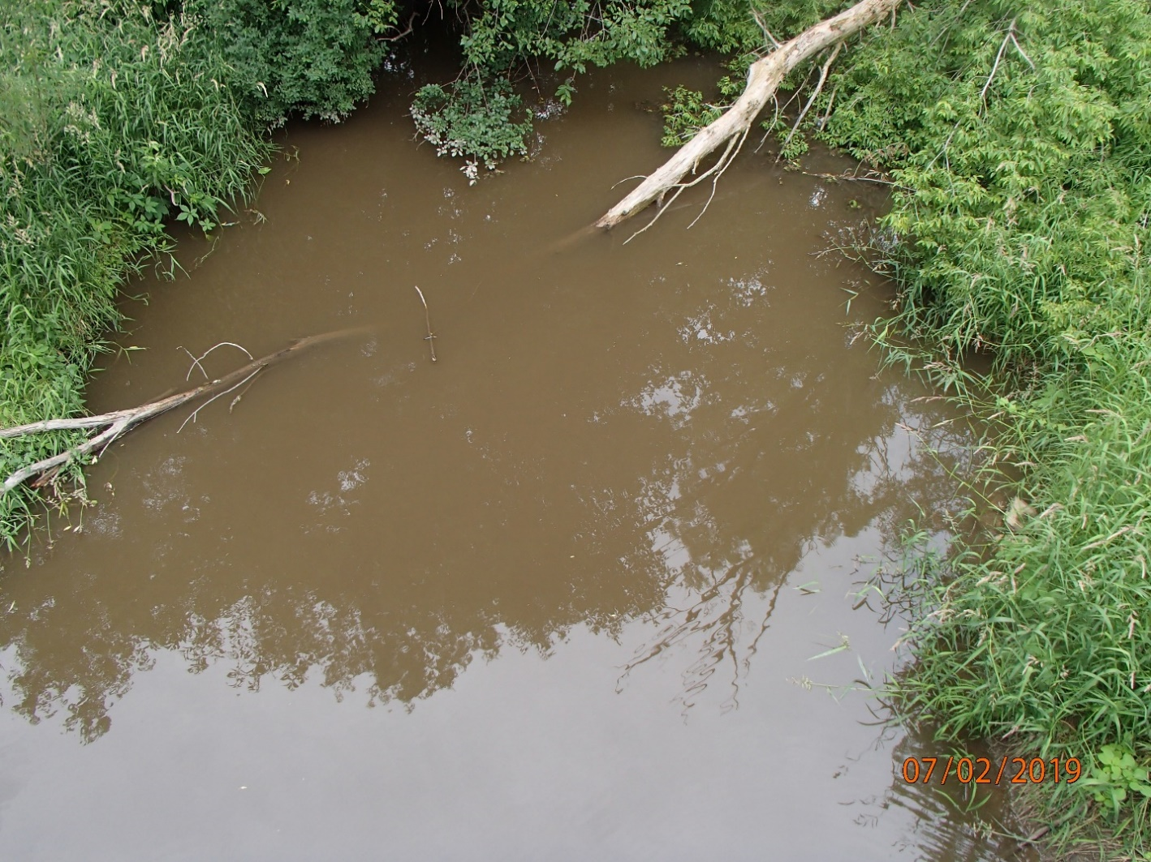
Photo 2: High Turbidity Observed in Taycheedah Creek. Photo taken by D. Bolha on July 2nd, 2019.

As Taycheedah Creek is a direct tributary to Lake Winnebago, fish that spend the majority of their time in the lake will have the opportunity to migrate upstream into Taycheedah Creek. As such, some species of fish that are not typically associated with wadable streams in Wisconsin may have been present at the time of the 2019 surveys. Fish species, such as Spotfin Shiner, Yellow Perch, Emerald Shiner, Walleye and Logperch, are typically observed in non-wadable rivers and lakes rather than wadable streams. The closer the fish community surveys were to Lake Winnebago (longitudinally upstream to downstream), there was an observed shift to more medium-sized stream and eventually large river/lake fish species collected in the surveys (Table 11, Chart 6). This change influenced the FIBI scores at the downstream locations in Table 8, Chart 3. When the downstream FIBI scores are collectively considered with the MIBI and nutrient levels in the creek, actual water quality within the creek is fair to good.

Location | % Small Stream Fish | % Medium Stream Fish | % Large River/Lake Fish
Taycheedah Creek US Hwy UU | 82 | 16 | 2
Taycheedah Creek at Hwy T | 76 | 24 | 0
Taycheedah Creek - Above Co. Tr. K | 60 | 30 | 10
Taycheedah Creek Below Saint Mary's Confluence | 13 | 71 | 16
Taycheedah Creek at Peebles Trail | 15 | 23 | 62
Table 11: Longitudinal Fish Community Change in Taycheedah Creek in 2019.

Chart 6: Longitudinal Fish Community Change in Taycheedah Creek in 2019.

Conclusions

The monitoring in 2019 indicates water quality in Taycheedah Creek ranges from fair to good. Some of the land use characteristics observed during the 2019 monitoring project that can have a negative impact to the water quality of Taycheedah Creek were limited buffer protection along the stream corridors, eroding streambanks, cropland erosion, channelization, tile drainage, presence of aquatic invasive species, and sedimentation of fish and aquatic life habitat (Photo 1-4). There are opportunities to install practices to lower the nutrients and sediment reaching Taycheedah Creek and Lake Winnebago downstream. Continuing efforts to work with landowners, farmers, municipalities, the county and Natural Resource Conservation Service staff to promote protection and restoration of Taycheedah Creek and its watershed by practices including, but not limited to, streambank restoration and buffer protection, cover crops, nutrient management planning, reduced tillage, wetland and floodplain restoration, and water and sediment control basins.

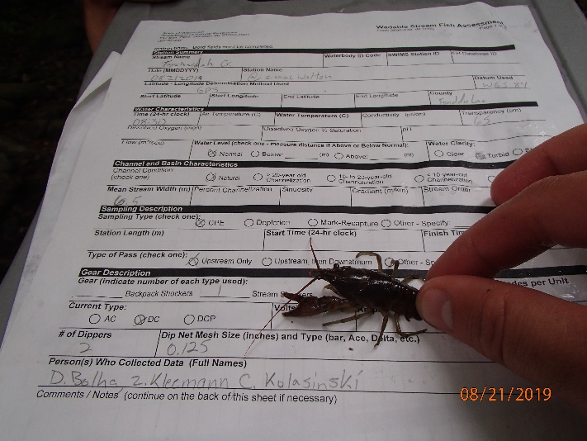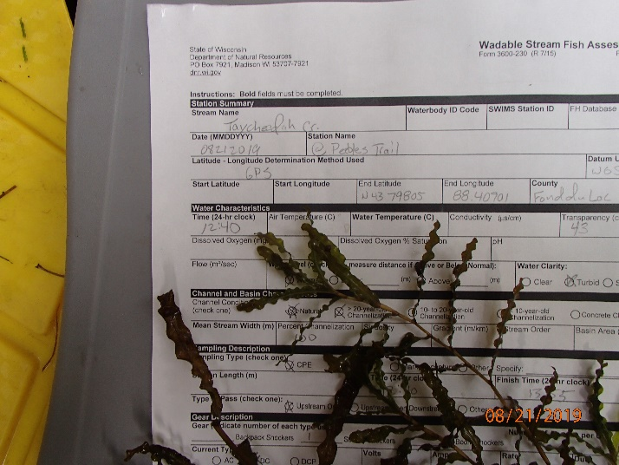
Photos 3-4: Aquatic Invasive Species Rusty Crayfish and Curly Leaf Pondweed, Collected in Taycheedah Creek. Photos Taken by D. Bolha on August 21st, 2019.

References

USGS (United States Geological Survey) (Robertson, D.M. et. al.). 2006. Nutrient Concentrations and Their Relations to the Biotic Integrity of Wadeable Streams in Wisconsin.

WDNR (Wisconsin Department of Natural Resources). 2002. Guidelines for Evaluating Habitat of Wadable Streams.

WDNR (Wisconsin Department of Natural Resources). 2015. Nutrient Chemistry Grab Sampling Method V3.3.
WDNR (Wisconsin Department of Natural Resources). 2017. Guidelines for the Standard Collection of Macroinvertebrate Samples from Wadable Streams v2.0.
WDNR (Wisconsin Department of Natural Resources). 2018. Wisconsin Consolidated Assessment and Listing Methodology Guidance Document.
WDNR (Wisconsin Department of Natural Resources). 2018. Guidelines for Assessing Fish Communities of Wadable Streams in Wisconsin v2.0.

