Curly-leaf Pondweed (Potamogeton crispus) and
Eurasian Water-milfoil (Myriophyllum spicatum) Pre/Post Herbicide and Fall EWM Bed Mapping Surveys
Big Trade Lake – WBIC: 2638700
Burnett County, Wisconsin

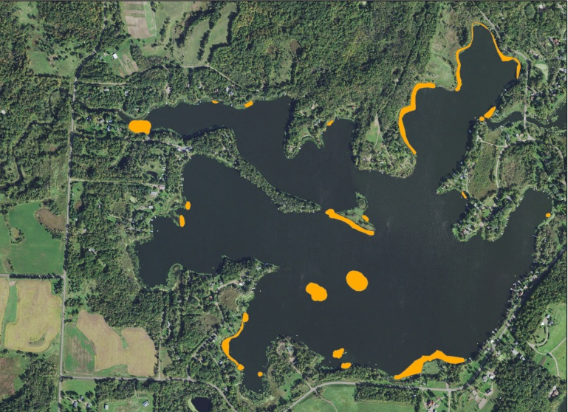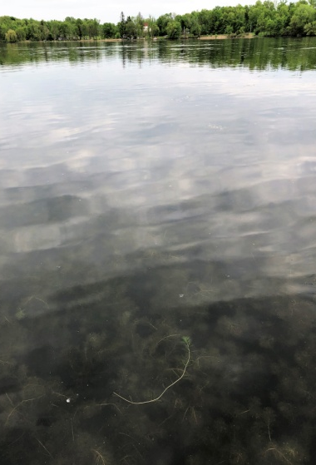
2018 EWM Final Treatment Areas Canopied EWM on Big Trade (5/22/18)
Project Initiated by:
Round-Trade Lakes Improvement Association Inc., Lake Education and Planning Services, LLC, and the Wisconsin Department of Natural Resources
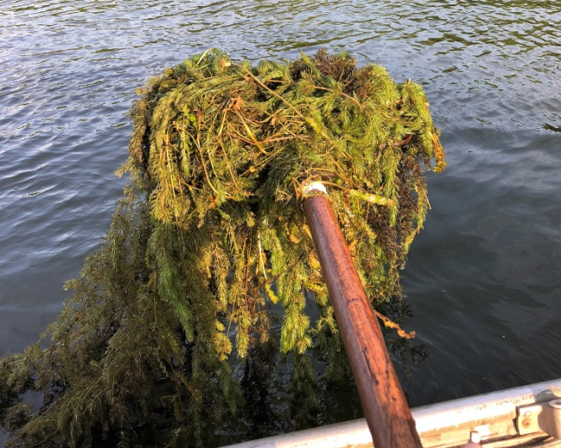
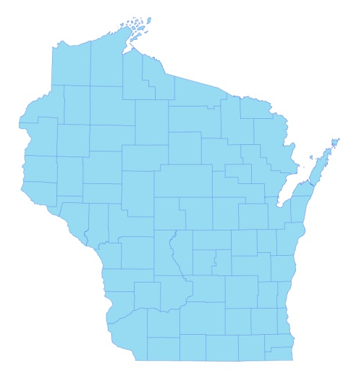

* Big Trade Lake

Dense Coontail Posttreatment (6/25/18)

Surveys Conducted by and Report Prepared by:
Endangered Resource Services, LLC
Matthew S. Berg, Research Biologist
St. Croix Falls, Wisconsin
May 22, June 25, and October 22-25, 2018
TABLE OF CONTENTS

Page
LIST OF FIGURES.………………..……..………………………………………………... ii

LIST OF TABLES…………………..……..……………………………………………….. iii

INTRODUCTION.……….…..……..……………………………………………………… 1

BACKGROUND AND STUDY RATIONALE…..……………………………………….. 1

METHODS……………………………………………………………….………………… 2

RESULTS AND DISCUSSION……………………………………………………………. 3

Finalization of Treatment Areas………………………………………………….…. 3

Pre/Post Herbicide Surveys…...………………………..……………………….…... 3

Fall Eurasian Water-milfoil Bed Mapping Survey…………………………….……. 13

Descriptions of Current and Former Eurasian Water-milfoil Beds…………………. 16

LITERATURE CITED……….……………………….……………………………………. 18

APPENDIXES……….…….………………………………………………….……………. 19

I: Survey Sample Points and Treatment Areas…………………………………………. 19

II: Vegetative Survey Datasheet...………………………………………………………. 22

III: Pre/Post Habitat Variable Maps………………………………………………………. 24

IV: Pre/Post Littoral Zone, Native Species Richness and Total Rake Fullness.………..… 27

V: CLP and EWM Pre/Post Density and Distribution.…………………………….…...... 34

VI: Pretreatment Native Species Density and Distribution…...………………………...... 39

VII: Posttreatment Native Species Density and Distribution…...……………………….... 50

VIII: Fall 2017 and 2018 EWM Bed Maps………………………………………………... 67

LIST OF FIGURES

Page
Figure 1: 2018 EWM Treatment Areas................................................................................. 1
Figure 2: Rake Fullness Ratings……………………………….…….…………………….. 2
Figure 3: 2018 Survey Sample Points and Final Treatment Areas………………………… 3
Figure 4: Treatment Area Depths and Bottom Substrate….………..……………………… 3
Figure 5: Pre/Post Littoral Zone.…………..…………………………..…………………… 5
Figure 6: Pre/Post Native Species Richness……………………………………………….. 6
Figure 7: Pre/Post Total Rake Fullness…………………………………………………….. 6
Figure 8: Pre/Post CLP Density and Distribution………….…………………………….… 7
Figure 9: Pre/Post Changes in CLP Rake Fullness….….………………………………….. 7
Figure 10: Pre/Post EWM Density and Distribution………….…………………………… 8
Figure 11: Pre/Post Changes in EWM Rake Fullness…..…………………………………. 8
Figure 12: Pre/Post Coontail Density and Distribution..……………………………..……. 9
Figure 13: Pre/Post Common Waterweed Density and Distribution..……...……………… 9
Figure 14: Pre/Post Macrophyte Changes…………………..……………………………... 12
Figure 15: 2017 and 2018 Fall EWM Bed Maps….…………………………..….…….….. 13

LIST OF TABLES

Page
Table 1: Spring EWM Treatment Summary –
Big Trade Lake, Burnett County – May 30, 2018…………………………………..…..….. 4

Table 2: Pre/Post Surveys Summary Statistics –
Big Trade Lake, Burnett County – May 22 and June 25, 2018.………………………….… 5

Table 3: Frequencies and Mean Rake Sample of Aquatic Macrophytes
Pretreatment Survey - Big Trade Lake, Burnett County - May 22, 2018…………………... 10

Table 4: Frequencies and Mean Rake Sample of Aquatic Macrophytes
Posttreatment Survey - Big Trade Lake, Burnett County - June 25, 2018…………………. 11

Table 5: Fall Eurasian Water-milfoil Bed Mapping Summary –
Big Trade Lake, Burnett County – October 22-25, 2018…………………………………... 14

INTRODUCTION:
Big Trade Lake (WBIC 2638700) is a 327 acre drainage lake in southwest/south-central Burnett County, Wisconsin in the Town of Trade Lake (T37N R18W S20 SW SW). It reaches a maximum depth of 39ft in the west-central bay and has an average depth of approximately 20ft. The lake is eutrophic in nature with summer Secchi disc readings from 1986-2018 ranging from 2.6-6.1ft and averaging 4.1ft (WDNR 2018). This poor to very poor water clarity produced a littoral zone that extended to approximately 13ft in 2018. The bottom substrate is predominately muck with scattered gravel and sandy areas along the shoreline and around the lake’s exposed and sunken islands (Bush et al 1968).

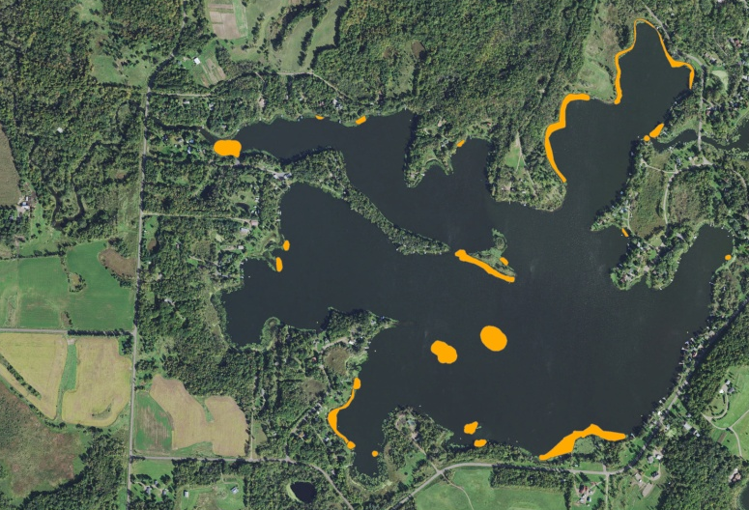
Figure 1: 2018 EWM Treatment Areas

BACKGROUND AND STUDY RATIONALE:
In 2009, the Wisconsin Department of Natural Resources (WDNR) confirmed the presence of Eurasian water-milfoil (Myriophyllum spicatum) (EWM) in Little Trade Lake which is connected to Big Trade Lake via the Trade River Channel. In 2012, we observed EWM in the channel, and, by 2013, we found it had spread to Big Trade Lake’s northeast bay with expansion into many other parts of the lake thereafter. Following the development of a WDNR approved Aquatic Plant Management Plan (APMP) that outlined strategies to control EWM and Curly-leaf pondweed (Potamogeton crispus) (CLP), another invasive exotic species that dominates the lake’s spring littoral zone, the Round-Trade Lake Improvement Association, Inc. (RTLIA) began using manual removal and herbicide treatments to control these species.

In 2018, the RTLIA – under the direction of Dave Blumer (Lake Education and Planning Services, LLC - LEAPS) – applied for and was awarded a WDNR Aquatic Invasive Species control grant (ACEI21618) to help cover the costs associated with management. These funds were used to chemically treat 23 areas totaling 13.34 acres (4.08% of the lake’s surface area) for EWM only (Figure 1). On May 22nd, we conducted a pretreatment survey to gather baseline data from these areas and to allow LEAPS/RTLIA to finalize treatment plans. After the May 30th herbicide application, we completed a June 25th posttreatment survey to evaluate the effectiveness of the treatment. We also conducted an October 22-25th EWM bed mapping survey to determine where control might be considered in 2019. This report is the summary analysis of these three field surveys.

METHODS:
Pre/Post Herbicide Surveys:
LEAPS provided treatment area shapefiles, and we generated pre/post survey points based on the size and shape of the proposed areas that covered 13.34 acres. The requested 160 point sampling grid approximated to almost 12 pts/acre – well over the minimum of 4-10 pts/acre required by WDNR protocol for pre/post treatment surveys (Appendix I).

During the surveys, we located each point using a handheld mapping GPS unit (Garmin 76CSx) and used a rake to sample an approximately 2.5ft section of the bottom. All plants on the rake were assigned a rake fullness value of 1-3 as an estimation of abundance, and a total rake fullness for all species was also recorded (Figure 2). Visual sightings of EWM and CLP were noted if they occurred within 6ft of the point; however, visuals of other species were not recorded as they do not figure into the pre/posttreatment calculation. In addition to plant data, we recorded the lake depth using a metered pole and the substrate (bottom) type when we could see it or reliably determine it with the rake.

We entered all data collected into the standard APM spreadsheet (Appendix II). Data was analyzed using the linked statistical summary sheet and the WDNR pre/post analysis worksheet. For pre/post differences of individual plant species as well as count data, we used the Chi-square analysis on the WDNR pre/post survey worksheet (UWEX 2010). For comparing averages (mean species/point and mean rake fullness/point), we used t-tests. Differences were determined to be significant at p<0.05, moderately significant at p<0.01 and highly significant at p<0.001.

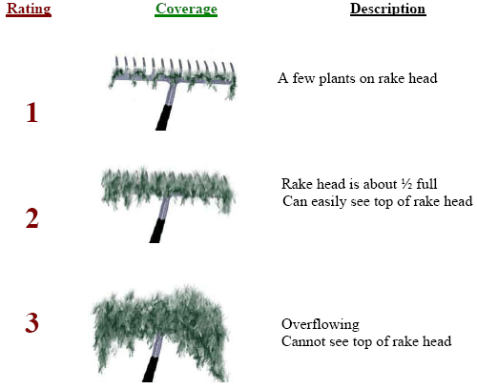
Figure 2: Rake Fullness Ratings

Fall Eurasian Water-milfoil Bed Mapping:
During the fall survey, we searched the entire visible littoral zone of the lake and mapped all known beds of EWM. A “bed” was determined to be any area where we visually estimated that EWM made up >50% of the area’s plants and was generally continuous with clearly defined borders. After we located a bed, we motored around the perimeter of the area, took GPS coordinates at regular intervals, and estimated both the range and mean rake fullness rating of EWM within the bed (Figure 2). Using the WDNR’s Forestry Tool’s Extension to ArcGIS 9.3.1, we plotted these coordinates to generate bed shapefiles and determine the acreage to the nearest hundredth of an acre.
RESULTS AND DISCUSSION:
Finalization of Treatment Areas:
Initial expectations were to treat 23 beds totaling 13.34 acres for Eurasian water-milfoil using 2,4-D in both liquid (Shredder Amine 4 – 10 beds - 11.473 acres) and granular (Sculpin G – 13 beds – 1.864 acres) forms at a target concentration of 4ppm (Figure 3) (Appendix III). The pretreatment survey found EWM throughout the lake so it was decided to maintain all of these areas as originally proposed (Table 1). Northern Aquatic Services (Dale Dressel – Dresser) carried out the treatment on May 30th. The reported water temperature at the time of application was 72°F, the ambient air temperature was 75°F, and winds were out of the south/southeast at 3mph.

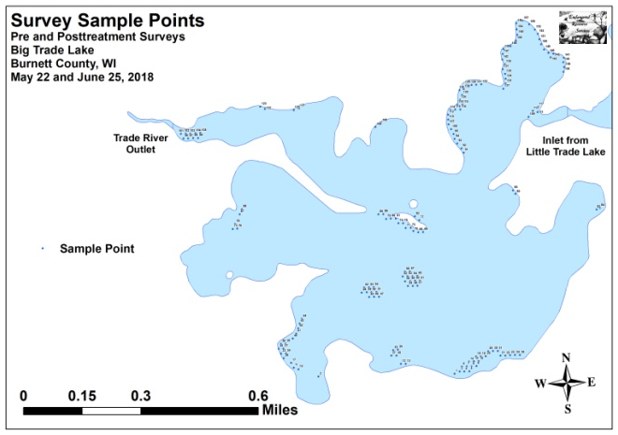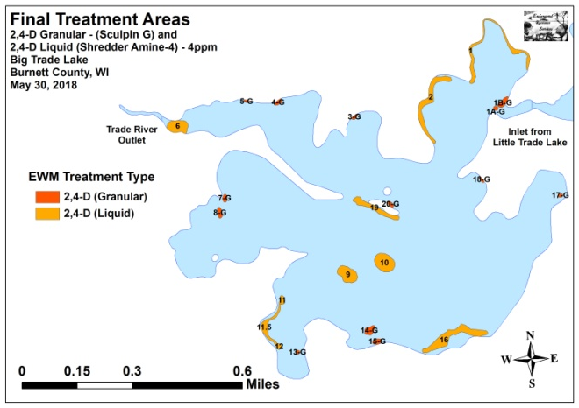
Figure 3: 2018 Survey Sample Points and Final Treatment Areas

Pre/Post Herbicide Surveys:
All points occurred in areas between 1.0ft and 18.0ft of water. The mean and median depths of plant growth were almost unchanged at 4.1ft/4.0ft respectively pretreatment and 4.4ft/4.0ft posttreatment (Table 2). Most Eurasian water-milfoil plants were established in a thin layer of sandy muck over sand and rock, while Curly-leaf pondweed was more common in areas with thicker levels of nutrient-rich organic muck (Figure 4) (Appendix III).

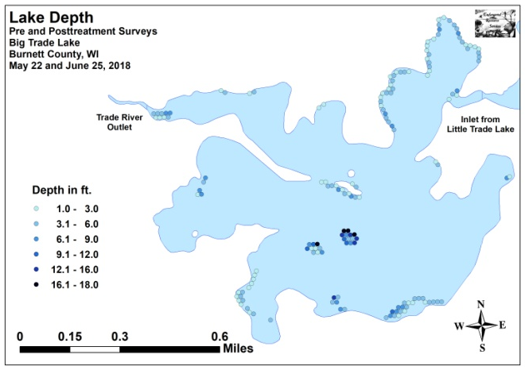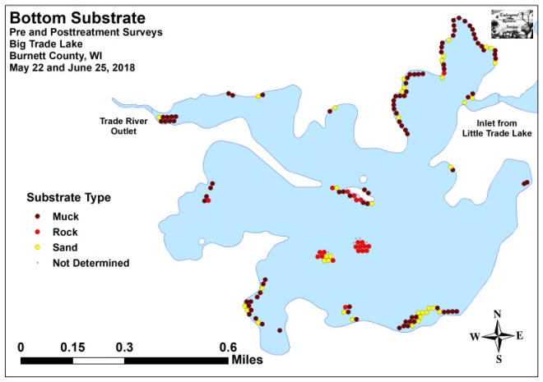
Figure 4: Treatment Area Depths and Bottom Substrate

Table 1: Spring EWM Treatment Summary
Big Trade Lake, Burnett County
May 30, 2018

Treatment Area | Proposed  Acreage | Final Acreage | Difference  +/- | Chemical (Brand) – Rate – Total gal/lbs
1 | 1.63 | 1.63 | 0.00 | 2,4-D (Shredder Amine 4) – 4ppm – 18.50gal
1A-G | 0.08 | 0.08 | 0.00 | 2,4-D (Sculpin G) – 4ppm – 15.70lbs
1B-G | 0.28 | 0.28 | 0.00 | 2,4-D (Sculpin G) – 4ppm – 54.94lbs
2 | 1.84 | 1.84 | 0.00 | 2,4-D (Shredder Amine 4) – 4ppm – 20.90gal
3-G | 0.09 | 0.09 | 0.00 | 2,4-D (Sculpin G) – 4ppm – 17.66lbs
4-G | 0.15 | 0.15 | 0.00 | 2,4-D (Sculpin G) – 4ppm – 29.43lbs
5-G | 0.06 | 0.06 | 0.00 | 2,4-D (Sculpin G) – 4ppm – 11.77lbs
6 | 1.05 | 1.05 | 0.00 | 2,4-D (Shredder Amine 4) – 4ppm – 11.90gal
7-G | 0.15 | 0.15 | 0.00 | 2,4-D (Sculpin G) – 4ppm – 39.24lbs
8-G | 0.20 | 0.20 | 0.00 | 2,4-D (Sculpin G) – 4ppm – 52.32lbs
9 | 1.14 | 1.14 | 0.00 | 2,4-D (Shredder Amine 4) – 4ppm – 16.20gal
10 | 1.38 | 1.38 | 0.00 | 2,4-D (Shredder Amine 4) – 4ppm – 19.60gal
11, 11.5, and 12 | 1.11 | 1.11 | 0.00 | 2,4-D (Shredder Amine 4) – 4ppm – 12.60gal
13-G | 0.08 | 0.08 | 0.00 | 2,4-D (Sculpin G) – 4ppm – 26.16lbs
14-G | 0.33 | 0.33 | 0.00 | 2,4-D (Sculpin G) – 4ppm – 107.90lbs
15-G | 0.20 | 0.20 | 0.00 | 2,4-D (Sculpin G) – 4ppm – 65.40lbs
16 | 2.25 | 2.25 | 0.00 | 2,4-D (Shredder Amine 4) – 4ppm – 32.00gal
17-G | 0.07 | 0.07 | 0.00 | 2,4-D (Sculpin G) – 4ppm – 22.89lbs
18-G | 0.07 | 0.07 | 0.00 | 2,4-D (Sculpin G) – 4ppm – 13.73lbs
19 | 1.08 | 1.08 | 0.00 | 2,4-D (Shredder Amine 4) – 4ppm – 15.30gal
20-G | 0.12 | 0.12 | 0.00 | 2,4-D (Sculpin G) – 4ppm – 15.70lbs
Total Acres | 13.34 | 13.34 | +0.00

Table 2: Pre/Post Surveys Summary Statistics
Big Trade Lake, Burnett County
May 22 and June 25, 2018

Summary Statistics: | Pre | Post
Total number of points sampled | 160 | 160
Total number of sites with vegetation | 145 | 144
Total number of sites shallower than the maximum depth of plants | 153 | 150
Freq. of occur. at sites shallower than max. depth of plants (in percent) | 94.8 | 96.0
Simpson Diversity Index | 0.77 | 0.86
Mean Coefficient of Conservatism | 5.7 | 5.3
Floristic Quality Index | 17.0 | 20.7
Maximum depth of plants (ft) | 13.0 | 11.0
Mean depth of plants (ft) | 4.1 | 4.4
Median depth of plants (ft) | 4.0 | 4.0
Average number of all species per site (shallower than max depth) | 2.40 | 2.90
Average number of all species per site (veg. sites only) | 2.53 | 3.02
Average number of native species per site (shallower than max depth) | 1.41 | 2.43
Average number of native species per site (sites with native veg. only) | 1.60 | 2.55
Species richness | 11 | 16
Mean rake fullness (veg. sites only) | 1.99 | 1.97

The littoral zone within the beds extended to 13.0ft during the pretreatment survey before declining sharply to 11.0ft posttreatment. However, the frequency of plant occurrence was almost unchanged at 94.8% coverage pretreatment and 96.0% posttreatment (Figure 5) (Appendix IV). Total richness jumped from 11 species pretreatment to 16 species posttreatment. The Simpson’s Diversity Index also increased from a moderately high pretreatment value of 0.77 to a high posttreatment value of 0.86. The Floristic Quality Index (another measure of native plant community health) climbed from 17.0 pretreatment to 20.7 posttreatment.

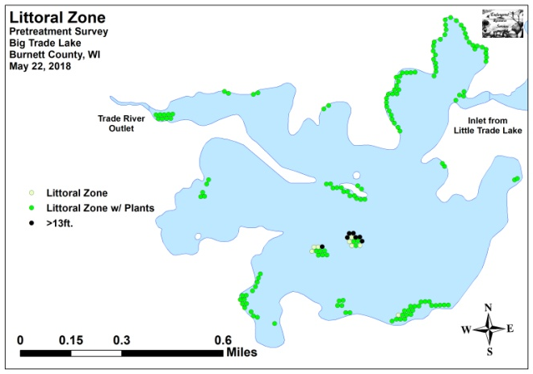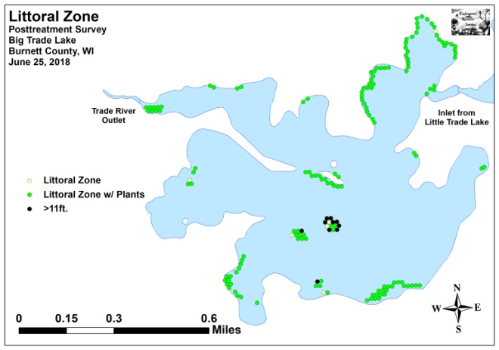
Figure 5: Pre/Post Littoral Zone

Mean native species richness at points with native vegetation rose sharply from 1.60 species/point pretreatment to 2.55 species/point posttreatment (Figure 6). Although this increase in localized richness was highly significant (p<0.001), it can largely be attributed to the rise in “duckweeds”; especially in the southwest bay and along the western shoreline in the north-central bay. Total mean rake fullness was almost unchanged from a moderate 1.99 pretreatment to 1.97 posttreatment (Figure 7) (Appendix IV).

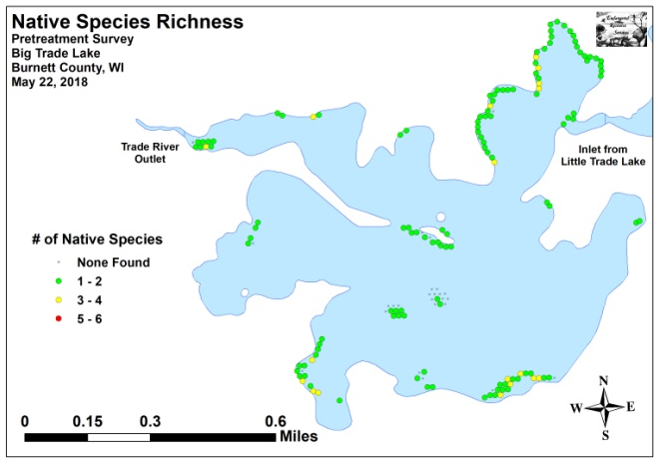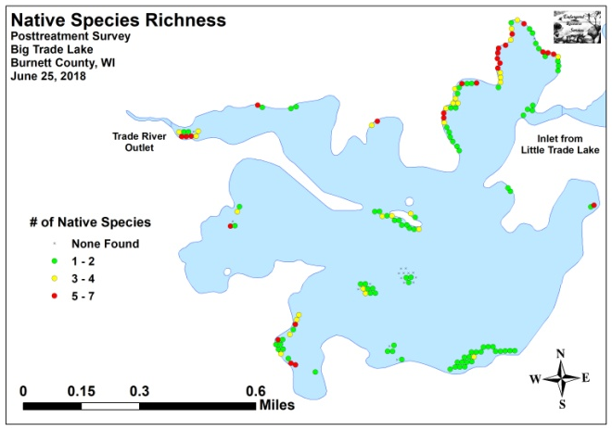
Figure 6: Pre/Post Native Species Richness

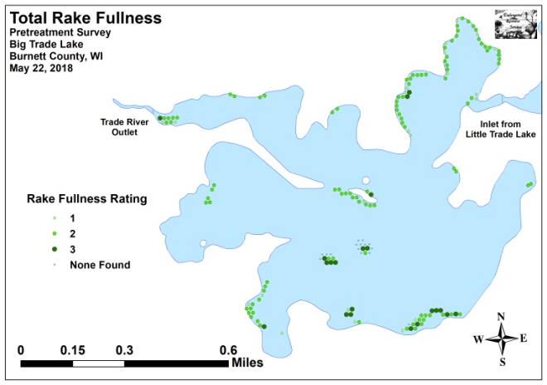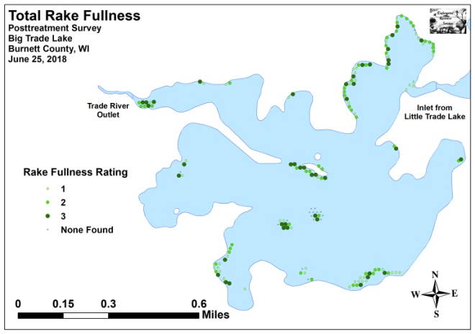
Figure 7: Pre/Post Total Rake Fullness

We found Curly-leaf pondweed at 118 of 160 sites during the pretreatment survey (73.8% coverage) and also recorded it as a visual at 12 points (Figure 8). Of these, ten had a rake fullness rating of 3, 59 rated a 2, and the remaining 49 were a 1. This produced a mean rake fullness of 1.67 and suggested that 43.1% of the treatment areas had a significant infestation (rake fullness 2 and 3). During the posttreatment survey, we found CLP at 71 points (44.4%) with two rating a 3, nine a 2, and 60 a 1. Although the mean rake fullness was just 1.18, this still suggested 6.9% of the treatment area had a significant infestation. Our results demonstrated a highly significant decline in total CLP, rake fullness 2, and visual sightings; and a significant decline in rake fullness 3 (Figure 9) (Appendix V). As pondweeds (monocots) aren’t expected to be sensitive to 2,4-D, these declines are likely at least partially due to this species annual senescence that normally occurs in late June.

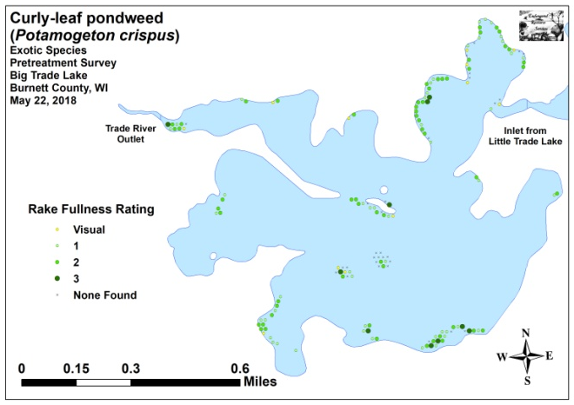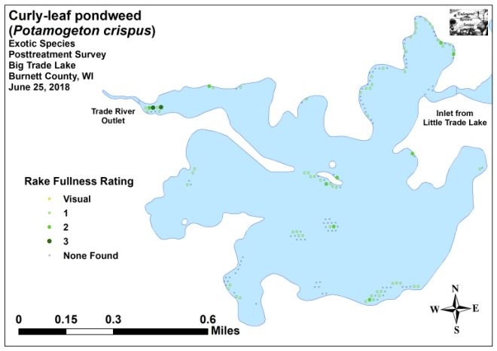
Figure 8: Pre/Post CLP Density and Distribution

_***
-*
_***
_***

Significant differences = * p<0.05, ** p<0.01, *** p<0.001
Figure 9: Pre/Post Changes in CLP Rake Fullness

During the pretreatment survey, Eurasian water-milfoil was present at 33 of 160 points (20.6% coverage) with 36 additional visual sightings (Figure 10). We rated six points a 3, 13 a 2, and 14 a 1. This extrapolated to 11.9% of the treatment areas having a significant infestation (rake fullness 2 and 3) and produced a mean rake fullness of 1.76. Posttreatment, we didn’t find EWM in the rake at any point, and we also didn’t record it as a visual or see any plants inter-point. This reduction was highly significant for total EWM, rake fullness 2, rake fullness 1, and visual sightings; and significant for rake fullness 3 (Figure 11) (Appendix V).

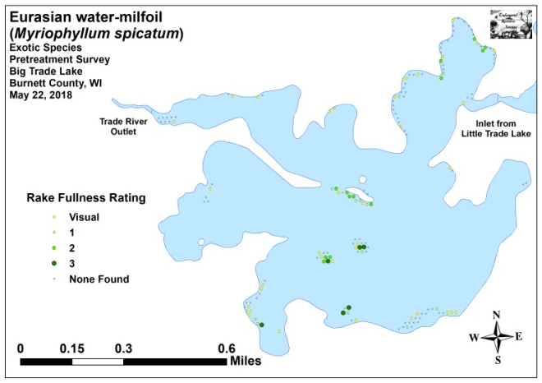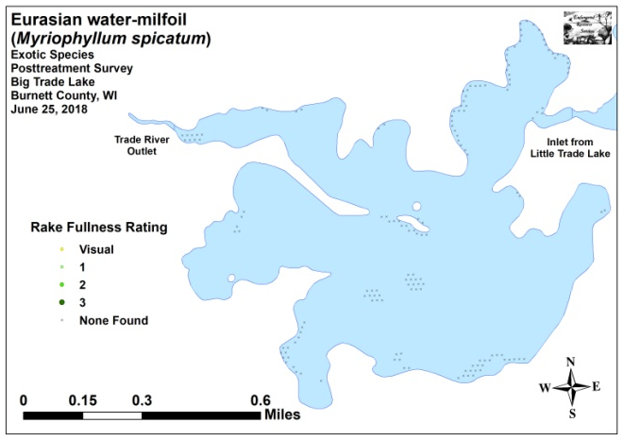
Figure 10: Pre/Post EWM Density and Distribution

_***
_***
_*
_***
_***

Significant differences = * p<0.05, ** p<0.01, *** p<0.001
Figure 11: Pre/Post Changes in EWM Rake Fullness

Coontail (Ceratophyllum demersum) (119 sites – mean rake 1.45 pretreatment) (Figure 12) and Common waterweed (Elodea canadensis) (40 sites – mean rake 1.28 pretreatment) (Figure 13) were the most common native species in the pretreatment survey (Table 3). Posttreatment, Coontail remained the most common native species despite experiencing non-significant declines (p=0.26/p=0.32) in distribution (110 sites) and density (mean rake fullness 1.41) (Table 4). Although it increased slightly (p=0.23) in mean rake fullness (1.39), Common waterweed also experienced a non-significant decline (p=0.23) in range (31 sites) posttreatment and fell to become just the sixth most common native species.

In addition to CLP and EWM, Northern water-milfoil (Myriophyllum sibiricum) suffered a highly significant decline in range posttreatment; and White water crowfoot (Ranunculus aquatilis) experienced a moderately significant decline (Figure 14). As both of these species are dicots and sensitive to 2,4-D, it’s likely these results are at least partially tied to the herbicide application. In spite of these losses, many species demonstrated significant expansion in distribution posttreatment. Specifically, White water lily (Nymphaea odorata), Common watermeal (Wolffia columbiana), Small duckweed (Lemna minor), and Large duckweed (Spirodela polyrhiza) enjoyed highly significant increases; Flat-stem pondweed (Potamogeton zosteriformis) demonstrated a moderately significant increase; and Spatterdock (Nuphar variegata), Sago pondweed (Stuckenia pectinata), and Small pondweed (Potamogeton pusillus) each showed a significant increase. Maps for all native species from the pre and posttreatment surveys are available in Appendixes VI and VII.

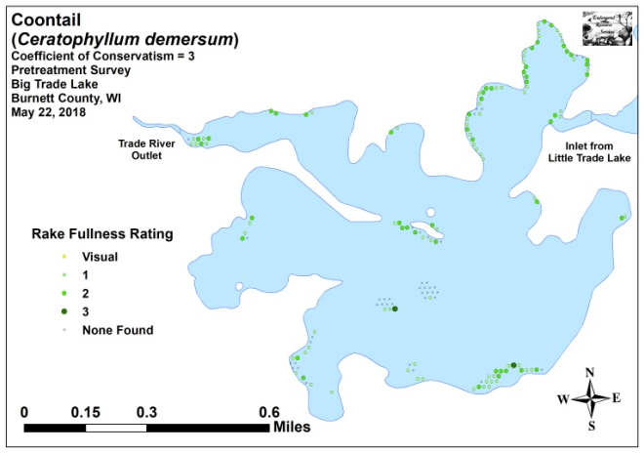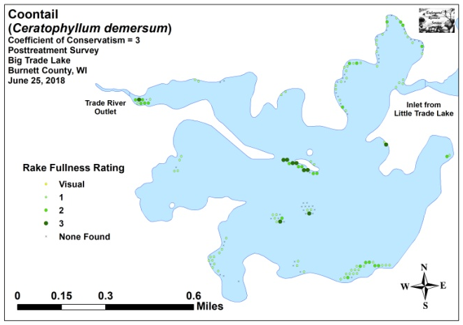
Figure 12: Pre/Post Coontail Density and Distribution

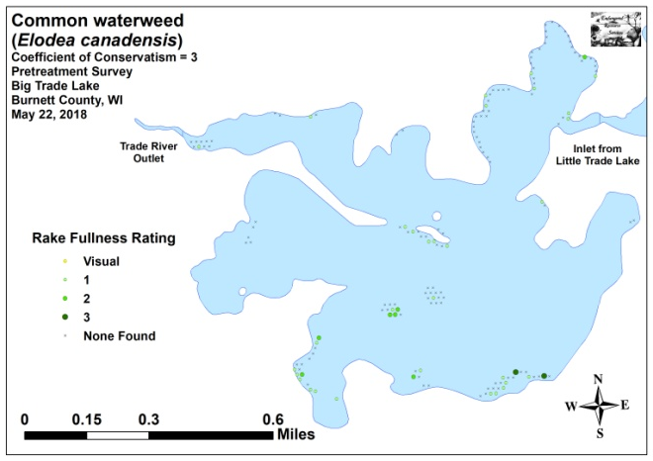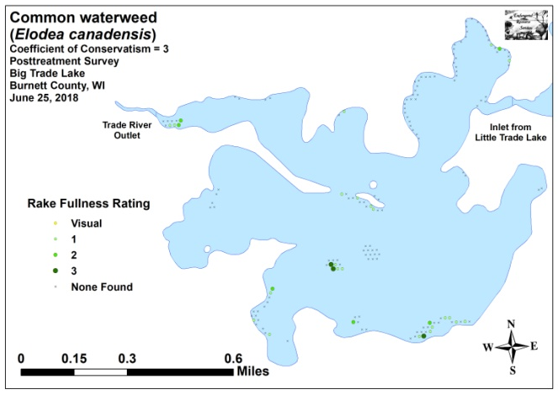
Figure 13: Pre/Post Common Waterweed Density and Distribution

Table 3: Frequencies and Mean Rake Sample of Aquatic Macrophytes
Pretreatment Survey – Big Trade Lake, Burnett County
May 22, 2018

Species | Common Name | Total  Sites | Relative Freq. | Freq. in Veg. | Freq. in Lit. | Mean Rake | Visual  Sight.
Ceratophyllum demersum | Coontail | 119 | 32.43 | 82.07 | 77.78 | 1.45 | 0
Potamogeton crispus | Curly-leaf pondweed | 118 | 32.15 | 81.38 | 77.12 | 1.67 | 12
 | Filamentous algae | 78 | * | 53.79 | 50.98 | 1.62 | 0
Elodea canadensis | Common waterweed | 40 | 10.90 | 27.59 | 26.14 | 1.28 | 0
Myriophyllum spicatum | Eurasian water-milfoil | 33 | 8.99 | 22.76 | 21.57 | 1.76 | 36
Ranunculus aquatilis | White water crowfoot | 18 | 4.90 | 12.41 | 11.76 | 1.06 | 0
Nymphaea odorata | White water lily | 17 | 4.63 | 11.72 | 11.11 | 1.06 | 0
Myriophyllum sibiricum | Northern water-milfoil | 11 | 3.00 | 7.59 | 7.19 | 1.00 | 0
Nuphar variegata | Spatterdock | 6 | 1.63 | 4.14 | 3.92 | 1.50 | 0
Chara sp. | Muskgrass | 2 | 0.54 | 1.38 | 1.31 | 1.00 | 0
Potamogeton zosteriformis | Flat-stem pondweed | 2 | 0.54 | 1.38 | 1.31 | 1.00 | 0
Lemna trisulca | Forked duckweed | 1 | 0.27 | 0.69 | 0.65 | 1.00 | 0

* Excluded from relative frequency analysis
Table 4: Frequencies and Mean Rake Sample of Aquatic Macrophytes
Posttreatment Survey – Big Trade Lake, Burnett County
June 25, 2018

Species | Common Name | Total  Sites | Relative Freq. | Freq. in Veg. | Freq. in Lit. | Mean Rake | Visual  Sight.
Ceratophyllum demersum | Coontail | 110 | 25.29 | 76.39 | 73.33 | 1.41 | 0
 | Filamentous algae | 86 | * | 59.72 | 57.33 | 1.72 | 0
Potamogeton crispus | Curly-leaf pondweed | 71 | 16.32 | 49.31 | 47.33 | 1.18 | 0
Nymphaea odorata | White water lily | 53 | 12.18 | 36.81 | 35.33 | 2.08 | 0
Wolffia columbiana | Common watermeal | 41 | 9.43 | 28.47 | 27.33 | 1.76 | 0
Lemna minor | Small duckweed | 39 | 8.97 | 27.08 | 26.00 | 1.64 | 0
Spirodela polyrhiza | Large duckweed | 38 | 8.74 | 26.39 | 25.33 | 1.32 | 0
Elodea canadensis | Common waterweed | 31 | 7.13 | 21.53 | 20.67 | 1.39 | 0
Nuphar variegata | Spatterdock | 15 | 3.45 | 10.42 | 10.00 | 2.13 | 0
Potamogeton zosteriformis | Flat-stem pondweed | 12 | 2.76 | 8.33 | 8.00 | 1.25 | 0
Stuckenia pectinata | Sago pondweed | 6 | 1.38 | 4.17 | 4.00 | 1.17 | 0
Ranunculus aquatilis | White water crowfoot | 5 | 1.15 | 3.47 | 3.33 | 1.20 | 0
Chara sp. | Muskgrass | 4 | 0.92 | 2.78 | 2.67 | 2.50 | 0
Potamogeton pusillus | Small pondweed | 4 | 0.92 | 2.78 | 2.67 | 1.00 | 0
Vallisneria americana | Wild celery | 3 | 0.69 | 2.08 | 2.00 | 1.33 | 0
Potamogeton richardsonii | Clasping-leaf pondweed | 2 | 0.46 | 1.39 | 1.33 | 1.00 | 0
Heteranthera dubia | Water star-grass | 1 | 0.23 | 0.69 | 0.67 | 1.00 | 0

* Excluded from relative frequency analysis
+*
+*
+***
+***
+***
+**
+*
-***
+***
-**
-***
-***
Significant differences = * p<0.05, ** p<0.01, *** p<0.001
Figure 14: Pre/Post Macrophyte Changes

Fall Eurasian Water-milfoil Bed Mapping Survey:
During the October 2018 survey, we located and mapped 26 Eurasian water-milfoil beds that covered 1.34 acres (0.41% of the lake’s total surface area) (Table 5). We also marked 145 additional pioneer EWM plants outside of these beds (Figure 15) (Appendix VIII). This total area was down sharply (-54.88%) from 2017 when we found 32 beds on 2.97 acres (0.91% coverage) and marked an additional 120 individual EWM plants. The 2018 total was almost identical to the fall 2016 survey when we found 21 beds covering 1.33 acres, but it was still more than double the 10 beds/0.62 acre we mapped in 2015.

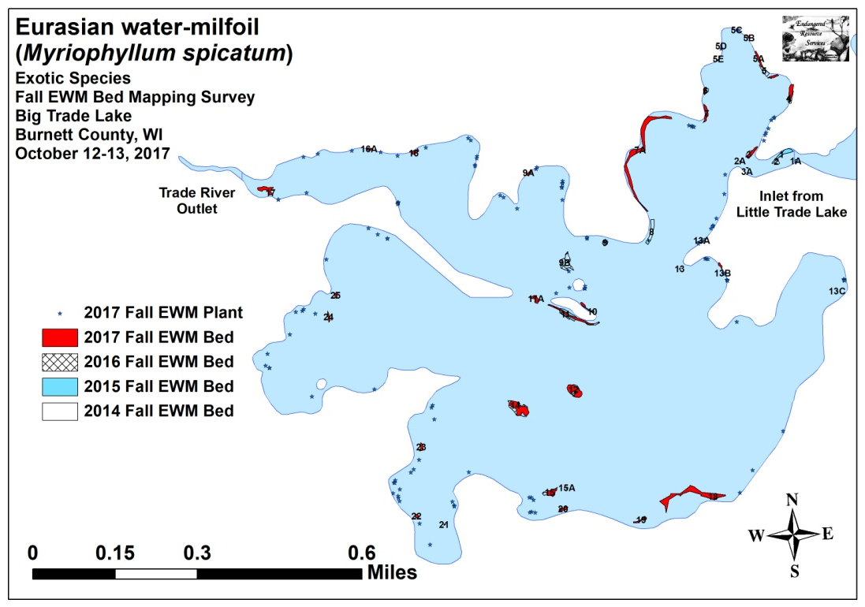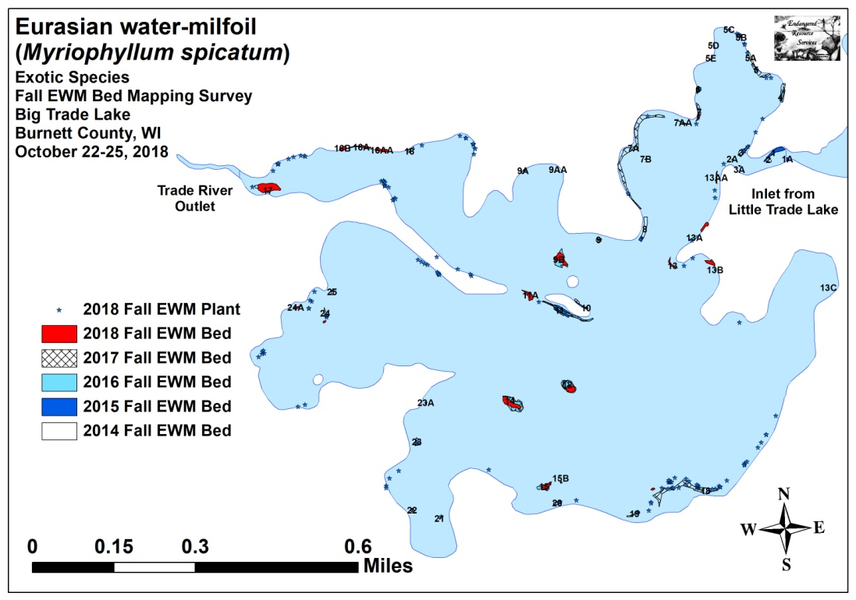
Figure 15: 2017 and 2018 Fall EWM Bed Maps

Table 5: Fall Eurasian Water-milfoil Bed and High Density Area Mapping Summary
Big Trade Lake, Burnett County
October 22-25, 2018

Bed Number | 2018  Fall Bed Acreage | 2017  Fall Bed Acreage | 2016  Fall Bed Acreage | 2015  Fall Bed Acreage | 2014  Fall Bed Acreage | 2013  Fall Bed Acreage | 2012  Fall Bed Acreage | 2018  Change in  Acreage | 2018 Rake Range; Mean Rake | 2018 Bed Characteristics/  Field Notes
1A | 0 | 0 | 0 | 0.01 | <0.01 | 0 | 0 | 0 | 0 | No EWM seen
1 and 2 | 0 | 0 | 0 | 0.12 | 0.03 | 0.07 | 0.02 | 0 | 0 | No EWM seen
2A | 0 | <0.01 | 0 | <0.01 | 0 | 0 | 0 | -<0.01 | 0 | No EWM seen
3 and 3A | 0 | 0.07 | 0.03 | 0 | 0.06 | 0.03 | 0 | -0.07 | <<<1 | 3 EWM plants – rake removed
4 | 0 | 0.11 | 0.08 | 0 | <0.01 | <0.01 | 0 | -0.11 | 0 | No EWM seen
5 and 5A | 0 | 0.09 | <0.01 | 0 | 0.08 | <0.01 | 0 | -0.09 | <<<1 | 5 EWM plants – rake removed
5B/5C | 0 | 0.01 | <0.01 | 0 | 0 | 0 | 0 | -0.01 | <<<1 | 4 EWM plants – rake removed
5D/5E | 0 | 0.01 | 0 | 0 | 0 | 0 | 0 | -0.01 | 0 | No EWM seen
6 | <0.01 | 0.02 | 0.01 | 0.03 | 0.03 | 0 | 0 | -0.01 | 2-3; 2 | Matted microbed in 2ft of water
7AA | 0.01 | 0 | 0 | 0 | 0 | 0 | 0 | 0.01 | <1-3; 1 | Narrow; regular towers
7 | 0.01 | 0.08 | 0.01 | 0 | 0.02 | 0 | 0 | -0.07 | <1-1; <1 | Scattered towers
7A | 0 | 0.72 | 0 | 0 | 0 | 0 | 0 | -0.72 | <<<1 | 2 EWM plants – rake removed
7B | <0.01 | 0 | 0 | 0 | 0 | 0 | 0 | <0.01 | 2-3; 2 | Canopied microbed
8 | 0 | 0 | <0.01 | 0.03 | 0.16 | 0 | 0 | 0 | 0 | No EWM seen
9 | <0.01 | 0 | 0.01 | 0.01 | 0.03 | 0 | 0 | <0.01 | 1-2; 1 | Microbed
9AA | <0.01 | 0 | 0 | 0 | 0 | 0 | 0 | <0.01 | <<1-2; 1 | Microbed
9A | 0 | 0.02 | 0 | 0 | 0 | 0 | 0 | -0.02 | 0 | No EWM seen
9B | 0.17 | 0 | 0.26 | 0 | 0 | 0 | 0 | 0.17 | <1-3; 2 | Extensive prop-clipping
10 | 0 | 0.03 | 0.01 | 0 | 0.01 | 0 | 0 | -0.03 | 0 | No EWM seen
11A | 0.08 | 0.07 | <0.01 | 0 | 0 | 0 | 0 | 0.01 | 1-3; 2 | Extensive prop-clipping
11 | 0 | 0.15 | 0.17 | 0.19 | 0.10 | 0 | 0 | -0.15 | <<<1 | 1 EWM plant – rake removed
12 | 0.10 | 0.22 | 0.18 | 0.15 | 0.01 | 0 | 0 | -0.12 | 2-3; 3 | Forming solid mat
13AA | 0.02 | 0 | 0 | 0 | 0 | 0 | 0 | 0.02 | 1-3; 2 | Microbed
13A | 0.05 | 0 | 0.03 | 0 | 0 | 0 | 0 | 0.05 | 1-3; 2 | Microbed along shore
13 | 0.03 | 0 | 0 | 0 | <0.01 | 0 | 0 | 0.03 | <<1-2; 1 | Regular towers in NWM bed
13B | 0.06 | 0.02 | 0.01 | 0 | 0 | 0 | 0 | 0.04 | <1-3; 1 | Regular thickening towers
13C | 0 | <0.01 | 0 | 0 | 0 | 0 | 0 | -<0.01 | 0 | No EWM found
Table 5: Fall Eurasian Water-milfoil Bed and High Density Area Mapping Summary
Big Trade Lake, Burnett County
October 22-25, 2018

Bed Number | 2018  Fall Bed Acreage | 2017  Fall Bed Acreage | 2016  Fall Bed Acreage | 2015  Fall Bed Acreage | 2014  Fall Bed Acreage | 2013  Fall Bed Acreage | 2012  Fall Bed Acreage | 2018  Change in  Acreage | 2018 Rake Range; Mean Rake | 2018 Bed Characteristics/  Field Notes
14 | 0.20 | 0.32 | 0.42 | 0.03 | 0 | 0 | 0 | -0.12 | 1-3; 2 | Thick at core; fragm. on edge
15A | <0.01 | 0 | 0.01 | 0 | 0 | 0 | 0 | <0.01 | 2-3; 3 | Microbed
15B | <0.01 | 0 | 0 | 0 | 0 | 0 | 0 | <0.01 | 2-3; 3 | Microbed
15 | 0.06 | 0.10 | 0.07 | 0.04 | 0 | 0 | 0 | -0.04 | 2-3; 2 | Significant monotypic bed
16 | 0 | 0.04 | <0.01 | 0 | 0 | 0 | 0 | -0.04 | 0 | No EWM found
16AA | 0.06 | 0 | 0 | 0 | 0 | 0 | 0 | 0.06 | <<1-3; 2 | Regular towers and microbeds
16A | 0.04 | 0.02 | 0 | 0 | 0 | 0 | 0 | 0.02 | <<1-2; 1 | Regular towers along shore
16B | 0.04 | 0 | 0 | 0 | 0 | 0 | 0 | 0.04 | 1-3; 2 | Microbed at shoreline
17 | 0.33 | 0.12 | <0.01 | 0 | 0 | 0 | 0 | 0.21 | <<1-2; 1 | Many prop-clipped towers
18 | 0.01 | 0.58 | 0 | 0 | 0 | 0 | 0 | -0.57 | 2-3; 2 | Microbed outside treated area
19 | 0 | 0.04 | 0 | 0 | 0 | 0 | 0 | -0.04 | <<<1 | 1 EWM plant – rake removed
20 | 0 | 0.04 | 0 | 0 | 0 | 0 | 0 | -0.04 | <<<1 | 1 EWM plant – rake removed
21 | 0 | <0.01 | 0 | 0 | 0 | 0 | 0 | -<0.01 | <<<1 | 1 EWM plant – rake removed
22 | <0.01 | 0.02 | 0 | 0 | 0 | 0 | 0 | -0.01 | 2-3; 3 | Microbed at core of treated area
23 | 0 | 0.04 | 0 | 0 | 0 | 0 | 0 | -0.04 | <<<1 | 2 EWM plants – rake removed
23A | <0.01 | 0 | 0 | 0 | 0 | 0 | 0 | <0.01 | 2-3; 3 | Microbed
24 | 0.01 | 0.03 | 0 | 0 | 0 | 0 | 0 | -0.02 | 1-3; 1 | Scattered large towers
24A | 0.02 | 0 | 0 | 0 | 0 | 0 | 0 | 0.02 | 1-3; 1 | Scattered large towers
25 | 0 | 0.02 | 0 | 0 | 0 | 0 | 0 | -0.02 | 0 | No EWM found
Total Acres | 1.34 | 2.97 | 1.33 | 0.62 | 0.60 | 0.17 | 0.06 | -1.63

Descriptions of Current and Former EWM Beds:
Beds 1A, 1, 2, and 2A: The channel downstream from the bridge remained clear as we didn’t find EWM anywhere in this area.

Bed 3: Treatment on Bed 3 appeared to have been highly effective as we only found three plants each of which we rake removed.

Beds 4, 5, 5A-5E: Treatment in the north bay also looked to have produced lasting control. We found just a few handfuls of plants in this area and worked to rake remove them.

Bed 6: A small microbed in 2ft of water survived the treatment and was already matting on the surface. This area would be an ideal location for manual removal.

Beds 7 and 7AA: Scattered towers survived the treatment on the western point in the far north end of the north-central bay. We also documented a thin row of towers establishing on the outer edge of the Hardstem bulrush (Schoenoplectus acutus) bed just west of the point.

Beds 7A and 7B: Treatment of Bed 7A was extremely successful as we only found two surviving plants along the entire southwest shoreline of the north-central bay. Unfortunately, for the first time ever, we found EWM plants had established on the bay’s sunken island (Bed 7B).

Bed 8: We didn’t see any EWM in this former bed.

Beds 9 and 9AA: These microbeds were little more than large clusters with perhaps 10 EWM plants each.

Bed 9A: The treatment in this area held up well as we didn’t see any EWM plants in this former bed.

Bed 9B and 11A: These beds were some of the worst areas on the lake. Located directly along the main navigation channels, we noticed many plants showed evidence of being prop-clipped. In water <5ft near the islands, the beds became a canopied mat and a moderate impairment to navigation.

Beds 10 and 11: Control in this area, which has been problematic in the past, was surprisingly complete as we saw just a single plant between Bed 11 and Bed 11A.

Beds 12 and 14: As in the past, the two large sunken islands in the middle of the lake were both covered with dense EWM despite being treated. Plants were all actively fragmenting, and we found many prop-clipped stems and fragments floating in the area.

Beds 13, 13A, and 13AA: These three small beds were established along the eastern shoreline of the north-central bay downstream from the Trade River Inlet. None of them posed significant navigational issues, but, at their current rate of expansion, they will likely become problematic in the near future along this heavily developed shoreline.
Bed 13B – Treatment in this area did not hold up as Eurasian water-milfoil was worse than it had been in the fall of 2017. Many plants in this developed bay showed evidence of being prop-clipped which may be why EWM was able to recolonize so quickly. This bay is also a likely settling place for fragments blown off the midlake rock bars by the prevailing southwesterly winds.

Bed 13C – We didn’t find any EWM in the lake’s far northeast bay.

Beds 15, 15A, and 15B – Much like the two large midlake sunken islands, the EWM beds that surround the Hardstem bulrush stand on the small sunken island along the south shoreline midlake have proven very difficult to control. We found these beds were again well-establish, canopied, nearly monotypic, and actively fragmenting.

Bed 16: Although we didn’t see any surviving plants in this treatment area, there were regular EWM satellite plants scattered along much of the north shoreline leading to the Trade River outlet.

Beds 16AA, 16A, and 16B: We found that, unlike in Bed 16, the EWM in Bed 16A seemed to have survived the treatment. By fall, plants in the area had spread to become three beds that appeared headed towards merging into a single “super bed” stretching along this part of the north shoreline in the lake outlet.

Bed 17: Despite treatment, the bed in front of the Cedar Point public landing expanded again in 2018. We noted that many plants were prop-clipped raising concerns that people leaving the lake will inadvertently transport EWM with them.

Beds 18, 19, and 20: Treatment killed the majority of plants in these three beds in the southeast bay. However, we found several dozen plants regrowing from burned root crowns and a small bed north of the treatment area surrounding Bed 18.

Beds 21, 22, 23, and 23A: Most areas in the southwest bay saw a significant reduction in EWM. We found a few surviving plants along the western shoreline, a microbed at the core of the worst area in Bed 22, and a small new bed along the bay’s northwest shoreline.

Beds 24, 24A, and 25: The herbicide knocked out the majority of plants in the treatment areas in the far western bay midlake. Just outside these areas, we found two small pioneer beds as well as scattered individual plants throughout much of the rest of the bay.

LITERATURE CITED

Busch, C., C. Olson, L. Sather, and C. Holt. [online]. 1968. Big/Little Trade Lake Map. Available from http://dnr.wi.gov/lakes/maps/DNR/2638700a.pdf (2018, December).

UWEX Lakes Program. [online]. 2010. Aquatic Plant Management in Wisconsin. Available from http://www.uwsp.edu/cnr-ap/UWEXLakes/Pages/ecology/aquaticplants/default.aspx (2018, December).

UWEX Lakes Program. [online]. 2010. Pre/Post Herbicide Comparison. Available from http://www.uwsp.edu/cnr-ap/UWEXLakes/Documents/ecology/Aquatic%20Plants/Appendix-D.pdf (2018, December).

WDNR. [online]. 2018. Big Trade Lake - Citizen Lake Water Quality Monitoring Database. Available from http://dnr.wi.gov/lakes/lakepages/LakeDetail.aspx?wbic=2638700&page=waterquality (2018, December).

Appendix I: Survey Sample Points and Treatment Areas
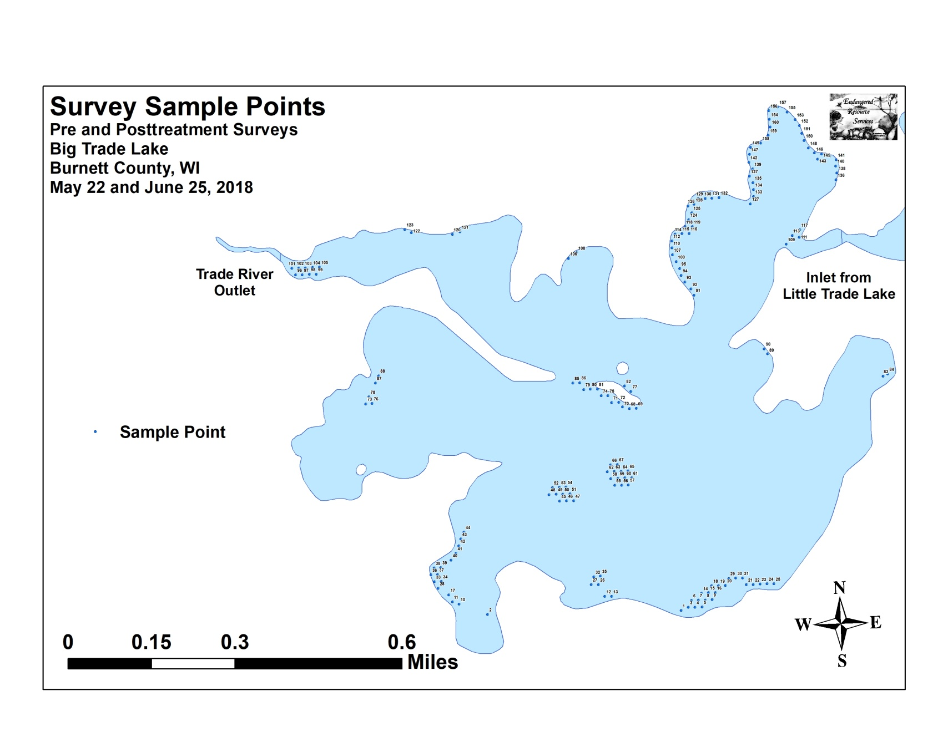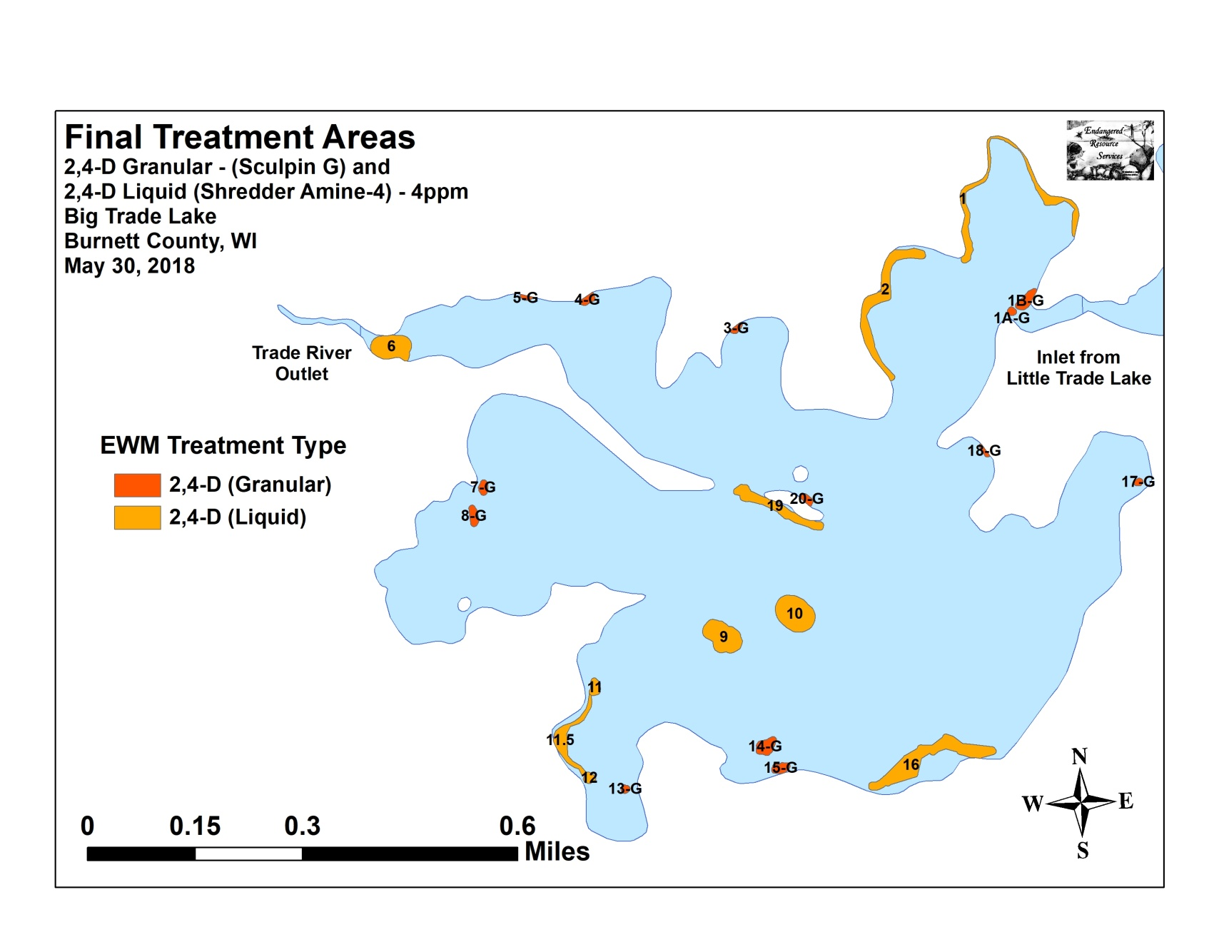

Appendix II: Vegetative Survey Datasheet

Observers for this lake: names and hours worked by each:
Lake: |  |  |  |  |  |  |  |  | WBIC |  |  |  |  |  |  |  |  | County |  |  |  |  |  | Date:
Site # | Depth (ft) | Muck (M), Sand (S), Rock (R) | Rake pole (P) or rake rope (R) | Total Rake Fullness | EWM | CLP | 1 | 2 | 3 | 4 | 5 | 6 | 7 | 8 | 9 | 10 | 11 | 12 | 13 | 14 | 15 | 16 | 17 | 18 | 19
1
2
3
4
5
6
7
8
9
10
11
12
13
14
15
16
17
18
19
20

Appendix III: Pre/Post Habitat Variable Maps
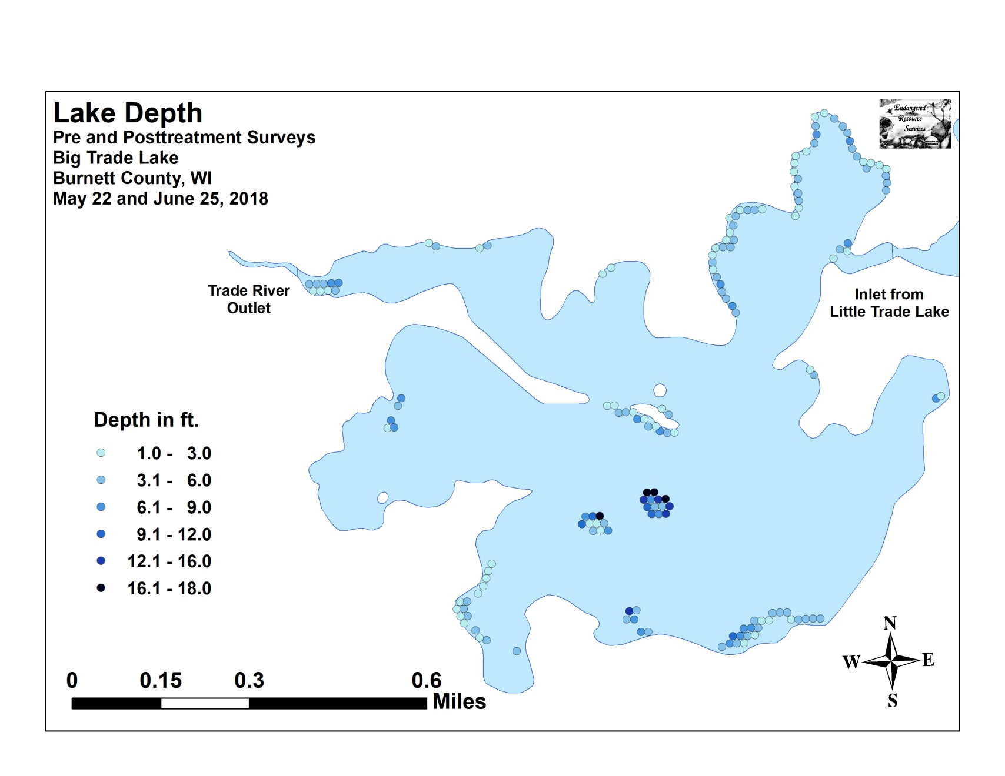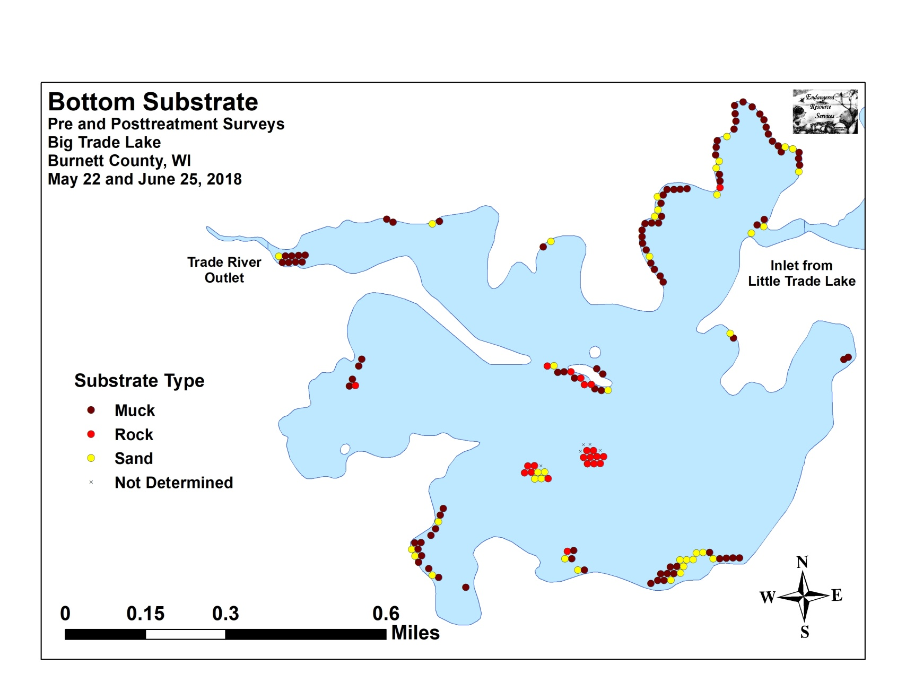

Appendix IV: Pre/Post Littoral Zone, Native Species Richness and
Total Rake Fullness
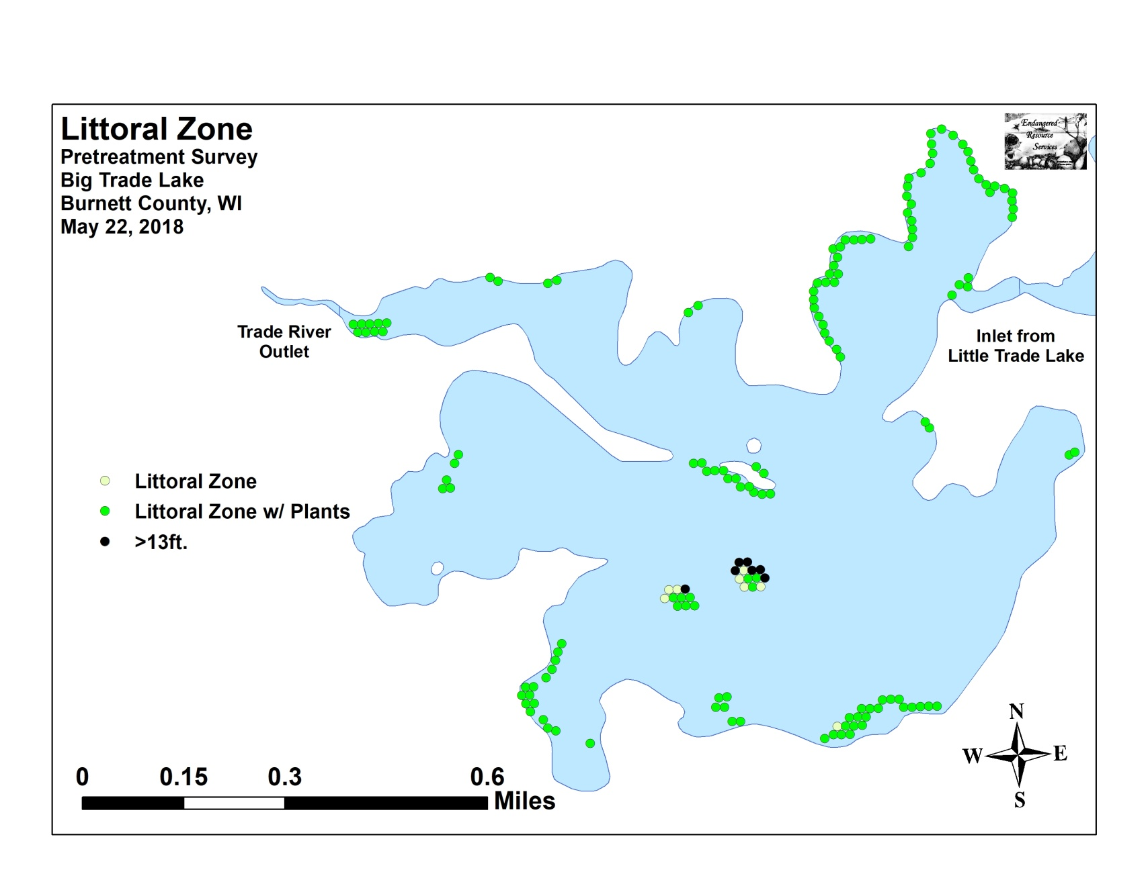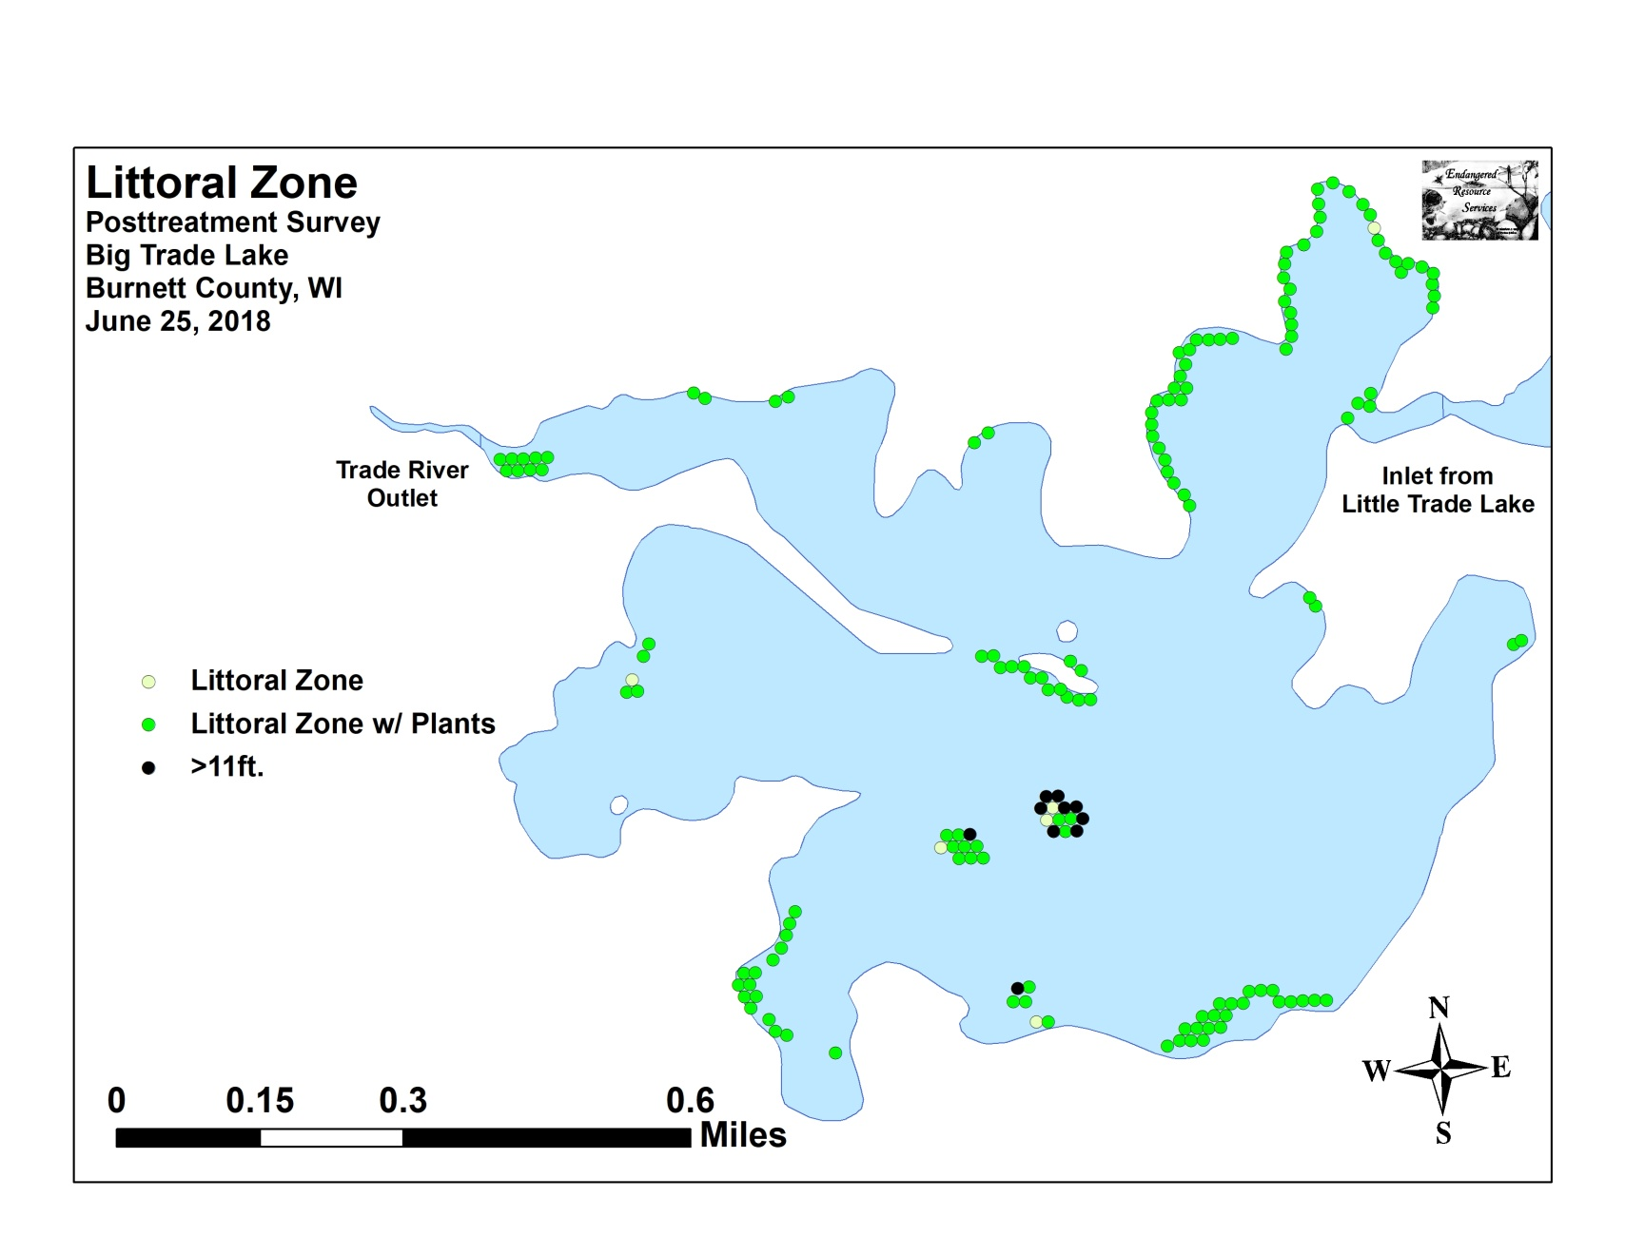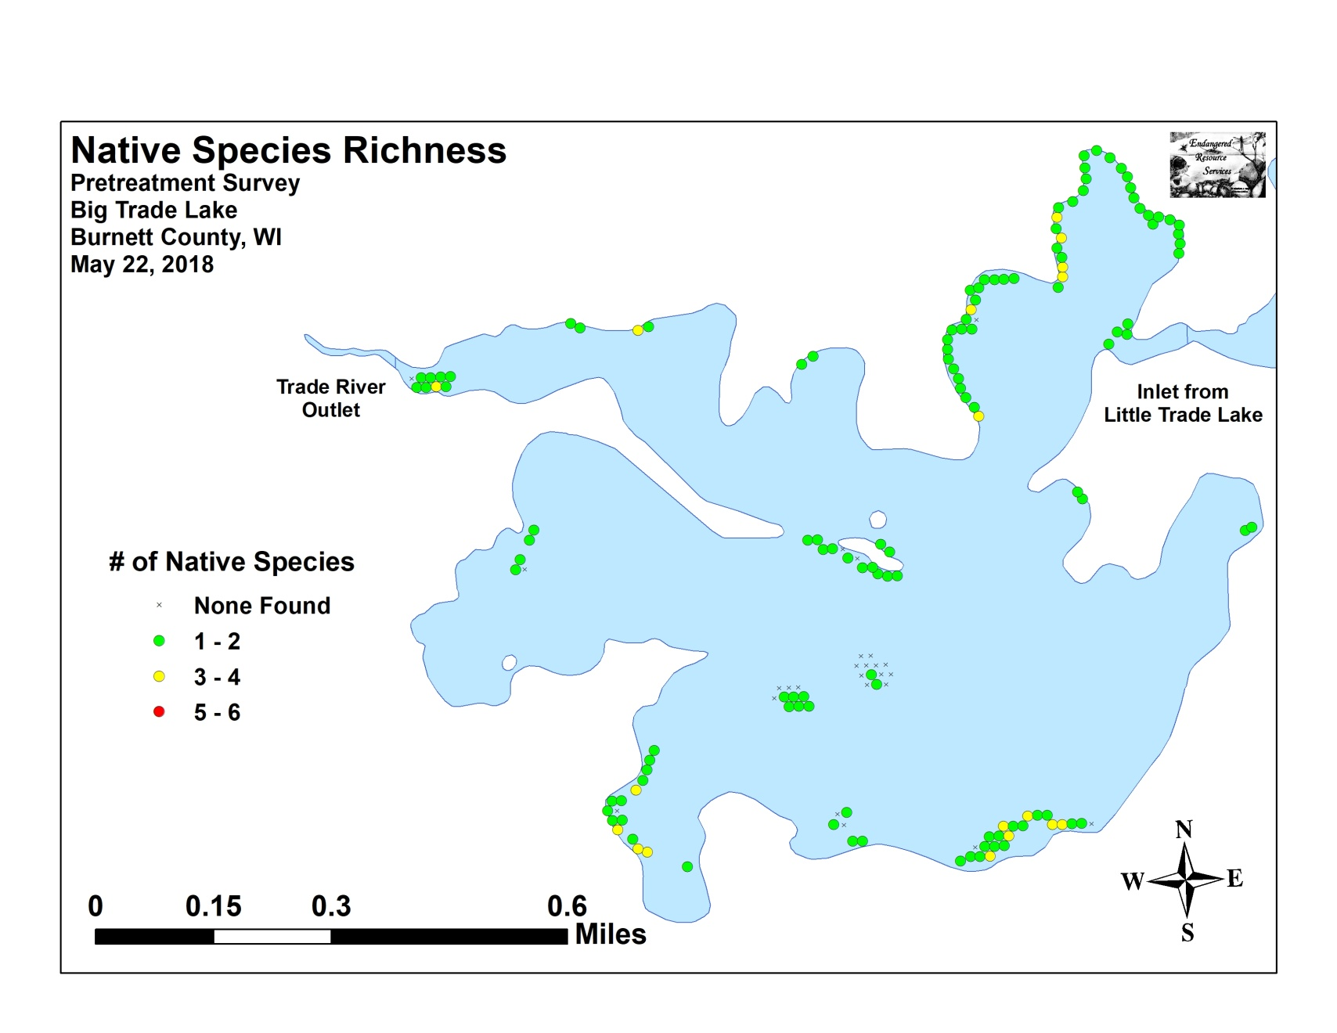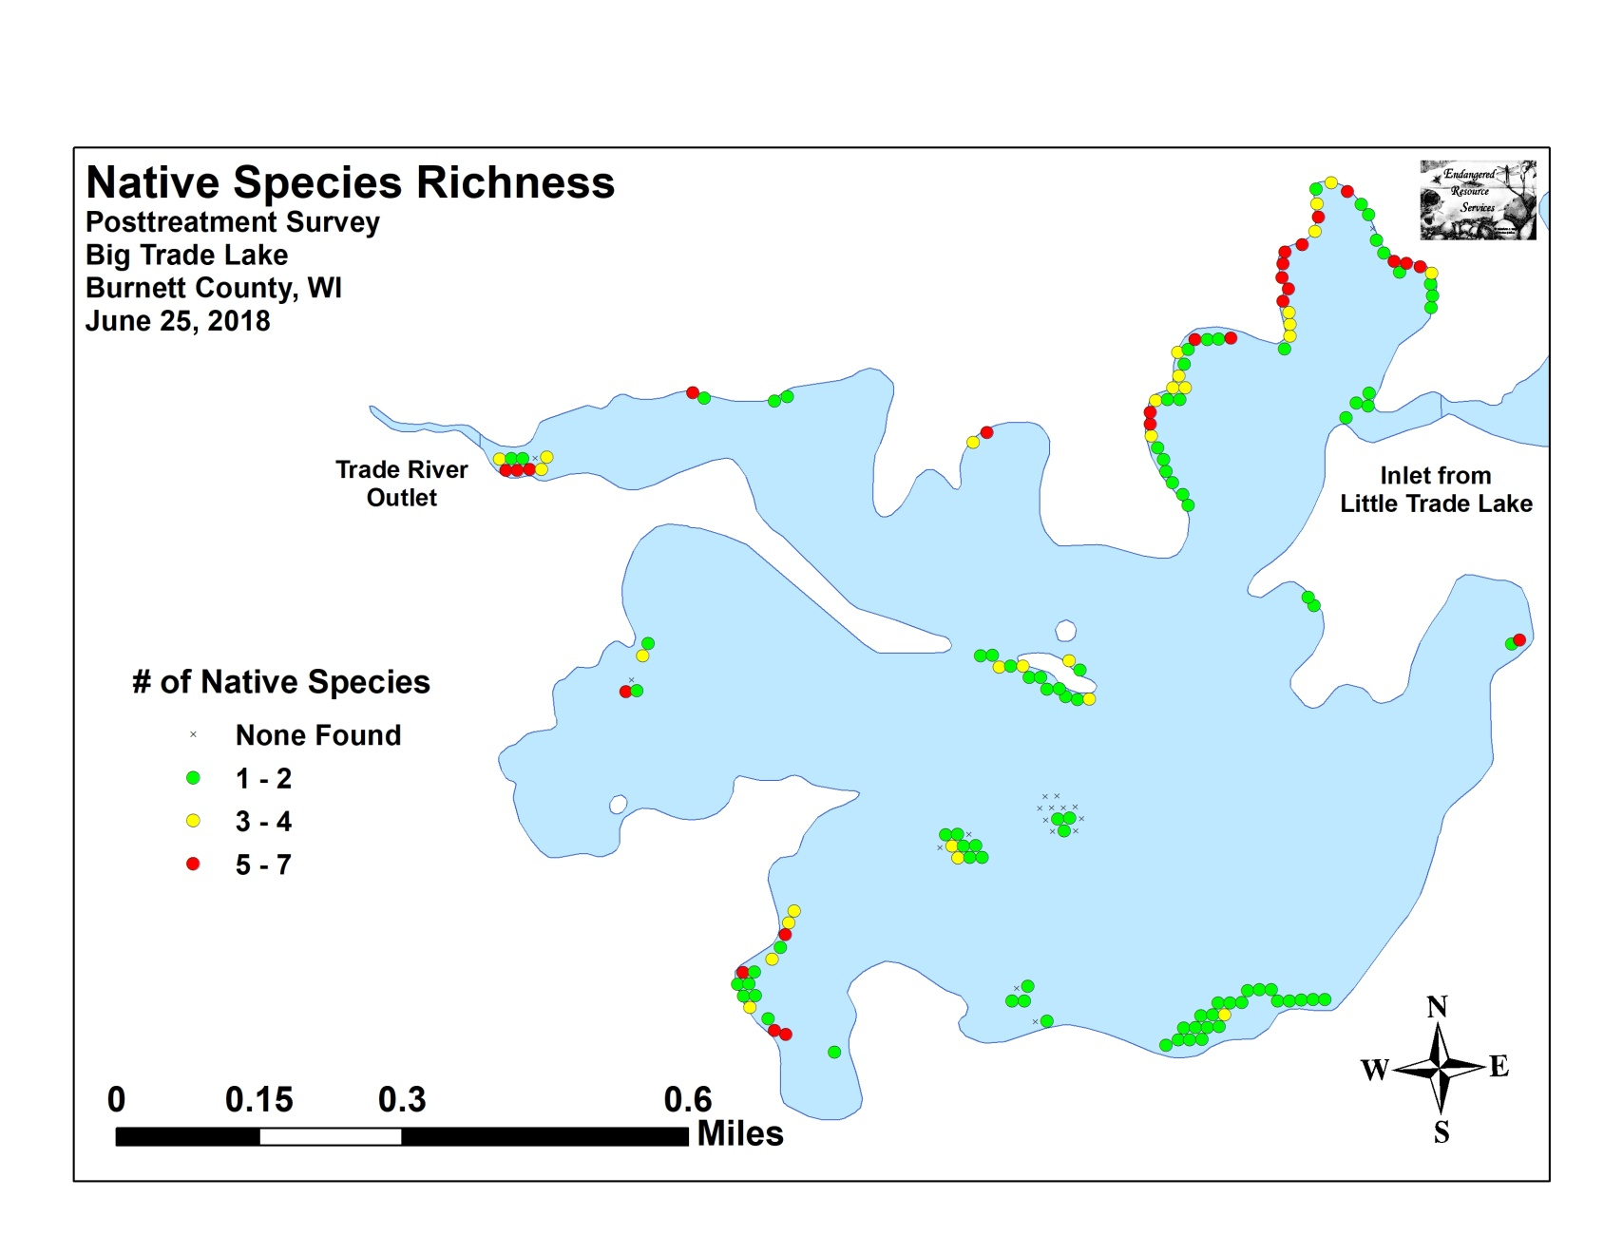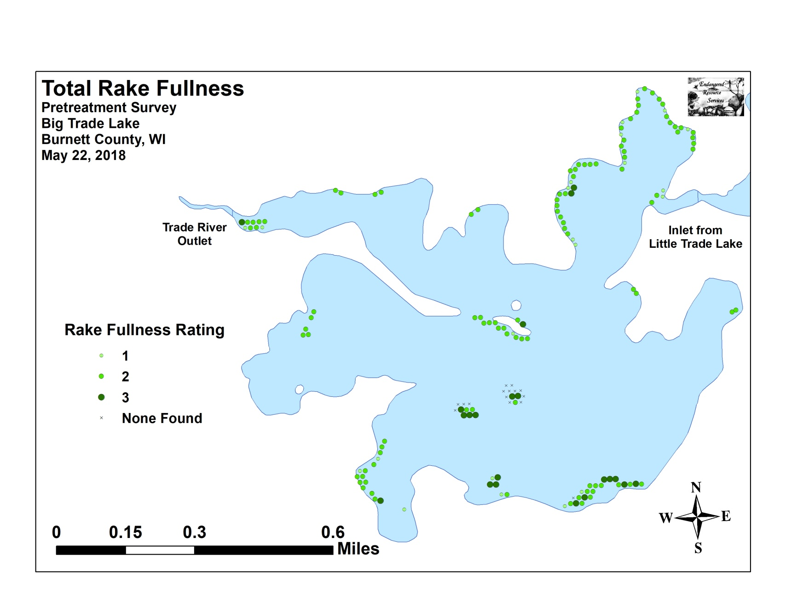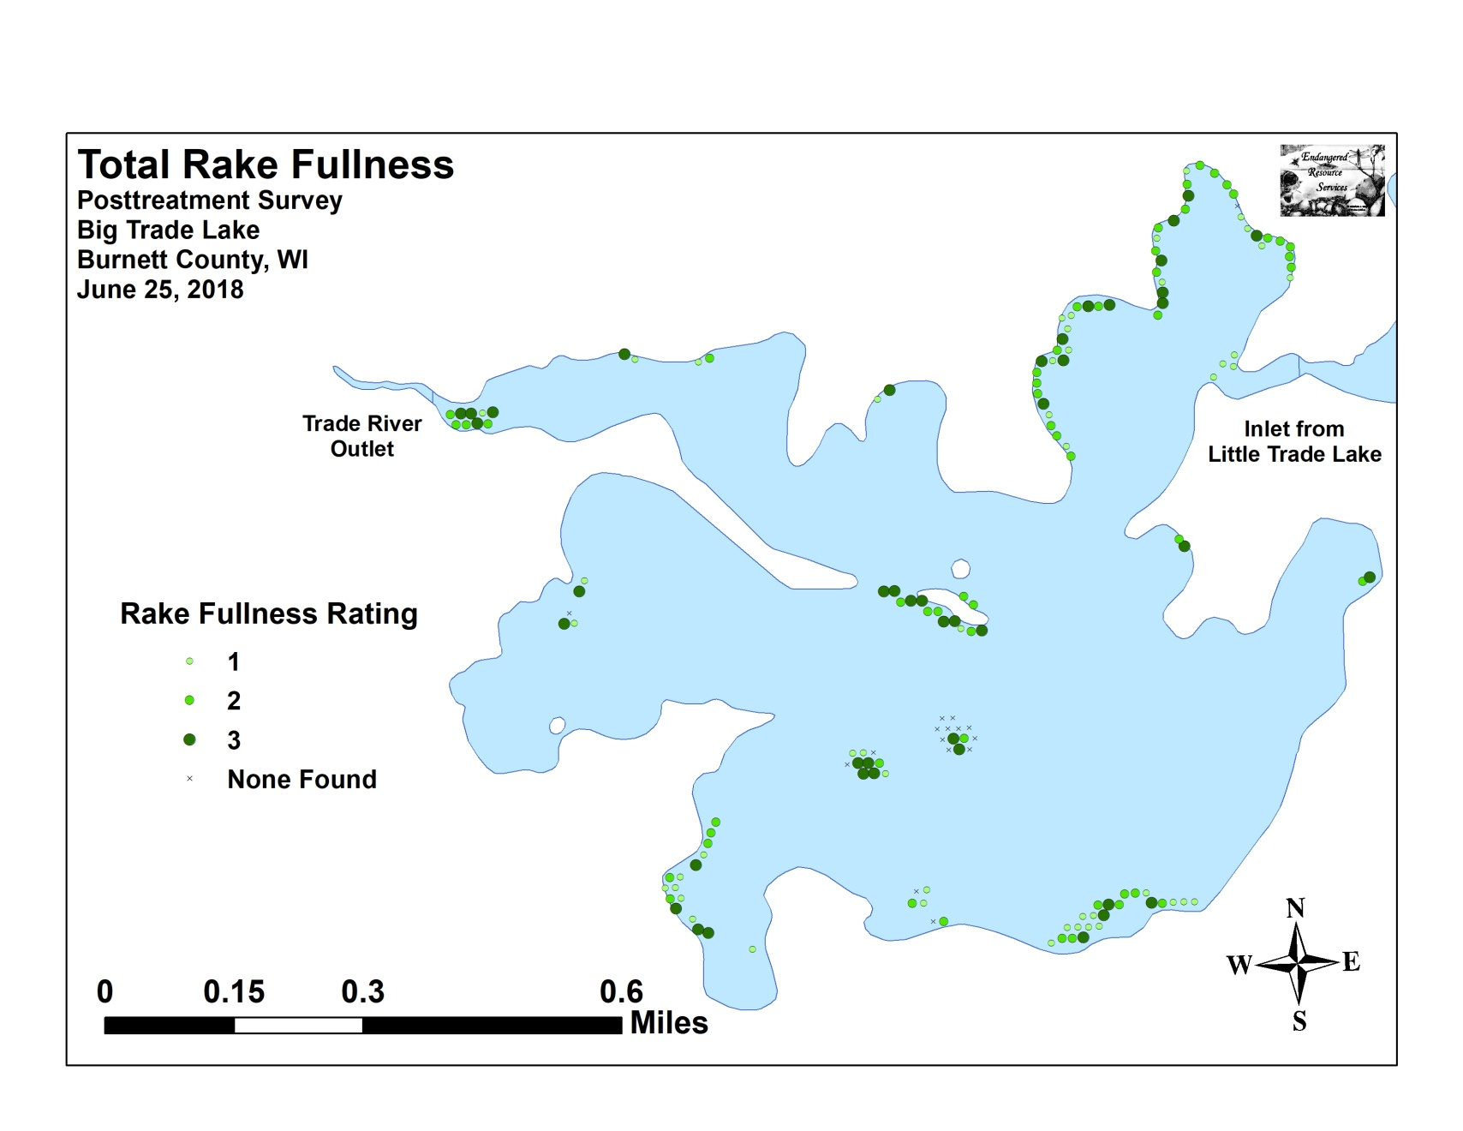

Appendix V: CLP and EWM Pre/Post Density and Distribution

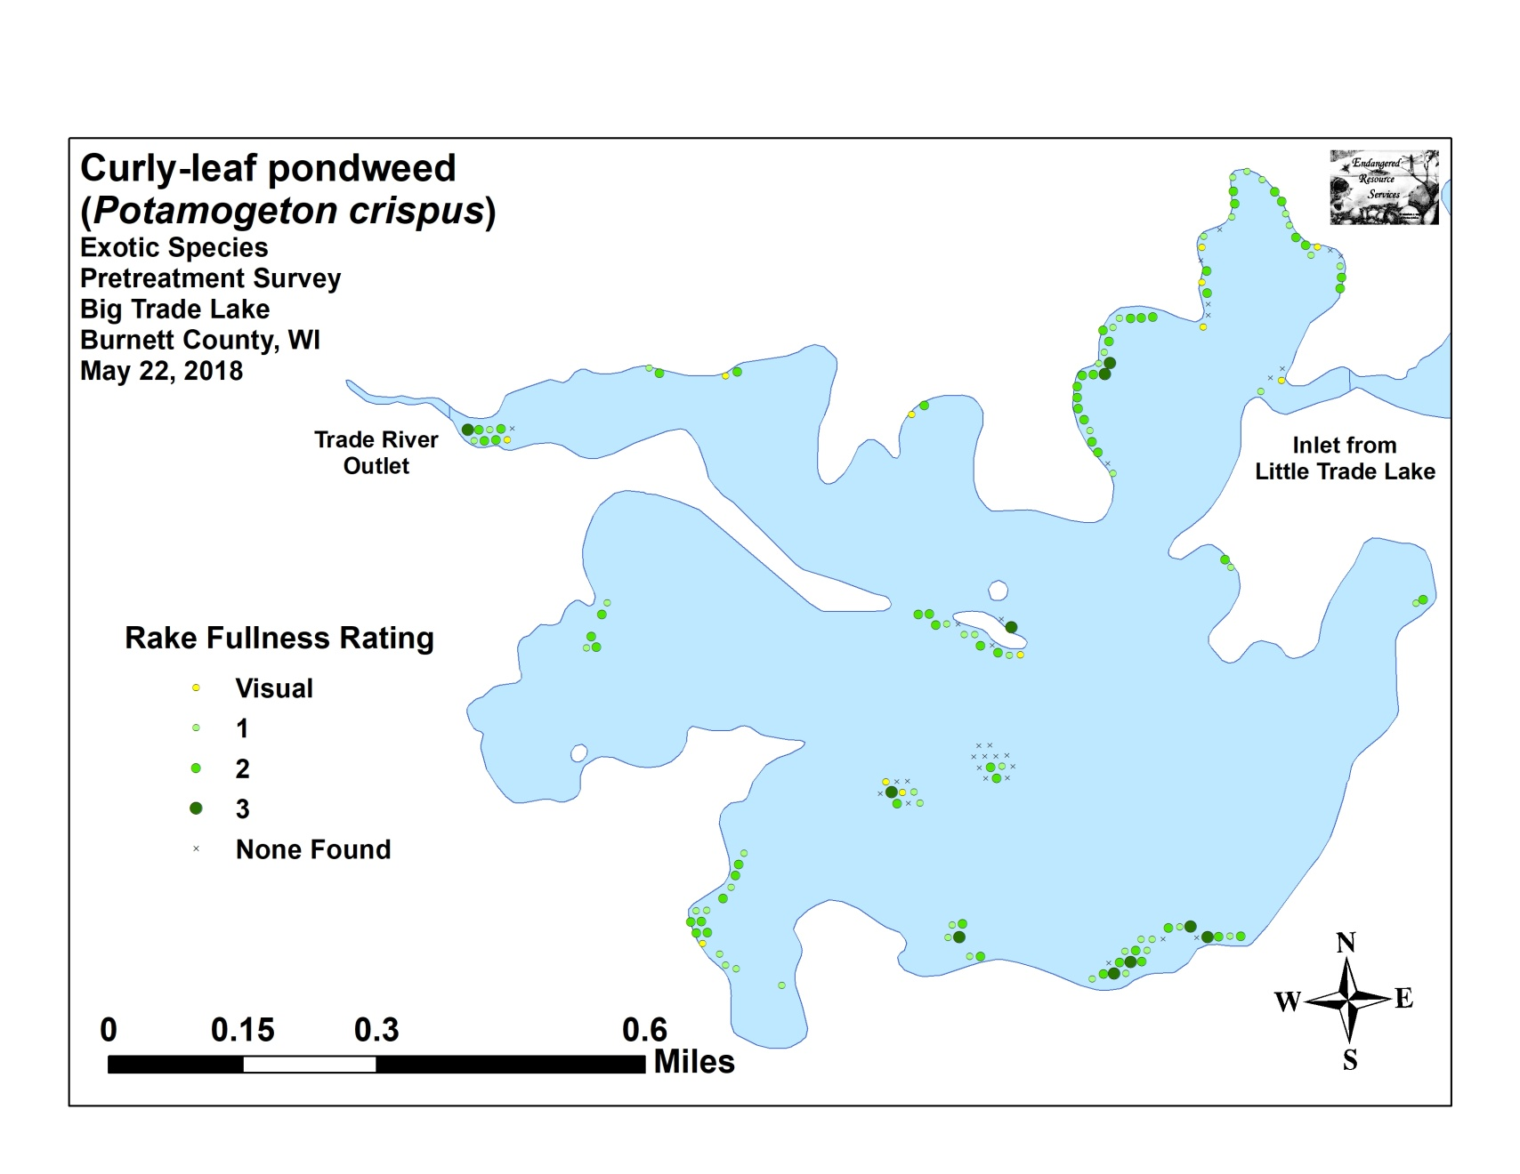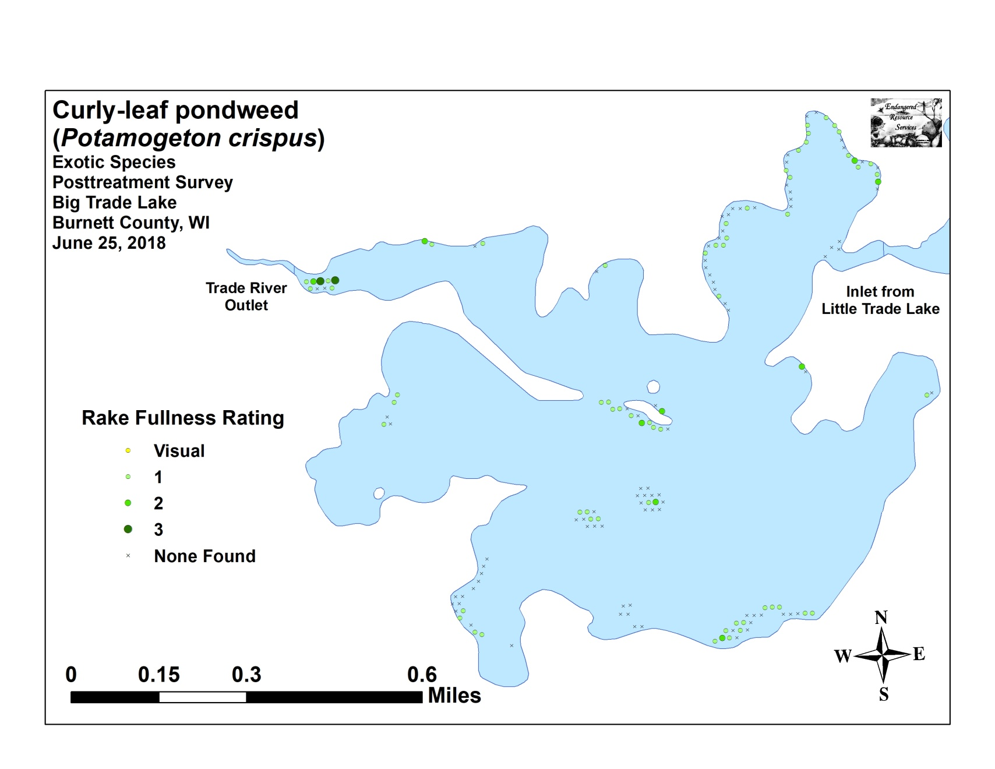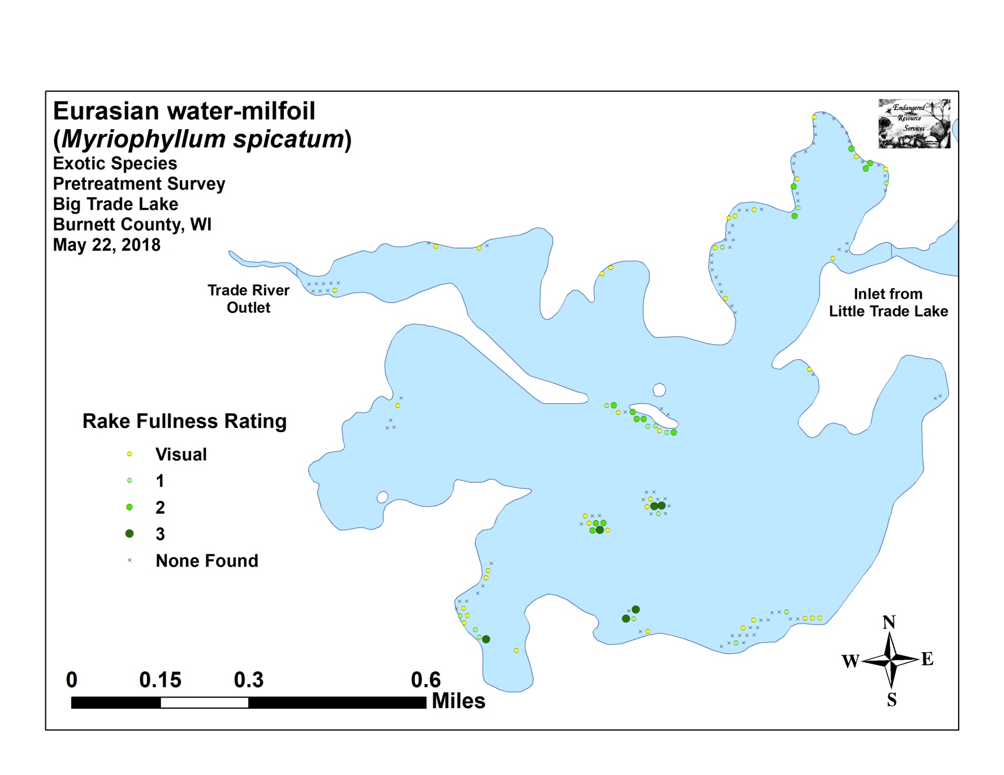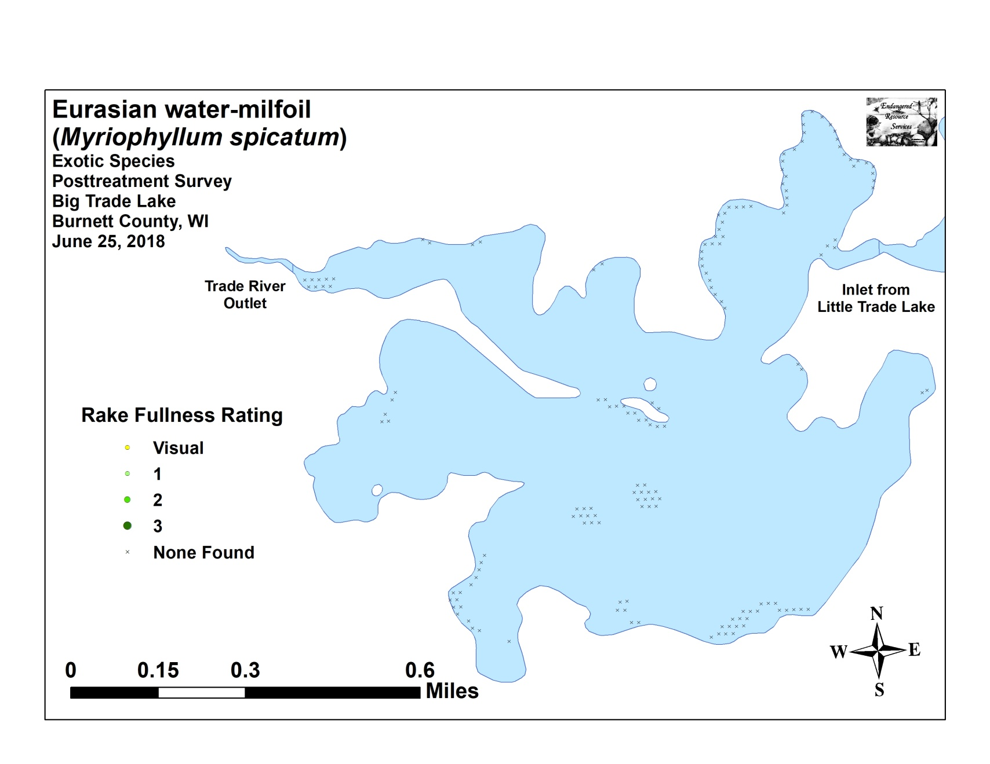

Appendix VI: Pretreatment Native Species Density and Distribution
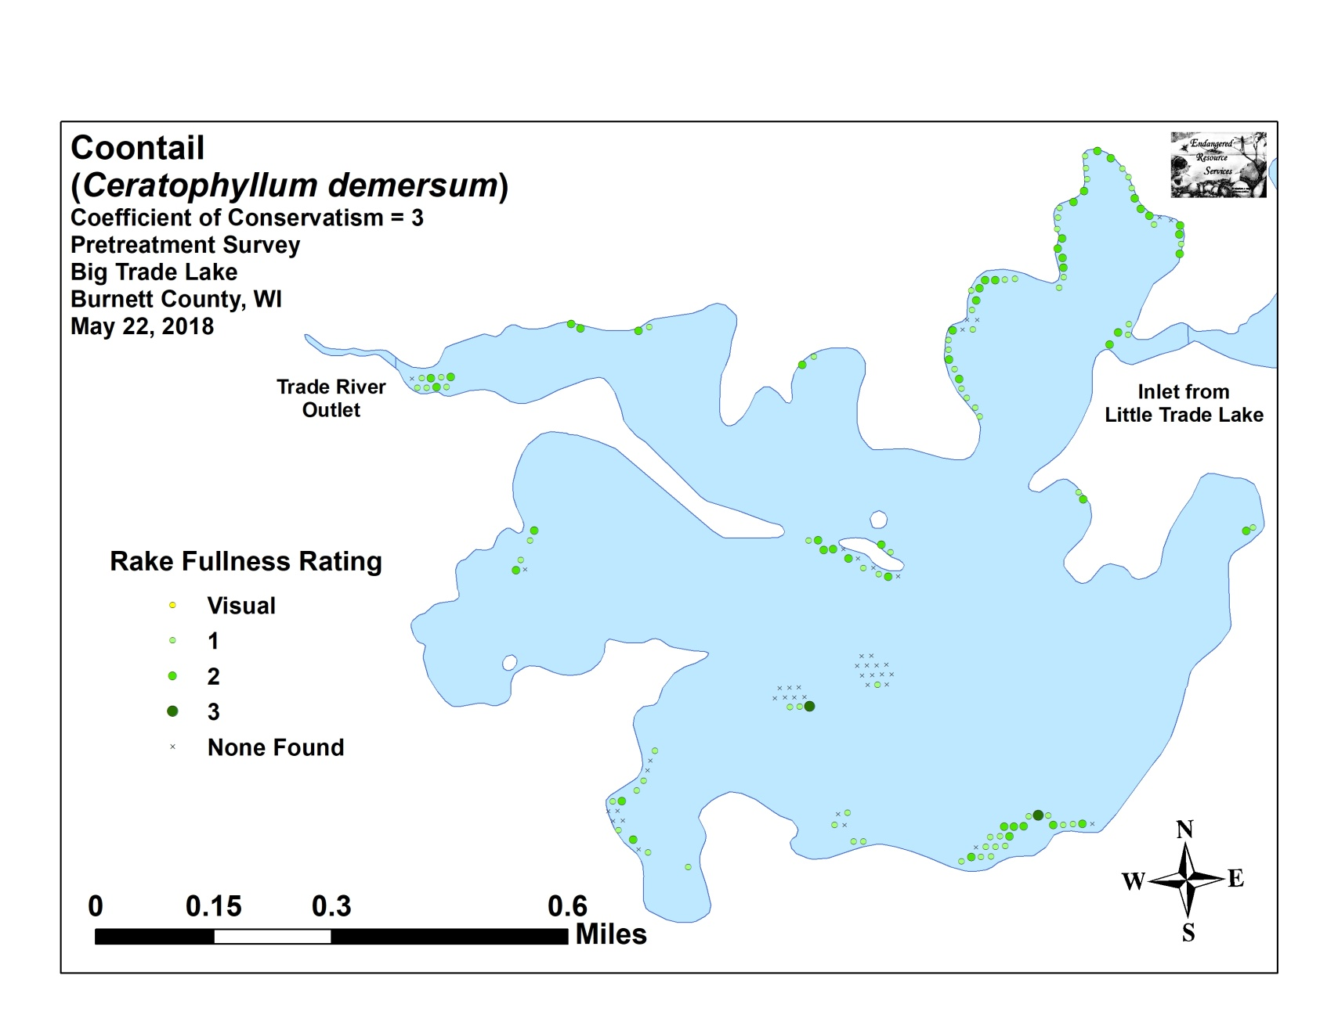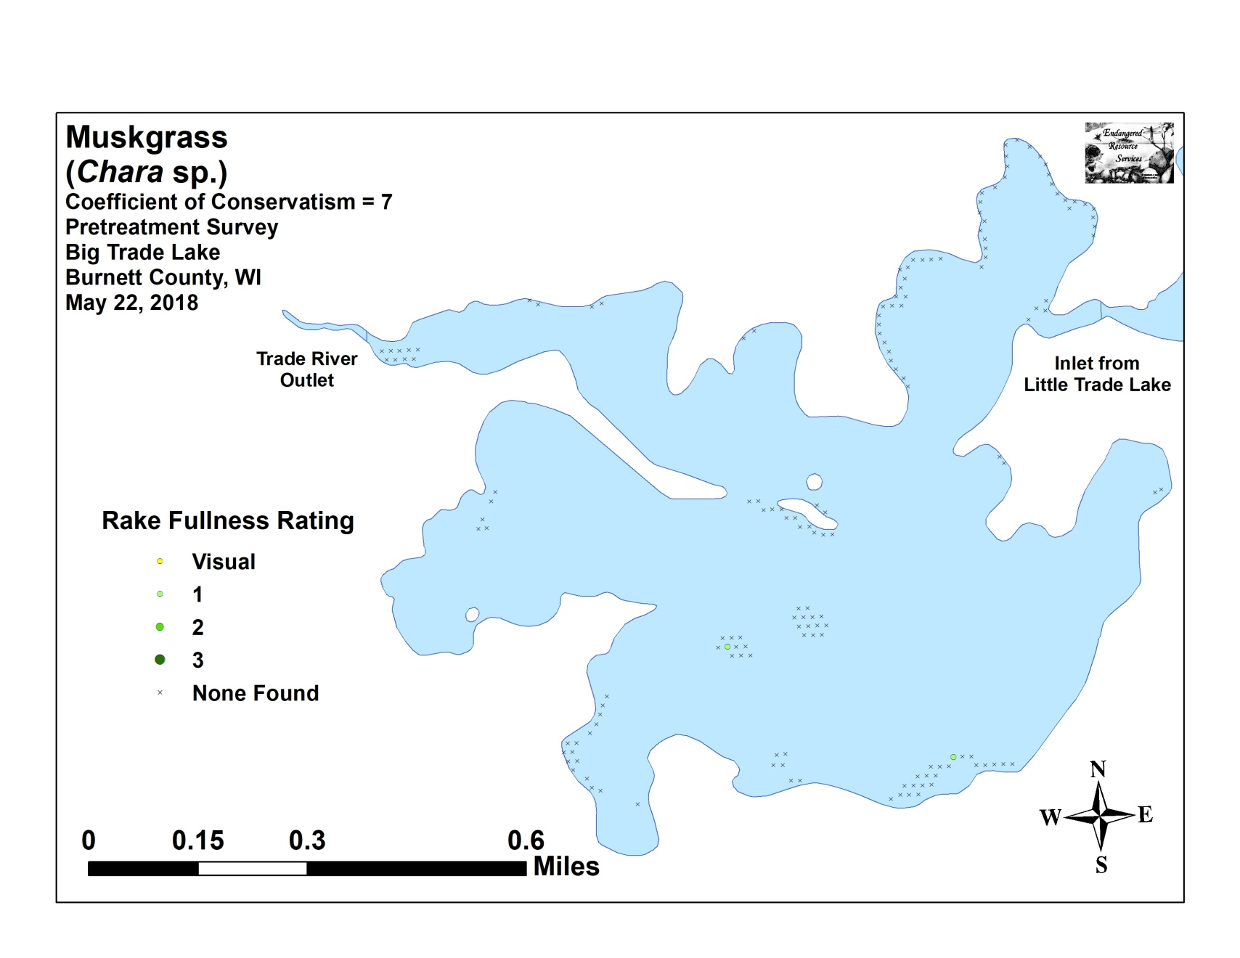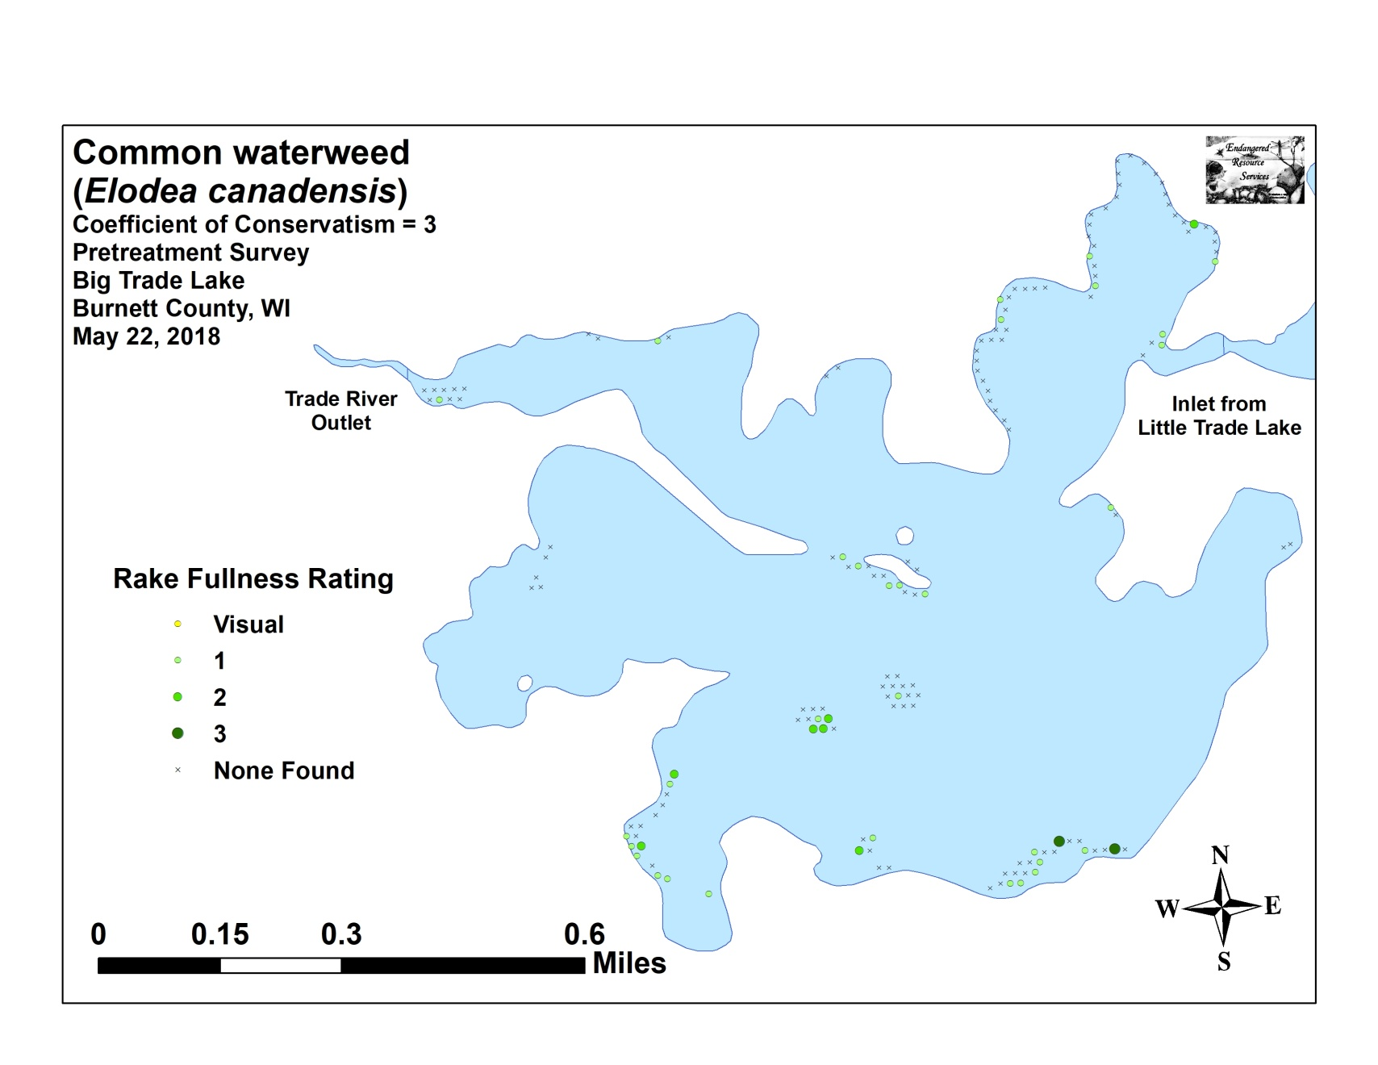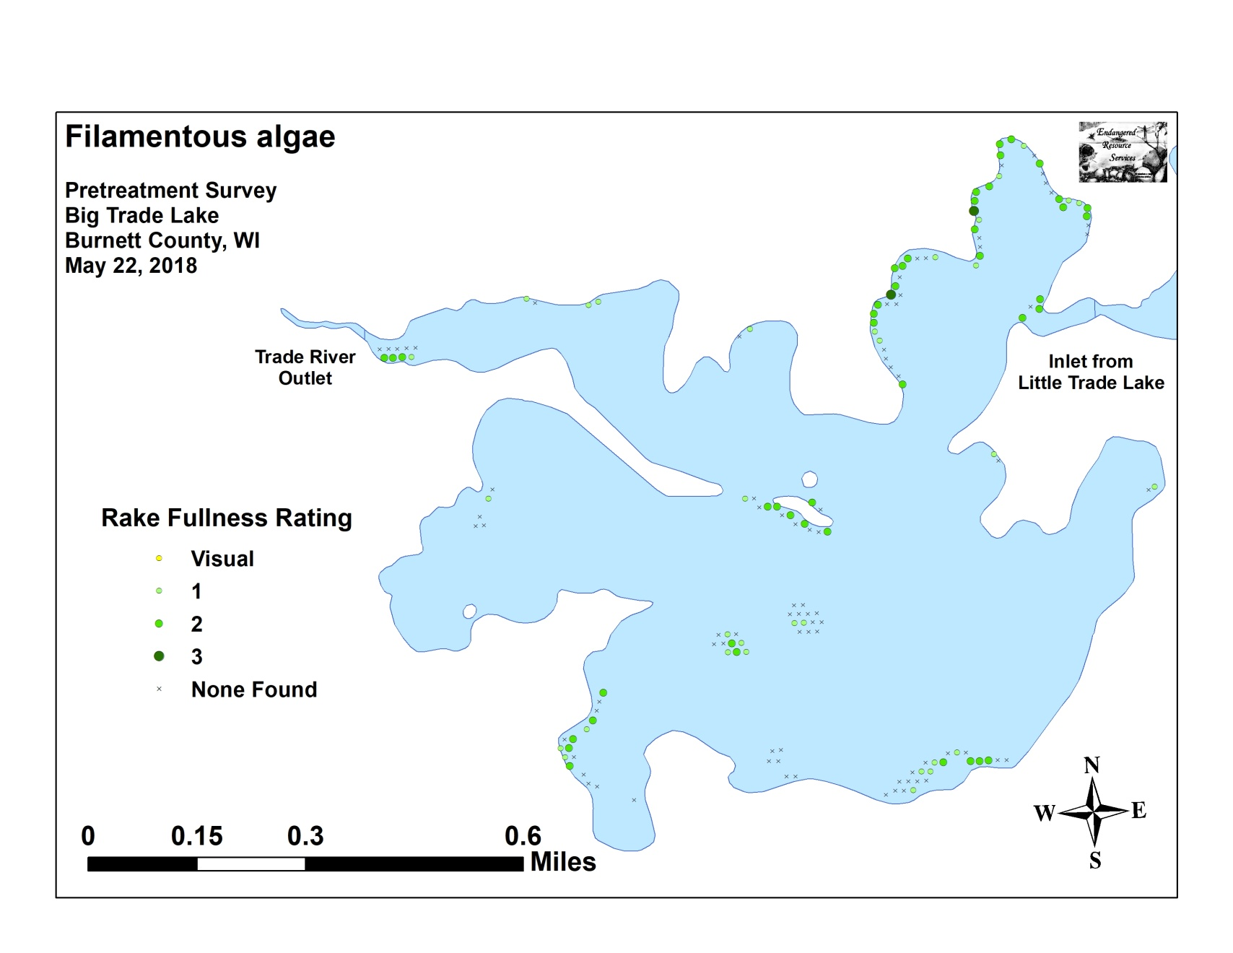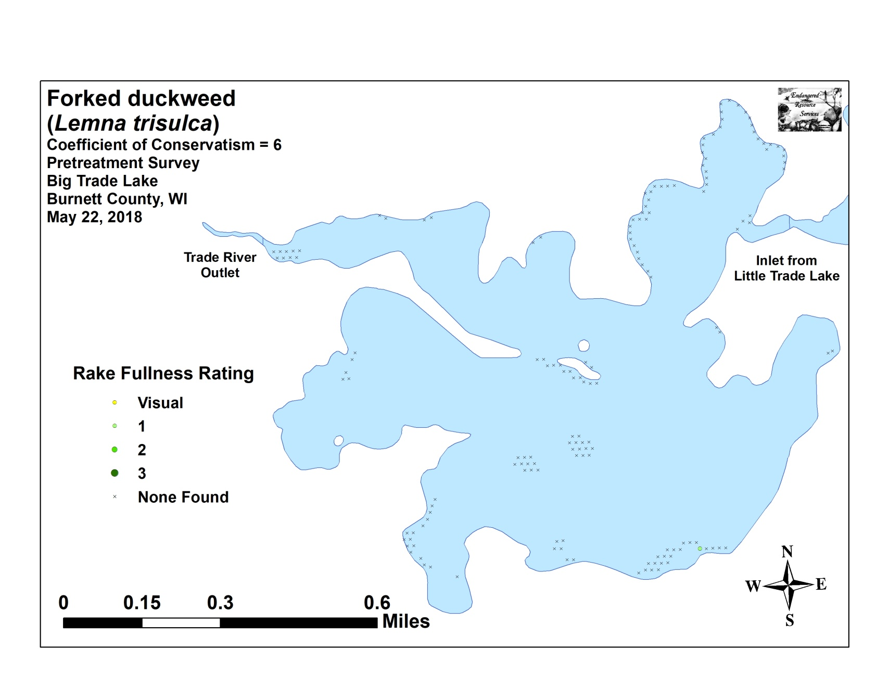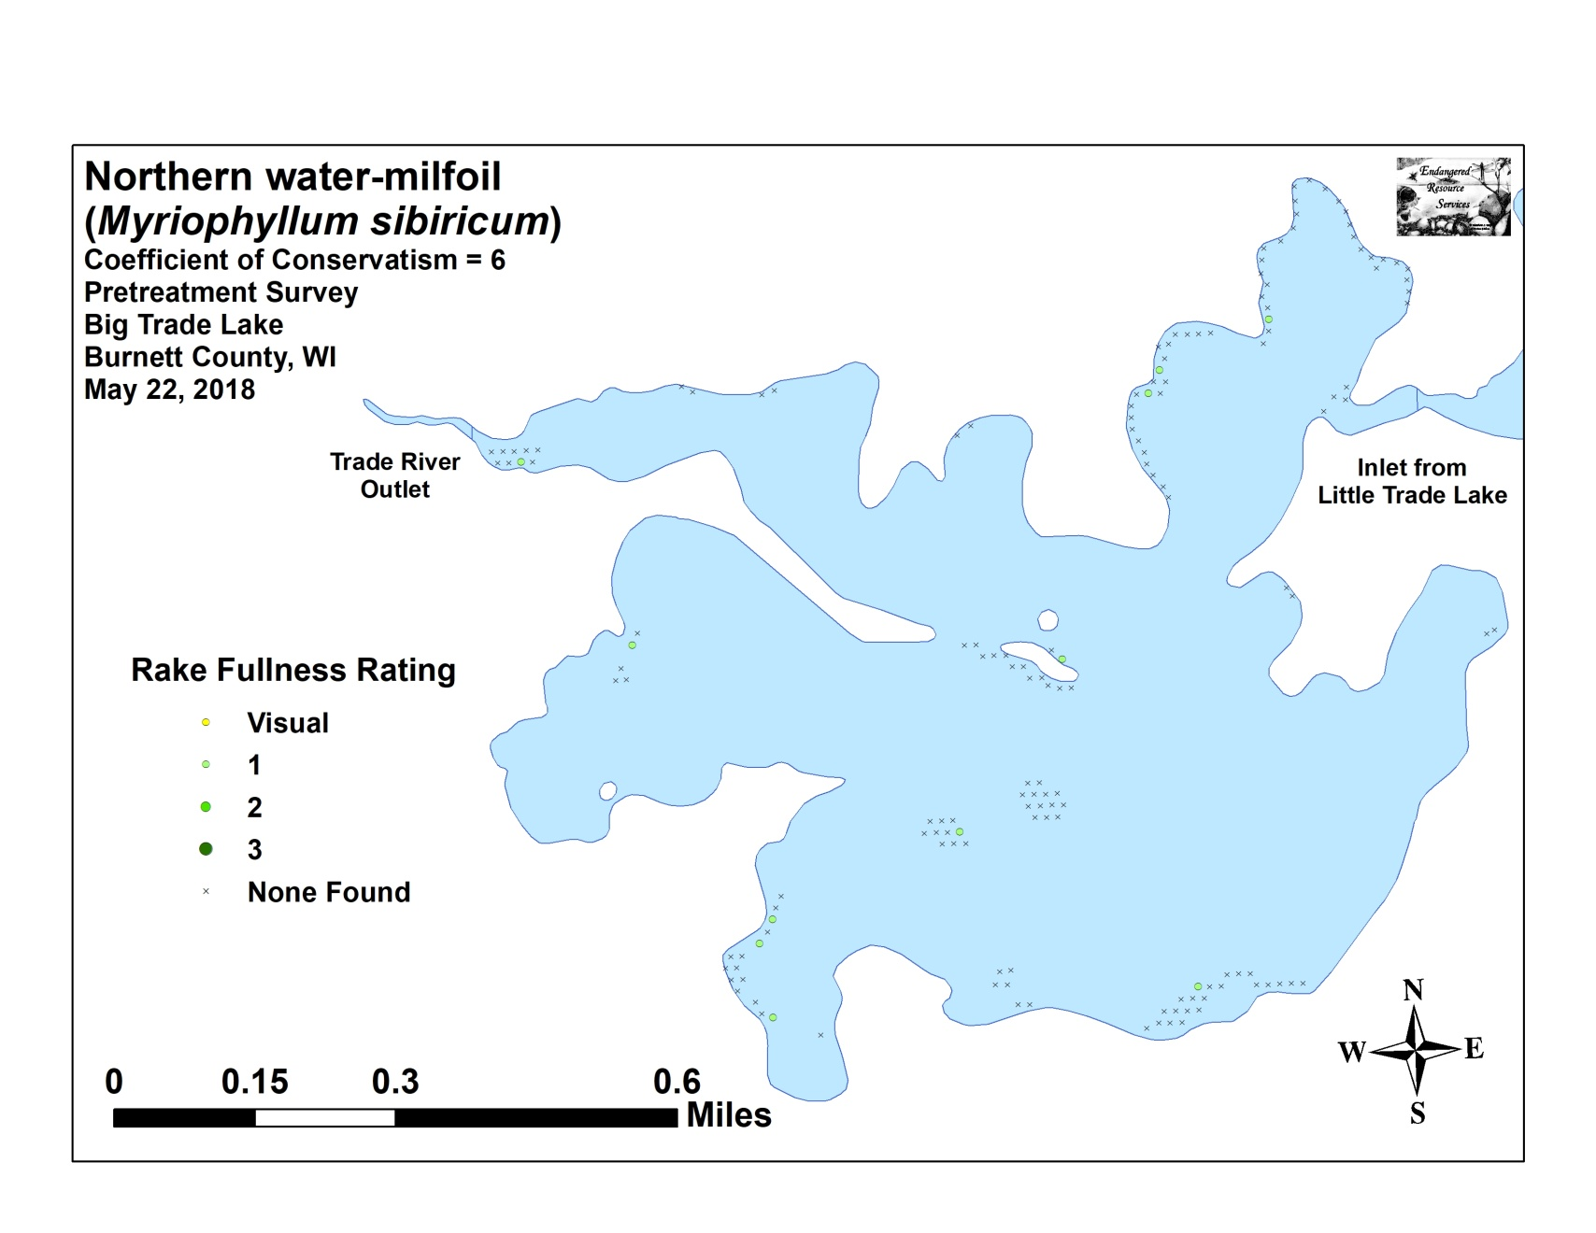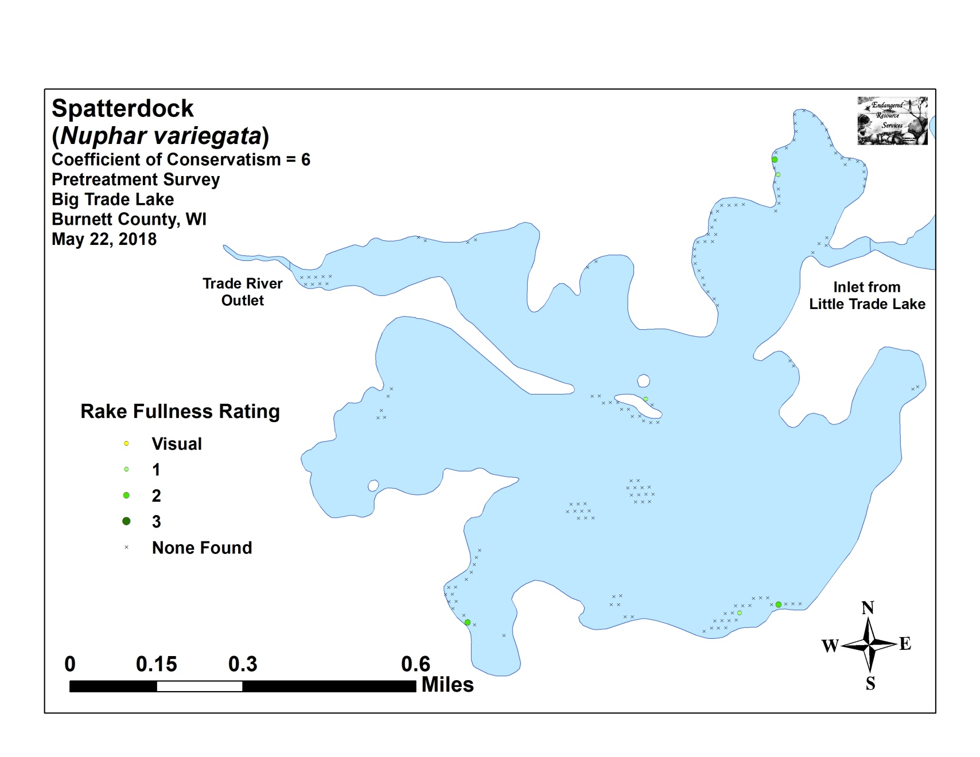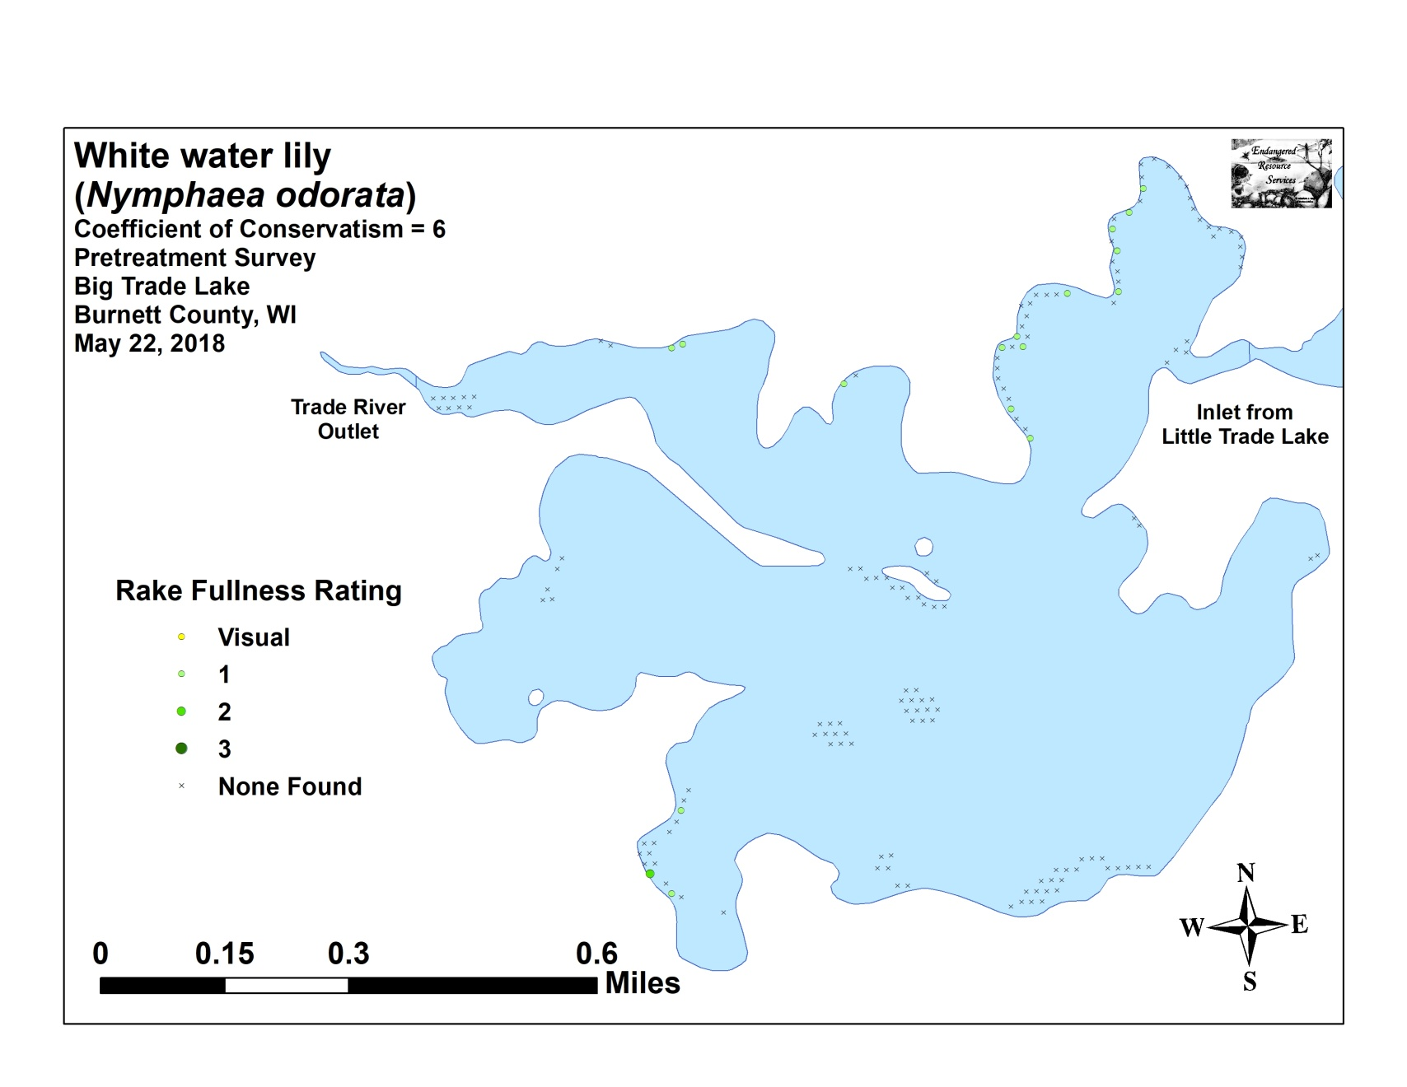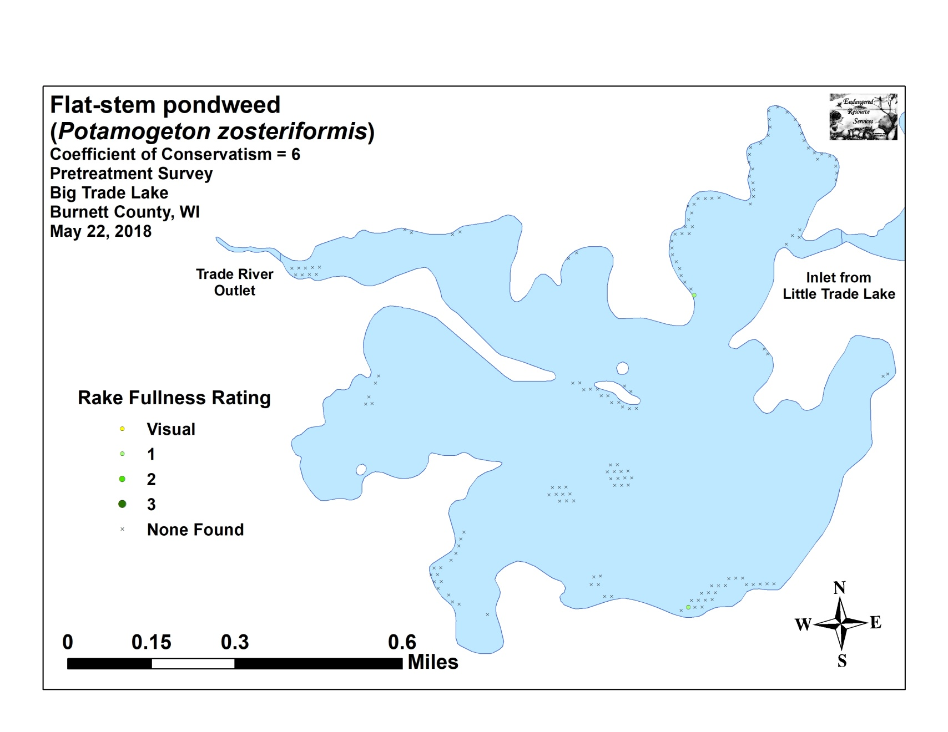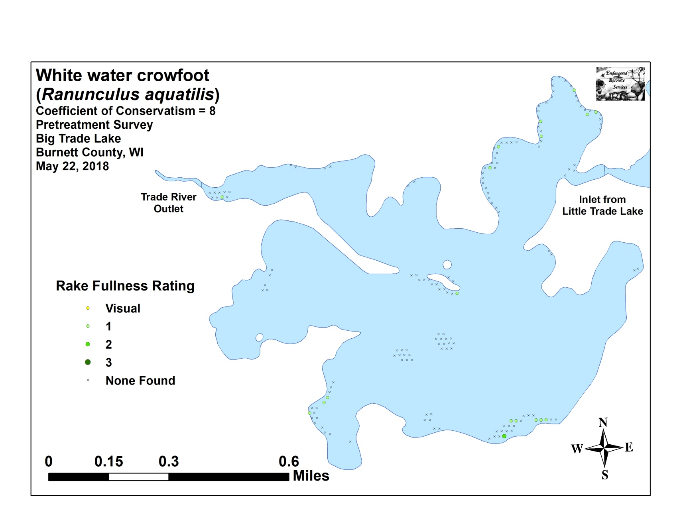

Appendix VII: Posttreatment Native Species Density and Distribution
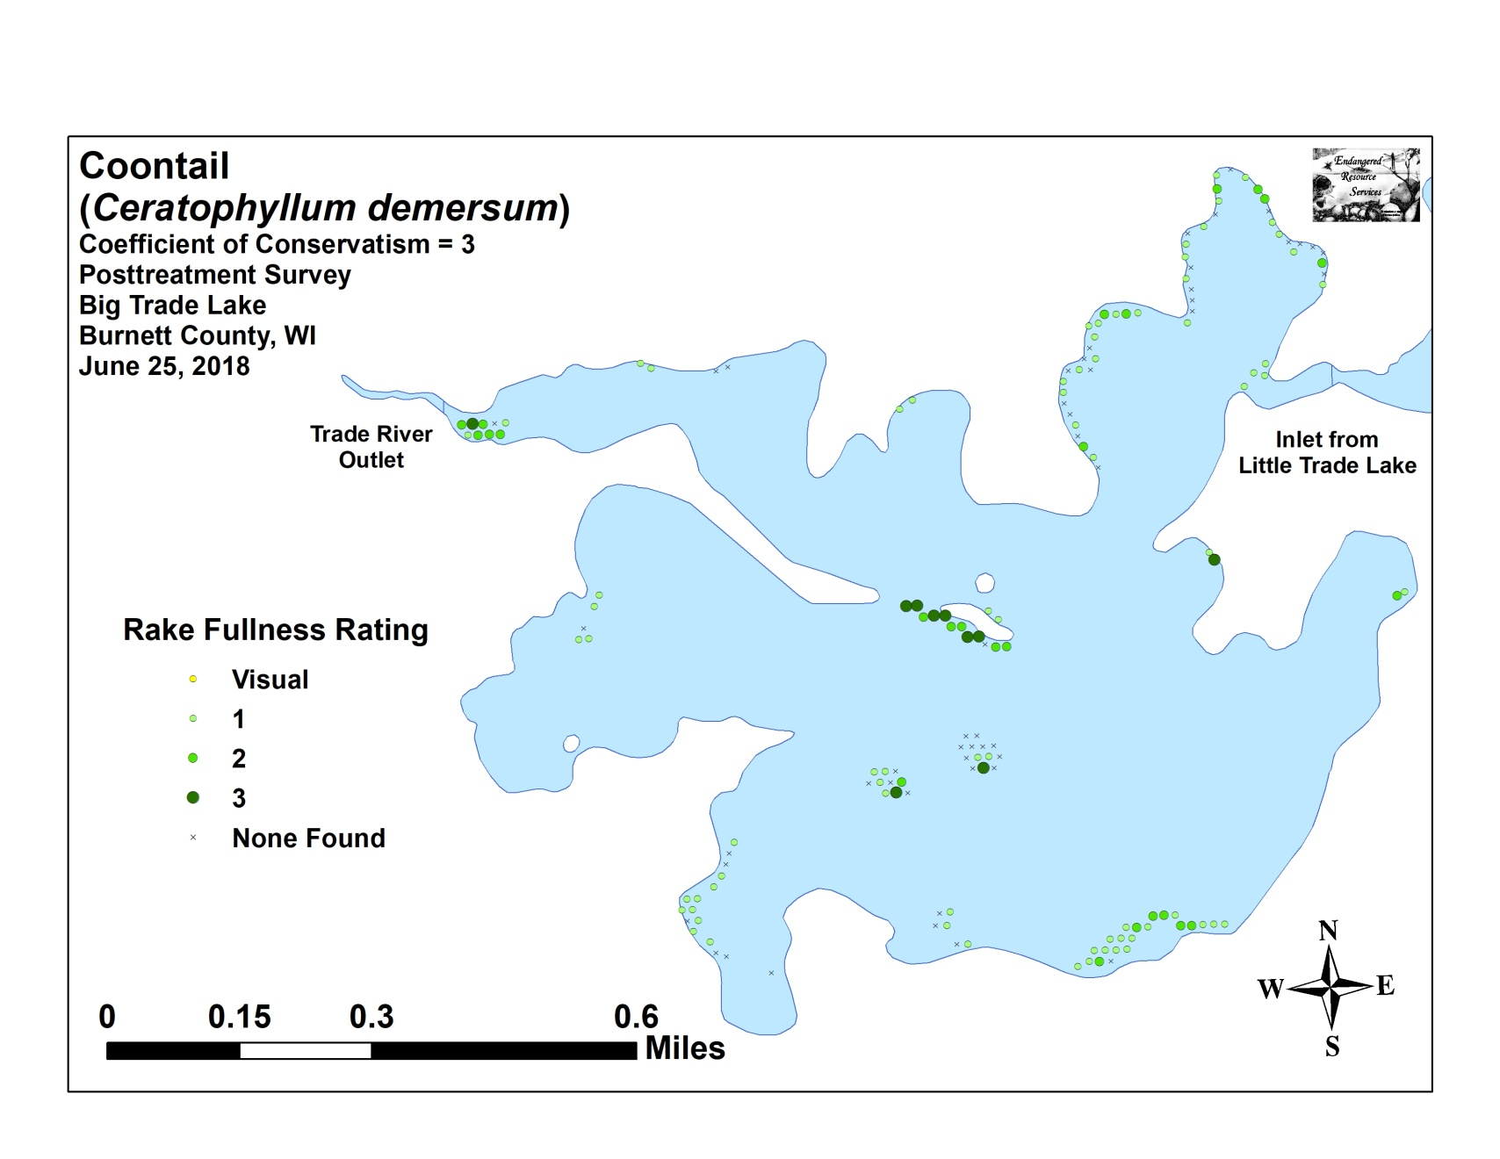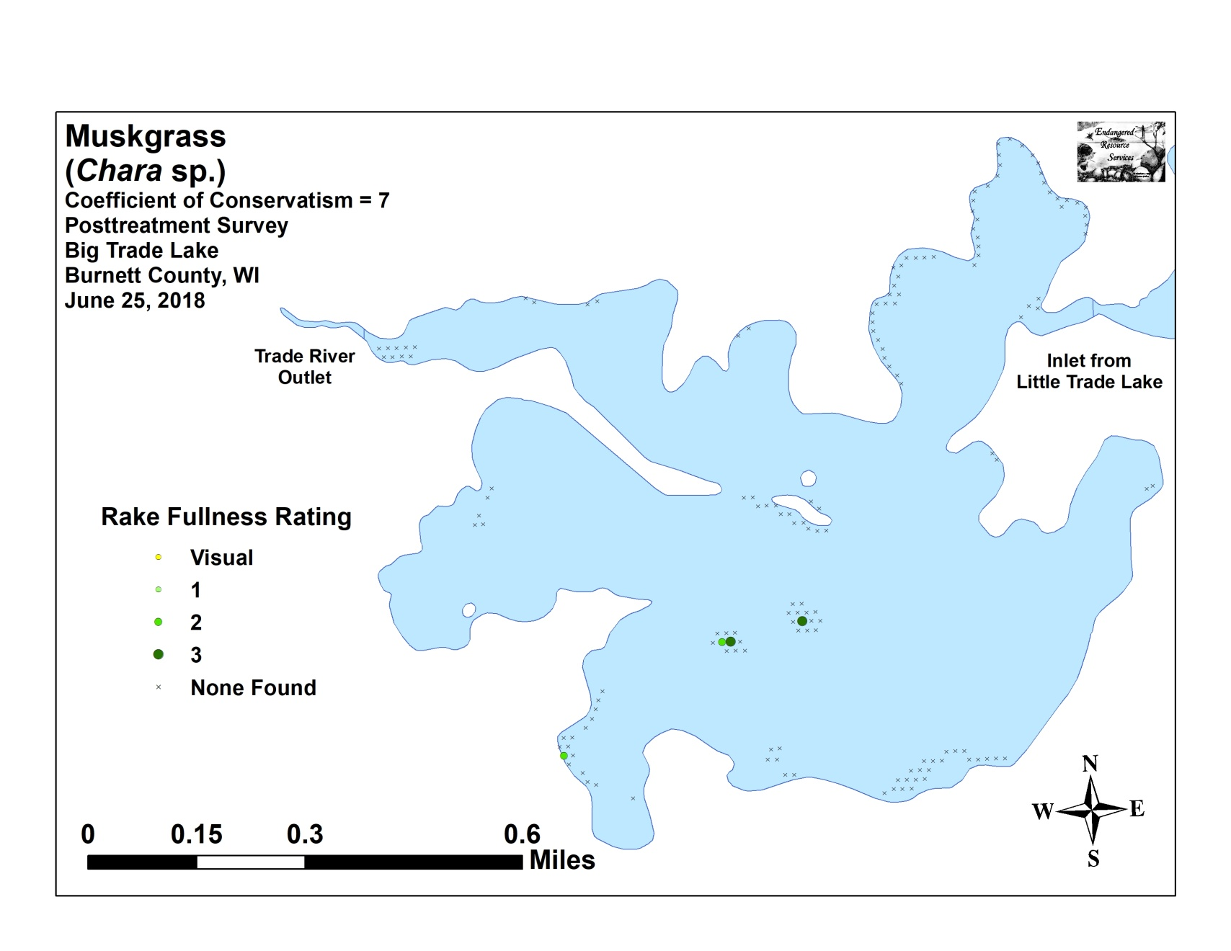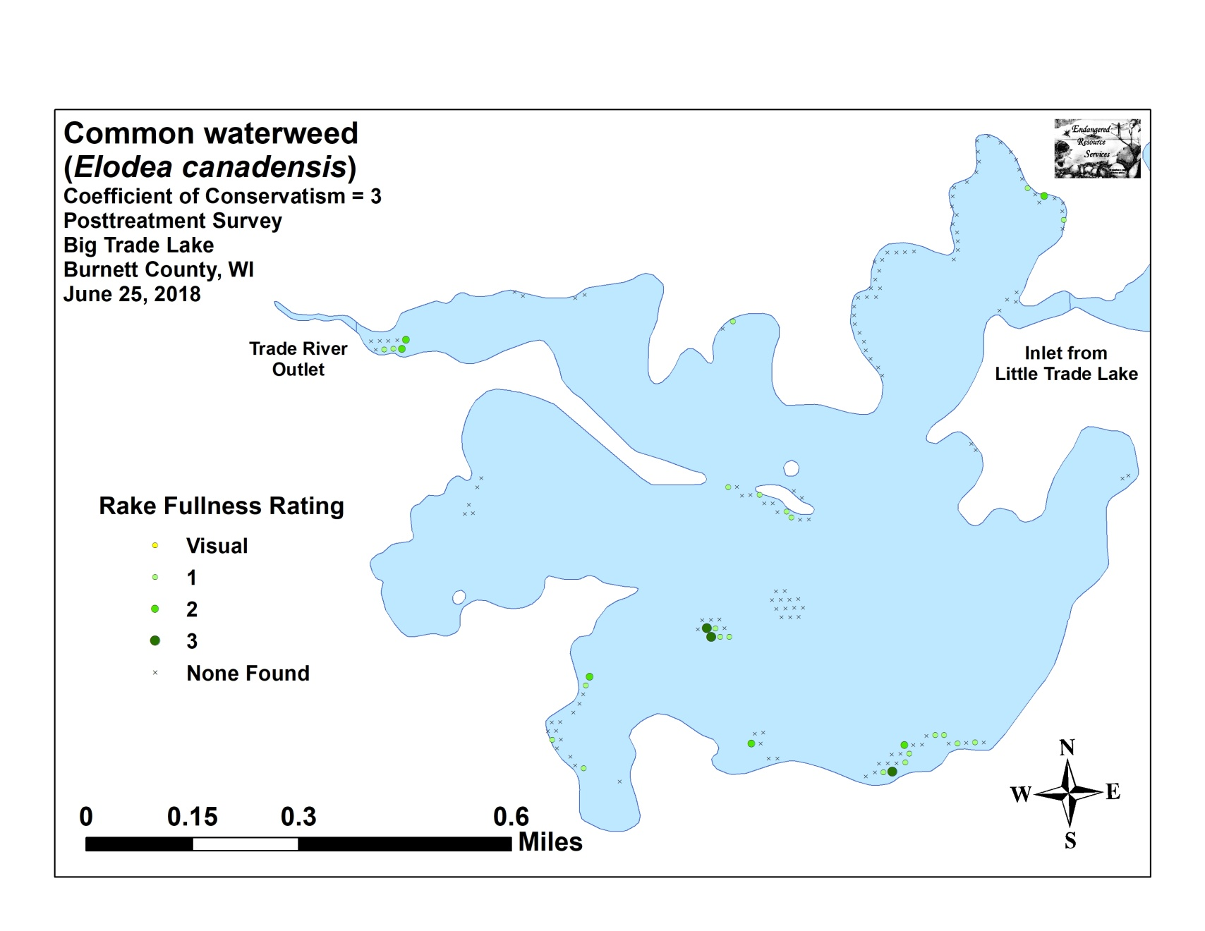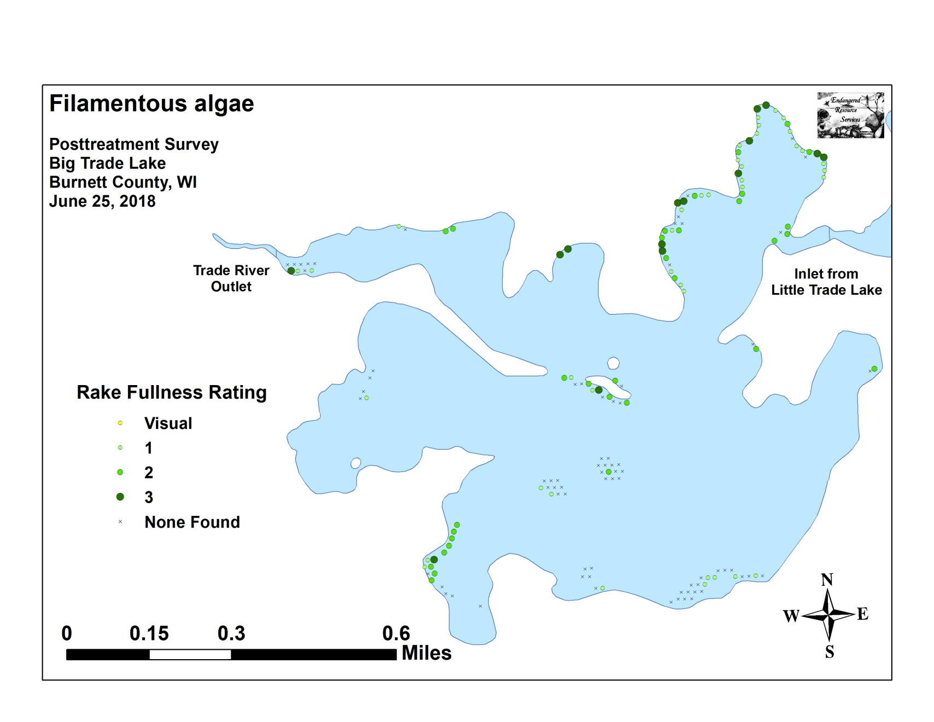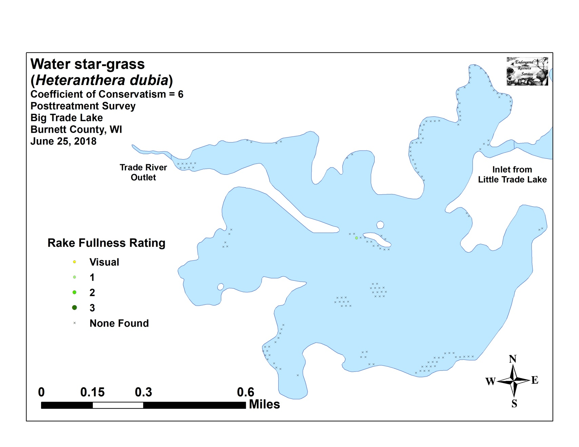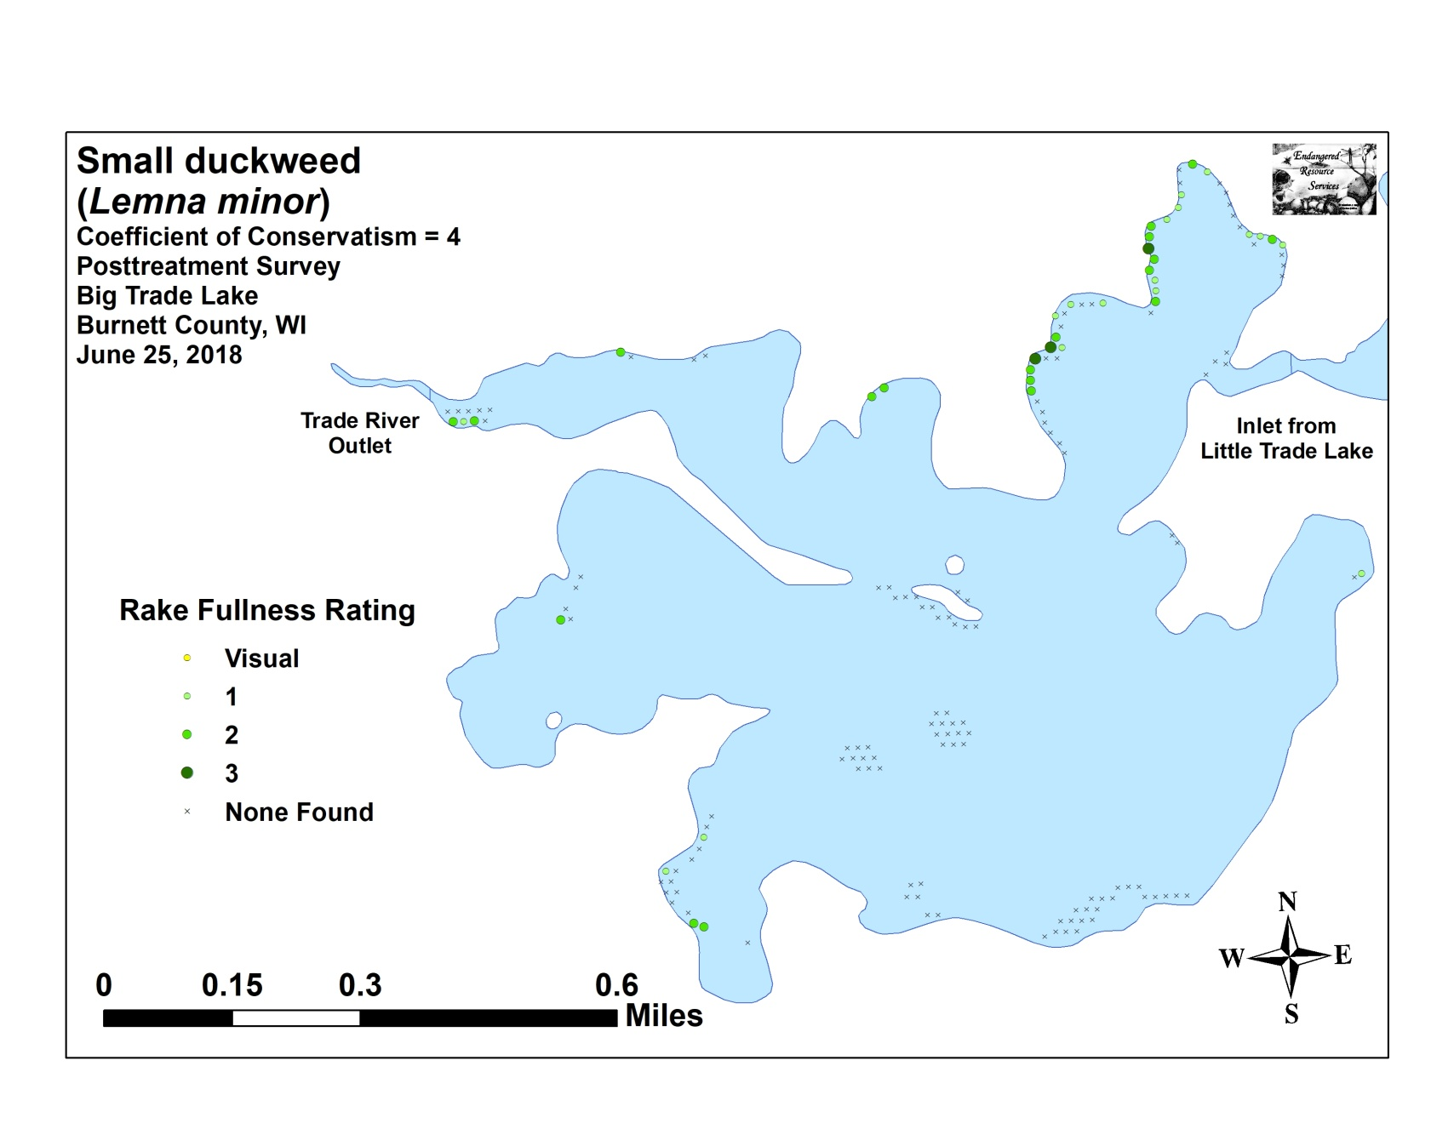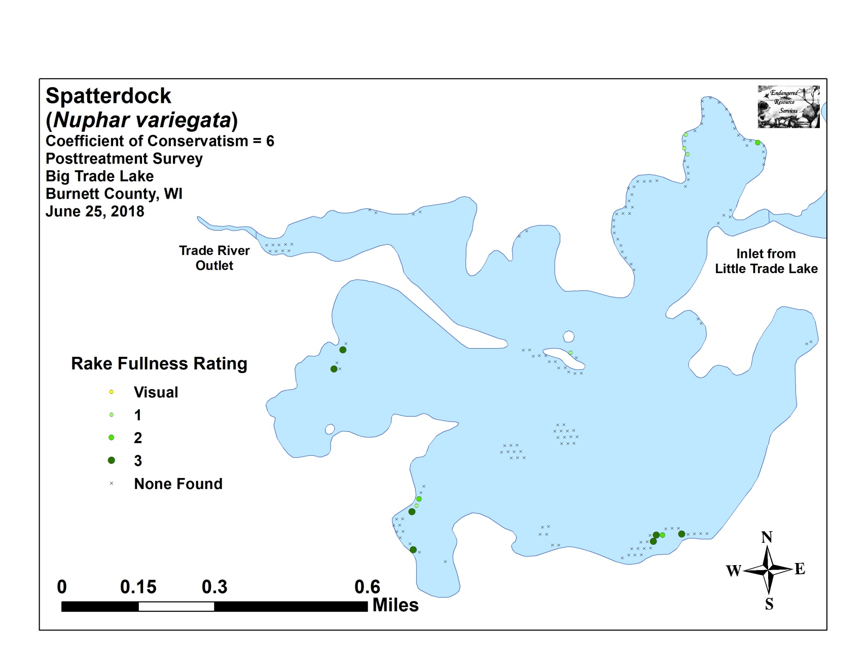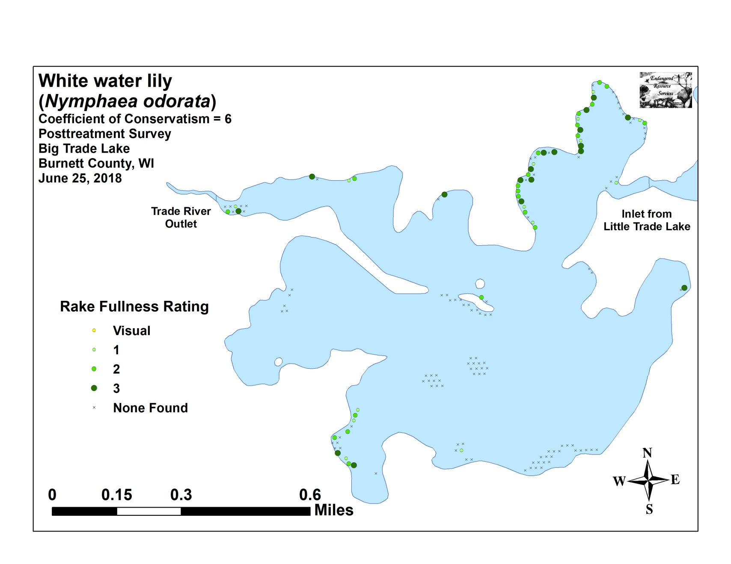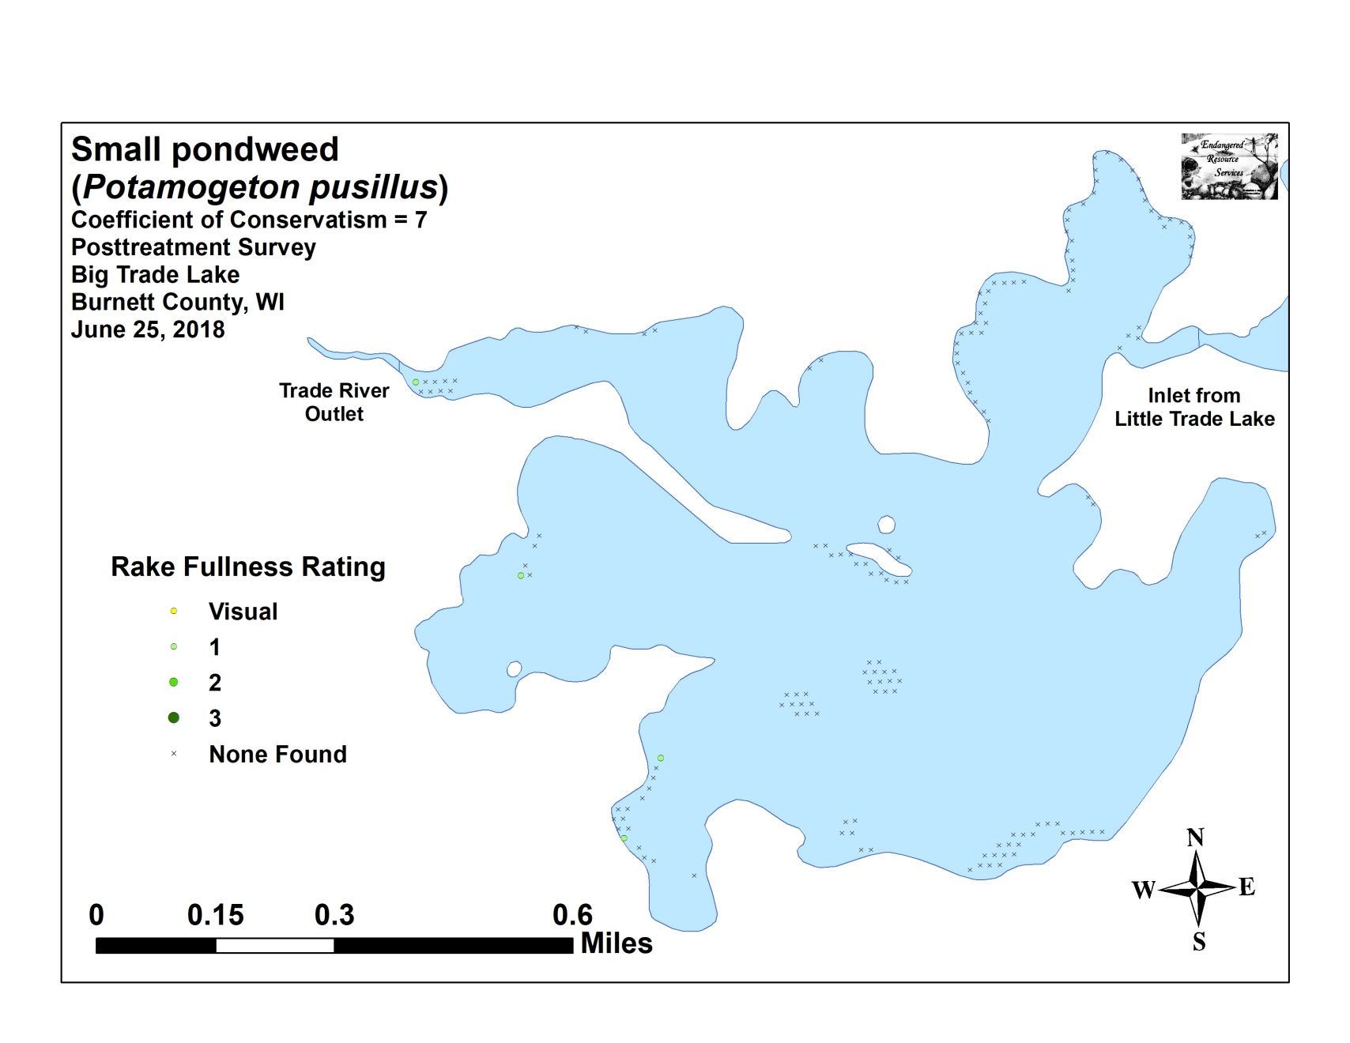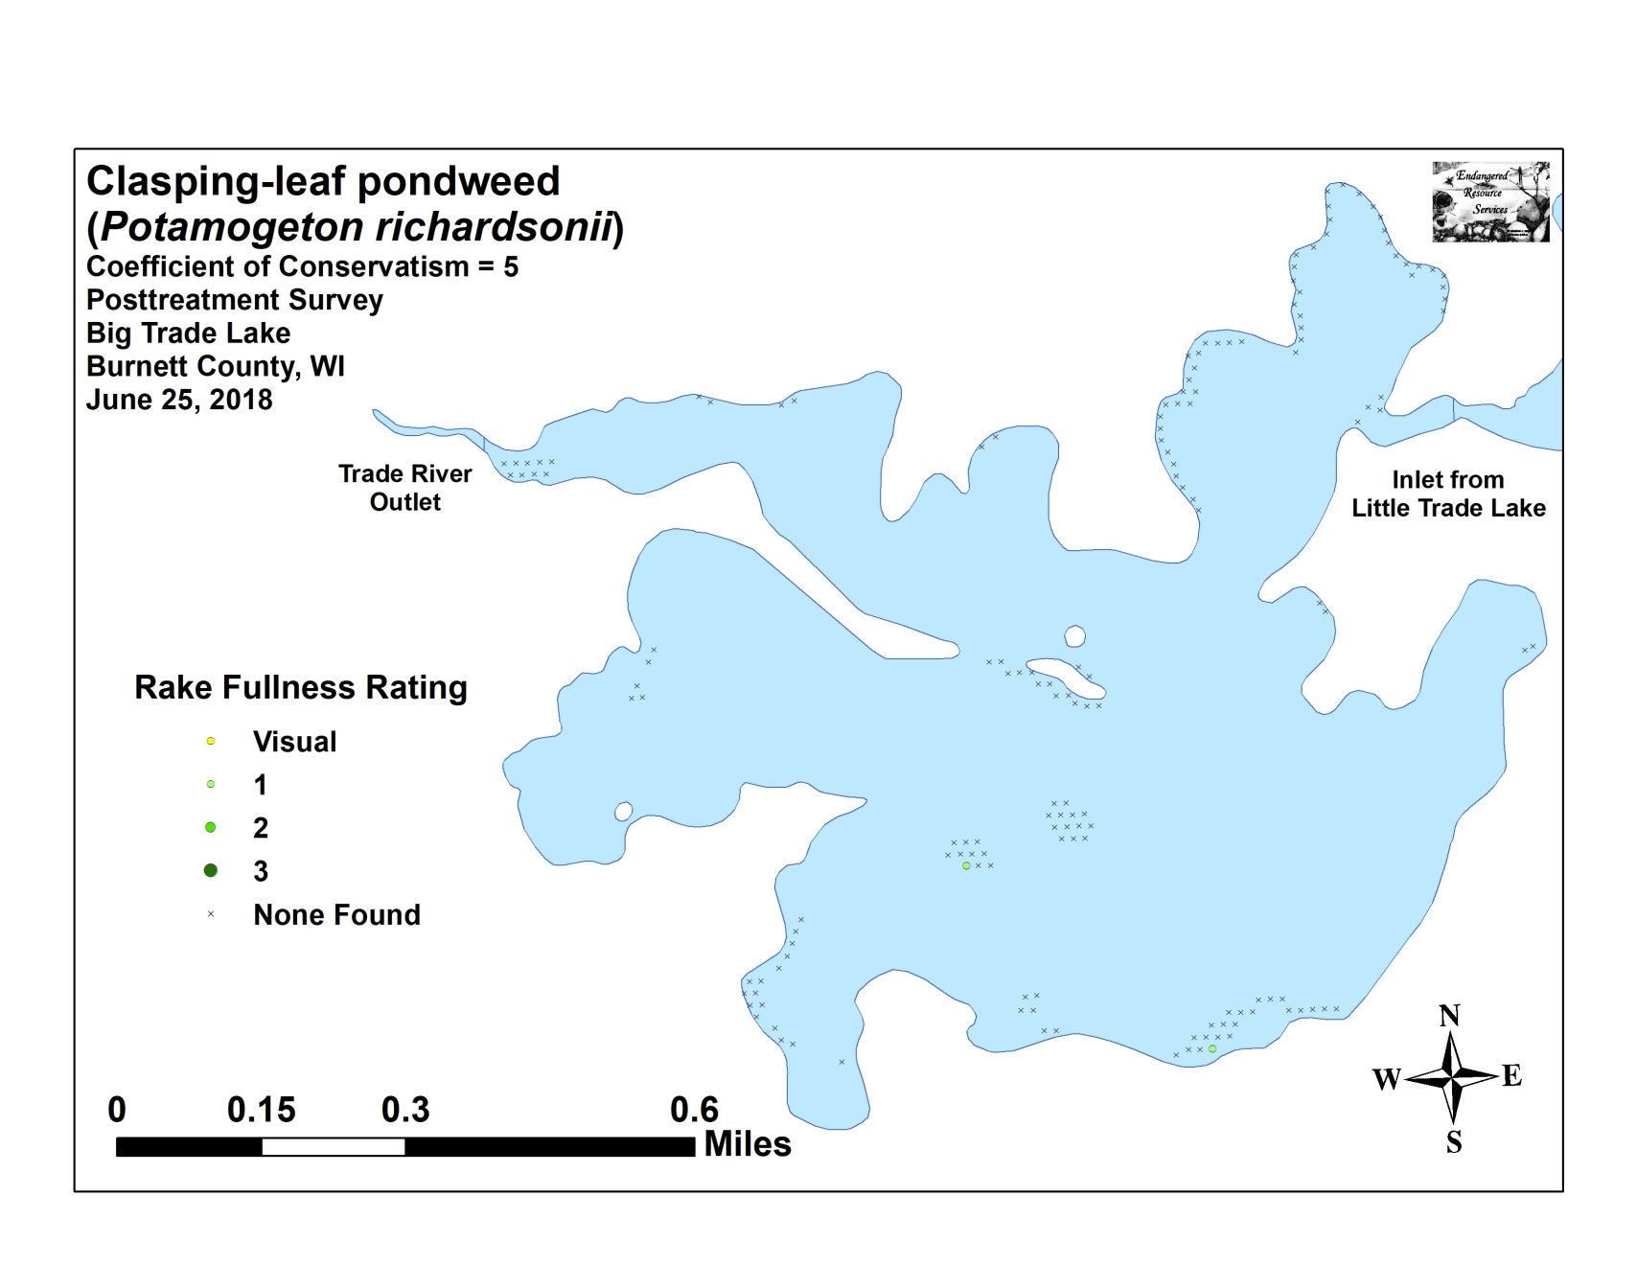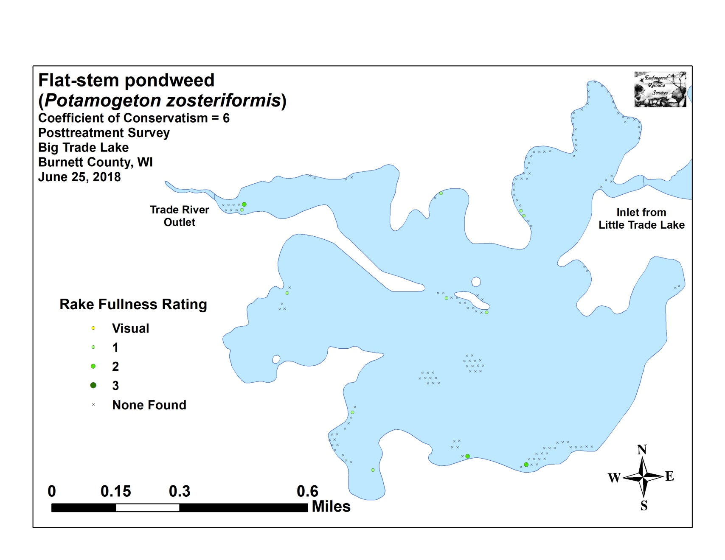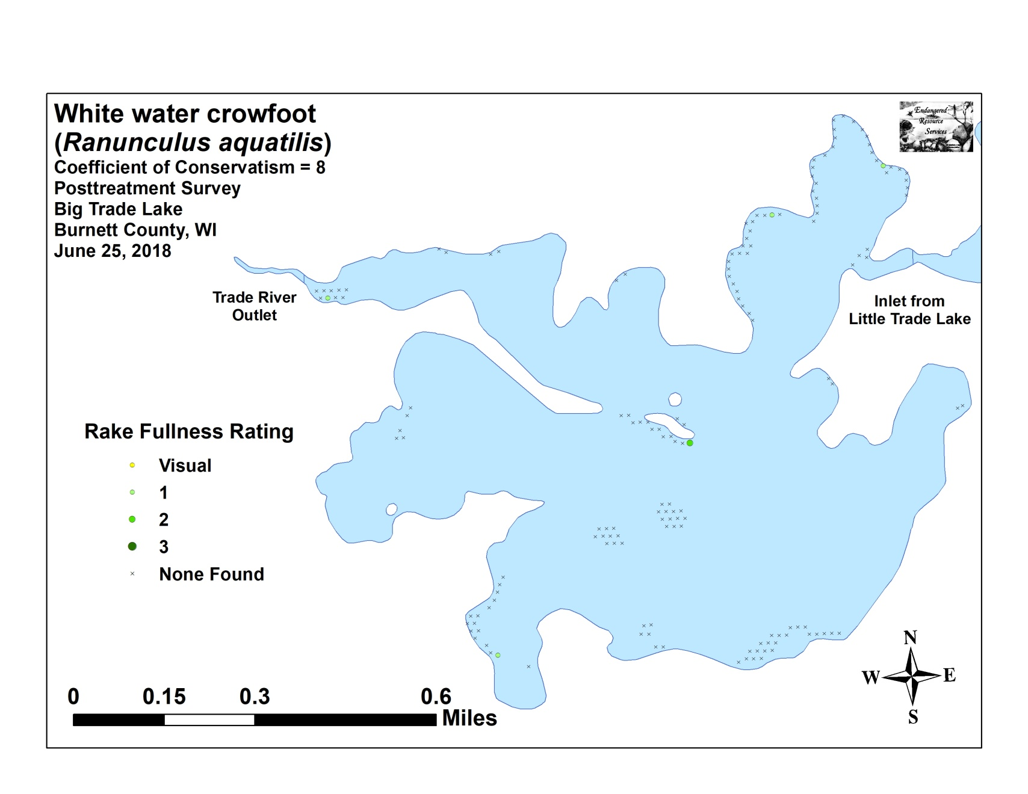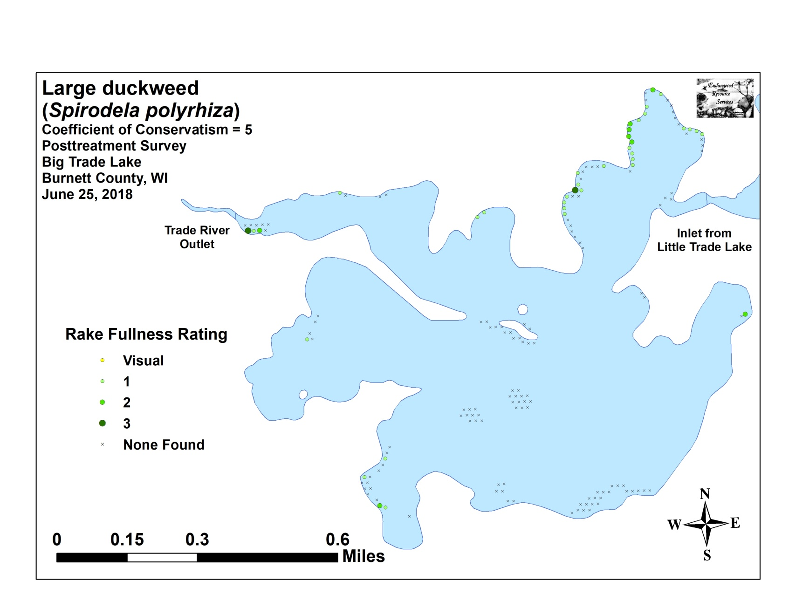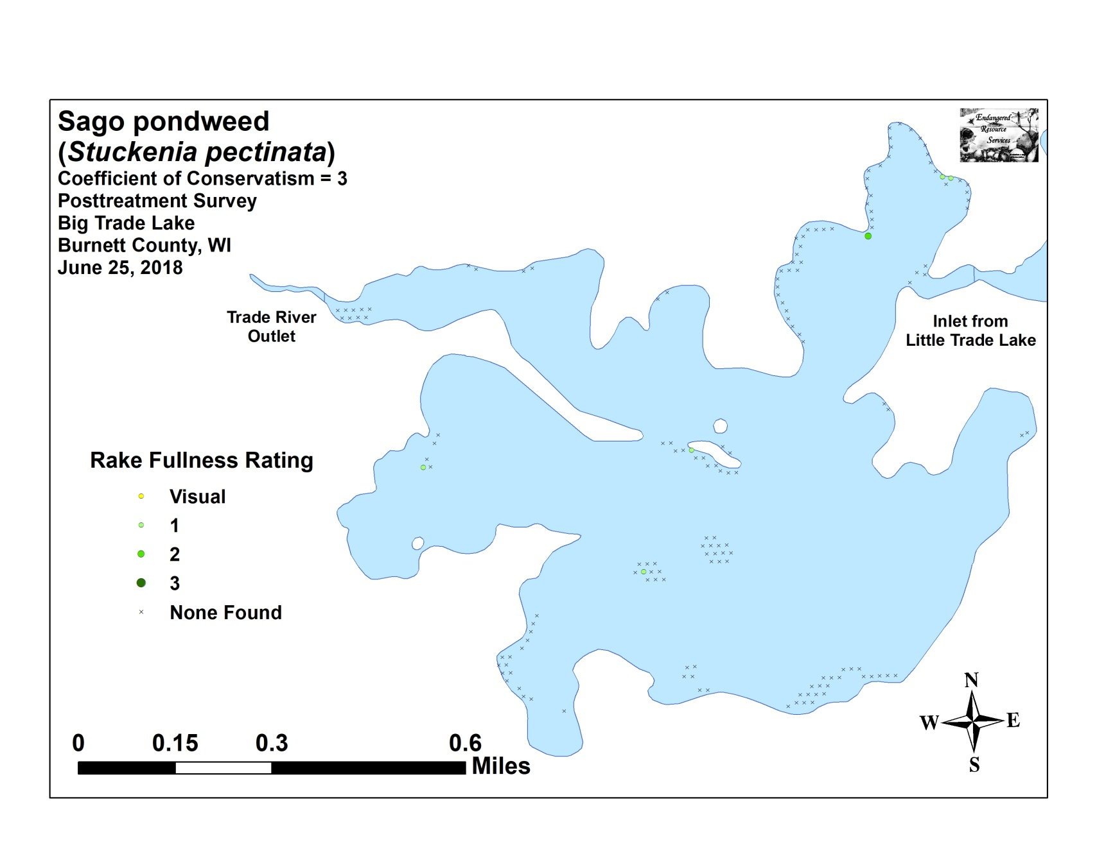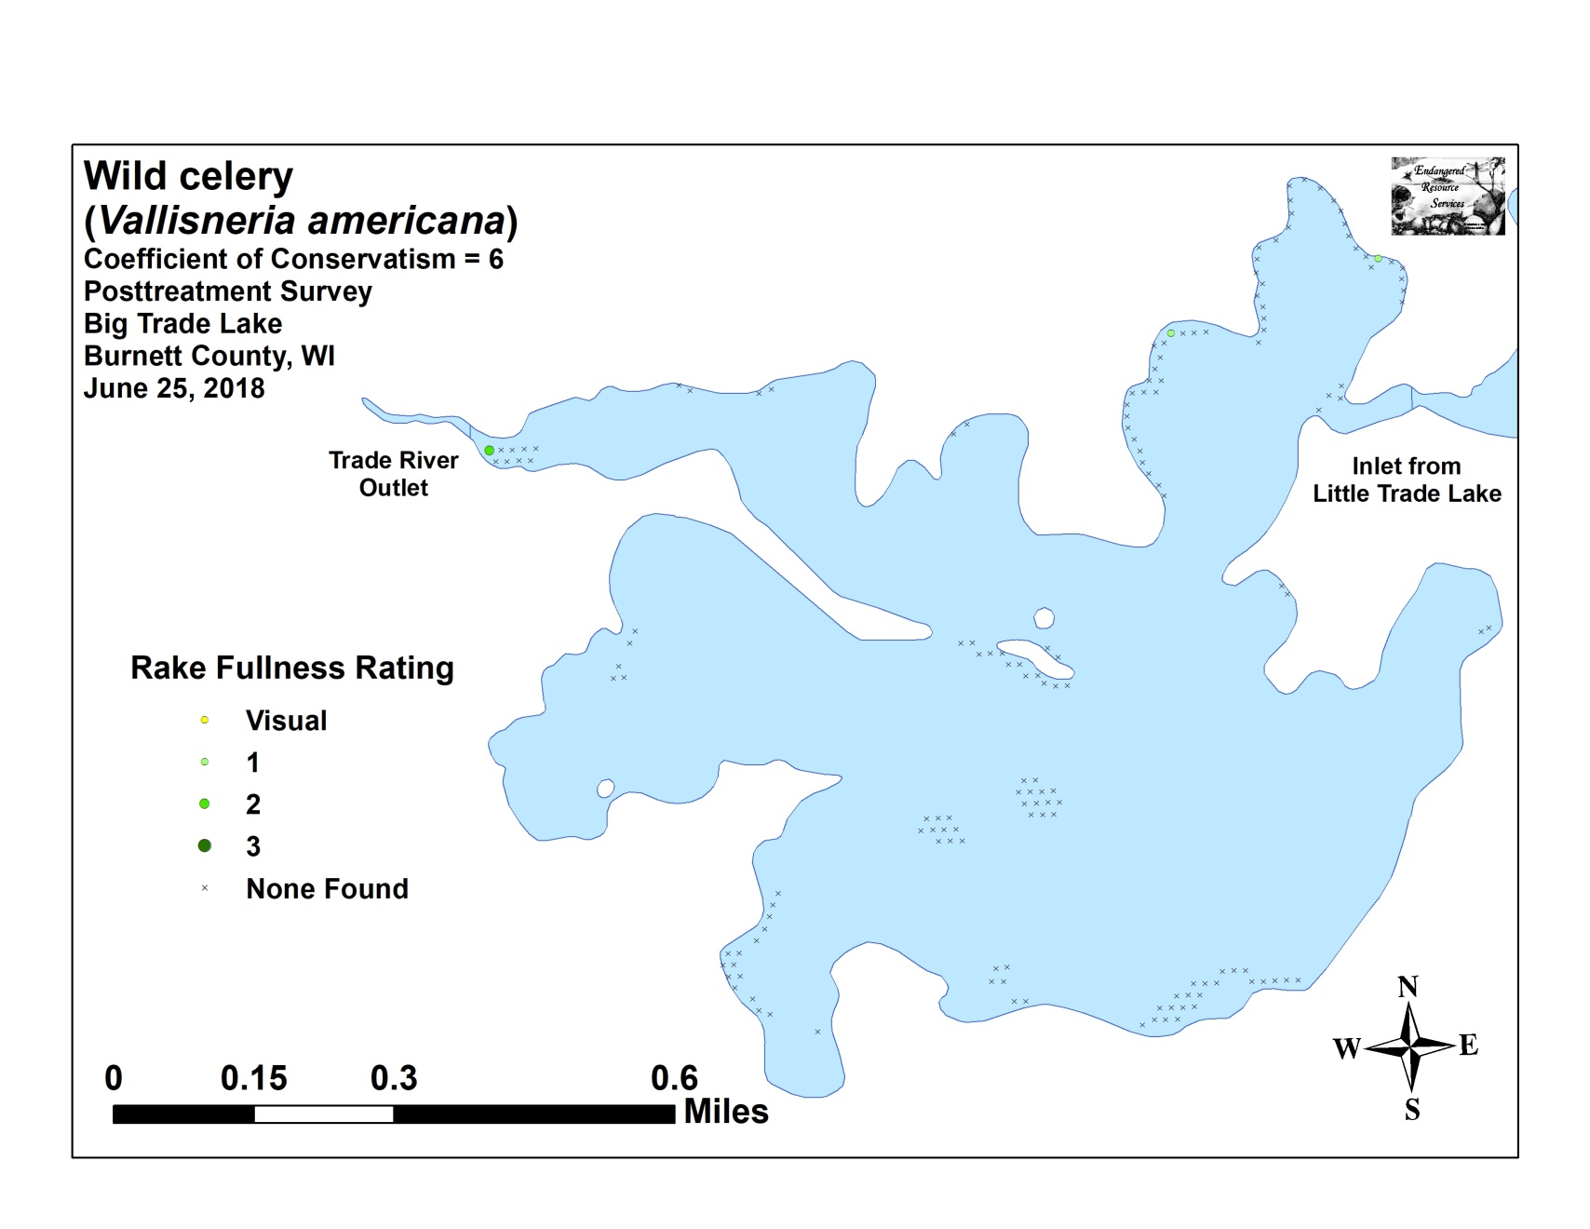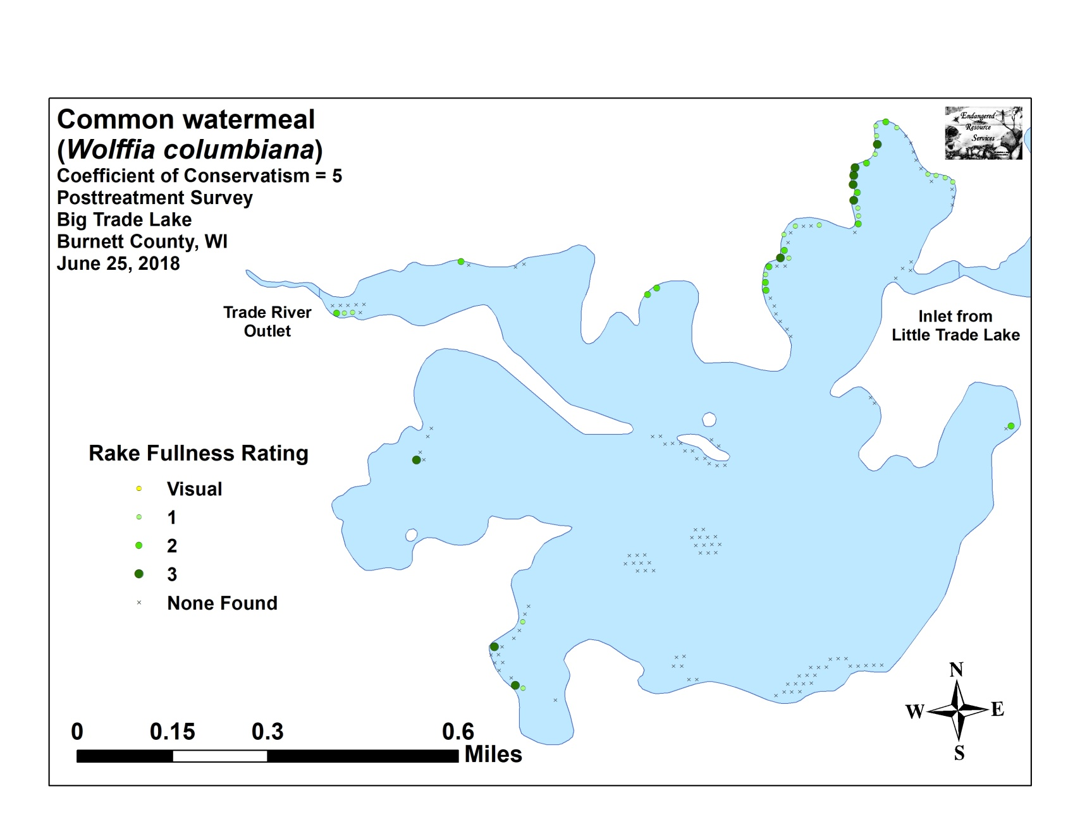

Appendix VIII: Fall 2017 and 2018 EWM Bed Maps
