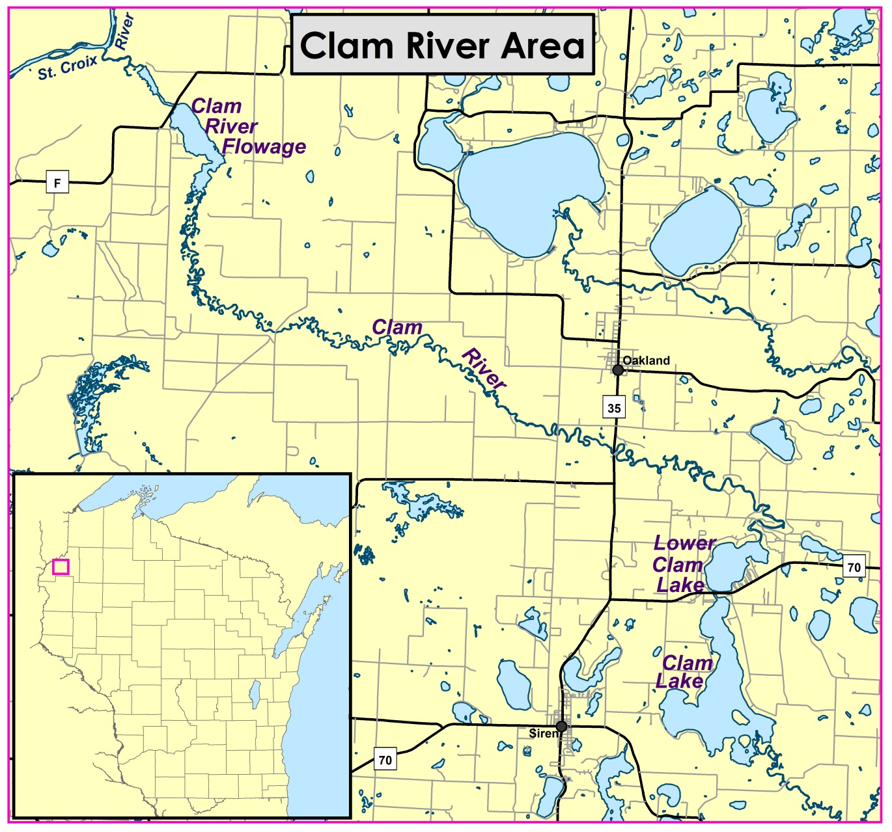

Table 7. Clam River Flowage TP and chlorophyll-a data from 2011-2014. Bold type indicates exceeded thresholds.
Start Date | Total Phosphorus (µg/l) | Chlorophyll-a (µg/l) | Collected by
04/27/2011 | 73 | 17 | Renewable World Energies, LLC
07/13/2011 | 110 | 62 | Renewable World Energies, LLC
08/23/2011 | 61 | 34 | Renewable World Energies, LLC
04/05/2012 | 61 | 13 | Renewable World Energies, LLC
07/11/2012 | 42 | 13 | Renewable World Energies, LLC
08/14/2012 | 67 | 43 | Renewable World Energies, LLC
05/08/2013 | 69 | 17 | Renewable World Energies, LLC
07/10/2013 | 64 | 23 | Renewable World Energies, LLC
08/07/2013 | 110 | 48 | Renewable World Energies, LLC
05/06/2014 | 41 | 9 | Renewable World Energies, LLC
06/30/2014 | 78 | 18 | St. Croix Environmental Services Dep.
07/17/2014 | 56 | 18 | Renewable World Energies, LLC
07/30/2014 | 82 | 44 | St. Croix Environmental Services Dep.
08/13/2014 | 81 | 34 | Renewable World Energies, LLC
08/27/2014 | 81 | 38 | St. Croix Environmental Services Dep.
04/16/2015 | 49 | 13 | Renewable World Energies, LLC
07/08/2015 | 61 | 12 | Renewable World Energies, LLC
08/06/2015 | 76 | 120 | Renewable World Energies, LLC

Table 6. Lower Clam Lake total phosphorus and chlorophyll-a data from 2009-2014. Bold type indicates exceeded thresholds.
Start Date | Total Phosphorus (µg/l) | Chlorophyll-a (µg/l) | Collected by
04/27/2009 | 78 | nd | Citizen Lake Monitoring Network
06/18/2009 | 46 | 24 | Citizen Lake Monitoring Network
07/23/2009 | 83 | 34 | Citizen Lake Monitoring Network
10/22/2009 | nd | 10 | Citizen Lake Monitoring Network
04/27/2010 | 107 | nd | Citizen Lake Monitoring Network
06/24/2010 | 96 | 28 | Citizen Lake Monitoring Network
07/20/2010 | 111 | 90 | Citizen Lake Monitoring Network
08/30/2010 | 136 | 58 | Citizen Lake Monitoring Network
10/13/2010 | nd | 21 | Citizen Lake Monitoring Network
05/24/2011 | 44 | nd | Citizen Lake Monitoring Network
07/07/2011 | 73 | 49 | Citizen Lake Monitoring Network
08/08/2011 | 121 | 93 | Citizen Lake Monitoring Network
06/30/2014 | 130 | 28 | St. Croix Environmental Services Dep.
07/30/2014 | 110 | 57 | St. Croix Environmental Services Dep.
08/28/2014 | 93 | 54 | St. Croix Environmental Services Dep.

