Nemadji River and Tributaries
Water Quality Assessment

Craig Roesler – DNR, Spooner (3/24/14)

Introduction

Monitoring of the Nemadji River and several of its tributaries was conducted during 2008 to 2010 by Superior office staff to assess water quality conditions, and to help determine if these streams should be placed on Wisconsin’s 303d list of impaired waters. Sites monitored are shown in figures 1 and 2. Streams monitored were the Nemadji River, Crawford Creek, Black River, Balsam Creek, Clear Creek, and Mud Creek.

The Wisconsin portion of the Nemadji River watershed is located in Douglas County in the northwest corner of the state. The upstream half of the watershed is located in Minnesota. The Nemadji River flows into Superior Bay on the south side of the City of Superior.

Crawford Creek was previously placed on the 303d list in 1998. The impairment identified is chronic aquatic toxicity. Pollutants identified at that time were creosote and PAH’s. Dioxins are also present. Koppers Industries operated a wood treatment facility that discharged to the creek and contaminated sediments in the creek and its floodplain. The Department is working with the responsible party to better define the degree and extent of sediment contamination and to work toward the clean-up of the creek and flood plain soils.

Erodible clay soils interspersed with sands and silts are present in the Crawford Creek watershed. Flows are “flashy” with high peak flows during runoff events, and low base flows between runoff events. Eroding stream banks, high turbidity, high suspended solids concentrations, and fine sediment bed load are other concerns for this stream.

Much of the Nemadji River watershed also has erodible clay soils interspersed with sands and silts. Erosion of stream banks and drainageways to streams provides most of the sediment load to the Nemadji River. The river carries a large load of both suspended sediment and bed load sediment. The Nemadji River is estimated to deliver 127,000 tons of sediment per year to Superior Bay and Lake Superior. The Army Corps of Engineers removes about 33,000 tons of sediment (mostly sand) per year near the mouth of the river to maintain the navigation channel. The river has high turbidity and high suspended solids concentrations.

The Nemadji River was added to the 303d list in 2010. The high sediment load was judged to exceed the narrative water quality standard found in NR102.04 (a) of the Wisconsin Administrative Code, which states “Substances that will cause objectionable deposits on the shore or in the bed of a body of water, shall not be present in such amounts as to interfere with public rights in waters of the state.” Minnesota placed the Nemadji River on its 303d list in 2004 due to exceedences of their turbidity standard (25 ntu), and began developing a TMDL in 2008. Wisconsin’s listing in 2010 was based in large part on Minnesota’s listing since conditions in the Minnesota and Wisconsin reaches are similar, although Wisconsin does not have a standard for turbidity or total suspended solids. The median turbidity measured in the Nemadji River at CTH C (Wisconsin) is 27.5 ntu (2006-2012), which exceeds Minnesota’s turbidity standard. Including the Nemadji River on Wisconsin’s 303d list would allow the two states to work together to develop a comprehensive TMDL that would benefit the entire watershed.

The other consideration that contributed to the listing decision was that creosote and PAH’s from Crawford Creek are a continuing source of pollutants to the Nemadji River.

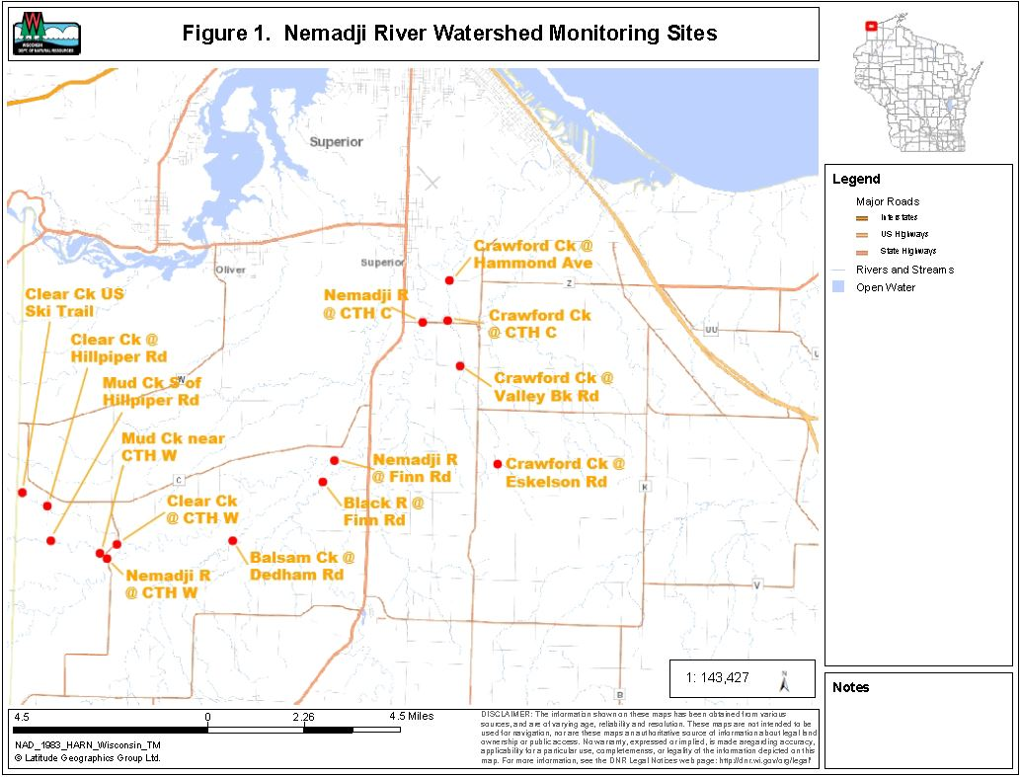

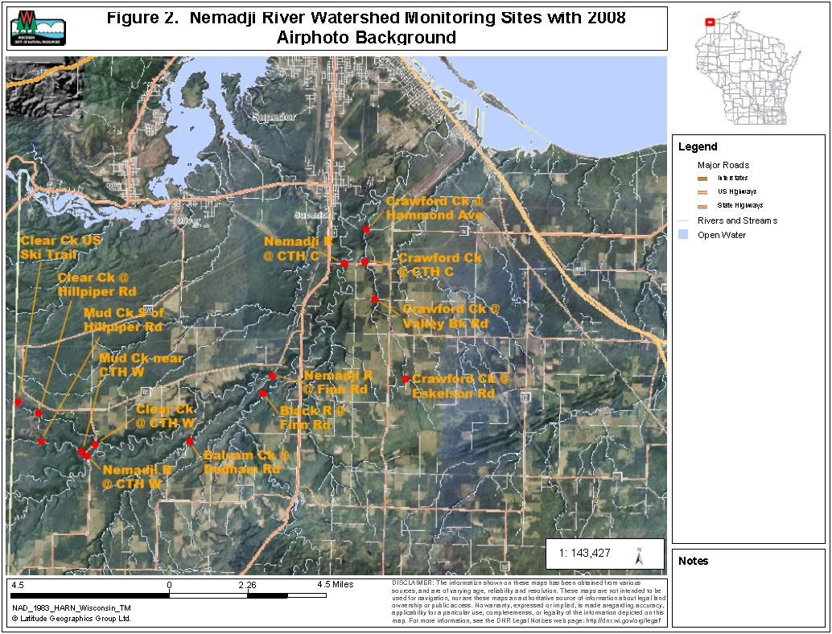

There are four point source discharges going directly or indirectly to the Nemadji River:

- Burlington Northern R.R. Co.; a taconite loading and storage facility (direct)
- Lakehead Pipeline Co.; oil storage tanks (direct)
- Superior Sewage Disposal System; municipal wastewater (direct)
- Four Corners School; school wastewater (indirect via unnamed tributary and Copper Creek to the Nemadji River)

The three direct discharges all enter the Nemadji River downstream of the Nemadji River monitoring site at CTH C. Monitoring the Nemadji River downstream of CTH C is difficult due to lack of access points and periodic backflows caused by Lake Superior seiches. The Four Corners School discharge is very small and located far upstream.
The data collected from this monitoring project does not support 303d listing of any of the other streams monitored (see discussion on p. 18).

Methods

One or more sites were monitored on each of the six streams:

- Nemadji River – 3 sites
- Crawford Creek – 3 sites
- Black River – 1 site
- Balsam Creek – 1 site
- Clear Creek – 3 sites
- Mud Creek – 2 sites

Monitoring was done for fish and macroinvertebrate communities, water chemistry, and stream habitat. The range of monitoring at each site varied (table 1).

Fish communities were assessed by electrofishing with a single anode backpack shocker on small stream sites, and a double anode tow barge stream shocker on larger stream sites. As many fish as possible were captured with a single upstream pass. Station lengths were 35 times the mean stream width, with a minimum length of 100 meters. Fish captured were counted and identified to species. Fish community data was used to determine the natural community of the stream, and to calculate potentially appropriate biotic indices.

Macroinvertebrate communities were assessed by collecting kick samples from riffles, using a 500 um mesh D-frame net. Samples were preserved in 85% ethanol and were processed by UW – Stevens Point’s Aquatic Biomonitoring Lab. Macroinvertebrates were counted and identified to the lowest possible taxa. Biotic indices and other statistics were generated.

Water samples were collected and field parameters were measured following standard DNR protocols. Water samples were preserved, as needed, and shipped on ice to the Wisconsin State Lab of Hygiene for analysis. Field parameters measured were:
- Temperature
- pH
- Dissolved Oxygen
- Conductivity
- Transparency (using a transparency tube)

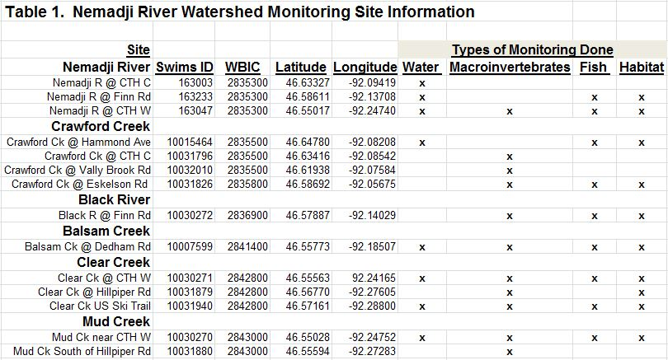

Lab parameters were:
- Total Phosphorus
- Ammonia – N
- Total Kjeldahl N
- Nitrate plus Nitrite – N
- Total Suspended Solids
- Turbidity
- Chlorophyll a
- Dissolved phosphorus

Findings and Discussion

Fish Communities

Complete fish survey results are contained in appendix A. Fish survey IBI’s (index of biotic integrity) are summarized in table 2.

Fish community indices of biotic integrity (IBI) ranged from excellent to fair. Sites on the Nemadji River, Black River, Balsam Creek, and Mud Creek had IBI ratings of excellent. Clear Creek had IBI ratings of good.

The Crawford Creek sites had the lowest IBI ratings of fair. The percent of fish that are tolerant of environmental disturbances exceeded 75% at these sites (92-100%; table 2). Seventy-five percent tolerant fish is the maximum typically expected in a Cool-Cold Headwater stream. The high percentages of intolerant fish at the Crawford Creek sites probably reflects the influence of erodible clay soils in a small watershed with moderate development, limited fish habitat, and very low base flows.

The stream sites varied in size and natural stream community types (table 2-2), from Cool-Cold Headwaters to Warm Mainstems. Clear Creek upstream of the ski trail was the only site where a coldwater species was found (mottled sculpin; appendix A).

Macroinvertebrate Communities

Macroinvertebrate IBI (MIBI) ratings were excellent or good at all but one site (table 3). The MIBI for Crawford Creek at CTH C was rated as fair. MIBI ratings were generally similar to the IBI’s for the fish communities. One exception was the Crawford Creek site at Eskelson Road, where the MIBI was excellent, while the fish IBI was only fair.

Hilsenhoff biotic index (HBI) ratings ranged from good to excellent. HBI’s are mostly influenced by organic matter loading and the resultant dissolved oxygen concentrations. The HBI’s suggest dissolved oxygen stress to macroinvertebrates is minimal.

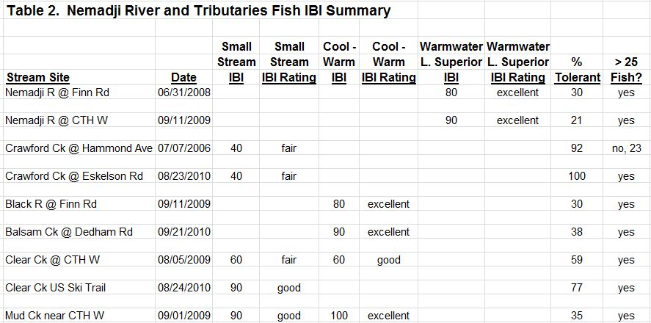
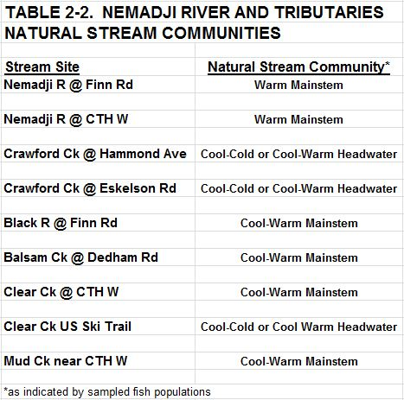

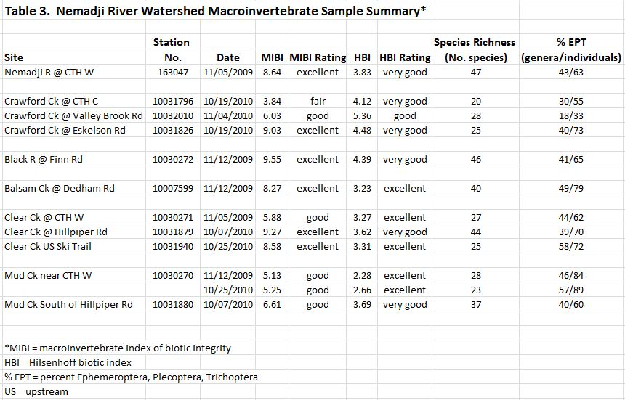

Water Chemistry

Water chemistry data for the Nemadji River and sampled tributaries is shown in table 4. Sampling frequency and duration varied by site making comparisons between sites tentative. No water samples were collected from the Black River.

Only the two Nemadji River sites had more than one sample collected for nutrients. Median concentrations of total phosphorus (TP) and total nitrogen (TN)(total Kjeldahl nitrogen plus nitrate and nitrite nitrogen) were low to moderate at these sites (table 4-2). TP concentration medians ranged from 30 – 46 ug/l. The percent of total phosphorus present in the dissolved form was low, with a median concentration of 3 ug/l. TN concentration medians ranged from 0.59 – 0.63 mg/l. More than 92% of the total nitrogen was present in an organic form.

The Nemadji River sites had low concentrations of ammonia and nitrate plus nitrite. Ammonia concentration medians were less than 0.015 mg/l. Nitrate plus nitrite concentration medians ranged from 0.029 – 0.038 mg/l.

All sites had fairly high total suspended solids (TSS) concentrations, fairly high turbidity, and fairly low transparency. The three Nemadji River sites and the Clear Creek site had the lowest turbidity medians (19-35 ntu), and the highest transparency medians (25-42 cm). The Mud Creek site had the highest turbidity median (57 ntu), and the lowest transparency median (17 cm).

Daytime dissolved oxygen (D.O.) concentrations were generally good. Only two concentrations were less than 5 mg/l. The Nemadji River at CTH C had a D.O. concentration of 4.5 mg/l on one date. Crawford Creek at Hammond Avenue had a D.O. concentration of 2.4 mg/l on one date.

Median conductivities ranged from 195 – 520 umhos/cm. Conductivity was highest in Clear Creek (median 520 umhos/cm), probably as a result of more groundwater discharge to this stream. pH median values ranged from 7.5 to 8.0

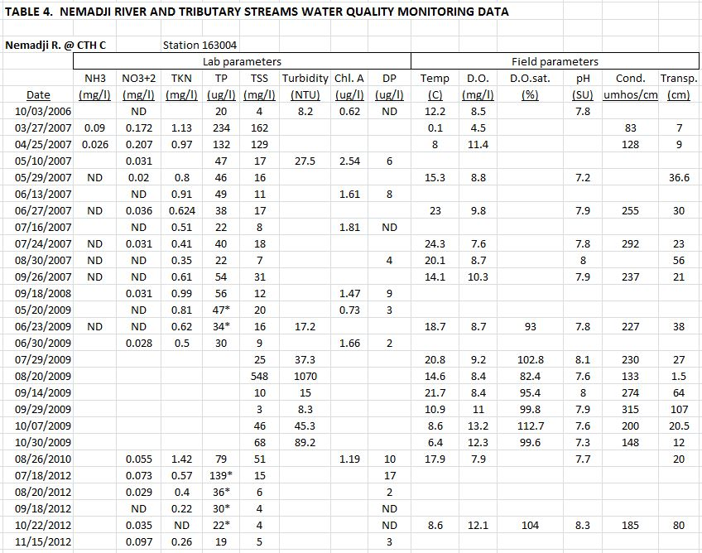

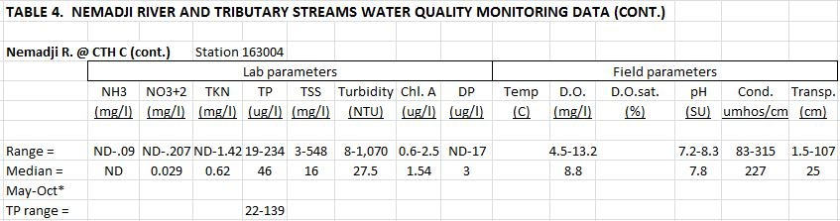

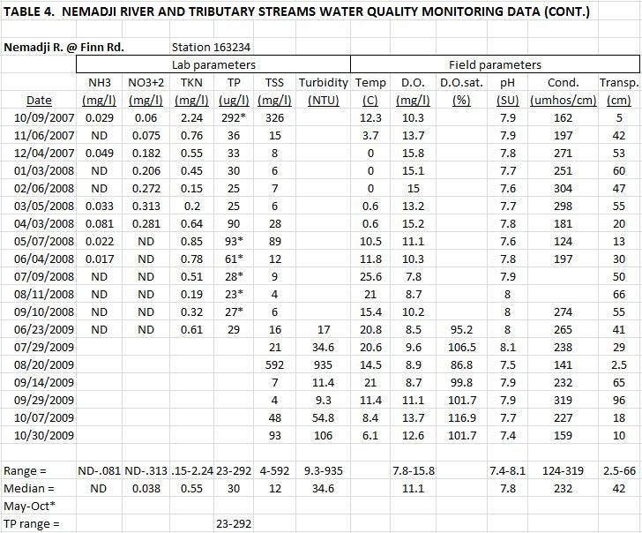

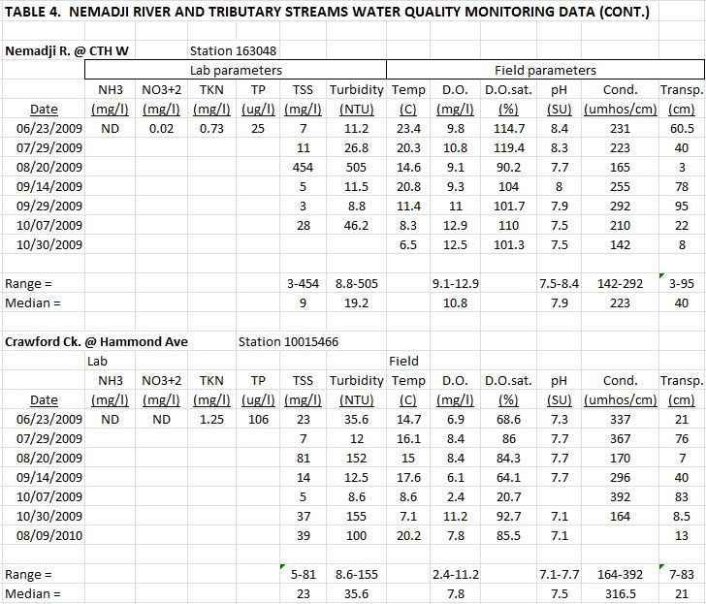

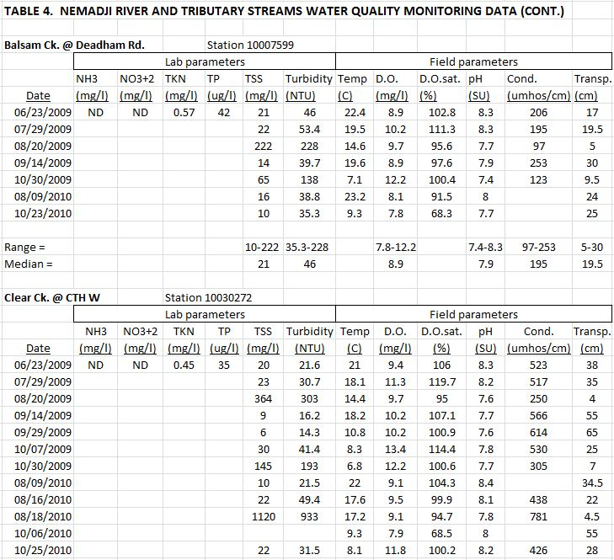

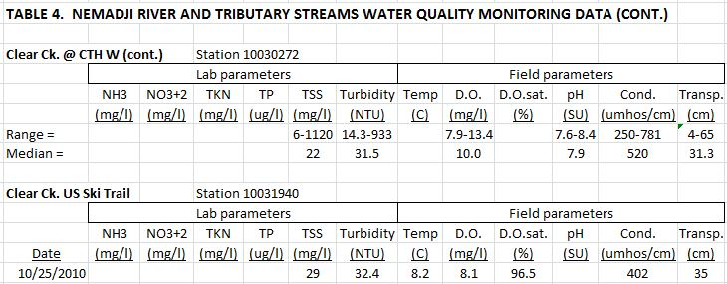

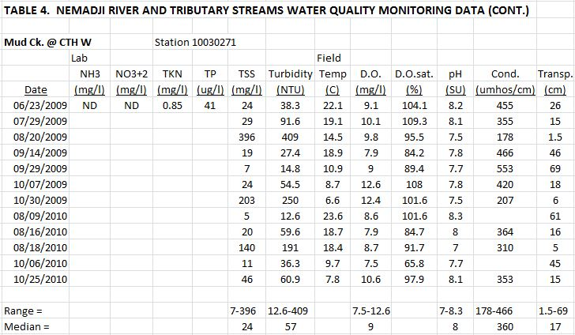

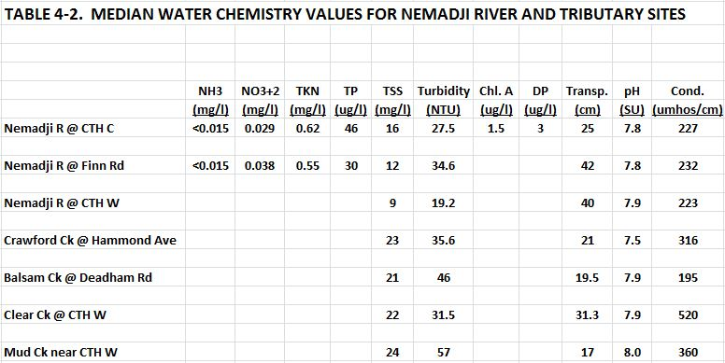

Conclusions

The sites monitored in Wisconsin’s portion of the Nemadji River watershed are diverse, with natural stream communities ranging from Cool-Cold headwaters to Warm mainstems. Erodible clay soils interspersed with sands and silts dominate the drainage areas for most sites. Erosion of stream banks and drainageways are the dominant source of sediment loads. Common stream concerns in this area include:

- High peak flows resulting from rapid runoff from clay soils.
- Low base flows resulting from limited groundwater discharge.
- Scouring of stream bed, and bank erosion resulting from high peak flows.
- High bed loads of sand and silt, reducing the substrate quality for fish and macroinvertebrates. .
- High TSS and turbidity, and low transparency resulting from erosion of clay soils.

Most of the Black River watershed extends south of the red clay plain area and has soils dominated by stony and sandy loams, and organic wetland soils. Water quality is likely to be better in that stream, but water sampling was not done at the Black River monitoring site. Both the fish IBI and the macroinvertebrate IBI for this site were excellent.

The Nemadji River and Crawford Creek have already been placed on Wisconsin’s 303d list of impaired waters, as discussed in the introduction section. The data collected during this project does not provide any further supporting information for having these streams on the list.

WISCALM guidance (2014) indicates at least two samples of one biological assemblage (fish or macroinvertebrates) collected in different calendar years and having “poor” ratings are required to list a stream as impaired. Neither the Nemadji River nor Crawford Creek had any poor ratings for fish IBI’s or macroinvertebrate IBI’s (table 5).

Total phosphorus (TP) concentrations can also be used toward listing a stream as impaired. Six monthly samples collected from May to October are needed for this assessment. The lower bound of the 90% confidence interval of the mean must exceed 75 ug/l to list a stream as impaired. Only two sites on the Nemadji River (CTH C and Finn Road) had the needed samples collected (table 5). At both sites the 75 ug/l TP threshold is not exceeded.

The data collected during this project for the other streams does not support 303d listing. No poor ratings for fish IBI’s or macroinvertebrate IBI’s were found. Sampling for TP concentrations was inadequate to determine if the 75 ug/l threshold is exceeded (table 5).

